How to assemble them quickly and accurately is a difficult problem when there are lots of fragments. It is no doubt time-consuming and inaccurate to try violently without considering any skills. In order to reassemble the fragments automatically, accurately and efficiently, we propose a new method based on the linear feature of fragment fracture surface. Analogous to manual assembly, our method first reassembles the certain fragments, then tries to assemble the uncertain fragments, and finally leaves the obvious ones that can’t be assembled.

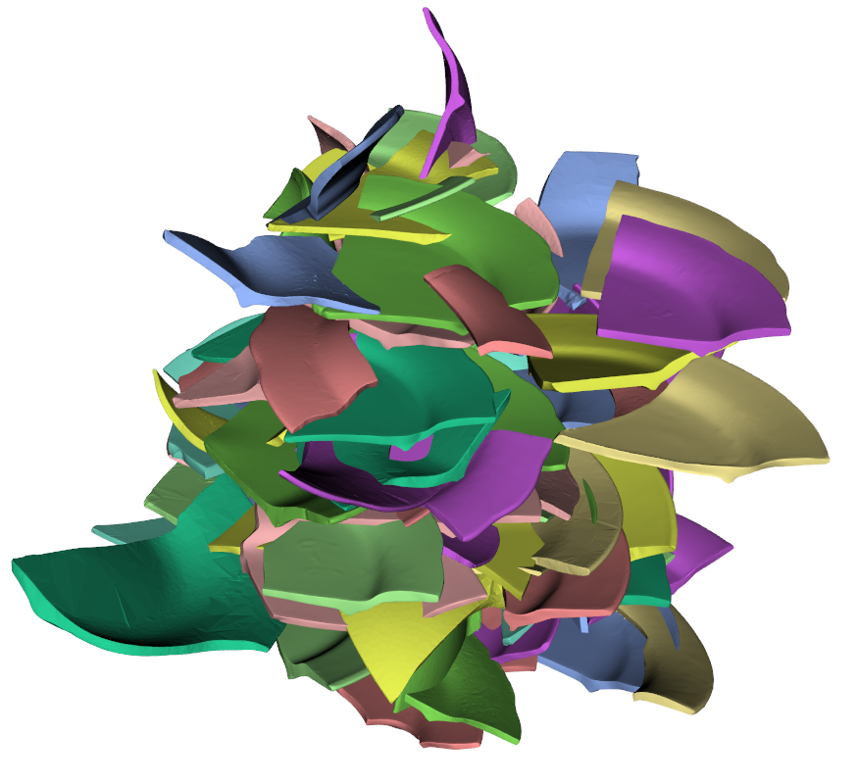

碎片

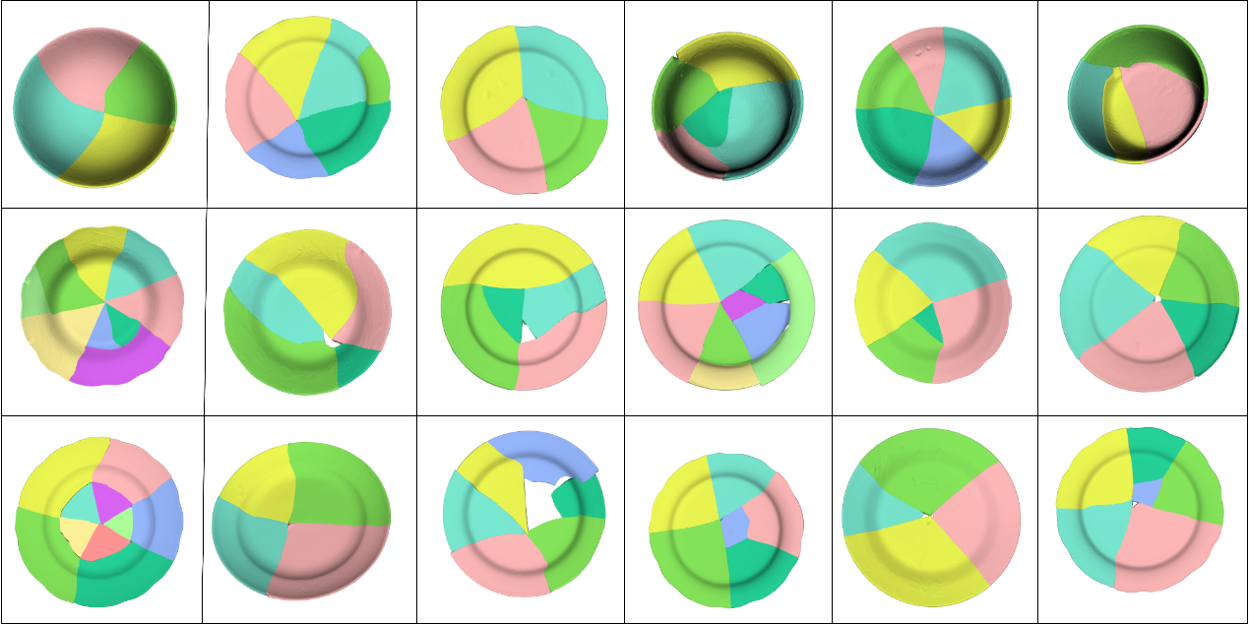

结果