Although some progress has been made in the work of computer vision-assisted cultural relics restoration, there are still some shortcomings. First of all, in terms of point cloud representation, how to convert the point cloud into input that can be applied to deep learning. Secondly, how to get the optimal feature descriptor to represent the feature. These are all issues that need to be resolved. Based on the above shortcomings, we hope to extract the local features of the fragment surface through a neural network structure, and use these features for registration. Thereby, it can effectively help cultural relics restoration personnel to improve the efficiency of restoration, and then achieve the purpose of protecting our country's precious historical cultural relics.
Disadvantages of manual repair：
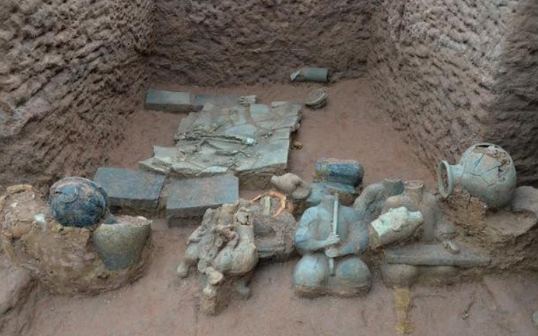
1. Long repair period and high cost
2. During the repair period, the mobility is low, and it is easy to cause secondary damage
Advantages of computer vision-assisted restoration of cultural relics
1. Break through the limitations of time and space
2. Improve repair efficiency and reduce the possibility of secondary damage
research method
1. Obtain the characteristics of invariant rotation of the debris surface through the neural network
2. Use the local features of the debris surface for registration

