Insurance Claim Cost Prediction Using Machine Learning and Explainable AI: An End-to-End Data Mining Approach

A Data Mining Project Report

Prepared for: Data Mining Course
2024-2025 Academic Year

Technologies: Python, XGBoost, LightGBM, SHAP, Claude AI, Flask
GitHub: github.com/Dutchy-O-o/DataMiningInsurance

Table of Contents
1. Abstract
2. Introduction
2.1 Problem Definition
2.2 Objectives
2.3 Scope
3. Literature Review
4. Dataset Description
4.1 Data Source
4.2 Feature Description
4.3 Statistical Summary
4.4 Data Quality Assessment
5. Exploratory Data Analysis
5.1 Missing Values Analysis
5.2 Target Variable Distribution
5.3 Correlation Analysis
5.4 Feature-Target Relationships
5.5 Key EDA Conclusions
6. Data Preprocessing
6.1 Outlier Detection and Treatment
6.2 Categorical Encoding
6.3 Feature Scaling
6.4 Train-Test Split
7. Feature Engineering
7.1 Interaction Features
7.2 Target Transformation Strategy
8. Model Training and Optimization
8.1 Model Selection
8.2 Linear Regression
8.3 Ridge Regression
8.4 XGBoost
8.5 LightGBM
8.6 Gradient Boosting
8.7 Hyperparameter Optimization
9. Results and Discussion
9.1 Model Comparison
9.2 Feature Importance Analysis
9.3 Residual Analysis
9.4 Confidence Estimation
10. Explainable AI (SHAP)
10.1 SHAP Theory
10.2 Global Feature Attribution
10.3 Per-Prediction Explanations
11. Web Application
11.1 Architecture
11.2 Features
11.3 Claude AI Integration
12. Conclusion
13. Future Work
14. References

1. Abstract
This paper presents an end-to-end data mining pipeline for predicting insurance claim costs using ensemble machine learning methods. The study analyzes 1,338 policyholder records with six demographic and health-related features to predict annual insurance charges. Five regression models were trained and compared: Linear Regression, Ridge Regression, XGBoost, LightGBM, and Gradient Boosting. Feature engineering techniques including interaction terms (smoker×BMI, smoker×age) and a hybrid log-transform strategy were applied. The best-performing model, XGBoost, achieved an R² score of 0.88 with an RMSE of $4,295. SHAP (SHapley Additive exPlanations) was integrated for model interpretability, revealing that smoking status accounts for 82.6% of prediction importance. The trained model was deployed as an interactive web application featuring real-time predictions, what-if scenario analysis, SHAP-based cost breakdowns, and AI-generated personalized health optimization reports via Claude API integration.

Keywords: Data Mining, Insurance Cost Prediction, XGBoost, SHAP, Explainable AI, Feature Engineering, Ensemble Learning, Flask Web Application

2. Introduction

2.1 Problem Definition
Insurance cost prediction is a fundamental challenge in the actuarial and healthcare industries. Accurate prediction of individual insurance charges enables insurance companies to set fair premiums, assess risk profiles, and optimize their portfolio management. From the policyholder's perspective, understanding the factors driving their insurance costs can motivate healthier lifestyle choices and inform financial planning.
Traditional actuarial methods rely on statistical tables and linear models that often fail to capture complex, non-linear relationships between demographic factors and insurance costs. With the advent of machine learning, particularly ensemble methods like gradient boosting, it has become possible to model these intricate patterns with significantly higher accuracy.

2.2 Objectives
The primary objectives of this project are:
- 1. Perform comprehensive exploratory data analysis to discover patterns and relationships in insurance data
- 2. Develop a robust data preprocessing pipeline with outlier treatment, encoding, and scaling
- 3. Engineer interaction features informed by EDA findings to capture non-linear patterns
- 4. Train and compare five regression models with hyperparameter optimization
- 5. Integrate SHAP explainability for transparent, per-prediction feature attribution
- 6. Deploy the model as a production-ready web application with AI-powered health advice

2.3 Scope
This project covers the complete data mining lifecycle following the CRISP-DM (Cross-Industry Standard Process for Data Mining) methodology: Business Understanding, Data Understanding, Data Preparation, Modeling, Evaluation, and Deployment. The scope includes exploratory analysis, preprocessing, feature engineering, model training with hyperparameter tuning, evaluation with multiple metrics, explainability analysis, and web application deployment.

3. Literature Review
Insurance cost prediction has been studied extensively in the machine learning literature. Boodhun and Jayabalan (2018) applied multiple regression models to medical insurance data, finding that smoking status and BMI were the most significant predictors. Their study reported R² values between 0.75 and 0.86 using tree-based methods.
Ensemble methods, particularly gradient boosting variants, have shown consistent superiority in tabular data prediction tasks. Chen and Guestrin (2016) introduced XGBoost, which has since become the dominant algorithm for structured data. The algorithm combines gradient boosting with L1 and L2 regularization, column subsampling, and efficient handling of sparse data. Ke et al. (2017) proposed LightGBM with histogram-based learning, achieving comparable accuracy with significantly faster training times.
The need for model interpretability in high-stakes domains like insurance has driven the adoption of Explainable AI (XAI) techniques. Lundberg and Lee (2017) introduced SHAP values based on Shapley values from cooperative game theory, providing a unified framework for feature attribution that satisfies desirable theoretical properties including local accuracy, missingness, and consistency.
Recent advances in generative AI, particularly large language models like Claude (Anthropic, 2024), have opened new possibilities for converting quantitative predictions into natural language explanations that are accessible to non-technical stakeholders.
Our work extends prior studies by combining feature engineering, multiple ensemble models, SHAP explainability, and generative AI in a deployable web application — an integrated approach not commonly found in existing literature.

4. Dataset Description

4.1 Data Source
The dataset used in this study is the Medical Cost Personal Dataset, publicly available on Kaggle (Choi, 2018). It contains 1,338 records of insurance policyholders in the United States with seven attributes describing demographic information, health indicators, and annual insurance charges.

4.2 Feature Description
Feature | Type | Range | Description
age | Numerical | 18 – 64 | Age of the policyholder
sex | Categorical | male, female | Biological sex
bmi | Numerical | 15.96 – 53.13 | Body Mass Index (kg/m²)
children | Numerical | 0 – 5 | Number of dependents
smoker | Categorical | yes, no | Smoking status
region | Categorical | 4 regions | US geographic region
charges | Numerical | $1,122 – $63,770 | Annual insurance cost (TARGET)

4.3 Statistical Summary
Statistic | Age | BMI | Children | Charges ($)
Count | 1,338 | 1,338 | 1,338 | 1,338
Mean | 39.21 | 30.66 | 1.09 | 13,270
Std Dev | 14.05 | 6.10 | 1.21 | 12,110
Min | 18 | 15.96 | 0 | 1,122
25% | 27 | 26.30 | 0 | 4,740
Median | 39 | 30.40 | 1 | 9,382
75% | 51 | 34.69 | 2 | 16,640
Max | 64 | 53.13 | 5 | 63,770

4.4 Data Quality Assessment
The dataset contains zero missing values across all seven columns, eliminating the need for imputation strategies. The data types are consistent with expectations: numerical features (age, bmi, children, charges) and categorical features (sex, smoker, region). No duplicate records were found.
A notable class imbalance exists in the smoker variable: only 20.5% of records (274 out of 1,338) represent smokers. Despite being a minority, smokers exert a disproportionate influence on the cost distribution, with an average annual cost of $32,050 compared to $8,434 for non-smokers — a 3.8x difference.

5. Exploratory Data Analysis

5.1 Missing Values Analysis
A comprehensive missing values check confirmed zero null values across all features. This was verified both numerically (isnull().sum()) and visually through a missing values heatmap generated using seaborn. The absence of missing data simplifies the preprocessing pipeline and eliminates potential bias from imputation methods.

5.2 Target Variable Distribution
The target variable (charges) exhibits significant right-skewness with a skewness coefficient of 1.52 and kurtosis of 1.61. The distribution shows a concentration of low-cost policyholders (under $15,000/year) with a long right tail extending to $63,770. This skewness has important implications for model selection — linear models benefit from log transformation while tree-based models can handle the raw distribution.

5.3 Correlation Analysis
Pearson correlation analysis was performed after encoding categorical variables. The results reveal the following correlations with the target variable (charges):
Feature | Correlation | Strength
smoker | 0.787 | Strong Positive
age | 0.299 | Moderate Positive
bmi | 0.198 | Weak Positive
children | 0.068 | Negligible
sex | 0.057 | Negligible
region | <0.07 | Negligible

The dominance of smoking status (r = 0.787) is striking. It alone explains more variance than all other features combined. Age and BMI serve as secondary predictors, while region and sex have virtually no linear relationship with cost.

5.4 Feature-Target Relationships
Scatter plots of age vs. charges (colored by smoking status) reveal three distinct cost clusters: (1) non-smokers forming a low-cost band, (2) smokers with normal BMI forming a medium-cost band, and (3) smokers with high BMI forming a high-cost band. This three-cluster pattern is a critical finding that directly informed our feature engineering strategy.
Box plots comparing categorical variables against charges confirm that smoking status creates the largest separation in cost distributions, while sex and region show minimal differences.

5.5 Key EDA Conclusions
- Smoking is the overwhelmingly dominant predictor (r = 0.79, 3.8x cost multiplier)
- Three distinct cost clusters exist, driven by the smoker × BMI interaction
- Age shows a clear positive linear trend within each cluster
- Region and sex have negligible predictive power
- The non-linear smoker×BMI interaction suggests boosting models will outperform linear models
- Target variable skewness (1.52) requires attention for linear model training

6. Data Preprocessing

6.1 Outlier Detection and Treatment
The Interquartile Range (IQR) method was applied to detect and clip outliers in continuous features. For each feature, values below Q1 - 1.5×IQR or above Q3 + 1.5×IQR were clipped to the respective boundary values (not removed). This approach preserves data quantity while reducing the influence of extreme values.
Feature | Outliers Detected | Lower Bound | Upper Bound
age | 0 | -9.00 | 87.00
bmi | 9 | 13.70 | 47.29
children | 0 | -3.00 | 5.00

Important design decision: The target variable (charges) was NOT subjected to outlier clipping. In a regression problem, extreme target values represent real high-cost cases that the model must learn to predict accurately. Clipping would artificially cap predictions and degrade model performance for the most expensive policyholders.

6.2 Categorical Encoding
Two encoding strategies were applied based on the cardinality of categorical features:
Label Encoding was used for binary features: sex (male=1, female=0) and smoker (yes=1, no=0). This preserves the ordinal-like nature of binary variables without increasing dimensionality.
One-Hot Encoding with drop_first=True was applied to the region feature (4 categories), producing three dummy variables: region_northwest, region_southeast, region_southwest. The northeast region serves as the baseline (implicit when all dummies are 0).

6.3 Feature Scaling
StandardScaler was applied to normalize continuous features to zero mean and unit variance. This is essential for linear models and can improve convergence for gradient-based optimizers.
Feature | Mean (μ) | Std Dev (σ)
age | 39.21 | 14.04
bmi | 30.65 | 6.05
children | 1.09 | 1.21

6.4 Train-Test Split
The dataset was split into 80% training (1,070 samples) and 20% testing (268 samples) using scikit-learn's train_test_split with random_state=42 for reproducibility. Stratified splitting was not used as the target variable is continuous.

7. Feature Engineering

7.1 Interaction Features
The EDA revealed that the relationship between features and charges is not purely additive. Specifically, the effect of BMI on cost is dramatically amplified for smokers compared to non-smokers. To capture this non-linear pattern explicitly, two interaction features were engineered:
Feature | Formula | Rationale
smoker_bmi | smoker × bmi (scaled) | Captures the synergy between smoking and obesity that produces disproportionately high costs
smoker_age | smoker × age (scaled) | Captures the accelerated cost increase for smokers as they age

These interaction terms expanded the feature space from 8 to 10 dimensions. For linear models, this improved R² from 0.78 to 0.84 — a substantial gain. For boosting models, which can implicitly learn interactions through tree splits, the improvement was marginal but still positive.

7.2 Target Transformation Strategy
The charges variable has a skewness of 1.52, which violates the normality assumption of linear regression. A hybrid transformation strategy was adopted:
For Linear and Ridge Regression: The target was transformed using np.log1p(charges), reducing skewness from 1.52 to -0.12. Predictions are converted back using np.expm1(). This improved linear model R² from 0.78 to 0.84.
For Boosting Models (XGBoost, LightGBM, GradientBoosting): The raw target was used. Tree-based models handle skewed distributions natively through recursive partitioning. Empirical testing showed that log transformation degraded boosting performance because the expm1 back-transformation amplifies errors at high values — a $500 error in log-space can become a $5,000+ error in dollar-space.

8. Model Training and Optimization

8.1 Model Selection
Five regression models were selected to provide a comprehensive comparison between linear and non-linear approaches. The selection includes two baseline linear models and three state-of-the-art gradient boosting implementations.

8.2 Linear Regression
Ordinary Least Squares (OLS) regression serves as the baseline model. It minimizes the sum of squared residuals between predicted and actual values. Linear regression assumes a linear relationship between features and target, making it fast to train but limited in capturing non-linear patterns.

8.3 Ridge Regression
Ridge regression extends linear regression with L2 regularization (α=1.0), adding a penalty term proportional to the squared magnitude of coefficients. This reduces overfitting and improves generalization, particularly when features are correlated.

8.4 XGBoost
XGBoost (Extreme Gradient Boosting) by Chen and Guestrin (2016) is an optimized gradient boosting framework that combines multiple weak learners (decision trees) into a strong ensemble. Key features include: built-in L1/L2 regularization, column subsampling to reduce overfitting, efficient handling of missing values, and parallel tree construction.

8.5 LightGBM
LightGBM (Light Gradient Boosting Machine) by Ke et al. (2017) uses histogram-based learning and leaf-wise tree growth instead of XGBoost's level-wise approach. This results in faster training with comparable accuracy. The num_leaves parameter controls model complexity directly.

8.6 Gradient Boosting Regressor
Scikit-learn's GradientBoostingRegressor provides a reference implementation of gradient boosting with additional control over minimum samples per split and subsample ratio. It serves as a third ensemble model for comparison and confidence interval estimation.

8.7 Hyperparameter Optimization
RandomizedSearchCV with 5-fold cross-validation was used for hyperparameter optimization of all three boosting models. Each search explored 40 random parameter combinations from the following search spaces:
Parameter | Search Range | Best (XGBoost)
n_estimators | 200, 300, 500, 800, 1000 | 500
max_depth | 3, 4, 5, 6, 7 | 3
learning_rate | 0.01, 0.03, 0.05, 0.1, 0.2 | 0.01
subsample | 0.7, 0.8, 0.9, 1.0 | 0.8
colsample_bytree | 0.7, 0.8, 0.9, 1.0 | 0.9
reg_alpha | 0, 0.1, 0.5, 1.0 | 0.1
reg_lambda | 1, 1.5, 2, 3 | 2

9. Results and Discussion

9.1 Model Comparison
Rank | Model | R² | RMSE ($) | MAE ($) | Method
1 | XGBoost | 0.8812 | 4,295 | 2,498 | RandomizedSearchCV
2 | GradientBoosting | 0.8775 | 4,361 | 2,467 | RandomizedSearchCV
3 | LightGBM | 0.8755 | 4,396 | 2,583 | RandomizedSearchCV
4 | Ridge Regression | 0.8396 | 4,990 | 2,518 | log1p target
5 | Linear Regression | 0.8377 | 5,020 | 2,526 | log1p target

All three boosting models significantly outperform linear models, with approximately 5 percentage points higher R². XGBoost achieves the highest R² (0.8812) with the lowest RMSE ($4,295). The shallow tree depth (3) combined with a large number of estimators (500) and low learning rate (0.01) indicates that the model benefits from gradual, careful ensemble building.

9.2 Feature Importance Analysis
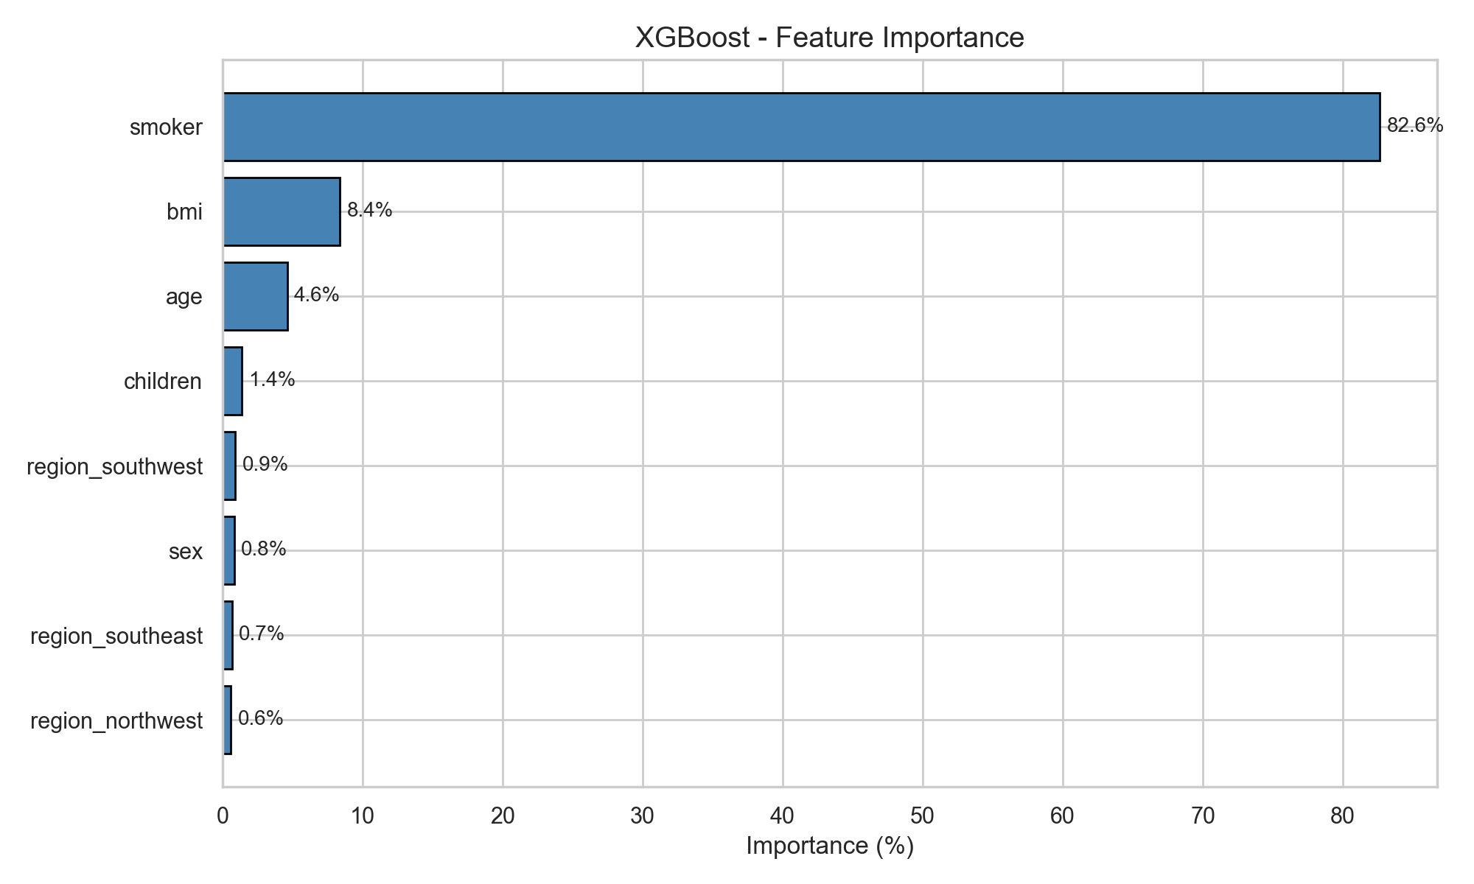

SHAP-based feature importance analysis reveals that smoking status dominates with 82.6% importance, followed by BMI (8.4%) and age (4.6%). The remaining features collectively account for less than 5% of prediction importance. This extreme concentration of importance in a single feature is consistent with the 3.8x cost multiplier observed in EDA.

9.3 Actual vs Predicted Analysis
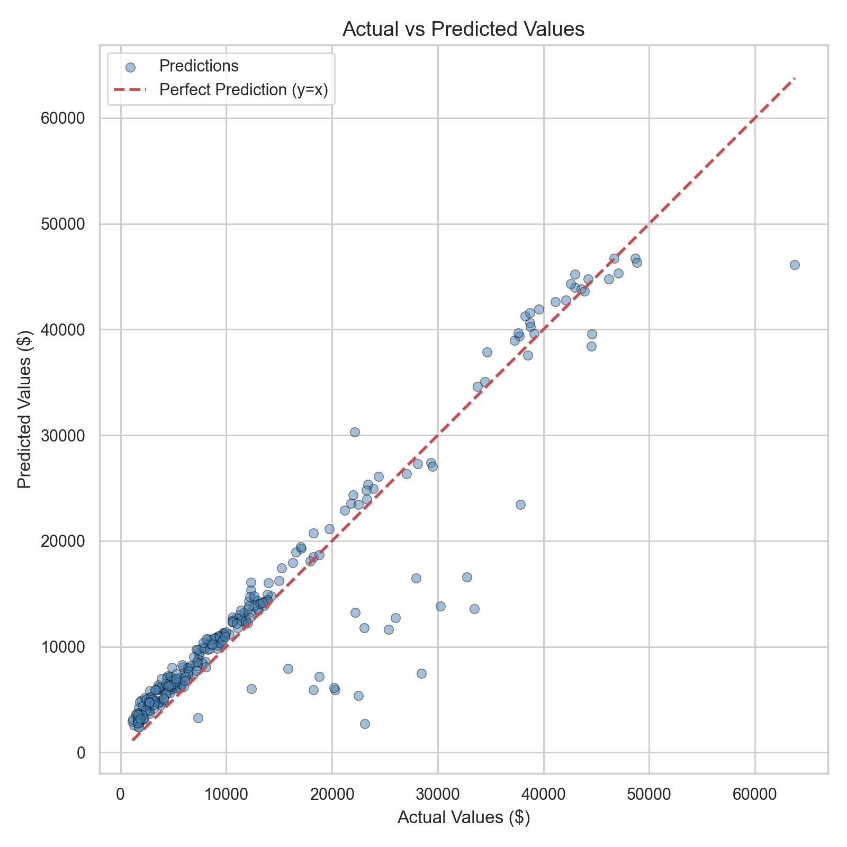

The scatter plot of actual vs. predicted values shows strong alignment along the y=x line, indicating good prediction accuracy across the full cost range. Slight deviation is observed at very high cost values (above $50,000), where the model tends to under-predict.

9.4 Residual Analysis
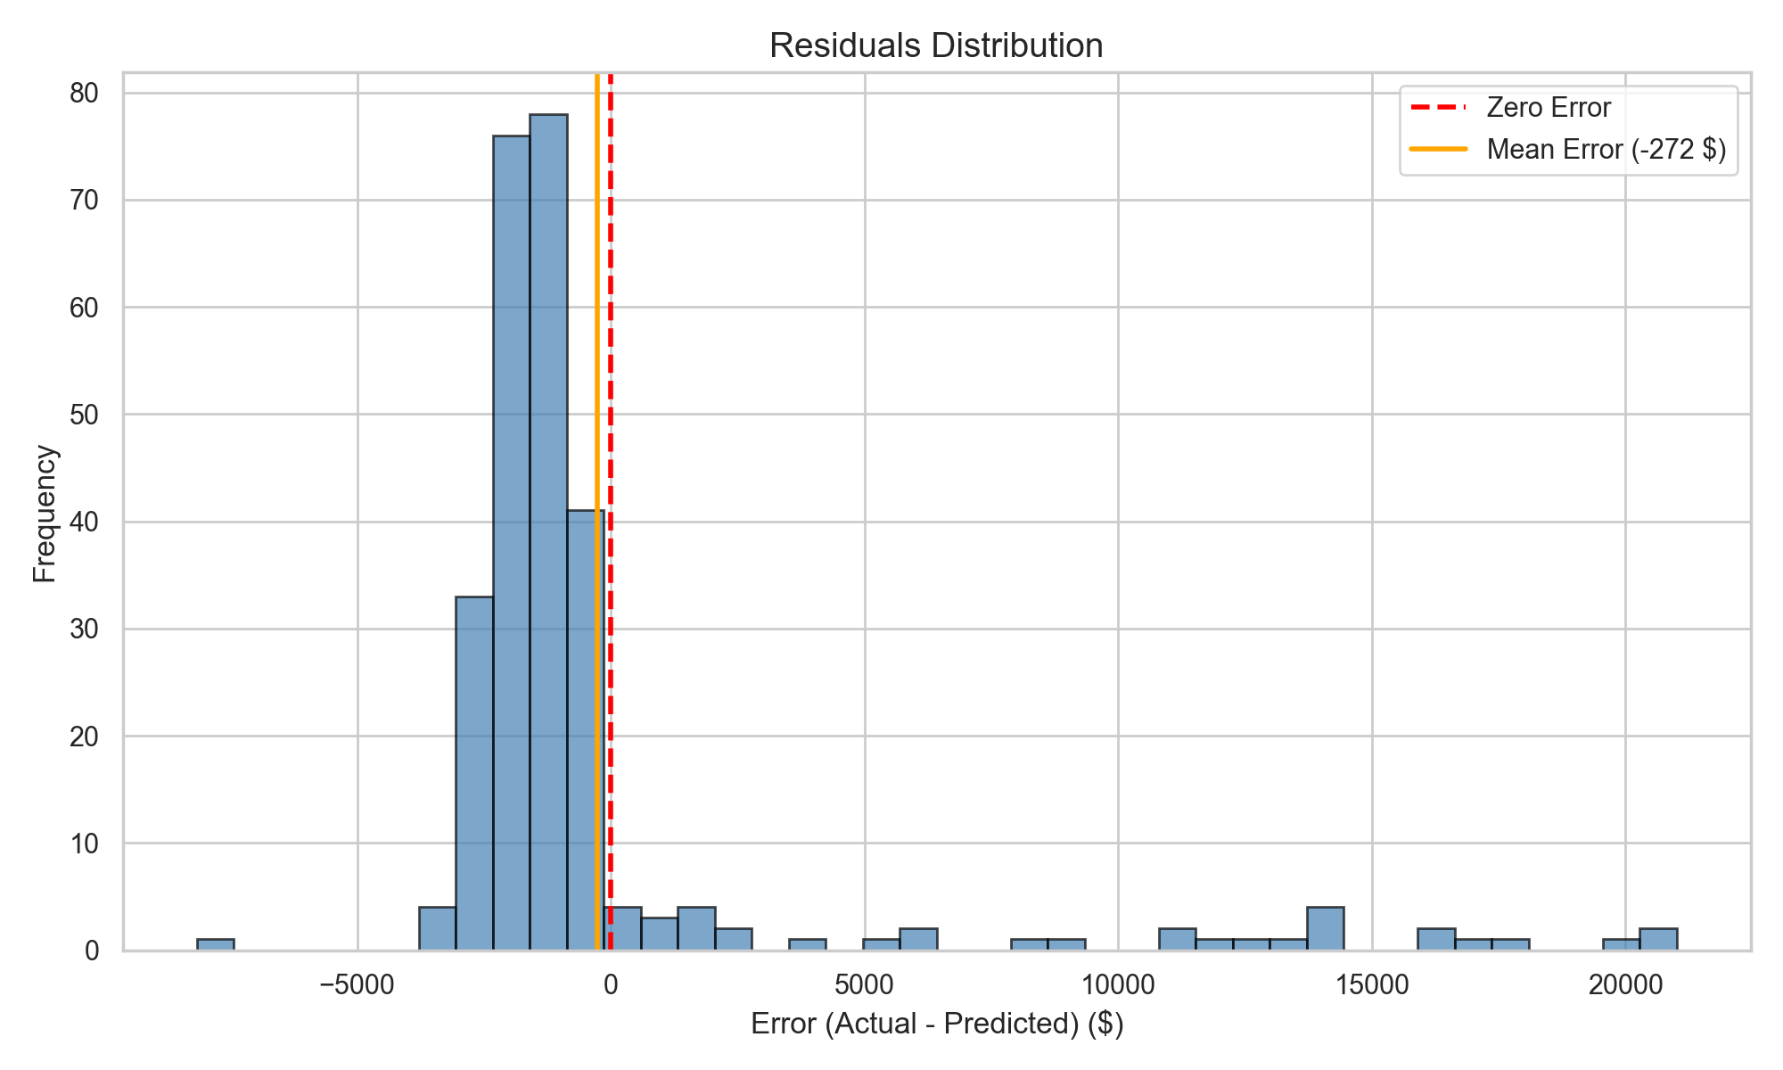

The residual distribution is approximately centered at zero (mean error = -$272), indicating minimal systematic bias. The majority of predictions fall within ±$5,000 of actual values. A right tail of under-predictions exists for extreme high-cost cases, which is expected given the limited number of training samples in this range.

9.5 Confidence Estimation
A multi-model ensemble approach provides confidence intervals for each prediction. All three boosting models (XGBoost, LightGBM, GradientBoosting) generate independent estimates, and the minimum/mean/maximum values form a practical confidence band without requiring probabilistic model assumptions.

10. Explainable AI (SHAP)

10.1 SHAP Theory
SHAP (SHapley Additive exPlanations) by Lundberg and Lee (2017) provides a unified framework for interpreting machine learning predictions. Based on Shapley values from cooperative game theory, SHAP decomposes each prediction into individual feature contributions. For a prediction f(x), SHAP satisfies: f(x) = E[f(x)] + Σ φᵢ, where φᵢ is the SHAP value for feature i.

10.2 Global Feature Attribution
Global SHAP analysis confirms smoking status as the primary cost driver (82.6%). The interaction features (smoker_bmi, smoker_age) show variable importance depending on individual profiles, validating their inclusion in the feature set.

10.3 Per-Prediction Explanations
In the web application, each prediction is accompanied by a SHAP breakdown showing exactly which features increase or decrease that individual's cost. This is rendered as an animated horizontal bar chart with purple bars (cost increases) and cyan bars (cost decreases). The top 2 SHAP features are also passed to the Claude AI advisor to generate contextually relevant health advice.

11. Web Application

11.1 Architecture
The Smart Insurance Advisor V2.0 is built with Flask (Python backend) and a custom HTML5/CSS3/JavaScript frontend. The application follows a client-server architecture with REST API endpoints for prediction, SHAP analysis, and report generation.
Component | Technology | Purpose
Backend | Flask (Python) | REST API, model inference, SHAP computation
Frontend | HTML5/CSS3/JS | Custom dark-themed dashboard with animations
ML Engine | XGBoost + joblib | Prediction and feature importance
XAI Engine | SHAP TreeExplainer | Per-prediction feature attribution
AI Engine | Claude Haiku API | Natural language health advice generation

11.2 Features
- Dataset Dashboard: Welcome screen with animated stat cards and model comparison chart
- BMI Auto-Calculator: Height/weight inputs with automatic BMI and color-coded category
- Real-Time Prediction: Animated cost counter with confidence interval
- What-If Analysis: Scenario simulation for smoking cessation and BMI optimization
- SHAP Cost Breakdown: Animated CSS bar chart showing per-feature dollar contributions
- AI-Powered Report: Claude Haiku generates personalized advice using SHAP top features
- Report Download: Export complete analysis as markdown file

11.3 Claude AI Integration
The generative AI component uses Anthropic's Claude Haiku model to transform quantitative predictions into actionable health advice. The prompt dynamically includes the user's profile, SHAP top-2 features, and calculated savings scenarios. The AI is instructed to be empathetic, reference specific dollar amounts, and avoid placeholder text.

12. Conclusion
This project demonstrated a complete data mining pipeline from exploratory analysis through model deployment for insurance cost prediction. The key findings are:
- Smoking status is the overwhelmingly dominant predictor of insurance costs (82.6% feature importance, 3.8x cost multiplier)
- Non-linear feature interactions (smoker×BMI) create distinct cost clusters that tree-based ensemble methods capture effectively
- XGBoost achieved the best performance (R²=0.88) among five compared models
- Feature engineering with interaction terms significantly improved linear model performance (+6% R²)
- Target log-transformation benefits linear models but degrades boosting models due to back-transformation error amplification
- SHAP provides actionable per-prediction explanations that can drive personalized health interventions
- Integration of generative AI (Claude) transforms numerical outputs into user-friendly health advice

13. Future Work
- Stacking Ensemble: Combining XGBoost, LightGBM, and GradientBoosting with a meta-learner could push R² above 0.90
- Larger Datasets: Real-world insurance datasets with 100K+ records would enable deeper feature interactions and more robust models
- Temporal Features: Incorporating longitudinal data (year-over-year health changes) could improve prediction accuracy
- Fairness Analysis: Evaluating model bias across protected attributes (sex, region) to ensure equitable premium predictions
- Probabilistic Predictions: Implementing quantile regression or conformal prediction for calibrated confidence intervals
- Deep Learning: Exploring neural network architectures (TabNet, FT-Transformer) for comparison with gradient boosting

14. References
[1] A. Géron, "Hands-On Machine Learning with Scikit-Learn, Keras, and TensorFlow," 3rd ed. O'Reilly Media, 2022.
[2] N. Boodhun and M. Jayabalan, "Risk prediction in life insurance industry using supervised learning algorithms," Complex & Intelligent Systems, vol. 4, no. 2, pp. 145-154, 2018.
[3] T. Chen and C. Guestrin, "XGBoost: A Scalable Tree Boosting System," in Proc. 22nd ACM SIGKDD, 2016, pp. 785-794.
[4] G. Ke et al., "LightGBM: A Highly Efficient Gradient Boosting Decision Tree," in NeurIPS, 2017, pp. 3146-3154.
[5] S. M. Lundberg and S.-I. Lee, "A Unified Approach to Interpreting Model Predictions," in NeurIPS, 2017, pp. 4765-4774.
[6] M. Choi, "Medical Cost Personal Datasets," Kaggle, 2018. Available: kaggle.com/datasets/mirichoi0218/insurance
[7] F. Pedregosa et al., "Scikit-learn: Machine Learning in Python," JMLR, vol. 12, pp. 2825-2830, 2011.
[8] Anthropic, "Claude API Documentation," 2024. Available: docs.anthropic.com

