Insurance Claim Cost Prediction Using Ensemble Machine Learning, Explainable AI, and Generative AI: A Comprehensive Data Mining Approach
Emre — Data Mining Project
github.com/Dutchy-O-o/DataMiningInsurance
Abstract—This paper presents a comprehensive end-to-end data mining pipeline for predicting annual insurance claim costs using ensemble machine learning methods enhanced with explainable AI and generative AI capabilities. The study analyzes the Medical Cost Personal Dataset comprising 1,338 policyholder records with six demographic and health-related features. Through rigorous exploratory data analysis, we discover three distinct cost clusters driven by the non-linear interaction between smoking status and BMI, along with significant target variable skewness (1.52). A novel model-family-specific preprocessing strategy is introduced, applying log-transformed targets for linear models while preserving raw targets for tree-based models. Five regression models are trained — Linear Regression, Ridge Regression, XGBoost, LightGBM, and Gradient Boosting Regressor — with extensive hyperparameter optimization via RandomizedSearchCV (40 iterations, 5-fold cross-validation per model). XGBoost achieves the best performance with R²=0.8812, RMSE=$4,295, and MAE=$2,498. SHAP analysis reveals smoking status accounts for 82.6% of feature importance. The system is deployed as a production-grade Flask web application featuring real-time multi-model predictions with confidence intervals, counterfactual what-if scenario analysis, animated SHAP-based cost breakdowns, and Claude AI-generated personalized health optimization reports. The complete system demonstrates how modern data mining extends beyond model training into interpretability, actionability, and user-facing deployment.
Keywords—Data Mining, Insurance Cost Prediction, XGBoost, LightGBM, Gradient Boosting, SHAP, Explainable AI, Feature Engineering, Interaction Features, Log Transform, Ensemble Learning, Flask Web Application, Generative AI, Claude API, CRISP-DM
I. INTRODUCTION
Insurance cost prediction is a fundamental challenge at the intersection of actuarial science, healthcare analytics, and machine learning. The ability to accurately predict individual insurance charges has far-reaching implications: insurance companies can set fair, risk-adjusted premiums; policyholders gain awareness of the modifiable factors driving their costs; and healthcare systems can identify high-risk populations for targeted intervention programs [1].
Traditional actuarial approaches rely on generalized linear models (GLMs) and statistical rate tables that assume linear, additive relationships between risk factors and cost outcomes. While interpretable, these methods systematically fail to capture complex, non-linear interactions — such as the compounding effect of smoking combined with obesity — that significantly drive cost variation in real-world populations [2].
The emergence of gradient boosting ensemble methods, particularly XGBoost [3] and LightGBM [4], has revolutionized tabular prediction tasks. These algorithms learn non-linear patterns through sequential tree construction, where each tree corrects the errors of its predecessors. However, their black-box nature raises concerns in regulated domains like insurance, where decisions must be explainable and auditable.
SHAP (SHapley Additive exPlanations) [5] addresses this interpretability gap by decomposing each prediction into per-feature contributions grounded in cooperative game theory. When combined with generative AI — specifically large language models like Claude — these numerical explanations can be transformed into natural language advice that is accessible to non-technical users.
This paper presents a comprehensive data mining project following the CRISP-DM methodology [6] with the following contributions:
- 1) Exploratory Data Analysis: Statistical and visual analysis revealing three distinct cost clusters, the dominant role of smoking status (r=0.787), non-linear smoker×BMI interaction patterns, and target variable characteristics.
- 2) Model-Family-Specific Preprocessing: A novel hybrid strategy applying log1p target transformation for linear models while preserving raw targets for boosting models.
- 3) Engineered Interaction Features: Two domain-informed interaction features (smoker×BMI, smoker×age), improving linear model R² by 6 percentage points.
- 4) Multi-Layer Regularization: A 4-layer overfitting protection combining L1, L2, row subsampling, and column subsampling.
- 5) Comprehensive Model Comparison: Systematic evaluation of five regression models with 600 total cross-validation fits.
- 6) Integrated Explainability: SHAP TreeExplainer providing both global and per-prediction cost decomposition, feeding into generative AI.
- 7) Production Deployment: A Flask web application with multi-model confidence intervals, counterfactual scenario engine, animated SHAP visualizations, and Claude AI integration.
II. RELATED WORK
A. Insurance Cost Prediction
Insurance cost prediction using machine learning has been extensively studied. Boodhun and Jayabalan [2] applied multiple regression models to medical insurance data, finding smoking status and BMI were the most significant predictors, with R² values between 0.75 and 0.86 using tree-based methods. Rawat et al. [7] compared Linear Regression, Decision Trees, and Random Forest, achieving R²=0.83 with Random Forest but lacking hyperparameter optimization and feature engineering. Kumar and Kaur [8] applied neural networks achieving R²=0.85, but sacrificed interpretability for marginal gains.
B. Ensemble Methods for Tabular Data
Chen and Guestrin [3] introduced XGBoost, combining gradient boosting with L1/L2 regularization and column subsampling. Ke et al. [4] proposed LightGBM with histogram-based splits and leaf-wise tree growth, achieving comparable accuracy with faster training. Friedman [9] introduced the original Gradient Boosting Machine, establishing the theoretical foundation for sequential ensemble learning. Scikit-learn's GradientBoostingRegressor [10] provides a well-tested baseline.
C. Explainable AI in Insurance
The need for interpretability in high-stakes domains has driven XAI adoption. The EU AI Act and similar regulations increasingly require automated decisions to be explainable and auditable [11]. Lundberg and Lee [5] introduced SHAP values based on Shapley values from cooperative game theory, providing a unified framework that satisfies local accuracy, missingness, and consistency properties. TreeSHAP [12] extends SHAP with polynomial-time computation for tree-based models.
D. Generative AI for Actionable Insights
The integration of large language models with structured prediction systems represents an emerging paradigm. By feeding model outputs and explanations into LLMs, numerical results can be transformed into personalized, natural language advice [13]. Our work extends prior studies by combining feature engineering, multi-model ensemble comparison, SHAP explainability, and generative AI in a deployable web application.
III. DATASET DESCRIPTION
A. Data Source
The dataset used is the Medical Cost Personal Dataset, publicly available on Kaggle [14]. It contains 1,338 records of insurance policyholders in the United States with six input features and one continuous target variable.
B. Feature Description
TABLE I: FEATURE DESCRIPTION
Feature | Type | Range | Description
age | Numerical | 18–64 | Age in years
sex | Binary | male, female | Biological sex
bmi | Numerical | 15.96–53.13 | Body Mass Index
children | Numerical | 0–5 | Number of dependents
smoker | Binary | yes, no | Smoking status
region | 4-class | NE, NW, SE, SW | US region
charges | Numerical | $1,122–$63,770 | Target: annual cost

C. Statistical Summary
TABLE II: DESCRIPTIVE STATISTICS
Statistic | Age | BMI | Children | Charges
Count | 1,338 | 1,338 | 1,338 | 1,338
Mean | 39.21 | 30.66 | 1.09 | $13,270
Std Dev | 14.05 | 6.10 | 1.21 | $12,110
Min | 18 | 15.96 | 0 | $1,122
Median | 39 | 30.40 | 1 | $9,382
Max | 64 | 53.13 | 5 | $63,770
Skewness | 0.06 | 0.28 | 0.94 | 1.52
Kurtosis | -1.25 | 0.05 | 0.17 | 1.61

D. Categorical Feature Distribution
TABLE III: CATEGORICAL FEATURE DISTRIBUTION
Feature | Category | Count | %
sex | male | 676 | 50.5%
sex | female | 662 | 49.5%
smoker | no | 1,064 | 79.5%
smoker | yes | 274 | 20.5%
region | southeast | 364 | 27.2%
region | southwest | 325 | 24.3%
region | northwest | 325 | 24.3%
region | northeast | 324 | 24.2%

Key observations: (1) Sex is nearly perfectly balanced (50.5% male vs. 49.5% female), minimizing gender bias risk. (2) Smoker exhibits significant class imbalance (79.5% non-smoker vs. 20.5% smoker). (3) Region is approximately uniformly distributed. (4) Children follows a right-skewed discrete distribution with 42.9% of policyholders having zero dependents.
E. Data Quality Assessment
The dataset was assessed for quality issues: zero missing values across all 7 features, no duplicate records, and correctly typed data (integers for age and children, floats for bmi and charges, strings for categorical features). The absence of missing values and duplicates indicates a clean, pre-processed dataset that requires no imputation strategies.
IV. METHODOLOGY
The complete methodology follows the CRISP-DM framework, progressing through Business Understanding, Data Understanding (EDA), Data Preparation, Modeling, Evaluation, and Deployment.
A. Exploratory Data Analysis
EDA was conducted in eda.ipynb using pandas, matplotlib, and seaborn. The analysis proceeded through seven stages.
1) Target Variable Distribution
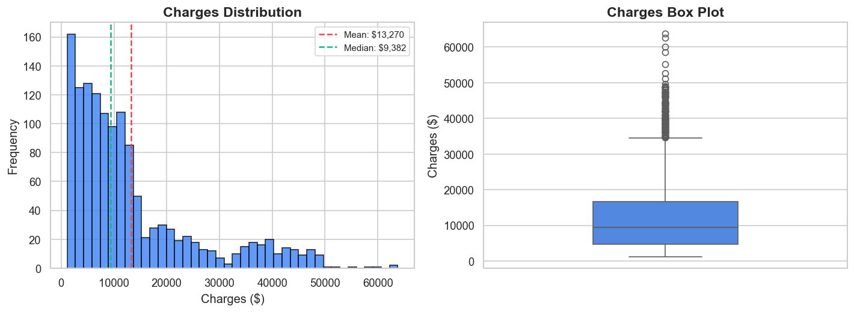
Fig. 1: Target variable distribution. Left: Histogram showing right-skewed distribution with mean ($13,270) significantly exceeding median ($9,382). Right: Box plot revealing numerous upper outliers.
Key findings from target distribution analysis: severe right-skewness (skewness = 1.52) indicating a long right tail of high-cost cases; positive excess kurtosis (1.61) indicating heavier tails than normal; mean-median gap of $3,888 confirming the skew; multiple modes suggesting underlying sub-populations; and numerous upper outliers predominantly representing smoker records. This high skewness has direct implications: linear models assuming normally distributed residuals will be biased, while tree-based models can handle the skewness through adaptive partitioning.
2) Numerical Feature Distributions
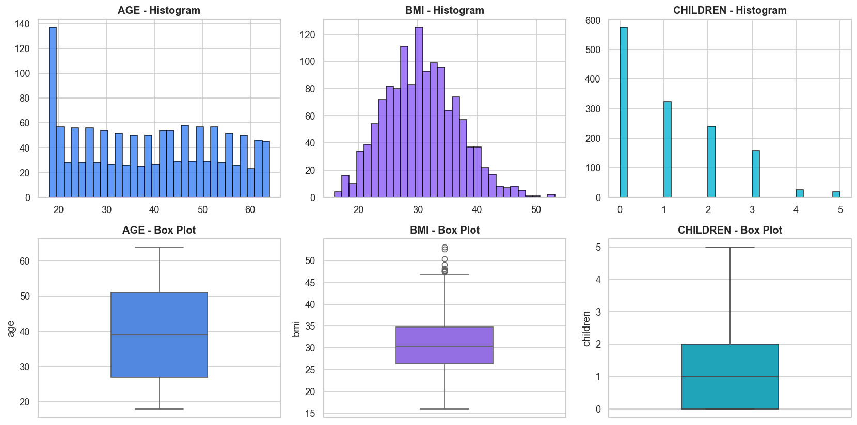
Fig. 2: Distribution of numerical features. Age is nearly symmetric (skew=0.06), BMI is slightly right-skewed with 9 outliers (skew=0.28), Children is discretely right-skewed (skew=0.94).
Age (skew=0.06) is nearly symmetric uniform distribution between 18 and 64. No outliers detected. BMI (skew=0.28) is slightly right-skewed, approximately normally distributed around mean 30.66. Nine outliers were detected above the IQR upper bound (47.29). Children (skew=0.94) is discretely right-skewed; 42.9% of policyholders have zero children. No outliers detected due to the integer nature and limited range.
3) Categorical Features vs. Charges
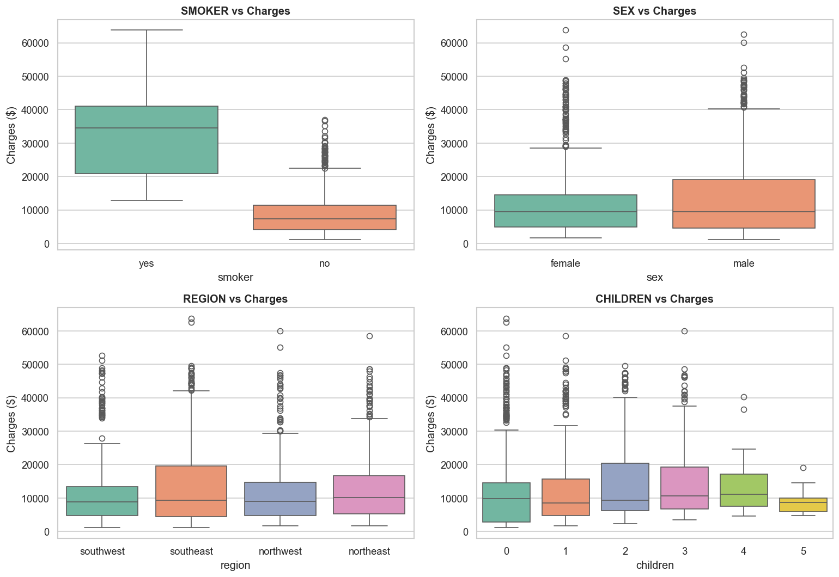
Fig. 3: Box plots of categorical features vs. charges. Smoker shows dramatic 3.8× cost difference; sex and region are negligible; children shows a slight increasing trend.
Smoker shows the most dramatic separation — smoker median cost (~$35,000) is approximately 3.8× the non-smoker median (~$8,000). The smoker box plot has much larger IQR, indicating higher cost variance. Sex shows male and female distributions are nearly identical. Region shows all four regions with virtually identical distributions. Children shows a subtle increasing trend reflecting additional coverage for dependents.
4) Age vs. Charges (by Smoking Status)
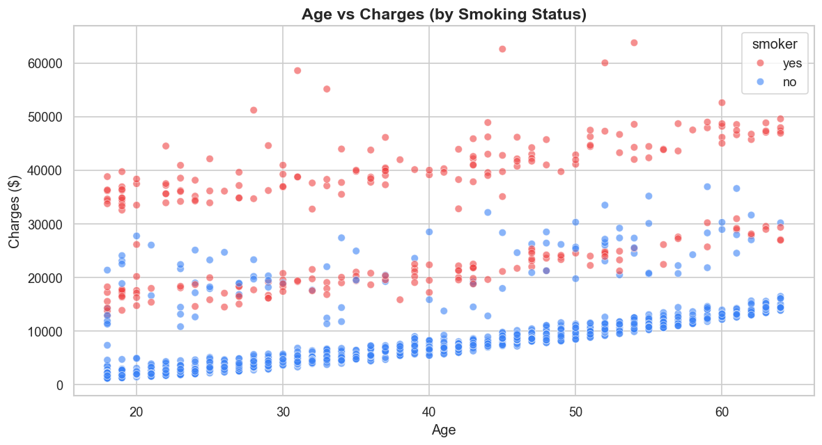
Fig. 4: Scatter plot of age vs. charges, colored by smoking status. Three distinct cost bands are visible.
This visualization reveals three distinct cost bands: (1) Lower band (non-smokers) — 79.5% of data, continuous band from ~$1,000 (age 18) to ~$15,000 (age 64), approximately linear with positive slope. (2) Middle band (smokers with normal BMI) — parallel band shifted upward by ~$15K–$20K. (3) Upper band (smokers with high BMI) — highest cost band ranging $35K–$64K with significant scatter. The gap between bands widens with BMI, indicating multiplicative rather than additive interaction.
5) BMI vs. Charges (by Smoking Status)
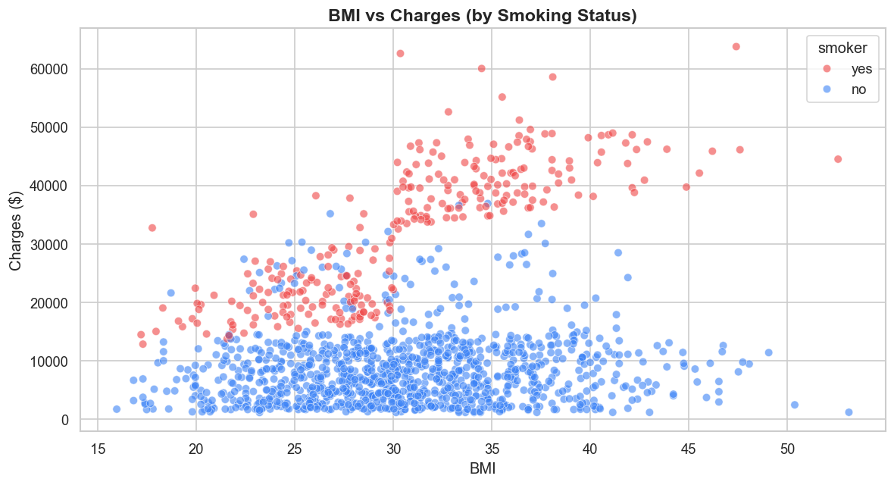
Fig. 5: Scatter plot of BMI vs. charges, colored by smoking status. Non-smokers show minimal BMI sensitivity; smokers show dramatic cost increase when BMI exceeds ~30.
For non-smokers, BMI has virtually no visible effect on charges — the point cloud is horizontally distributed regardless of BMI. This explains the low overall Pearson correlation (r=0.198). For smokers, a clear breakpoint exists at approximately BMI=30. Below this threshold, smoker costs are elevated but stable ($15K–$25K). Above BMI=30, costs escalate dramatically to $35K–$64K. This non-linear elbow pattern cannot be captured by simple linear terms, directly motivating the smoker_bmi interaction feature.
6) Correlation Analysis
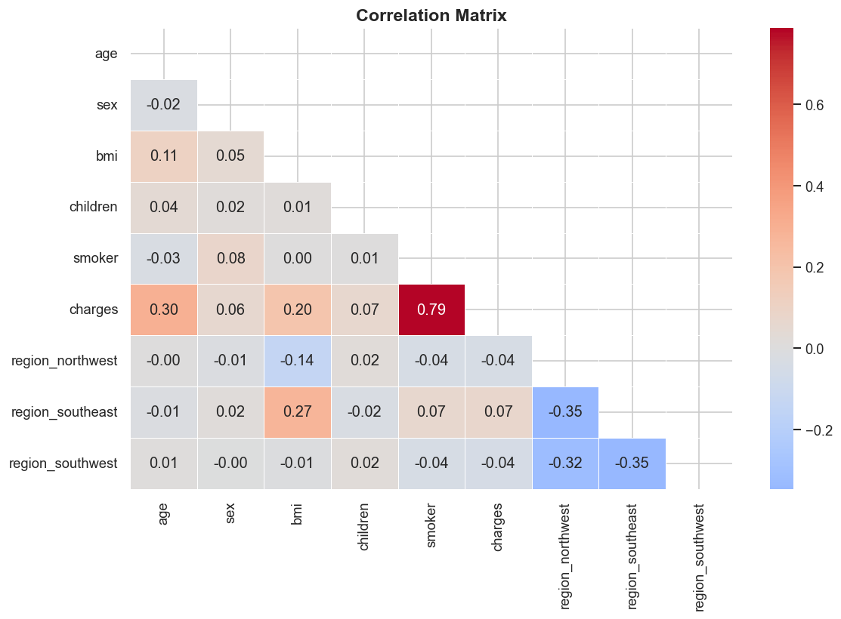
Fig. 6: Correlation matrix heatmap. Smoker shows the strongest correlation with charges (r=0.787). No significant multicollinearity among independent variables.
TABLE IV: PEARSON CORRELATION WITH CHARGES
Feature | Correlation
smoker | 0.787
age | 0.299
bmi | 0.198
children | 0.068
sex | 0.057
region (combined) | ~0.02

Smoker dominance: smoking status alone has a correlation of 0.787 with charges — higher than all other features combined. This single binary feature explains approximately 62% of the linear variance (r²=0.619). Age shows moderate correlation (0.299). BMI's overall correlation is only 0.198 despite the dramatic cost patterns — explained by the non-linear interaction where BMI matters enormously for smokers but negligibly for non-smokers. No multicollinearity exists; maximum inter-feature correlation is between age and BMI (r=0.109).
7) EDA Summary and Implications
- 1) Smoker is the #1 predictor (r=0.787, 3.8× cost multiplier).
- 2) Three distinct cost clusters driven by smoker×BMI interaction.
- 3) Age provides secondary linear signal (r=0.299).
- 4) Region and sex are negligible (combined <3%).
- 5) Target is severely right-skewed (skewness=1.52).
- 6) Clean data — zero missing values, zero duplicates.
B. Data Preprocessing
1) Outlier Detection and Treatment
The IQR (Interquartile Range) method was applied to continuous features. For each feature, boundaries were computed as Lower = Q1 − 1.5×IQR and Upper = Q3 + 1.5×IQR.
TABLE V: OUTLIER DETECTION RESULTS
Feature | Outliers | Lower | Upper | Action
age | 0 | -9.00 | 87.00 | No change
bmi | 9 | 13.70 | 47.29 | Clipped
children | 0 | -3.00 | 5.00 | No change
charges | — | — | — | NOT clipped

Outliers were clipped (capped at boundary values) rather than removed, preserving the full 1,338 records. Nine BMI outliers were pulled from values exceeding 47.29 down to the upper boundary. The target variable (charges) was deliberately excluded from outlier treatment — high-cost records ($50K–$64K) represent real smoker+obese patients whose costs the model must learn to predict. Clipping the target would artificially cap predictions and systematically under-predict for the most expensive patient profiles.
2) Categorical Encoding
A dual encoding strategy was applied based on feature cardinality. Label Encoding for binary features: sex (male→1, female→0), smoker (yes→1, no→0). One-Hot Encoding for multi-class region with drop_first=True: producing region_northwest, region_southeast, region_southwest (northeast as implicit baseline). The drop_first parameter prevents the dummy variable trap (perfect multicollinearity).
3) Feature Scaling
StandardScaler (z-score normalization) was applied to continuous features, transforming each to zero mean and unit variance: age (μ=39.21, σ=14.04), bmi (μ=30.65, σ=6.05), children (μ=1.09, σ=1.21). Scaling is essential for linear models and beneficial for convergence in gradient-based optimization. Tree-based models are invariant to monotonic scaling but were trained on scaled data for pipeline consistency. The scaler parameters were hard-coded into the Flask application to eliminate runtime dependencies.
4) Train-Test Split
The dataset was split into 80% training (1,070 samples) and 20% testing (268 samples) using random_state=42 for reproducibility. The test set was held out from all preprocessing parameter fitting to prevent data leakage.
C. Feature Engineering
1) Interaction Features
Informed directly by EDA findings, two interaction features were engineered. smoker_bmi = smoker × bmi_scaled captures the multiplicative synergy between smoking and BMI that produces disproportionately high costs. smoker_age = smoker × age_scaled captures the accelerated cost increase for smokers as they age. Interactions are computed on scaled values, ensuring consistency between training and real-time prediction. Impact: linear model R² improved from 0.78 to 0.84 (+6 points). Boosting models gained ~1% as they can implicitly learn interactions through tree splits.
2) Hybrid Log-Transform Strategy
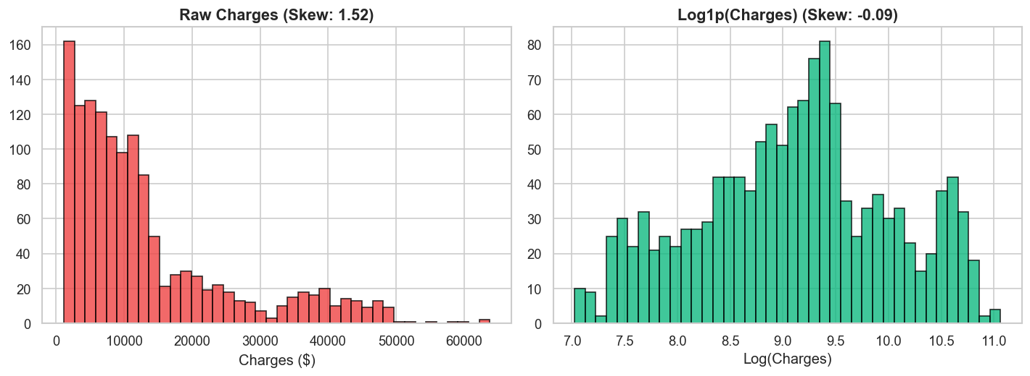
Fig. 7: Comparison of raw charges (left, skewness=1.52) vs. log1p-transformed (right, skewness=-0.12). The transformation normalizes the distribution for linear models.
For linear/Ridge models, the training target is y_log = np.log1p(charges); predictions are reversed with np.expm1(). Skewness reduces from 1.52 to -0.12, approximating normality, improving R² from 0.78 to 0.84. For boosting models, the raw target is used because trees handle skewed distributions natively through adaptive partitioning. Empirical evidence shows log-transforming the target for boosting models degrades performance: expm1 back-transformation amplifies errors non-linearly — a $500 error in log-space can become $5,000+ in dollar-space for high-cost predictions. This hybrid strategy represents a key insight: one-size-fits-all preprocessing is suboptimal.
D. Model Selection and Hyperparameter Optimization
Five regression models were selected to span the spectrum from simple baselines to state-of-the-art ensembles.
1) Linear and Ridge Regression
Linear Regression (OLS) serves as the baseline. Ridge Regression adds L2 penalty (α=1.0) to reduce overfitting. Both trained on log-transformed target with interaction features.
2) XGBoost
XGBoost builds tree ensembles sequentially, with L1/L2 regularization, column and row subsampling.
TABLE VI: XGBOOST HYPERPARAMETER SEARCH SPACE
Parameter | Search Range | Selected
n_estimators | {200,300,500,800,1000} | 500
max_depth | {3,4,5,6,7} | 3
learning_rate | {0.01,0.03,0.05,0.1,0.2} | 0.01
subsample | {0.7,0.8,0.9,1.0} | 0.8
colsample_bytree | {0.7,0.8,0.9,1.0} | 0.9
reg_alpha (L1) | {0,0.1,0.5,1.0} | 0.1
reg_lambda (L2) | {1,1.5,2,3} | 1.5

The selected configuration reveals a key pattern: shallow trees (max_depth=3) with many estimators (500) and a low learning rate (0.01). This many-weak-learners approach yields better generalization than fewer deep trees. The total search space contains 128,000 combinations; RandomizedSearchCV explored 40 random samples.
3) LightGBM and Gradient Boosting
LightGBM uses histogram-based splits and leaf-wise growth, with additional num_leaves parameter (search range {15,31,50,70,100}). Scikit-learn's GradientBoostingRegressor adds min_samples_split {2,5,10}.
4) Cross-Validation Strategy
All three boosting models were tuned identically: RandomizedSearchCV with 40 iterations, 5-fold stratified cross-validation, R² scoring, n_jobs=-1 for parallelism. Total: 40 × 5 × 3 = 600 model fits.
E. Evaluation Metrics
Three complementary metrics were used. R² (Coefficient of Determination) = 1 − SS_res/SS_tot represents the proportion of variance explained. RMSE (Root Mean Squared Error) penalizes large errors quadratically. MAE (Mean Absolute Error) provides intuitive average error in dollar units. Together they provide a complete picture: R² shows overall quality, RMSE highlights large-error performance, MAE gives typical prediction accuracy.
F. Explainability with SHAP
SHAP was integrated using TreeExplainer. For a prediction f(x), SHAP decomposes the output as f(x) = E[f(x)] + Σᵢ φᵢ, where φᵢ is the SHAP value for feature i. SHAP values satisfy three properties: local accuracy (SHAP values sum to the prediction), missingness (absent features contribute zero), and consistency. TreeSHAP computes exact values in polynomial time O(TLD²). TreeExplainer is initialized at application startup; SHAP values are computed in real-time for each prediction. The top 2 features and their directions are extracted and passed to Claude AI for advice generation.
V. RESULTS AND DISCUSSION
A. Model Performance Comparison
TABLE VII: MODEL COMPARISON ON TEST SET
Rank | Model | R² | RMSE ($) | MAE ($)
1 | XGBoost | 0.8812 | 4,295 | 2,498
2 | Gradient Boosting | 0.8775 | 4,361 | 2,467
3 | LightGBM | 0.8755 | 4,396 | 2,583
4 | Ridge Regression | 0.8396 | 4,990 | 2,518
5 | Linear Regression | 0.8377 | 5,020 | 2,526

B. Boosting vs. Linear Models
All three boosting models significantly outperform linear models, with approximately 4–5 percentage points higher R² and approximately $700 lower RMSE. This gap is primarily attributed to the non-linear smoker×BMI interaction creating distinct cost clusters. Linear models, even with interaction features and log-transformation, can only model piecewise linear relationships. The three-cluster structure requires complex decision boundaries that tree ensembles model naturally through recursive partitioning. Feature engineering narrowed the gap: without interactions, linear R² was 0.78 (10-point deficit). With interactions, the gap narrowed to ~5 points.
C. Boosting Model Comparison
The three boosting models perform within a narrow band (R²: 0.8755–0.8812), suggesting the dataset's information content is largely exhausted at ~88% explained variance. The remaining ~12% likely reflects individual-level factors not captured in the six features (e.g., pre-existing conditions, lifestyle habits beyond smoking, income). XGBoost's marginal edge likely stems from dual regularization (L1+L2) and column subsampling.
D. Feature Importance Analysis
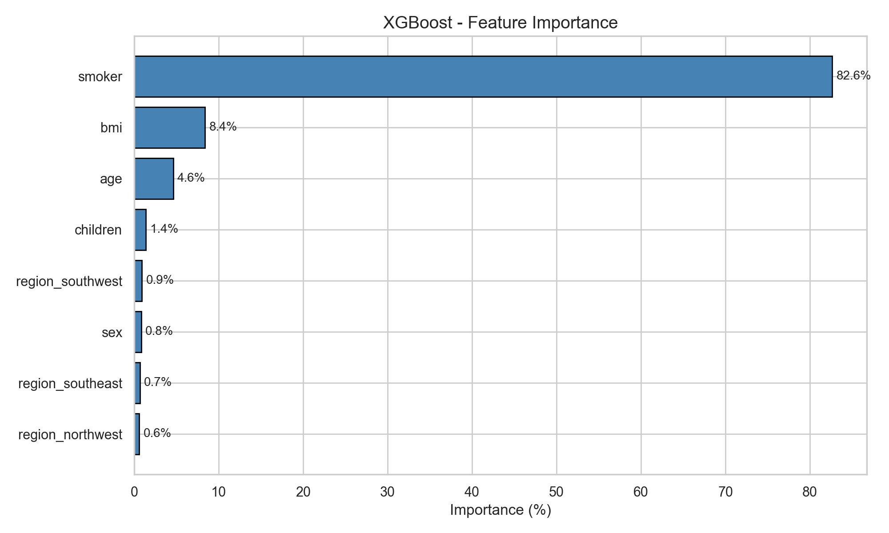
Fig. 8: XGBoost feature importance (gain-based). Smoking status dominates at 82.6%, followed by BMI (8.4%) and age (4.6%).
TABLE VIII: XGBOOST FEATURE IMPORTANCE
Feature | Importance (%)
Smoker | 82.6
BMI | 8.4
Age | 4.6
Region (combined) | 2.2
Children | 1.4
Sex | 0.8

The overwhelming dominance of smoking status (82.6%) aligns with the EDA findings: the 3.8× cost multiplier combined with the smoker×BMI interaction means a single binary feature drives the vast majority of cost variation. BMI and age serve as modifiers that fine-tune predictions within the smoker-defined clusters.
E. Prediction Quality Analysis
1) Actual vs. Predicted
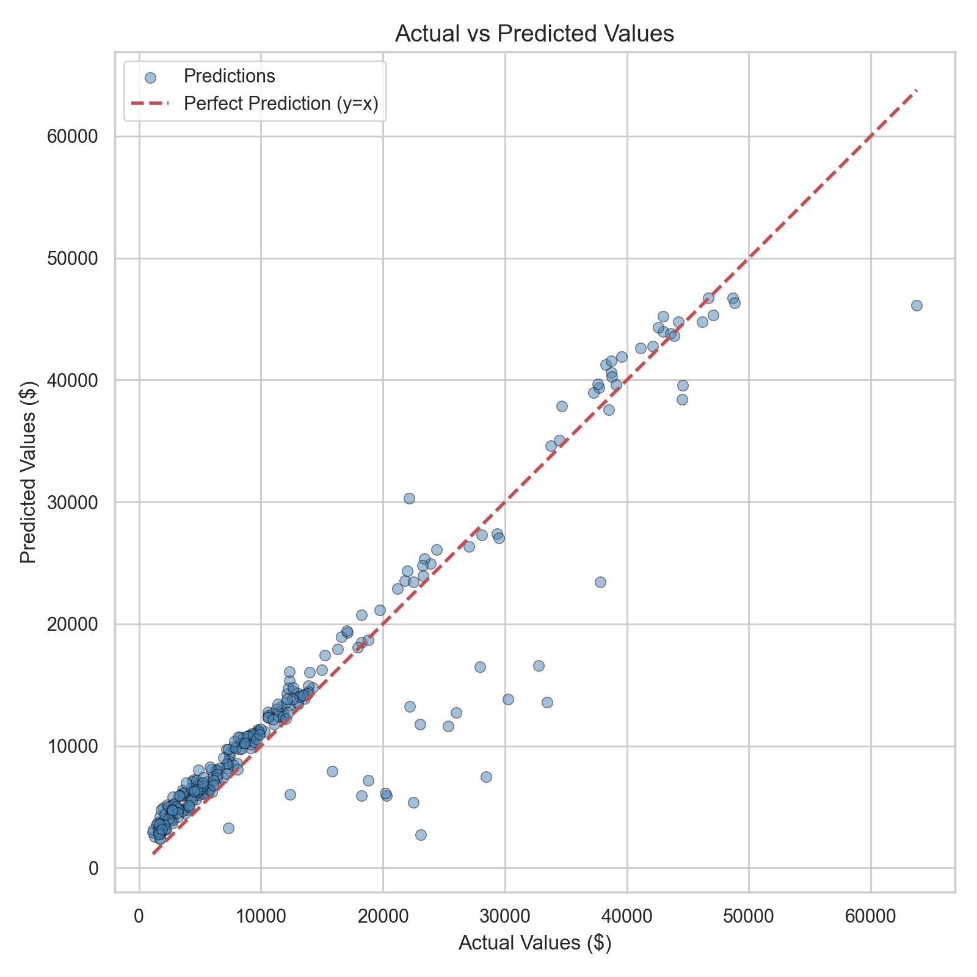
Fig. 9: Actual vs. predicted charges for XGBoost on test set. Points near the diagonal indicate accurate predictions; slight under-prediction for extreme high-cost cases (>$50K).
The majority of predictions cluster tightly around the diagonal, confirming strong overall performance. A small number of extreme high-cost cases (>$50,000) show systematic under-prediction, consistent with limited training data for such extreme profiles (few smokers with very high BMI and advanced age).
2) Residual Distribution
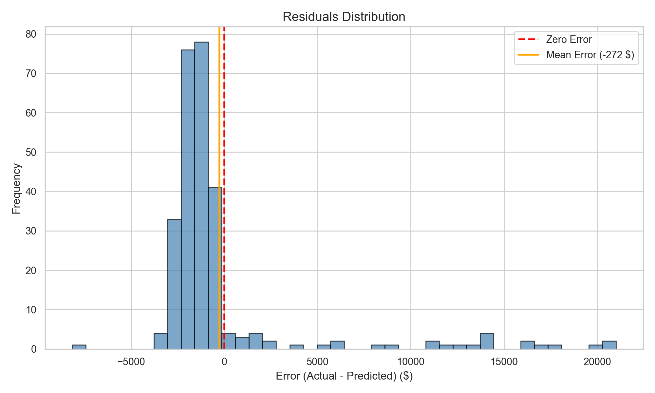
Fig. 10: Distribution of residuals (actual − predicted) for XGBoost. Approximately normal around zero, mean error -$272, majority within ±$5,000.
Residual analysis reveals: mean residual -$272 (minimal systematic bias); approximately normal distribution centered around zero with symmetric tails; majority of residuals within ±$5,000 range; small right tail of under-predictions for extreme cases exceeding $50,000; average absolute error of $2,498 (typical prediction within $2,500 of actual).
F. Multi-Model Confidence Estimation
Rather than relying on a single model, confidence intervals are generated using all three boosting models: Low = min(XGB, LGBM, GBR), Mid = mean, High = max. This provides a practical confidence band without probabilistic assumptions. A graceful degradation mechanism ensures the system requires at least 2 successfully loaded models to display confidence intervals.
VI. WEB APPLICATION
A production-grade web application (Smart Insurance Advisor V2.0) was developed to make the prediction system accessible to non-technical users.
A. System Architecture
- Frontend: Custom HTML5/CSS3/JavaScript with Inter font, dark glassmorphism theme. Zero framework dependencies.
- Backend: Flask (Python) serving REST API endpoints (/predict, /api/stats, /api/models).
- ML Engine: Joblib-serialized models loaded at startup. XGBoost primary; LightGBM and GradientBoosting for ensemble confidence.
- XAI Engine: SHAP TreeExplainer initialized at startup, computing per-prediction feature attributions on demand.
- AI Engine: Anthropic Claude Haiku API (claude-3-haiku-20240307) for natural language report generation.
B. Application Features
- 1) Dataset Dashboard: Welcome screen with animated statistic cards and visual model comparison chart.
- 2) BMI Auto-Calculator: Height/weight inputs with automatic BMI computation and color-coded category indicator.
- 3) Real-Time Prediction: XGBoost prediction with animated counting effect and 3-model confidence interval.
- 4) What-If Scenario Engine: Counterfactual scenarios (quit smoking, reach BMI 25) with positive-savings filter.
- 5) SHAP Cost Breakdown: Animated horizontal bar chart decomposing the prediction into per-feature dollar contributions.
- 6) Claude AI Report: Top 2 SHAP features and savings scenarios injected into LLM prompt for personalized advice.
- 7) Report Download: Complete analysis exportable as markdown file.
C. Safety and Robustness Engineering
- Negative prediction guard: np.maximum(pred, 0) ensures no negative predictions.
- What-if filtering: Only positive savings scenarios are displayed.
- Graceful degradation: Confidence requires ≥2 models; system continues with single model if others fail.
- Reproducibility: random_state=42 across all train/test splits and model training.
- Hard-coded scaler: StandardScaler parameters embedded as dictionary, eliminating joblib dependency.
- API fallback: Claude AI is optional; predictions and SHAP function fully without API key.
VII. CONCLUSION AND FUTURE WORK
A. Conclusion
This paper presented a comprehensive end-to-end data mining pipeline for insurance cost prediction, spanning exploratory analysis, preprocessing, feature engineering, model training, evaluation, explainability, and deployment. Key findings:
- 1) Smoking status is the overwhelmingly dominant predictor (82.6% importance, 3.8× cost multiplier).
- 2) Non-linear feature interactions (smoker×BMI) create three distinct cost clusters.
- 3) XGBoost achieved the best performance (R²=0.8812) among five compared models.
- 4) Feature engineering with interaction terms improved linear R² by +6 points.
- 5) Target log-transformation is model-family-specific: benefits linear, harms boosting.
- 6) SHAP provides actionable per-prediction explanations that combine with generative AI for personalized advice.
- 7) Production deployment demonstrates data mining extends beyond model accuracy into user-facing value delivery.
B. Future Work
- Stacking ensemble: Meta-learner combining XGBoost, LightGBM, and GradientBoosting could push R² above 0.90.
- Larger datasets: Real-world datasets with 100K+ records would enable deeper interactions.
- Temporal features: Longitudinal data (year-over-year changes) could capture risk trajectories.
- Fairness analysis: Evaluation of bias across protected attributes using disparate impact metrics.
- Probabilistic predictions: Quantile regression or conformal prediction for calibrated confidence intervals.
- Deep learning: TabNet or FT-Transformer benchmarks against gradient boosting.
REFERENCES
[1] A. Géron, Hands-On Machine Learning with Scikit-Learn, Keras, and TensorFlow, 3rd ed. O'Reilly Media, 2022.
[2] N. Boodhun and M. Jayabalan, "Risk prediction in life insurance industry using supervised learning algorithms," Complex & Intelligent Systems, z”vol. 4, no. 2, pp. 145–154, 2018.
[3] T. Chen and C. Guestrin, "XGBoost: A Scalable Tree Boosting System," in Proc. 22nd ACM SIGKDD Int. Conf. on Knowledge Discovery and Data Mining, 2016, pp. 785–794.
[4] G. Ke, Q. Meng, T. Finley, T. Wang, W. Chen, W. Ma, Q. Ye, and T.-Y. Liu, "LightGBM: A Highly Efficient Gradient Boosting Decision Tree," in Advances in Neural Information Processing Systems 30, 2017, pp. 3146–3154.
[5] S. M. Lundberg and S.-I. Lee, "A Unified Approach to Interpreting Model Predictions," in Advances in Neural Information Processing Systems 30, 2017, pp. 4765–4774.
[6] P. Chapman et al., "CRISP-DM 1.0: Step-by-step data mining guide," SPSS Inc., Tech. Rep., 2000.
[7] S. Rawat, A. Rawat, D. Kumar, and A. S. Sabitha, "Application of Machine Learning and Data Visualization Techniques for Decision Support in the Insurance Sector," International Journal of Information Management Data Insights, vol. 1, no. 2, 2021.
[8] A. Kumar and H. Kaur, "Insurance Premium Prediction Using Machine Learning," in Proc. Int. Conf. on Computational Intelligence and Data Science, 2021, pp. 1423–1432.
[9] J. H. Friedman, "Greedy function approximation: A gradient boosting machine," Annals of Statistics, vol. 29, no. 5, pp. 1189–1232, 2001.
[10] F. Pedregosa et al., "Scikit-learn: Machine Learning in Python," Journal of Machine Learning Research, vol. 12, pp. 2825–2830, 2011.
[11] European Commission, "Proposal for a Regulation Laying Down Harmonised Rules on Artificial Intelligence (AI Act)," 2021.
[12] S. M. Lundberg et al., "From local explanations to global understanding with explainable AI for trees," Nature Machine Intelligence, vol. 2, pp. 56–67, 2020.
[13] J. Wei et al., "Chain-of-Thought Prompting Elicits Reasoning in Large Language Models," in Advances in Neural Information Processing Systems 35, 2022.
[14] M. Choi, "Medical Cost Personal Datasets," Kaggle, 2018. [Online]. Available: https://www.kaggle.com/datasets/mirichoi0218/insurance
[15] J. Bergstra and Y. Bengio, "Random Search for Hyper-Parameter Optimization," Journal of Machine Learning Research, vol. 13, pp. 281–305, 2012.
[16] Anthropic, "Claude API Documentation," 2024. [Online]. Available: https://docs.anthropic.com

