System diagram

High-Level Technical Architecture Diagram

The Galaxy data processing solution consists of four sub-pipelines, as detailed in https://vbl-core.visualstudio.com/Vanquis Engineering/_wiki/wikis/Vanquis-Engineering.wiki/11629/Galaxy-Pipelines-Process

Galaxy Load ETL Process diagram

Code Repositories
NB. For convenience, the CI/CD pipelines have the same names as the repos. They build individual projects rather than the solutions.
- DataPlatform.Galaxy
Experian Files Loading to Galaxy Datalake (Pipeline A & B)
See ADF PL_SftpTransfer (Pipeline A)
See ADF PL_GalaxyPipeline (Pipeline B)
This repo includes the Azure Functions for decryption, checking files complete, etc.
NB. PL_GalaxyPipeline runs Databricks Notebooks generated by the PipelineGenerator tool
- DataPlatform.SBP
Load selected and derived columns to on-prems data warehouse (Pipeline C)
See ADF PL_Check_Readiness
- DataPlatform.Galaxy.Synapse
Create Synapse Galaxy DW in Azure Cloud (Pipeline D)
See Synapse Studio
NB. This uses views generated by the PipelineGenerator tool

Databases
Server, Port : Database | Location | Table Names | Level
PPSVR0080\SQL0010, 1433 or 5433 : ExperianBureau | On Prem | dbo.t_ExperianBureau_CustomerMgmt | Prd
PPSVR0081, 5433 : ExperianBureau_UAT | On Prem | dbo.t_ExperianBureau_CustomerMgmt | UAT
PPSVR0081, 5433 : ExperianBureau | On Prem | dbo.t_ExperianBureau_CustomerMgmt_dq | Tst
PVSVR0321, 1433 : ExperianBureau | On Prem | dbo.t_ExperianBureau_CustomerMgmt | Dev
NB. Galaxy's OnPrem UAT is actually the "Restore Server": see Current Access

Synapse Serverless
Synapse provides the Cloud Analytical layer.
Due to infrequent usage, Synapse Serverless (on-demand) is used instead of a dedicated pool. Serverless deactivates when compute isn't used for a period of time.
Synapse doesn't store the data itself; it provides views for accessing the external data held in ADLS.
See https://vbl-core.visualstudio.com/Vanquis Engineering/_wiki/wikis/Vanquis-Engineering.wiki/11910/As-Is-To-Be-ER-Models for more details.

Test Summary
https://vbl.sharepoint.com/sites/SingleBureauTeam/Shared Documents/Forms/AllItems.aspx?csf=1&web=1&e=Qb2v70&OR=Teams-HL&CT=1638964743224&cid=6d35420f-600d-4e61-bc98-b0a1ce679f7c&FolderCTID=0x012000DD8C950DE79DF341B8E96E1989194EEC&id=%2Fsites%2FSingleBureauTeam%2FShared Documents%2FGeneral%2FGalaxy%2FTesting%2FTest Summary Report&viewid=44d97b59-45f7-41d4-9d21-cacf85f3ac12
Test completion report location

System dependencies

Internal
- Vanquis Azure cloud environment is in working condition and properly governed
- On-prems DW (server 80) is available and accessible

External (if applicable)
- Experian SFTP is available accessible
- Experian loads Galaxy raw files (encrypted with Vanquis Galaxy public key) in to Experian SFTP monthly as scheduled.

Security

Access control [Bureau Team]
The following AD Groups control access to Synapse. Each environment will have a matching group name with dev/tst/uat instead of prd*.
Name | Role
RSCPERM_SYNW_GSYNAPSEPRD_SYNAPSEADMINISTRATOR | Synapse Administrator
RSCPERM_SYNW_GSYNAPSEPRD_CREDITBUREAU_READ | Access to CreditBureau Table
RSCPERM_SYNW_GSYNAPSEPRD_STORAGEBLOBDATAREADER | Storage Blob Reader, to access the underlying datafiles
- All users of Synapse will require the Storage Blob Reader Role.
- If users require permissions to publish or use Synapse workspace in the Azure Portal they will additionally require the Synapse Administrator Role.
- If users need access to query the CreditBureau table to make SQL queries they will require the Access to CreditBureau Table Role.

System backup and restore [Database Team]
The following describes the backup / restore for Azure Resources
Resource Type | Details | Ref
Function App | Not applicable: IaC and Pipelines | N/A
Elastic App Service Plan | Not applicable: IaC and Pipelines | N/A
Container Instance | Not applicable: IaC and Pipelines | N/A
Vnet | Not applicable: IaC and Pipelines | N/A
NSG | Not applicable: IaC and Pipelines | N/A
Databricks Workspace | Not applicable: IaC and Pipelines | Restore would require manually re-creating secret scope
KeyVault | Not applicable: IaC and Pipelines | KeyVault additionally is configured with soft-delete enabled
DataFactory | Not applicable: IaC and Pipelines | N/A
EventGridTopic | Not applicable: IaC and Pipelines | N/A
Synapse | Not applicable: IaC and Pipelines | N/A
Storage Account | Account Recoverable up-to 14 days after deletion | https://github.com/MicrosoftDocs/azure-docs/blob/main/articles/storage/common/storage-account-recover.md
Data Lake | Account Recoverable up-to 14 days after deletion | https://github.com/MicrosoftDocs/azure-docs/blob/main/articles/storage/common/storage-account-recover.md

Backup
Which parts of the system need to be backed up? How does backup happen? Is service affected? Should the system be [partially] shut down first?

Restore & Recovery processes[?]
The following describes how to rebuild the galaxy solution. These instructions are applicable if you also need to re-build a specific environment.
Support and Contact for process: Data Bureau Principal Data Engineer and Principal Cloud Engineer.
- Run the following ADO Pipeline (develop branch for non-prd / main branch for prd)
  - DataPlatform-Galaxy (Pipeline A & B)
- Retrieve Galaxy Data Lake name
  - Navigate to rg-galaxy-weu-dev-dp
  - Make a note of the Data Lake name - this will be a storage account with the word lake in the name
  - Repeat for tst & uat environments (& prd if applicable)
    - rg-galaxy-weu-tst-dp
    - rg-galaxy-weu-uat-dp
    - rg-galaxy-weu-prd-dp
- Update variable 'galaxy_data_lake_name' with data lake name in variable groups for SBP and Galaxy Synapse
  - SBP
    - DataPlatform-SBP-Dev
    - DataPlatform-SBP-Tst
    - DataPlatform-SBP-Uat
    - DataPlatform-SBP-Prd
  - Galaxy Synapse
    - DataPlatform-Galaxy-Synapse-Dev
    - DataPlatform-Galaxy-Synapse-Tst
    - DataPlatform-Galaxy-Synapse-Uat
    - DataPlatform-Galaxy-Synapse-Prd
- Run the following ADO Pipelines (develop branch for non-prd / main branch for prd)
- DataPlatform-SBP (Pipeline C) (https://dev.azure.com/vbl-core/Vanquis Engineering/_build?definitionId=1730 )
- DataPlatform-Synapse (Pipeline D) (https://dev.azure.com/vbl-core/Vanquis Engineering/_build?definitionId=1724 )
- Manually create the secret-scope for Databricks for Pipelines A, B & C (adb-galaxy-weu-prd-dp & adb-sbp-weu-prd-dp)
- For further development, if environment has been re-built; you will need to update the Galaxy Data Lake linkedServices to the new galaxy data lake name in each repository.

How-To Create Secret-Scope
Ref: https://docs.microsoft.com/en-us/azure/databricks/security/secrets/secret-scopes#--create-an-azure-key-vault-backed-secret-scope
- Go to https://<databricks-instance>#secrets/createScope. This URL is case sensitive; scope in createScope must be uppercase.
- Enter 'galaxy' or 'galaxy_sbp' as the name of the secret scope.
- Use the Manage Principal drop-down to specify All Users have MANAGE permission.
- Enter the DNS Name (for example, https://kvgalaxydev.vault.azure.net/ ) and Resource ID for the Key Vault. These properties are available from the Properties tab of the Azure Key Vault in the Azure portal.
- Click the Create button.

Operational tasks

Batch processing
What kind of batch processing takes place? (e.g. Files are pushed via SFTP to the media server. The system processes up to 100 of these per hour on a cron schedule)

OnPrem - Pipeline C
Galaxy files are pulled from Experian via sftp straight to our blob storage on the cloud on a monthly basis. This triggers Pipeline B whose end point is a data lake with data stored in parquet file format. This datalake privides the data for OnPrem - Pipeline C - for each galaxy file type. Pipeline C is triggered when all required parquet files (generated in Pipeline B) are ready to access.

Synapse blob storage - Pipeline D
Synapse follow the naming standards below in the dev/test/uat/prod env
- sagsynapseweudevlakeom8f
- sagsynapseweutstlake4j2n
- sagsynapseweuuatlakejhwo
- sagsynapseweuprdlake2vgb

Deployment
We are using terraforms to create the azure resources and deploy the solution to relevant environment.
There are currently 4 environments in azure.
- Dev
- Tst
- Uat
- Prd

Pipeline Deployment Instructions
Galaxy:
Galaxy (Pipelines A & B) can be deployed with no dependencies.
- Run the following ADO Pipeline (develop branch for non-prd / main branch for prd)
  - DataPlatform-Galaxy (Pipeline A & B)
SBP:
SBP (Pipelines C) has a dependency on the galaxy infrastructure previously been deployed - The galaxy datalake name must be updated in the appropriate variable groups see Recovery Process
- Run the following ADO Pipeline (develop branch for non-prd / main branch for prd)
  - DataPlatform-SBP (Pipeline C)
Synapse:
Synapse (Pipeline D) has the following dependencies
- Galaxy infrastructure previously been deployed - The galaxy datalake name must be updated in the appropriate variable groups see Recovery Process .
- Galaxy Pipeline has been run successfully
  - Non prod envionments use the latest successful galaxy pipeline artefacts
#---Deploy Synapse Schema/s
- job: 'Deploy_Synapse_Schema'
...
definition: 1669 #Galaxy Pipeline
runVersion: 'latest' #Latest Successful
- Prod environment uses the the latest successful galaxy 'main' branch pipeline artefact.
#---Deploy Synapse Schema/s
- job: 'Deploy_Synapse_Schema'
...
definition: 1669 #Galaxy Pipeline
runBranch: 'refs/heads/main' #Latest from main
- Synapse Workspace must be published in the development environment
  - Log onto synpase workspace - dev environment
  - Go to Manage and ensure develop branch is selected, click publish
  - Wait until publishing shows as complete
- Run the following ADO Pipeline (develop branch for non-prd / main branch for prd)
  - DataPlatform-Synapse (Pipeline D) (https://dev.azure.com/vbl-core/Vanquis Engineering/_build?definitionId=1724 )

Pipeline Details:
The infrastructure and code are deployed using YML pipelines. Run the below pipelines to release code and infrastructure
Name | Project | Pipeline
DataPlatform.Galaxy | Vanquis Engineering | https://dev.azure.com/vbl-core/Vanquis Engineering/_build?definitionId=1669
DataPlatform.SBP | Vanquis Engineering | https://dev.azure.com/vbl-core/Vanquis Engineering/_build?definitionId=1730
DataPlatform.Galaxy.Synapse | Vanquis Engineering | https://dev.azure.com/vbl-core/Vanquis Engineering/_build?definitionId=1724

Troubleshooting
Please refer to the generic technical troubleshooting guide:
https://dev.azure.com/vbl-core/Vanquis Engineering/_wiki/wikis/Vanquis-Engineering.wiki/11625/Troubleshooting
Basic monitoring and alerting to be implemented in the first phase; this is at a file level so in the event of an error e.g. format not expected; one record with bad data; then the file will fail and invoke an alert to IT Ops in the first instance.

Known Constraints
- Alerts are only enabled for the automatically executed pipeline runs every month. There will be no alert for manually triggered pipeline executions.
- The alert messages can only be customised with the Common Alert Schema (Log Alerts (V2) removes the feature for defining custom payload)
- Limited options for customising PagerDuty incident record (Log Alerts (V2) removes the feature for defining custom payload)

Known Errors (as documented in the Test completion report)
SFTP in Non Prod ("Meet network issue when connect to Sftp server 'x.x.x.x' ")

Pipeline Sequence
NB. Pipelines A, B and C are ADF. Pipeline D uses Synapse Pipelines, which looks/behaves the same as ADF.
The Experian files are fixed width ASCII files, PGP-encrypted by Experian. Galaxy obtains them via SFTP.
Processing is split into four pipelines, named Pipeline A to D.
The last step in each Pipeline triggers the next Pipeline in the sequence.

Pipeline A: Experian SFTP to cloud blob storage
ADF PL_SftpTransfer is
- Triggered by hourly schedule SftpHourlyPullTrigger
- Gets a list of files available on SFTP, but waits DelayBeforeReadMins before loading them. This is a workaround for Experian's upload process. (See Incident-00633552 workaround #400310)

- Copies any *.pgp files to ADLS galaxy-load-processing/incoming, then on to Archive, before deleting the original from Experian's SFTP.
NB. In effect, this moves the original file from SFTP and creates an archive copy.
NB. Non-Production environments cannot connect to Experian's SFTP, so this is mocked using PL_LoadTestFile_Sftp.
Therefore, Trigger sftp_load_trigger should be disabled in Production.

Pipeline B: Blob storage to data lake, in parquet format
ADF PL_GalaxyPipeline is
- Triggered for each file created in galaxy-load-processing/incoming
NB. Each file starts its own run, so they may run concurrently.
- File is decrypted to galaxy-load-processing/temp/[RunId]/raw
- [year], [month] and [fileType] derived from file
- File moved to folder galaxy-load-processing/[year]/[month]/[fileType]
NB. Original encrypted file is moved to awaitingArchive
- Azure Function CheckFileCompleteness ensures the current filetype's segments are all present. If not, the pipeline will abort, and a later call for the filetype will process all of its segments.
NB. Only CACC is currently segmented.
- A logical lock is placed on galaxy-load-processing/[year]/[month]/[fileType] to prevent any concurrent processes processing the same filetype.
NB. Only the winning process will process the data, and any others will abort.
- Generated Databricks Notebooks are used for the main processing, with one notebook per filetype:
  - The FileType's Databricks Notebook will process the file(s) in galaxy-load-processing/[year]/[month]/[fileType]
  - Data is written to ADLS data/CreditBureau in parquet files, with separate files for PII and Base data
  - Original unencrypted file(s) in awaitingArchive are moved to data/Archive/Galaxy/[year]/[month]
  - The logical lock is removed
  - Custom Event vanquis.galaxy.load.completed is raised; it includes the [year], [month] and [fileType]

Pipeline C: Data lake to OnPrem datawarehouse
ADF PL_Check_Readiness
- Triggered by the Custom Event vanquis.galaxy.load.completed
- If data has already been loaded for the month it will quit silently
NB. A backlog ticket considers whether this should be a warning (https://vbl-core.visualstudio.com/Vanquis Engineering/_workitems/edit/386526)
- Runs Sub_Check_File_Validation to ensure all files for all filetypes are present.
The Validation activity quits silently if any are missing. This will happen multiple times during a run, until the last file has been generated by Pipeline_B.
NB. The parameter fileLookupQuery has a hardcoded list of which PII and Base files should be present. Below are list BASE/PII files required for the on-prem data load
Source file | BASE/PII
CACC_O | BASE
HSH_O | BASE
PUIN_O | BASE
TOTL_O | BASE

- Runs PL_load_Experianbureau
  - Runs the Databricks Notebook /Shared/SBP/act_nb_single_bureau
    - applies many hardcoded transformations
    - combines the results into a single Spark dataframe
    - writes the output as csv to /data/SingleBureau/[year]/[month]/SingleBureau_[yearmonth]_formatted.csv
  - (Pre-Copy script) Deletes rows over monthsToDelete months old from OnPrem DB ExperianBureau table dbo.t_ExperianBureau_CustomerMgmt. monthsToDelete is parametrized (not hardcoded). As per the current requirement, 84 months old data will be deleted from on-prem
  - Copies the csv to the OnPrem DB ExperianBureau table dbo.t_ExperianBureau_CustomerMgmt
  - Records the No. rows the table holds for MONTH(GETDATE()) -1 in LogAnalytics

Pipeline D: Data lake to cloud Synapse
NB. Pipeline D uses Synapse Studio instead of ADF

Synapse PL_GalaxyDataLakeSync makes new data available in Synapse
Due to infrequent usage, Synapse Serverless (on-demand) is used instead of a dedicated pool. Synapse Serverless deactivates when unused for a period of time.
NB. Copying files to ADLS doesn't require compute, but any DDL or DML requires a Retry to allow Synapse to warmup.
- Trigger Galaxy_parquetFile_ready fired by the Custom Event vanquis.galaxy.load.completed
- Copies *.parquet files from Galaxy ADLS to Synapse ADLS /data/CreditBureau/OwnBook/Base/[filetype]/*/*/Data_Base.parquet/*.parquet
- Views are created using Stored Procedures:
  - HSH feeds' views are created using SP [Galaxy.gen11].CreateGalaxyView_HSH then SP [Galaxy.gen11].CreateGalaxyView_HSH_AFF
  - other feeds's view use FileType-specific SPs, [Galaxy.gen11].CreateGalaxyView_*
NB. The views' Stored Procedures were generated by the Pipeline Generator tool during deployment.
The Stored Procedure activities have Retry/Interval defined, in case Synapse needs to warmup.

Synapse PL_sbp_stage_csv_to_parquet creates parquet copies of the staging files
- Trigger SbpStagingCsvToParquet fired by Pipeline C creating files matching /data/SingleBureau/*_formatted.csv
- Saves the files as parquet in Synapse ADLS, under the same relative path, converting all files to UTF8 /data/SingleBureau/*/*/*.parquet
- Runs Stored Procedure [Galaxy.gen11].[CreateCustomerManagementView] to (re)create the view [Galaxy.gen11].[v_CustomerManagement]

GALAXY PIPELINE TESTING STEPS

Overview
This page describes the process for testing Galaxy Pipelines for a specific month/year.
It should be considered a work-in-progress, as there are TechDebt tickets in the backlog to simplify the process.
NB. While two methods are described, ideally this will be consolidated as a single process, for simplicity.
The following conventions have been used
- [env] indicates the testing environment: Dev, Test or UAT.
- [mm] indicates the month
- [yyyy] indicates the year
Each month's data is independent, so previous periods can be reloaded.
NB. A TechDebt ticket proposes a simple ADF Pipeline to perform most of the setup.

Environments
A similar process is used Dev, Test and UAT.
- Blob storage is called sagalaxyweu[env]dp*
- ADLS is called sagalaxyweu[env]lake*
- OnPrem database is called ExperianBureau, except in UAT where it's called ExperianBureauPKU TBC
- OnPrem table is called t_ExperianBureau_CustomerMgmt, except in UAT where it's called t_galaxy TBC
NB. Other env differences will be highlighted below.

Steps

1) Ensure changes have been deployed
Check the following AzDo Pipelines have been deployed to Development, Test or UAT (as applicable):
- DataPlatform.Galaxy
- DataPlatform.Galaxy.Synapse
- DataPlatform.SBP
NB. Having everything up-to-date is a good marker of when the process last tested stable.

2) Clean-up OnPremises DB
Pipeline C will abort if the data is already in the ExperianBureau Database, so the relevant month's data needs to be cleared-down.
NB. Replace [yyyy][mm] with required month in the SQL below.
- Dev and Test
DELETE FROM t_ExperianBureau_CustomerMgmt WHERE filedate = CAST('[yyyy][mm]01' AS DATE);
- UAT
In MS Teams Galaxy UAT, ask Richard Rogers (or another DBA) to delete the specified month from UAT
NB. UAT currently uses a different table name
DELETE FROM t_galaxy WHERE filedate = CAST('[yyyy][mm]01' AS DATE);

3) Remove old Parquet files
Pipeline C waits for all expected files.
The old files need to be removed to prevent PL_Check_Readiness firing subsequent steps early.
This means deleting the following files from ADLS:
- data/CreditBureau/OwnBook/Base/*/[yyyy]/[mm]/Data_Base.parquet
- data/CreditBureau/OwnBook/PII/*/[yyyy]/[mm]/Data_PII.parquet

4) Method-specific steps
There are two main methods of testing the Pipelines, with Skip-Pipeline-A saving around 10 minutes.
The difference is at which stage a set of files is introduced into the dataflow.
A set consists of 11 files (see bottom of page), with the same [yyyy][mm] suffix.
Files can be copied from one of the following locations:
- ADLS Archive (data/Archive/Galaxy/[yyyy]/[mm])
- ADLS folder (data/sftp_drop)
- Blob Archive (galaxy-load-processing/Archives/[yyyy]/[mm])

Full-End-to-End
Mocks Experian SFTP using ADF PL_LoadTestFile_Sftp.
- Generate new test files
Solution PKU.Tests' Integration.Test.Gen C# project
Changes are required to
- galaxy_column_value_domains.csv
- app.settings
The values in these files must be in-sync:
- Build Integration.Test.Gen
- Run Integration.Test.Gen
- Upload files in ADLS data/sftp_drop
This will trigger PL_LoadTestFile_Sftp, copying them to Galaxy_Test/to_vanquis.
- Run Pipeline A PL_SftpTransfer manually, which will process all files.
The trigger is hourly in Prod, but disabled in other envs.
or

Skip-Pipeline-A
Copy old files from ADLS back to Blob, so they can be processed again.
- Create galaxy-load-processing\incoming folder in Blob storage, if it doesn't already exist
- Copy a set of files to Blob galaxy-load-processing\incoming

5) Monitor Processing
- Check that ADF Pipeline Bs have started: there should be one PL_GalaxyPipeline per file.
This should take around 1.5 hrs in UAT
The last CACC file tends to take the most time, as it does the processing for all five CACC segments.
- Check ADF Pipeline C runs correctly.
This is expected to take around 0.75 hrs in UAT
- Check ADF Pipeline D runs correctly.
- Check all expected alerts/notifications have fired

Sample Experian source file names
- THC.E.EXGB.GVBK.VAN2.HSH.SEG01.OB.1.[yyyy][mm]
- THC.E.EXGB.GVBK.VAN2.PUIN.SEG01.OB.1.[yyyy][mm]
- THC.E.EXGB.GVBK.VAN2.TOTL.SEG01.OB.1.[yyyy][mm]
- THC.E.EXGB.GVBK.VAN2.EROL.SEG01.OB.1.[yyyy][mm]
- THC.E.EXGB.GVBK.VAN2.CCAF.SEG01.OB.1.[yyyy][mm]
- THC.E.EXGB.GVBK.VAN2.CAPS.SEG01.OB.1.[yyyy][mm]
- THC.E.EXGB.GVBK.VAN2.CACC.SEG01.OB.5.[yyyy][mm]
- THC.E.EXGB.GVBK.VAN2.CACC.SEG02.OB.5.[yyyy][mm]
- THC.E.EXGB.GVBK.VAN2.CACC.SEG03.OB.5.[yyyy][mm]
- THC.E.EXGB.GVBK.VAN2.CACC.SEG04.OB.5.[yyyy][mm]
- THC.E.EXGB.GVBK.VAN2.CACC.SEG05.OB.5.[yyyy][mm]

Pipeline Failure Notification
If any failure occurs during the process, the following measures will be taken by the pipelines automatically:
- triggers failure mail alert to the recipient list.
- logs respective error messages to log analytics workspace
The logs and email notifications contains the information of the sub-pipeline where the issue occurs. The Galaxy data processing solution consists of four pipelines:
- Pipeline A (adf-galaxy-weu-prod-dp)
- Pipeline B (adf-galaxy-weu-prod-dp)
- Pipeline C (adf-sbp-weu-prod-dp)
- Pipeline D (synw-gsynapse-weu-prod-dp)

Extract and Inspect Error Logs

Inspect High-Level Error Logs

Azure Log Analytics
The high-level error message can be retrieved from the Azure Log Analytics:
{Prod Azure Log Analytics location will be updated later}

Inspect Detailed Error Logs
When the Azure Log Analytics cannot provide detailed information of the error, the detailed error information needs to be inspected at the component level.

Date Pipeline Errors
Go to the monitoring panel of the data factory instance where the error occurs:
- Pipeline A (adf-galaxy-weu-prod-dp)
- Pipeline B (adf-galaxy-weu-prod-dp)
- Pipeline C (adf-sbp-weu-prod-dp)
- Pipeline D (synw-gsynapse-weu-prod-dp)
For example, if the Pipeline B fails, please go to the monitoring panel of the adf-galaxy-weu-prod-dp instance

Click the failed pipeline run you want to investigate.

You can then look at the message of the error.

Azure Functions Errors
The Azure Functions error logs can be found in the App Insight instance associated with the Azure function:
{Prod App Insight location will be updated later}

Databricks Errors
For Databricks Notebook related issure, you can drill into the Databricks log of the job run.

Azure Synapse Errors

Monitoring and alerts

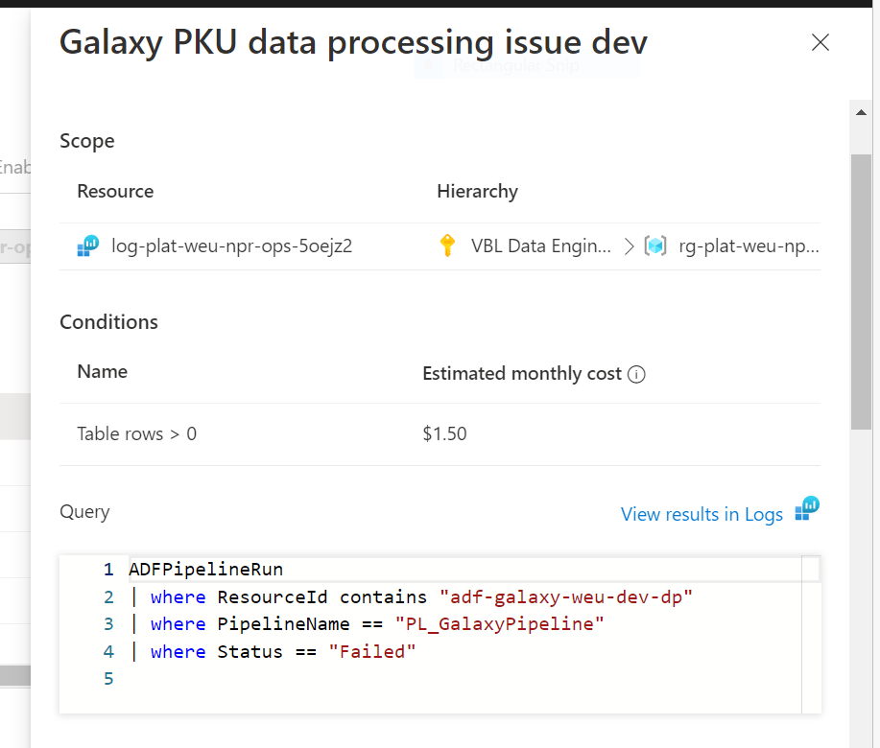

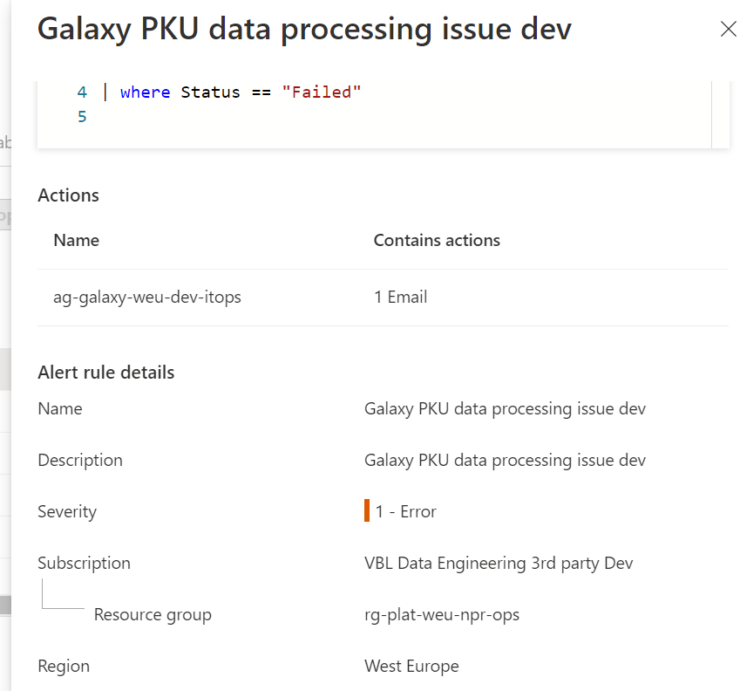

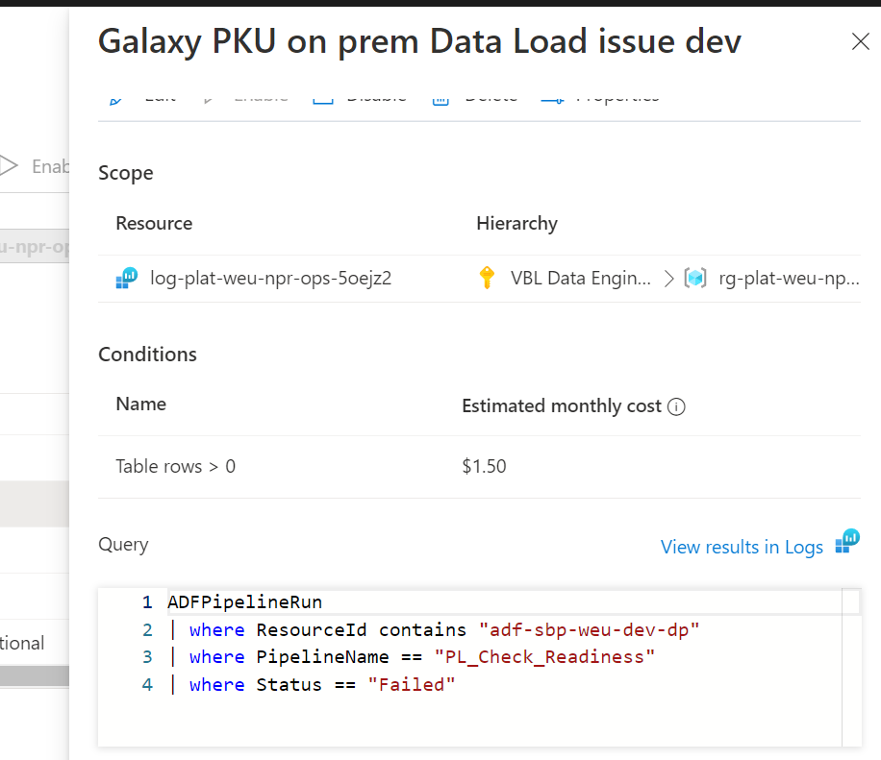

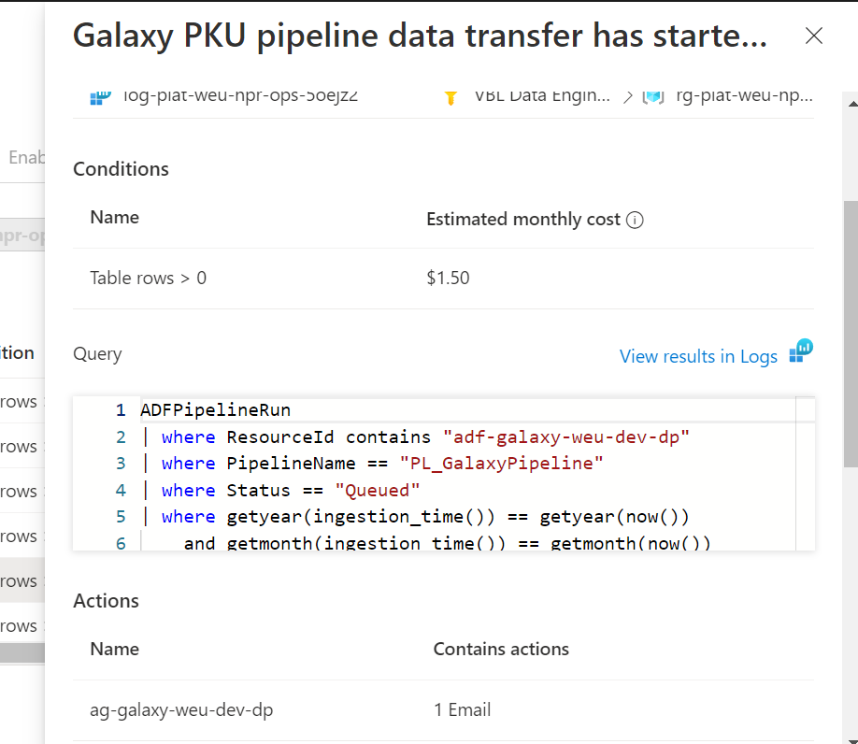

ADFPipelineRun
| where ResourceId contains "adf-galaxy-weu-dev-dp"
| where PipelineName == "PL_GalaxyPipeline"
| where Status == "Queued"
| where getyear(ingestion_time()) == getyear(now())
and getmonth(ingestion_time()) == getmonth(now())
| summarize
FileReceivedCount= count(),
Ingestion_Time=min(ingestion_time())
| where datetime_diff("Second", now(), Ingestion_Time) > 0
and datetime_diff("Second", now(), Ingestion_Time) <= 300
| where FileReceivedCount >= 1

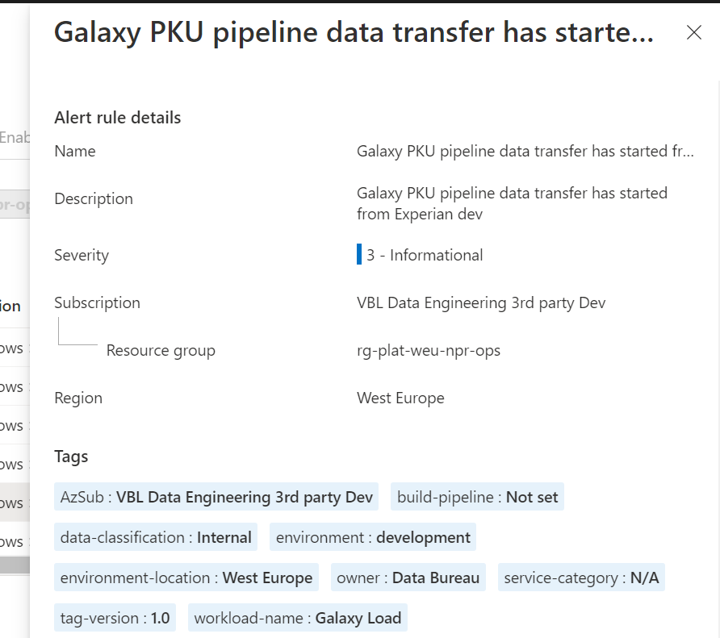

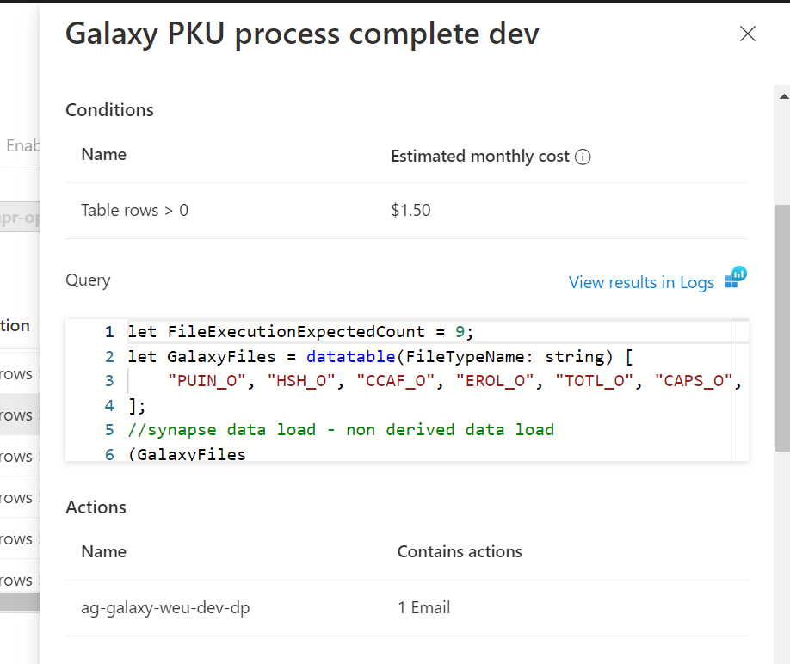

let FileExecutionExpectedCount = 9;
let GalaxyFiles = datatable(FileTypeName: string) [
"PUIN_O", "HSH_O", "CCAF_O", "EROL_O", "TOTL_O", "CAPS_O", "CACC_O"
];
//synapse data load - non derived data load
(GalaxyFiles
| join (SynapseIntegrationPipelineRuns
| where _ResourceId contains "synw-gsynapse-weu-dev-dp"
| where PipelineName == "PL_GalaxyDataLakeSync"
| where Status == "Succeeded"
| where getyear(ingestion_time()) == getyear(now())
and getmonth(ingestion_time()) == getmonth(now())
| extend FileTypeName = strcat(parse_json(Parameters).fileType)
| extend IngetstionTime = ingestion_time()
)
on $left.FileTypeName == $right.FileTypeName
| summarize LatestIngestionTime = min(IngetstionTime) by FileTypeName
| summarize
ReceivedFileCount = count(),
MaxIngestionTime = max(LatestIngestionTime),
Source="Synapse1"
| where ReceivedFileCount > 0
)
//synapse data load - derived columns
| union kind = outer (SynapseIntegrationPipelineRuns
| where _ResourceId contains "synw-gsynapse-weu-dev-dp"
| where PipelineName == "PL_sbp_stage_csv_to_parquet"
| where Status == "Succeeded" // "Succeeded"
| where getyear(ingestion_time()) == getyear(now())
and getmonth(ingestion_time()) == getmonth(now())
| summarize
ReceivedFileCount = iff(count() > 0, 1, 0),
MaxIngestionTime = min(ingestion_time()),
Source="Onprem"
| where ReceivedFileCount > 0)
//On-prem data load
| union kind = outer (ADFPipelineRun
| where _ResourceId contains "adf-sbp-weu-dev-dp"
| where PipelineName == "PL_load_Experianbureau"
| where Status == "Succeeded"
| where getyear(ingestion_time()) == getyear(now())
and getmonth(ingestion_time()) == getmonth(now())
| summarize
ReceivedFileCount = iff(count() > 0, 1, 0),
MaxIngestionTime = min(ingestion_time()),
Source="Onprem"
| where ReceivedFileCount > 0)
| summarize
FileExecutionActualCount = sum(ReceivedFileCount),
OverallMaxIngestionTime = max(MaxIngestionTime)
| where FileExecutionActualCount == FileExecutionExpectedCount
| where datetime_diff("Second", now(), OverallMaxIngestionTime) > 0
and datetime_diff("Second", now(), OverallMaxIngestionTime) <= 300

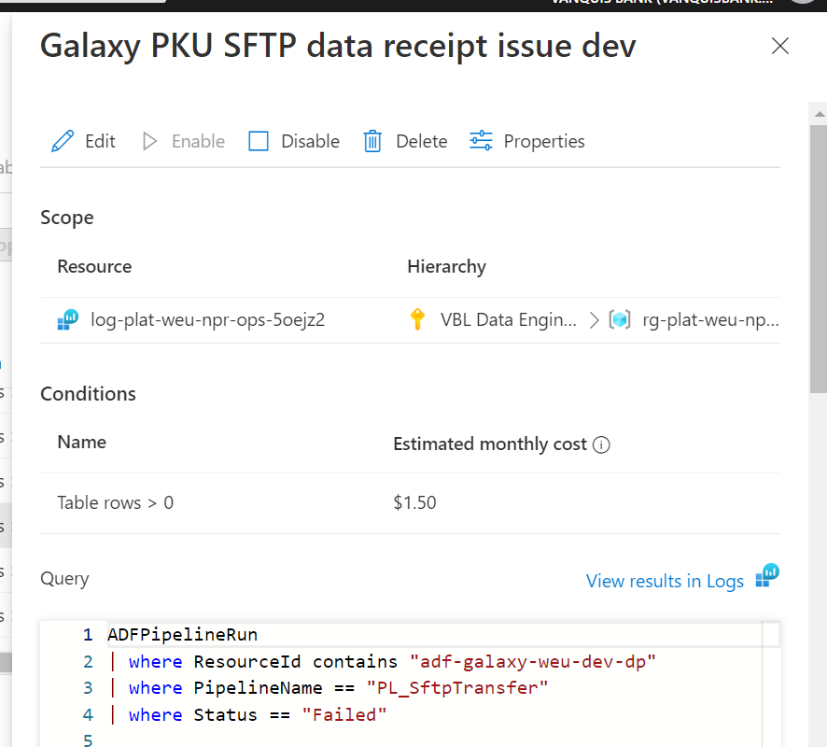

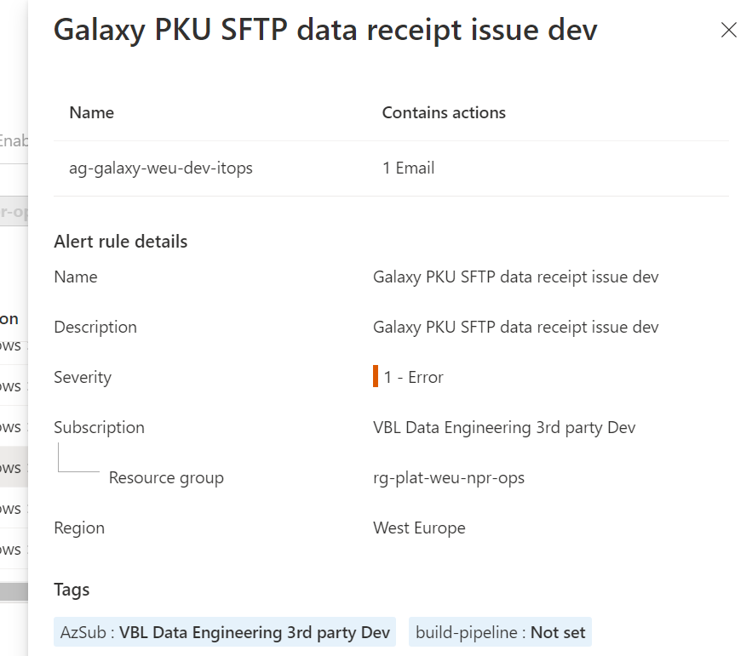

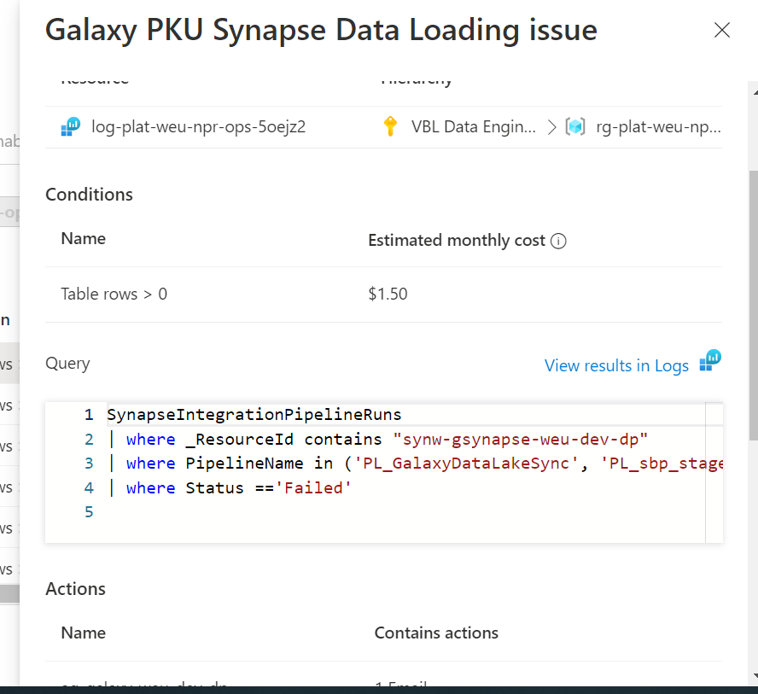

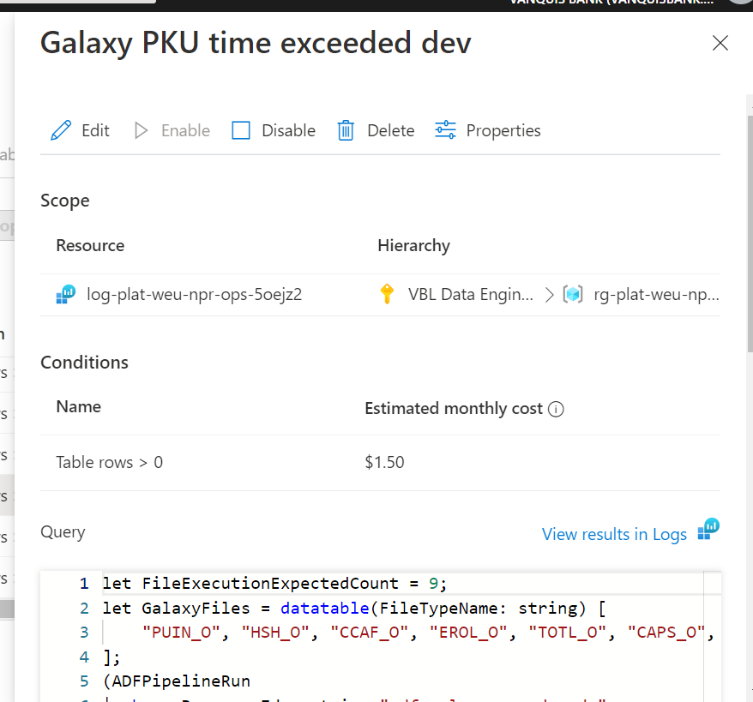

let FileExecutionExpectedCount = 9;
let GalaxyFiles = datatable(FileTypeName: string) [
"PUIN_O", "HSH_O", "CCAF_O", "EROL_O", "TOTL_O", "CAPS_O", "CACC_O"
];
(ADFPipelineRun
| where ResourceId contains "adf-galaxy-weu-dev-dp"
| where PipelineName == "PL_GalaxyPipeline"
| where Status == "Queued"
| where getyear(ingestion_time()) == getyear(now())
and getmonth(ingestion_time()) == getmonth(now())
| summarize
Id=1,
FileReceivedCount= count(),
First_File_Received_Time=min(ingestion_time())
| where FileReceivedCount > 0
)
| join (
//synapse data load - nod derived data load
(GalaxyFiles
| join (SynapseIntegrationPipelineRuns
| where _ResourceId contains "synw-gsynapse-weu-dev-dp"
| where PipelineName == "PL_GalaxyDataLakeSync"
| where Status == "Succeeded"
| where getyear(ingestion_time()) == getyear(now())
and getmonth(ingestion_time()) == getmonth(now())
//| where datetime_diff("Minute", now(), Start) < 30
| extend FileTypeName = strcat(parse_json(Parameters).fileType)
| extend IngetstionTime = ingestion_time()
)
on $left.FileTypeName == $right.FileTypeName
| summarize LatestIngestionTime = min(IngetstionTime) by FileTypeName
| summarize
ReceivedFileCount = count(),
Source="Synapse1"
)
//synapse data load - derived columns
| union kind = outer (SynapseIntegrationPipelineRuns
| where _ResourceId contains "synw-gsynapse-weu-dev-dp"
| where PipelineName == "PL_sbp_stage_csv_to_parquet"
| where Status == "Succeeded"
| where getyear(ingestion_time()) == getyear(now())
and getmonth(ingestion_time()) == getmonth(now())
| summarize
ReceivedFileCount = iff(count() > 0, 1, 0),
Source="Onprem"
| where ReceivedFileCount > 0)
//On-prem data load
| union kind = outer (ADFPipelineRun
| where ResourceId contains "adf-sbp-weu-dev-dp"
| where PipelineName == "PL_load_Experianbureau"
| where Status == "Succeeded"
| where getyear(ingestion_time()) == getyear(now())
and getmonth(ingestion_time()) == getmonth(now())
| summarize
ReceivedFileCount = iff(count() > 0, 1, 0),
Source="Onprem"
| where ReceivedFileCount >= 1)
| summarize
Id= 1,
FileExecutionActualCount = sum(ReceivedFileCount)
)
on $left.Id == $right.Id
| where FileExecutionActualCount < FileExecutionExpectedCount
| where datetime_diff("Second", now(), First_File_Received_Time) > 28800
and datetime_diff("Second", now(), First_File_Received_Time) <= 29100

