1. From Building to Designing & Governing
- As a data engineer, you focus on pipelines, models, and performance.
- As a director, you focus on architectural blueprints, standards, governance, and scalability across the org.
- You’ll be expected to define the “North Star architecture” and ensure teams align with it.

2. From Individual Delivery to Organizational Impact
- Senior engineers deliver complex projects; directors deliver strategy, frameworks, and capabilities that dozens of teams use.
- You’ll spend more time enabling cross-team consistency (data models, lakehouse/cloud strategy, API standards, lineage/observability).

3. From Technical Depth to Technical Breadth + Business Alignment
- Directors don’t need to code daily, but must understand enough about cloud infra, ML platforms, streaming, MDM, governance, security to guide decisions.
- You’ll also need to connect data engineering decisions to business outcomes (faster time to insights, reduced costs, compliance readiness).

4. From Team Lead to Org Builder
- Instead of mentoring a handful of engineers, you’ll be:
  - Building teams (hiring, career frameworks).
  - Influencing budgets & vendor selection.
  - Creating policies for data quality, SLAs, observability, and governance.

📈 Steps to Get There
- Strengthen Your Leadership Scope
  - Volunteer to own cross-functional initiatives (e.g., a data mesh rollout, cloud migration, data catalog implementation).
  - Show you can drive outcomes across multiple teams, not just yours.
- Build Architectural Thought Leadership
  - Contribute to data strategy documents, reference architectures, and decision frameworks.
  - Present at internal architecture reviews or external conferences.
- Develop Business & Communication Skills
  - Learn to translate data engineering to business language (“this platform saves us $2M annually” instead of “we migrated to Spark structured streaming”).
  - Build relationships with product, finance, compliance, and operations leaders.
- Get Exposure to Governance & Compliance
  - Directors are often accountable for data security, privacy, lineage, and regulatory readiness (GDPR, CCPA, HIPAA, etc.).
  - If you haven’t yet, lead an initiative in these areas.
- Mentorship & Sponsorship
  - Find a current director or VP to mentor you.
  - Ask them what gaps they see in your profile.
- Position Your Experience
  - Frame your current impact in director language:
    - Instead of: “Built streaming pipelines with Kafka & Spark.”
    - Say: “Defined real-time data platform strategy, enabling 5 teams to deliver insights within seconds instead of hours.”

🚀 Optional Accelerators
- Certifications (not mandatory, but can signal readiness): AWS Data Analytics Specialty, GCP Professional Data Engineer, DAMA Certified Data Management Professional (CDMP).
- Publish internal whitepapers or external blog posts on data architecture best practices.
- Take leadership courses (Harvard ManageMentor, Coursera leadership tracks, or internal company programs).

Phase 1: Foundation & Vision (Weeks 1–4)
- Ten Characteristics of a Modern Data Architecture – Read here
- Principles of Good Data Architecture (Medium) – Read here
- Atlan’s Data Architect Roles & Responsibilities Guide – Read here
- The Data Warehouse Toolkit (Ralph Kimball) – Book link
- Coursera: Data Engineering Foundations – Course link
- MIT Professional Program: Data Leadership – Program link

🏗️ Phase 2: Architecture & Governance Mastery (Weeks 5–8)
- Data Mesh: A Systematic Gray Literature Review (arXiv) – Paper link
- DAMA-DMBOK (Data Management Body of Knowledge) – Book link
- Why Data Architects Are Key to Modern Enterprises (CIO Influence) – Read here
- Datacamp: Data Modeling for Data Warehouses – Course link
- Datacamp: Data Engineering on AWS – Course link
- DAMA Certified Data Management Professional (CDMP) – Certification info

📊 Phase 3: Leadership & Strategy (Weeks 9–12)
- Lead Data Engineer Career Guide (Medium) – Read here
- The Data Management Playbook (Steve Hoberman) – Book link
- Harvard Business Review – Data & Analytics Leadership Articles – Browse here
- LinkedIn Learning: Executive Presence for Technical Leaders – Course link
- Coursera: Strategic Leadership and Management Specialization – Course link

🚀 Phase 4: Future-Proofing & Influence (Weeks 13–24)
- KEA: Tuning an Exabyte-Scale Data Infrastructure (Microsoft) – Paper link
- Data Mesh (Book by Zhamak Dehghani) – Book link
- Netflix Tech Blog – Read here
- Uber Engineering Blog – Read here
- Airbnb Engineering Blog – Read here
- Coursera: Advanced Data Engineering – Course link

Data Mesh
Resource | What You’ll Learn / Why It’s Good
Architecture and functions in a data mesh (Google Cloud) | Shows how to structure components, roles, and architecture in a Data Mesh. Google Cloud
Confluent: Data Mesh – Architectural Basics & Implementation | Principles, use cases, how to get started practically (with event streaming etc.). Confluent
AWS: Architecting a Data Mesh | How AWS suggests building a data mesh using their services; good for seeing cloud applicability. Amazon Web Services, Inc.
GetDBT: Data Mesh Architecture Explained | Clear explanations of how domain ownership works, and why mesh vs monolithic/central model matters. dbt Labs
ArXiv: Architectural Design Decisions for Self-Serve Data Platforms in Data Meshes | Academic + industrial insights on choices in self-serve platforms, trade-offs, patterns. arXiv

🏞 Lakehouse Architecture & Real-Time Streaming
Resource | What You’ll Learn / Why It’s Good
Databricks: Data Lakehouse Architecture | The core concept: how it blends data lake + warehouse strengths; open standards; batch + streaming etc. Databricks
Analytics8: Data Lakehouse Explained – Building Modern & Scalable Architecture | Good guide to decide when & how to migrate vs build lakehouse, key components. Analytics8
Prophecy: Lakehouse Architecture Guide for Modern Data Strategy | Explains real-time alongside historical analytics, trade-offs etc. prophecy.io
Apache Hudi: What is a Data Lakehouse & How it Works | Technical deeper dive into storage formats, transaction support, schema evolution etc. hudi.apache.org
Microsoft: Near Real-Time Lakehouse Data Processing | Example of end-to-end architecture keeping lakehouse data in sync in near real-time. Microsoft Learn
“Shift Left Architecture” – Batch → Real‐Time Data Products (Kai Waehner) | Designing architecture to move analytics closer to streaming / real-time, with technologies like Kafka, Flink, etc. Kai Waehner

How Do You Operationalise Data Architecture?
At the start, it may take more time, cost a bit more, and require new resources. But if you do it the right way, the payoff is significant. Here are five essentials to consider:
🏛️ Centralise the Architecture Function
Avoid silos by centralising data architecture. This ensures alignment with company-wide goals and clarifies domain ownership of data assets and products.
🤖 Automate & Standardise with Technology
Leverage modern data modelling tools to design and document assets, reduce human error, and integrate with governance platforms. Automation ensures consistency, efficiency, and scalability.
🤝 Engage Business Teams
Architecture isn’t just technical, it must serve the business. Regular workshops with stakeholders build alignment, ensuring teams understand how data enables strategy and value creation.
🎯 Hire the Right Resources
Bring in a dedicated data architect who can strategically connect systems. Don’t leave this critical responsibility to already stretched engineers. A skilled architect is the foundation of a high-performing data platform.
🔄 Stay Flexible in Your Approach
An Enterprise Data Model is never static. Use a mix of philosophies and approaches that fit business priorities. Flexibility reduces risk and unlocks value
Don’t push Data Architecture to the backburner. Prioritising it now sets the stage for long-term success. Hiring the right people, choosing the right approach, and embedding automation are quick wins to get started.

Data products -

In this article, Willem Koenders shares a reference architecture that turns complex Data Management into actionable steps, breaking down the key elements of Data Product design and showing how to implement them using AWS services.
🏗️ Build repeatable Data Product frameworks that actually work
🎯 Choose the right technology stack with confidence
🚀 Cut solution design time by 25-50%
✨ See FAIR principles in action through a financial services case study

A simple reference architecture for data products | by Willem Koenders | ZS Associates | Medium

“Data Governance and Data Architecture Work Hand in Hand”
Data governance and data architecture are not separate disciplines, they are two sides of the same coin.
- Data architecture defines how data is collected, stored, integrated, and delivered. It’s the blueprint: the pipelines, models, catalogs, storage layers, and APIs.
- Data governance ensures how that architecture is used- with rules for quality, compliance, security, and ownership. It ensures data is handled responsibly with policies, standards, lineage, and accountability.
Why they are inseparable:
- Without governance, even the best-designed architecture can become a "data maze"- a technically sound structure filled with unreliable, non-compliant, or poorly understood data.
- Without architecture, governance is just a set of rules with no foundation to enforce policies or make metadata actionable.
Why governance matters:
- It builds trust by making data accurate, consistent, and traceable.
- It ensures compliance with regulations like GDPR and CCPA.
- It enables scalability as new sources and systems are added.
- It drives adoption because people understand and trust the data they use.
The real value comes when governance is built into architecture from day one, not bolted on later. That’s how companies move from “just storing data” to delivering data that is truly business-ready.

The difference between data architecture and data management is a nuanced one.
Data management is the overall framework for governing, maintaining, and ensuring the quality of data across an organization.
Data architecture is the structural design (aka the blueprint) that shows how that data is organized, connected, and flows between systems.
I can't tell you how many times I've met a data architect or DBA who has no clue how the business functions. This is why a Data Management Framework is so important for global trade - it helps to advise the blueprint for the underlying data architecture of trade systems
A Data Management Framework (DMF) makes data architecture tangible for trade professionals. You don’t have to be technical to use it and a framework gives you a way to ask:
- Where is the data that drives my daily trade compliance tasks?
- Who owns the accuracy of HTS codes, licenses, or origin data?
- How can I make sure all systems reference the same “source of truth”?
Using a semiconductor moving through multiple countries. If its classification, license requirement, and customs filings don’t align across systems, the shipment stalls. With a clear DMF in place, professionals can map where that data lives, assign ownership and single source of truth (SSOT) , and make sure architecture supports compliance business flows.
In theory, a DMF can help with fewer errors, faster compliance checks, and ultimately, smoother commerce enablement.
An example of a quick action checklist for trade professionals:
1. Identify your critical compliance data (HTS codes, licenses, country of origin).
2. Map where this data currently lives across systems.
3. Assign ownership — who is responsible for keeping each data point accurate.
4. Align systems to reference a single source of truth.

𝐖𝐡𝐚𝐭 𝐢𝐬 𝐚 𝐒𝐮𝐬𝐭𝐚𝐢𝐧𝐚𝐛𝐥𝐞 𝐃𝐚𝐭𝐚 𝐀𝐫𝐜𝐡𝐢𝐭𝐞𝐜𝐭𝐮𝐫𝐞?
Most data initiatives don’t fail because the wrong tools were chosen. They fail because the underlying architecture is fragile: unclear ownership, siloed processes, and missing alignment between IT and business.
In 𝐑𝐞𝐭𝐚𝐢𝐥 & 𝐂𝐏𝐆 this is especially visible. Like in every other industry legacy systems are common. Business units push ahead with their own tools, whereas IT is stuck in maintenance mode.
The result: inconsistent KPIs, fragile pipelines, and a lack of trust in data.
✅ Why sustainable architecture matters in this context: A 𝐒𝐮𝐬𝐭𝐚𝐢𝐧𝐚𝐛𝐥𝐞 𝐃𝐚𝐭𝐚 𝐀𝐫𝐜𝐡𝐢𝐭𝐞𝐜𝐭𝐮𝐫𝐞 provides the foundation for today and tomorrow.
That means: when new source systems are built, you also think from day one about how the data inside will be analyzed, reused, and trusted.
In my opinion a sustainable data architecture comes with different components:
▷ 𝐒𝐮𝐩𝐩𝐨𝐫𝐭 𝐟𝐨𝐫 𝐯𝐚𝐫𝐢𝐨𝐮𝐬 𝐝𝐚𝐭𝐚 𝐬𝐨𝐮𝐫𝐜𝐞𝐬 like custom landing zones, standard connectors, multiple protocols & file formats
▷ 𝐔𝐧𝐢𝐟𝐢𝐞𝐝 𝐏𝐥𝐚𝐭𝐟𝐨𝐫𝐦: warehousing, engineering, streaming, AI/ML
▷ 𝐂𝐚𝐭𝐚𝐥𝐨𝐠 & 𝐆𝐨𝐯𝐞𝐫𝐧𝐚𝐧𝐜𝐞: ownership, lineage, standardized metrics & KPIs
▷ 𝐔𝐬𝐞 𝐂𝐚𝐬𝐞𝐬: (standard/ad-hoc) reporting, custom apps, dashboarding, GenAI, AI/ML
and apply key design principles such as:
▷ 𝐒𝐞𝐩𝐚𝐫𝐚𝐭𝐢𝐨𝐧 𝐨𝐟 𝐜𝐨𝐧𝐜𝐞𝐫𝐧𝐬 - ingestion, preparation, analysis are decoupled
▷ 𝐃𝐞𝐬𝐢𝐠𝐧 𝐛𝐲 𝐜𝐨𝐧𝐭𝐫𝐚𝐜𝐭 - schemas, SLAs, clear ownership
▷ 𝐌𝐨𝐝𝐮𝐥𝐚𝐫𝐢𝐭𝐲 - tools can change without breaking logic
▷ 𝐆𝐨𝐯𝐞𝐫𝐧𝐚𝐧𝐜𝐞 & 𝐜𝐮𝐥𝐭𝐮𝐫𝐞 - data is a shared product, not an IT by-product

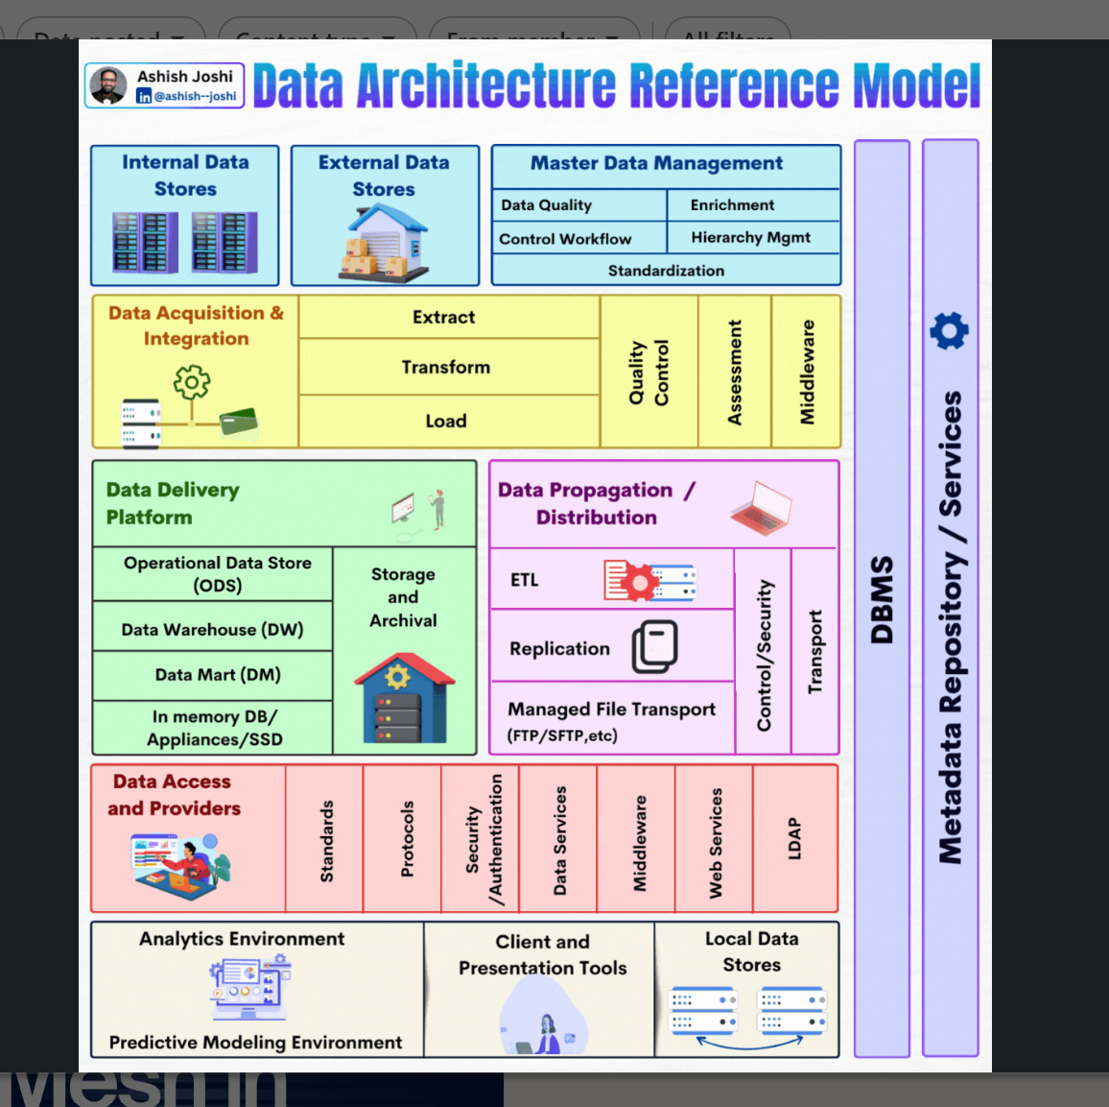

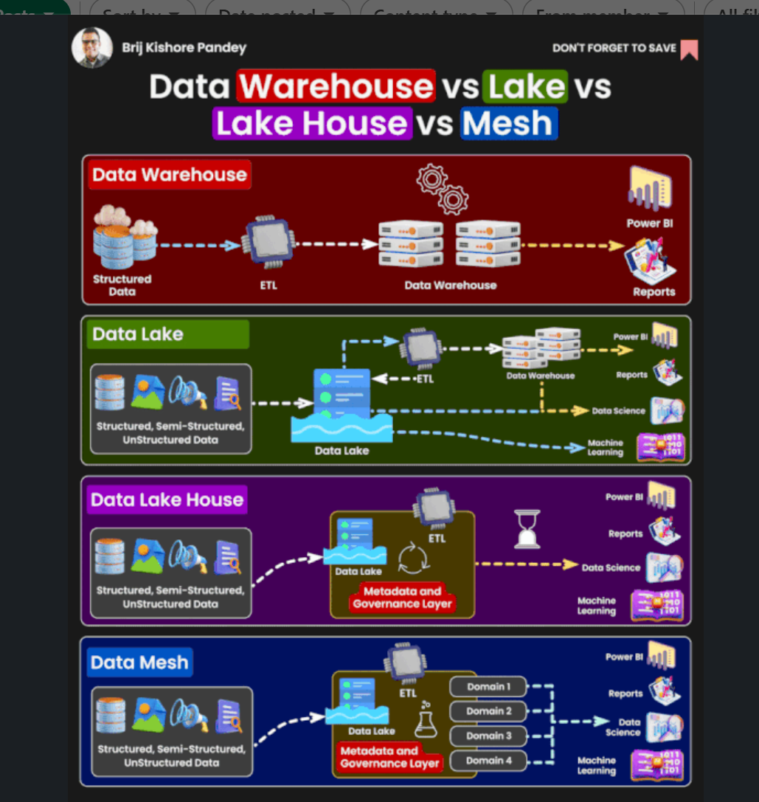

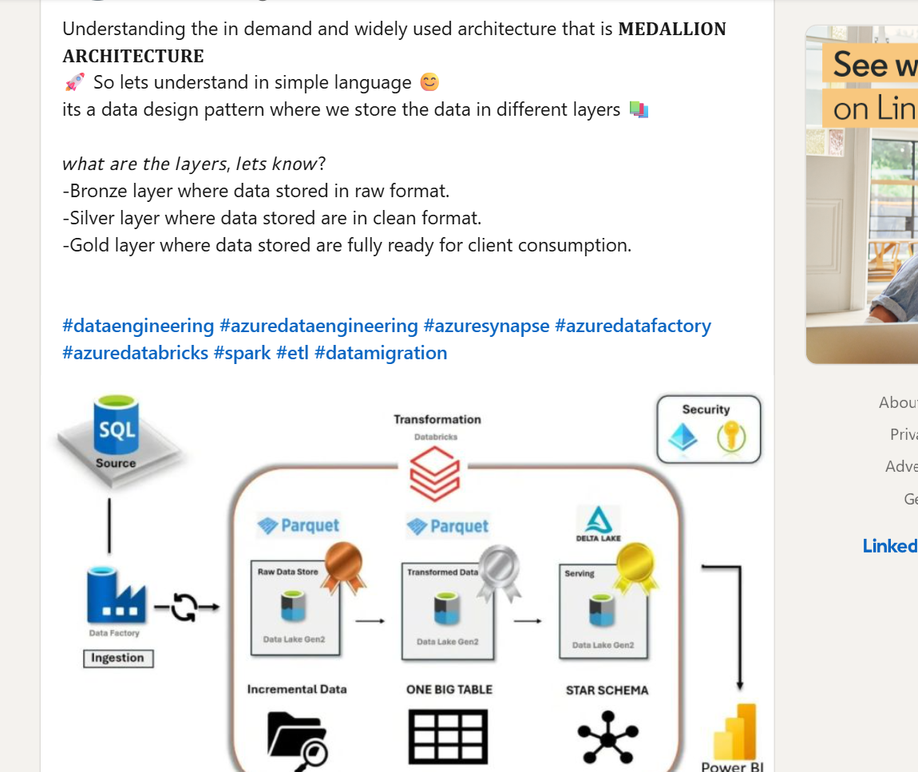

Architectural pattern

Each one has its own unique benefits.
Understanding architectural patterns is essential. Here’s a cheat sheet to help you with some of the main ones:
1) Event-Driven Architecture (EDA)
• Components: Event producer, event broker, event consumers
• Description: Systems react to events and communicate through an event broker
• Use cases: Real-time data processing, IoT applications, asynchronous communication
2) Layered Architecture
• Layers: Presentation, business/application, data access, persistence, infrastructure
• Description: Organizes code into layers with specific responsibilities, promoting separation of concerns
• Use cases: Enterprise applications, systems that require a clear separation between UI and business logic
3) Monolithic Architecture
• Components: Single-layer application with interconnected modules (e.g., user posts, comments, groups)
• Description: All components are part of a single application, sharing a common database
• Use cases: Simple apps, startups, systems with minimal scalability concerns
4) Microservices Architecture
• Components: API Gateway, independent services (e.g., catalog, shopping cart)
• Description: Applications are built as a set of small services, each running independently and communicating through APIs
• Use cases: Large-scale applications, systems requiring high scalability and flexibility
5) Model-View-Controller (MVC) Architecture
• Components: Model, View, Controller
• Description: Separates application logic into three interconnected components, promoting code organization
• Use cases: Web applications, systems requiring a clear separation between data handling and user interface
6) Master-Slave Architecture
• Components: Master server, slave servers
• Description: A master server handles writes and updates, while slave servers handle read operations
• Use cases: Database replication, systems needing load balancing and redundancy

Here are 15 top data terms you should know:
1️⃣ Data Mining – Discovering patterns and relationships in large datasets
2️⃣ Data Analytics – Interpreting data to inform decisions and strategies
3️⃣ Data Visualization – Presenting insights through graphs, charts, and dashboards
4️⃣ Data Contract – An agreement defining how data is structured and delivered between teams
5️⃣ Data Modeling – Designing the structure of data systems and relationships
6️⃣ Data Integration – Combining data from multiple sources into a unified view
7️⃣ Data Cleaning – Removing errors, duplicates, and inconsistencies from datasets
8️⃣ Data Warehouse – Central repository for structured data optimized for analytics
9️⃣ Data Mart – A smaller, subject-specific subset of a data warehouse
🔟 Data Lake – A centralized storage for raw, unstructured, and structured data
1️⃣1️⃣ Delta Lake – An open-source storage layer adding reliability to data lakes
1️⃣2️⃣ Data Pipeline – Automated processes that move and transform data from source to destination
1️⃣3️⃣ Data Mesh – A decentralized approach to data architecture emphasizing domain ownership
1️⃣4️⃣ Data Lakehouse – A hybrid platform combining the best of data lakes and warehouses
1️⃣5️⃣ Data Swamp – A mismanaged data lake that lacks structure, quality, or usability

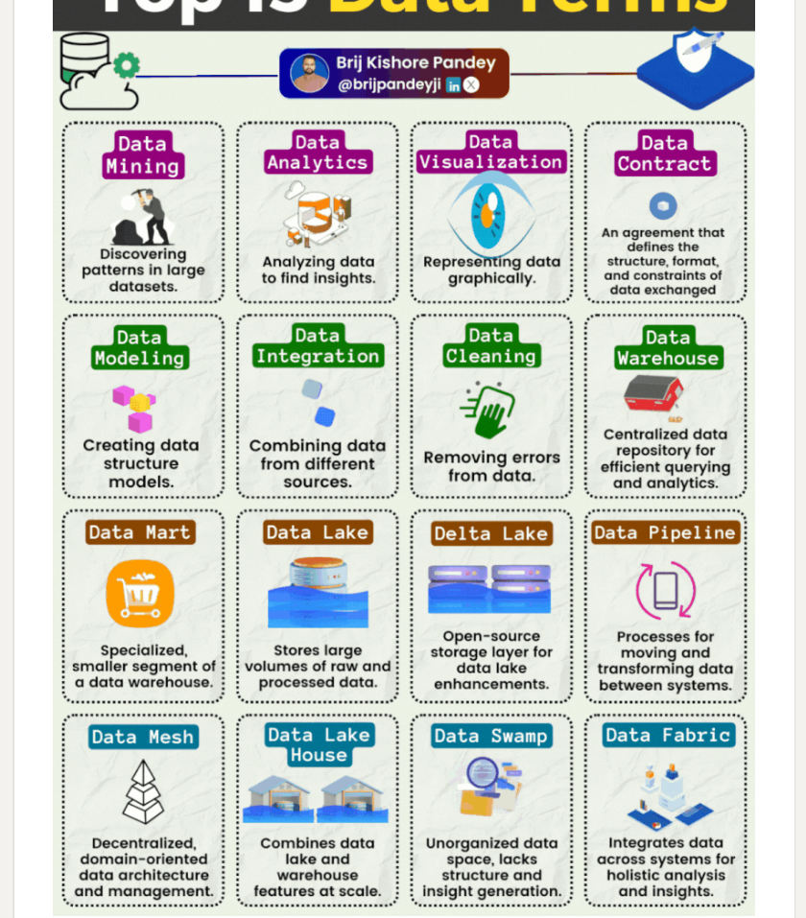

Enterprise Data Platform | LinkedIn

