This document will provide the step by step working of the website along with the details on technologies used and its usage.

1. 127.0.0.1/login.php  
     
   This page is run in Apache and used to validate the user. If the user info is present in our database(UserInfo.xml) it will read the xml file(module used -> simpleXml) and check if the user exists and the password belongs to the correspondent user.  
     
   If the password entered is wrong it will prompt   
     
     
     
     
     
     
     
     
     
     
     
     
     
     
     
   The “New User? Create account” redirects it to a new page where you can register and the information gets incorporated in our database.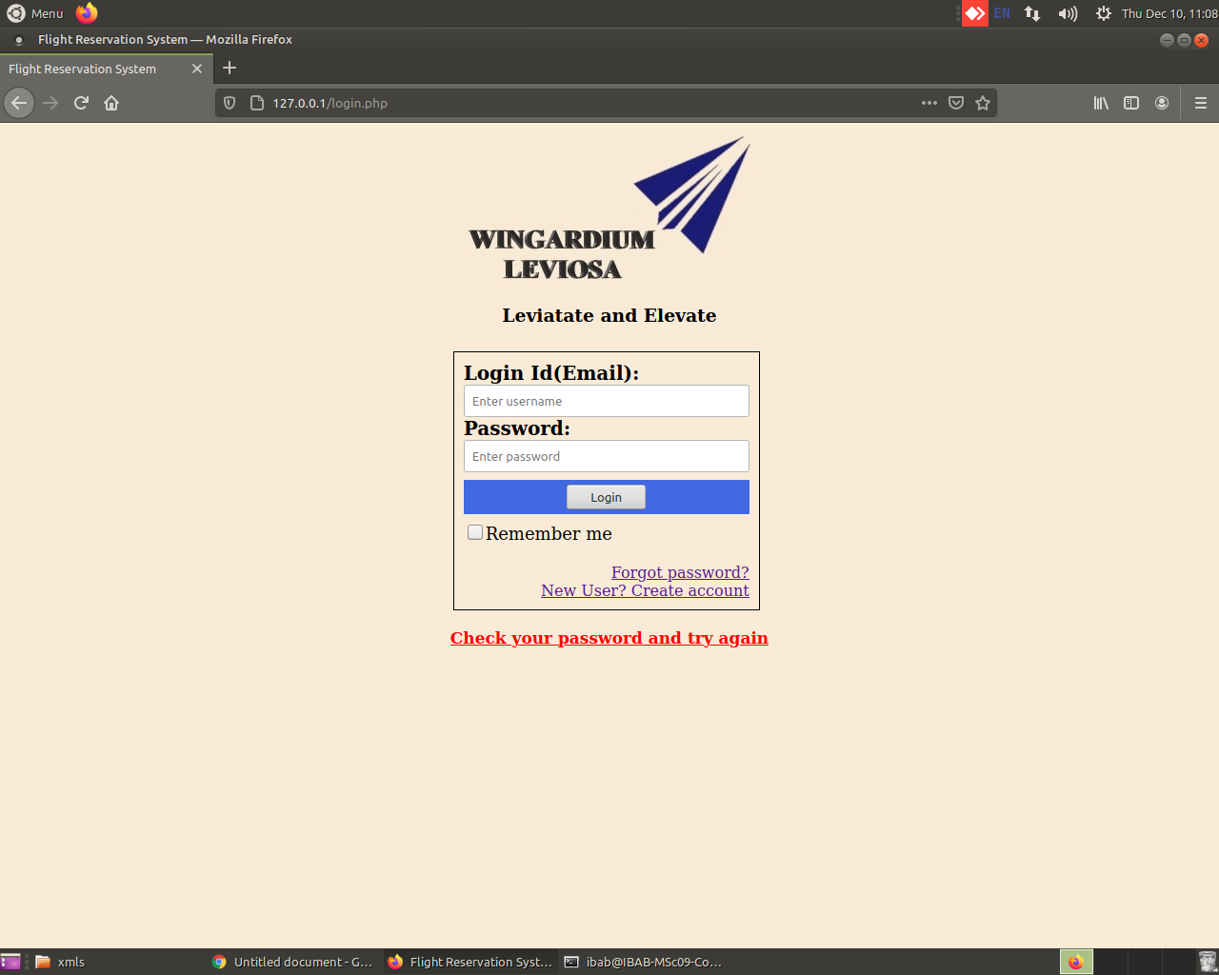
2. 127.0.0.1:8080/register.html & Servlet register.java (Server- Tomcat)  
     
   Here all the ‘*’ marked fields are required and won’t work without filling these fields. If the password and confirm password column are not the same it will ask us to check the password and try again. This html page is linked to register.java servlet which is used to create “UserInfo.xml” by Java File Handling and store all the relevant information into our database.   
   *Note- Since the code is in root and the file saved was outside root, a system command “chmod 666” was used with the xml to make sure it has the permission to be readable and writable.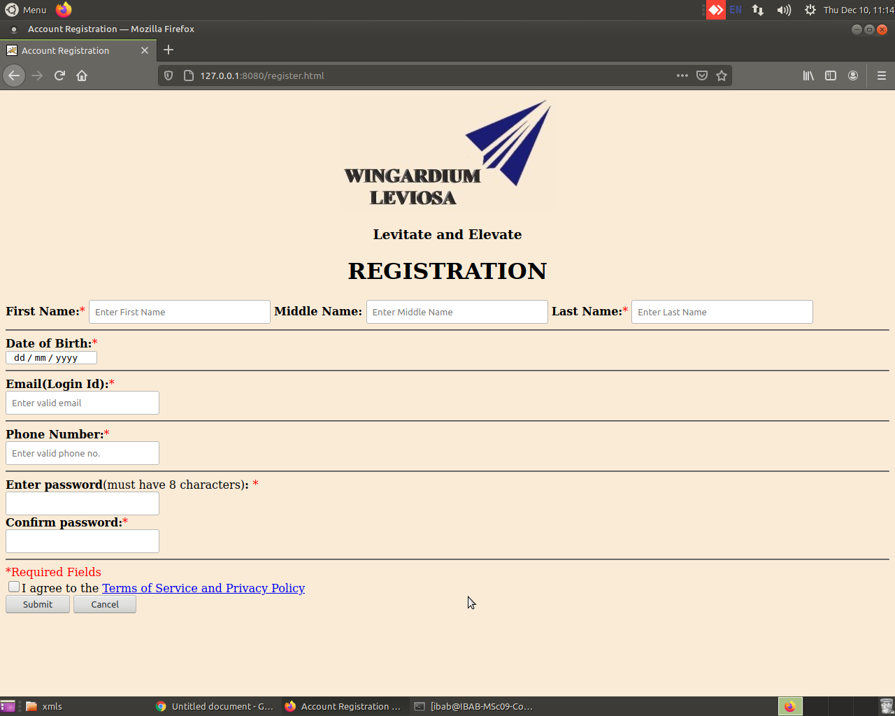

Upon successful registration

If the passwords don’t match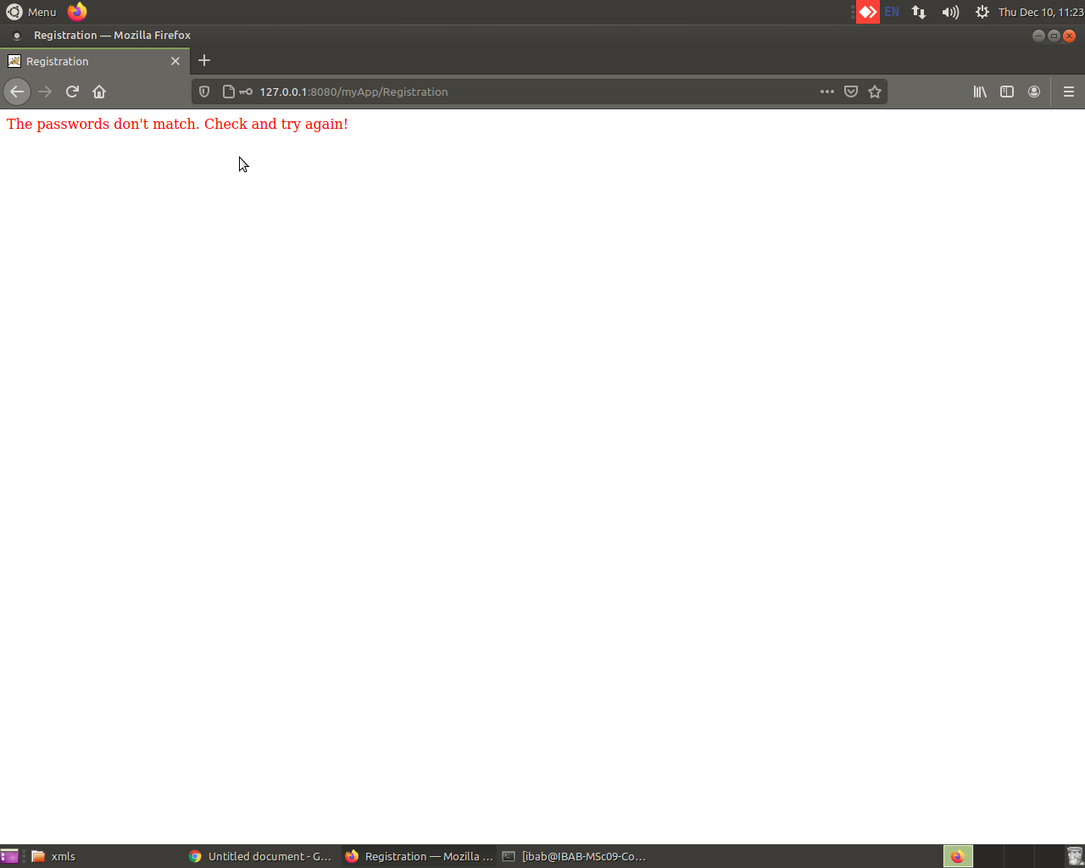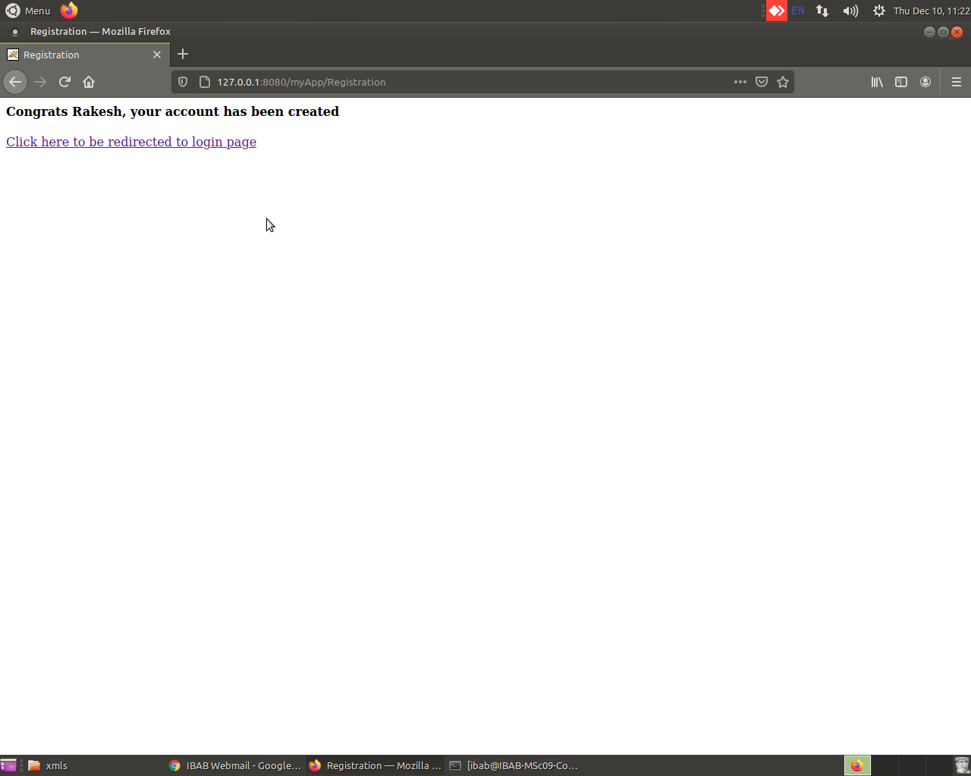

1. 127.0.0.1:8080/home.html (Server- Tomcat)  
     
   This is the main home/booking selection page. We select the booking details on this page.   
   a. Destinations -> Kolkata, Bengaluru, Chennai, Mumbai & Delhi.  
   b. Option for one-way and round trip.  
   c. Departure and Return(for round trip) dates  
   d. Airlines -> Jet Airways, Spicejet, Vistara, IndiGo, Air India  
   e. Max 3 seats can be booked at a time  
   f. Seat type  
   Upon submitting it redirects to a jsp booking.jsp and the cancel button provides the user to reset his/her selection.  
     
   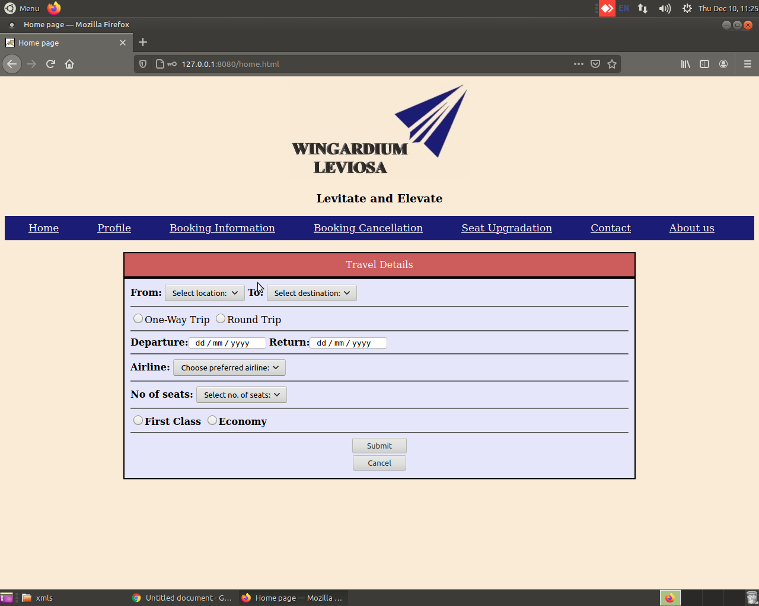
2. 127.0.0.1:8080/booking.jsp & Servlet booking.java (Server- Tomcat)  
   The booking confirmation/amount calculation page. It used a simple algorithm based on base value of seats, airlines and travel type, along with the km to cost conversion to get a **dynamic output for cost w.r.t to travel details**( use of java Collections-> ArrayList and HashMap).   
   Upon submission the details from this jsp is forwarded to Servlet booking.java which updates the database “booking_details.xml” for the same, and also **generates a unique 6 character booking id**. If we hit “Cancel” it redirects us back to the home page.   
   Upon booking you’ll be prompted the below statement and get a link to see the status of your booking.  
     
     
     
     
     
     
   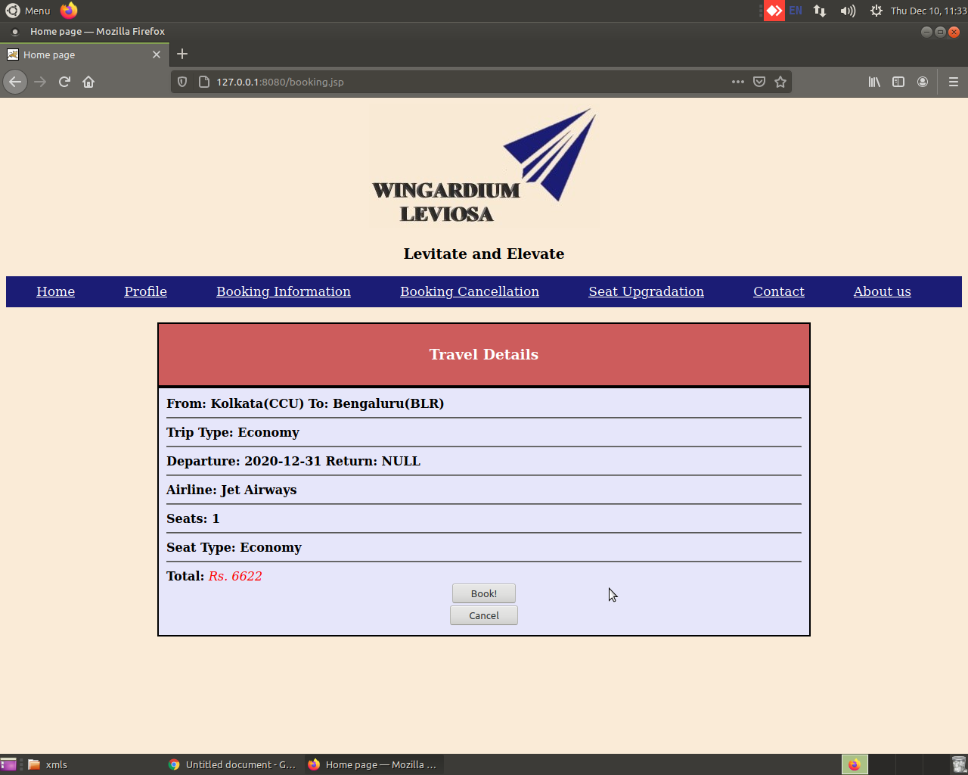
3. 127.0.0.1/Your_bookings.php (Server- Apache)  
   This is the main page where you can see your booking and all the relevant details associated, also it provides **provision to cancel or upgrade it**(hyperlink to the updation pages).  
   The **status is dynamically modulated by using certain time modules** to check if a trip is active(date not yet arrived), ongoing(in the case of round trips), cancelled(booking has been cancelled), or completed(the date has passed).  
   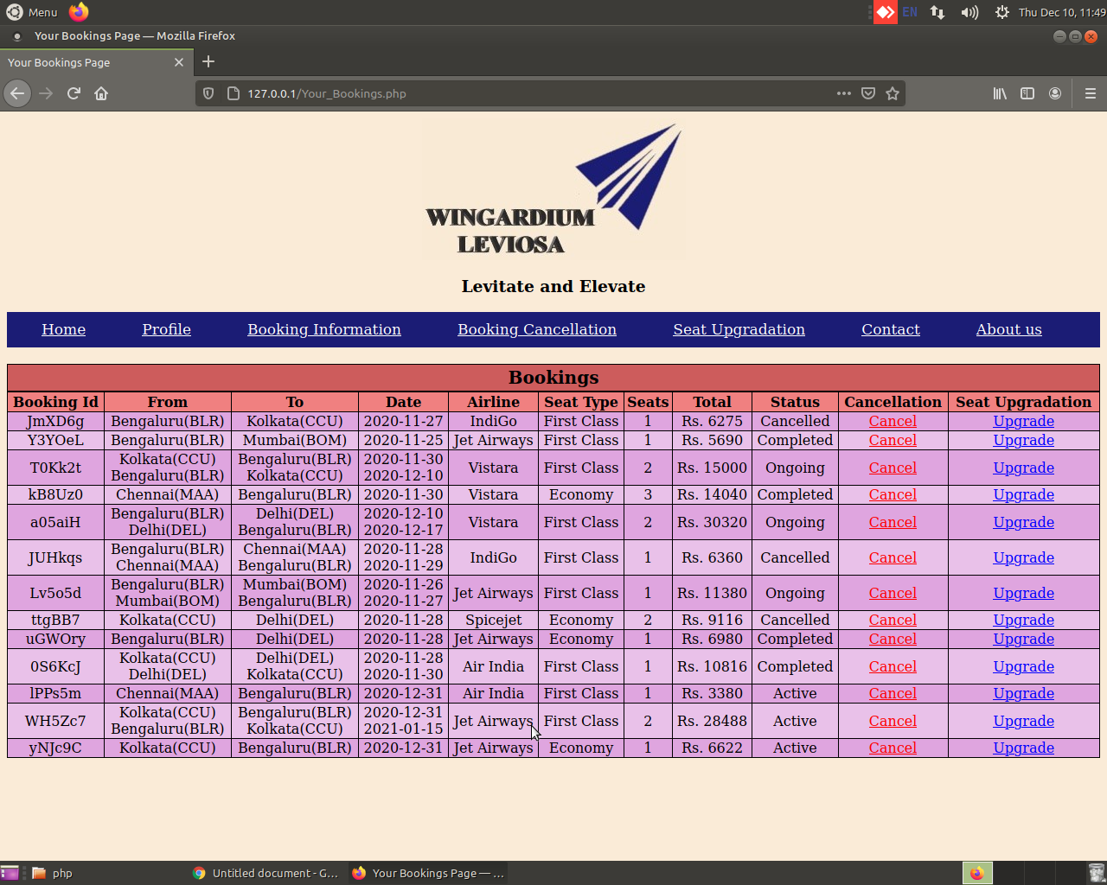
4. 127.0.0.1/cancel2.php (Server- Apache)  
     
   In order to cancel a trip, we need to provide the specific booking id, upon which it will search the database, and if the **trip status is still “Active”,** it will **Cancel the booking** and will update the database as per required.  
   Here I have cancelled the booking id “WH5Zc7”  
     
   Before Cancellation  
   After Cancellation  
     
     
     
     
     
     
     
     
     
     
   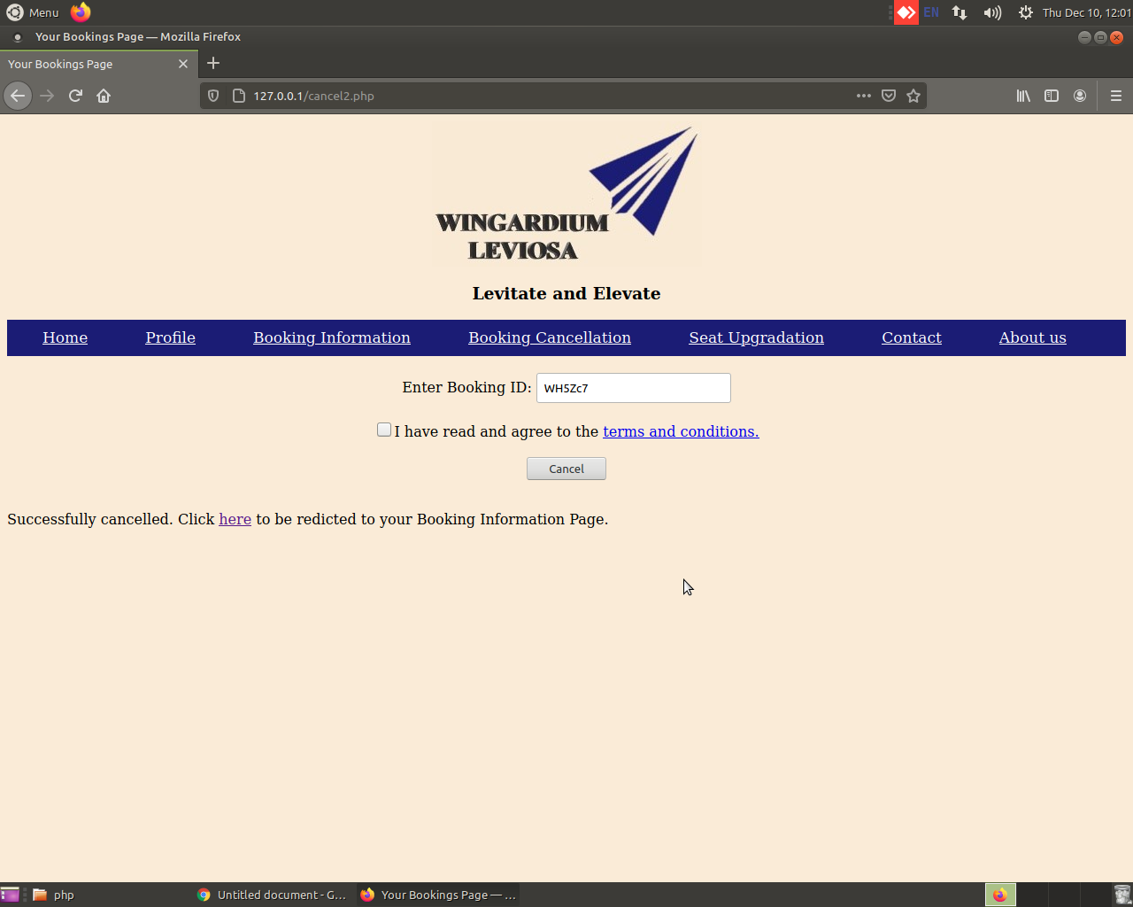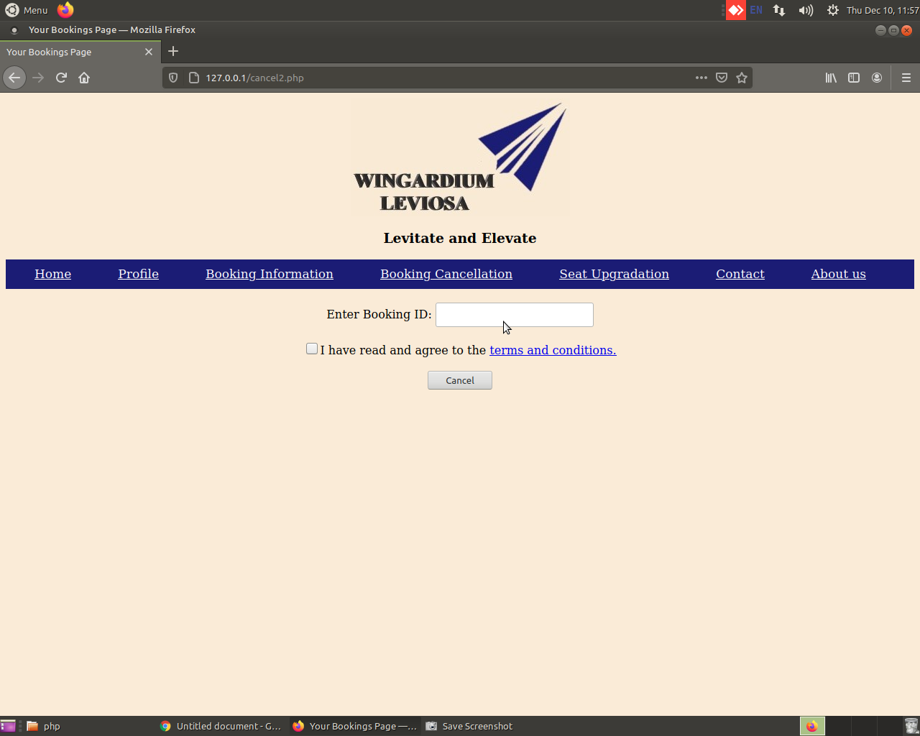
5. 127.0.0.1/seatupgrade.php (Server- Apache)

This works like the cancellation page where we have to input the booking id to make changes to the database. The provision is for only an upgrade from Economy to FIrst-Class.  
Upon successful upgradation  
Before upgrade  
After upgrade  
If the booking is already for First Class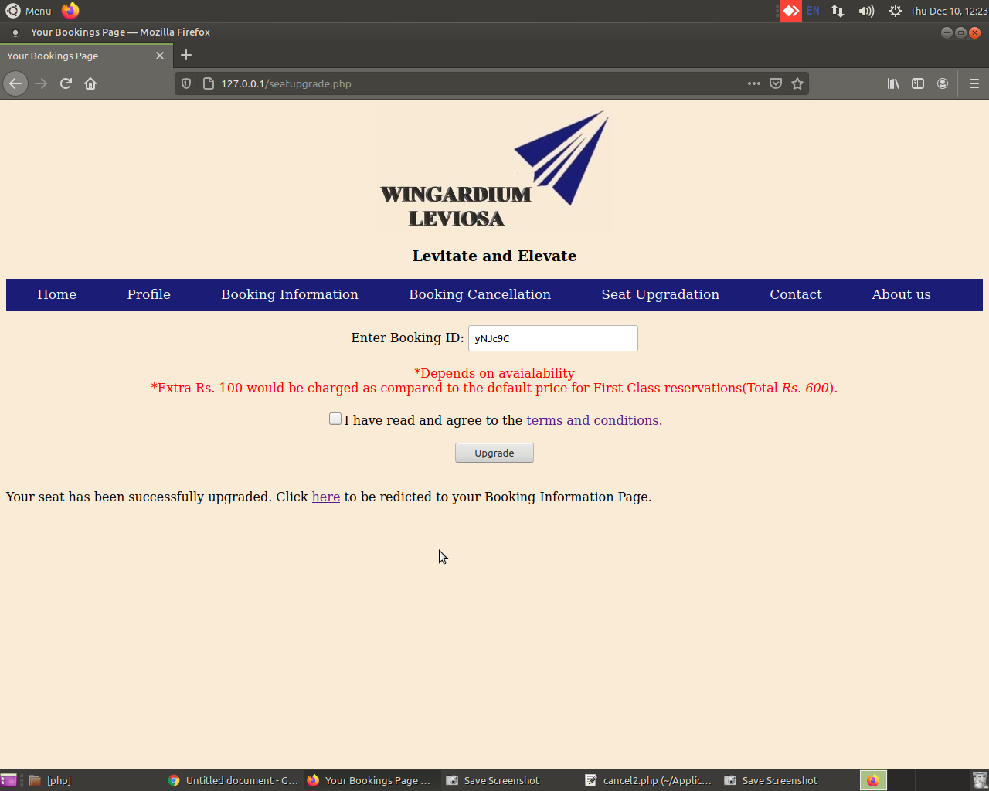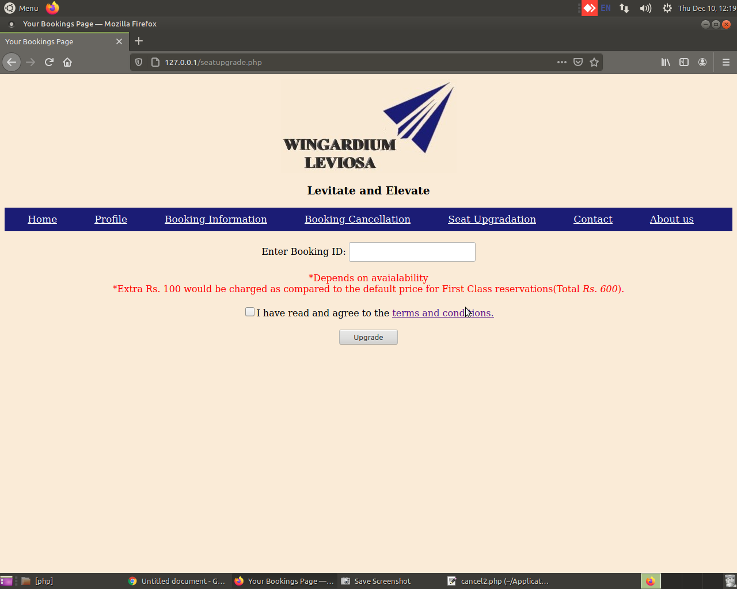

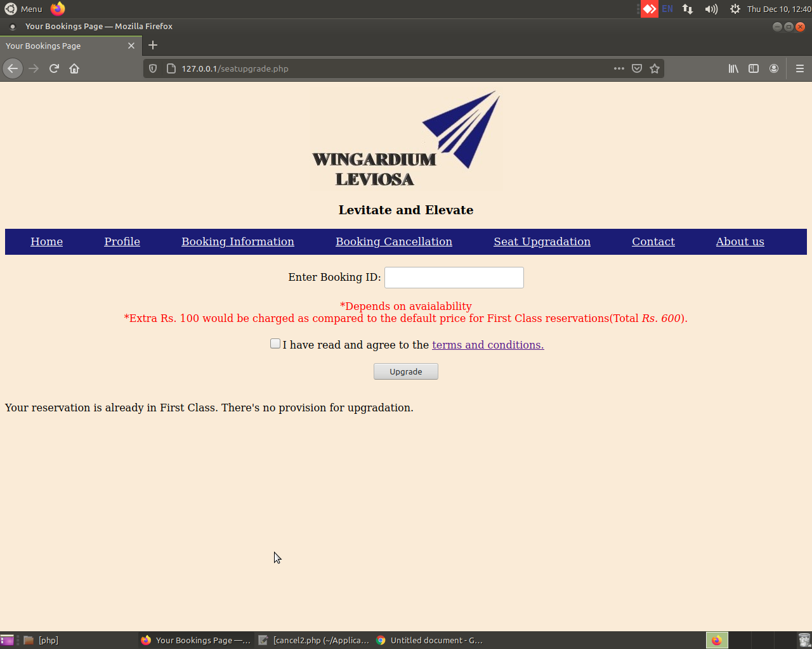

**Fututre Scalability:-**

I. At this moment it has generic booking for a single user only and can retrieve the same but by using interserver sessions we can make a session per user till we invalidate it(logging out).

II. Some links are non existential, but are yet to be worked on(E.g., Profile, Contact, About us and Forgot password)

III. It can be made more optimized with respect to booking upgradation.

IV. Ticket printing provision can be added.