Breakdown of a sound signal into its frequencies with the use of
the Fourier Transform
2430248
Work presented to the BIO as part of the IB Health Sciences program
20

Introduction
Since I was young, I’ve loved playing musical instruments, especially the piano. Music is a crucial part of my life as it helps me relax in stressful times, trains my memory and dexterity and stimulates my creativity. I’ve also always been fascinated by how music and math tie together so well: each note is a very specific sound frequency and chords add up those frequencies when notes are played together. Further in my life, I saw videos about a mathematical tool called a Fourier Transform. It’s a cool concept, I thought, but didn’t think much of it at that time. What I failed to realize is how well that “cool concept” can be used to listen to music in a different way, the mathematical way. As an attempt to link music and math, two seemingly distant domains, together, I will use the Fourier Transform to break down a sound signal (a recording of a chord) into its primitive frequencies for the purpose of determining what notes are being played. I will start by defining the Fourier Transform along with its broader class, integral transforms. I will then manually apply the FT to analyse a basic mathematical function to illustrate a concrete example. Finally, I will apply the FT to a recording of a piano chord to see how well it can extract the notes.
This exploration relies heavily on integral transforms. The IT is a crucial concept initially developed by Leonard Euler and further expanded by other mathematicians, such as Pierre-Simon Laplace and Joseph Fourier. As its name implies, it is a creative use of the integral to map a function to a different function space for the purpose of highlighting its composing frequencies. Thus, for the IT to be useful, the function to be transformed must be a sum of basic functions with different frequencies (ex. $sin(uθ)$, $e^{ux}$, etc.). An intuition can be built by imagining the IT as a filter that determines how closely the given function matches another basic function with a given frequency, often referred to as a kernel. The definition of the integral transform is:
$$\left(Tf\right)\left(u\right)= \int_{a}^{b}{f\left(t\right)K\left(u, t\right)dt}$$
Where:
- $f\left(t\right)$ is the function to transform, originally in the $t$domain
- The interval $\left[a, b\right]$ is the domain of the function to transform
- $K\left(u, t\right)$ is the kernel, which is multiplied with the original function at each frequency $u$
- $\left(Tf\right)\left(u\right)$ is the transformed function, mapped to the frequency domain
Depending on the kernel, the IT’s function can be customized. The Fourier Transform’s kernel is $K\left(u, t\right)=e^{-2πiut}$, where $u$ is a real parameter. The FT’s speciality is analysing sinusoids (oscillating functions that can be decomposed into sines and cosines) as it maps functions from a time domain to a frequency domain. This will be explored further later on. The definition of the Fourier Transform is:
$$\hat{f}\left(u\right)=\int_{-∞}^{∞}{f\left(t\right)e^{-2πiut}}dt$$
$$\hat{f} : R→C$$
The FT uses complex numbers to encode sinusoids and rotation. The use of complex numbers in ITs and in the FT is a fascinating subject to explore by itself, but it goes beyond the purpose of this exploration. However, Euler’s formula will be of great help in understanding how the FT works:
$$e^{iθ}=cosθ+isinθ$$
It states that a rotation in the complex plane corresponds to raising the number $e$ to an imaginary power $iθ$, where $θ$ is the angle of rotation in radians to the left of the positive x axis. If we substitute Euler’s formula into our previous definition of the FT, we get:
$$\hat{f}\left(u\right)=\int_{-∞}^{∞}{f\left(t\right)e^{-2πiut}}dt$$
$$\hat{f}\left(u\right)=\int_{-∞}^{∞}{f\left(t\right)\left(\cos\left(-2πut\right)+i\sin\left(-2πut\right)\right)dt}$$
Using sine and cosine rules,
$$\hat{f}\left(u\right) =\int_{-∞}^{∞}{f\left(t\right)\left(\cos\left(2πut\right)-i\sin\left(2πut\right)\right)dt}$$
$$\hat{f}\left(u\right) =\int_{-∞}^{∞}{f\left(t\right)\cos\left(2πut\right)dt}-i\int_{-∞}^{∞}{f\left(t\right)\sin\left(2πut\right)dt}$$
It is clear that $\hat{f}\left(u\right)$ is a complex number. Contrary to real numbers, complex values hold much more information as they are 2-dimentional. They possess a magnitude, noted $|z|$, and a direction (also known as the argument), noted $\arg{z}$. Complex numbers can also be expressed as vectors, with their real part as their $x$ coordinate and their imaginary part as their $y$ coordinate. When the FT is graphed, we take $z$’s magnitude, meaning its distance from the origin. In this representation, the FT has two filters: one for sines and the other for cosines. After each filter is applied, the resulting integrals are represented as the lengths of a right triangle, and its hypotenuse becomes $\hat{f}\left(u\right)$. This way, the angle formed by the hypotenuse and the adjacent edge, called the argument, corresponds to the phase of the signal.
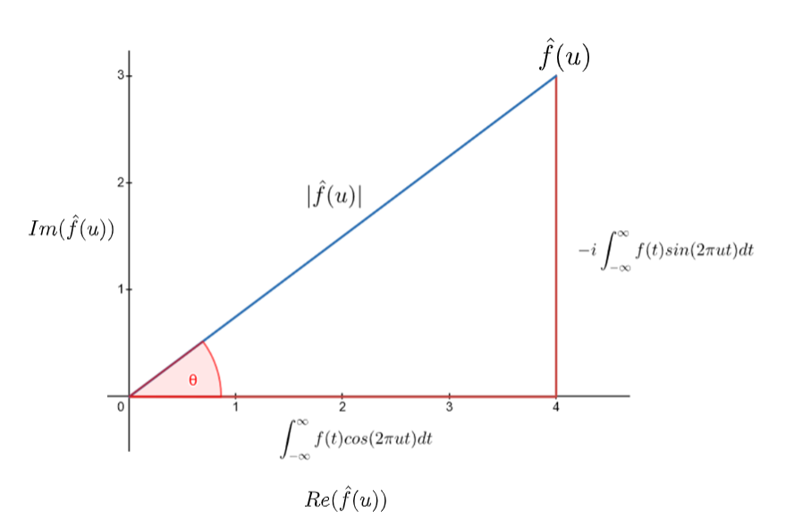
Figure 1. Complex number $\hat{f}(u)$ seen as a vector in the complex plane. The graph was made using GeoGebra.
As you can probably deduce, there also exists a phase spectrum associated with the FT. It is a plot of the angle of the phase (argument) as a function of the frequency. This shows how offset the given frequency is in the signal, usually in the interval $[-π, π]$. A phase of 0 means the frequency strictly follows a cosine wave, with a phase of $\frac{π}{2}$ indicating a sine wave.

What does the FT do?
The FT is useful when frequencies are involved. Any signal or function that repeats itself in a predictable way and with a constant period (like sound signals) are good candidates for the FT. In a nutshell, the Fourier Transform takes any oscillating, or periodic, function and extracts the frequencies that make it up. It does so by constructing another domain, called the frequency domain. For each value of the frequency axis $u$, the integrals are computed, and the magnitude of the complex number (called the amplitude) is graphed on the $y$ axis. In doing so, frequencies that match the function most give bigger amplitudes, as their corresponding sine and cosine waves, when multiplied with the signal and integrated, result in positive area.
However, I must admit that there is a problem with how I defined the FT. It is defined as taking the integral from $-∞$to $∞$. This is a problem because if the frequency matches the signal perfectly (only results in positive area), the integral blows up to infinity and $\hat{f}\left(ω\right)$ is not defined at that frequency. Recalling the definition from earlier:
$$\hat{f}\left(u\right) =\int_{-∞}^{∞}{f\left(t\right)\cos\left(2πut\right)dt}-i\int_{-∞}^{∞}{f\left(t\right)\sin\left(2πut\right)dt}$$
Suppose without loss of generalization that $f\left(t\right)=a\cos{2πbt}$, where $a$ is the amplitude and $b$ is the frequency of $f(t)$. At $u=b$:
$$Re(\hat{f}\left(u\right)) =\int_{-∞}^{∞}{a\cos{2πbt}\cos{2πbt}dt}$$
$$Re(\hat{f}\left(u\right)) =a\int_{-∞}^{∞}{\cos^{2}{2πbt}dt}$$
Because $\cos^{2}{t}$ is positive for its whole domain, its area under the curve is also always positive. If $f(t)$ was a sine wave, it would be $Im(\hat{f}\left(u\right))$ that would blow up to infinity instead. There are a couple ways I can fix this, two of which I will describe here.

Normalizing the amplitudes
The bigger the interval of the function $f(t)$ that is analysed, the bigger the amplitudes will be (by definition of the integral). A way to compensate for this fact is to divide the FT by the length of the interval. Thus, the normalised definition of the Fourier Transform is:
$$\hat{f}\left(u\right)=\frac{1}{b-a}\int_{a}^{b}{f\left(t\right)e^{-2πiut}}dt$$
Where [a, b] is finite. The drawback to this definition is that it’s only useful for finite intervals, giving an approximation of the FT. We can generalize this to account for and infinite interval by taking an improper integral, letting $a$ and $b$ go to $-∞$ and $∞$ respectively.
$$\lim_{\begin{aligned}a→-∞ \\ b→∞\end{aligned}}{ \frac{1}{b-a}\int_{a}^{b}{f\left(t\right)e^{-2πiut}}dt}$$

Restraining the definition only for Shwartz functions
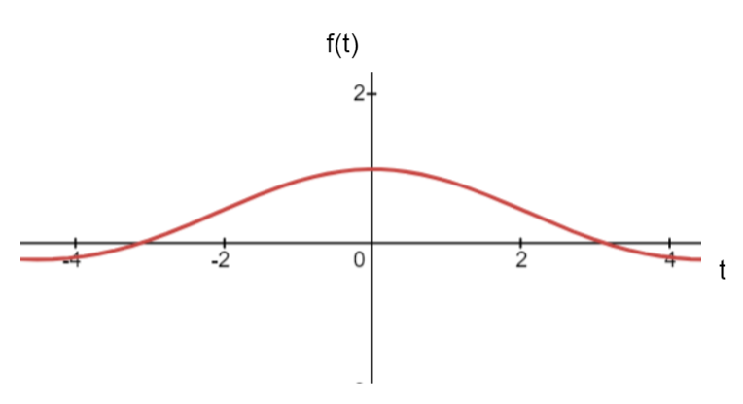
A Shwartz function is a type of function whose derivative converges to 0. By restraining the FT to Shwartz functions, we’re certain the improper integrals won’t diverge to infinity and stay bounded. The frequency domain will then be defined for each frequency $u$. An example of a periodic Shwartz function is $f\left(t\right)=\frac{\sin{t}}{t}$, whose value (and derivative) approach 0 as $x$ goes to $±∞$.
Figure 2. Graph of function $f\left(t\right)=\frac{\sin{t}}{t}$ made in Desmos.
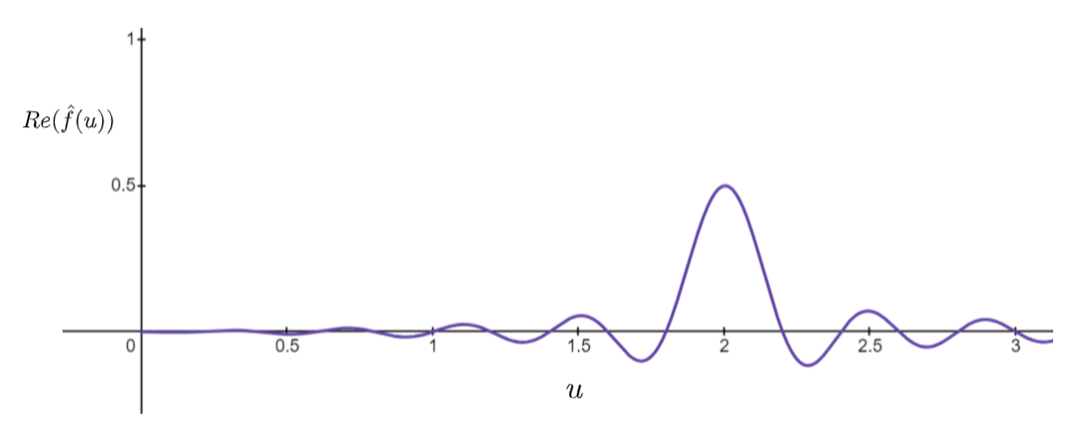
Here is the graph of $Re(\hat{f}\left(u\right))$ for $f\left(t\right)=\cos{2πt}$:
Figure 3. Graph of $Re(\hat{f}\left(u\right))$ for the function $f\left(t\right)=\cos{2πt}$ to highlight certain aspects. The graph was made in Desmos.
The function $f(t)$ matches best a cosine function with period 1, as shown by the global maximum at $u=1$ in Figure 3. The other local minima exist because the whole interval of $f(t)$ was not used, giving an approximation of the FT. The formula I used for computing $Re(\hat{f}\left(u\right))$ in Figure 3 is:
$$Re\left(\hat{f}\left(u\right)\right)=\frac{1}{5}\int_{0}^{5}{f\left(t\right)\cos{2πut}dt}$$
If a bigger interval was used (like $[0, 50]$ instead of $[0, 5]$), the other local maxima would approach 0. In this case, the cosine functions ($\cos{2πut}$) with periods close to 1 aren’t integrated over a big enough interval to completely destructively interfere with $f(t)$, resulting in a non-zero integral. The values of the amplitudes themselves will be analysed later.

How does the FT work?
I do not have the necessary knowledge to evaluate improper integrals. I will approximate the FT by taking samples of $f(t)$ with finite spacing $dt$ between them. This will allow me to construct a part of the frequency domain and tell me what the dominant frequencies are.
The Discrete Fourier Transform (DFT) is a practical application of the original FT. It is used for signals composed of finite samples, such as an audio file or image. It is a discrete version of the normalized definition of the FT. I will be using the DFT for the manual extracting of frequencies from a function.
The definition of the DFT is:
$$\hat{f}\left(u\right)=\frac{1}{N}\sum_{n=0}^{N-1}{f\left(t_{n}\right)e^{-2πi\frac{u}{N}n}}$$
Where:
- $N$ is the number of samples
- $\frac{u}{N}$ is the frequency step
- $t_{n}$is the t-value of the $n^{th}$ sample
Because the signal is discrete, the DFT has a limited resolution. More precisely, it can only measure the frequencies up to the one corresponding with the sampling rate (the previous definition assumes the interval of the function corresponds to its period). If the sampling rate is 44 100 Hz, then so is the top frequency that can be measured when transformed.

In its expanded form, this becomes:
$$\hat{f}\left(u\right)=\frac{1}{N}\sum_{n=0}^{N-1}{f\left(t_{n}\right)\cos\left(2π\frac{u}{N}n\right)}-i\frac{1}{N}\sum_{n=0}^{N-1}{f\left(t_{n}\right)sin(2π\frac{u}{N}n)}$$

Manual application of the DFT
I will now manually apply the DFT for the function $f\left(t\right)=\sin{2πt}$. I will try the frequencies $u∈\{0.5, 1.0, 1.5\}$. It is known that this function has a frequency of 1. I will use 10 samples of the original function equally spaced in the domain $[0, 1]$.
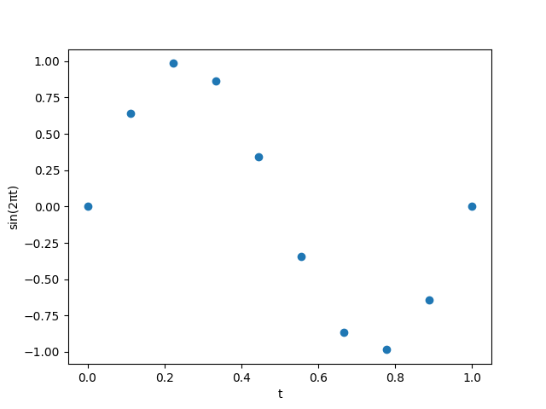
Figure 4. Graph of $f\left(t\right)=\sin{2πt}$ using the matplotlib library in Python.
t | sin(2πt)
0.00 | 0.00
0.11 | 0.64
0.22 | 0.98
0.33 | 0.87
0.44 | 0.34
0.56 | -0.34
0.67 | -0.87
0.78 | -0.98
0.89 | -0.64
1.00 | 0.00
Table 1. Samples of function $f\left(t\right)=\sin{2πt}$ corresponding to Figure 3.

For $u=0.5$:
For the first discrete sum (real part of $\hat{f}\left(u\right)$):
$$Re(\hat{f}\left(0.5\right))=\frac{1}{10}\sum_{n=0}^{9}{f\left(t_{n}\right)\cos\left(2π\frac{0.5}{10}n\right)}$$
$$=\frac{1}{10}(f\left(0\right)\cos{2π\frac{0.5}{10}}0+f\left(0.11\right)\cos{2π\frac{0.5}{10}}1+f\left(0.22\right)\cos{2π\frac{0.5}{10}}2+f\left(0.33\right)\cos{2π\frac{0.5}{10}}3+f\left(0.44\right)\cos{2π\frac{0.5}{10}}4+f\left(0.55\right)\cos{2π\frac{0.5}{10}}5+f\left(0.56\right)\cos{2π\frac{0.5}{10}}6+f\left(0.67\right)\cos{2π\frac{0.5}{10}}7+f\left(0.89\right)\cos{2π\frac{0.5}{10}}8+f\left(1\right)\cos{2π\frac{0.5}{10}}9)$$
$$=\frac{1}{10}(0.00+0.60+0.75+0.43+0.06+0.06+0.43+0.75+0.60+0.00)$$
$$=0.37$$
For the second discrete sum (imaginary part of $\hat{f}\left(u\right)$):
$$Im(\hat{f}\left(0.5\right))=\frac{1}{10}\sum_{n=0}^{9}{f\left(t_{n}\right)\sin\left(2π\frac{0.5}{10}n\right)}$$
$$=\frac{1}{10}(f\left(0\right)\sin{2π\frac{0.5}{10}}0+f\left(0.11\right)\sin{2π\frac{0.5}{10}}1+f\left(0.22\right)\sin{2π\frac{0.5}{10}}2+f\left(0.33\right)\sin{2π\frac{0.5}{10}}3+f\left(0.44\right)\sin{2π\frac{0.5}{10}}4+f\left(0.55\right)\sin{2π\frac{0.5}{10}}5+f\left(0.56\right)\sin{2π\frac{0.5}{10}}6+f\left(0.67\right)\sin{2π\frac{0.5}{10}}7+f\left(0.89\right)\sin{2π\frac{0.5}{10}}8+f\left(1\right)\sin{2π\frac{0.5}{10}}9)$$
$$=\frac{1}{10}(0.00+0.22+0.63+0.75+0.34-0.33-0.75-0.63-0.22-0.00)$$
$$=0.00$$
Grouping real and imaginary parts together:
$$\hat{f}\left(0.5\right)=0.37-0.00i$$
$$\left|\hat{f}\left(0.5\right)\right|=0.37$$
For $u=1$:
For the first discrete sum (real part of $\hat{f}\left(u\right)$):
$$Re(\hat{f}\left(1\right))=\frac{1}{10}\sum_{n=0}^{9}{f\left(t_{n}\right)\cos\left(2π\frac{1}{10}t_{n}\right)}$$
$$=\frac{1}{10}(f\left(0\right)\cos{2π\frac{1}{10}}0+f\left(0.11\right)\cos{2π\frac{1}{10}}1+f\left(0.22\right)\cos{2π\frac{1}{10}}2+f\left(0.33\right)\cos{2π\frac{1}{10}}3+f\left(0.44\right)\cos{2π\frac{1}{10}}4+f\left(0.55\right)\cos{2π\frac{1}{10}}5+f\left(0.56\right)\cos{2π\frac{1}{10}}6+f\left(0.67\right)\cos{2π\frac{1}{10}}7+f\left(0.89\right)\cos{2π\frac{1}{10}}8+f\left(1\right)\cos{2π\frac{1}{10}}9)$$
$$=\frac{1}{10}(0.00+0.49+0.17-0.43-0.32+0.32+0.43-0.17-0.49-0.00)$$
$$=0.00$$
For the second discrete sum (imaginary part of $\hat{f}\left(u\right)$):
$$Im(\hat{f}\left(1\right))=\frac{1}{10}\sum_{n=0}^{9}{f\left(t_{n}\right)\sin\left(2π\frac{1}{10}t_{n}\right)}$$
$$=\frac{1}{10}(f\left(0\right)\sin{2π\frac{1}{10}}0+f\left(0.11\right)\sin{2π\frac{1}{10}}1+f\left(0.22\right)\sin{2π\frac{1}{10}}2+f\left(0.33\right)\sin{2π\frac{1}{10}}3+f\left(0.44\right)\sin{2π\frac{1}{10}}4+f\left(0.55\right)\sin{2π\frac{1}{10}}5+f\left(0.56\right)\sin{2π\frac{1}{10}}6+f\left(0.67\right)\sin{2π\frac{1}{10}}7+f\left(0.89\right)\sin{2π\frac{1}{10}}8+f\left(1\right)\sin{2π\frac{1}{10}}9)$$
$$=\frac{1}{10}(0.00+0.41+0.97+0.75+0.12+0.12+0.75+0.97+0.41+0.00)$$
$$=0.45$$
Grouping real and imaginary parts together:
$$\hat{f}\left(1\right)=0.00+0.45i$$
$$\left|\hat{f}\left(1\right)\right|=0.45$$
For $u=1.5$:
For the first discrete sum (real part of $\hat{f}\left(u\right)$):
$$Re(\hat{f}\left(1.5\right))=\frac{1}{10}\sum_{n=0}^{9}{f\left(t_{n}\right)\cos\left(2π\frac{1.5}{10}t_{n}\right)}$$
$$=\frac{1}{10}(f\left(0\right)\cos{2π\frac{1.5}{10}}0+f\left(0.11\right)\cos{2π\frac{1.5}{10}}1+f\left(0.22\right)\cos{2π\frac{1.5}{10}}2+f\left(0.33\right)\cos{2π\frac{1.5}{10}}3+f\left(0.44\right)\cos{2π\frac{1.5}{10}}4+f\left(0.55\right)\cos{2π\frac{1.5}{10}}5+f\left(0.56\right)\cos{2π\frac{1.5}{10}}6+f\left(0.67\right)\cos{2π\frac{1.5}{10}}7+f\left(0.89\right)\cos{2π\frac{1.5}{10}}8+f\left(1\right)\cos{2π\frac{1.5}{10}}9)$$
$$=\frac{1}{10}(0.00+0.32-0.49-0.87-0.17-0.17-0.87-0.49+0.32+0.00)$$
$$=-0.24$$
For the second discrete sum (imaginary part of $\hat{f}\left(u\right)$):
$$Im(\hat{f}\left(1\right))=\frac{1}{10}\sum_{n=0}^{9}{f\left(t_{n}\right)\sin\left(2π\frac{1}{10}t_{n}\right)}$$
$$=\frac{1}{10}(f\left(0\right)\sin{2π\frac{1.5}{10}}0+f\left(0.11\right)\sin{2π\frac{1.5}{10}}1+f\left(0.22\right)\sin{2π\frac{1.5}{10}}2+f\left(0.33\right)\sin{2π\frac{1.5}{10}}3+f\left(0.44\right)\sin{2π\frac{1.5}{10}}4+f\left(0.55\right)\sin{2π\frac{1.5}{10}}5+f\left(0.56\right)\sin{2π\frac{1.5}{10}}6+f\left(0.67\right)\sin{2π\frac{1.5}{10}}7+f\left(0.89\right)\sin{2π\frac{1.5}{10}}8+f\left(1\right)\sin{2π\frac{1.5}{10}}9)$$
$$=0.00+0.56+0.85+0.00-0.30+0.30+0.00-0.85-0.56-0.00$$
$$=0.00$$
Grouping them together:
$$\hat{f}\left(1\right)=-0.24+0.00i$$
$$\left|\hat{f}\left(1\right)\right|=0.24$$
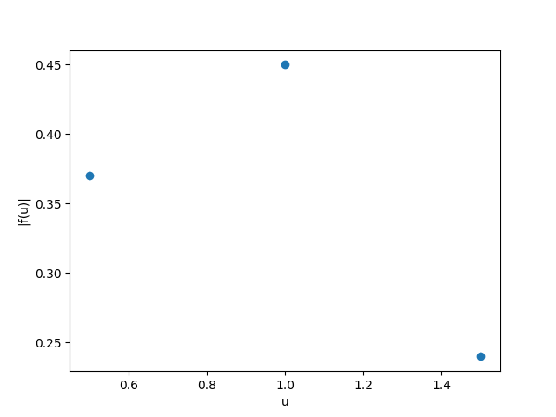
Here’s the resulting plot of the three frequencies and their resulting amplitudes:
Figure 5. Graph of $\left|\hat{f}\left(u\right)\right|$ as a function of $u$ for $u∈\{0.5, 1.0, 1.5\}$. The graph was made using matplotlib.
The highest amplitude was observed at $u=1.0$, corresponding with the frequency of $f(t)$. However, we can see the frequencies at $u=0.5$ and $u=1.0$ are not 0. Does that mean that they’re present in $f(t)$? No, they are just a consequence of approximation. If I took closer samples and a bigger interval to analyze, all frequencies except $u=1.0$ would tend towards 0.
What’s interesting is what $\left|\hat{f}\left(u\right)\right|$ represents. There is a link between $\left|\hat{f}\left(u\right)\right|$ at $u=1.0$ and the “real” amplitude in $f(t)$; in this case, the real amplitude is 1. If we do a better approximation, we find out that $\left|\hat{f}\left(u\right)\right|$ approaches 0.5, or half of the real amplitude. Why? Well, when we multiply $f(t)$ with a sine wave of frequency 1, it is the same thing as doing $f{\left(t\right)}^{2}$, because $f(t)$ is itself a sine wave of frequency 1. Taking the integral, $∫\sin^{2}{2πt}dt=\frac{t}{2}-\frac{\sin{4πt}}{8π}$. It just so happens that the second term ($\frac{\sin{4πt}}{8π}$) is 0 for the interval $[a, b]$ that I chose, simplifying to $\frac{b-a}{2}=\frac{1-0}{2}=0.5$. To generalize, $α≈2\left|\hat{f}\left(u\right)\right|$ (and $α=2\left|\hat{f}\left(u\right)\right|$ if $\sin{4πt}=0 ∀ t∈\{a, b\}$), where $α$ is the “real” amplitude of $f(t)$.

The FFT: an efficient algorithm for computing the DFT
At first glance, we would be easily led to use the DFT’s definition for the making of the program. However, directly implementing the DFT by its definition, meaning multiplying each sample of our signal with a sinusoid of a given frequency and then summing them up, would result in a time complexity of $O\left(n^{2}\right)$, meaning $t ∝ n^{2}$, where $t$is the time taken to calculate the DFT and $n$ is the number of samples in the signal. But we can do better. The Fast Fourier Transform is an optimized algorithm that performs a DFT in $O\left(n\log{n}\right)$ time by “factorizing the DFT matrix into a product of sparse (mostly zero) factors.” This is a huge time save, especially for bigger values of $n$. The intricacies of the FFT’s inner workings will not be explained in this exploration. Nevertheless, I will be using the FFT algorithm to write the program in the next section.

Implementing the DFT in Python
Finally, I will now analyze a sound recording with the DFT to extract the signal’s frequencies. I will be using a couple libraries to achieve this, such as tkinter and soundfile to read the file and extract the frequencies, along with numpy and matplotlib to display the signal and the DFT.
Every musical note corresponds to a specific frequency. A chord is composed of two or more notes played at the same time. It is very hard for a human to identify these notes just by listening to the chord unless they have perfect pitch. However, for a computer, it is incredibly easy with the right tools.
I must first define a couple variables to help in computing the DFT, such as the length of the signal to transform, the time step between samples ($dT$) and the sample rate. I chose to analyze 0.3 seconds as I saw that works best. The sample rate is 44 100 Hz. A shorter duration wouldn’t have enough samples and a longer one will “dilute” the frequencies as the piano chord gets quieter. I will also extract the first channel from the audio file as that will be our signal. I’ll then compute the FFT using numpy’s built-in function and store the axes’ values in two lists, one for the frequencies and one for the corresponding magnitudes. As the FFT function returns a two-dimensional complex number, I will pass it to np.abs() to compute its modulus (distance from the origin). I normalized the DFT’s magnitudes so that the most present frequency (biggest spike) has a magnitude of 1. Finally, I will plot the graphs. All the source code can be found at my GitHub repository or in Appendix 2.

Testing the program
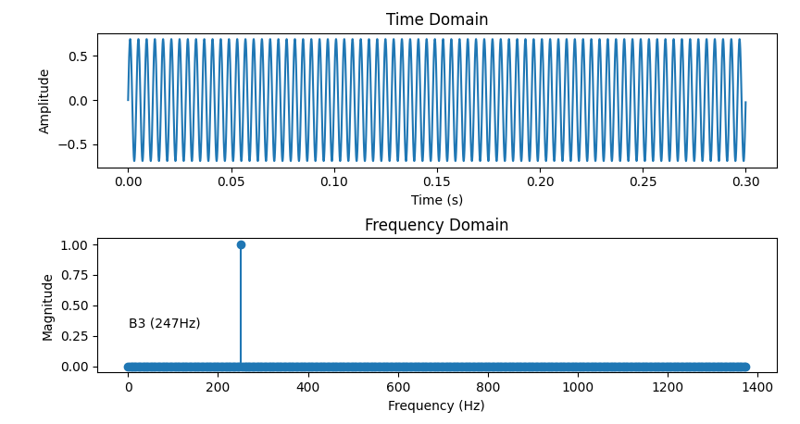
Before I test the sound recording, let’s start with a simple 250Hz sound wave. The file is called 250.wav. I will read 0.1s from it. Here are the plots:
Figure 6. Graphs of the 250 Hz signal over time and its corresponding DFT. The graph was made using matplotlib.
The DFT works! We only see one big spike at $u=250$ and close to 0 everywhere else. The program thinks the note is B3 because its frequency is very close to 250Hz.

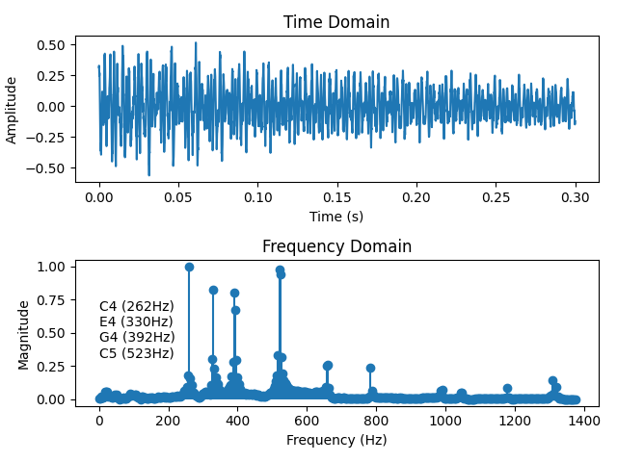
Let’s give it something a bit more difficult: a recording of the C major chord played on piano. The file is called C_maj.wav. I will read 0.3s from it. Here are the plots:
Figure 7. Graphs of the C major chord recording over time and its corresponding DFT. The graph was made using matplotlib.
The program correctly identified all the notes in a C major chord. For the same reasons mentioned before, this is only an approximation (a very good one at that). It is why we see that there are other smaller spikes (frequencies) that appear in the graph and which shouldn’t be there. This can be explained by the fact that the microphone might have picked up other noises from the environment along with the chord.

Conclusion
The goal of this exploration was to analyze a sound recording of a piano coord with the Fourier Transform to extract its frequencies, which can then be mapped to specific music notes. I achieved this by first defining the FT and explaining its purpose and its inner workings. The Fourier Transform is a beautiful yet powerful mathematical tool that ties together three different domains in math: trigonometry, integral calculus, and complex numbers. The constructive/destructive interference properties of trigonometric functions, along with integrals, are used to filter out specific frequencies from a given function. Complex numbers then encode the type of trigonometric functions that are constituents of the signal (sin vs. cos) along with how horizontally shifted they are from the origin (phase). I then built a discrete version of the FT, the DFT; a tool which I used to manually test three frequencies on the function $f\left(t\right)=\sin{2πt}$. As this was an approximation, the results were not infinitely precise. I explained why that is the case and how that affects my results. Finally, I constructed a program in Python to apply the DFT to a sound recording of a piano coord, achieving the goal of this exploration. The program correctly found the frequencies corresponding to the notes C4, E4, G4 and C5.
This exploration made me really understand why the FT works the way it does and made me see complex numbers not as simple numbers, but as a creative way to encode trigonometry; after all, they’re both related. I also understood the little details that are often glossed over or seem random, such as the fact that the amplitude ($α$) of $f(t)$ is almost exactly twice the magnitude of $|\hat{f}\left(u\right)|$. I expanded my Python knowledge by learning to manipulate and analyze data programmatically. I think that I’ve laid out a clear understanding of the topic and have clearly defined the tools that I used in this exploration. I believe that the approach I used was the only one that permitted me to achieve my goal. I do not see any other reliable way of identifying musical notes from a sound recording. However, I think that manually applying the DFT was unnecessary as it took up too much of the limited space that I had, which could have been used to expand on some important explanations or introduce new ideas. I did not talk about the Dirac delta function as I judged that it requires too much context to set up and is not that pertinent for the goal of the exploration.
The FT can only be used to analyze a specific family of functions: periodic ones. When applying the DFT, one must make sure that they have enough samples for the range of frequencies to analyze, or else they can get false positives as the resolution of the frequency domain (how far apart the samples are) is too low. The biggest frequency to test should be at most half of the sampling frequency (see Shannon’s theorem).
Beyond this exploration, the Fourier Transform can be used to solve a plethora of different problems. For example, one might use it to study earthquakes to help civil engineers make infrastructure that doesn’t have the same resonating frequencies as the ones found in the earthquakes. This can be especially useful in geographical locations prone to tectonic plates displacements, such as Japan or Hawaii. A continuation for this exploration would be exploring the inverse Fourier Transform, another integral transform whose behaviour is exactly opposite that of the FT: it takes the frequency domain as input and returns the original function $f(t)$. The Fourier Transform along with its inverse then unlocks the ability to modify a signal (ex. removing low or high frequencies). Another continuation for this exploration would be analyzing musical instruments’ frequency footprints. Each instrument’s frequency domain looks slightly different, even if the same notes are being played. This difference can be used to identify the instrument just by hearing it.

I confirm that this work is my own and that this is the final version. I flagged all borrowed ideas or sayings, whether they were originally written, spoken or seen.

Bibliography
3Blue1Brown. “But What Is the Fourier Transform? a Visual Introduction.” YouTube, 26 Jan. 2018, www.youtube.com/watch?v=spUNpyF58BY.
Alex Becker (www.fourier-transform.com). Online Fourier Transform Tutorial [Internet]. Available from: https://www.fourier-transform.com/nyquist.html
App DP. Digital Piano App [Internet]. Digital Piano App. Available from: https://digitalpiano.app/
Deakin, M.A.B. Euler's invention of integral transforms. Arch. Hist. Exact Sci. 33, 307–319 (1985). Available from: https://doi.org/10.1007/BF00348586
Dutu. GitHub - Dutu2019/explomath [Internet]. GitHub. Available from: https://github.com/Dutu2019/explomath
Fourier Transforms. Ian N. Sneddon, 2019.
Integrate[Power[sin(2*pi*x),2],x] - Wolfram|Alpha [Internet]. Available from: https://www.wolframalpha.com/input?i2d=true&i=Integrate%5BPower%5Bsin%5C%2840%292*pi*x%5C%2841%29%2C2%5D%2Cx%5D
McCoy, Ryan. “Exploring Image Compression with Fourier and Wavelet Transformations Using Python.” Medium, 20 Oct. 2023, medium.com/@ryanwmccoy/exploring-image-compression-with-fourier-and-wavelet-transformations-using-python-0b3c15a72703.
MichaelCZE. GitHub - MichaelCZE/Python-Piano: Virtual keyboard made in Python [Internet]. GitHub. Available from: https://github.com/MichaelCZE/Python-Piano/
Naismith Sneddon I. Fourier transforms. 1995.
Sammy. Music note to frequency chart [Internet]. MixButton. 2024. Available from: https://mixbutton.com/mixing-articles/music-note-to-frequency-chart/
Van Loan C. Computational frameworks for the fast fourier transform [Internet]. 1992. Available from: https://doi.org/10.1137/1.9781611970999
Wikipedia contributors. Schwartz space [Internet]. Wikipedia. 2025. Available from: https://en.wikipedia.org/wiki/Schwartz_space
Zach Star. The intuition behind Fourier and Laplace transforms I was never taught in school [Internet]. YouTube. 2019. Available from: https://www.youtube.com/watch?v=3gjJDuCAEQQ

Appendix 1
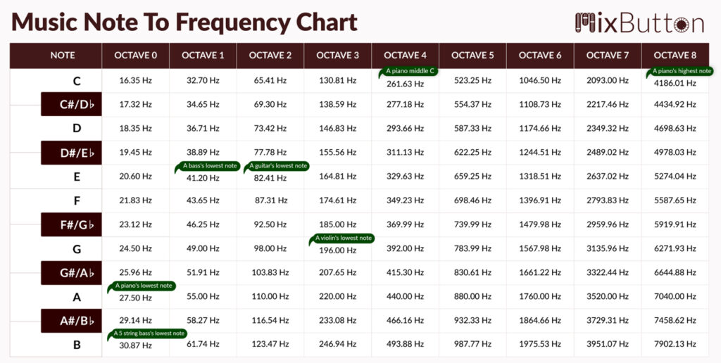
Table 1. Music notes to frequency chart

Appendix 2

I’m using the abbreviation FT to refer to a Fourier transform in the goal of shortening the text length.
I’m using the abbreviation IT to refer to an integral transform in the goal of shortening the text length.
Deakin, M.A.B. Euler's invention of integral transforms. Arch. Hist. Exact Sci. 33, 307–319 (1985). https://doi.org/10.1007/BF00348586
Van Loan C. Computational frameworks for the fast fourier transform [Internet]. 1992. Available from: https://doi.org/10.1137/1.9781611970999
See Appendix 1
Dutu. GitHub - Dutu2019/explomath [Internet]. GitHub. Available from: https://github.com/Dutu2019/explomath
Alex Becker (www.fourier-transform.com). Online Fourier Transform Tutorial [Internet]. Available from: https://www.fourier-transform.com/nyquist.html

