Table of Contents

One Edu — Hosting & Infrastructure Architecture

Board Briefing · Cloud Hosting Design

Document | Hosting & Infrastructure Architecture
Product | One Edu — Education Super App
Prepared for | Board of Directors
Classification | Internal / Confidential
Version | 1.0
Date | June 2026
Cloud platform | Microsoft Azure
Primary region | UK South (UK West for DR)
Status | For board review

Document Revision History
Version | Date | Author | Summary of change
0.9 | June 2026 | Architecture Team | Internal draft for review.
1.0 | June 2026 | Architecture Team | Initial board release — single-region & multi-region designs, component briefs, security & governance briefing.

1. Executive Summary
One Edu will be hosted on Microsoft Azure as a secure, compliant, multi-tenant SaaS platform. The design is deliberately phased to control cost and risk:
- Launch (Phase 1): a single Azure region hosting the first institution, built on managed Azure App Service and Azure SQL Database — a lean, production-grade footprint with high availability.
- Scale (future): the same blueprint is replicated into additional geographic regions, giving each country its own data boundary. This proves the platform is expansion-ready without re-architecture.
Two architectures are presented separately in this document:
- Single-Region (Single-Tenant) Architecture — the day-one production environment (Section 5).
- Multi-Region (Multi-Tenant) Architecture — the target operating model as the platform grows internationally (Section 6).
The estimated monthly hosting + tooling cost (excluding staff) for the launch environment is summarised in Section 9 and detailed in the companion workbook CostEstimate-OneEdu-Board.xlsx.

2. Purpose & Scope
Purpose. To give the Board a clear, non-exhaustive view of how One Edu is hosted, why each major component exists, and how the design satisfies security, data-protection, availability and growth requirements.
In scope: cloud hosting topology, core platform services, environments, security & compliance posture, high-availability & disaster recovery, and the expansion model.
Out of scope: application feature design (covered by the SRS), detailed network IP plans, and day-rate / staffing costs.

3. Architecture Principles
# | Principle | What it means in practice
P1 | Managed-first | Prefer Azure platform (PaaS) services over self-managed servers — less to patch, operate and secure.
P2 | Secure & compliant by design | Tenant isolation, encryption, and data-residency are built in from day one, not added later.
P3 | Phased investment | Pay for capability as modules go live; avoid over-provisioning at launch.
P4 | Expansion-ready | One regional blueprint, stamped per country — growth needs no redesign.
P5 | High availability | No single point of failure for production; automated recovery.
P6 | One core technology set | Standardise on Azure App Service + Azure SQL to keep the team’s operating skills focused.

4. Solution Overview
One Edu is delivered through native mobile apps (iOS/Android) and a responsive web app, all served from a hardened Azure environment. Traffic enters through a global edge with a Web Application Firewall, is processed by the application tier, and reads/writes a securely isolated data tier. Supporting services provide identity, notifications, AI, monitoring and security.
The platform is organised into a Phase 1 (launch) core and a Phase 2 (growth) set of services that are switched on as the corresponding product modules are released.

5. Single-Region (Single-Tenant) Architecture
This is the day-one production environment — one Azure region hosting the first institution (~5,000 students).

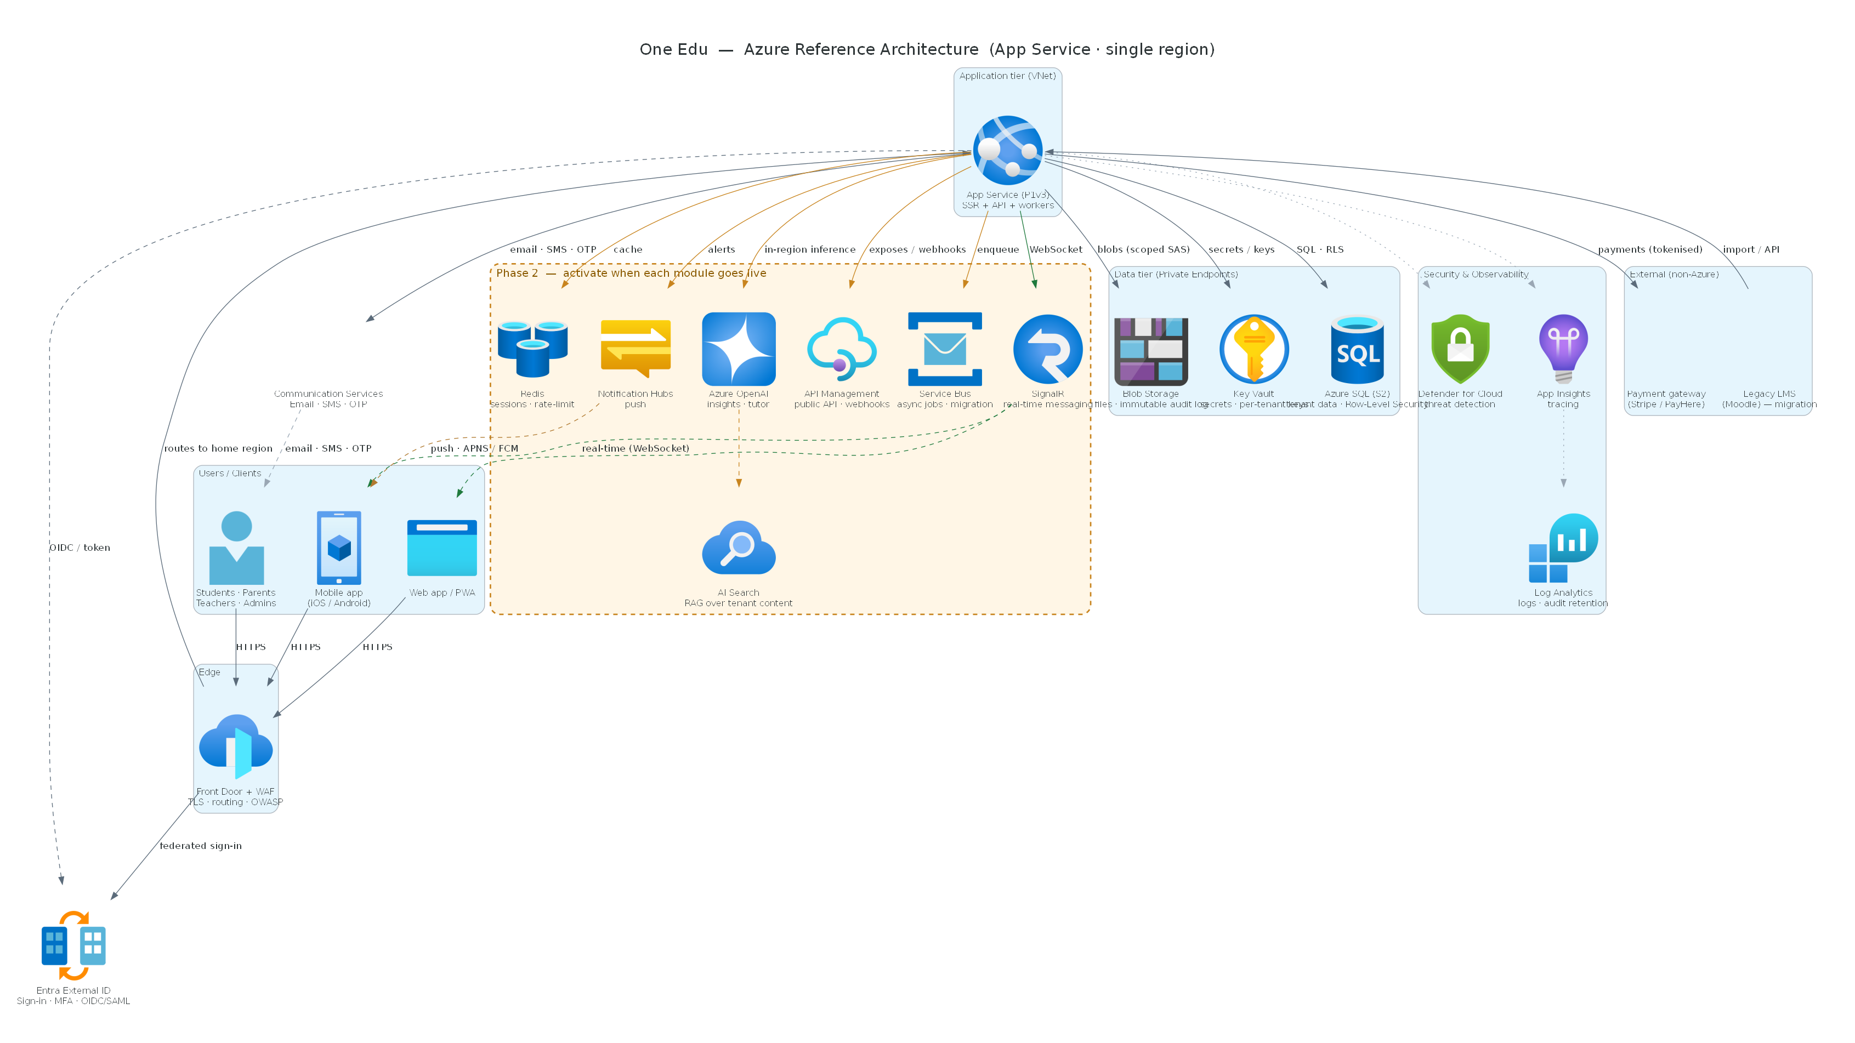
Single-region hosting architecture for One Edu
Figure 1 — Single-region architecture. Services inside the amber zone are Phase 2 (activated as each module goes live); everything else is the Phase 1 launch.

5.1 How it works (request flow)
- Users on the mobile app or web app connect over HTTPS to Azure Front Door, which terminates TLS and applies the Web Application Firewall.
- Front Door routes to Azure App Service, which runs the application (server-rendered UI + API).
- The app authenticates users via Microsoft Entra External ID (sign-in + multi-factor authentication).
- The app reads and writes the data tier over private connections: Azure SQL (tenant data, with Row-Level Security), Blob Storage (files + immutable audit log) and Key Vault (secrets and encryption keys).
- Communication Services sends email/SMS/OTP; App Insights / Log Analytics and Defender for Cloud provide monitoring and threat detection.
- As modules launch, the Phase 2 services (real-time messaging, caching, async jobs, push notifications, AI) are enabled and the app pushes updates back to devices (push via APNS/FCM, live updates via WebSocket).

5.2 Component briefs — Phase 1 (launch)
Component | Azure service | Role / why it’s here
Edge & firewall | Azure Front Door + WAF | Single secure entry point; TLS, global routing, blocks common web attacks (OWASP).
Application tier | Azure App Service (Premium v3) | Runs the web/API workload; auto-scales; zone-redundant for HA.
Identity | Microsoft Entra External ID | Customer sign-in, social/SSO federation, and enforced MFA for staff/admins.
Primary database | Azure SQL Database | Stores all institution data; Row-Level Security keeps tenants isolated; built-in HA.
File storage | Azure Blob Storage | Documents/media; a write-once container holds the tamper-evident audit log.
Secrets & keys | Azure Key Vault | Central, encrypted store for secrets and per-tenant encryption keys.
Messaging | Azure Communication Services | Email, SMS and one-time passcodes (e.g. enrolment confirmations).
Monitoring | App Insights + Log Analytics | End-to-end tracing, dashboards, alerting, and long-term audit retention.
Security posture | Microsoft Defender for Cloud | Continuous threat detection across app, database and storage.
Backup | Azure SQL PITR | Automated point-in-time recovery.

5.3 Component briefs — Phase 2 (activated as modules launch)
Component | Azure service | Activated for
Real-time messaging | SignalR / Web PubSub | In-app chat and live updates.
Cache | Azure Cache for Redis | Sessions and rate-limiting at scale.
Async jobs / events | Azure Service Bus | Background processing and data migration (e.g. from Moodle).
Mobile push | Azure Notification Hubs | Push notifications to iOS/Android (via APNS/FCM).
AI | Azure OpenAI + AI Search | In-region AI insights and tutor (retrieval over the institution’s own content).
Public/partner API | Azure API Management | Versioned external API, webhooks, rate-limiting.
Network hardening | Private Endpoints + NAT | Private-only data tier for the strictest compliance posture.

5.4 External services (not Azure)
Service | Purpose
Payment gateway (Stripe / PayHere) | Card capture & PCI-DSS scope; One Edu never stores card data.
Legacy LMS (Moodle) | Source system for data migration into One Edu.
Apple / Google app stores | Distribution of the native mobile apps.

6. Multi-Region (Multi-Tenant) Architecture — Expansion Model
As One Edu grows into new countries, the same regional blueprint is replicated per geography. This is the target operating model and demonstrates expansion readiness to investors and regulators.

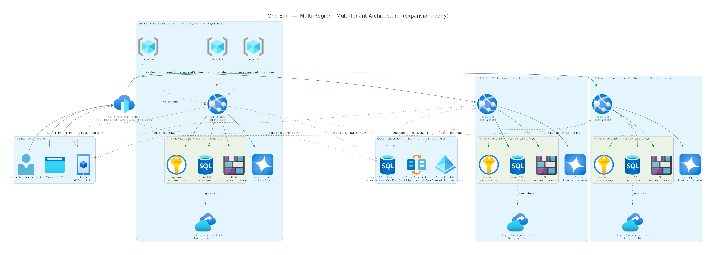
Multi-region, multi-tenant hosting architecture for One Edu
Figure 2 — Multi-region, multi-tenant architecture. Each geo-region is a self-contained data boundary; a small global control plane (non-PII only) routes tenants and manages cross-region identity.

6.1 Key concepts
- Global front door & routing. A single global Azure Front Door receives all users and routes each institution (tenant) to its home region.
- Global control plane (non-PII only). A small Azure SQL global registry holds only non-personal metadata — which tenant lives in which region, the platform-wide student identifier (“One Edu ID”), and billing. No student personal data is stored globally. Global identity (Entra External ID) and platform-admin access (with just-in-time elevation) also sit here.
- Self-contained regional stacks. Each region (e.g. UK, EU, APAC) runs the full Phase 1/2 stack — App Service, Azure SQL, Blob, Key Vault, AI — and keeps all personal data inside that region.
- Tenant isolation. Within each region, multiple institutions share the stack but are strictly isolated (Row-Level Security + per-tenant keys). One institution can never see another’s data.
- Disaster recovery. Each region has a paired DR region within the same legal jurisdiction (e.g. UK South ↔ UK West).

6.2 Why this matters to the Board
Benefit | Explanation
Data residency / legal compliance | Each country’s data stays in-country — meeting GDPR, UK GDPR, and equivalent laws.
Trust & sales | Institutions and regulators can be shown exactly where their data lives.
Scalability | New markets are entered by stamping the blueprint — no rebuild.
Resilience | A regional incident is contained; other regions are unaffected.
Controlled cost | Most shared services are amortised across tenants, so per-tenant cost falls as the platform grows.
Note: the global registry uses Azure SQL (consistent with the rest of the estate). A globally-distributed database (e.g. Cosmos DB) would only be considered if very high multi-region write throughput is needed in future — it is not required at launch or early growth.

7. Security & Governance / Compliance
Security and data-protection are engineered into the hosting platform, not added afterwards. One Edu processes the personal data of children across multiple jurisdictions, so the design assumes the highest bar. This section briefs how the components deliver security (defence-in-depth) and governance (GDPR-class compliance).

7.1 Security — defence in depth, layer by layer
Every request passes through multiple independent controls, so no single failure exposes data.
Layer | Control | Delivered by
Edge | TLS encryption, Web Application Firewall (OWASP rules), volumetric (DDoS) protection | Azure Front Door + WAF
Identity | Multi-factor authentication for staff/admins, federated SSO, conditional access; just-in-time (“break-glass”) privileged access | Microsoft Entra External ID + PIM
Application | Server-side authorisation (role-based), input validation, per-module entitlement enforcement | Azure App Service
Data — isolation | Per-tenant Row-Level Security; no query path can return another tenant’s rows | Azure SQL Database
Data — encryption | TLS in transit; AES-256 at rest; sensitive fields encrypted with per-tenant keys | Azure SQL + Blob Storage + Key Vault
Secrets | No credentials in code; centralised, access-controlled, automatically rotated | Azure Key Vault
Network | Private-only data tier — no public database endpoint (Phase 2 hardening) | Private Endpoints + Virtual Network
Detection & response | Threat detection, anomalous-access alerts, vulnerability findings | Microsoft Defender for Cloud
Assurance | Independent penetration test before launch; OWASP Top 10 clearance each release | Process / gate

7.2 Governance & data-protection compliance (GDPR-class)
Each regulatory obligation is mapped to the hosting components that satisfy it — so compliance is demonstrable, not aspirational.
Obligation (GDPR-class) | How the platform meets it | Component(s)
Data residency — keep data in-country | A tenant’s personal data lives only in its geo-region; the global plane holds non-PII metadata only | Per-region stacks; Azure SQL global registry (non-PII)
Confidentiality / tenant isolation | Row-Level Security + per-tenant encryption keys make cross-tenant access impossible | Azure SQL, Key Vault
Audit & accountability | Tamper-evident, write-once log of security-significant events (logins, exports, admin changes) | Blob (immutable container) + Log Analytics
Data-subject rights (access / erasure / portability) | Records assembled across all modules for a subject; export and erasure workflows with lawful-retention overrides | App Service + Azure SQL / Blob
Lawful basis & consent | Consent and legal basis recorded per processing activity; withdrawal triggers downstream workflows | Application data model
Retention & minimisation | Automated purge of records past their retention period; statutory floors enforced | Scheduled jobs + Azure SQL
High-risk processing (DPIA) | Biometric/AI features are blocked until an approved Data Protection Impact Assessment exists | Application governance module
Breach response | Anomaly detection → containment → templated regulator / data-subject notification within the statutory window (e.g. 72h) | Defender for Cloud + process
Transparency | Per-tenant data-residency attestation; AI usage notice to guardians | Control plane + application
Children’s data | Maximum-privacy defaults, guardian (or adult-student) consent, no harmful profiling | Application + identity

7.3 Standards & frameworks
The platform is designed to support, per geo-region: EU GDPR, UK GDPR & DPA 2018, FERPA, COPPA, PIPEDA, India DPDP, PDPA (Sri Lanka / Singapore / Thailand) and UAE PDPL, plus UK safeguarding guidance (KCSIE) and the ICO Children’s Code. Targeted platform certifications: ISO 27001 and SOC 2 Type II (and Cyber Essentials Plus for the UK).
In one line for the Board: data is encrypted, isolated per institution, kept in its own country, fully audited, and every privacy right (access, erasure, consent, breach notification) is supported by a specific component — making One Edu demonstrably compliant, not just compliant on paper.

8. Availability, DR, Scalability & Operations
Aspect | Design
High availability | App Service runs ≥2 zone-redundant instances; Azure SQL has built-in in-region HA (99.99%).
Disaster recovery | DR region within the same jurisdiction; SQL geo-restore; recovery objectives RTO ≤ 15 min / RPO ≤ 5 min.
Backups | Automated point-in-time recovery (up to 35 days).
Scalability | App Service auto-scales; database scales by tier/serverless; architecture supports thousands of tenants.
Observability | Structured logging, distributed tracing, dashboards and alerting (App Insights / Log Analytics / Grafana).
Environments | DEV, UAT and PROD (Section 9).

9. Environments & Indicative Cost
Three environments are maintained, sized to the lowest viable SKUs to control cost. DEV mirrors UAT on the application + database tiers for parity.
Environment | Purpose | Indicative monthly (USD)
DEV | Active development | ~$103
UAT | Testing / client demos | ~$169
PROD (with HA) | Live institution | ~$672
Development tools & SaaS | Team of 5 (incl. Claude, Azure DevOps, app-store licences) | ~$150
Initial monthly run (excl. manpower) |  | ≈ $1,094
Phase 2 add-ons (on activation) |  | + ~$565
Full breakdown, assumptions and GBP figures are in the companion workbook CostEstimate-OneEdu-Board.xlsx. Figures exclude staff costs and variable payment-gateway fees.

10. Delivery Roadmap (Phasing)
Phase | Scope | Hosting impact
Phase 1 — Launch | First institution, single region, core modules | App Service + Azure SQL + edge/security/monitoring (~$1,094/mo all-in).
Phase 2 — Module growth | Real-time, AI, public API, push, hardening | Activate the amber-zone services as each module ships (~$565/mo).
Phase 3 — Geographic expansion | New countries/regions | Replicate the regional blueprint; add the global control plane.

11. Assumptions & Risks
Assumptions - Single institution (~5,000 users) at launch; UK South region; Windows on App Service. - Email handled by a separate provider; payment handled by a PCI-DSS-certified gateway. - Costs are list-price estimates; final figures via Azure Pricing Calculator and vendor quotes.
Key risks & mitigations - Demand growth beyond sizing → tiers scale on demand; reserved-instance pricing reduces cost. - Regulatory change per market → per-region data boundaries and configurable compliance profile. - Third-party dependency (payments, push) → standards-based integrations; replaceable providers.

12. Glossary
Term | Meaning
PaaS | Platform-as-a-Service — managed cloud services (less to operate than servers).
WAF | Web Application Firewall — blocks common web attacks.
HA / DR | High Availability / Disaster Recovery.
RTO / RPO | Recovery Time / Point Objective — max acceptable downtime / data loss.
Tenant | A single subscribing institution and its isolated data.
Row-Level Security (RLS) | Database feature enforcing that each tenant sees only its own rows.
Geo-region | A compliance/data-residency boundary mapping to Azure regions.
One Edu ID | Platform-wide unique student identifier, consistent across institutions.
MFA | Multi-Factor Authentication.
PITR | Point-In-Time Recovery (database restore).

Prepared for board review. Diagrams are available at full resolution in the project’s docs/images/ folder; detailed costs in CostEstimate-OneEdu-Board.xlsx.

