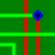 FreePcb
Development branch by Duxah ® 2014-2019.

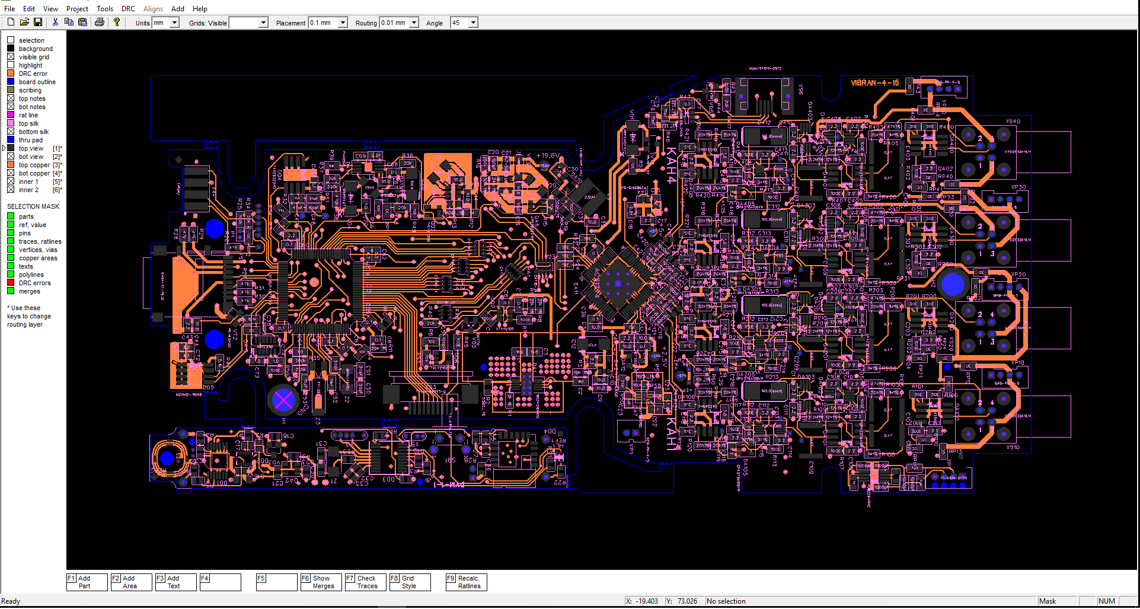


1 English

Download FreePcb Watch video Ask a Question Home

FreePcb is a program for designing printed circuit boards for Microsoft Windows. The FreePcb-2.000 and above program presented on this site is an upgrade of version 1.359 published in 2010. Now FreePcb has made great strides in comparison with the 2010 version and is suitable for both simple and large-scale developments, although the appearance of the program has remained unchanged. Includes footprint editor, provides the ability to create your own libraries, can import external netlists in the PADS-PCB format. The program is focused on accessibility, ease of use, saving computer hard disk memory, but at the same time it includes almost all the tools necessary for professional use. Supports the preservation of REF-names of parts when paneling printed circuit boards. A distinctive feature of this program is the interface with the use of function keys.
Improvements and new features:
- Improved graphical display of selected objects
- Improved detailing frame
- free rotation of parts
- moving the group to the opposite side
- set of zero coordinate on any object(menu TOOLS)
- merge a group of parts into one object
- alignment of parts
- alignment of traces
- alignment of mergers
- Improved work with polygons
- the ability to set a specified gap between any lines (set_clearance)
- preparation of the code for the introduction of micro transition holes
- possibility of rounding corners of traces
- possibility of adding smooth transition holes
- changing some parameters at once
- combining several footprints into one directly in PCB editing mode
- the ability to organize libraries alphabetically, by the number of pins or by the number of holes
- external program INFOBOX.EXE knows how to find parts on a printed circuit board
- in freepcb, you can not fill copper polygons. gaps are drawn automatically when creating the Gerber files, but sometimes you need to fill it. External program AREA_SPLITTER.EXE fills polygons
- export to mechanical format dxf
- import from dxf
- import pictures from bmp
- Export to commercial PCAD (ACCEL ASCII)
- Import PCAD( ACCEL ASCII )
(2014-2017)

Version 2-019 (2018-02-20):
- The function of automatic selection of parallel segments for quick editing is added
- AREA_SPLITTER.EXE and INFOBOX.EXE improved, show pins
Version 2-020 (2018-05-01):
- added 3 new layers: 2 for notes, scribing
- when moving the origin in the footprint the position of the part on the board remains
- when selecting a detail pin, the network is also highlighted
- in export DXF_3dFaces drawing of pads by solid
- in InfoBox when clicking on a cell in the column "Net in PCB" on the left all pins of this net are displayed
- in InfoBox when clicking on a cell in the "Pin" column on the right all pins of this detail are displayed
- Select/Unselect
Version 2-021 (2018-06-01):
- in the InfoBox column is added the range of indexes of notation details
- added the SET ORIGIN TO SELECTED ITEM function in the TOOLS menu
- 2 grid styles: points and lines
- Improved auto-refs (REF-AUTO-POS)
- added the SHOW_MERGES (F6) button to find the merge on the board, selection several mergers
Version 2-022 (2018-07-22):
- added the SELECT ALL button in the EDIT menu
Version 2-023 (2018-10-07):
- in the footprint editor added the ability to create pins with one common name (MULTIPIN)
- added the ability to divide the net into 2 different (SPLITNET)
- added the ability to block a netlist in the Project-> Nets menu ...
Version 2-024 (2018-12-31):
- added a button to select all objects located inside any polyline (F9 INSIDE CONTOUR)
- copper polygon with edge thickness 0 and the none fill style is now a ghost polygon, and serves as a fill area for the program Area Splitter
- rotation of a group of objects at any integer angle
- if the symbol | is added to the element designation (REF) that the text after the symbol on the printed circuit board is not displayed (for multichannel devices).
- display of clearance when the trace segment moves by the keyboard arrows (set in the TOOLS->DRC->trace to trace, you can temporarily change it with the SET_CLEARANCE function, return to the initial value when you save the file again).
(2014-2017).
Version 2-025 (2019-04-12):
The SET_CLEARANCE function becomes universal and takes on a larger scale. For example, you can set clearance between the segment of trace and the side of copper area.
- the measurement tool (activated with the M key) leaves a trace on the screen with the display of numerical value, and is a polyline, i.e. allows you to measure the perimeter of a polygon
- Opening a file by dragging on the window
Version 2-026 (2019-04-19):
- Added option to the LAYERS menu: file colors versus system colors.
Version 2-027 (2019-04-27):
- Improved SET_POSITION function for polyline vertices
Version 2-028 (2019-06-12):
- In the footprint editor, you can edit a group of objects:
duplication, rotation, mirroring.
- Added warning in DRC check if PCB name is missing
- When you press the buttons 3 or 4 again, the silk screen layer goes to the background
- Now you can move the side of the polyline with the keyboard arrows
- The names of the GERBER-files became as in the classic PCB-editors <file name>. <Layer>
- A button to quickly export gerber files to ViewMate has been added to the File menu. (for viewing and printing)
- Overwrite protection when saving a file that was created in FREEPCB version 1.359
 Posted on the website 15.06.2019!
The download includes a folder with the program, manual 1.359, footprint libraries, examples of printed circuit boards, a description of the 2.028 file format for developers.
If you like the program FreePcb2.028 place the link www.freepcb.online on your site. Have fun using FreePcb2!

Home

More video:

Routing branch

Remove bridge

Arc elements

Align merges

Align parts

Align board

Drag part

Hilite 2 gerber

Hilite first pin and printing

Example routing

Example routing with external netlist

Export DXF example

Copper area cutter

Copper area cutter

Copper area cutter

Import BMP

Combine footprints

Save footprint to lib

Editing traces

Change side (for group)

Set Clearance more

Split Net

Set Ref & Value size (for group)

Radius of trace to raise/lower

How to save designations when panelizing

1 way

2 way

How to save footprints when paneling if the footprint names in files are the same, but footprints are different (it happens)

Home

Contacts.

 Use the forum on YahooGroup.

Follow the link to the forum, register and ask any questions about the program.

If you have any suggestions related to FREEPCB or you do not want to submit your question for public review, send an email.

If you want to improve the translation of this document send your file from https://www.freepcb.online/Discuss/

Home

© 2019

