Duxbury Dragons

FIRST Team #4908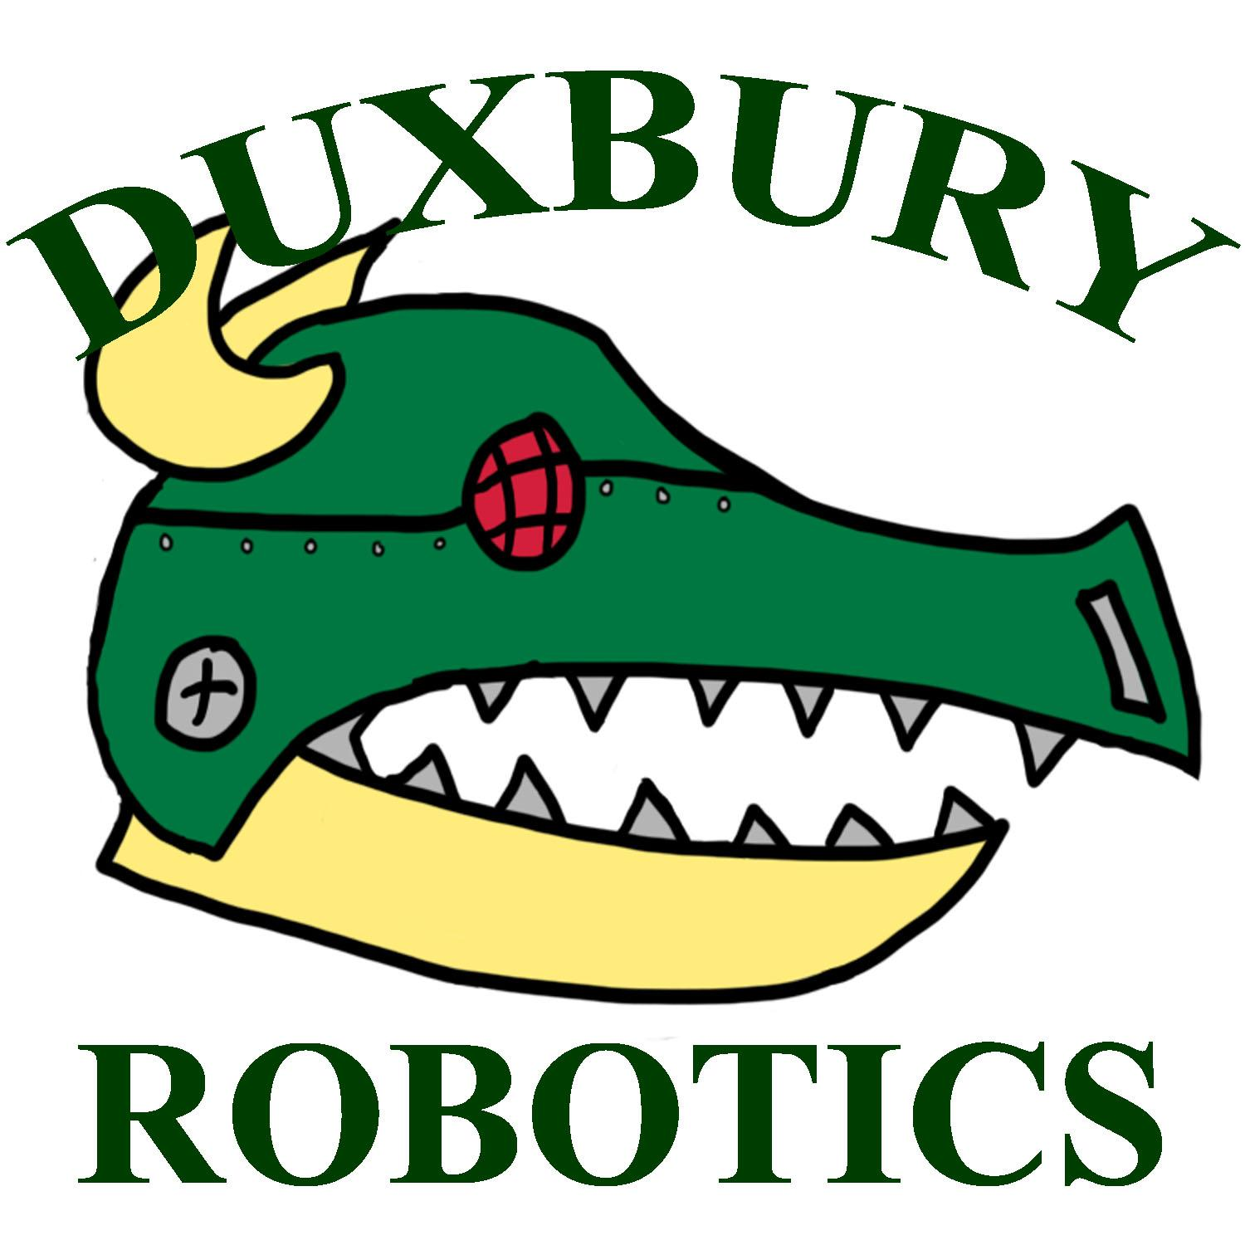

Business Plan 2014-2015

Table of Contents

1. Executive Summary

1.1 Mission Statement......................................................................................... 3

1.2 What is FIRST ................................................................................................. 3

1.3 What is the FIRST Robotics Competition.................................................. 3

1.4 The Game......................................................................................................... 4

2. Team Summary

2.1 Team Origins .................................................................................................. 5

2.2 Mentors............................................................................................................ 5

2.3 Student Leadership....................................................................................... 6

2.4 Handbook........................................................................................................ 6

3. Sponsors

3.1 Team Sponsors................................................................................................ 7

3.2 Sponsor Benefits............................................................................................. 8

4. Team Management

4.1 Team Organization.......................................................................................... 10

4.2 Management Principles.................................................................................. 12

5. Impact on Community

5.1 Promoting the Growth of FIRST Teams....................................................... 12

6. Team Values and Goals

6.1 Teamwork.......................................................................................................... 13

6.2 Goals................................................................................................................... 13

**1. Executive Summary**

**1.1** Mission Statement

*“To pursue an extensive fascination in science, technology, engineering, and management while preparing students for everyday experiences in a demanding and rewarding environment.”*

**1.2** What is FIRST

FIRST is an international organization, which organizes educational competitions for students of all ages. The acronym F.I.R.S.T. stands for “For Inspiration and Recognition of Science and Technology.” The organization runs a series of unique competitions to engage students of all ages. Through the FIRST Lego League, and Junior Lego League, young elementary and middle school aged children are introduced to robotics and compete at FIRST organized events. Through the FIRST Tech Challenge, students from 7th through 12th grade build and compete using robots built with standard parts. However, Duxbury Robotics competes exclusively in another FIRST organized competition: the FIRST Robotics Competition, FIRST’s flagship competition.

**1.3** What is the FIRST Robotics Competition

*The FIRST Robotics Competition (Abv. FRC) as described by FIRST*

“The varsity Sport for the MindTM, FRC combines the excitement of sport with the rigors of science and technology. Under strict rules, limited resources, and time limits, teams are challenged to raise funds, design a team "brand," hone teamwork skills, and build and program robots to perform prescribed tasks against a field of competitors. It’s as close to "real-world engineering" as a student can get. Volunteer professional mentors lend their time and talents to guide each team.”

The FIRST Robotics Competition differs from FIRST’s other programs as teams use industrial materials to build their robots. Each year a new game is designed by FIRST, and teams are given six weeks to complete their robot, and prepare for the new game.

**1.4** The Game

*The 2014 game, Aerial Assist, as described by FRC:*

AERIAL ASSIST is played by two competing Alliances of three robots each on a flat 25’ x 54’ foot field, straddled by a truss suspended just over five feet above the floor. The objective is to score as many balls in goals as possible during a two (2)-minute and 30-second match. The more Alliances score their ball in their goals, and the more they work together to do it, the more points their Alliance receives.

The match begins with one 10-second Autonomous Period in which robots operate independently of driver. Each robot may begin with a ball and attempt to score it in a goal. Alliances earn bonus points for scoring balls in this mode and for any of their robots that move into their zones. Additionally, each high/low pair of goals will be designated “hot” for five seconds, but the order of which side is first is randomized. For each ball scored in a “hot” goal, the Alliance earns additional bonus points.

For the rest of the match, drivers remotely control robots from behind a protective wall. Once all balls in autonomous are scored, only one ball is re-entered in to play, and the Alliances must cycle a single ball as many times as possible for the remainder of the match. With the single ball, they try to maximize their points earned by throwing balls over the truss, catching balls launched over the truss, and scoring in the high and low goals on the far side of the field.

*Details pertaining to the 2015 game are set to be announced on January 3, 2015.*

**2. Team Summary**

**2.1** Team Origins

In 2012, juniors Kevin DiBona, Evan Nudd, and Pat Lydon founded Duxbury Robotics, a club that met biweekly with science teacher Mr. Scott. During the first year, Duxbury Robotics was not so much a team as it was an after-school club, containing seven or so members. Duxbury Robotics was not yet involved with FIRST, and therefore did not attend any competitions in its inaugural year. However, the students still demonstrated a raw passion for building, designing, and programming that drove them to expand and ascend. At the beginning of the 2013-2014 school year, Duxbury Robotics exhibited a robot they had created the previous year during lunchtime in order to spark interest in their club. The plan worked, and fifty-seven students showed up for the first meeting. Since then, the club has turned into a team, enrolling in the FRC and becoming FIRST team #4908. Duxbury Robotics meets six days a week during competition season. The team experienced a stellar rookie year, and is looking forward to the years to come.

**2.2** Team Mentors

**Mr. Scott** teaches physics and chemistry at Duxbury High School (DHS) and started the robotics club in 2011. Prior to becoming a full time teacher, Mr Scott spent 30 years working in the nuclear power industry as a mechanical engineer and the General Manager of an engineering firm.

**Mr. Files** teaches technology-related courses such as woodworking, CAD and drafting, and manufacturing. He has been a teacher at Duxbury Middle School and High School since 2010.

**Mrs. Lewis** is science supervisor grades 6-12 in Duxbury Public Schools. She has been involved in Duxbury schools since 2002, and was previously a writer about chemicals for a scientific magazine.

**2.3** Team Leadership

**Captain -** Daniel Connor

**Mechanical Division**

**Heads:** Matthew Antonino, Conor Allen

**Electrical/Programming Division**

**Heads:** Tate Allen, Michael Mutkoski

**Business Division**

**Heads:** Celia Borghesani, Brendan McCarthy

**2.4** Handbook

The team handbook dictates the behavior expected of team members, and how transgressions will be dealt with. The Duxbury High School (DHS) Handbook remains the ultimate guide to student expectations at DHS. However in respect to Duxbury Robotics, the robotics handbook further describes rules specific to Duxbury Robotics. The team handbook is available on the Duxbury Robotics website under Resources.

*As described by the Duxbury High School Handbook:*

DUXBURY PUBLIC SCHOOLS DOES NOT TOLERATE DISCRIMINATION BASED ON ANY NON-MERIT FACTOR, INCLUDING RACE, NATIONAL ORIGIN, COLOR, RELIGION, SEX, SEXUAL ORIENTATION, GENDER IDENTITY, DISABILITY (PHYSICAL OR MENTAL), AGE, STATUS AS A PARENT, OR GENETIC INFORMATION.

**3. Sponsors**

**3.1** Team Sponsors



**Anchor Press Conway Insurance Per Simmons**



**NASA PTC**

**3.2** Sponsorship Benefit Information

Duxbury Robotics is always looking for new partners to help us fulfill our mission. From publicity and advertisement to merchandising and , our partners enjoy many benefits in their affiliation with Duxbury Robotics. Each season our sponsors are invited to events including competitions, showcases, and other team events. We wish to maintain healthy relationships with our sponsors that are mutually beneficial to both the team and its partners.

During the season, weekly updates from the team will be available on the Duxbury Robotics Youtube Channel.

|  |  |  |
| --- | --- | --- |
| **Membership Level** | **Value** | **Benefits** |
| **Standard** | Up to $199 | - Thank-You Letter  - Name on website |
| **Silver** | $200 to $499 | Basic in addition to:  - Name on team uniform  - Logo on website |
| **Gold** | $500 to $999 | Silver in addition to:  - Logo in pit  - Name, logo, and special thanks on all pamphlets and handouts (distributed at competitions and locally) |
| **Diamond** | $1000 to $1999 | Gold in addition to:  - Name and logo on robot  - Commemorative plaque |
| **Platinum** | $2000+ | Diamond in addition to:  - Included in name of team  ex. *Company Name & Duxbury High School*  - Student volunteers for company |

**\*\*\*DIscount available for local businesses. Contact us for more information.**

We are open to discussing other benefits with sponsors; to inquire as to what else we can do for you, contact us at **robotics@duxbury.k12.ma.us**.

**4. Team Management**

**Summary**

The team is structured similar to an engineering and design company. The team has a financial side and a technical side. The Financial side of the house is responsible for all fundraising, expenditures, obtaining sponsors, publicity and travel organization. The technical side of the house is subdivided into a number of functions including designing, manufacturing, construction, controls, programing and operations.

New in our 2015 season, the team has been reorganized into a series of committees. The team is divided into three greater divisions: Mechanical, Electrical/Programming, and Business, each with their own committee. Each of these divisions is subdivided into several other subcommittees.

**4.1** Team Organization

**4.1.1** Mechanical

**4.1.1.1** Mechanical CAD (Mechanical Computer Aided Design)

The Mechanical CAD Committee is responsible for designing the robot along the basis that the team has decided upon. The team decides the overall design of the robot, and the specific specifications are left to the Mechanical CAD Committee. After providing the initial plans to the Manufacturing Committee, the Mechanical CAD Committee works with the Manufacturing Committee to make any necessary design changes. The Mechanical CAD Committee is responsible for updating the plans to match the current design.

**4.1.1.2** Manufacturing

The Manufacturing Committee is responsible for manufacturing the robot using the plans provided by the Mechanical CAD Committee. Any further changes to the design of the robot are made by the Manufacturing Committee in conjunction with the Mechanical CAD Committee. The Mechanical CAD Committee then alters the plans to reflect these changes.

**4.1.1.3** Strategy

The Strategy Committee is responsible for strategizing how to best participate in the game. The Strategy Committee is also responsible for building the necessary field components (goal posts, trusses, etc.) that are needed to test the robot’s abilities to perform the required tasks, and testing the robot when necessary.

**4.1.2** Electrical/Programming

**4.1.2.1** E/P CAD (Electrical/Programming Computer Aided Design)

The E/P CAD committee is responsible for designing the electrical board and organizing its components. The committee uses PTC Creo to virtually design the electrical board, and their plans are then handed to the Assembly Committee. Their plans are then used by the Assembly Committee to build the electrical board. Provided that the E/P CAD Committee may be asked to make necessary design changes by the Manufacturing Committee, the E/P CAD Committee will also be responsible for further revisions to the electrical board. In such cases, the E/P CAD Committee will present a revised version of the original plans to the Assembly Committee.

**4.1.2.2** Programming

The Programing Committee is responsible for programing the robot to perform a variety of functions necessary to operate. These functions include driving/moving, shooting, catching, and many other functions that may be necessary to perform tasks required in certain games. Each year the programs and programming languages used to develop the robot’s software may vary. The Programming Committee may use a variety of programming languages including Java, and C++.

**4.1.2.3** Assembly

The Assembly Committee is responsible for building the robot’s electrical board from the plans provided by the E/P CAD Committee. Over the course of the build season, further revisions to the electrical board will inevitably be made. The Assembly Committee will be responsible for implementing these further revisions to the electrical board. The E/P CAD Committee will present the Assembly Committee with plans to make these necessary changes to the electrical board.

**4.1.3** Business

**4.1.3.1** Sponsorship

The Sponsorship Committee is responsible for identifying potential sponsors, and building relationships with them in order to secure the necessary funds required for the operation of the team. The Sponsorship Committee is also responsible for maintaining these partnerships, and fostering mutually beneficial relationships. These alliances focus on imparting a better understanding of the design and engineering processes that are used by businesses. The Sponsorship Committee’s ultimate goal is to develop long term strategic alliances with partners, which benefit the students.

**4.1.3.2** Fundraising

The fundraising committee is responsible for raising funds through organized campaigns selling merchandise and services. Fundraising is also responsible for organizing team events, such as our annual Robotics Gala. This committee focuses on raising funds, however its primary purpose is to, along with Social Media, raise public awareness about the team, and engage the community of Duxbury to get involved with Duxbury Robotics.

**4.1.3.3** Social Media

The social media committee runs and manages our media presence. The committee writes and publishes articles, and regularly updates our social media accounts (Facebook, Twitter, Youtube, and Instagram.) Social Media also maintains the Duxbury Robotics website (duxburyrobotics.com.) The committee’s overarching purpose is to foster our connection with the community of Duxbury and to convince its residents to get involved with Duxbury Robotics.

**4.2** Management Principles

**4.2.1** Financial Expenditure Control

While bringing funds into the team is critical, it is also equally as critical to keep track of how those finances are utilized. Students are assigned the task of debiting and crediting our accounts to track the finances and to provide regular reports that reflect the current status of our account. These reports are provided to the team mentors and are available to the school administration.

**5. Impact on Community**

**5.1** Promoting the Growth of FIRST Teams

As a rookie team, Dragons Robotics has done an immense amount of work in fostering the ideals of FIRST in our organization. Examples of this include:

-Advocating for work and competition ethics. FIRST emphasizes a high standard of morals to which the Dragons and its members uphold. As a rookie team, we did not quite fully understand the significance of the ethics of FIRST, but, following our experiences with other teams, we soon learned that a fair game between robots that followed the rules and guidelines leads to greater success.

-Helping with Duxbury’s FIRST Lego League Robotics team. DHS team members have gone to the middle school and helped prepare the middle school’s team for the Lego Robotics League. As middle school participants ascend to high school, they will be more knowledgeable about the logistics of robotics, and therefore better prepared for the FIRST team.

-Actively promoting Dragons Robotics through media. In addition to our involvement in Duxbury High School and the FIRST community, Dragons Robotics has pushed for the involvement of other tools to help promote the growth of FIRST. We have a section of our financial division that focuses on two main aspects that help spread FIRST to the Duxbury community: the local newspaper and social media. The newspaper has been instrumental in spreading FIRST and Dragons Robotics in the community, for it has allowed us to become known with regards to our team development. Social media has also allowed the Dragons to spread FIRST because of social media’s connection with a younger audience. We hope that this not only helps us to grow and gain sponsorships, but also share the benefits of FIRST on a local and global scale.

**6. Team Values and Goals**

**6.1** Teamwork

Students on FIRST team #4908 learn mandatory life skills, namely how to work as a team. Proper communication is essential in creating a successful team environment, and students quickly learn that blaming each other for problems that occur will solve nothing, and is therefore unacceptable. The ability to collaborate is very important to Duxbury Robotics.

**6.2** Goals

As a rookie team, one might think that we have only ourselves to prove; this is not the case however. In competition, we will strive to create a working robot that can prove to be a versatile asset to our alliance. This success would prove to us, our community, and our sponsors that age and experience are not the only factors when it come to FIRST.

**Thank You**

