
项目需求模型IT流程控制与优化

System Requirements Specification

AUTHORISATION
Prepared by: David Du
Project Role | Name & Title | Signature | Date
Development Team Leader
Reviewed by:
Project Manager | Jacky Ding  Deputy Executive Manager
Architecture Team Leader
Approved by:
Portfolio Manager
System Manager / System Owner

DOCUMENT REVISION HISTORY
Revision No. | Status | Revision Date | Author | Summary of Changes
L 1.0 | Final | 27/12/2023 | David Du | Initial document

DOCUMENT LOCATION
An approved copy of the project document should be uploaded to the project portal or document management system
Intranet / SharePoint
EDP.ITD

Table of Contents
AUTHORISATION 1
DOCUMENT REVISION HISTORY 1
DOCUMENT LOCATION 1
1. SYSTEM OVERVIEW 3
1.1. System Perspective 3
1.1.1. High-level architecture diagram 3
1.1.2. Major system features 3
2. USE CASES 3
2.1. Use Case Group 1 [Name] 4
2.1.1. Use Case Diagram 4
2.1.2. Use Cases 1 4
2.1.3. Use Cases 2 5
2.2. Use Case Group 2 [Name] 6
2.2.1. Use Case Diagram 6
2.2.2. Use Cases 1 6
2.2.3. Use Cases 2 6
3. FUNCTIONAL REQUIREMENTS 6
3.1. Behavioral Requirements 6
3.2. Data Requirements 8
3.3. Interface Requirements 9
3.3.1. Screen Layout Requirements 9
3.3.2. Reporting Requirements 9
3.3.3. External Interface Requirements 10
4. Appendix A – System Requirements Information Gathering Template 11

Document Instructions:
- Replace <text within brackets> and any instructions [usually in blue and/or in a box] with project specific information. Some of the topics may not apply to all projects. In the topics where a response is optional, a choice [“N/A for this report”] is included in the instructions.
- Any fill-in text in black should remain unchanged.
- Remove all brackets and change font color to automatic black.
- Remove all instructions, including this text, before saving this document.
Refer TSG Portal - http://epb.corp.hkjc.com/sites/ishare/tsg/SitePages/Home.aspx

SYSTEM OVERVIEW
[While the BR document gives an overview of the project (goals, Stakeholders, Requirements Providers, their needs and business requirements), this section within the SRS needs to address the system more specifically. This section should discuss the major functions of the system, the scope of the work involved and the product environment; identify who can use the system. In addition, provide the system overview in the table below]

System Perspective

High-level architecture diagram

[Explain the context of the system. This can be done using a simple context diagram or a high-level architecture diagram. The diagram should, if possible, depict the major components of the system and its relationship with its environment.

The origin of the system should be clearly spelled out, e.g., if it is a product developed from scratch, it is modifying an existing system, a new sub-system for an existing system, a replacement for an existing system etc.]

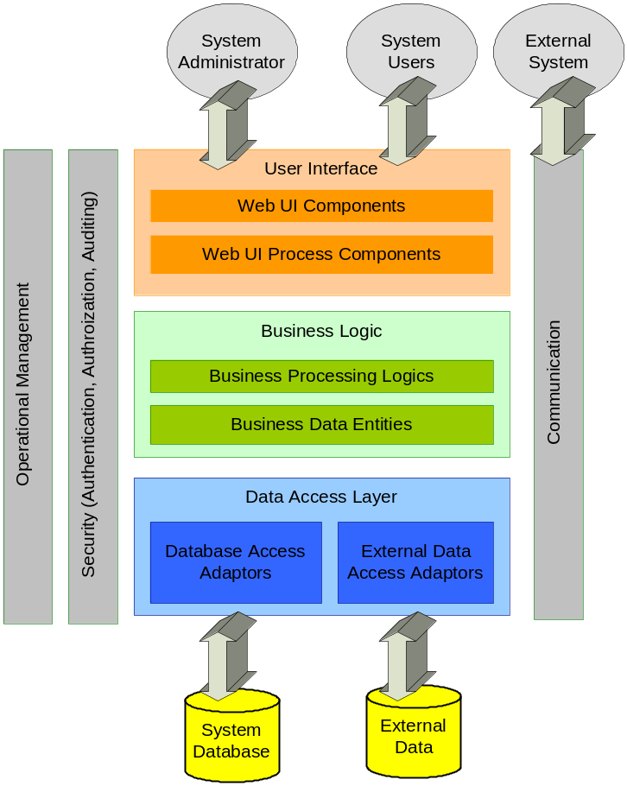

Major system features
[List no more than 5 major features of the system. This helps in verifying that the original intent of the system is not lost during the development of requirements.]

USE CASES
Use Cases help to capture the functional requirements. They can be depicted using a Use Case Diagram with one or more Use Case Scenarios. The following template can be used for Use Case Scenarios

The following steps outline the process for creating Use Cases:
- There are two ways to identify Use Cases
- Actor based
- Identify the users (actors) related to the system or organization
- For each actor, identify the processes they initiate and participate.
- Event Based
- Identify the external events the system needs to respond
- Relate the events to actors and Use Cases
- Once the processes or external events are identified, create the Use Cases for each of them using the Use Case template provided.
- Structure the Use Cases. Avoid over structure, this makes it harder to follow
- Review and validate the Use Cases with the users]

User Survey

Use Case Diagram
[The Use Case diagram illustrates a set of Use Cases for a system, the actors and the relation between the actors and the Use Cases. Create a Use Case diagram here, and explain its Use Cases in the template provided below.]

[Use cases can be described in different levels of details. Two to three levels is often appropriate. The example below shows two levels of detail for Managinge Stable Staff Profile function.]
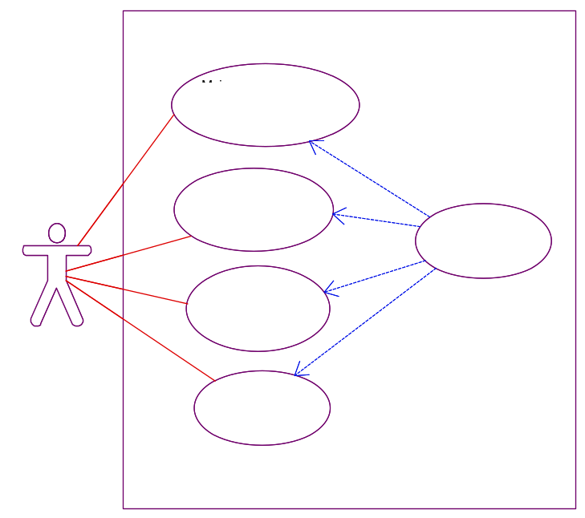

Use Cases 1
[A Use Case diagram has one or more Use Cases that explain it.

This table should be copied and completed for each individual Use Case. If a Requirements Management Tool is available, the Requirements Management Tool should automate the Use Case Identification and History.]

[The below table shows an example of a complete SRS description.]

Use Case Identification and History
Use Case ID: |  | e.g. Proj.UC.1.1.1
Use Case Name: |  | <Name - concise results oriented-name with an action verb and a noun>  e.g. Maintain Stable Staff Race Day Job Code |  |  | Version No:
Purpose: |  | <The directly observable purpose of this Use Case >  e.g. To record the operational duty taken by a stable staff in a particular race day. The record will be used to calculate race day duty payment.
Last Update by: |  |  |  | On (date):
User/Actor: |  | <Description of the person who uses the system to accomplish the task>  e.g. Stable Staff
Trigger: |  | <Who (system or user) triggers this Use Case?>  e.g. Stable Staff trigger through GUI
References: |  | <Identify any references to other Use Cases. This is important, especially, if the Use Case is an extension of another Use Case>
Frequency of Use: |  | <How often does this series of activities occur?>  On demand, usually 1 day before race day.
Preconditions: |  | <What is true of the system state before this flow of actions begin?>  e.g. 1. User's identity has been authenticated.  2. User is authorized to assign race day job duty.  3. Race day job code is available.  4. RIS database is online.  5. RIS starter information is ready.
Post Conditions: |  | <What is true of the system state when the flow of activities finish?>  e.g. Race day job duty information is stored to the system.
Non-functional Requirements |  | <List any Non-functional requirements that the Use Case needs to meet, relevant to performance, reliability, etc. List them in the following format  Requirement Type: Requirement >  e.g. nil
Assumptions: |  | <List special considerations that need to be kept in mind for this Use Case only>  e.g. nil
Business Rules: |  | <Refer to the approved Business Rule ID or describe explicitly here>  e.g. Staff with a principal job code head lad or stable assistant cannot act as work rider.
Steps: |  | <Interactions between actors and the system. Conditional statements can be used to express alternate flow, exception flow etc>  e.g. Refer to activity diagram below
Step | User Actions |  | System Actions

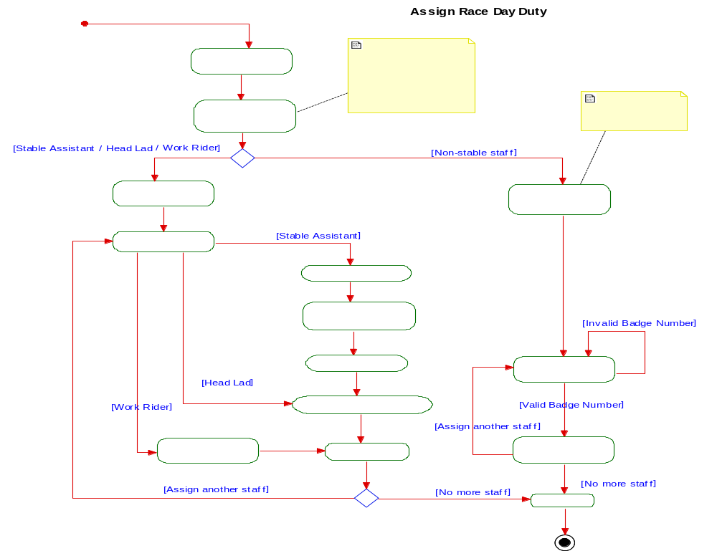

Use Cases 2

Electronic Archiving and Tracking of Meeting Minutes

Use Case Diagram

Use Cases 1

Use Cases 2

Project Data Archive

Use Case Diagram

Use Cases 1

Use Cases 2

FUNCTIONAL REQUIREMENTS
[All the requirements should be documented using the Requirements Data Template provided in Appendix A. The requirements should be placed under the appropriate sections based on the requirements type.]

Behavioral Requirements
[Specify what the system must do and describe the behavior of the system. Include requirements for how the system should behave under abnormal circumstances, e.g. missing or invalid data. Supplement with diagram if applicable]

[Behavioral requirement which have significant impact on the development effort shall be completed. For example, the following requirement globally affects the whole system behavior which suggests a certain amount of work shall be given at Gate 3 to justify the EAP.]

STD001: Field Validation Verification
NOTE: This is a Standard Requirement and should NEVER be deleted. Any exclusions or modifications should be noted in the Status section.
Standard Requirement ID | STD001 | Requirement Type | Behavioral Requirement | Version | 1.0
Parent Requirement # | N/A
Description | All applications provide validity checking for all input, process, output and interface fields except where approved by the Architect. Typical validity edits include but are not limited to: lower/upper-bound conformance, syntactical correctness, authorisation checking, sequence checking, limit checking, range checking, reasonableness, existence, completeness, duplicity, logical relationships, key verification, table look-ups and correct formatting. All checking is performed as soon as possible with real-time error messages provided for online input to facilitate remediation activities and minimize error propagation. [
Rationale | Any errors should be trapped and handled as soon as possible to prevent an application from using, storing or transmitting invalid data.
Source | Architecture team |  | Source Document | None
Acceptance/Fit Criteria | The requirement is verified by:  1) Constructing a list of all application input, process, output and interface fields.  2) For each of these fields, note the application location where the field may be changed, where it is correspondingly verified and the validation checks that are performed  3) For fields that are not verified, list a justification.
Dependencies | None | Tailoring Guidelines | May only be tailored out for: all minor enhancements projects to existing systems/applications.
SR Status | Agreed-To | Already Met | Tailored Out (justification needed) | Modified (deviation needed) | Excluded (deviation needed); include any justification here also |  |  | Segment Owner | Architecture
Change History | N/A

Data Requirements
[Specify the detailed data requirements for the system, including inputs, internal data, and outputs. Include the sources and destinations of the data, as well as requirements regarding frequency, latency (real-time, near real-time, daily) and volume. Identify data that must be converted, replicated or shared across software components. State the System Logical Data Requirements, Data Input files, Internal Data Files, and Data Output files. For interface related data fields, refer to a specific section in DV017]

# | Business Requirement | Required Data Field | Enterprise Data?  (Y/N) | Definition | Usage | Identifier?  (Y/N) | Data Type | Format | Valid Values | Business Rules | Data Protection Level
1 | CAP-UC-1101 – Retrieve Password Recovery Questions | Display Language | N | Display Language | It is used to show the display language of the password recovery questions. | N | varchar | N/A | English,  Traditional Chinese,  Simplified Chinese | N/A | N/A
2 | CAP-UC-1104 – Check Customer Type | Web user account ID | Y | Web User Account ID | For check customer type | Y | varchar | 20 chars | validate the format based on the global Web User Account ID format | N/A | Level 1
3 | CAP-UC-1104 – Check Customer Type | Betting Account Number | Y | Betting Account Number | For check customer type | Y | Number | 8 Digits | 8 Digits | N/A | Level 1

[The Data Requirement document aims to provide unified view to present the data. There are four sections in the document:
- Core Data Attributes (To be completed in Requirement Development Phase)
- It included the data definition, usage, format, valid values and other technical attributes describing the data.
- System Lineage (To be completed in System Design Phase)
- It details the storage details of the upstream and downstream system for the data elements.
- Data Replication and Distribution (To be completed in System Design Phase)
- It focuses on technical requirements, which include volume, method and frequency, for data transition to upstream and downstream system. ]
- Data Quality (To be completed in System Design Phase)
- It details the data quality requirement from three perspectives, which include completeness, validity and consistency.

Data Standard Attribute Descriptions
Attribute | Attribute Meaning | Attribute Options | Option Meaning
Definition | Common language and understanding of the meaning of a given data element agreed to by all parties
Usage | Intended purpose of a given data element
Is Identifier | An indicator of whether the attribute is used as an identifier, which can uniquely identify a record (for e.g. Customer ID), in the data model | 1. Y  2. N | 1. Yes  2. No
Data Type | Technical data type to store this data element in the database. For examples, varchar, number, date, etc.
Format | Syntax and the representation of data element. For instance, birthdate must be in DD/MM/YYYY format.
Valid Values | Set of allowed values for the data element
Business Rules | Business rules that apply to the data element, for instance, certain clubhouse services (tennis, gym rooms and restaurants) are available to members only.
Data Protection Level | The category of pre-defined data protection level to be applied to the data element. | 1. Level 1  2. Level 2  3. Level 3  4. N/A | 1. Unique Identifier  2. Sensitive Personal Data  3. Characteristic and Behavior
Enterprise Data | For classification on Enterprise Data – refer to Logical Data Model in Enterprise Architecture Portal

[The following data requirement shall be given:
- For data flow across systems,
(a) Data source and destinations,
(b) Requirements on data converting/replicating
- If internal data file is required, list out requirements of the data file.

Provide references if interface file format or example is available and has to be followed.
Attributes of data entities are optional depending on the impact to effort estimation.]

Interface Requirements
[Describe the logical characteristics of each interface between the software system and the users. Define the software components for which a user interface is needed. The User Interface is typically the User Interface (Screens) and the reports.

There could be zero, one or more Use Cases or Screenshots that support User interface Requirements.
Use the Requirements Data Template, provided in Appendix A, to capture each requirement.]

Screen Layout Requirements
[Define what data and functionality needs to be included in each screen. Use the Requirements Data Template, provided in Appendix A, to capture each requirement.
The user interface should be consistent with established HKJC look, feel and technical conventions. Refer to DV016 if applicable. For project involving HKJC related public websites, consult Web Solutions and Services team on the website design & layout to ensure its compliance with corporate guidelines during website design stage.]

[Complete before development stage]

[Provide screenshots or wire frames, if available, from prototypes, demonstrations or existing systems. This helps in deriving the user interface and behavioral requirements.]

Reporting Requirements
[Apart from the Requirements Data Template, the following table may be used to provide description for each reporting requirement. This is an overview list of reports and is in addition to the Requirements Data for each reporting requirement.]

[Complete before development stage]

Report Type | Report Name | Description | User Type | Frequency
<Example: Financial, Operational, Executive, etc.> |  | <In a couple of sentences describe the information that the user would like to obtain from this report> | <List the user types who need this report> | <Example: Daily, weekly, monthly, etc.>

External Interface Requirements
[Specify each API method that is required to be built for the planned system to be accessible by another system as an external interface. Refer to DV017 if applicable]

Appendix A – System Requirements Information Gathering Template
[To ensure that each requirement has the necessary amount of information; use the following template to capture the following required data for each requirement. This template should be used for all types of requirements, and then placed in the specification document under the appropriate requirement type section. To use the template, select the template, copy and paste in the intended section.]
<REQ ID>: <REQ Title>
Standard Requirement ID | <REQID> | Requirement Type |  | <Req Type> |  | Version |  |  |  | <Use Case #>
Parent Requirement # | <Enter the unique ID #(s) for each requirement that this requirement supports (this field is empty for high-level requirements, e.g., business requirements) >
Description | <Enter concise description of requirement>
Rationale | <Provide a brief rationale, and or business value for the requirement. >
Source | <Name of Requirements Provider> |  |  |  | Source Document |  |  | <File name>
Acceptance/Fit Criteria | <Provide a target that makes it possible to test / verify if requirement was satisfied>
Dependencies | <List critical dependencies> |  | Tailoring Guidelines |  | <Enter the guidelines/conditions when tailoring of this requirement is allowed>
SR Status | Agreed-To | Already Met | Tailored Out (justification needed) | Modified (deviation needed) | Excluded (deviation needed); include any justification here also |  |  |  |  |  | Segment Owner |  | <Who initiates this requirement>
Change History | <List of history of changes>

Requirement ID:
Every requirement needs to be uniquely identified. The Requirement ID is the unique label given to that requirement. Each team can develop its unique numbering convention for system requirements:
S1.1a where S=System, 1=business requirement number, 1 =system requirement number, a=first revision)

Note: System requirement number should always follow a business requirement number, and always be in the second position

Requirement Type:
Functional Requirements
- Behavioral
- Data
- Interface
- API

Non-functional requirements
- Architectural requirements
- Hardware Requirements
- Software Requirements
- Network Requirements
- Portability Requirements
- Service Continuity Management Requirements
- Capacity Management Requirements
- Availability Management Requirements
- Help Desk Requirements
- Enterprise Operations Monitoring (EoM) Requirements
- Security Management Requirements

Use Case#: The associated Use Case(s) for this system requirement

Parent Requirement#:
Requirements have a natural hierarchy. They flow from high-level business requirements to system requirements. This field captures the higher level requirement for the one described.

Description:
Lists background information about the requirement and a detailed description of the requirement itself.

Rationale:
Lists the business reason / justification for satisfying this requirement.

Source:
The business requirement and/or requirements provider that are a basis for this requirement.

Source Document:
The source document is any reference document that either generated the requirement directly, or was the impetus for its creation

Acceptance / Fit Criteria:
Tests and/or other criteria that can confirm the satisfactory completion of this requirement.

Dependencies:
Dependencies are other requirements (not contained in the parent-to-child relationship) that are critical to successfully implementing the stated requirement. (E.g. This system functional requirement has a dependency on a specific data system requirement, in which if the data requirement is not satisfied, the functional requirement cannot be satisfied.). Dependencies are usually only captured for the same level of requirement hierarchy (e.g., system requirements dependant on another system requirements).
Note: It is not necessary to capture all requirement relationships in this section. It is only required to capture critical dependencies.

Stakeholders:
All business and IT groups that have a primary stake in the successful implementation of this system.

Priority:
Essential = System not acceptable unless this requirement is provided in an agreed manner.
Conditional = would enhance the system, but would not make it unacceptable if absent.
Optional = Might be worthwhile if resources permit.

Status:
Draft = Proposed but not yet Agreed-To nor Rejected
Agreed-To = Concurred by business owner and project manager to implement in this project
Deferred = Removed from the project scope but may be reconsidered as part of a future release
Rejected = Not agreed-to and removed from the scope of this project

Change History:
A chronological list of approved changes for this requirement

