PHẠM HỒNG DUY-1150070008
MÁY 16
LAB 6
Máy đổi tiền
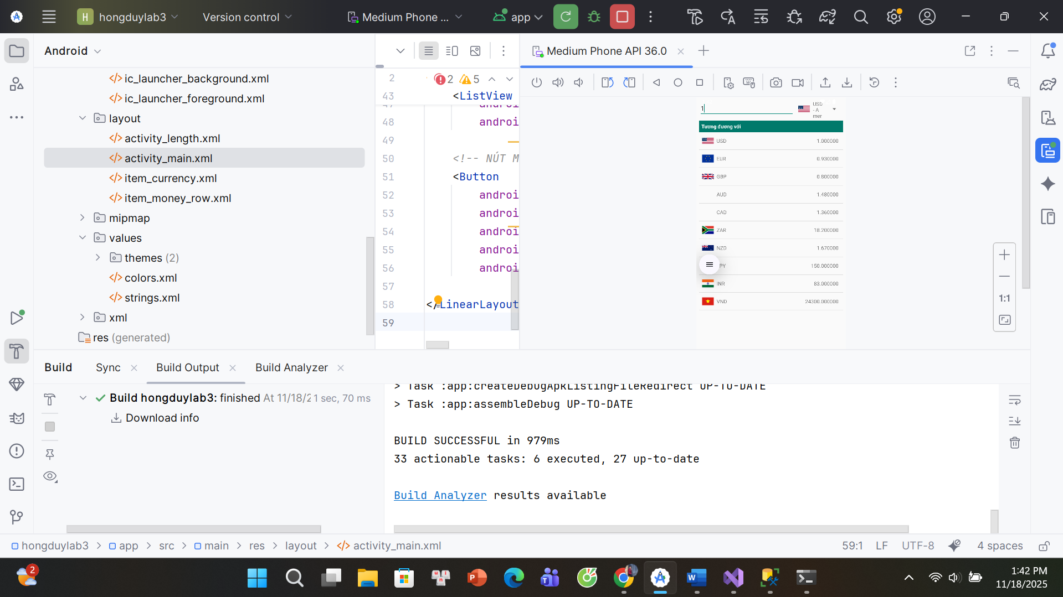
Đổi độ dài
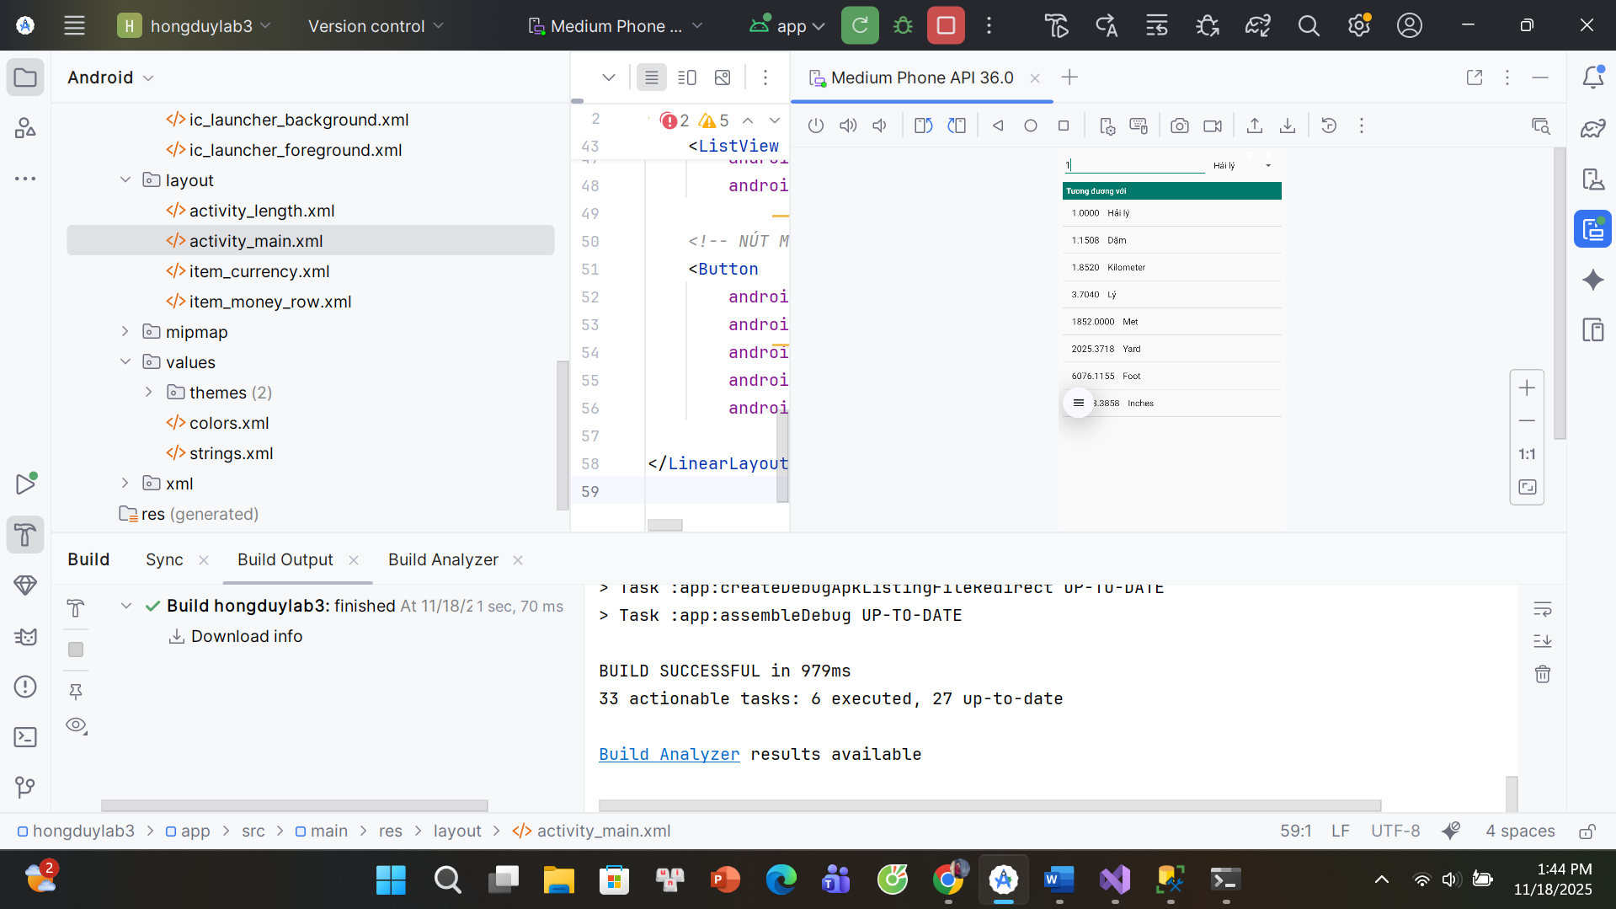
1. AndroidManifest.xml
<?xml version="1.0" encoding="utf-8"?>
<manifest xmlns:android="http://schemas.android.com/apk/res/android"
package="com.example.hongduylab3">
<application
android:allowBackup="true"
android:icon="@mipmap/ic_launcher"
android:label="@string/app_name"
android:roundIcon="@mipmap/ic_launcher_round"
android:supportsRtl="true"
android:theme="@style/Theme.AppCompat.Light.NoActionBar">
<activity
android:name=".LengthActivity" />
<activity
android:name=".MainActivity"
android:exported="true">
<intent-filter>
<action android:name="android.intent.action.MAIN" />
<category android:name="android.intent.category.LAUNCHER" />
</intent-filter>
</activity>
</application>
</manifest>
2. res/values/strings.xml
<?xml version="1.0" encoding="utf-8"?>
<resources>
<string name="app_name">Chương trình đổi tiền</string>
<string name="author">Phạm Hồng Duy</string>
<string name="computer">HP ZBook G5</string>
<string name="textbox_hint">Nhập số tiền</string>
<string name="btn_convert_money">Đổi tiền</string>
<string name="btn_convert_length">Đổi độ dài</string>
<string name="btn_open_length">Mở chương trình đổi độ dài</string>
<string name="hint_length">Nhập độ dài</string>
<string name="usd_name">American Dollar</string>
<string name="eur_name">European Cash</string>
<string name="gbp_name">Great Britain</string>
<string name="aud_name">Australia Dollar</string>
<string name="cad_name">Canadian Dollar</string>
<string name="zar_name">South Africa Rand</string>
<string name="nzd_name">New Zealand Dollar</string>
<string name="vnd_name">Việt Nam Đồng</string>
<string name="inr_name">Indian Rupee</string>
<string name="jpy_name">Yên Nhật</string>
<string name="usd_unit">USD</string>
<string name="eur_unit">EUR</string>
<string name="gbp_unit">GBP</string>
<string name="inr_unit">INR</string>
<string name="aud_unit">AUD</string>
<string name="cad_unit">CAD</string>
<string name="zar_unit">ZAR</string>
<string name="nzd_unit">NZD</string>
<string name="jpy_unit">JPY</string>
<string name="vnd_unit">VND</string>
</resources>
3. res/layout/activity_main.xml
<?xml version="1.0" encoding="utf-8"?>
<LinearLayout xmlns:android="http://schemas.android.com/apk/res/android"
android:orientation="vertical"
android:layout_width="match_parent"
android:layout_height="match_parent"
android:padding="8dp">
<LinearLayout
android:layout_width="match_parent"
android:layout_height="wrap_content"
android:orientation="horizontal">
<EditText
android:id="@+id/edtMoney"
android:layout_width="0dp"
android:layout_height="wrap_content"
android:layout_weight="2"
android:inputType="numberDecimal"
android:hint="@string/textbox_hint" />
<Spinner
android:id="@+id/spCurrency"
android:layout_width="0dp"
android:layout_height="wrap_content"
android:layout_weight="1"
android:layout_marginStart="4dp" />
</LinearLayout>
<TextView
android:id="@+id/tvHeaderMoney"
android:layout_width="match_parent"
android:layout_height="wrap_content"
android:text="Tương đương với"
android:textStyle="bold"
android:padding="6dp"
android:background="#00796B"
android:textColor="#FFFFFF"
android:layout_marginTop="8dp" />
<ListView
android:id="@+id/lvMoney"
android:layout_width="match_parent"
android:layout_height="0dp"
android:layout_weight="1"
android:dividerHeight="1dp" />
<Button
android:id="@+id/btnOpenLength"
android:layout_width="match_parent"
android:layout_height="wrap_content"
android:text="@string/btn_open_length"
android:layout_marginTop="8dp" />
</LinearLayout>
4. res/layout/activity_length.xml
<?xml version="1.0" encoding="utf-8"?>
<LinearLayout xmlns:android="http://schemas.android.com/apk/res/android"
android:orientation="vertical"
android:layout_width="match_parent"
android:layout_height="match_parent"
android:padding="8dp">
<LinearLayout
android:layout_width="match_parent"
android:layout_height="wrap_content"
android:orientation="horizontal">
<EditText
android:id="@+id/edtLength"
android:layout_width="0dp"
android:layout_height="wrap_content"
android:layout_weight="2"
android:inputType="numberDecimal"
android:hint="@string/hint_length" />
<Spinner
android:id="@+id/spUnit"
android:layout_width="0dp"
android:layout_height="wrap_content"
android:layout_weight="1"
android:layout_marginStart="4dp" />
</LinearLayout>
<TextView
android:id="@+id/tvHeader"
android:layout_width="match_parent"
android:layout_height="wrap_content"
android:text="Tương đương với"
android:textStyle="bold"
android:padding="6dp"
android:background="#00796B"
android:textColor="#FFFFFF"
android:layout_marginTop="8dp" />
<ListView
android:id="@+id/lvResult"
android:layout_width="match_parent"
android:layout_height="0dp"
android:layout_weight="1"
android:dividerHeight="1dp" />
</LinearLayout>
5. res/layout/item_currency.xml
<?xml version="1.0" encoding="utf-8"?>
<LinearLayout xmlns:android="http://schemas.android.com/apk/res/android"
android:orientation="horizontal"
android:layout_width="match_parent"
android:layout_height="48dp"
android:gravity="center_vertical"
android:paddingHorizontal="8dp">
<ImageView
android:id="@+id/img_flag"
android:layout_width="32dp"
android:layout_height="24dp"
android:adjustViewBounds="true" />
<TextView
android:id="@+id/tv_currency"
android:layout_width="wrap_content"
android:layout_height="wrap_content"
android:layout_marginStart="8dp"
android:textSize="14sp" />
</LinearLayout>
6. res/layout/item_money_row.xml
<?xml version="1.0" encoding="utf-8"?>
<LinearLayout xmlns:android="http://schemas.android.com/apk/res/android"
android:orientation="horizontal"
android:layout_width="match_parent"
android:layout_height="48dp"
android:gravity="center_vertical"
android:paddingHorizontal="8dp">
<ImageView
android:id="@+id/img_flag_row"
android:layout_width="32dp"
android:layout_height="24dp"
android:adjustViewBounds="true" />
<TextView
android:id="@+id/tv_code_row"
android:layout_width="wrap_content"
android:layout_height="wrap_content"
android:layout_marginStart="8dp"
android:textSize="14sp" />
<TextView
android:id="@+id/tv_value_row"
android:layout_width="0dp"
android:layout_height="wrap_content"
android:layout_weight="1"
android:gravity="end"
android:textSize="14sp"
android:layout_marginEnd="4dp" />
</LinearLayout>

7. java/com/example/hongduylab3/MainActivity.java
package com.example.hongduylab3;
import androidx.appcompat.app.AppCompatActivity;
import android.content.Intent;
import android.os.Bundle;
import android.text.Editable;
import android.text.TextWatcher;
import android.widget.EditText;
import android.widget.ListView;
import android.widget.Spinner;
import android.widget.Button;
public class MainActivity extends AppCompatActivity {
EditText edtMoney;
Spinner spCurrency;
ListView lvMoney;
Button btnOpenLength;
double[][] rate = {
{1, 0.93, 0.80, 1.48, 1.36, 18.2, 1.67, 150, 83, 24300},
{1.07, 1, 0.86, 1.59, 1.46, 19.6, 1.80, 161, 90, 26000},
{1.25, 1.16, 1, 1.85, 1.70, 22.8, 2.10, 188, 105, 30000},
{0.67, 0.63, 0.54, 1, 0.92, 12.3, 1.13, 102, 57, 16200},
{0.73, 0.68, 0.59, 1.08, 1, 13.4, 1.24, 112, 63, 18000},
{0.055,0.051,0.044,0.081,0.074,1, 0.092, 8.3, 4.7, 1350},
{0.60, 0.55, 0.48, 0.88, 0.80, 10.8, 1, 93, 52, 15000},
{0.0067,0.0062,0.0053,0.0098,0.0089,0.12, 0.0107,1, 0.56,161},
{0.012,0.011,0.0095,0.017,0.015,0.21, 0.018,1.8,1, 290},
{0.000041,0.000038,0.000033,0.000062,0.000055,0.00074,0.000067,0.0062,0.0034,1}
};
String[] units;
String[] names;
int[] flags;
double[] values;
MoneyListAdapter listAdapter;
@Override
protected void onCreate(Bundle savedInstanceState) {
super.onCreate(savedInstanceState);
setContentView(R.layout.activity_main);
edtMoney = findViewById(R.id.edtMoney);
spCurrency = findViewById(R.id.spCurrency);
lvMoney = findViewById(R.id.lvMoney);
btnOpenLength = findViewById(R.id.btnOpenLength);
units = new String[]{
getString(R.string.usd_unit),
getString(R.string.eur_unit),
getString(R.string.gbp_unit),
getString(R.string.aud_unit),
getString(R.string.cad_unit),
getString(R.string.zar_unit),
getString(R.string.nzd_unit),
getString(R.string.jpy_unit),
getString(R.string.inr_unit),
getString(R.string.vnd_unit)
};
names = new String[]{
getString(R.string.usd_name),
getString(R.string.eur_name),
getString(R.string.gbp_name),
getString(R.string.aud_name),
getString(R.string.cad_name),
getString(R.string.zar_name),
getString(R.string.nzd_name),
getString(R.string.jpy_name),
getString(R.string.inr_name),
getString(R.string.vnd_name)
};
flags = new int[]{
R.drawable.flag_usd,
R.drawable.flag_eur,
R.drawable.flag_gbp,
R.drawable.flag_aud,
R.drawable.flag_cad,
R.drawable.flag_zar,
R.drawable.flag_nzd,
R.drawable.flag_jpy,
R.drawable.flag_inr,
R.drawable.flag_vnd
};
CurrencySpinnerAdapter spinnerAdapter =
new CurrencySpinnerAdapter(this, units, names, flags);
spCurrency.setAdapter(spinnerAdapter);
values = new double[units.length];
listAdapter = new MoneyListAdapter(this, units, flags, values);
lvMoney.setAdapter(listAdapter);
spCurrency.setOnItemSelectedListener(
new android.widget.AdapterView.OnItemSelectedListener() {
@Override
public void onItemSelected(android.widget.AdapterView<?> parent,
android.view.View view, int position, long id) {
updateMoneyList();
}
@Override
public void onNothingSelected(android.widget.AdapterView<?> parent) { }
});
edtMoney.addTextChangedListener(new TextWatcher() {
@Override public void beforeTextChanged(CharSequence s, int start, int count, int after) {}
@Override public void onTextChanged(CharSequence s, int start, int before, int count) {
updateMoneyList();
}
@Override public void afterTextChanged(Editable s) {}
});
btnOpenLength.setOnClickListener(v -> {
Intent intent = new Intent(MainActivity.this, LengthActivity.class);
startActivity(intent);
});
}
private void updateMoneyList() {
String text = edtMoney.getText().toString().trim();
if (text.isEmpty()) {
for (int i = 0; i < values.length; i++) values[i] = 0;
listAdapter.notifyDataSetChanged();
return;
}
double amount;
try {
amount = Double.parseDouble(text);
} catch (NumberFormatException e) {
for (int i = 0; i < values.length; i++) values[i] = 0;
listAdapter.notifyDataSetChanged();
return;
}
int from = spCurrency.getSelectedItemPosition();
for (int i = 0; i < values.length; i++) {
values[i] = amount * rate[from][i];
}
listAdapter.notifyDataSetChanged();
}
}
8. java/com/example/hongduylab3/LengthActivity.java
package com.example.hongduylab3;
import androidx.appcompat.app.AppCompatActivity;
import android.os.Bundle;
import android.text.Editable;
import android.text.TextWatcher;
import android.widget.EditText;
import android.widget.ListView;
import android.widget.Spinner;
import android.widget.ArrayAdapter;
import java.util.ArrayList;
import java.util.Locale;
public class LengthActivity extends AppCompatActivity {
EditText edtLength;
Spinner spUnit;
ListView lvResult;
String[] unitNames = {
"Hải lý", "Dặm", "Kilometer", "Lý", "Met", "Yard", "Foot", "Inches"
};
double[] toMeter = {
1852.0,
1609.344,
1000.0,
500.0,
1.0,
0.9144,
0.3048,
0.0254
};
ArrayList<String> resultList;
ArrayAdapter<String> listAdapter;
@Override
protected void onCreate(Bundle savedInstanceState) {
super.onCreate(savedInstanceState);
setContentView(R.layout.activity_length);
edtLength = findViewById(R.id.edtLength);
spUnit = findViewById(R.id.spUnit);
lvResult = findViewById(R.id.lvResult);
ArrayAdapter<String> spinAdapter =
new ArrayAdapter<>(this,
android.R.layout.simple_spinner_item, unitNames);
spinAdapter.setDropDownViewResource(android.R.layout.simple_spinner_dropdown_item);
spUnit.setAdapter(spinAdapter);
resultList = new ArrayList<>();
listAdapter = new ArrayAdapter<>(this,
android.R.layout.simple_list_item_1, resultList);
lvResult.setAdapter(listAdapter);
spUnit.setOnItemSelectedListener(new android.widget.AdapterView.OnItemSelectedListener() {
@Override
public void onItemSelected(android.widget.AdapterView<?> parent,
android.view.View view, int position, long id) {
updateResult();
}
@Override
public void onNothingSelected(android.widget.AdapterView<?> parent) { }
});
edtLength.addTextChangedListener(new TextWatcher() {
@Override public void beforeTextChanged(CharSequence s, int start, int count, int after) {}
@Override public void onTextChanged(CharSequence s, int start, int before, int count) {
updateResult();
}
@Override public void afterTextChanged(Editable s) {}
});
}
private void updateResult() {
String text = edtLength.getText().toString().trim();
resultList.clear();
if (text.isEmpty()) {
listAdapter.notifyDataSetChanged();
return;
}
double value;
try {
value = Double.parseDouble(text);
} catch (NumberFormatException e) {
listAdapter.notifyDataSetChanged();
return;
}
int fromIndex = spUnit.getSelectedItemPosition();
double inMeter = value * toMeter[fromIndex];
for (int i = 0; i < unitNames.length; i++) {
double converted = inMeter / toMeter[i];
String line = String.format(Locale.US, "%.4f %s", converted, unitNames[i]);
resultList.add(line);
}
listAdapter.notifyDataSetChanged();
}
}
9. java/com/example/hongduylab3/CurrencySpinnerAdapter.java
package com.example.hongduylab3;
import android.content.Context;
import android.view.LayoutInflater;
import android.view.View;
import android.view.ViewGroup;
import android.widget.ArrayAdapter;
import android.widget.ImageView;
import android.widget.TextView;
import androidx.annotation.NonNull;
import androidx.annotation.Nullable;
public class CurrencySpinnerAdapter extends ArrayAdapter<String> {
private final Context context;
private final String[] units;
private final String[] names;
private final int[] flags;
public CurrencySpinnerAdapter(@NonNull Context context,
String[] units,
String[] names,
int[] flags) {
super(context, 0, units);
this.context = context;
this.units = units;
this.names = names;
this.flags = flags;
}
@NonNull
@Override
public View getView(int position, @Nullable View convertView,
@NonNull ViewGroup parent) {
return createItem(position, convertView, parent);
}
@Override
public View getDropDownView(int position, @Nullable View convertView,
@NonNull ViewGroup parent) {
return createItem(position, convertView, parent);
}
private View createItem(int position, View convertView, ViewGroup parent) {
View view = convertView;
if (view == null) {
view = LayoutInflater.from(context)
.inflate(R.layout.item_currency, parent, false);
}
ImageView imgFlag = view.findViewById(R.id.img_flag);
TextView tvCurrency = view.findViewById(R.id.tv_currency);
imgFlag.setImageResource(flags[position]);
String text = units[position] + " - " + names[position];
tvCurrency.setText(text);
return view;
}
}
10. java/com/example/hongduylab3/MoneyListAdapter.java
package com.example.hongduylab3;
import android.content.Context;
import android.view.LayoutInflater;
import android.view.View;
import android.view.ViewGroup;
import android.widget.BaseAdapter;
import android.widget.ImageView;
import android.widget.TextView;
import java.util.Locale;
public class MoneyListAdapter extends BaseAdapter {
private final Context context;
private final String[] units;
private final int[] flags;
private final double[] values;
private final LayoutInflater inflater;
public MoneyListAdapter(Context context,
String[] units,
int[] flags,
double[] values) {
this.context = context;
this.units = units;
this.flags = flags;
this.values = values;
this.inflater = LayoutInflater.from(context);
}
@Override
public int getCount() {
return units.length;
}
@Override
public Object getItem(int position) {
return values[position];
}
@Override
public long getItemId(int position) {
return position;
}
@Override
public View getView(int position, View convertView, ViewGroup parent) {
View view = convertView;
if (view == null) {
view = inflater.inflate(R.layout.item_money_row, parent, false);
}
ImageView imgFlag = view.findViewById(R.id.img_flag_row);
TextView tvCode = view.findViewById(R.id.tv_code_row);
TextView tvValue = view.findViewById(R.id.tv_value_row);
imgFlag.setImageResource(flags[position]);
tvCode.setText(units[position]);
String text = String.format(Locale.US, "%.6f", values[position]);
tvValue.setText(text);
return view;
}
}

LAB 7
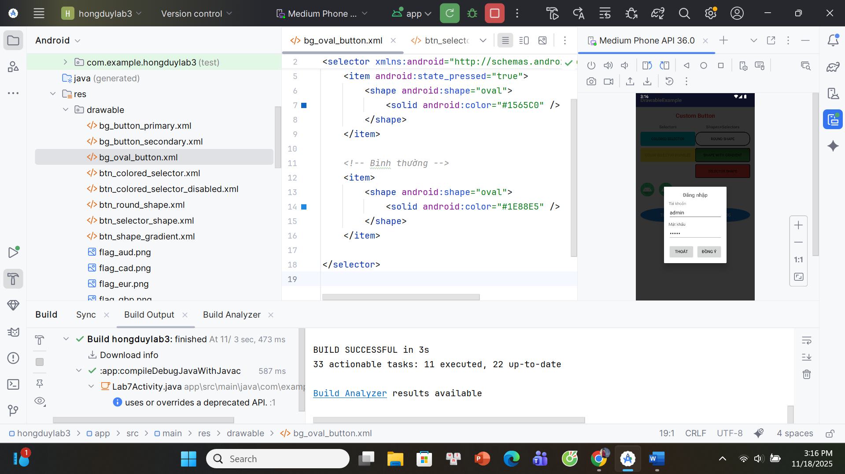

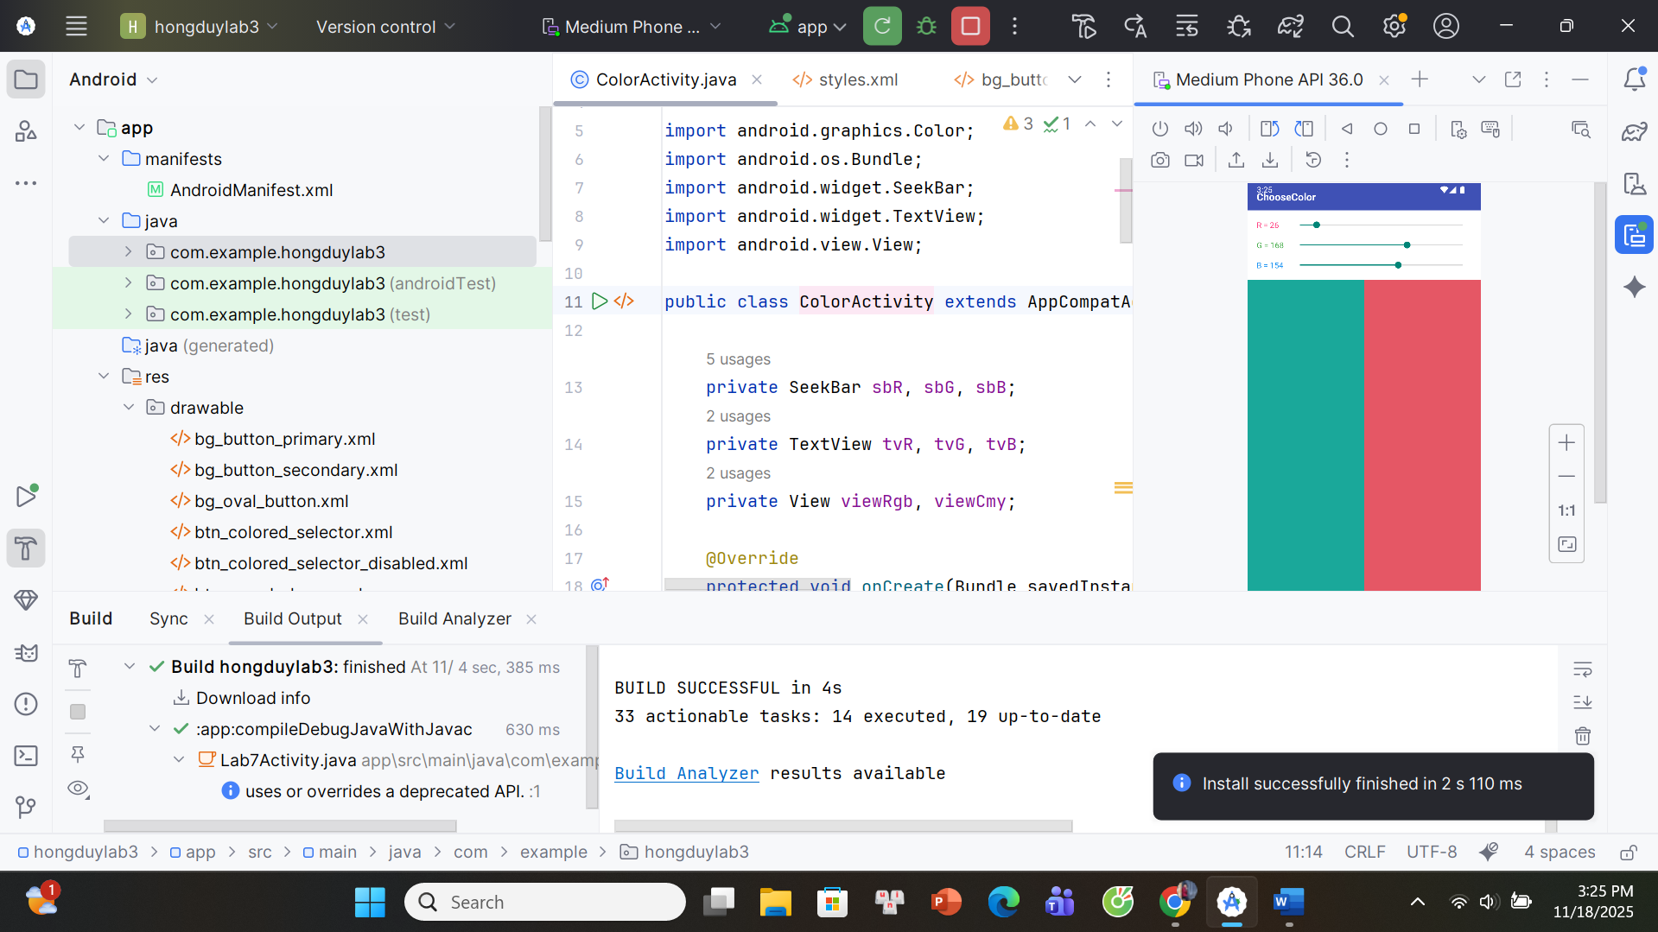

1-Lab7Activity.java
package com.example.hongduylab3;
import androidx.appcompat.app.AppCompatActivity;
import android.app.Dialog;
import android.content.Intent;
import android.os.Bundle;
import android.view.Gravity;
import android.view.LayoutInflater;
import android.view.Window;
import android.view.View;
import android.widget.Button;
import android.widget.EditText;
import android.widget.Toast;
public class Lab7Activity extends AppCompatActivity {
Button btnToast, btnDialog, btnOpenColor;
@Override
protected void onCreate(Bundle savedInstanceState) {
super.onCreate(savedInstanceState);
setContentView(R.layout.activity_lab7);
btnToast = findViewById(R.id.btnToast);
btnDialog = findViewById(R.id.btnDialog);
btnOpenColor = findViewById(R.id.btnOpenColor); // nút mở ChooseColo
btnToast.setOnClickListener(v -> showCustomToast());
btnDialog.setOnClickListener(v -> showLoginDialog());
btnOpenColor.setOnClickListener(v -> {
Intent i = new Intent(Lab7Activity.this, ColorActivity.class);
startActivity(i);
});
}
private void showCustomToast() {
LayoutInflater inflater = getLayoutInflater();
View layout = inflater.inflate(R.layout.toast_custom, null);
Toast toast = new Toast(getApplicationContext());
toast.setDuration(Toast.LENGTH_SHORT);
toast.setView(layout);
toast.setGravity(Gravity.CENTER_HORIZONTAL | Gravity.CENTER_VERTICAL, 0, -50);
toast.show();
}
private void showLoginDialog() {
Dialog dialog = new Dialog(this);
dialog.requestWindowFeature(Window.FEATURE_NO_TITLE);
dialog.setContentView(R.layout.dialog_login);
EditText edtUser = dialog.findViewById(R.id.edtUser);
EditText edtPass = dialog.findViewById(R.id.edtPass);
Button btnOk = dialog.findViewById(R.id.btnOk);
Button btnCancel = dialog.findViewById(R.id.btnCancel);
edtUser.setText("admin");
edtPass.setText("123456");
btnCancel.setOnClickListener(v -> dialog.dismiss());
btnOk.setOnClickListener(v -> {
String u = edtUser.getText().toString().trim();
if ("admin".equals(u)) {
Toast.makeText(Lab7Activity.this,
"Đăng nhập: " + u, Toast.LENGTH_SHORT).show();
} else {
Toast.makeText(Lab7Activity.this,
"Sai tài khoản", Toast.LENGTH_SHORT).show();
}
dialog.dismiss();
});
dialog.show();
}
}
2-ColorActivity.java
package com.example.hongduylab3;
import androidx.appcompat.app.AppCompatActivity;
import android.graphics.Color;
import android.os.Bundle;
import android.widget.SeekBar;
import android.widget.TextView;
import android.view.View;
public class ColorActivity extends AppCompatActivity {
private SeekBar sbR, sbG, sbB;
private TextView tvR, tvG, tvB;
private View viewRgb, viewCmy;
@Override
protected void onCreate(Bundle savedInstanceState) {
super.onCreate(savedInstanceState);
setContentView(R.layout.activity_color);
sbR = findViewById(R.id.sbR);
sbG = findViewById(R.id.sbG);
sbB = findViewById(R.id.sbB);
tvR = findViewById(R.id.tvR);
tvG = findViewById(R.id.tvG);
tvB = findViewById(R.id.tvB);
viewRgb = findViewById(R.id.viewRgb);
viewCmy = findViewById(R.id.viewCmy);
sbR.setMax(255);
sbG.setMax(255);
sbB.setMax(255);
sbR.setProgress(26);
sbG.setProgress(168);
sbB.setProgress(16);
SeekBar.OnSeekBarChangeListener listener = new SeekBar.OnSeekBarChangeListener() {
@Override public void onProgressChanged(SeekBar seekBar, int progress, boolean fromUser) {
updateColor();
}
@Override public void onStartTrackingTouch(SeekBar seekBar) { }
@Override public void onStopTrackingTouch(SeekBar seekBar) { }
};
sbR.setOnSeekBarChangeListener(listener);
sbG.setOnSeekBarChangeListener(listener);
sbB.setOnSeekBarChangeListener(listener);
updateColor();
}
private void updateColor() {
int r = sbR.getProgress();
int g = sbG.getProgress();
int b = sbB.getProgress();
tvR.setText("R = " + r);
tvG.setText("G = " + g);
tvB.setText("B = " + b);
int rgb = Color.rgb(r, g, b);
viewRgb.setBackgroundColor(rgb);
int c = 255 - r;
int m = 255 - g;
int y = 255 - b;
int cmy = Color.rgb(c, m, y);
viewCmy.setBackgroundColor(cmy);
}
}
3-activity_lab7.xml
<?xml version="1.0" encoding="utf-8"?>
<RelativeLayout xmlns:android="http://schemas.android.com/apk/res/android"
android:layout_width="match_parent"
android:layout_height="match_parent"
android:background="#FFFFFF">
<LinearLayout
android:id="@+id/layoutTitleBar"
android:layout_width="match_parent"
android:layout_height="48dp"
android:background="#3F51B5"
android:gravity="center_vertical">
<TextView
android:id="@+id/tvAppTitle"
android:layout_width="wrap_content"
android:layout_height="wrap_content"
android:layout_marginStart="16dp"
android:text="DrawableExample"
android:textColor="#FFFFFF"
android:textSize="18sp"
android:textStyle="bold" />
</LinearLayout>
<LinearLayout
android:orientation="vertical"
android:layout_width="match_parent"
android:layout_height="match_parent"
android:layout_below="@id/layoutTitleBar"
android:padding="16dp">
<LinearLayout
android:layout_width="match_parent"
android:layout_height="wrap_content"
android:orientation="horizontal"
android:gravity="center_vertical">
<TextView
android:layout_width="0dp"
android:layout_height="wrap_content"
android:layout_weight="1"
android:text="Custom Button"
android:textColor="#E53935"
android:textStyle="bold"
android:textSize="20sp"
android:gravity="center" />
<Button
android:id="@+id/btnOpenColor"
android:layout_width="wrap_content"
android:layout_height="wrap_content"
android:text="COLOR"
android:textAllCaps="true"
android:textSize="12sp"
android:background="@drawable/btn_round_shape"
android:layout_marginStart="8dp" />
</LinearLayout>
<LinearLayout
android:layout_width="match_parent"
android:layout_height="wrap_content"
android:orientation="horizontal"
android:layout_marginTop="16dp">
<TextView
android:layout_width="0dp"
android:layout_height="wrap_content"
android:layout_weight="1"
android:text="Selectors"
android:textStyle="bold"
android:textSize="14sp"
android:gravity="center" />
<TextView
android:layout_width="0dp"
android:layout_height="wrap_content"
android:layout_weight="1"
android:text="Shapes+Selectors"
android:textStyle="bold"
android:textSize="14sp"
android:gravity="center" />
</LinearLayout>
<LinearLayout
android:layout_width="match_parent"
android:layout_height="wrap_content"
android:orientation="horizontal"
android:layout_marginTop="8dp">
<LinearLayout
android:layout_width="0dp"
android:layout_height="wrap_content"
android:layout_weight="1"
android:orientation="vertical">
<Button
android:layout_width="match_parent"
android:layout_height="wrap_content"
android:text="COLORED SELECTOR"
android:textAllCaps="true"
android:textSize="12sp"
android:background="@drawable/btn_colored_selector" />
<Button
android:layout_width="match_parent"
android:layout_height="wrap_content"
android:text="COLOR SELECTOR
DISABLED"
android:textAllCaps="true"
android:textSize="12sp"
android:background="@drawable/btn_colored_selector_disabled"
android:enabled="false"
android:layout_marginTop="8dp" />
</LinearLayout>
<LinearLayout
android:layout_width="0dp"
android:layout_height="wrap_content"
android:layout_weight="1"
android:orientation="vertical">
<Button
android:layout_width="match_parent"
android:layout_height="wrap_content"
android:text="ROUND SHAPE"
android:textAllCaps="true"
android:textSize="12sp"
android:background="@drawable/btn_round_shape" />
<Button
android:layout_width="match_parent"
android:layout_height="wrap_content"
android:text="SHAPE WITH GRADIENT"
android:textAllCaps="true"
android:textSize="12sp"
android:background="@drawable/btn_shape_gradient"
android:layout_marginTop="8dp" />
<Button
android:layout_width="match_parent"
android:layout_height="wrap_content"
android:text="SELECTOR SHAPE"
android:textAllCaps="true"
android:textSize="12sp"
android:background="@drawable/btn_selector_shape"
android:layout_marginTop="8dp" />
</LinearLayout>
</LinearLayout>
<LinearLayout
android:layout_width="match_parent"
android:layout_height="wrap_content"
android:orientation="horizontal"
android:gravity="center_vertical"
android:layout_marginTop="16dp">
<ImageView
android:layout_width="48dp"
android:layout_height="48dp"
android:src="@mipmap/ic_launcher" />
<ImageView
android:layout_width="48dp"
android:layout_height="48dp"
android:src="@mipmap/ic_launcher"
android:layout_marginStart="16dp" />
</LinearLayout>
<LinearLayout
android:layout_width="match_parent"
android:layout_height="wrap_content"
android:orientation="horizontal"
android:gravity="center"
android:layout_marginTop="40dp">
<Button
android:id="@+id/btnToast"
android:layout_width="0dp"
android:layout_height="48dp"
android:layout_weight="1"
android:text="TOAST"
android:textAllCaps="true"
android:textColor="#FFFFFF"
android:background="@drawable/bg_oval_button"
android:layout_marginEnd="8dp" />
<Button
android:id="@+id/btnDialog"
android:layout_width="0dp"
android:layout_height="48dp"
android:layout_weight="1"
android:text="DIALOG"
android:textAllCaps="true"
android:textColor="#FFFFFF"
android:background="@drawable/bg_oval_button"
android:layout_marginStart="8dp" />
</LinearLayout>
<TextView
android:layout_width="match_parent"
android:layout_height="wrap_content"
android:text="Made by Phạm Hồng Duy"
android:textSize="12sp"
android:textColor="#3F51B5"
android:gravity="center"
android:layout_marginTop="16dp" />
</LinearLayout>
</RelativeLayout>
4-toast_custom.xml
<?xml version="1.0" encoding="utf-8"?>
<LinearLayout xmlns:android="http://schemas.android.com/apk/res/android"
android:orientation="horizontal"
android:layout_width="wrap_content"
android:layout_height="wrap_content"
android:background="#1565C0"
android:padding="8dp">
<ImageView
android:layout_width="24dp"
android:layout_height="24dp"
android:src="@mipmap/ic_launcher" />
<TextView
android:layout_width="wrap_content"
android:layout_height="wrap_content"
android:layout_marginStart="8dp"
android:text="Custom Toast, made by Phạm Hồng Duy"
android:textColor="#FFFFFF"
android:textSize="14sp" />
</LinearLayout>
5-activity_color.xml
<?xml version="1.0" encoding="utf-8"?>
<LinearLayout xmlns:android="http://schemas.android.com/apk/res/android"
android:orientation="vertical"
android:layout_width="match_parent"
android:layout_height="match_parent"
android:background="#FFFFFF">
<LinearLayout
android:layout_width="match_parent"
android:layout_height="48dp"
android:background="#3F51B5"
android:gravity="center_vertical">
<TextView
android:layout_width="wrap_content"
android:layout_height="wrap_content"
android:layout_marginStart="16dp"
android:text="ChooseColor"
android:textColor="#FFFFFF"
android:textSize="18sp"
android:textStyle="bold" />
</LinearLayout>
<LinearLayout
android:layout_width="match_parent"
android:layout_height="wrap_content"
android:orientation="vertical"
android:padding="16dp">
<LinearLayout
android:layout_width="match_parent"
android:layout_height="wrap_content"
android:orientation="horizontal"
android:gravity="center_vertical">
<TextView
android:id="@+id/tvR"
android:layout_width="60dp"
android:layout_height="wrap_content"
android:text="R = 0"
android:textColor="#FF4081" />
<SeekBar
android:id="@+id/sbR"
android:layout_width="0dp"
android:layout_height="wrap_content"
android:layout_weight="1" />
</LinearLayout>
<LinearLayout
android:layout_width="match_parent"
android:layout_height="wrap_content"
android:orientation="horizontal"
android:gravity="center_vertical"
android:layout_marginTop="16dp">
<TextView
android:id="@+id/tvG"
android:layout_width="60dp"
android:layout_height="wrap_content"
android:text="G = 0"
android:textColor="#4CAF50" />
<SeekBar
android:id="@+id/sbG"
android:layout_width="0dp"
android:layout_height="wrap_content"
android:layout_weight="1" />
</LinearLayout>
<LinearLayout
android:layout_width="match_parent"
android:layout_height="wrap_content"
android:orientation="horizontal"
android:gravity="center_vertical"
android:layout_marginTop="16dp">
<TextView
android:id="@+id/tvB"
android:layout_width="60dp"
android:layout_height="wrap_content"
android:text="B = 0"
android:textColor="#2196F3" />
<SeekBar
android:id="@+id/sbB"
android:layout_width="0dp"
android:layout_height="wrap_content"
android:layout_weight="1" />
</LinearLayout>
</LinearLayout>
<LinearLayout
android:layout_width="match_parent"
android:layout_height="0dp"
android:layout_weight="1"
android:orientation="horizontal">
<View
android:id="@+id/viewRgb"
android:layout_width="0dp"
android:layout_height="match_parent"
android:layout_weight="1"
android:background="#00FF00" />
<View
android:id="@+id/viewCmy"
android:layout_width="0dp"
android:layout_height="match_parent"
android:layout_weight="1"
android:background="#FF00FF" />
</LinearLayout>
</LinearLayout>
6-custom_button
<?xml version="1.0" encoding="utf-8"?>
<selector xmlns:android="http://schemas.android.com/apk/res/android">
<item android:state_pressed="true">
<shape android:shape="rectangle">
<corners android:radius="24dp" />
<gradient
android:startColor="#1976D2"
android:endColor="#0D47A1"
android:angle="90" />
<padding
android:left="16dp"
android:top="10dp"
android:right="16dp"
android:bottom="10dp" />
</shape>
</item>
<item>
<shape android:shape="rectangle">
<corners android:radius="24dp" />
<gradient
android:startColor="#2196F3"
android:endColor="#1976D2"
android:angle="90" />
<padding
android:left="16dp"
android:top="10dp"
android:right="16dp"
android:bottom="10dp" />
</shape>
</item>
</selector>
<?xml version="1.0" encoding="utf-8"?>
<selector xmlns:android="http://schemas.android.com/apk/res/android">
<item android:state_pressed="true">
<shape android:shape="rectangle">
<corners android:radius="24dp" />
<solid android:color="#00796B" />
<padding
android:left="16dp"
android:top="10dp"
android:right="16dp"
android:bottom="10dp" />
</shape>
</item>
<item>
<shape android:shape="rectangle">
<corners android:radius="24dp" />
<solid android:color="#009688" />
<padding
android:left="16dp"
android:top="10dp"
android:right="16dp"
android:bottom="10dp" />
</shape>
</item>
</selector>
<?xml version="1.0" encoding="utf-8"?>
<selector xmlns:android="http://schemas.android.com/apk/res/android">
<item android:state_pressed="true">
<shape android:shape="oval">
<solid android:color="#1565C0" />
</shape>
</item>
<item>
<shape android:shape="oval">
<solid android:color="#1E88E5" />
</shape>
</item>
</selector>
<?xml version="1.0" encoding="utf-8"?>
<selector xmlns:android="http://schemas.android.com/apk/res/android">
<item android:state_pressed="true">
<shape>
<corners android:radius="4dp" />
<solid android:color="#00796B" />
</shape>
</item>
<item>
<shape>
<corners android:radius="4dp" />
<solid android:color="#00BCD4" />
</shape>
</item>
</selector>
<?xml version="1.0" encoding="utf-8"?>
<selector xmlns:android="http://schemas.android.com/apk/res/android">
<item android:state_enabled="false">
<shape>
<corners android:radius="4dp" />
<solid android:color="#FFEB3B" />
</shape>
</item>
<item>
<shape>
<corners android:radius="4dp" />
<solid android:color="#FFC107" />
</shape>
</item>
</selector>
<?xml version="1.0" encoding="utf-8"?>
<shape xmlns:android="http://schemas.android.com/apk/res/android"
android:shape="rectangle">
<corners android:radius="20dp" />
<solid android:color="#FFFFFF" />
<stroke
android:width="2dp"
android:color="#000000" />
</shape>
<?xml version="1.0" encoding="utf-8"?>
<selector xmlns:android="http://schemas.android.com/apk/res/android">
<item android:state_pressed="true">
<shape android:shape="rectangle">
<corners android:radius="4dp" />
<solid android:color="#D32F2F" />
<stroke
android:width="2dp"
android:color="#000000" />
</shape>
</item>
<item>
<shape android:shape="rectangle">
<corners android:radius="4dp" />
<solid android:color="#F44336" />
<stroke
android:width="2dp"
android:color="#000000" />
</shape>
</item>
</selector>
<?xml version="1.0" encoding="utf-8"?>
<shape xmlns:android="http://schemas.android.com/apk/res/android"
android:shape="rectangle">
<corners android:radius="4dp" />
<gradient
android:startColor="#4CAF50"
android:endColor="#2E7D32"
android:angle="90" />
<stroke
android:width="2dp"
android:color="#000000" />
</shape>

LAB 8
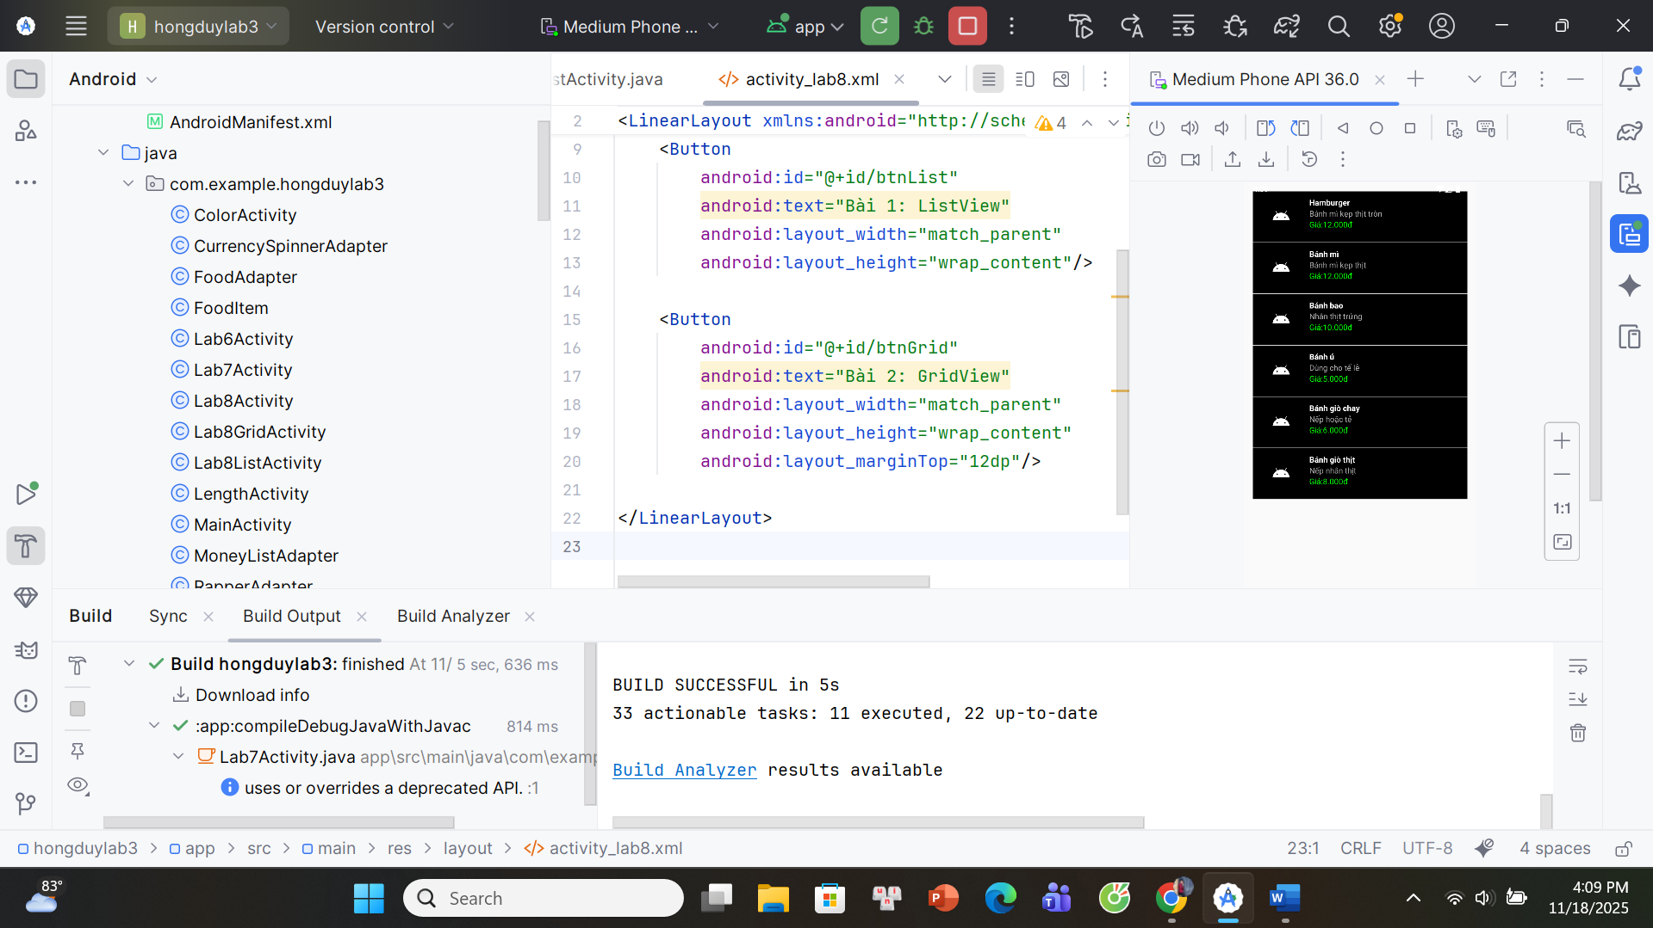
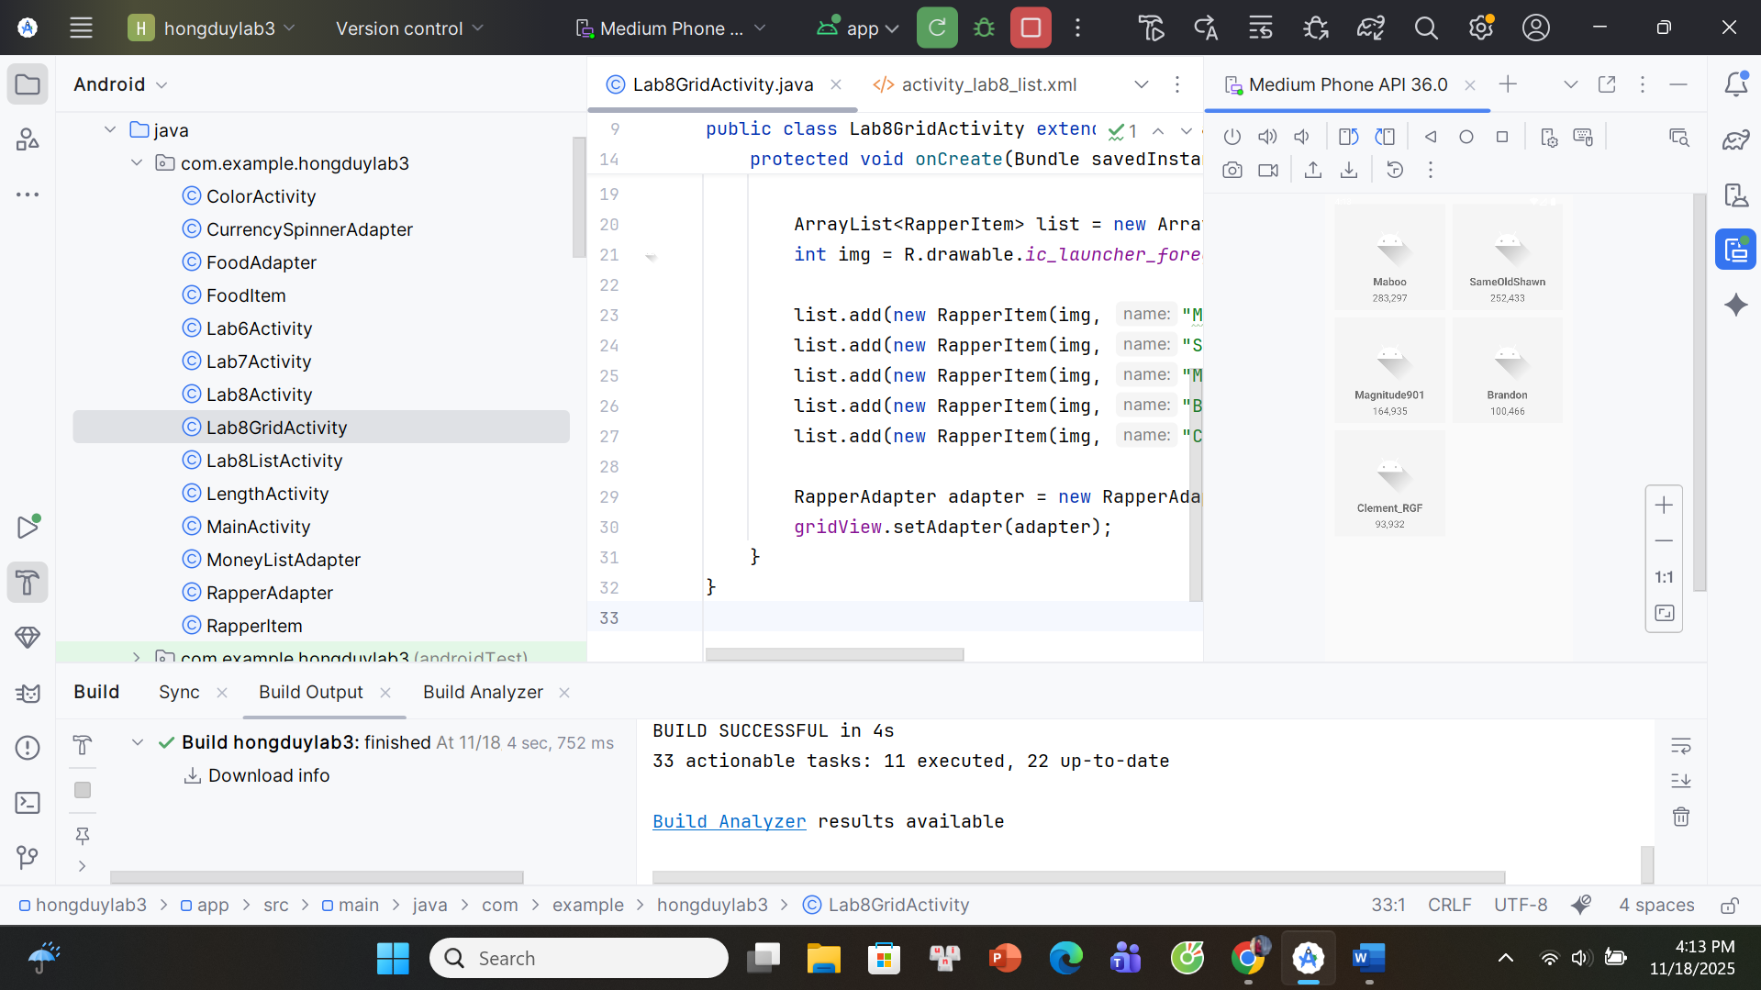
1-Lab8Activity.java
package com.example.hongduylab3;

import androidx.appcompat.app.AppCompatActivity;
import android.os.Bundle;
import android.content.Intent;
public class Lab8Activity extends AppCompatActivity {
@Override
protected void onCreate(Bundle savedInstanceState) {
super.onCreate(savedInstanceState);
setContentView(R.layout.activity_lab8);
findViewById(R.id.btnList).setOnClickListener(v ->
startActivity(new Intent(this, Lab8ListActivity.class)));
findViewById(R.id.btnGrid).setOnClickListener(v ->
startActivity(new Intent(this, Lab8GridActivity.class)));
}
}
2-Lab8ListActivity.java
package com.example.hongduylab3;
import androidx.appcompat.app.AppCompatActivity;
import android.os.Bundle;
import android.widget.ListView;
import java.util.ArrayList;
public class Lab8ListActivity extends AppCompatActivity {
ListView lvFood;
@Override
protected void onCreate(Bundle savedInstanceState) {
super.onCreate(savedInstanceState);
setContentView(R.layout.activity_lab8_list);
lvFood = findViewById(R.id.lvFood);
ArrayList<FoodItem> list = new ArrayList<>();
int img = R.drawable.food;
list.add(new FoodItem(img, "Hamburger", "Bánh mì kẹp thịt tròn", "Giá:12.000đ"));
list.add(new FoodItem(img, "Bánh mì", "Bánh mì kẹp thịt", "Giá:12.000đ"));
list.add(new FoodItem(img, "Bánh bao", "Nhân thịt trứng", "Giá:10.000đ"));
list.add(new FoodItem(img, "Bánh ú", "Dùng cho tế lễ", "Giá:5.000đ"));
list.add(new FoodItem(img, "Bánh giò chay", "Nếp hoặc tẻ", "Giá:6.000đ"));
list.add(new FoodItem(img, "Bánh giò thịt", "Nếp nhân thịt", "Giá:8.000đ"));
FoodAdapter adapter = new FoodAdapter(this, list);
lvFood.setAdapter(adapter);
}
}
3-Lab8GridActivity.java
package com.example.hongduylab3;
import androidx.appcompat.app.AppCompatActivity;
import android.os.Bundle;
import android.widget.GridView;
import java.util.ArrayList;
public class Lab8GridActivity extends AppCompatActivity {
GridView gridView
@Override
protected void onCreate(Bundle savedInstanceState) {
super.onCreate(savedInstanceState);
setContentView(R.layout.activity_lab8_grid);
gridView = findViewById(R.id.gridRapper);
ArrayList<RapperItem> list = new ArrayList<>();
int img = R.drawable.rapper;
list.add(new RapperItem(img, "Maboo", "283,297"));
list.add(new RapperItem(img, "SameOldShawn", "252,433"));
list.add(new RapperItem(img, "Magnitude901", "164,935"));
list.add(new RapperItem(img, "Brandon", "100,466"));
list.add(new RapperItem(img, "Clement_RGF", "93,932"));
list.add(new RapperItem(img, "Nebja", "84,187"));
list.add(new RapperItem(img, "BBDS", "81,762"));
list.add(new RapperItem(img, "PleaseDe-ModMe", "79,243"));
list.add(new RapperItem(img, "DLizzle", "76,331"));
list.add(new RapperItem(img, "palacelight", "75,497"));
list.add(new RapperItem(img, "TheDarkKnight", "69,138"));
list.add(new RapperItem(img, "hellrel", "68,903"));
RapperAdapter adapter = new RapperAdapter(this, list);
gridView.setAdapter(adapter);
}
}
4-FoodAdapter
package com.example.hongduylab3;
import android.content.Context;
import android.view.*;
import android.widget.*;
import java.util.ArrayList;
public class FoodAdapter extends BaseAdapter {
Context context;
ArrayList<FoodItem> data;
public FoodAdapter(Context ctx, ArrayList<FoodItem> list) {
context = ctx;
data = list;
}
@Override
public int getCount() { return data.size(); }
@Override
public Object getItem(int position) { return data.get(position); }
@Override
public long getItemId(int position) { return position; }
@Override
public View getView(int position, View convertView, ViewGroup parent) {
if (convertView == null) {
convertView = LayoutInflater.from(context)
.inflate(R.layout.item_food, parent, false);
}
FoodItem item = data.get(position);
ImageView img = convertView.findViewById(R.id.imgFood);
TextView tvName = convertView.findViewById(R.id.tvName);
TextView tvDesc = convertView.findViewById(R.id.tvDesc);
TextView tvPrice = convertView.findViewById(R.id.tvPrice);
img.setImageResource(item.imageRes);
tvName.setText(item.name);
tvDesc.setText(item.desc);
tvPrice.setText(item.priceText);
return convertView;
}
}
5-FoodItem.java
package com.example.hongduylab3;
public class FoodItem {
public int imageRes;
public String name, desc, priceText;
public FoodItem(int imageRes, String name, String desc, String priceText) {
this.imageRes = imageRes;
this.name = name;
this.desc = desc;
this.priceText = priceText;
}
}
6-activity_lab8.xml
<?xml version="1.0" encoding="utf-8"?>
<LinearLayout xmlns:android="http://schemas.android.com/apk/res/android"
android:orientation="vertical"
android:padding="20dp"
android:gravity="center"
android:layout_width="match_parent"
android:layout_height="match_parent">
<Button
android:id="@+id/btnList"
android:text="Bài 1: ListView"
android:layout_width="match_parent"
android:layout_height="wrap_content"/>
<Button
android:id="@+id/btnGrid"
android:text="Bài 2: GridView"
android:layout_width="match_parent"
android:layout_height="wrap_content"
android:layout_marginTop="12dp"/>
</LinearLayout>
7-activity_lab8_list.xml
<?xml version="1.0" encoding="utf-8"?>
<LinearLayout xmlns:android="http://schemas.android.com/apk/res/android"
android:orientation="vertical"
android:padding="16dp"
android:layout_width="match_parent"
android:layout_height="match_parent">
<ListView
android:id="@+id/lvFood"
android:layout_width="match_parent"
android:layout_height="match_parent" />
</LinearLayout>
8-activity_lab8_grid.xml
<?xml version="1.0" encoding="utf-8"?>
<LinearLayout xmlns:android="http://schemas.android.com/apk/res/android"
android:layout_width="match_parent"
android:layout_height="match_parent"
android:orientation="vertical"
android:padding="16dp">
<GridView
android:id="@+id/gridRapper"
android:layout_width="match_parent"
android:layout_height="match_parent"
android:numColumns="2"
android:verticalSpacing="12dp"
android:horizontalSpacing="12dp"
android:stretchMode="columnWidth" />
</LinearLayout>
9-item_food.xml
<?xml version="1.0" encoding="utf-8"?>
<RelativeLayout xmlns:android="http://schemas.android.com/apk/res/android"
android:padding="10dp"
android:layout_width="match_parent"
android:layout_height="90dp"
android:background="#000">
<ImageView
android:id="@+id/imgFood"
android:src="@drawable/ic_launcher_foreground"
android:layout_width="80dp"
android:layout_height="80dp" />
<TextView
android:id="@+id/tvName"
android:text="Tên món"
android:textColor="#FFF"
android:textStyle="bold"
android:layout_toRightOf="@id/imgFood"
android:layout_marginLeft="10dp"
android:layout_width="wrap_content"
android:layout_height="wrap_content"/>
<TextView
android:id="@+id/tvDesc"
android:text="Mô tả"
android:textColor="#AAA"
android:layout_below="@id/tvName"
android:layout_toRightOf="@id/imgFood"
android:layout_marginLeft="10dp"
android:layout_width="wrap_content"
android:layout_height="wrap_content"/>
<TextView
android:id="@+id/tvPrice"
android:text="Giá"
android:textColor="#00FF00"
android:layout_below="@id/tvDesc"
android:layout_toRightOf="@id/imgFood"
android:layout_marginLeft="10dp"
android:layout_width="wrap_content"
android:layout_height="wrap_content"/>
</RelativeLayout>
10-item_rapper.xml
<?xml version="1.0" encoding="utf-8"?>
<LinearLayout xmlns:android="http://schemas.android.com/apk/res/android"
android:orientation="horizontal"
android:padding="10dp"
android:background="#000"
android:layout_width="match_parent"
android:gravity="center_vertical"
android:layout_height="wrap_content">
<ImageView
android:id="@+id/imgRapper"
android:layout_width="60dp"
android:layout_height="60dp"
android:src="@drawable/ic_launcher_foreground" />
<LinearLayout
android:orientation="vertical"
android:layout_marginLeft="10dp"
android:layout_width="wrap_content"
android:layout_height="wrap_content">
<TextView
android:id="@+id/tvRapperName"
android:text="Name"
android:textColor="#9C27B0"
android:textStyle="bold"
android:textSize="17sp" />
<TextView
android:id="@+id/tvScore"
android:text="123,456"
android:textColor="#FFC107" />
</LinearLayout>
</LinearLayout>
11-Lab8GridActivity.java
package com.example.hongduylab3;
import androidx.appcompat.app.AppCompatActivity;
import android.os.Bundle;
import android.widget.GridView;
import java.util.ArrayList;
public class Lab8GridActivity extends AppCompatActivity {
GridView gridView;
@Override
protected void onCreate(Bundle savedInstanceState) {
super.onCreate(savedInstanceState);
setContentView(R.layout.activity_lab8_grid);
gridView = findViewById(R.id.gridRapper);
ArrayList<RapperItem> list = new ArrayList<>();
int img = R.drawable.ic_launcher_foreground;
list.add(new RapperItem(img, "Maboo", "283,297"));
list.add(new RapperItem(img, "SameOldShawn", "252,433"));
list.add(new RapperItem(img, "Magnitude901", "164,935"));
list.add(new RapperItem(img, "Brandon", "100,466"));
list.add(new RapperItem(img, "Clement_RGF", "93,932"));
RapperAdapter adapter = new RapperAdapter(this, list);
gridView.setAdapter(adapter);
}
}
12-RapperAdapter.java
package com.example.hongduylab3;
import android.content.Context;
import android.view.View;
import android.view.ViewGroup;
import android.view.LayoutInflater;
import android.widget.BaseAdapter;
import android.widget.ImageView;
import android.widget.TextView;
import java.util.ArrayList;
public class RapperAdapter extends BaseAdapter {
Context context;
ArrayList<RapperItem> list;
public RapperAdapter(Context c, ArrayList<RapperItem> l) {
context = c;
list = l;
}
@Override
public int getCount() { return list.size(); }
@Override
public Object getItem(int i) { return list.get(i); }
@Override
public long getItemId(int i) { return i; }
@Override
public View getView(int i, View view, ViewGroup parent) {
view = LayoutInflater.from(context).inflate(R.layout.grid_item, parent, false);
ImageView img = view.findViewById(R.id.imgAvatar);
TextView name = view.findViewById(R.id.tvName);
TextView score = view.findViewById(R.id.tvScore);
RapperItem item = list.get(i);
img.setImageResource(item.img);
name.setText(item.name);
score.setText(item.score);
return view;
}
}
13-RapperItem.java
package com.example.hongduylab3;
public class RapperItem {
int img;
String name, score;
public RapperItem(int img, String name, String score) {
this.img = img;
this.name = name;
this.score = score;
}
}

