Ex1:

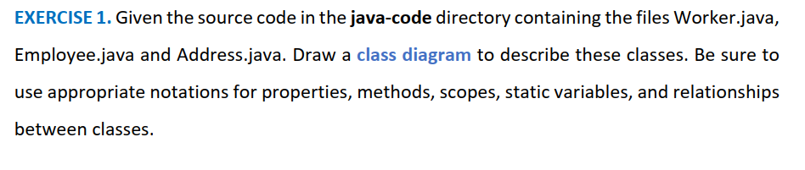

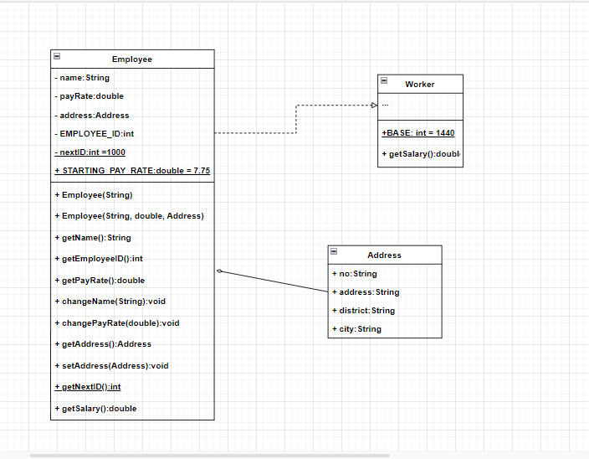

Ex2:

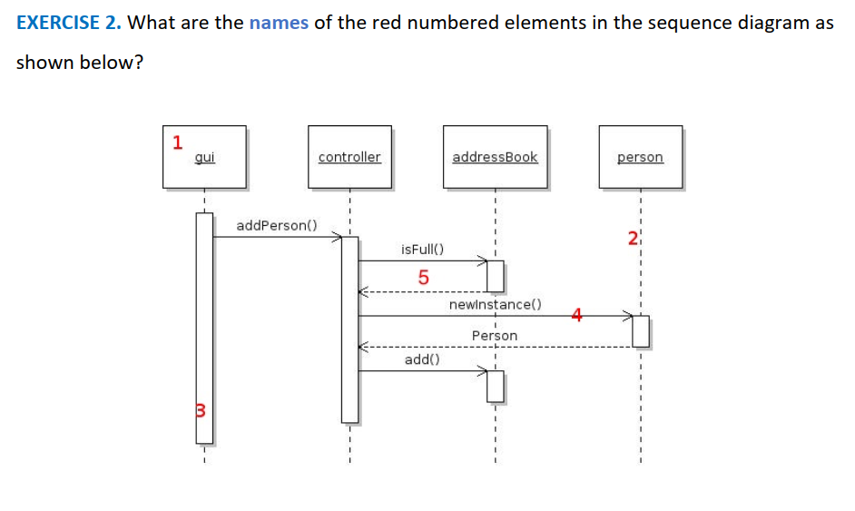

1: Lifeline symbol

2: Object lifeline

3: Activation bar

4: Asynchronous

5: Return message

Ex3:

