* CSDL & init/seed đúng: 2đ

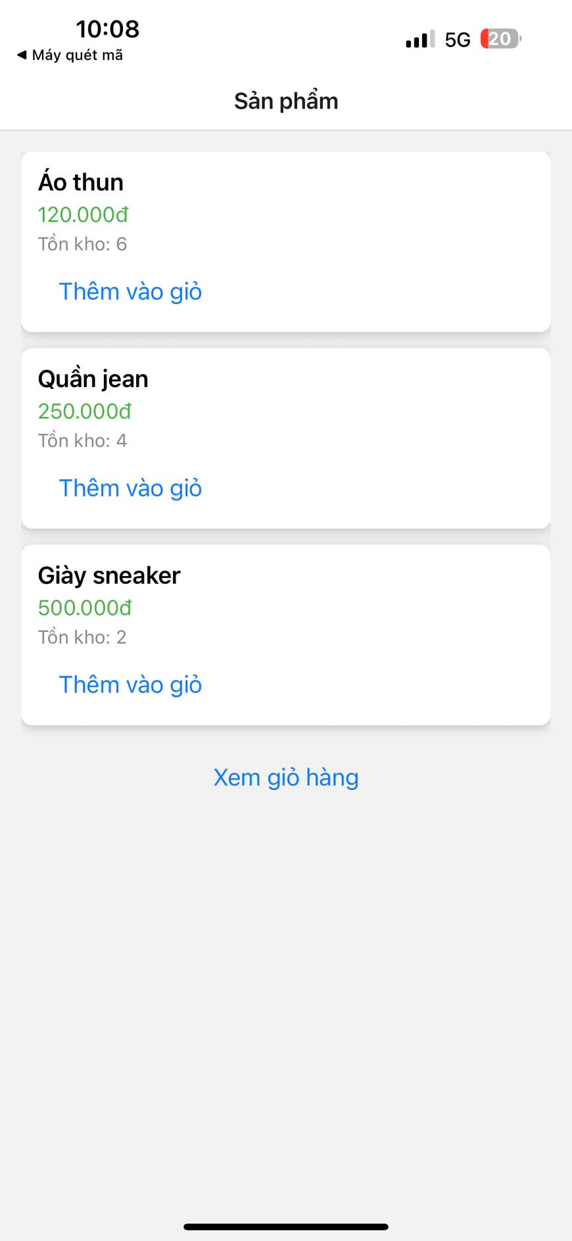

* Trang Sản phẩm & thêm vào giỏ đúng: 2đ

* Trang Giỏ hàng (sửa số lượng/xóa): 2đ

* Trang Hoá đơn & tính tổng: 2đ

* Kiểm tra tồn kho + UX hợp lý: 1đ

* Code sạch (TypeScript, tách repo, chú thích): 1đ

<https://github.com/Duy2801/22678211_NguyenDucDuy_Tuan9>