Test Report

Project: E-commerce Testing mini project by Tduy
Tested by: Thanh Duy
Date: 25/12/2025
---

Summary
This report summarizes the results of testing an E-commerce mock website AutomationExercise.com. The testing process include Manual UI Testing, API Testing and Automation Testing

Testing Result
Total of test cases: 48 (36 UI Test cases + 12 API Test cases)
Number of test cases passed: 37
Number of test cases failed: 11 (6 API + 5 UI )

Bug Report
Total Bugs Found: 18
- 5 Functional Bugs
- 6 API Bugs
- 7 Usability Bugs
High severity: 7
Medium severity: 1
Low severity: 10

Test Scope

In-scope
API Testing: 12 Endpoints (GET list products, POST login/register, DELETE account). API Performance Testing, API Automation Testing
Manual Functional Testing
- Registration & Login Flow.
- Product Search Functionality.
- Shopping Cart (Add, Update, Remove).
- Checkout Process.
Exploratory Testing
Usability Testing
Automation Testing: main flow (create account -> login -> search product -> add to cart -> checkout)

Out-scope
- External links (advertisements)
- Advanced Security Testing (Backend penetration testing)

Test results

API Testing (12 cases)
Number of test cases passed: 6
Number of test cases failed: 6
Main bugs:
- API status code return HTTP 200 for error handling cases (should have returned 400 or 404) due to website’s API design,
- No validation from backend (allowed empty email registration, mobile phone field accepts non-numeric characters…)

Functional Testing (36 cases)
Number of test cases passed: 31
Number of test cases failed: 5
Main bugs:
- Allowed weak password (security)
- Case sensitivity disallowed
- UX error: search bar disappeared when enter a specific category of products
- System allowed user to add an invalidly large product quantities

Usability Testing
Number of bugs found: 7
Main bugs:
- Search function does not trigger on ENTER key (user must click search button)
- Search box disappeared when navigating to specific product category
- Cart does not provide +/- buttons to adjust product quantity, won’t let users choose specific products they want to buy at the time

API Performance Testing
Number of Endpoints: 7
- Get all product
- Get all brands
- Create Account
- Verify login valid
- Seacrh Product
- Delete an Existing Account
- Error Handling invalid endpoint
With Scenario: Get all products → Get all brands → Create account → Verify login → Search product (“top”) → Delete account → Error handling (404)

Smoke Testing
To verify basic flow works as expected
- Threads: 1
- Ramp-up period: 1
- Loop Count: 1
Summary Report
- Total Samples: 7
- Average response time: 0.7 second (min 0.4s, max 1,9s)
- Throughtput: 2.1 requests/second
- Error: 0%

Basic Load testing
To verify performance under expected basic user load.
- Threads: 10
- Ramp-up period: 20
- Loop Count: 1
Summary Report
- Total Samples: 70
- Average response time: 0.95 second (min 0.5s, max 2.9s)
- Throughtput: 1.9 requests/second
- Error: 0%
=> Basic load test with 10 virtual users (20s ramp-up, 1 loop) completed successfully with 0% errors. Average response times remain under 1s for all APIs except Get all products (~2.2s) due to larger payload.
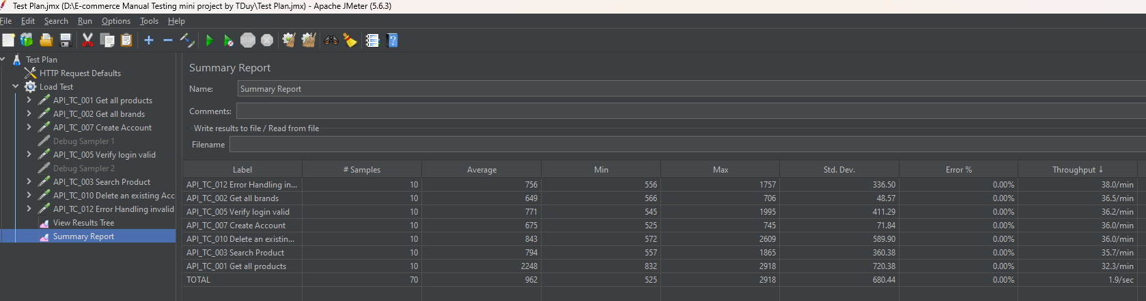

Endurance Testing (mini)
To Verify performance over extended periods ~= 28 mins
- Threads: 5
- Ramp-up period: 10
- Loop Count: infinite checked
Summary Report
- Total Samples: 2170
- Average response time: 1.4 second (min 0.3s, max 125s)
- Throughtput: 1.3 requests/second
- Error: 0.51%
Findings: No performance degradation detected; API remained stable under continuous load.
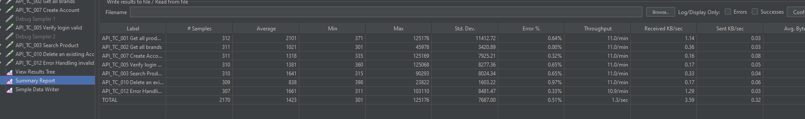

Automation Testing

Cypress + Javascript
Pages folder: contains POM for pages HomePage, SignUp, LogIn, SearchProduct, AddToCart, Checkout
E2E folder: contains test execution file for each POM and a full purchase flow PurchaseFlow.cy.js
Report folder: contains report.html generated from mochawesome

Selenium + Python
Pages folder: contains POM for pages similar to cypress’s pages
Tests folder: contains test execution file and a full purchase flow similar to cypress
Report folder: contains report.html generated from pytest-html

Actual Timeline
Test case design: 24/12/2025 – 26/12/2025
Test Execution : 26/12/2025
API Testing and API Performance Testing: 26/12/2025 – 28/12/2025
Automation Testing with Cypress: 4/1/2025 – 5/1/2025
Automation Testing with Selenium: 5/1/2025 – 7/1/2025
Bug reporting & analysis: from start to finish

