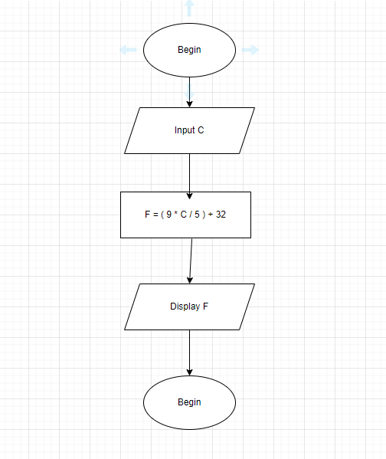BEGIN

INPUT C

F = ( 9 \* C / 5 ) + 32

DISPLAY F

END