**gLab 3, 4**

- URL: http://localhost:3000

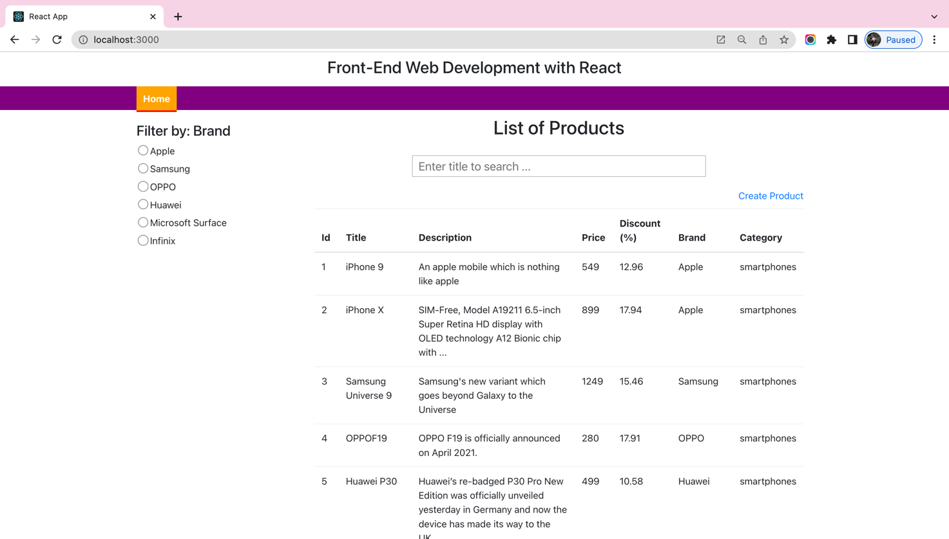

*Figure 1 - Exam result screen 1*

- URL: http://localhost:3000/product/add

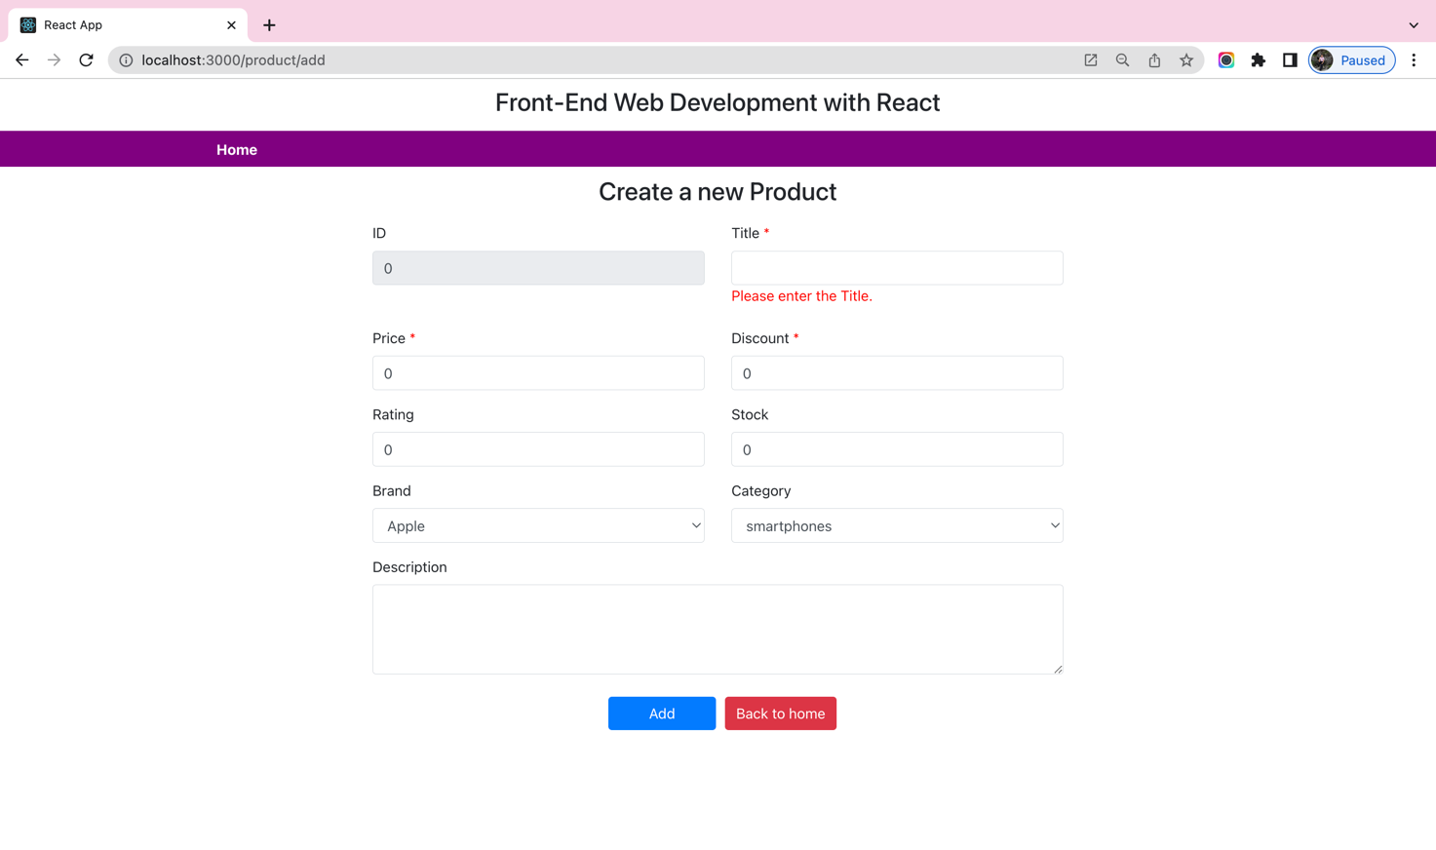

*Figure 2 - Exam result screen 2*

**Requirements:**

**1.** Create a component named “**Header**”:

* The component is designed as follows:



* When the user clicks on the “**Home**” link, will be routed to the URL: http://localhost:3000/

**2.** Create a component named “**Home**” as follows:

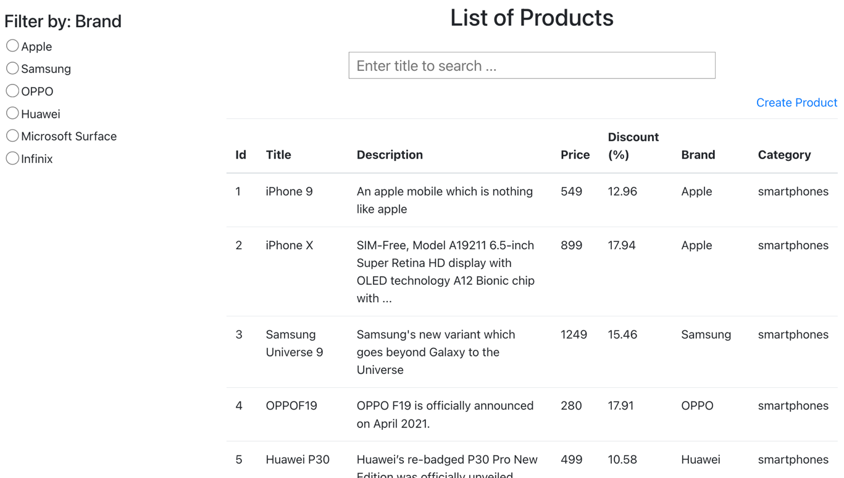

* + Design the appropriate search form and the “**Create product**” link (this link is routed to the URL: **http://localhost:3000/product/add**)

3. Create a component named “**Add**” as follows:

http://localhost/product/add

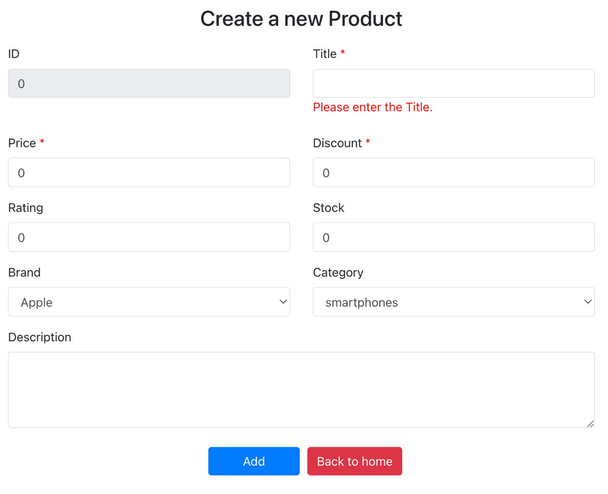

**--- END ---**