Create Matrix

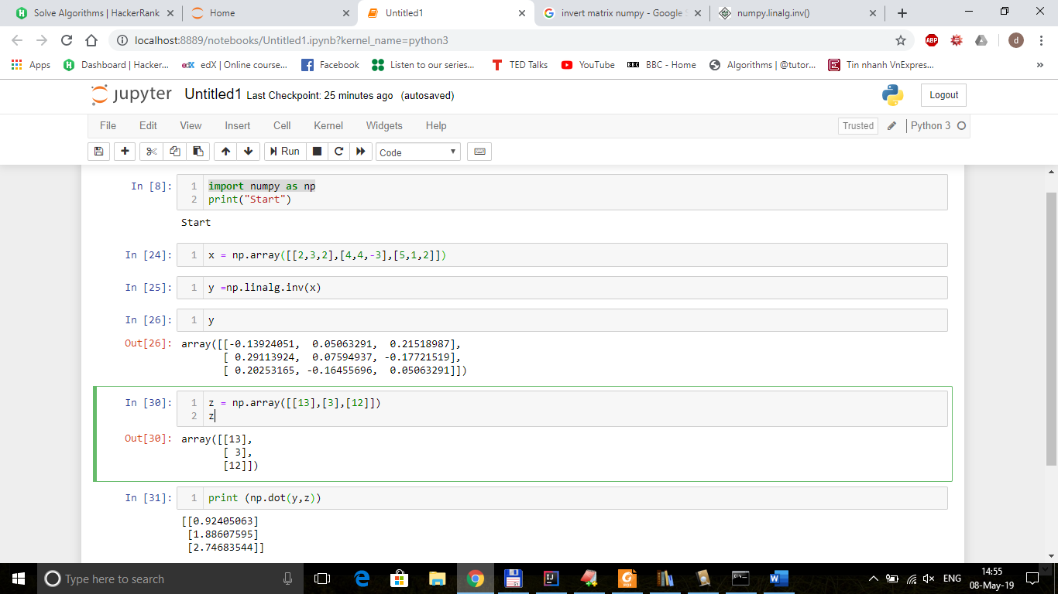

pip install numpy. (Note: On windows  
you must add pip to your PATH environment variables. To avoid this, use python -m pip install <the package  
name>)

