**BÀI BÁO CÁO TUẦN 4**

Họ và tên: Nguyễn Trọng Khánh Duy

MSSV: 20210284

***Assignment 1***

**CODE:**

#Laboratory Exercise 5, Assignment 1

.data

test: .asciiz "Nguyen Trong Khanh Duy"

.text

li $v0, 4 # $v0 = 4

la $a0, test # Dia chi cua test duoc ghi vao $a0

syscall # Loi goi dich vu he thong

**Kết quả:**

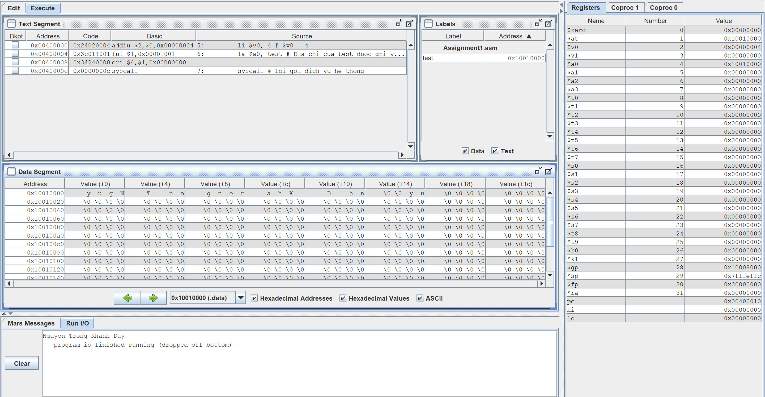

**Nhận xét:** Chuỗi được lưu vào bộ nhớ với thứ tự ngược lại. Và mỗi value sẽ có 4 ký tự.



***Assignment 2***

**CODE:**

#Laboratory Exercise 5, Assignment 2

#Gia su s1 = 11, s2 = 46 => sum = 57

.data

str1: .asciiz "The sum of "

str2: .asciiz " and "

str3: .asciiz " is "

.text

li $s0, 11 # s0 = 11

li $s1, 46 # s1 = 46

li $v0, 4 # $v0 = 4

la $a0, str1 # Dia chi cua str1 duoc ghi vao $a0

syscall

li $v0, 1 # $v0 = 1

add $a0, $s0, $zero # a0 = s0 + 0

syscall

li $v0, 4 # $v0 = 4

la $a0, str2 # Dia chi cua str2 duoc ghi vao $a0

syscall

li $v0, 1 # $v0 = 1

add $a0, $s1, $zero # a0 = s1 + 0

syscall

li $v0, 4 # $v0 = 4

la $a0, str3 # Dia chi cua str3 duoc ghi vao $a0

syscall

add $s2, $s1, $s0 # sum = s2 = s1 + s0

li $v0, 1 # $v0 = 1

add $a0, $s2, $zero # a0 = s2 + 0

syscall

Exit:

li $v0, 10 # $v0 = 10

syscall

**Kết quả:**

***Assignment 3***

**CODE:**

#Laboratory Exercise 5, Assignment 3

.data

x: .space 32 # destination string x, empty

y: .asciiz "Hello" # source string y

.text

strcpy:

add $s0, $zero, $zero # $s0 = i = 0

la $a1, y # $a1 = address of y[i]

la $a0, x # $a0 = address of x[i]

L1:

add $t1, $s0, $a1 # $t1 = $s0 + $a1 = i + y[0]

lb $t2, 0($t1) # $t2 = value at $t1 = y[i]

add $t3, $s0, $a0 # $t3 = $s0 + $a0 = i + x[0]

sb $t2, 0($t3) # x[i]= $t2 = y[i]

beq $t2, $zero, end_of_strcpy # if y[i] == 0, exit

nop

addi $s0, $s0, 1 # $s0 = $s0 + 1 <-> i = i + 1

j L1 # next character

nop

end_of_strcpy:

**Kết quả:**

***Assignment 4***

**CODE:**

#Laboratory Exercise 5, Assignment 4

.data

string: .space 50

Message1: .asciiz "Nhap xau: "

Message2: .asciiz "Do dai xau la: "

.text

main:

get_string:

li $v0, 54

la $a0, Message1

la $a1, string

la $a2, 50

syscall

get_length:

la $a0,string # $a0 = address(string[0])

add $t0, $zero, $zero # $t0 = i = 0

check_char:

add $t1, $a0, $t0 # $t1 = $a0 + $t0

# = address(string[i])

lb $t2, 0($t1) # $t2 = string[i]

beq $t2, $zero, end_of_str # is null char?

addi $t0, $t0, 1 # $t0 = $t0 + 1 -> i = i + 1

j check_char

end_of_str:

end_of_get_length:

print_length:

li $v0, 56

la $a0, Message2

addi $a1, $t0, -1 #Do ký tự cuối là null nên ta phải - 1

syscall

**Kết quả:**

***Assignment 5***

**CODE:**

#Laboratory Exercise 5, Assignment 5

.data

get_char: .space 20

message1: .asciiz "Nhap ky tu thu "

message2: .asciiz ": "

message3: .asciiz "\n"

message4: .asciiz "Chuoi ky tu vua nhap la: "

.text

li $s0, 20 # N = 20

li $s1, 0 # i = 0

la $s2, get_char # Load address of get_char[0]

li $s3, 10 # Char \n in ASCII

read_char:

beq $s1, $s0, end_read_char # i = N branch to exit

# Show message "Nhap ky tu thu i: "

li $v0, 4

la $a0, message1

syscall

addi $t1, $s1, 1

li $v0, 1

move $a0, $t1

syscall

li $v0, 4

la $a0, message2

syscall

li $v0, 12 # Read character

syscall

move $t0, $v0

beq $t0, $s3, end_read_char # Press "Enter" branch to exit

li $v0, 4

la $a0, message3

syscall

add $s5, $s2, $s1 # $s5=Address of get_char[i]=get_char[0]+i

sb $t0, 0($s5) # Store character to get_char[i]

addi $s1, $s1, 1 # i++

j read_char

end_read_char:

li $v0, 4 # Show message4

la $a0, message4

syscall

print_string:

li $v0, 11 # Show ky tu tai dia chi trong $s5

lb $a0, 0($s5)

syscall

beq $s5, $s2, exit # $s5 = address cua ky tu cuoi cung

addi $s5, $s5, -1 # Tien dan den ky tu dau tien

j print_string

exit:

li $v0, 10

syscall

**Kết quả:**

