HWYP Marketing Strategy

# Client Details

|  |  |  |  |
| --- | --- | --- | --- |
| **Name** | **Email** | **Phone** | **Preferred Contact Method** |
| Dianne Loots | loots.dianne@gmail.com | 0481 535 651 |  |

# Mentor Details

|  |  |  |  |
| --- | --- | --- | --- |
| **Name** | **Email** | **Phone** | **Preferred Contact Method** |
| Rachel Chung | rachelc@practera.com |  |  |

# 

# Team Details

|  |  |  |  |
| --- | --- | --- | --- |
| **Name** | **Email** | **Phone** | **Role** |
| Duy Nhan Ta | duynhan2709@gmail.com | 0405552709 | Marketing expert- Presentation coordinator |
| Shannon Wichmann | wichmannshannon@gmail.com | 0415 633 614 | Research & editing- analyst |
| Vanlyda Neang | vanlyda0804@gmail.com | 0452640342 | Subject matter expert |
| Anuj Shukla | aushukla1@gmail.com | 0490693050 | Team leader- Client & team correspondence |
| WENLIN YAO | www8yy@gmail.com | 0426093899 | Report author |

# 

# 

# Project Background - Shannon

* What is the main business situation or challenge which you and your team are looking to answer/research for your Client?

The Horse Whispering Program has been run by volunteers and has been operating primarily in Queensland, Gold Coast for 10 years with the purpose to deliver a life coaching program to youth between the age of 8 and 16 from a variety of disadvantaged backgrounds. The client is seeking to attract a variety of donors/sponsors whom are willing to donate funds to support the Horse Whispering Youth Program which is to be addressed through delivering an effective marketing campaign for the business by developing marketing strategies.

* Why is this challenge/situation important for the company to understand?

This challenge is crucial for the company to understand to insure privacy is being taken into account with the development of marketing strategies and to achieve the goals of the Horse Whispering Program whilst achieving broader coverage to focus on attracting sponsors. Through achieving this marketing challenge, the Program will have the ability to gain sponsorships which will enable them to breakeven and still have some profits to go towards marketing activities and employment costs (To give to the volunteers who aren't paid) along with the prospect for greater expansion in different regions.

Note: There is plenty of attraction to the Horse Whispering Program with referrals but FUNDING is the target from larger donor organisations/businesses which can assist with the necessary funding

# Project Scope

|  |  |  |
| --- | --- | --- |
| **Project Outcomes** | **Key activities to achieve the outcome** | **Activity lead** |
| **Outcome 1- Social media branding platform and strategies** | Below are the strategies to avail Ad Grants and optimizing the current social media platform page.   1. **Ad Grants-** Apply for Google Ad Grants which offers up to $10,000/ month worth of Ad coverage to non-profits. 2. **Optimise Facebook page-** Enable the “Donate” button on the page profile. This will enable donors to quickly navigate the link for donation. 3. **Optimise Donation campaign-** Consider launching monthly donations for small amounts. This will increase in retaining your donors. 4. **Develop a content strategy-** It is a good idea to develop a set of colour coded theme templates and using to post your activities and pictures on Facebook. Further the content can made engaging more by using hashtags. This will give a sense of consistency and will engage the audience.   **P.S.** As per your query, we did our research, and found that unfortunately Facebook does not offer any kind of Ad grants. However, Google Ad Grants is a much better option to avail if your application is successful. | Anuj |
| **Outcome 2 - Specifically Targeting the Sponsors** | Divide potential donors, sponsors into 5 categories:   1. **Focus on Individual Donations:**   Good idea for small and medium sized Organizations like The Horse Whispering Program. Downside of this group is that take time to built relationship with donors but totally worth the time.     1. **In Kind donation (donation of facilities, supplies)**   Cooperate with companies to donate goods or services instead of paycheck   1. **IGrants from foundations (Community foundation)**   Community foundations do have their own grant funds that they disperse which they rely on called donor advised funds. Contact foundations can help the program get a boost to get things started or meet larger fundraising goals.   1. **Earned income( fee for service)**   Selling services or good to raise money for the program. But the income has to align with the mission of the mission of The Horse aWhispering Program. | Duy Nhan Ta |
| **Outcome 3 - Customer insights about target group -** | To set up a suitable marketing strategy of "horse whispering youth program", market questionnaire is an important part. Questionnaire survey can collect different information from a large number of people, and can provide a variety of data for research, and the data is authentic.  There are seven questions in the questionnaire, which are divided into two parts  1) **Structured questionnaires ,** the simplest answer is "yes" or "no".  2) **Unstructured questionnaires**, this type of question is open answer, we can get more specific consumer answers.  The time of the questionnaire is set at 3-4 minutes (including answering the questions of unstructured questionnaires). If the consumers choose not to answer the questions of unstructured questionnaires, it will only take a shorter time. Because people don't want to spend too much time here  The questionnaire software we used is called "surveymonkey", which is a free software. The questionnaire will be placed on different social platforms, such as Facebook, instagram and email  The questions that have been prepared are as follows:   1. **Have you ever heard of Horse Whispering Youth Program?** YES/ NO   PS: The purpose of Question 1 is to know how many people know about the "horse whispering youth program". This question can let us know the market position of the program.   1. **What is your age?**     under 16 years  16-25 years  26-49 years  50-65 years  Over 65 years  PS: The purpose if the question 2 is want to know the target group of our respondent who used to involve with nonprofit organizations   1. **Which state do you live in?**   New South Wales/ Queensland/Victoria/Tasmania/Western Australia/South Australia   1. **In your free time, would you like to be a volunteer or participate in some activities?**   **If your answer is "NO", can you tell us why you can't be a volunteer in your spare time? For example: Take care of the children, Busy with work ？(less than 100 words)**  PS: The purpose of question 4 is mainly to understand how much people in the society are interested in the activities or volunteers of Nonprofit organisations? Why?  If we can know why not so many people are willing to become volunteers in their free time, then maybe we can modify the form of activities in the future.   1. **(Option question) If you live in the gold coast, would you like to be one of the "Horse Whispering Youth Program" volunteers when you are free.**  YES/NO   PS: This question is specific because it's directly about our customers.It is an option question with regional restrictions. Because HWYP mainly provides services in Gold Coast.   1. **If you have ever participated in the activities by Nonprofit organisation, through what platform do you know the activity information?**   Social media (such as: Facebook, Wechat, Instagram)  TV/radio  Charity event  other (please let us know if you can)  PS: The purpose of question 6 is: there are many nonprofit organizations in the society. We can refer to the effective marketing models of other organizations.   1. **Do you have any experience in the activities of Nonprofit organisations? Do you have any suggestions for these activities? (Unlimited words)**   PS: From question 7, we can get different suggestions from different consumers to better improve the future development of horse whispering youth program. | Wenlin Yao |
| **Outcome 4- Organising an event-** | Organise an event which targets and invites Horse lovers to connect with disadvantaged children and try to get media coverage such as Current Affair to promote their NGO which could then attract sponsors with a donate link being on the TV creating greater awareness and attracting donations   * Possible event: Charity horse ride event where there's a workshop with the children they assist for potential visitors to watch, a volunteer booth with the referrals to promote the organisation, a “Donate” booth and food stands to gain public awareness and sponsor awareness of the event (Tell us your story - 9Now).   **Tactical Planning ( Possible event 2)**  - **Event:** Run with horse charity eventwith AU$2 donation challenge  - **Goal:** Fundraising and attracting volunteer  - **Target customer:** Donors**:** social media users with minimum $2 donation, Sponsor: Private company who willing to advertise their brand and build up their reputation along with tax deductions, or public sectors, Volunteer: High School and university student who love running and horse.  - **How:** set up a long-distance marathon event, gathering the marathon volunteers to create that event and promote it on social media to attract the donors just for a minimum AU$2 donation. Ask the donor to post on social media that they have donated $2 to the event to support Horse Whispering Youth Program, in order to attract other donors.  - **Key Success**: easy to donate with a small donation amount and can donate from anywhere.  - **Budget:** To be discussed. However, it should be a small start-up budget.  - **Issue:** the event is successful if it can attract many donors on social media. Thus, the event should be initiative by a well-known person (ex, famous TV-Star) | Lyda & Shannon |
| **Resources required** | Internal resources, data and information required (eg; planning documents, internal stakeholders and customers to interview, performance results, research reports, internal datasets)  Outcome 1: Client eligibility for application, research reports (Success of Google Ads etc.), Template designs  Outcome 2: Performance report on sponsors (Portion of donations to charities), internal data as to current referrals and sponsors,  Outcome 3: Data from the survey to conduct trend analysis, customers to complete it and team members to share on social media.  Outcome 4: Previous performance reports on past events, Media Coverage / Influencer , Small start up budget | |
| **Project Constraints** | Any known dependencies that could constrain the ability of the project team to achieve the project objectives   * Time factor (especially for organising events) * Inadequate information, lack of internal data * Budget * Privacy Laws | |

# Timeline

Below insert a Gantt chart which demonstrates the timeline which you have outlined above. See examples below of Gantt Chart software’s which you may wish to use:

Outcome 1:

Act 1: 12-02-21 to 12-02-21

Act 2: 12-02-21 to 12-02-21

Act 3: 13-02-21 to 13-02-21

Act 4: 14-02-21 to 16-02-21

Outcome 2:

Act 1: 12-02-21 to 14-02-21

Act 2: 15-02-21 to 16-02-21

Act 3: 17-02-21 to 19-02-21

Act 4: 19-02-21 to 21-02-21

Outcome 3:

Act 1: 12-02-21 to 19-02-21

Act 2: 19-02-21 to 23-02-21

Outcome 4:

Act 1: 12-02-21 to 16-02-21

Act 2: 16-02-21 to 20-02-21

Act 3: 20-02-21 to 23-02-21

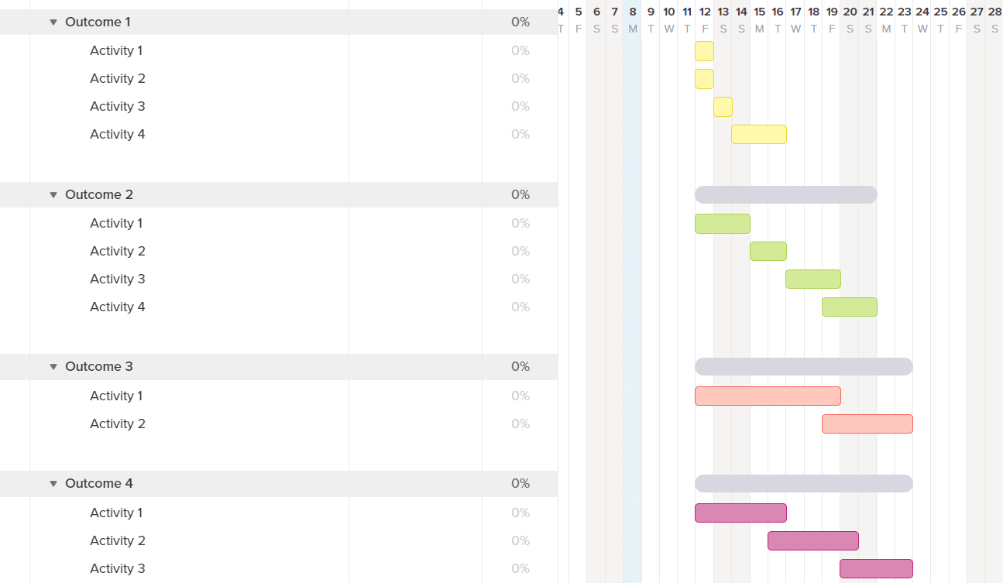

# Meeting Dates/Times/Venues

Provide details of the meeting dates, times and venues which you have arranged with your Client and Mentor. Remember to send a calendar invite!

|  |  |
| --- | --- |
| **Mentor Meetings**: | **Client Meetings**: |
| Week 1: Thur-11-Feb-2021 9:30am, Zoom meeting | Week 1: Thur-11-Feb-2021 10:30am, Zoom meeting |
| Week 2: Thur-18-Feb-2021 9:30am, Zoom meeting | Week 2: Thur-18-Feb-2021 10:30am, Zoom meeting |
| Week 3: Wed-24-Feb-2021 9:30am, Zoom meeting | Week 3: Wed-24-Feb-2021 10:30am, Zoom meeting |
| Final Presentation: Tentative Time & Date | Final Presentation: Thur-25-Feb-2021 9:30am, Zoom meeting |