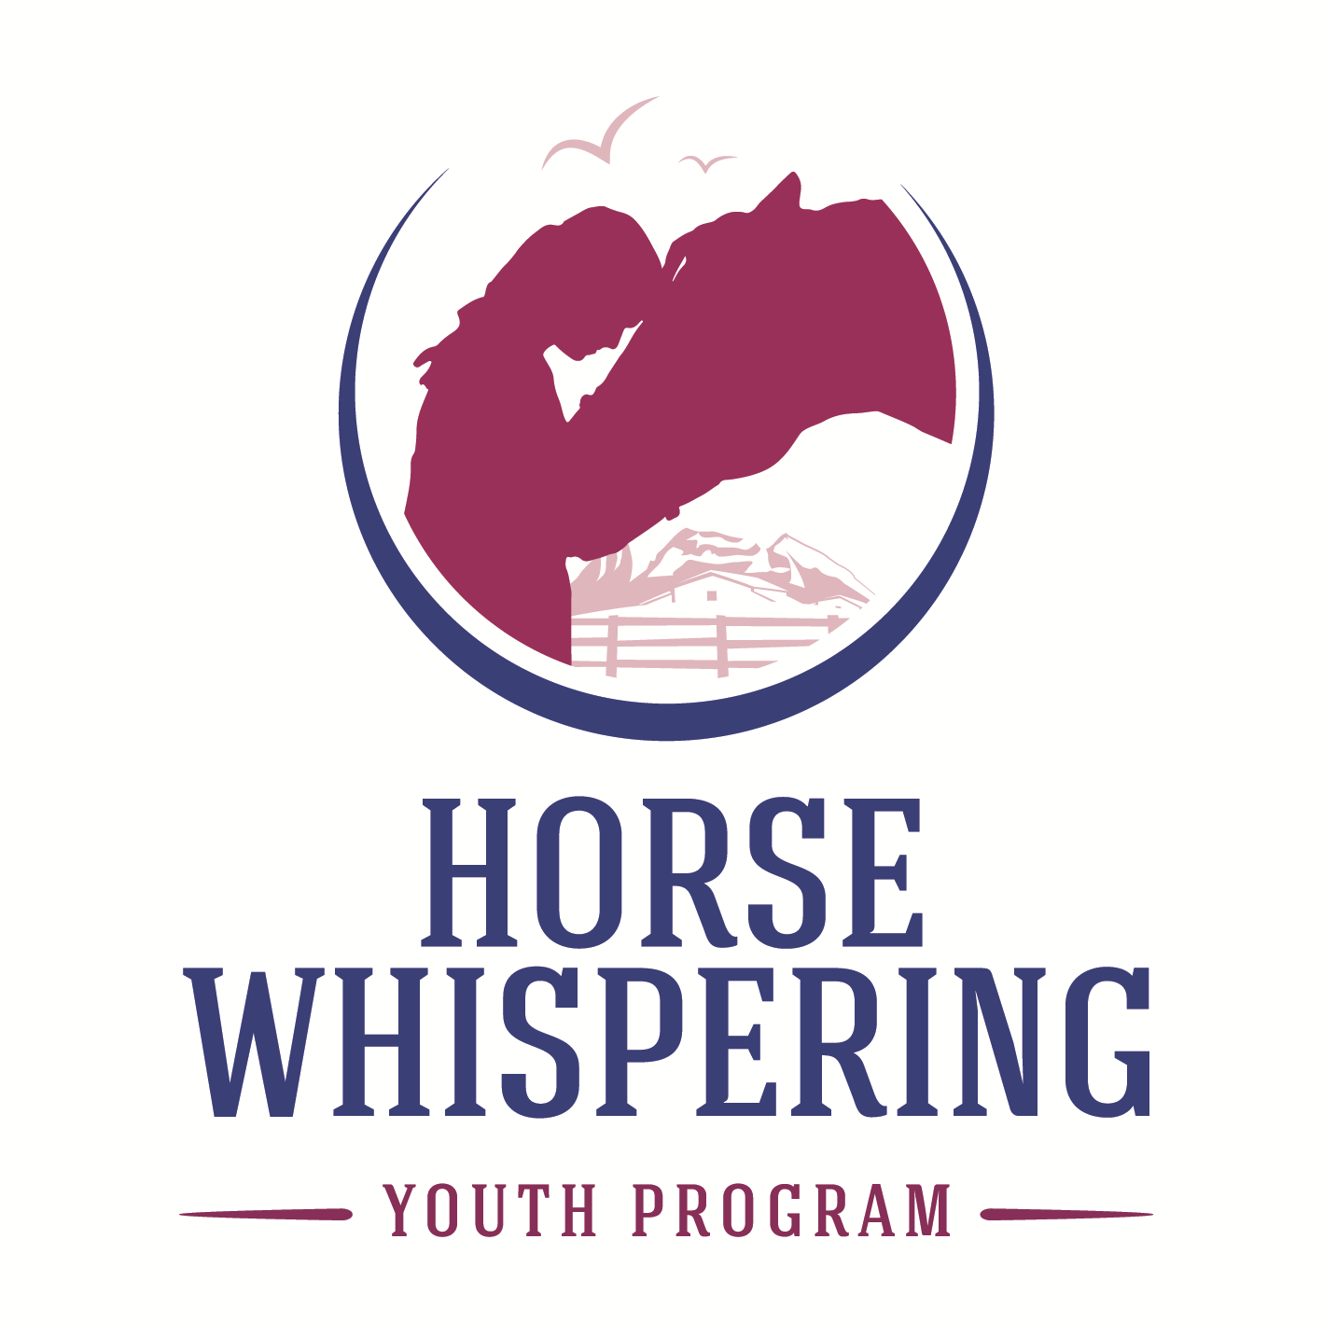

Business Strategy v1 2020

The tradition of horses helping humans is thousands of years old. Down through history, horses have helped humans in a myriad of different ways: from carrying our loads and pulling our buggies, to ploughing our fields. Continuing this tradition, the founder of Horse Whispering Youth Program, Sue Spence, has trained her horses to help disadvantaged and at-risk youth. The innovative program Sue has developed helps youth overcome barriers such as low self-esteem, bullying, inadequate family support, emotional difficulties, behavioural problems and mental health issues to achieve significantly improved self-confidence, interpersonal relationships and control over their emotions and behaviour.
Our Vision
To be a leading effective communication and body language program responsibly educating youth and the broader youth support networks.

Our Mission
To deliver an equine assisted life coaching program that introduces youth to more effective communication and body language skills. Helping them develop their emotional control in a way that sees them move intuitively towards healthier behavioural choices.

Our Values
There should never be any Intimidation or Fear in Communication. There should only be RESPECT and TRUST.

Key Areas
The Business is structured around the following five Key Areas.

1. Management  1.1 Management Committee  1.2 Business Structure, Planning & Development  1.3 Risk Management & Insurance  1.4 Administration & Finance  2. Human Resources  2.1 Staff (employees & contractors)  2.2 Volunteers  2.3 Tertiary Student Interns  3. Marketing  3.1 Website & Social Media  3.2 Publications  3.3 Promotions | 4. Program Delivery  4.1 Youth Program  4.2 Parents Workshops  4.3 Youth Workers Training & Engagement  4.4 Teachers Workshops  4.5 Mental Health Professionals Workshops  4.6 Facebook: a tool to expand learning beyond the program to our program graduates’ own environments  5. Stakeholders  5.1 Funding Providers  5.2 Commercial Sponsors  5.3 NFP Service Organisations  5.4 Donors  5.5 Members

Objectives
Objectives have been set for each of the Key Areas as follows.

1. Management

1.1 Management Committee - Objectives
- Provide strategic leadership and governance of the organisation.
- Ensure all constitutional and regulatory responsibilities of the organisation are met in an open and transparent manner.
- Ensure Management meetings are held regularly and conducted at a high standard of governance and reporting.
- Appoint an appropriately qualified Program Facilitator and Secretary to work as an Executive Team to manage the operational aspects of the organisation on behalf of the Management Committee.

1.2 Business Structure, Planning & Development - Objectives
- Ensure HWYP operates under a business structure that facilitates the fulfilment of its statement of objects and function.
- Develop and implement strategies to grow the financial capacity of the organisation to provide for ongoing program delivery while at the same time building the long-term sustainability of the organisation.

1.3 Risk Management & Insurance - Objectives
- Develop and maintain a comprehensive and up to date risk management system that encompasses risk identification, risk assessment and risk mitigation strategies.
- Ensure the organisation, management committee, staff, volunteers, program participants and other stakeholders are adequately protected by an appropriate suite of insurances.
Current Status: The following insurance coverage is in place:
- Public and Products Liability
- Association Insurance (which includes Professional Indemnity and Directors & Officers)
- Volunteer Personal Accident & Staff Work Cover

1.4 Administration & Finance - Objectives
- Develop and maintain functional and professional administration and booking procedures.
- Develop and maintain a high standard of financial accountability through efficient and effective financial and budgeting procedures.
- Ensure the financial statements are audited and/or verified on an annual basis.

2. Human Resources

  - Staff (includes employees & contractors) - Objectives
- Recruit, gain and train the necessary staff to assist with program delivery.
- Ensure all staff receive appropriate instruction and training on the safety requirements of working with horses.
- Ensure all staff receive ongoing on-the-job training, as necessary.
- Ensure all staff receive an adequate wage for their services.

2.2 Volunteers - Objectives
- Develop and implement effective strategies to recruit, gain and train the necessary volunteers to assist with program delivery.
- Ensure all volunteers are adequately supervised when working with horses.
- Donate additional sessions to past program participants (program graduates) as part of a work experience program.

2.3 Tertiary Student Interns - Objectives
- Develop and implement a tertiary student work experience program.
- Ensure all tertiary students receive appropriate instruction & training and supervision when working with horses.

3. Marketing

3.1 Website & Facebook - Objectives
- Maintain an informative website that enables youth workers, families and mental health professionals to gain an insight into and an opportunity to participate in our programs.
- Develop and maintain an informative and fun Facebook page that engages program graduates in conversation and ongoing education and enhancement of the communication & body language skills they learned through the program.

3.2 Publications - Objectives
- Develop informative flyers, brochures and other publications to use for marketing and educational purposes.

3.3 Promotions – Objectives
- Develop and implement a marketing plan to promote and increase community awareness of HWYP objectives and programs.

4 Program Delivery

4.1 Youth Program - Objectives
- Design and deliver equine assisted education programs to help disadvantaged youth achieve improved communication and body language skills, self-confidence, interpersonal relationships and control over their emotions and behaviour.
- Design and implement appropriate and accurate outcome-impact metrics to define and measure HWYP’s social impact in the community.

4.2 Parent Workshops - Objectives
- Design and deliver workshops to educate program participants’ parents on the values and objectives of the youth program.

4.3 Youth Workers Training & Engagement - Objectives
- Design and deliver training days for youth workers to engage them in program delivery for the youth they refer to the program.

4.4 Teachers Workshop - Objectives
- Design and deliver workshops to educate teachers on the values and objectives of the youth program.

4.5 Mental Health Professionals Workshop - Objectives
- Design and deliver workshops to educate mental health professionals on the values and objectives of the youth program.

4.6 Facebook - Objectives
- Create and maintain a HWYP Facebook page as a method to expand learning beyond the program to graduates’ own environments.

5. Stakeholders

5.1 Funding Providers - Objectives
- Apply for all funding opportunities from Government, Community & Commercial grants/funding providers that HWYP is eligible for.
- Acquit all funding received in line with the application in an open and transparent manner, completing all acquittal requirements as necessary and in a timely manner.

5.2 Commercial Sponsorship - Objectives
- Develop an offering of assets & benefits to sell to prospective sponsors.
- Develop and deliver sponsorship proposals to prospective businesses; and to follow-up and negotiate with expressions of interest.

5.3 NFP Service Organisations - Objectives
- Liaise and network with the local youth network to promote and increase awareness of HWYP objectives and programs.

5.4 Donors - Objectives
- Develop and deliver donation flyers to prospective benefactors; and to follow-up and negotiate with expressions of interest.

5.5 Members - Objectives
- Develop an offering of services & benefits to attract members to join the organisation, thus creating an additional income stream.
- Develop and deliver membership recruitments flyers to individuals who may be interested in becoming members of HWYP.

KEY PRIORITIES & Action planned to achieve them
# | KEY PRIORITIES & Actions | Responsible | Timeframe for delivery | Key Areas
1 | Promotional & Educational Videos  Create a Promotional Video to be used on website, Facebook & for presentations  Create an Educational Video to be used for off-site presentations & workshops | SS & GW | June 2014  June 2014 | Marketing  Program Delivery
2 | Promotional Proposal  Develop and distribute a promotional proposal to local youth organisations, schools, universities and TAFEs to increase awareness of HWYP programs to recruit potential program participants and work experience students. | SS & GW | March 2014 | Marketing, HR & Program Delivery
3 | Donations Flyer  Develop and distribute a donations flyer seeking tax deductible donations from individuals interested in supporting the HWYP objectives and programs. | SS & GW | June 2014 | Stakeholders
4 | Facebook – expanded learning program  Develop and maintain a HWYP Facebook page as a way to engage program graduates in conversation and ongoing education and enhancement of the communication & body language skills they learned through the program. | SS & GW | June 2014 | Program Delivery
5 | Program modifications  Increase number of participants per session from 4 to 8 by using a HWYP trained youth worker to assist in program delivery for the youth they refer; enabling the participant cost to be decreased. | SS & GW | April 2014 | Program Delivery
8 | Youth Worker Training Day  Develop and deliver a youth worker training day to ensure assistants in program delivery are educated on horse safety and other factors. | SS & GW | April 2014 | Program Delivery
9 | Parents, Teachers & Mental Health Professionals Workshops  Develop and deliver workshops for parents, teachers & mental health professionals on the values and objectives of the program. | SS & GW | April 2014 | Program Delivery
HHH | Corporate Development Marketing Campaign  Develop a marketing campaign to sell Team Building Workshops to small business to bring in additional income stream to support HWYP objectives. | Toby, SS, GW | April 2014 | Program Delivery

