# Phiên bản Eclipse

**Eclipse IDE for Enterprise Java and Web Developers**

**Version: 2022-06 (4.24.0)**

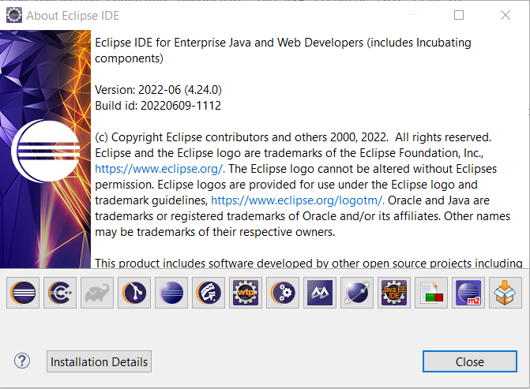

# Phiên bản Tomcat

**Tomcat v10.0 Server**

# Link Download Video Sản Phẩm Demo

https://drive.google.com/file/d/1lRLYKEG56kInq0WCYCcSebd9ZFt3IywI/view?usp=sharing