REVIEW SRS PRS

Product Type Management (Page 13)
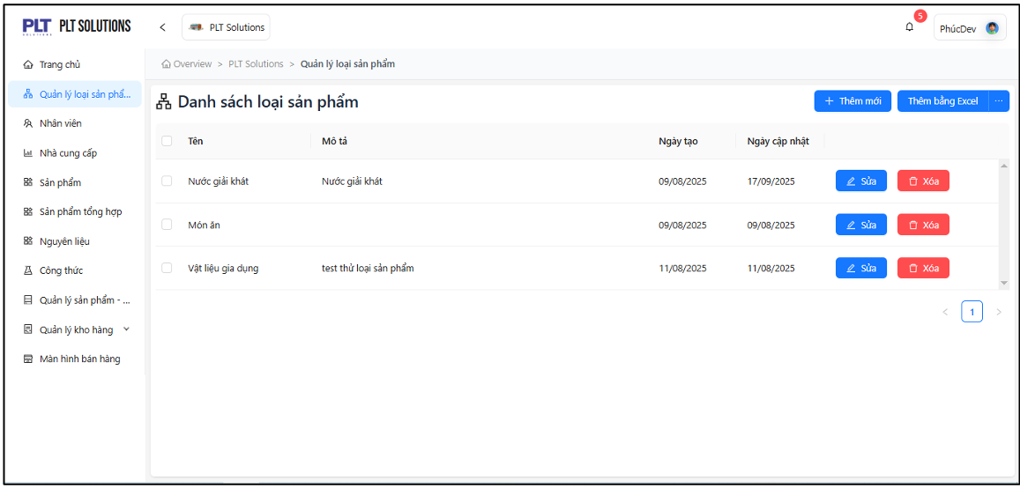
- Screen Product Type List Management (Page 13)
- Should add seach bar to make it easy for employees to search and find the item.
- Add button “<<-”/“->>” for easy page switch to first/end.
- Add a "Search by name" or filter by "Create date."

Supplier Management (Page 33)
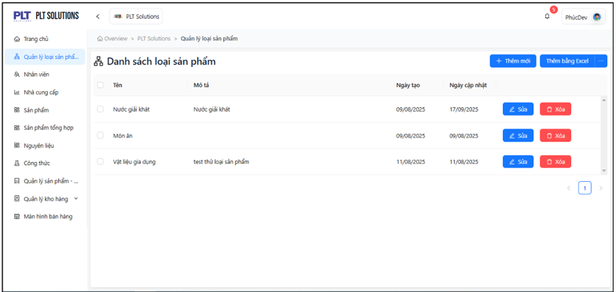
- Suppulier List Management (Page 33)
- Add button “<<-”/“->>” for easy page switch to first/end.
- Add filter (Categories) for suppliers for easy management filter each supplier by each category

Product Management (Page 48)
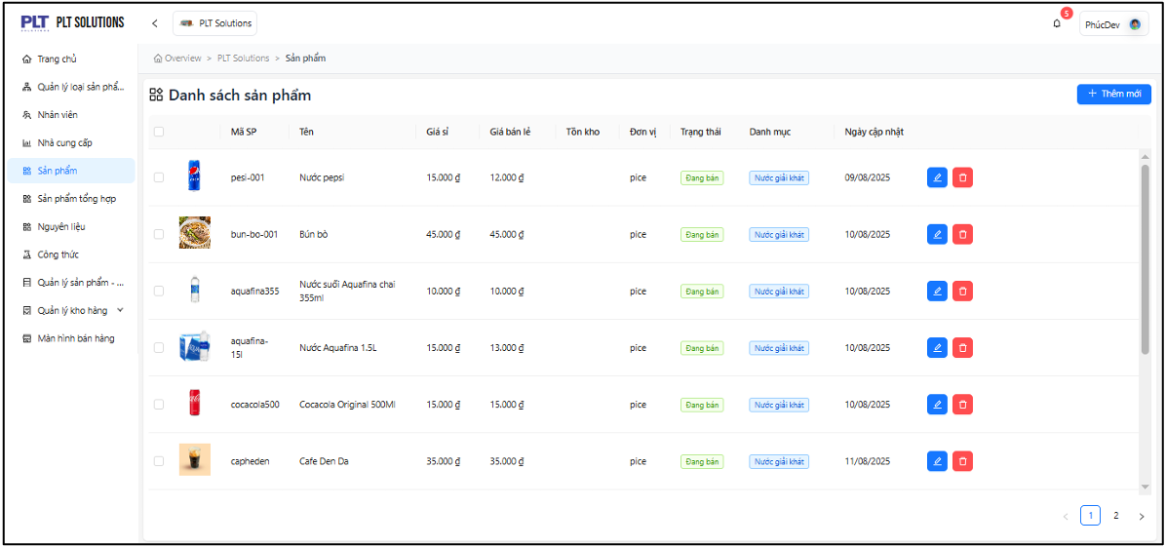
- Screen Product List Management (Page 48)
- Add button “<<-”/“->>” for easy page switch to first/end.
- Add filter (Categories/Status/Unit) for easy management filter each product by each category/status/unit.
- Add a "Search by name/id" or filter by "Create date."
- Should add seach bar to make it easy for employees to search and find the item.

Message Delete
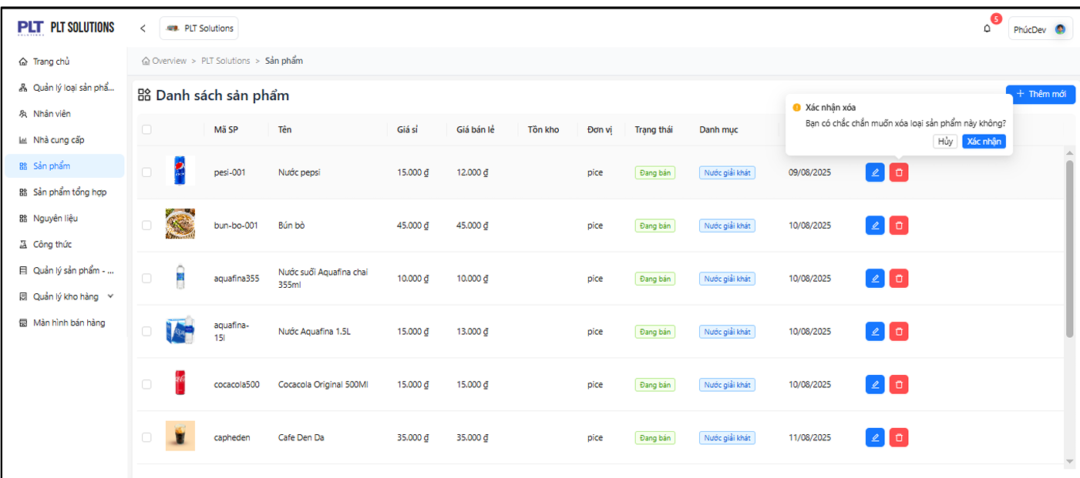
- Screen Message Delete A Item
- Recommend display delete notifications in the middle of the screen for uses to easy to see and click

Composite Product Management (Page 57)
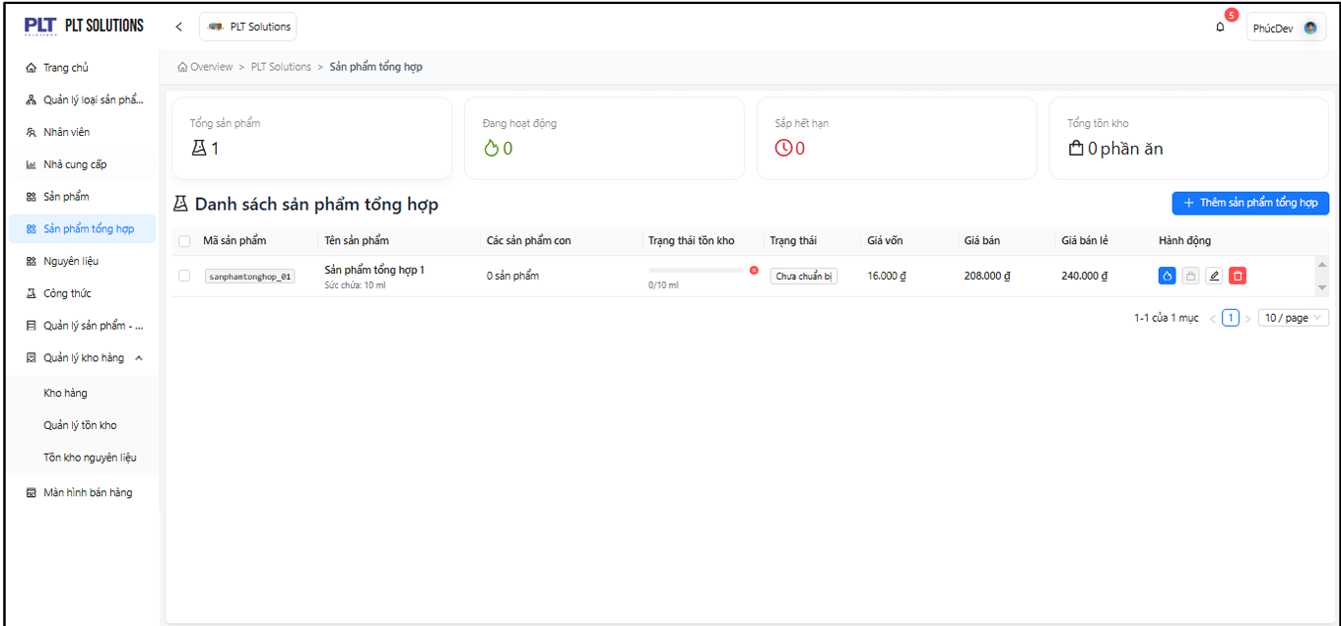
- Screen Composite Product List Management (Page 57)
- Add button “<<-”/“->>” for easy page switch to first/end.
- Should add seach bar to make it easy for employees to search and find the composite item.
- Add a "Search by name/id".
- Add filter (Status) for easy management filter each composite product by each status.

Warehouse Management (Page 95)
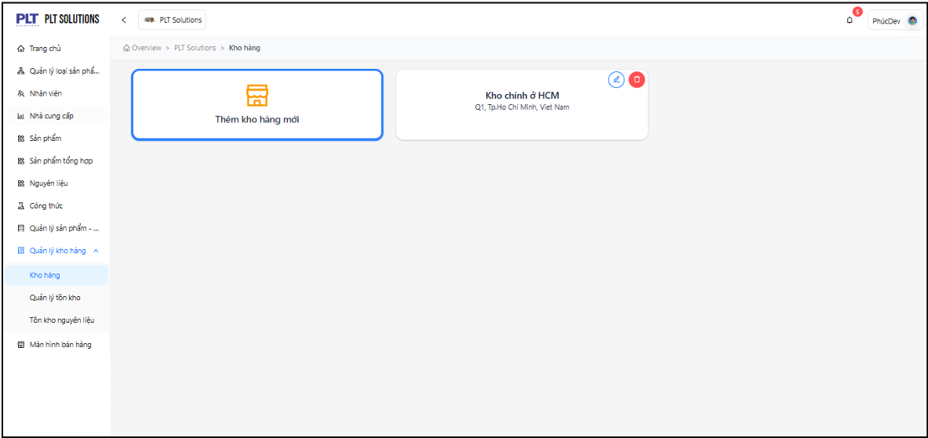
- Screen Warehouse List Management (Page 95)
- Should Show Warehouse list by area
- Add button “<<-”/“->>” for easy page switch to first/end.
- Should add seach bar to make it easy for employees to search and find the warehouse.
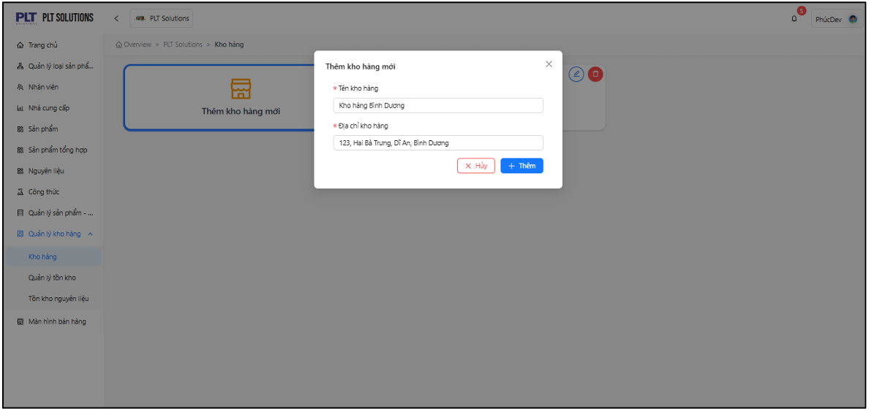
- Screen Add Warehouse Management (Page 95)
- Recommended divide the address into sections with each other: address, street, district, city
- And use dropdown for district, city for easy to filter warehouse with it.
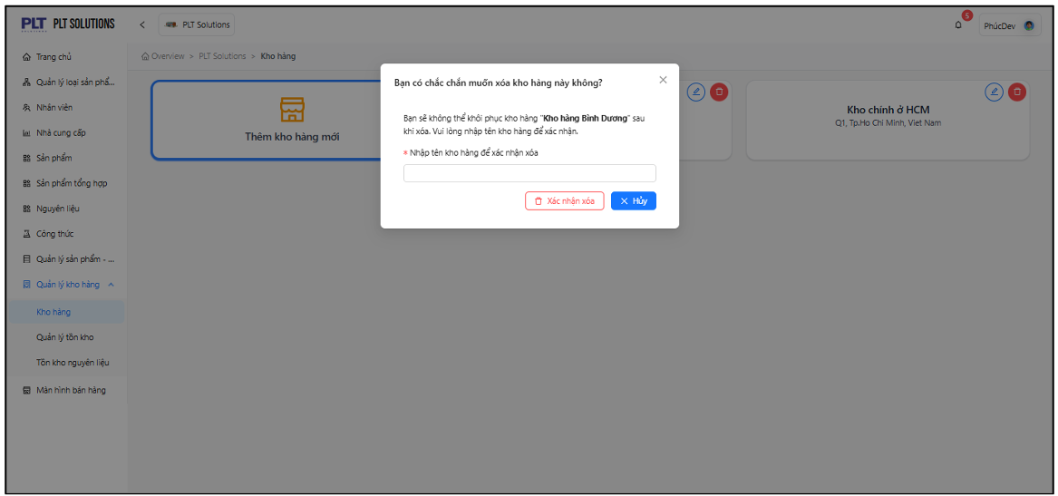
- Screen Delete Warehouse Management (Page 96)
- Recommend delete textbox “Enter name warehouse to confirm” it’s useless

Formular Management
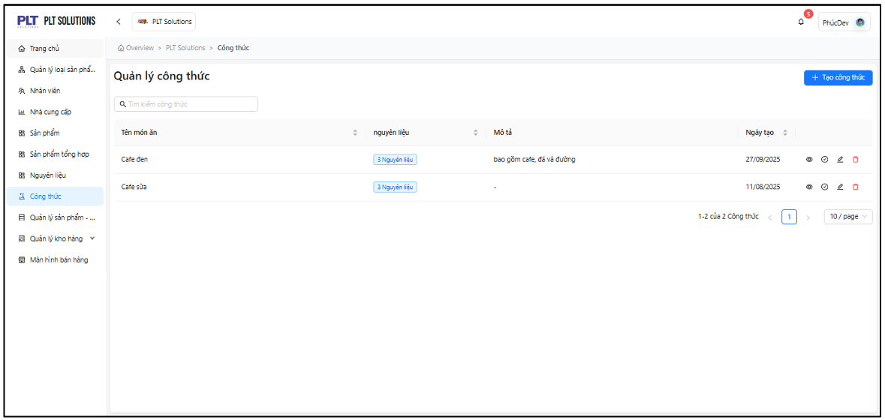
- Screen Formular List Management
- There should be an additional category section for recipes for food or drinks
- Add button “<<-”/“->>” for easy page switch to first/end.
- Add filter (Categories) for easy management filter each formular by each status.
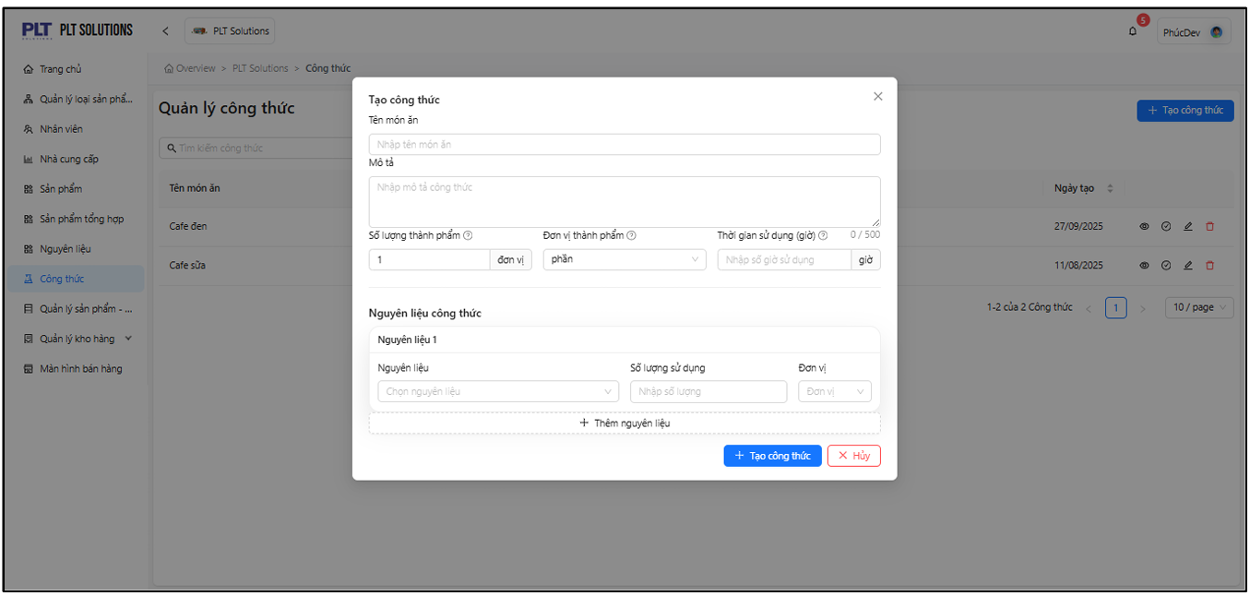
- Screen Add Formular Management
- Recommend add a dropdown category to select whether it is a drink or a food.

