

|  |
| --- |
| PROJECT REPORT OOP |
|  |
| January 3  GROUP THD  Authored by: THD |



# PLANT AND ZOMBIE PROJECT

|  |
| --- |
| 1.INTRODUCTION: -TEAM MEMBERS:  . NGUYỄN TẤN TÀI – ITITWE19023  . VŨ NHẬT DUY – ITITIU17047  . NGUYỄN GIA HUY – ITITWE19005  -CONTRIBUTION:  . NGUYỄN TẤN TÀI: Game panel  . NGUYỄN GIA HUY: Plant  . VŨ NHẬT DUY: Zombie, special features  . Orthers: work together |

# PLANT AND ZOMBIE PROJECT

2. FEATURES AND SPECIAL FEATURES

: SPAWN SUN, COST 50 SUN TO PURCHASE

: SHOOT PEA TO KILL ZOMBIE, COST 100 SUN

: SHOOT PEA TO KILL ZOMBIE AND INCLUDE SLOW DEBUFF, COST 150 SUN

: SHOOT 2 PEAS IN 1 TIME, COST 200

: EXTRA HEALTH, COST 50, WHEN HP=0 ROLLING IN STRAINGE LINE AND KILL ALL ENEMY IN SAME LINE

: BUCKETHEAD ZOMBIE, EXTRA HEALTH

: CONEHEAD ZOMBIE, EXTRA HEALTH

: SPECIAL ZOMBIE, AFTER HEALTH < 1000 RUN FASTER

# PLANT AND ZOMBIE PROJECT

3. SLIDE PRESENTATION:

LINK: <https://docs.google.com/presentation/d/1hOJdaf-wAVpYLKpgvfJaFEJ9C5jO1KIr129yAiIBYjU/edit?fbclid=IwAR1b2S_-HKhz1GjgA-sToh0otNS1EONikRkXREQn-fQPKoPWQWIwU2IdqTE#slide=id.gb22198a46b_0_1039>

# PLANT AND ZOMBIE PROJECT

4. CODE:

-SOME IMAGES OF CODE

LINK FOR FULL CODE: <https://github.com/DuyVu285/PlantsVsZombiesproject>

# PLANT AND ZOMBIE PROJECT

5. DIAGRAM:

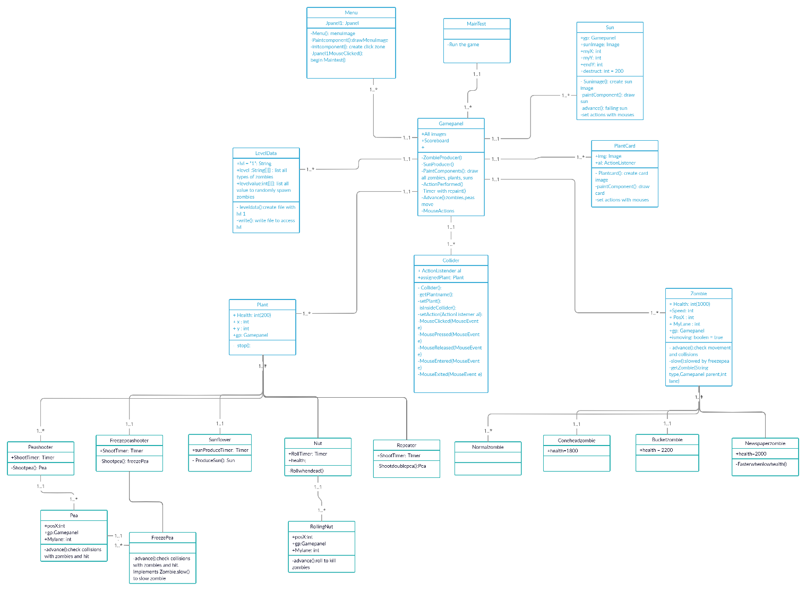Link:

https://imgur.com/GTkLrHp

# PLANT AND ZOMBIE PROJECT

6. REFERENCE:

-GITHUB

-YOUTUBE: <https://www.youtube.com/watch?v=AgMRkRLPeFU>

# PLANT AND ZOMBIE PROJECT

THANK YOU FOR READING

TDH GROUP:

NGUYỄN TẤN TÀI

VŨ NHẬT DUY

NGUYỄN GIA HUY