Software Requirements
Specification
for

E-Commerce System

Version 1.0.0 approved

Prepared by Antigravity Test Suite

Graduation Thesis Test Team

June 11, 2026

Table of Contents
Table of Contents ii
Revision History ii
- Introduction 1
  - Purpose 1
  - Document Conventions 1
  - Intended Audience and Reading Suggestions 1
  - Product Scope 1
  - References 1
- Overall Description 2
  - Product Perspective 2
  - Product Functions 2
  - User Classes and Characteristics 2
  - Operating Environment 2
  - Design and Implementation Constraints 2
  - User Documentation 2
  - Assumptions and Dependencies 3
- External Interface Requirements 3
  - User Interfaces 3
  - Hardware Interfaces 3
  - Software Interfaces 3
  - Communications Interfaces 3
- System Features 4
  - System Feature 1 4
  - System Feature 2 (and so on) 4
- Other Nonfunctional Requirements 4
  - Performance Requirements 4
  - Safety Requirements 5
  - Security Requirements 5
  - Software Quality Attributes 5
  - Business Rules 5
- Other Requirements 5
Appendix A: Glossary 5
Appendix B: Analysis Models 5
Appendix C: To Be Determined List 6

Revision History

Name | Date | Reason For Changes | Version

Introduction

Purpose
This is a test purpose description for document verification.

Document Conventions

Term: SRS
Definition: Software Requirements Specification

Term: HITL
Definition: Human-in-the-Loop

Intended Audience and Reading Suggestions
System designers, QA engineers, and developers.

Product Scope
Testing the automated document generation features.

References
N/A

Overall Description

Product Perspective
A standalone system that converts wireframes to standard SRS documents.

Product Functions

- Parse hand-drawn wireframes using YOLO.

- Review UI elements with Human-in-the-Loop.

- Draft SRS chapters using RAG.

- Export complete IEEE-standard documents.

User Classes and Characteristics

User: Business Analyst
Characteristics: Reviews and refines specifications.

Operating Environment
Cross-platform cloud execution via Streamlit Cloud.

Design and Implementation Constraints

- Strict adherence to IEEE templates.

- Responsive UI layout.

User Documentation

- External AI APIs are accessible.

- Supabase is configured.

Assumptions and Dependencies
N/A

Functional Requirements

3.1 Upload Wireframe
ID | FR-001
Feature | Upload Wireframe
Actor(s) | Business Analyst
Description | The system shall allow users to upload wireframe mockup files.
Priority | High
Pre-Conditions | - User is on the main workspace page.
Main Flow | 1. User clicks upload button. 2. System validates image format. 3. System stores image bytes in session state.
Post-Conditions | - Image is visible in the review preview.
Alternative Flows | Condition: Invalid file format  Steps: System shows warning notification. System requests another file.

Non-Functional Requirements

ID: NFR-001 | Type: Performance | Metric: Response time
Description: Visual component extraction must execute within 3 seconds.

Business Rules

ID: BR-001 | Name: Upload Limit
Description: Files must not exceed 10 megabytes in size.

Other Requirements
<Define any other requirements not covered elsewhere in the SRS. This might include database requirements, internationalization requirements, legal requirements, reuse objectives for the project, and so on. Add any new sections that are pertinent to the project.>

Appendix A: Glossary
N/A

Appendix B: Analysis Models

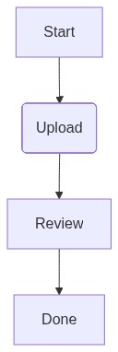

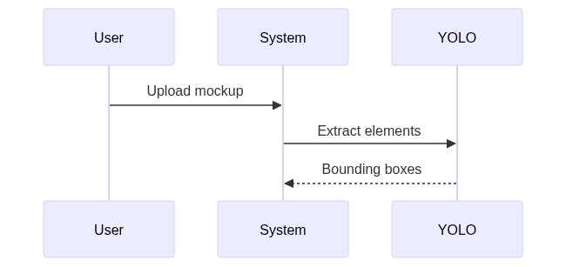

These diagrams represent the data flows during wireframe parsing and verification.

B.3 User Interface Mockup & UI Component Specifications
Mockup Screen Name: Checkout Detail Page Mockup
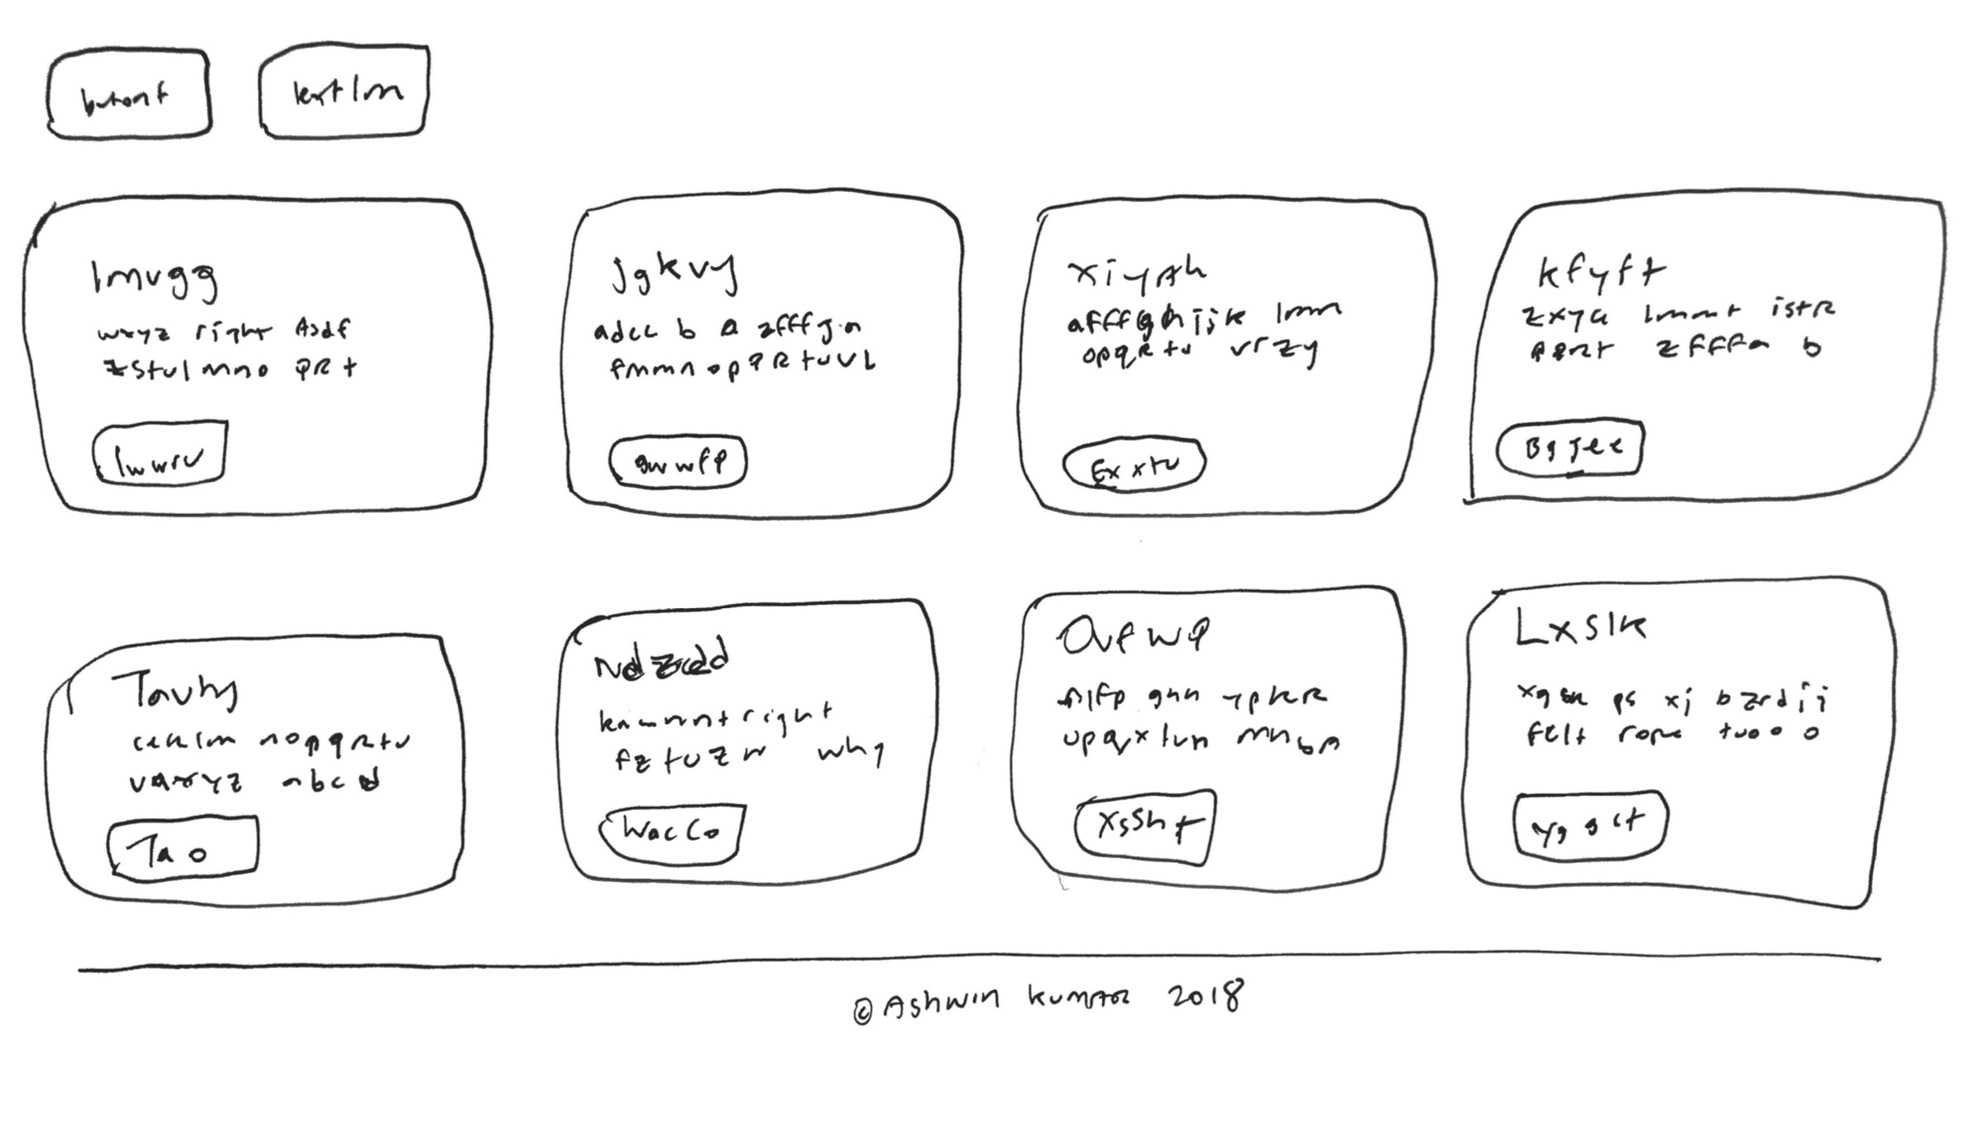

B.4 UI Component Specification Table
ID | Type | Label | Description
btn_checkout | button | Proceed to Checkout | Primary action button located at the bottom right corner.
input_email | text_input | Email Address | Standard email input field positioned at the top section.
dropdown_shipping | dropdown | Select Shipping Method | List of shipping options available based on user address.

B.5 Detected User Flows

- User enters email address in standard text input.

- User selects preferred shipping method from the shipping dropdown options.

- User clicks 'Proceed to Checkout' to complete the transaction.

Appendix C: To Be Determined List
<Collect a numbered list of the TBD (to be determined) references that remain in the SRS so they can be tracked to closure.>

