**Response_to_Reviewe4r_Comments**

Dear Reviewer，

Thank you for your thoughtful suggestions, which we have carefully considered and addressed in our revised manuscript. We truly appreciate the time and effort you put into reviewing our work, and we have made certain modifications based on your feedback. Our responses to each of your comments are detailed below:

**Q1：For readers trying to reproduce the proposed method, the details of the LOF algorithm are important. As explained by the authors in the review reply, the number of neighbors parameter for LOF is not critical. Perhaps a sentence would be sufficient to increase the reproducibility of the proposed method. Something as "The LOF method primarily involves the hyperparameter k (number of neighbors), which represents the number of neighbors used for calculating the local density of each data point, i.e., the number of points in the k-distance neighborhood. In practical applications, the setting of this hyperparameter is not particularly critical and does not significantly impact the effectiveness of the RSIS method.". In this way, readers who attempt to reproduce the method would understand not to focus on the LOF hyperparameters.**

**Answer：**

Thank you for your valuable feedback. We have carefully considered your suggestion and have added the following content to Section 3.1.1 of the revised manuscript: “The LOF method involves a hyperparameter, representing the number of neighbors used to calculate the local density of each data point. In practical applications, setting this hyperparameter is not particularly critical and does not significantly affect the effectiveness of the RSIS method. In our experiments, we set the LOF algorithm’s hyperparameter to the integer value of the ratio between the sample size and the number of clusters.”

The added content is highlighted in red in the revised manuscript.

**Q2： I appreciate the explanation of the kNN optimization given in the Revision Note. If I were a reader reading this paper for the first time, I would still be intrigued as to why the kNN optimization works. I know the paper is already dense and this part is not the focus, but maybe part of the explanation given to me could be included in the paper to satisfy the reader's curiosity in this matter. The excerpt concerning the goal of the clustering step ("Our purpose in clustering is to meet the assumptions of the RSIS method as much as possible and to ensure a good connection with other algorithms of RSIS (such as multi-stage minimum weight matching)") is especially enlightening, as it also presents that the clustering technique does not need to be optimal; it only needs to be good enough to help the next step.**

**Answer：**

Thank you for your suggestion. We have also added the following content at the end of Section 3.1.2:

“Our purpose in clustering is to align as closely as possible with the assumptions of the RSIS method, which will be discussed in later sections, and to ensure seamless integration with other RSIS algorithms, such as multi-stage minimum weight matching.”

We appreciate your valuable feedback, and we believe this addition will enhance the clarity and readability of the paper.

**Q3: I understood the point about Fig. 9 starting point. I still find it very confusing because the metrics are not comparable; thus, there is no readability gain to keep them in the same chart. The paper is comparing the three configurations using p1 and p2. I suggest separating the metrics into two charts or explaining the 0.08 starting point in the text as explained in the Revision Note**

**Answer：**

We understand your concerns, and indeed, there is no readability gain from keeping them in the same chart. After careful discussion, we believe it would be challenging to separate the metrics into two charts, as the number of figures in our paper is already substantial, making it difficult to maintain a clean layout without redundancy. We also feel that this chart design is fairly standard; our inspiration for this design came from Y. Guo, W. Wang, X. Wang, "A Robust Linear Regression Feature Selection Method for Data Sets with Unknown Noise," IEEE Transactions on Knowledge and Data Engineering, 35(1) (2021), pp. 31–44 . (see Figure 1)

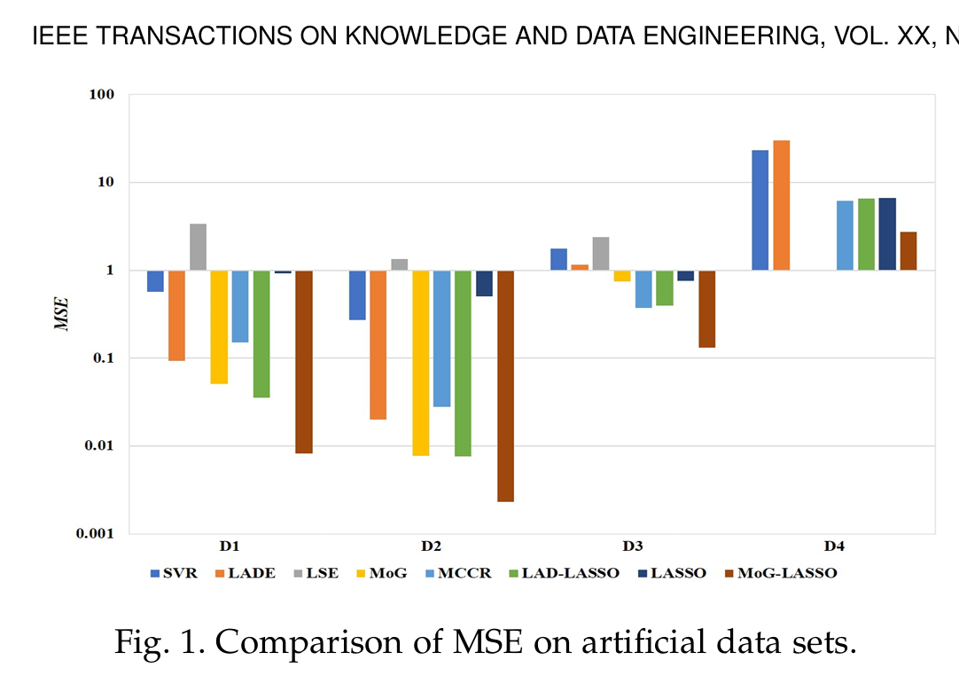

We apologize for not providing further explanation on the 0.08 starting point, as we do not consider this a critical detail. It was chosen merely to help readers see that the RSIS method achieves strong performance on both metrics. We feel that adding too much explanation here would make the text overly verbose.

**Q4: Because it is a new complex method, comparing it to other methods is not trivial or direct. Perhaps in the Conclusion section, the authors could point to a future direction where the advantages of using this method could be compared to other methods.**

**Answer：**

We believe that the future research directions for a new method should focus on its practical applications, improvements that further enhance its optimization effects, or expansion into other fields for broader study. The RSIS method is designed from the perspective of data synthesis with the goal of improving model generalization performance. Currently, there are no comparable methods with a similar approach, and even comparing it with other optimization methods would lack meaningful equivalence, as their mechanisms are fundamentally different.

We hope our explanation addresses your concerns satisfactorily.

Thank you again for your valuable suggestions.

Best regards,

Haiyue Yu   
Yongxiong Wang