Assignment 1

Name : Du zhi

1. Login to Pere cluster. (if your account is not yet ready, you can submit later when your account is created)

linux/mac terminal : ssh user-name[@pere.marquette.edu](mailto:puris@pere.marquette.edu) (substitute username with your marquette userid

On windows: use putty (download if not present)

Hostname is pere.marquette.edu and password is your marquette password

Sample programs, README file and job script are in the attachment.

1. Compile and running a hello.c C program using GCC.

WMP_(0UUMXO$Z)JI(8WY7SU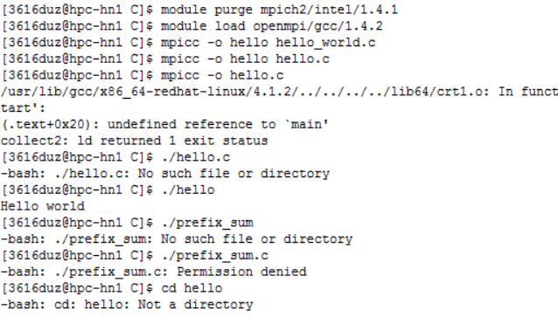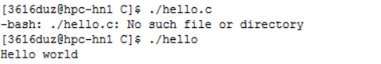

1. Prefix sum assignment ( instructions in prefix\_sum.c)

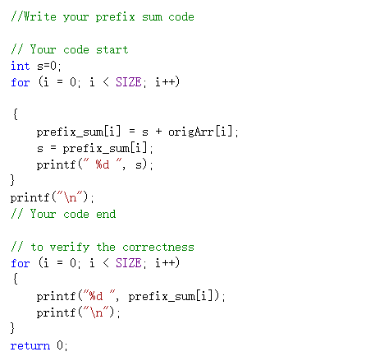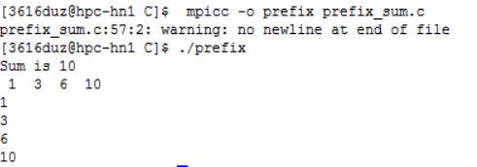

c. Compile a hello\_world.c MPI program.

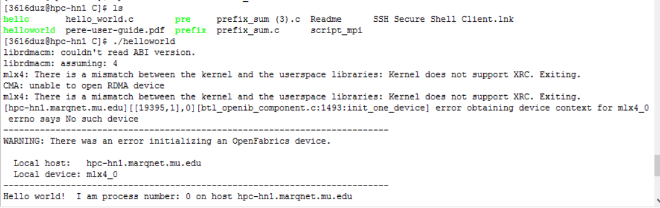

Run the program by submitting an mpi job script.

To transfer file from your machine to PERE you can use a FTP client or WINSCP software (download first) from windows. From mac or linux, you can use scp command from command line.

scp command examples : http://www.hypexr.org/linux\_scp\_help.php

scp simple.c [muid@pere.mu.edu](mailto:muid@pere.mu.edu):example/ (example is a directory here)

scp -r puris@pere.marquette.edu:/home/MARQNET/puris/C ~/Desktop/

-r is used when you want to copy an entire directory

OR using sftp if you have to copy a file called simple.c to PERE

sftp muid@pere.mu.edu

put simple.c

bye

2. Describe the efficiency of each of the following code sections, using Big-O notation:

a) int compute(int N)

{

return (N \* (N + 3) \* 2N) / 10;

}

According to the code, the Big-O notation is 1.

The circle is simple.

b) j = 1;

while (j < N)

{

j = j \* 2;

}

According to the code, the Big-O notation is logn^2

c) int div(int a, int b)

{

int count = 0;

int sum = b;

while (sum <= a)

{

sum += b;

count++;

}

return count;

}

According to the code, the Big-O notation is N.

3. Describe a method to parallelize matrix multiplication using threads in a paragraph.

### We can use array function to solve multiplication of matrices by “for”circulation。