

FACULTY OF ENGINEERING AND TECHNOLOGY BACHELOR OF TECHNOLOGY

Dara Science (DS) (203105414)

VI SEMESTER

Computer Science & Engineering Department



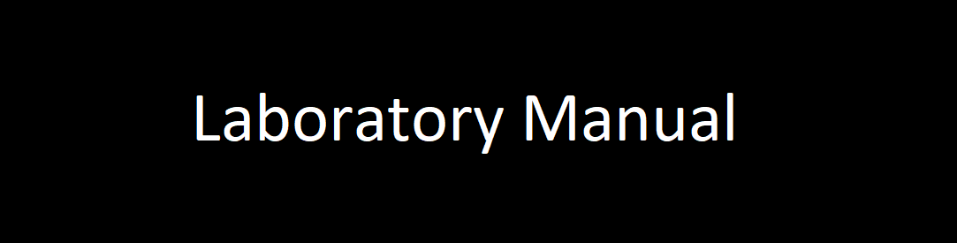

**CERTIFICATE**

*This is to certify that*

*Mr.* **VARIA DHRUV PRAFULBHAI** *with Enrollment No.* **210303105821** has *successfully completed his laboratory experiments in the subject* **Data Science (203105414)** *from the department of* **Computer Science and Engineering** *during the academic year* ***2023-2024.***



**Date of Submission …..…………… Staff In charge …..……………**

**Head of Department …..……………**

**TABLE OF CONTENT**

|  |  |  |  |  |  |  |  |
| --- | --- | --- | --- | --- | --- | --- | --- |
| **Sr.**  **No** | **Experiment Title** | **Page No** | | **Date of Start** | **Date of Completing** | **Sign** | **Marks**  **(Out of 10)** |
| **From** | **To** |
| 1 | House Rent Prediction using Linear Regression. |  |  |  |  |  |  |
|  |  |  |  |  |  |  |  |

**Practical – 1**

**Aim – House Rent Prediction Using Linear Regression**