# IMS configuration

**Payment gateway:**

* Nuvei payment config (Config.xml)

**Location:** App_Data/Nuvei/Config.xml

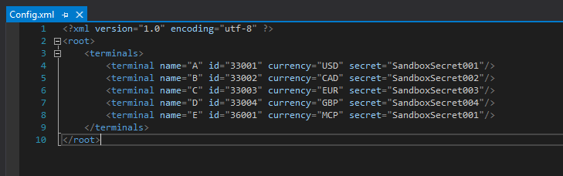

**App Link:**

* Web config

Location: /Web.config

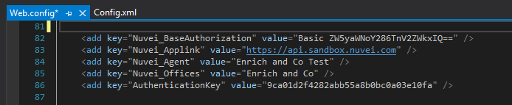

# Nuvei on boarding

Step by step

## Create

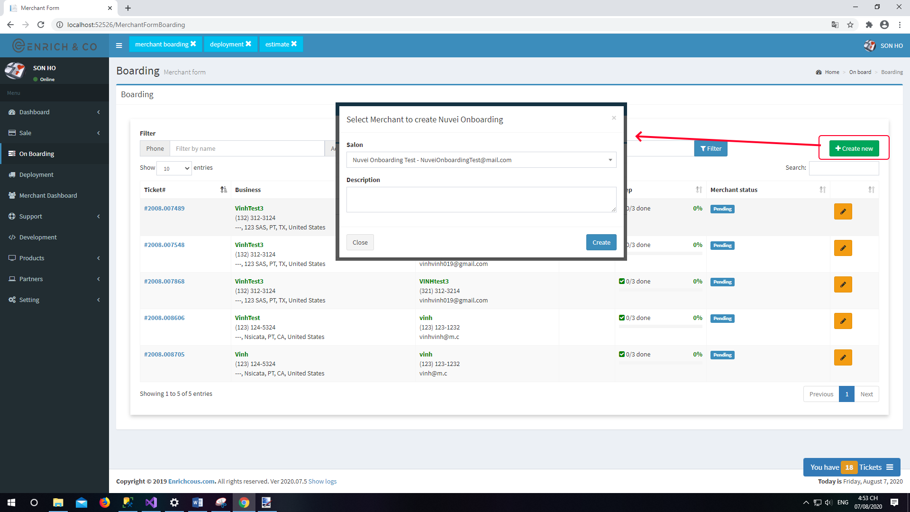

## Update

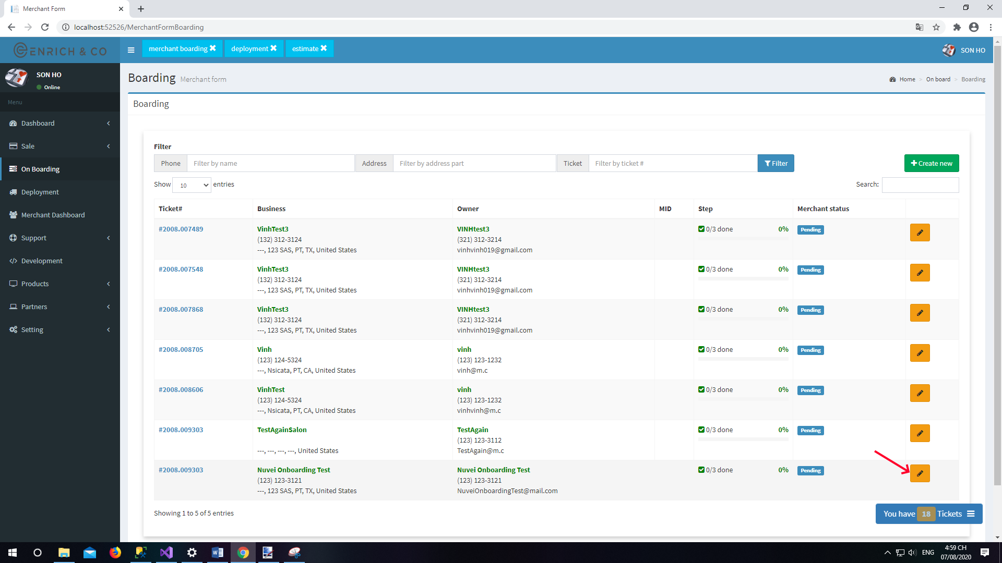

### Step 1

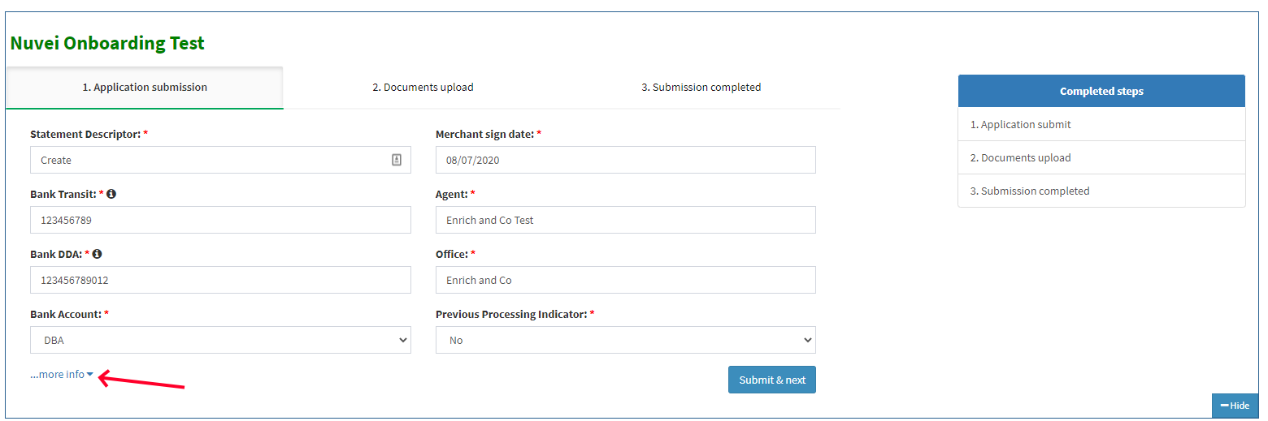

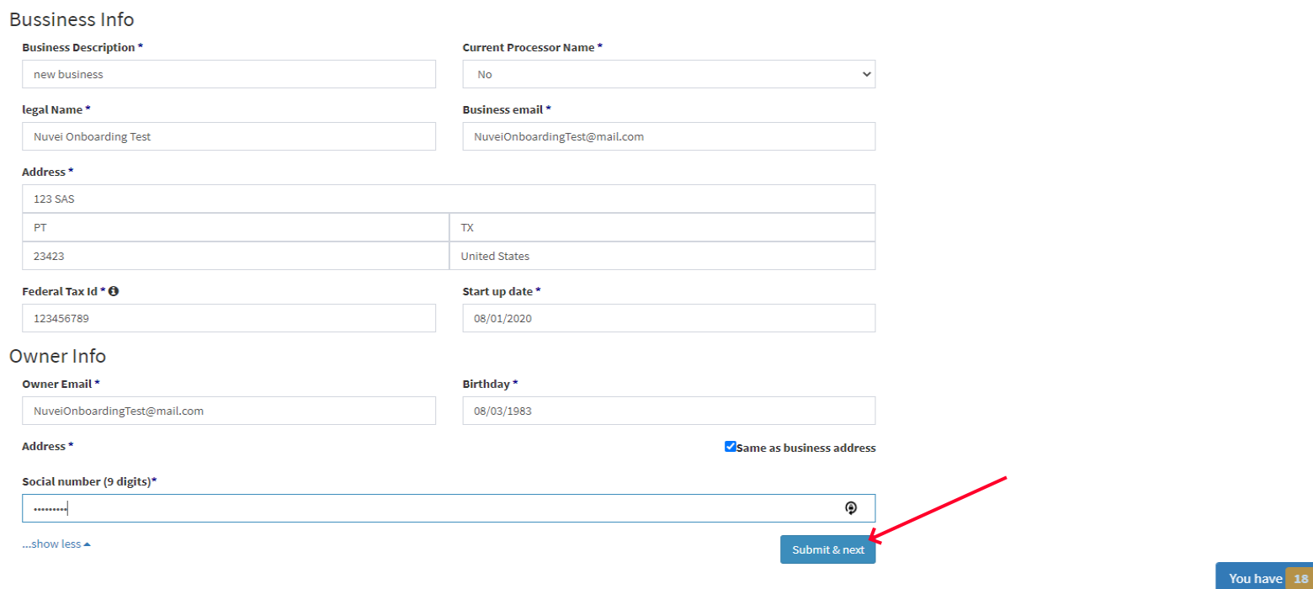

### Step 2

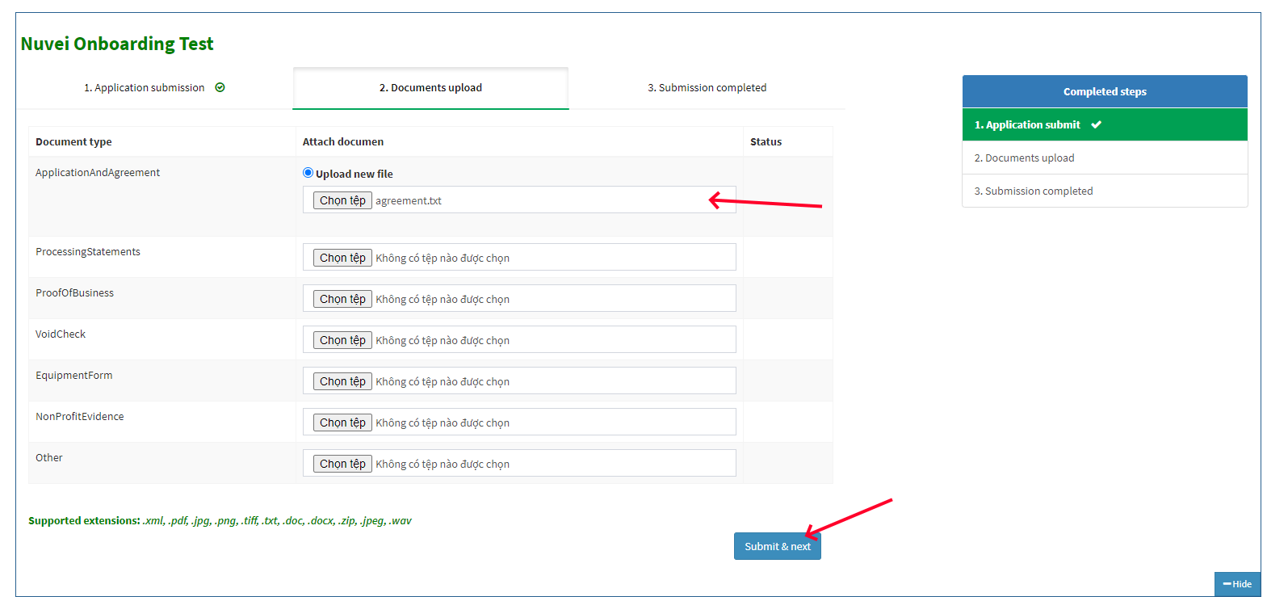

### Step 3

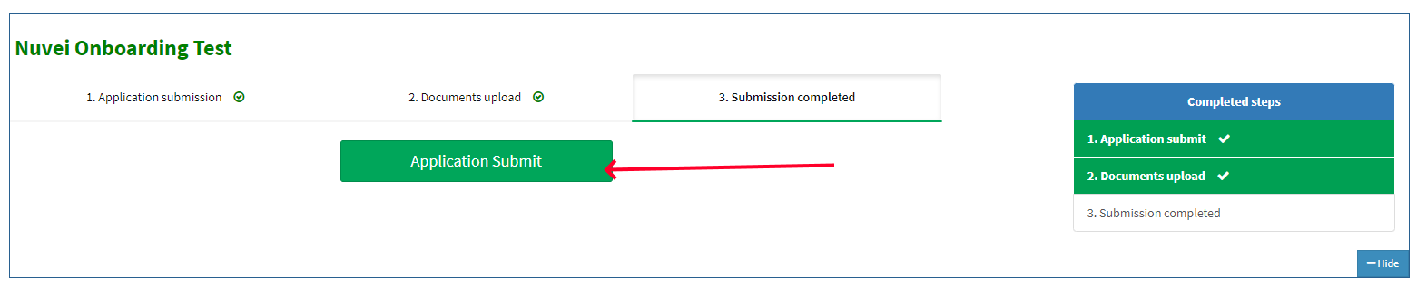

### Completed

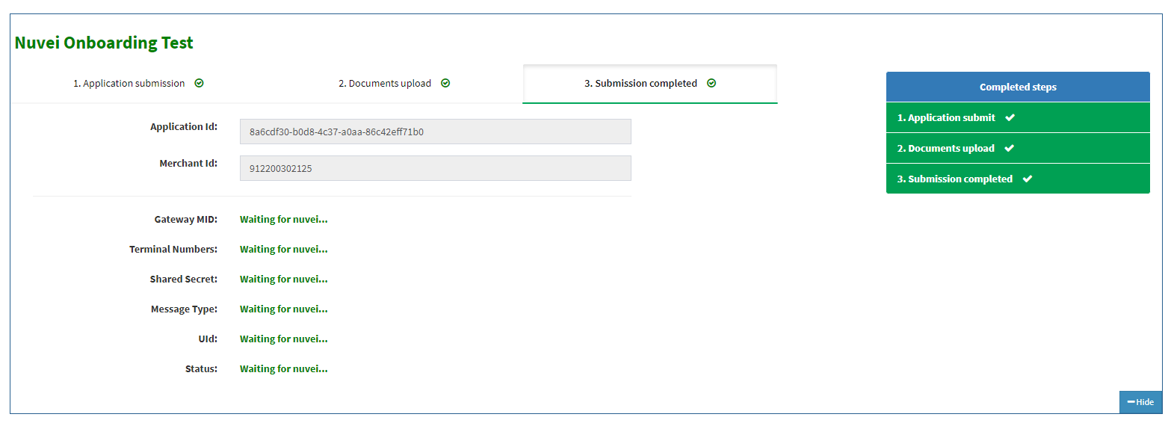

### Result

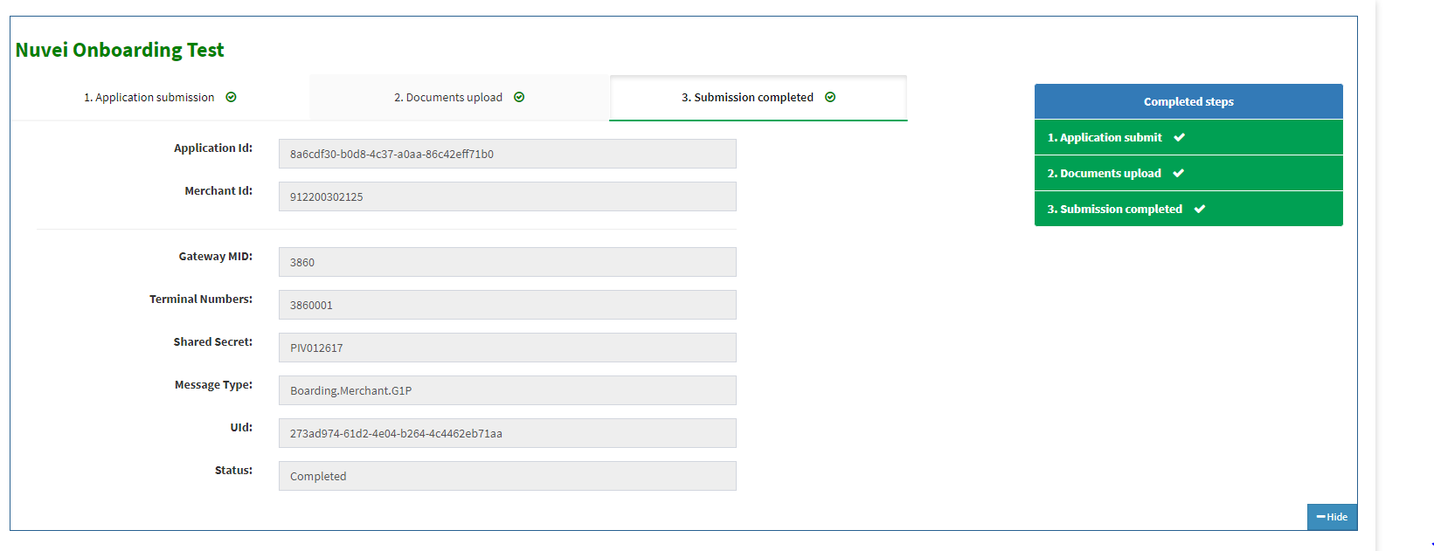

# POST API

Help nuvei notify subscription status go back ims.

Url: https://ims.enrichcous.com/api/nuveinotification

Header: AuthenticationKey: **9ca01d2f4282abb55a8b0bc0a03e10fa**

Please review on link:

<https://developer.nuvei.com/partner-notification-system>

Ex:

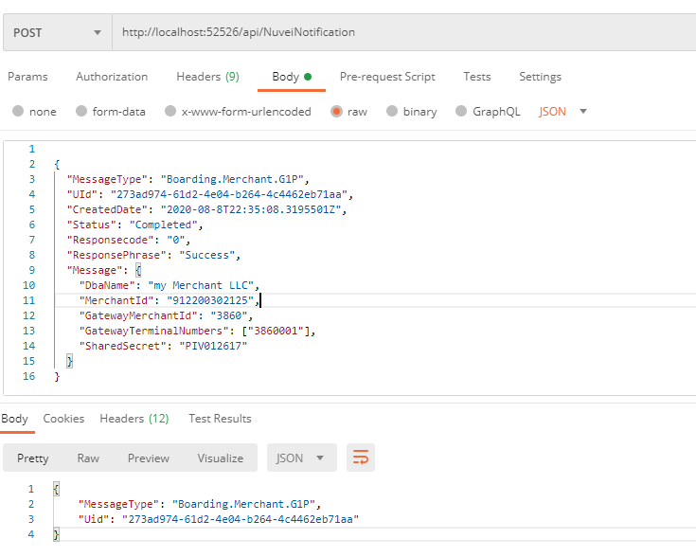

Json:

{

  "MessageType": "Boarding.Merchant.G1P",

  "UId": "273ad974-61d2-4e04-b264-4c4462eb71aa",

  "CreatedDate": "2020-08-8T22:35:08.3195501Z",

  "Status": "Completed",

  "Responsecode": "0",

  "ResponsePhrase": "Success",

  "Message": {

    "DbaName": "my Merchant LLC",

    "MerchantId": "912200302125",

    "GatewayMerchantId": "3860",

    "GatewayTerminalNumbers": ["3860001"],

    "SharedSecret": "PIV012617"

  }

}

Return:

{

    "MessageType": "Boarding.Merchant.G1P",

    "Uid": "273ad974-61d2-4e04-b264-4c4462eb71aa"

}