/* --COPYRIGHT--,

* Copyright (c) 2019, TAPIT Co., Ltd.

* https://tapit.vn

* ************** ADC_SingleChannel_ContinuousMode *****************

* Description: Read ADC value at PA0 pin

* Version: 1.0

* Author: Hang Tran

* Release: May 27, 2019

* Built with CubeMX Version 5.2.0 and Keil C Version 5.26.2

*****************************************************************

*/

**STM32CubeMX:**

Step 1:

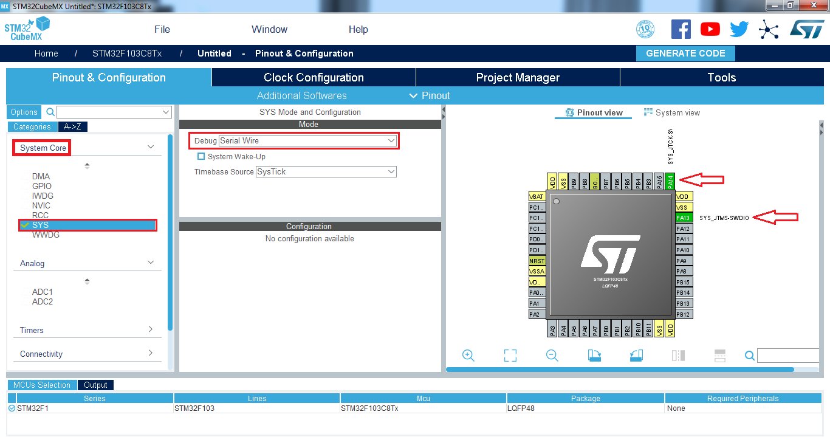

Step 2:

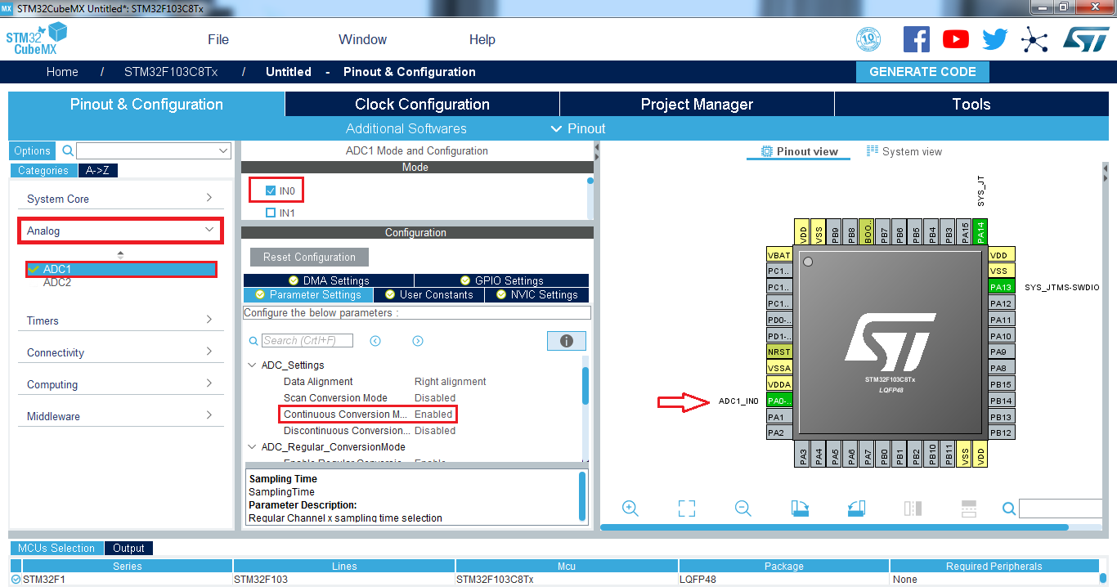

Step 3:

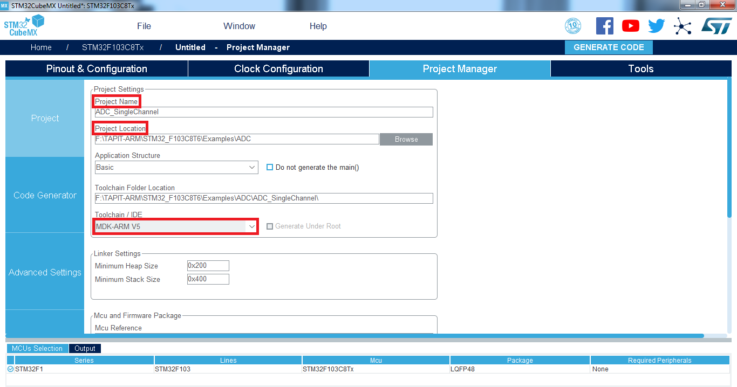

Step 4:

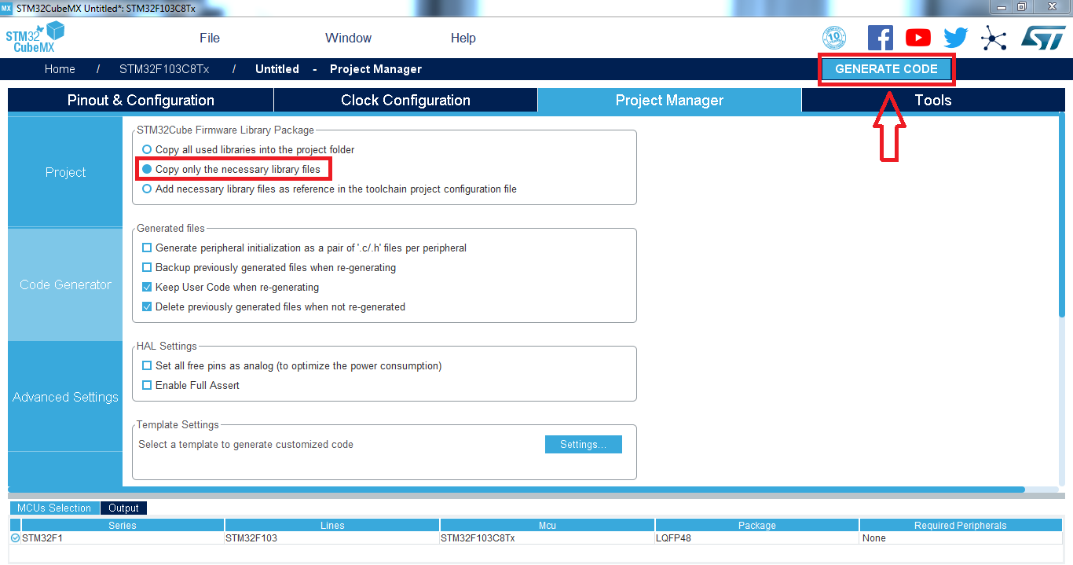

Keil C:

