/* --COPYRIGHT--,

* Copyright (c) 2019, TAPIT Co., Ltd.

* https://tapit.vn

* ***************** FLASH_ConfigFlashViaUART ********************

* Description: Change the value in memory via UART 1. The transmitted data

must have the end character “|” to indicate the process of receiving data has ended.

* Version: 1.0

* Author: Hang Tran

* Release: May 27, 2019

* Built with CubeMX Version 5.2.0 and Keil C Version 5.26.2

*****************************************************************

*/

**STM32CUBEMX:**

Step 1:

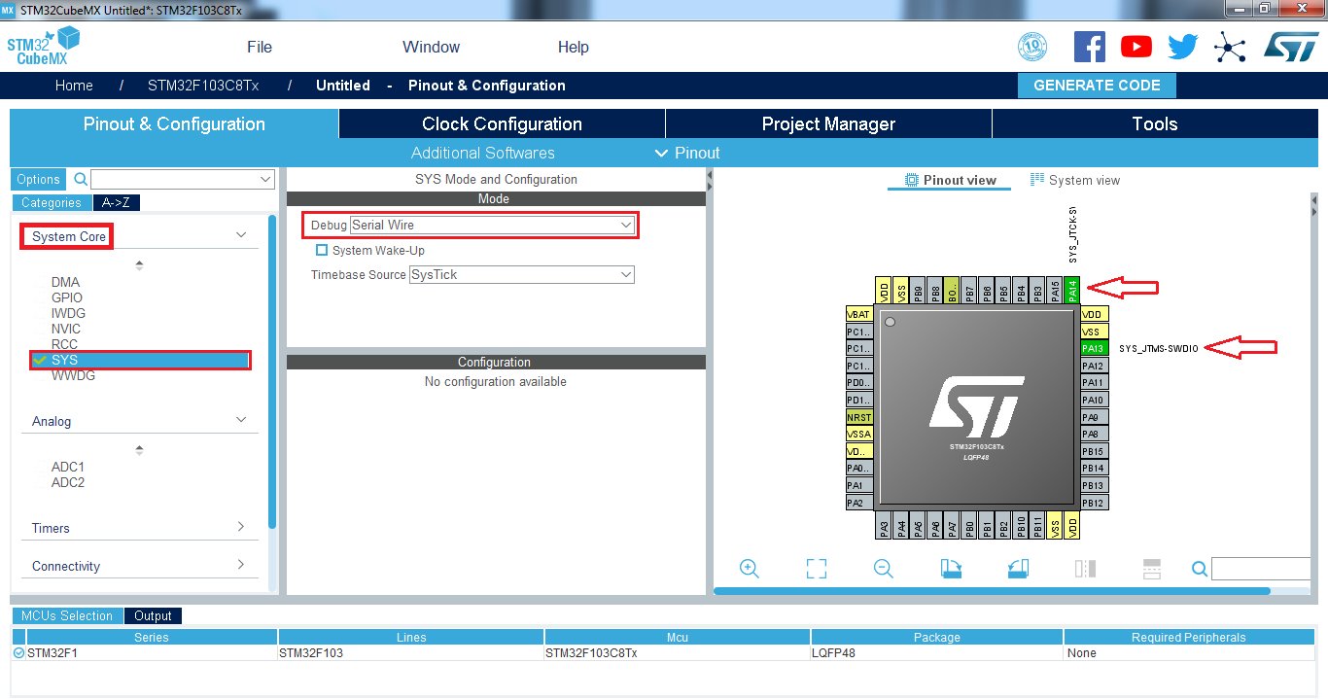

Step 2:

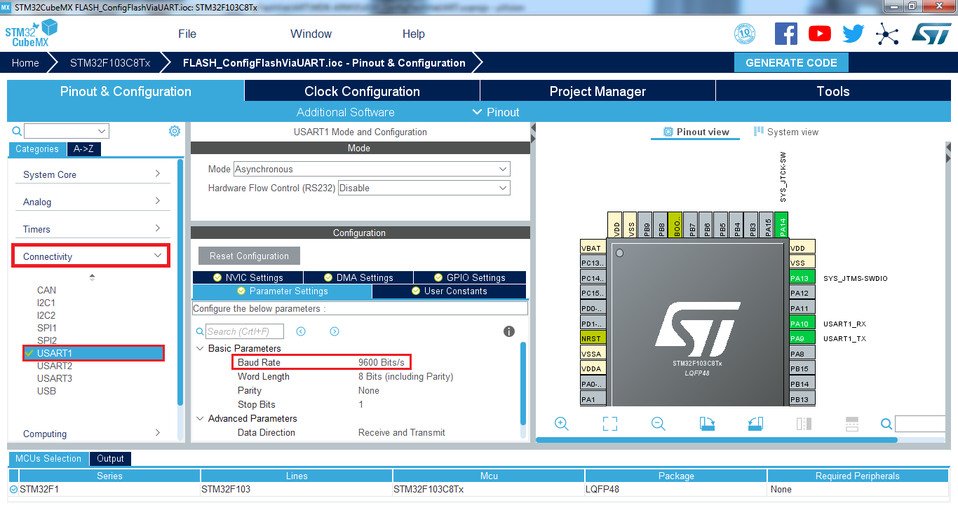

Step 3:

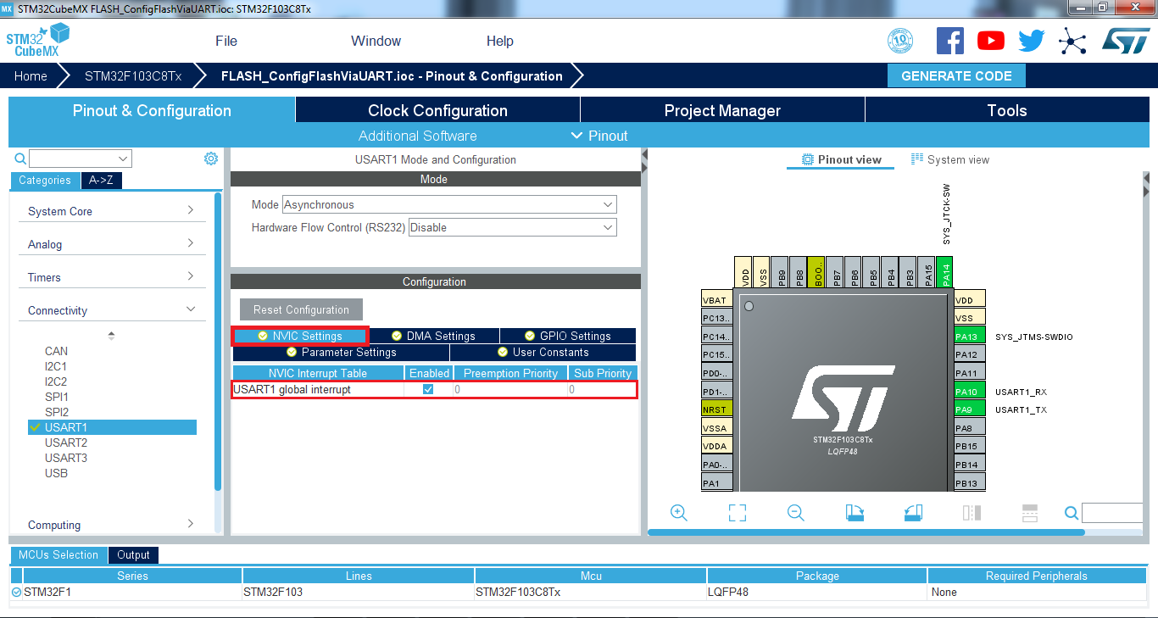

Step 4:

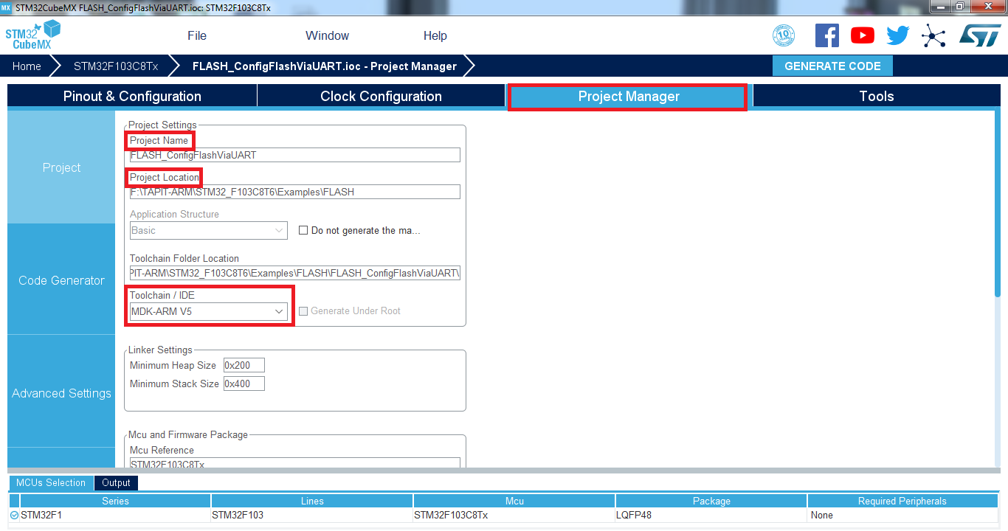

Step 5:

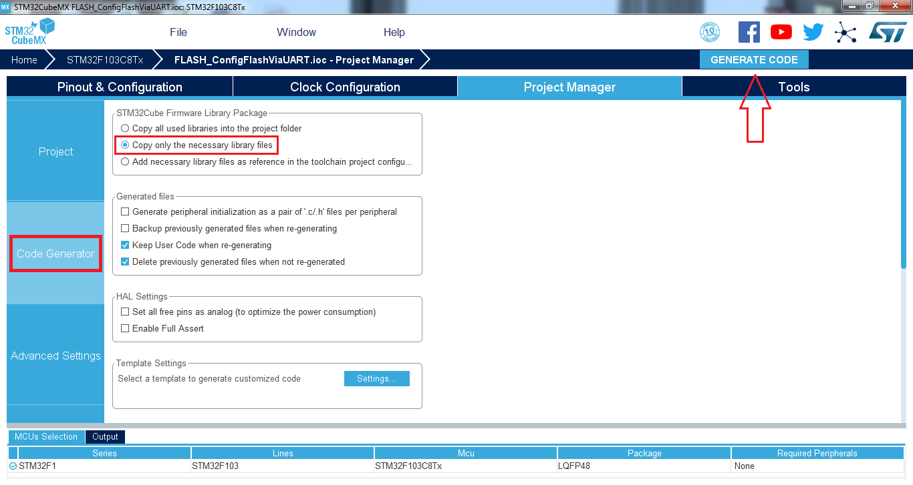

**KEIL C UVISION:**

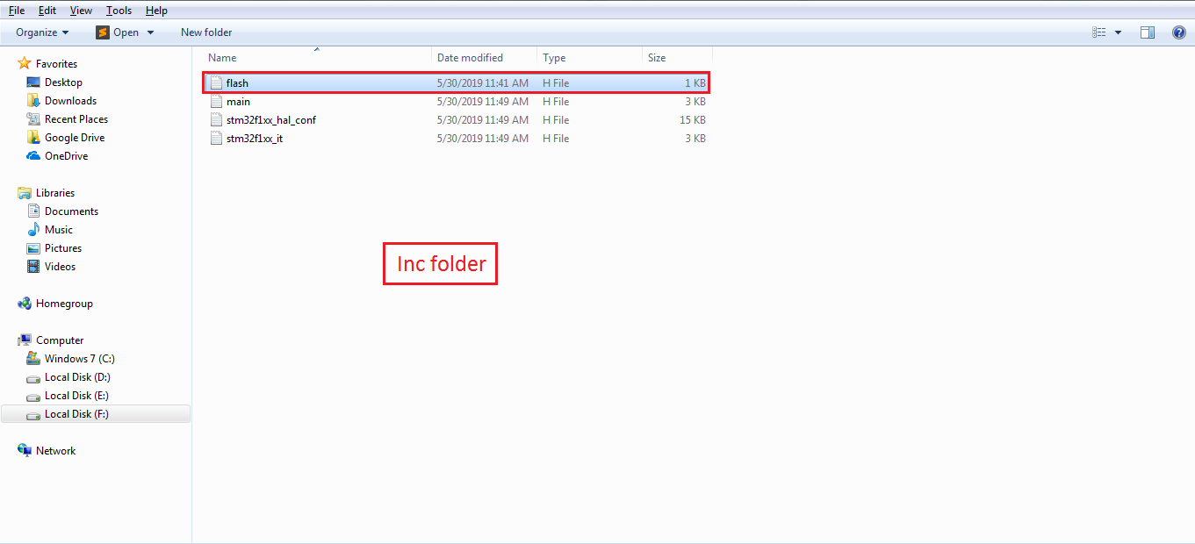

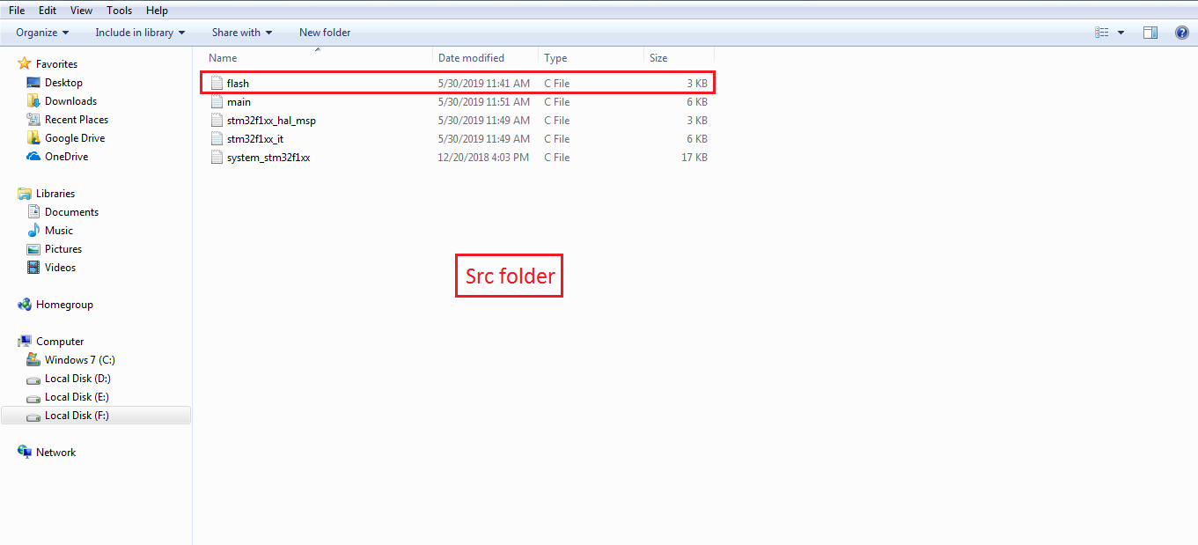

**RESULT:**

