/* --COPYRIGHT--,

* Copyright (c) 2019, TAPIT Co., Ltd.

* https://tapit.vn

* ***************** UART_Transmit&ReceiveInterrupt *******************

* Description: Receive any data (with the fixed length given) from other device in the

interrupt handler function then if the data is received successfully, it will transmit

back to the transmitter the same data

* Version: 1.0

* Author: Hang Tran

* Release: May 27, 2019

* Built with CubeMX Version 5.2.0 and Keil C Version 5.26.2

*******************************************************************

*/

**STM32CUBEMX**

Step 1:

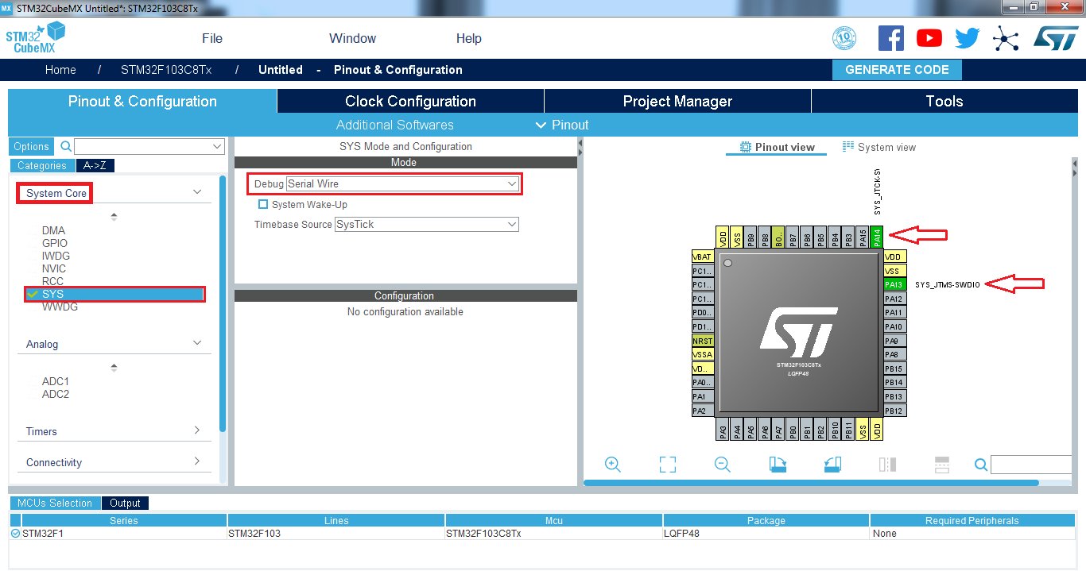

Step 2:

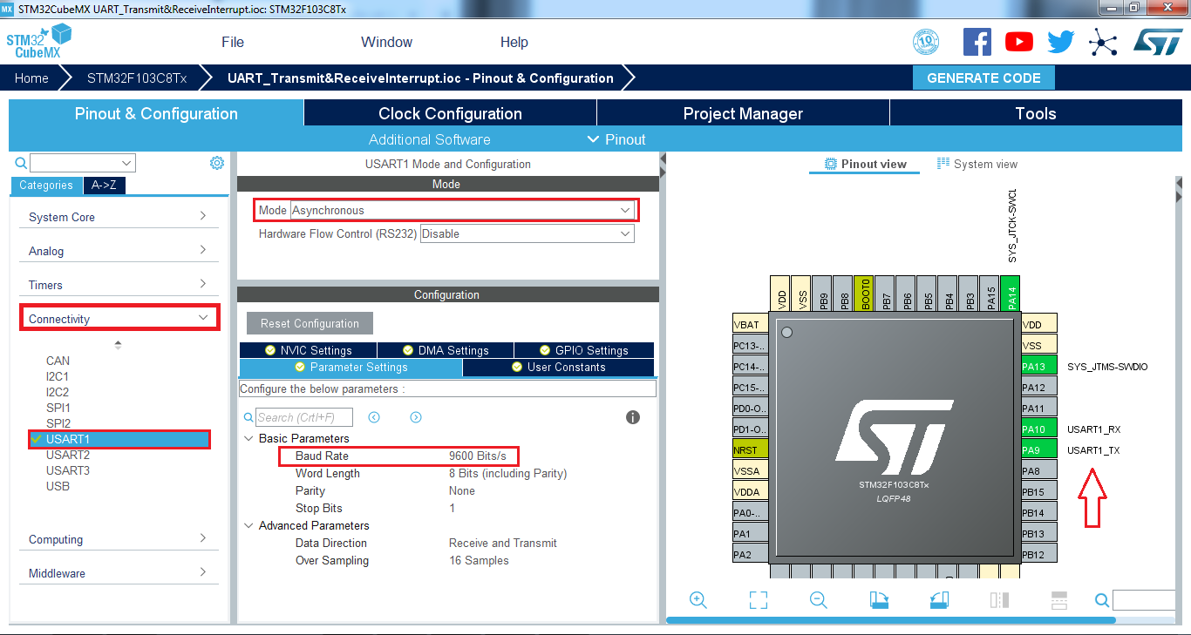

Step 3:

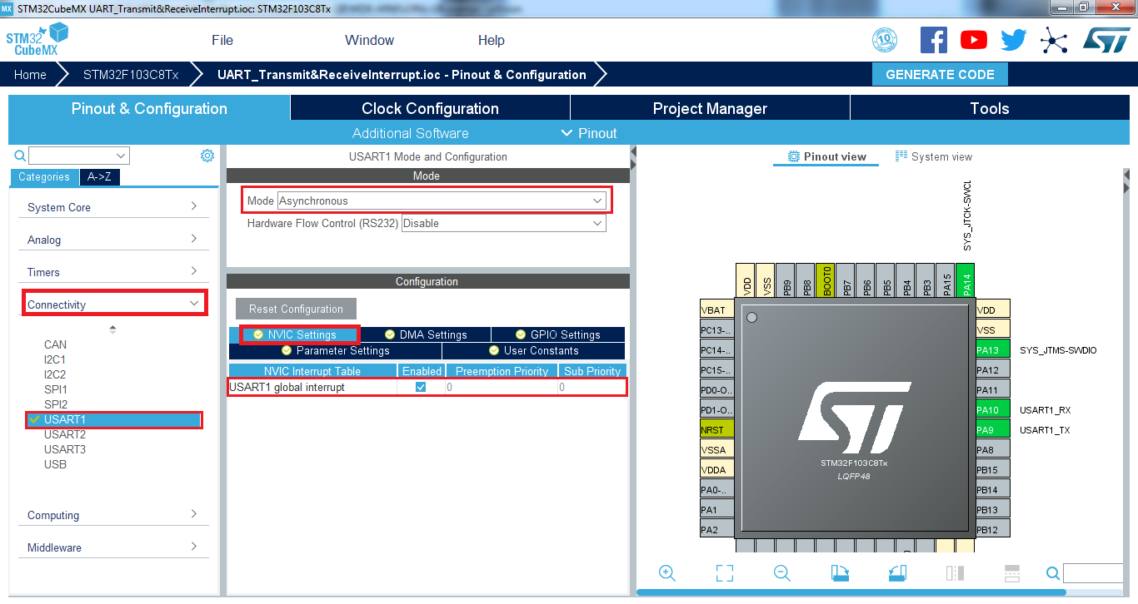

Step 4:

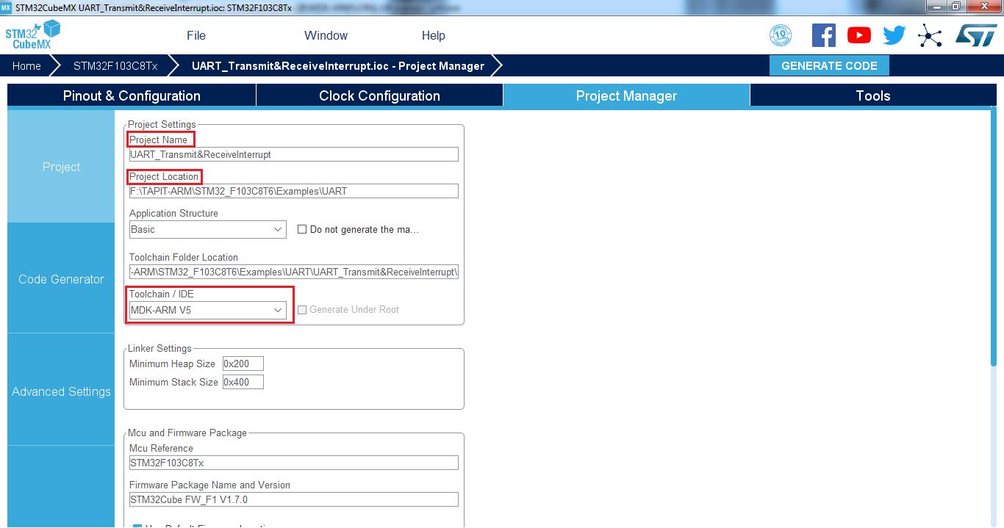

Step 5:

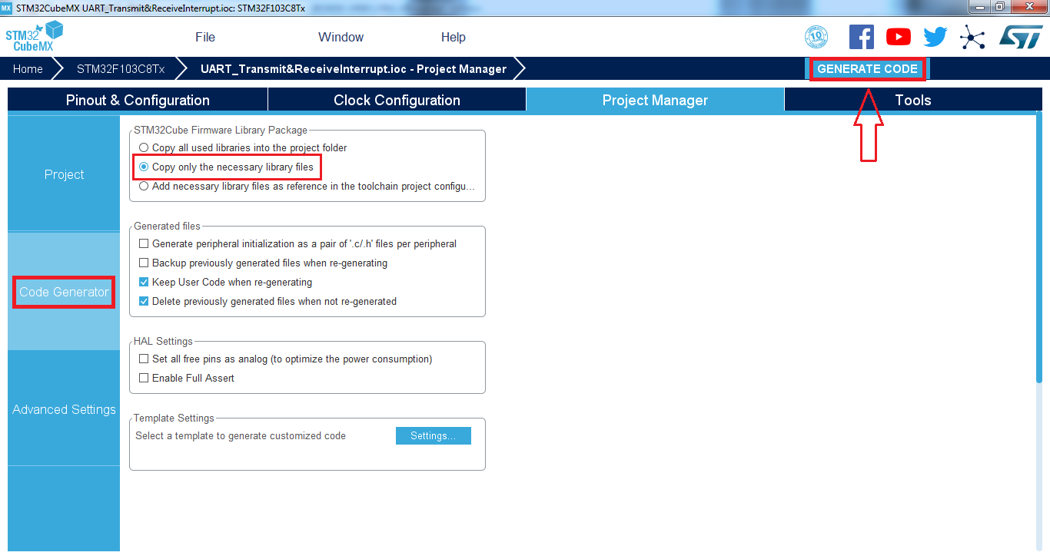

KEIL C UVISON:

