/* --COPYRIGHT--,

* Copyright (c) 2019, TAPIT Co., Ltd.

* https://tapit.vn

* ****************** UART_Transmit&ReceivePolling *********************

* Description: Receive any data (with the fixed length given) from other device. If the

data is received successfully, it will transmit back to the transmitter “Receive OK”

* Version: 1.0

* Author: Hang Tran

* Release: May 27, 2019

* Built with CubeMX Version 5.2.0 and Keil C Version 5.26.2

*********************************************************************

*/

**STM32CUBEMX:**

Step 1:

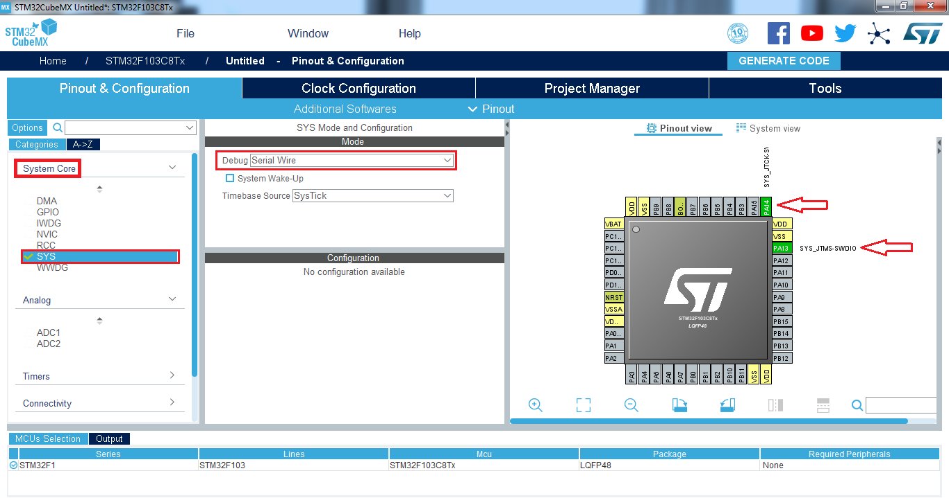

Step 2:

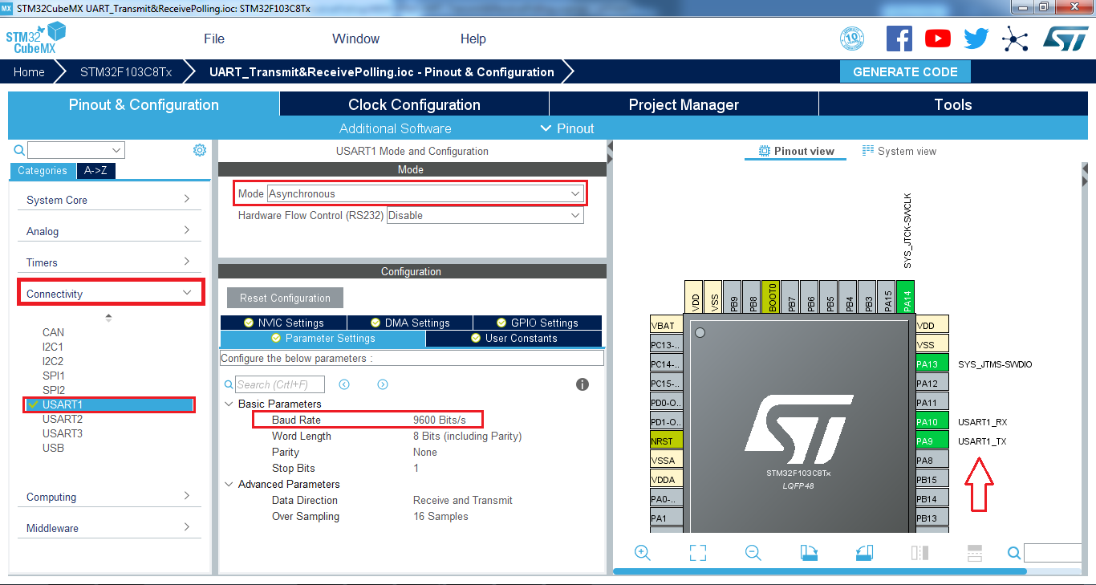

Step 3:

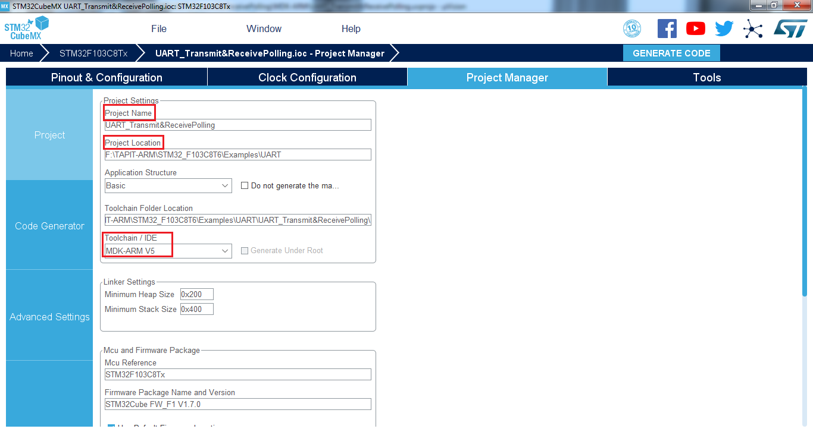

Step 4:

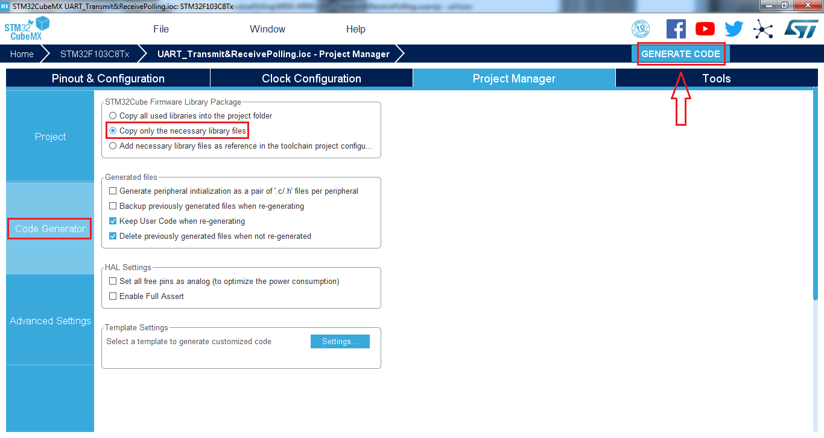

**KEIL C UVIONS:**

Step 1:

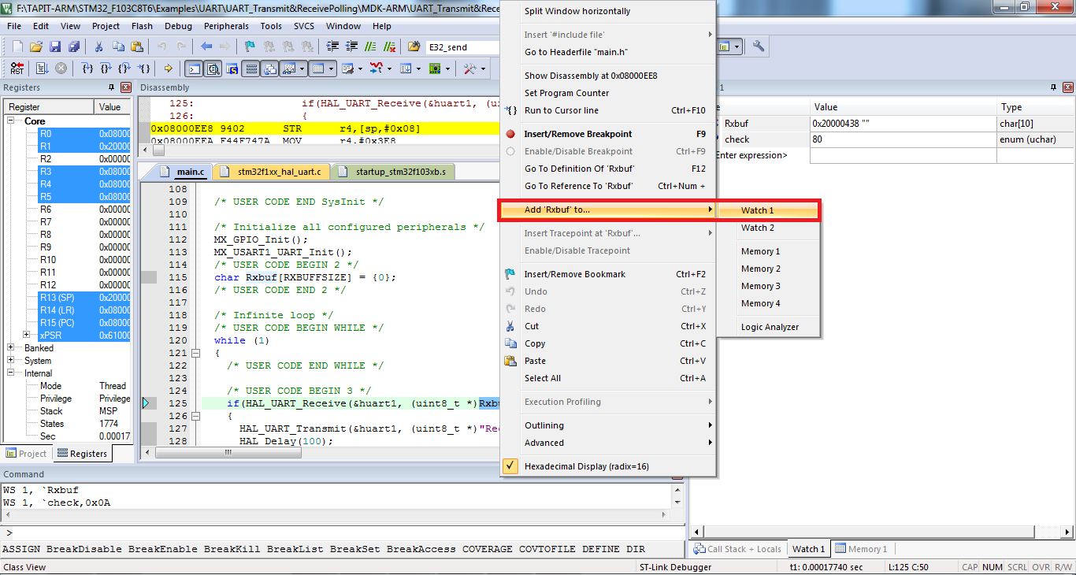

Step 2:

