/* --COPYRIGHT--,

* Copyright (c) 2019, TAPIT Co., Ltd.

* https://tapit.vn

* ********************* WWDG_EarlyWakeupCallback *********************

* Description: The program consists of 2 initial status LEDs that are off. An LED will

reverse the state to check the operation of the MCU. The remaining LED will be

turned on when entering the EWC function, off when MCU is reset.

* Version: 1.0

* Author: Hang Tran

* Release: May 27, 2019

* Built with CubeMX Version 5.2.0 and Keil C Version 5.26.2

*********************************************************************

*/

**STM32CUBEMX:**

Step 1:

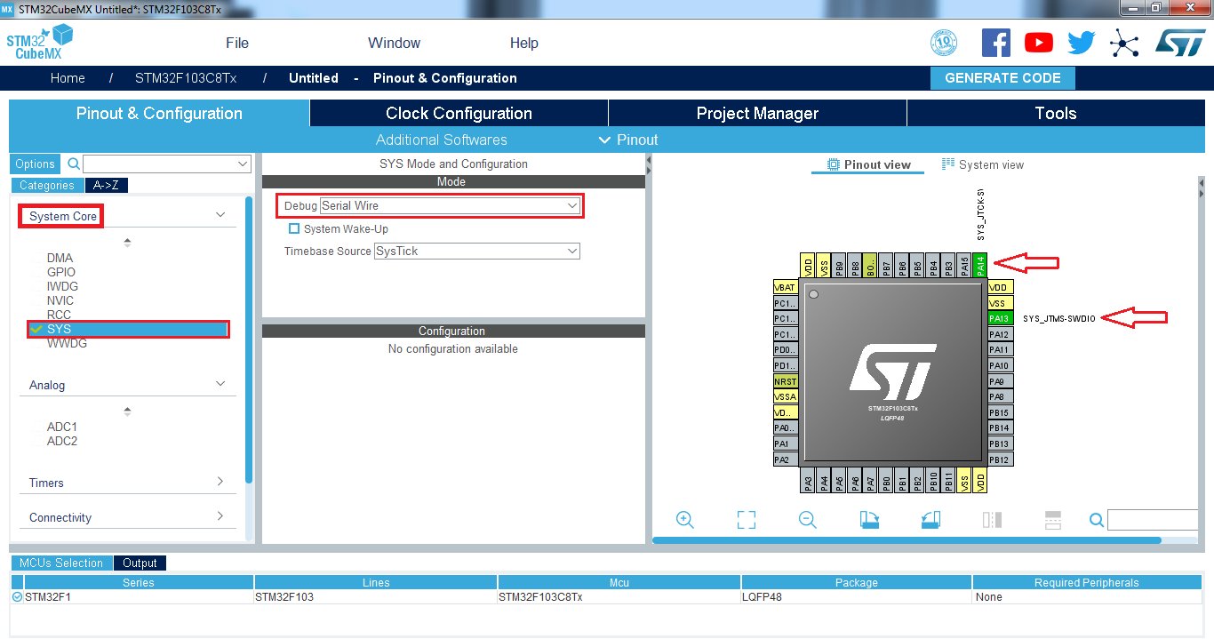

Step 2:

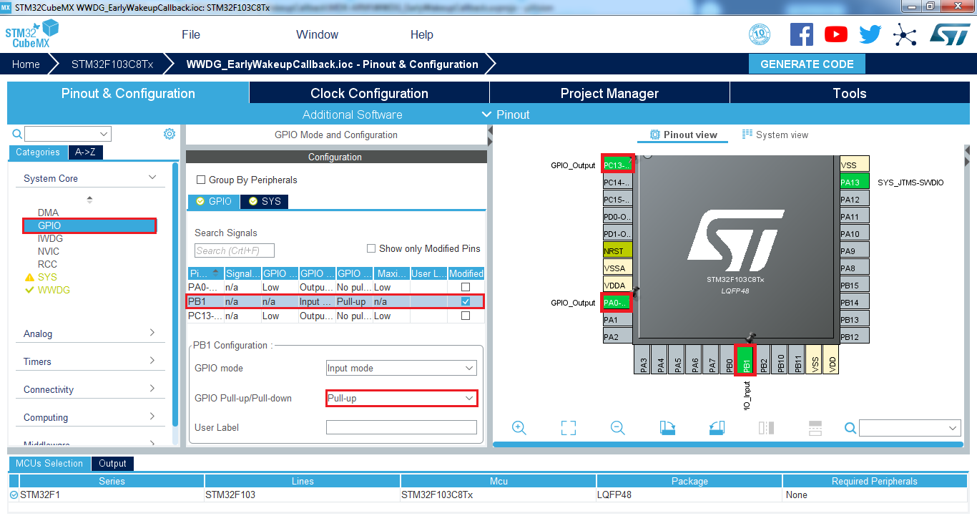

Step 3:

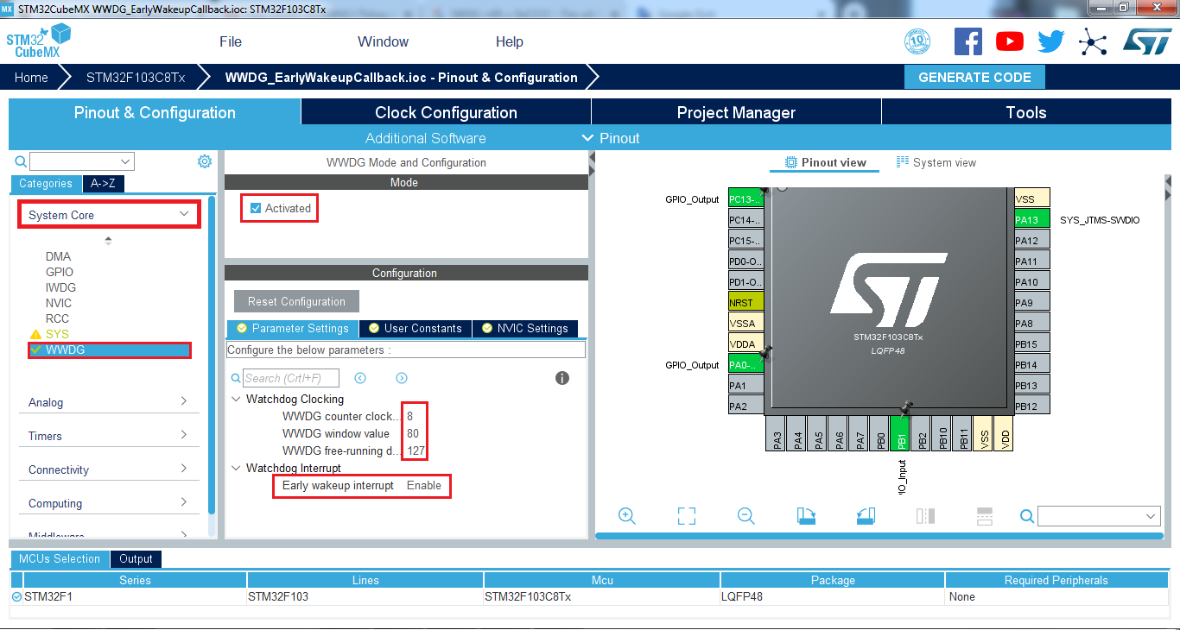

Step 4:

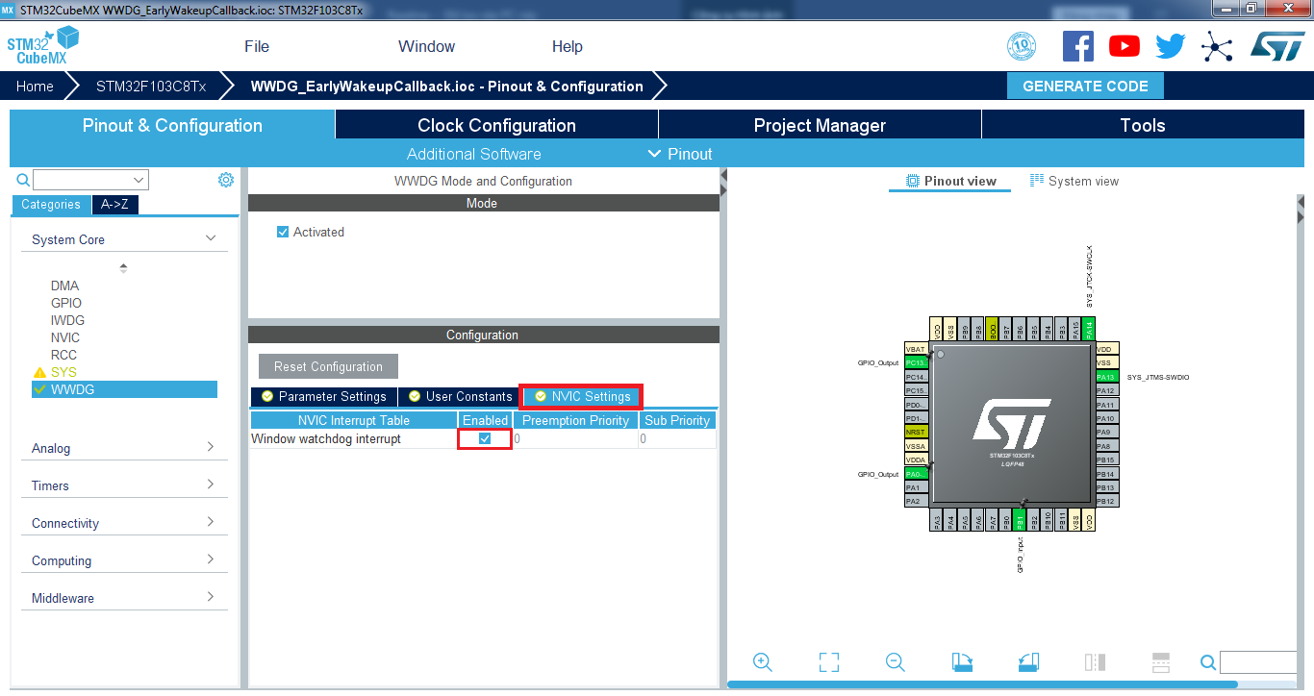

Step 5:

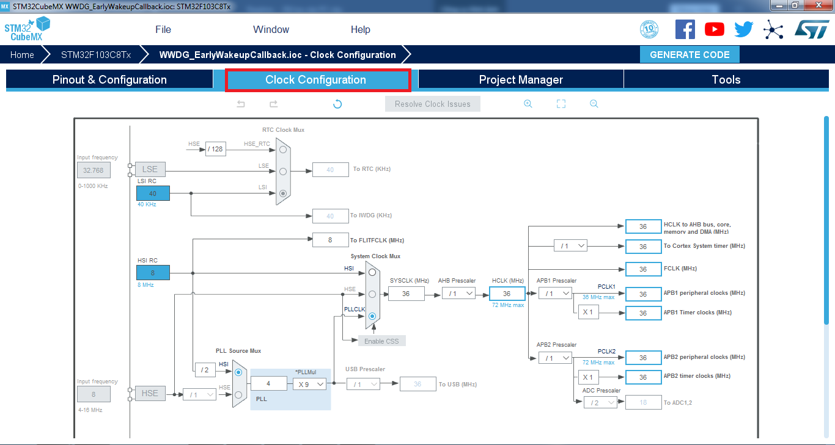

Step 6:

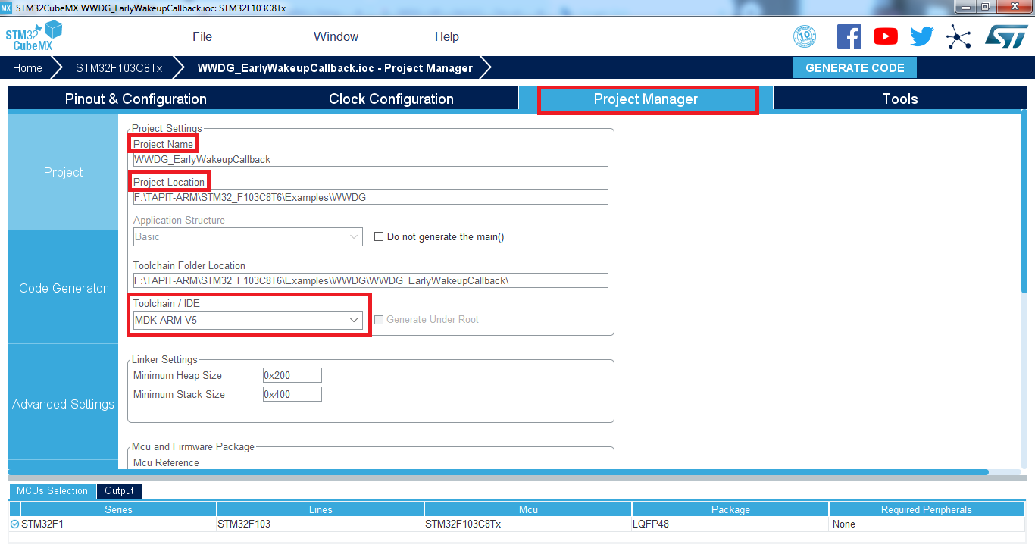

Step 7:

