ENERGIS 10IN Managed PDU
Product Label Documentation

Author David Sipos
Document number: ENE-TDOC-LABEL
Document name: ENE-TDOC-LABEL-Label-Description

Revision: 1.0.0
Status: Released
Date: 14.12.2025

Document status: Internal - CE Technical File

This Technical File applies exclusively to ENERGIS 10IN Managed PDU, Hardware Revision 1.1.0, and corresponding firmware versions released for this hardware. Firmware versions are identified in the device user interface and are covered by this Technical File insofar as they do not change safety-relevant behavior. The Technical File is maintained in electronic form by the manufacturer and can be made available without undue delay. All documents listed herein are retained for at least 10 years after the last product has been placed on the EU market.

Revision History
A revision is a new edition of the document and affects all sections of this document.
Version | Date | Responsible | Modification
1.0.0 | 18.12.2025 | David Sipos | Initial creation of the document

Contents
1. Introduction and Scope 3
2. Applicable Documents 3
3. Label Description 3
Header 4
Electrical Ratings 4
Technical Data Table 4
Compliance and Safety Symbols 4
Network and Serial Information 4
Footer 4
Design Features 5
4. Intended Use 5

1. Introduction and Scope
This document describes the content, structure, and intended use of the product identification and rating label affixed to the ENERGIS 10IN Managed PDU. The label provides essential electrical, operational, and compliance information required for safe installation, operation, and regulatory conformity. This documentation applies to all units bearing the referenced label format and serial numbering scheme.

2. Applicable Documents
- ENE-LDOC-DOC-EU-Declaration-of-Conformity
- ENE-UDOC-UM-ENERGIS-UserManual_rev_1.0.0
- ENE-LDOC-RA-Risk-Assessment-EN-ISO-12100
- ENE-LDOC-TFI-Technical-File-Index

3. Label Description
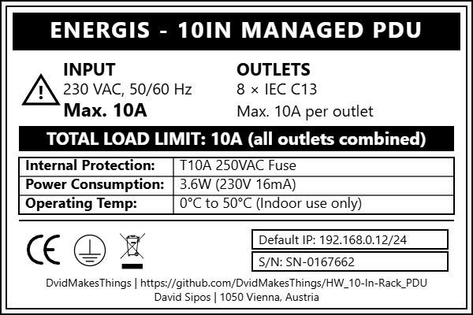

The label is a printed, durable adhesive plate affixed to the product enclosure. It contains the following elements:

Header
- Product name: ENERGIS – 10IN MANAGED PDU (bold, prominent at the top)

Electrical Ratings
- INPUT: 230 VAC, 50/60 Hz, Max. 10A
- OUTLETS: 8 × IEC C13, Max. 10A per outlet
- TOTAL LOAD LIMIT: 10A (all outlets combined, highlighted in a black bar for emphasis)

Technical Data Table
- Internal Protection: T10A 250VAC Fuse
- Power Consumption: 3.6W (230V 16mA)
- Operating Temp: 0°C to 50°C (Indoor use only)

Compliance and Safety Symbols
- CE marking
- WEEE (crossed-out wheelie bin) symbol

Network and Serial Information
- Default IP: The default IP address programmed into the device
- S/N: Unique device identification number

Footer
- Manufacturer/project contact:
  - DvidMakesThings | https://github.com/DvidMakesThings/HW_10-In-Rack_PDU
  - David Sipos | 1050 Vienna, Austria

Design Features
- Clear sectioning with bold headers and boxed layout
- Use of icons for compliance and warnings
- All critical ratings are bolded or highlighted for quick reference

4. Intended Use
The label is intended to:
- Provide installers and users with immediate access to key electrical and operational ratings
- Indicate compliance with relevant EU directives and environmental regulations
- Identify the product uniquely via serial number and default network configuration
- Support traceability and conformity assessment during inspections or audits
- Warn users of maximum load limits and safe operating conditions
The label must remain legible and attached to the product throughout its service life. It is not intended to be removed or replaced except by the manufacturer or authorised service personnel.

