ENERGIS 10IN Managed PDU
PEM-Adapter 1.0.0 PCB Layout Documentation

Author David Sipos
Document number: ENE-TDOC-PCBLayouts
Document name: ENE-TDOC-PCBLayouts-PEM-Adapter-1.0.0-PCB-
Layout-Documentation

Revision: 1.0.0
Status: Released
Date: 14.12.2025

Document status: Internal - CE Technical File

This Technical File applies exclusively to ENERGIS 10IN Managed PDU, Hardware Revision 1.1.0, and corresponding firmware versions released for this hardware. Firmware versions are identified in the device user interface and are covered by this Technical File insofar as they do not change safety-relevant behavior. The Technical File is maintained in electronic form by the manufacturer and can be made available without undue delay. All documents listed herein are retained for at least 10 years after the last product has been placed on the EU market.

Revision History
A revision is a new edition of the document and affects all sections of this document.
Version | Date | Responsible | Modification
1.0.0 | 12.12.2025 | David Sipos | Initial creation of the document

Contents
1. Introduction 3
1.1 Purpose 3
2. General Information 3
3. ENERGIS_PEM-Adapter_1.0.0 Layout 4
L1 Top layer 4
L2 Inner layer 5
4. PCB Stackup and Conductor Layout 6
4.1 PCB Stackup Overview 6
4.2 Layer Stackup Details (2-Layer Configuration) 6
4.3 Conductor Routing and Copper Pours 7
4.4 Notes on Manufacturing and Tolerances 7

1. Introduction
This document provides general technical information related to the printed circuit board (PCB) designs used within the ENERGIS 10-inch managed PDU system. It applies to all PCB layouts associated with the product, including but not limited to the main control board, display/interface board, and auxiliary adapter boards.

1.1 Purpose
The purpose of this document is to support technical documentation, compliance activities, and internal reference by describing the general characteristics, intended use, and design context of the PCB assemblies. It does not describe firmware behavior in detail and does not replace schematics, layout files, or test reports referenced elsewhere in the technical file.
This document is applicable to the PCB hardware revisions identified in the corresponding design documentation and manufacturing outputs. Any future hardware revisions may require an update or extension of this document where relevant.

2. General Information
The PCB assemblies covered by this document are designed for use as internal components of the ENERGIS 10-inch managed PDU and are not intended to be operated as standalone products. Each board fulfills a specific functional role within the overall system architecture and operates only when installed in the designated enclosure and used in accordance with the product documentation.
The PCB designs are developed using standard electronic design practices and manufactured using industry-standard PCB fabrication and assembly processes. Component selection is based on availability, electrical performance, and compliance with applicable regulatory requirements, including RoHS where applicable.
All PCB assemblies are intended for indoor use within controlled environmental conditions as specified in the product documentation. The boards do not include user-serviceable parts and are not designed for modification or repair by the end user.
Detailed design data, including schematics, layout files, manufacturing data, and test results, are referenced in the Technical File Index and maintained as part of the overall technical documentation set.

3. ENERGIS_PEM-Adapter_1.0.0 Layout

L1 Top layer
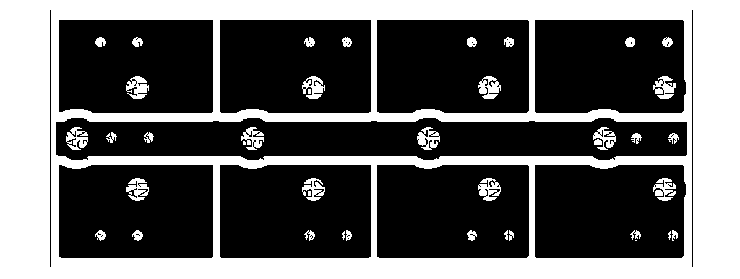

L2 Inner layer


4. PCB Stackup and Conductor Layout

4.1 PCB Stackup Overview
The PCB covered by this document is a 2-layer FR4 adapter board used to convert the ENERGIS 4-outlet PEM module connections to Faston connector outputs. The board does not implement any controlled impedance routing and does not contain signal reference planes. It is a power interconnect PCB intended for mains distribution within the ENERGIS system.
PCB Material and Construction:
- Material Type: FR4
- Laminate Specification: JLCPCB standard 2-layer FR4 stackup
- Number of Layers: 2
- Finished Board Thickness: 1.6 mm
- Copper Weight (Top and Bottom): 1 oz
- Dielectric Constant (FR4): approximately 4.5
- Manufacturing Standard: JLCPCB standard 2-layer process

4.2 Layer Stackup Details (2-Layer Configuration)
Layer | Description | Material / Copper Weight | Thickness (mm)
L1 | Conductor Layer (Top) | Copper, 1 oz | 0.0350
 | Dielectric Core | FR4 | ~1.5300
L2 | Conductor Layer (Bottom) | Copper, 1 oz | 0.0350
 | Total Finished Thickness |  | ~1.6000 mm

The dielectric core thickness is derived from the finished board thickness minus the two outer copper layers and is subject to standard manufacturing tolerances.

4.3 Conductor Routing and Copper Pours
This PCB is used for power interconnection only. Conductors are implemented primarily as copper pours for the following nets:
- 4 × Line (L)
- 4 × Neutral (N)
- 1 × Protective Earth (PE), common
No dedicated ground plane or signal reference plane is implemented. The layout is optimized for safe and reliable mains distribution using appropriate conductor widths/areas, clearance, and creepage distances as defined by the design rules and applicable requirements.

4.4 Notes on Manufacturing and Tolerances
- Core thickness, copper thickness, and dielectric properties are subject to standard PCB manufacturing tolerances.
- Copper thickness variations may affect resistance and current-carrying capability.
- No impedance-controlled routing or post-manufacturing impedance validation is required for this PCB.

