USER MANUAL

ENERGIS
10IN Managed PDU
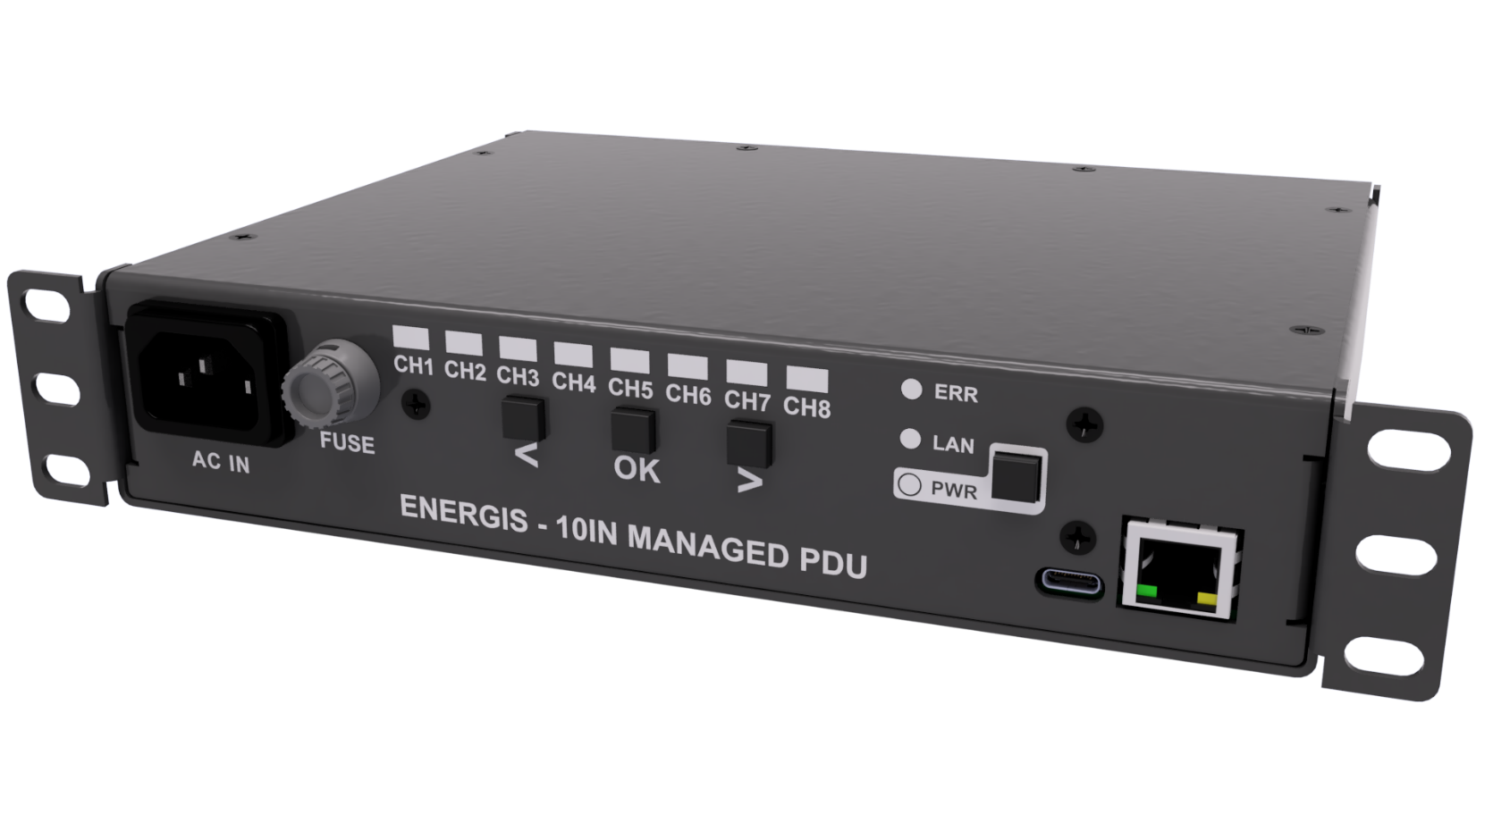

Revision: 1.1.0
Revision History
A revision is a new edition of the document and affects all sections of this document.
Version | Date | Responsible | Modification
1.0.0 | 12.12.2025 | David Sipos | Initial creation of the document
1.1.0 | 13.01.2026 | David Sipos | Added Software version 1.1.0 changes

Contents
Contents 3
1. Introduction 5
2. Safety and Warnings 6
2.1 Intended use 6
2.2 Personnel and access 6
2.3 Electrical ratings and loading 6
2.4 Grounding and connection 7
2.5 Environment and mounting 7
2.6 Operation and handling 7
2.7 Symbols 7
3. Product Overview 8
3.1 Key features 8
3.2 Rear panel 8
3.3 Front panel 9
4. Installation 10
4.1 Mounting 10
4.2 Power connection 11
4.3 Connecting loads 12
4.4 Network connection 13
4.5 USB connection 14
5. Front Panel Operation 15
5.1 Channel indicators 15
5.2 Status indicators 15
5.3 Selection window and button behavior 16
5.4 Examples 17
6. Web Interface (Basic Use) 18
6.1 Accessing the web interface 18
6.2 Control page (/control.html) 19
6.3 Settings page (/settings.html) 21
6.4 Help and documentation pages 22
6.5 Advanced monitoring and integration 23
7. Basic Troubleshooting 24
7.1 Cannot reach the web interface 24
7.2 Outlets do not switch 25
7.3 Measurements show zero 25
7.4 Forgotten or unknown IP address 26
8. Overcurrent Protection 27
8.1 Maximum Current Limits 27
8.2 The protection workflow 27
8.3 Channel Behavior During Overload 28
8.4 Manual Reset 28
Important Notes 28
9. Firmware Updates 29
9.1 General notes 29
9.2 Update procedure (UF2 via USB) 29
10. Technical Data (Summary) 31
10.1 Electrical characteristics 31
10.2 Environmental conditions 31
10.3 Mechanical data 32
10.4 Interfaces 32
10.5 Regional Variants and Ratings 33
11. Support and Warranty 34
11.1 Firmware, documentation and issue tracking 34
11.2 Warranty and limitations 34

1. Introduction

ENERGIS is an 8-channel managed power distribution unit (PDU) designed for small racks, lab environments and test benches where individual control of outlets and basic power monitoring are required. The device provides eight IEC C13 outlets in a compact 10-inch form factor and is intended to sit close to the equipment it supplies.

Each outlet can be switched independently, and the unit measures voltage, current, power and accumulated uptime per channel. This allows the user to power cycle devices remotely, check that loads are within expected limits and verify that equipment is actually drawing power. Status indicators on the front panel show the state of each outlet and the overall health of the device, giving a quick visual overview without the need for additional tools.

ENERGIS can be operated locally from the front panel or remotely over the network. A built-in web interface provides a simple control and monitoring view in any modern browser, without the need to install software on the host computer. Network settings and basic preferences can also be adjusted through the web interface so that the unit can be integrated into existing infrastructure with fixed addressing or custom naming.

For users who need deeper integration with monitoring and automation systems, ENERGIS also exposes a command line interface over USB, a structured HTTP API, an SNMP interface and an OpenMetrics endpoint suitable for Prometheus and similar tools. These programmable interfaces and their exact behavior are documented in detail in the separate Automation Manual.
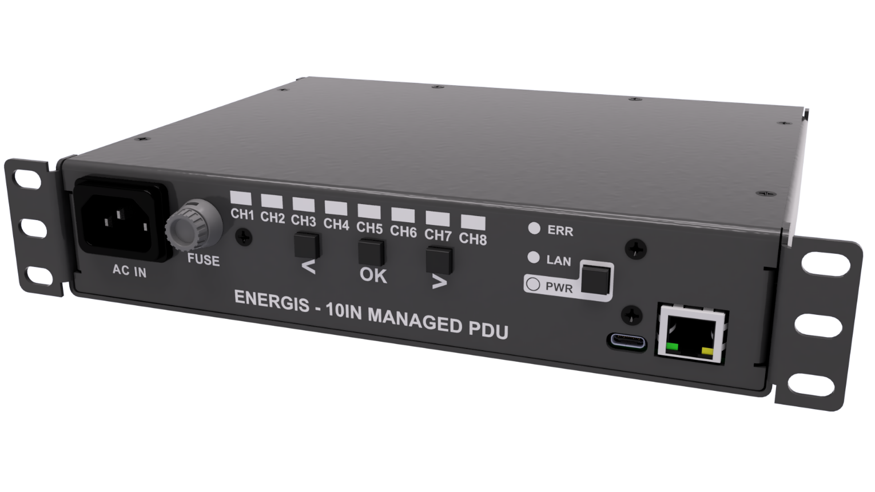

2. Safety and Warnings

This product switches and distributes mains voltage. Incorrect installation or use can lead to electric shock, fire, or damage to connected equipment. Read and follow all instructions in this section before putting ENERGIS into service.

2.1 Intended use

ENERGIS is a rack-mount power distribution unit for indoor IT, lab and similar equipment that is compatible with the local mains voltage and IEC C13 outlets. It is not a household extension cord, not a surge protector, and not a safety device. The unit is not designed or approved for life-support, medical, or any application where loss of power could result in injury or significant damage.

2.2 Personnel and access
Installation, wiring and servicing must be carried out only by qualified personnel familiar with mains electrical systems and local regulations.
- Do not open the enclosure. There are no user-serviceable parts inside.
- Servicing with the cover removed must only be performed with the unit fully disconnected from the AC supply.
- Do not modify the enclosure, wiring, connectors or protective earth.

2.3 Electrical ratings and loading
- AC input: 85-305 VAC
- Maximum input current: IEC/ENEC: 10A (EU), UL/CSA: 15A (US/CA).
- Maximum per-channel current: IEC/ENEC: 10A (EU), UL/CSA: 15A (US/CA).
- The sum of all active outlet currents must not exceed 10A (IEC/ENEC) or 15A (UL/CSA).

Do not daisy-chain multiple PDUs from a single outlet or feed another distribution strip from ENERGIS. Only connect equipment that is rated for the local mains voltage and fitted with suitable IEC C14 inlets or adapters approved for the load current. Exceeding these limits can overheat wiring and relay contacts and may cause fire or permanent damage to the unit.

2.4 Grounding and connection
The AC inlet must be connected to a properly grounded (earthed) mains outlet. Do not defeat the protective earth connection. Use only power cords with an approved plug for your region and with a current rating of at least the device rated input current (10 A for EU, 15 A for US/CA). Ensure that the rack and any metalwork are bonded to protective earth in accordance with applicable local electrical codes.

2.5 Environment and mounting
Intended for indoor use in dry locations only. Protect the unit from moisture, condensation, corrosive atmospheres and conductive dust. Operate within a range of 0 °C to 50 °C. At higher temperatures, reduce the total load to avoid overheating.

Mount the unit securely in a 10-inch rack or use it on a stable surface so that it cannot tip or fall. Do not cover the enclosure. Ensure adequate airflow around the unit and any other heat-generating equipment in the rack.

2.6 Operation and handling
Treat all outlets as live whenever the PWR indicator is on. Outlets may be switched remotely; equipment can become energized without local interaction at the rack. Before connecting, disconnecting or relocating loads, switch the affected outlet off and, if possible, disconnect the main supply.

Do not operate the unit if the enclosure, AC inlet, outlets or front-panel connectors show signs of damage, discoloration or overheating. Disconnect from mains and have the unit inspected by qualified service personnel.

2.7 Symbols
Where the following symbols are used on the product or in this manual, they have the meanings:

WARNING | - Risk of electric shock, fire or personal injury if instructions are ignored.
CAUTION | - Risk of equipment damage or data loss.

Following these safety instructions is a condition of proper use of the ENERGIS PDU.

3. Product Overview
ENERGIS is a compact 10-inch rack-mount PDU with individually switchable outlets and basic power monitoring per channel. It is intended to sit close to the equipment it supplies and to be operated either from the front panel or over the network.

3.1 Key features
- 8 individually switchable IEC C13 outlets.
- Per-channel indication of voltage, current, power and accumulated uptime.
- Front-panel status LEDs for outlet state, power status, network link and device health.
- Built-in web and SNMP interface for remote control and basic monitoring.
- Static IP configuration by default, changeable via the web interface or console.
- USB-C serial console for local configuration and diagnostics.

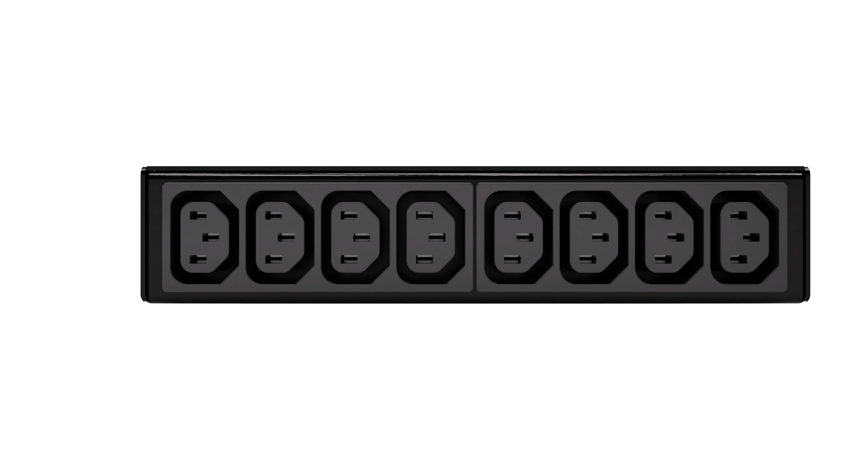
3.2 Rear panel
1
8
2
3
4
5
6
7

The rear panel carries the eight load outlets.

- Outlet block (CH1-CH8):
  - Eight IEC C13 outlets for powering connected equipment.
  - Outlets are numbered from 1 to 8 on the rear panel to match the channel indicators on the front panel.

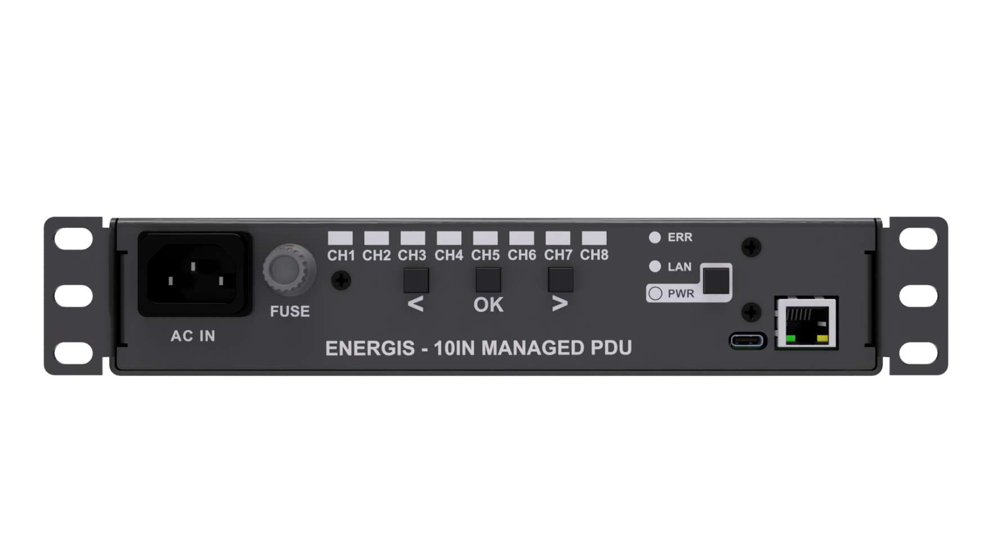
3.3 Front panel
1
2
3
4
5
6

The front panel provides local control and a quick visual overview of the device state.

- AC inlet: IEC appliance inlet for connection to the mains supply. Use a suitable mains lead rated for the specified input current (see Safety and Specifications).
- Channel indicators (CH1-CH8): One LED pair per outlet.
- Green LED: shows whether the corresponding outlet is switched on or off.
- Orange LED: used as a selection indicator during the 10 s selection window.
- Navigation buttons
- < and >: move the active selection between channels during the selection window.
- OK: toggles the currently selected outlet on or off with a short press; used for local control as described in the Operation section.
- Status LEDs
- ERR: lights when the unit has detected an internal fault condition.
- LAN: indicates that an Ethernet link is present.
- PWR: indicates that the internal power supply is within its expected operating range.
- Power button
- Long press (>2s) when the device is powered initiates the low power sleep mode. The PWR LED blinks every second. Short press in active mode has no effect
- Short press, when the device is in sleep mode wakes up the device and puts it back in active mode.
- Connectors
- USB-C: exposes the serial console as a USB-CDC device for configuration and diagnostics.
- RJ-45 Ethernet: network interface for the web interface and remote control.
s

4. Installation

This section describes how to put ENERGIS into service: mounting it in the rack, connecting the mains supply, attaching loads and bringing the network and optional USB console online. Read the Safety and Warnings chapter first and follow all local electrical regulations during installation.

4.1 Mounting
ENERGIS is intended for use in 10-inch racks and small cabinets. The unit should be mechanically secured before any electrical connections are made, and the mounting position should allow cables to be routed without strain and the front panel to remain visible.

Recommended procedure:
- Install ENERGIS in a suitable 10-inch rack or cabinet using the integrated mounting ears and appropriate screws or cage nuts.
- Support the unit during installation so that no mechanical stress is applied to the front panel, connectors or enclosure.
- Provide adequate clearance above, below and behind the unit for cable routing and basic airflow inside the rack.
- Avoid placing the unit directly above equipment that exhausts hot air upwards, unless the rack cooling is planned for this arrangement.
- Position the unit so that the front panel LEDs and buttons are clearly visible and accessible during normal operation and service.

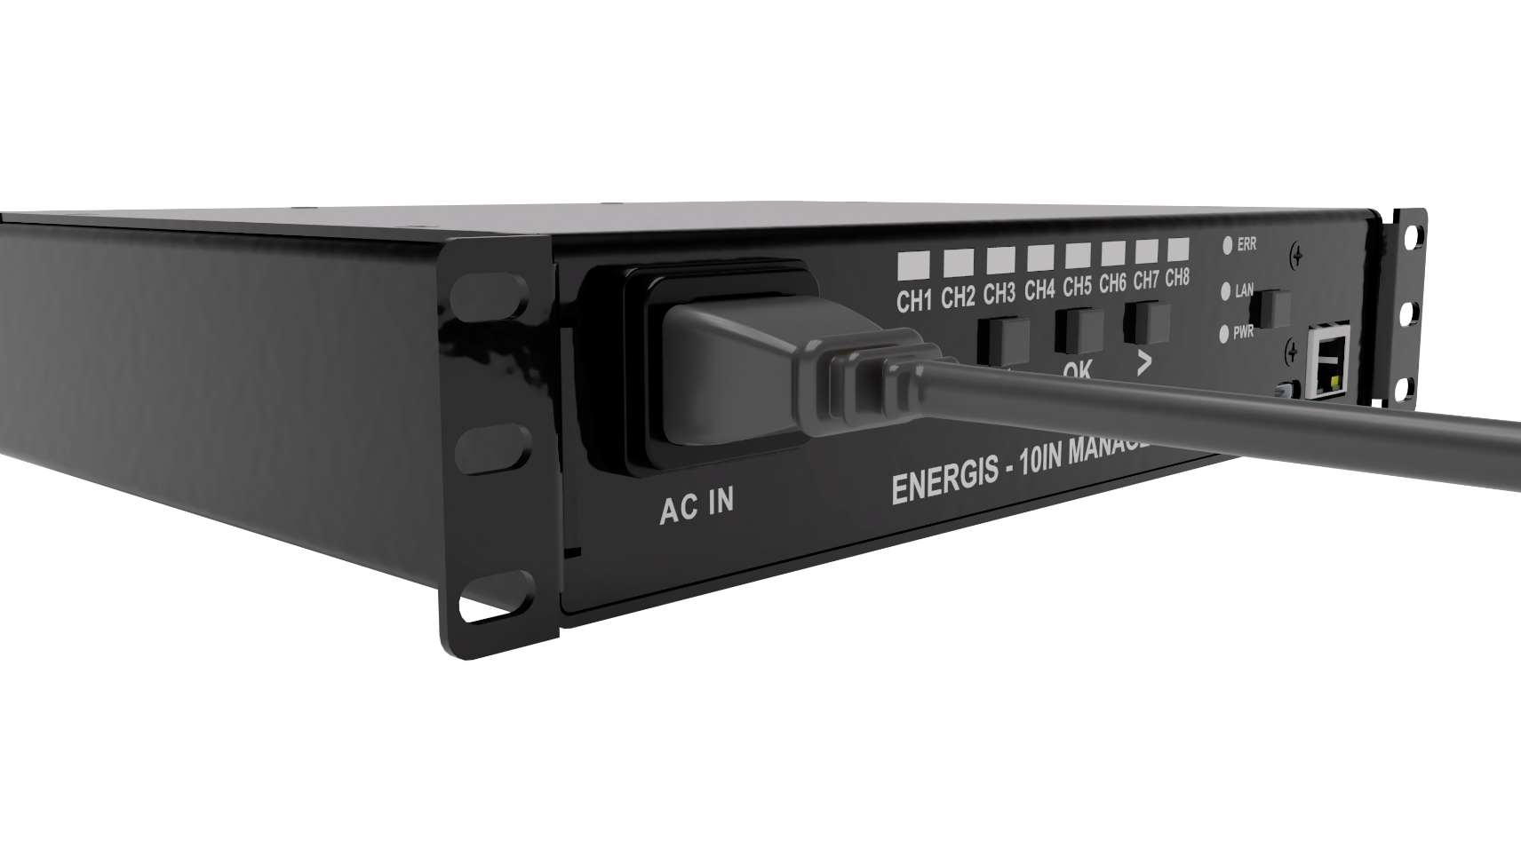
4.2 Power connection
WARNING - Risk of electric shock, fire or personal injury if instructions are ignored. All work on the mains supply must be carried out by qualified personnel.

Before energizing the unit, verify that the local mains voltage matches the rating on the product label. All power connections must be made with the unit mechanically secured in the rack and using cables that are correctly rated for the expected current.

Recommended procedure:
- Verify that the local mains supply matches the voltage indicated on the ENERGIS rating label.
- Connect the AC inlet to a properly grounded mains outlet using a mains lead approved for your region and rated for at least the device rated input current (10A EU, 15A US/CA).
- Ensure that the upstream circuit protection (fuse or breaker) and wiring are suitable for the device rated input current (10A EU, 15A US/CA).
- Observe the overall loading limit: the sum of all active outlet currents must not exceed the device rated input current (10A EU, 15A US/CA).
- After switching on the upstream supply, check that the PWR LED on the front panel lights, indicating that the internal power supply is within its operating range.

4.3 Connecting loads

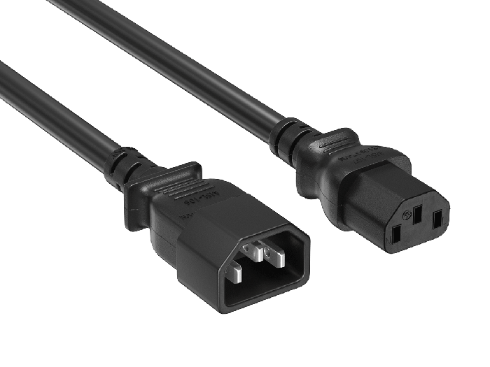
The rear panel provides eight IEC C13 outlets for the connected equipment. Loads should be distributed so that the total current remains within the specified limit and the rack wiring is not overstressed. It is good practice to document which device is connected to which channel to avoid confusion during remote operation.

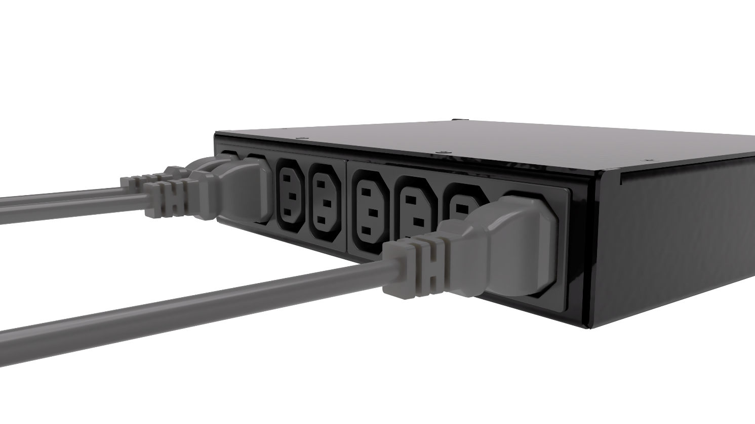

Recommended procedure:
- Connect equipment to the IEC C13 outlets using IEC C14 cord sets or suitable adapters that are correctly wired and rated for the required current.
- Match the outlet numbering (CH1 to CH8) on the rear panel with your installation documentation so that remote switching commands map to the intended devices.
- Where possible, switch the relevant channel off before plugging in or unplugging a device, to minimize arcing at the connector and avoid unplanned restarts.
- Distribute high-power devices across the outlets in a way that keeps the total current within the inlet rating (10A EU, 15A US/CA) and maintains a reasonable thermal load in the rack.
- Do not daisy chain other PDUs or multi-way extensions from ENERGIS outlets.

WARNING - Risk of electric shock, fire or personal injury if instructions are ignored. All work on the mains supply must be carried out by qualified personnel.

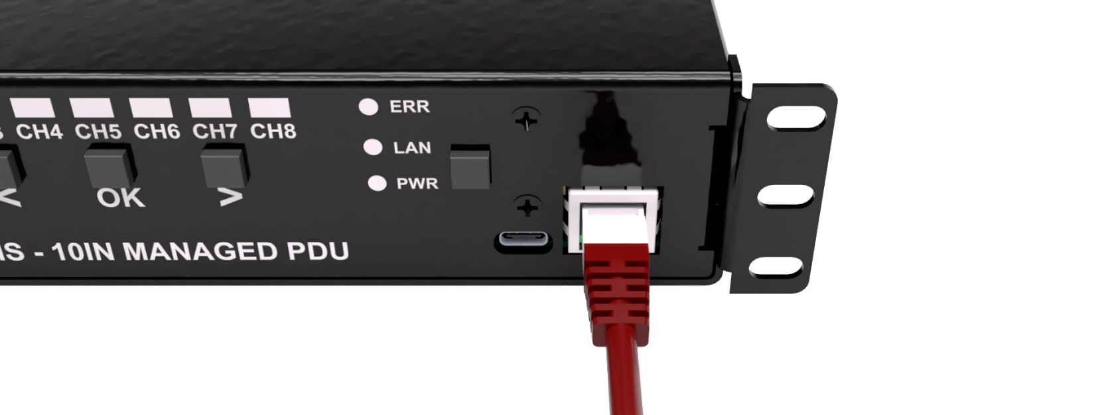
4.4 Network connection

A network connection is required for access to the web interface and for remote monitoring or integration. ENERGIS ships with a static IP configuration that is printed on the product label so that the unit can be reached on a small dedicated segment immediately after installation.

Recommended procedure:
- Connect the RJ-45 Ethernet port on the front panel to a switch or router using a standard twisted-pair Ethernet patch cable (CAT5/CAT5E).
- Confirm that the LAN LED lights, indicating that a physical link is present.
- Read the default static IP address from the label on the underside of the unit and verify that it is valid and non-conflicting on the intended network segment.
- From a host in the same subnet, open a web browser and enter the device IP to access the web interface.
- If your network requires a different static address or DHCP operation, plan the change and apply it later via the Settings page of the web interface, described in section 6.3.

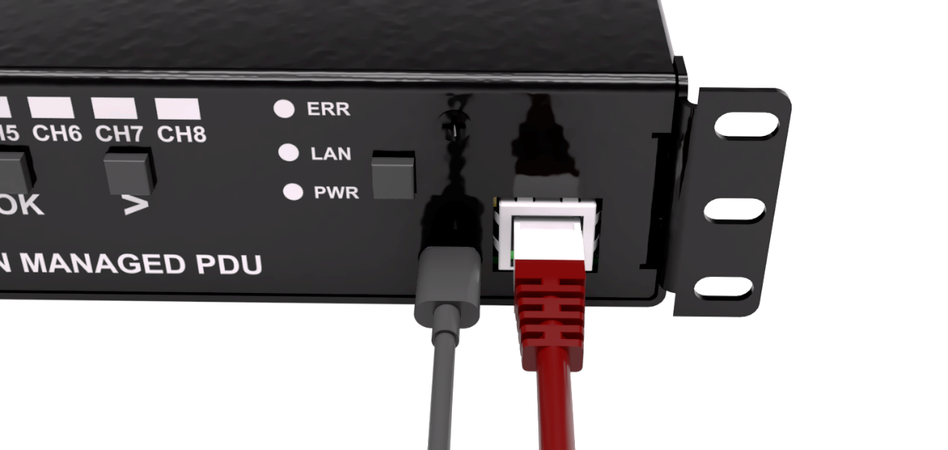
4.5 USB connection

The USB-C connector provides an optional local management path that does not depend on the network. It is intended for commissioning, diagnostics and advanced configuration rather than day-to-day operation.

Recommended procedure:
- If a local console is required, connect the USB-C port on the front panel to a computer using a suitable USB cable.
- Allow the operating system to detect ENERGIS as a USB-CDC (virtual COM) device.
- Open a serial terminal on the host and select the appropriate port with the configured parameters if you need direct console access.
- Use this interface only when necessary; normal operation and basic configuration are normally carried out via the front panel and web interface.
- For the list of available console commands and their detailed syntax, refer to the Automation Manual.

5. Front Panel Operation
The front panel provides basic local control of all eight outlets and a quick indication of the overall device status. All functions described in this chapter can be used without any network or USB connection.

5.1 Channel indicators
Each outlet has a pair of LEDs on the front panel, labelled CH1 to CH8. These LEDs indicate both the switching state of the outlet and, during configuration, which channel is currently selected.
- Green LED (per channel)
  - On: the corresponding outlet is switched on and supplying mains voltage to the rear C13 connector.
  - Off: the outlet is switched off.
- Orange LED (per channel)
  - Off: no selection window is active.
  - Blinking: the channel is currently selected during the 10 s selection window and can be controlled with the buttons.
  - Only one channel is highlighted at a time during normal operation.

The orange “selection” indication is only active while the selection window is open. Outside this window, the orange LEDs remain off and the front panel shows only the on/off state via the green LEDs.

5.2 Status indicators
In addition to the per-channel LEDs, three status LEDs show the overall health and connectivity of the unit:
- PWR: Indicates that the internal power supply is present and within its expected operating range. This LED must be lit for the device to function.
- LAN: Indicates that an Ethernet link is detected on the RJ-45 connector. It does not indicate that higher-level protocols (such as IP) are correctly configured, only that a physical link is present.
- ERR: Lights when the unit has detected an internal error condition. The error can be cleared locally with a long press of the Set button (see below). If the LED lights again after clearing, further investigation may be required.

These status indicators allow a quick check of basic conditions (power, network link, fault state) without using the web interface or console.

5.3 Selection window and button behavior
The front panel buttons control a time-limited “selection window” during which channels can be chosen and switched. This avoids accidental switching from incidental button presses.

Opening the selection window
- A short press on any button (Left, Right or Set) when no window is active opens a 10 second selection window.
- When the window opens, one channel becomes active and its orange LED starts blinking. No outlets are switched at this point; the first press only enables selection.

If there is no further button activity for 10 seconds, the selection window closes automatically and all orange LEDs turn off. The green on/off indication remains unchanged.

Operation within the selection window: While the selection window is open (orange LED blinking on one channel):
- Left / Right buttons
  - Step the active selection to the previous or next channel.
  - The orange LED moves across the channels to show which outlet is currently selected.
  - The selection wraps around between channel 1 and channel 8.
- Set button (short press)
  - Toggles the currently selected outlet on or off.
  - The corresponding green LED changes state to reflect the new outlet status.
- Set button (long press)
  - A long press (approximately one second) clears the ERR LED if an error condition has been latched.
  - This action does not change the state of any outlet.
Each button press within the window restarts the 10 second timeout. If there is no activity for 10 seconds, the window closes and the orange selection indication turns off.

Power button
Device state | Press type | Behavior
Active | Long press (> 2 s) | Enters low-power sleep mode: all outputs are turned off, and the PWR LED blinks at 0.5 Hz (1 s ON / 1 s OFF). All device functions become unavailable
Active | Short press | No effect.
Sleep | Short press | Wakes the device from sleep and returns to active mode. Normal functionality becomes available again
Sleep | Long press (> 2 s) | No effect.

5.4 Examples

The following examples illustrate typical front panel operations.

- Turn outlet 3 on
  - Press any button to open the selection window. One channel will start blinking orange.
  - Use the Left/Right buttons until channel 3’s orange LED is blinking.
  - Press the Set button briefly. The green LED for channel 3 turns on, indicating that the outlet is now supplying power.
- Turn outlet 5 off
  - Press any button to open the selection window.
  - Use the Left/Right buttons until channel 5’s orange LED is blinking.
  - Press the Set button briefly. The green LED for channel 5 turns off, indicating that the outlet is now switched off.
- Clear an error condition
  - Ensure the front panel ERR LED is lit.
  - Press and hold the Set button for about one second.
  - Release the button. The ERR LED turns off to indicate that the error has been cleared.

If the ERR LED lights again after clearing, refer to the troubleshooting and diagnostics sections of this manual or the Automation Manual for further investigation.

6. Web Interface (Basic Use)
The web interface provides a convenient way to switch outlets and view basic measurements from any computer on the same network, without installing additional software. This chapter describes only the user-facing pages; protocol-level details are covered in the Automation Manual. This chapter covers only the user-facing pages. Protocol-level details and integration options are documented separately.

6.1 Accessing the web interface
To use the web interface, you need the IP address of the device.
- The factory-default IP address is printed on the label on the underside of the unit.
- If the address has been changed, it can be checked via the serial console using the NETINFO command (see Automation Manual).

Once you know the IP address:
- Open a web browser on a computer in the same network segment.
- Enter the address in the address bar in the form:

http://<device-ip>/

- The browser loads the main control page. If the page does not load, check the network cabling, verify that the ETH LED is lit and confirm that the PC is in the same subnet.

6.2 Control page (/control.html)

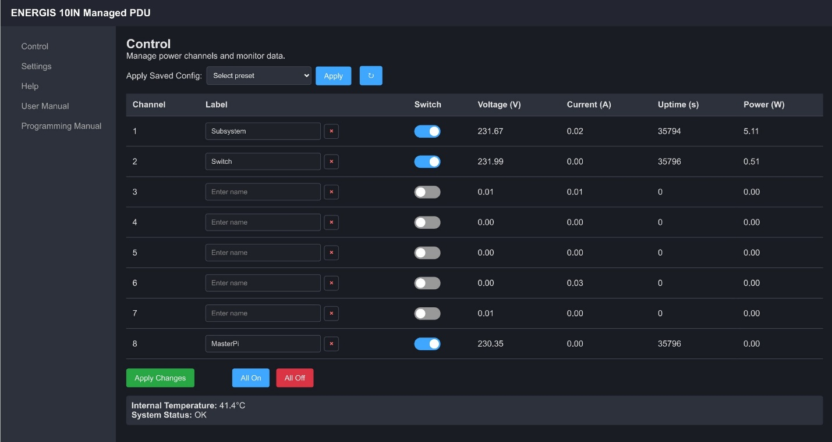
The control page is the main view for daily operation. It shows the state of all outlets and the basic measurements per channel.

Typical elements of the page include:
- Apply saved config
  - Allows the user to select any of the 5 user-configurable presets and apply them to the output
- Per-channel controls
  - One row per outlet (CH1-CH8).
  - A clear indicator showing whether the outlet is currently ON or OFF.
  - A control element (toggle switch or button) to change the state of the outlet.
  - Label field for individual channel name
  - The outlet state on the page follows the actual relay state in the device.
- Live measurements
  - For each channel, the page displays:
    - Voltage [V]
    - Current [A]
    - Power [W]
    - Uptime or run-time indication for the channel
  - Values update periodically so that the user can confirm that connected equipment is powered and drawing current as expected.
- Overall status / header area
  - Device name and basic system information (for example firmware version).
  - A summary indication if all outlets are off or if one or more errors are present.

The control page is intended for routine tasks such as turning outlets on and off, verifying loads and checking that equipment is running without having to access the front panel.

6.3 Settings page (/settings.html)
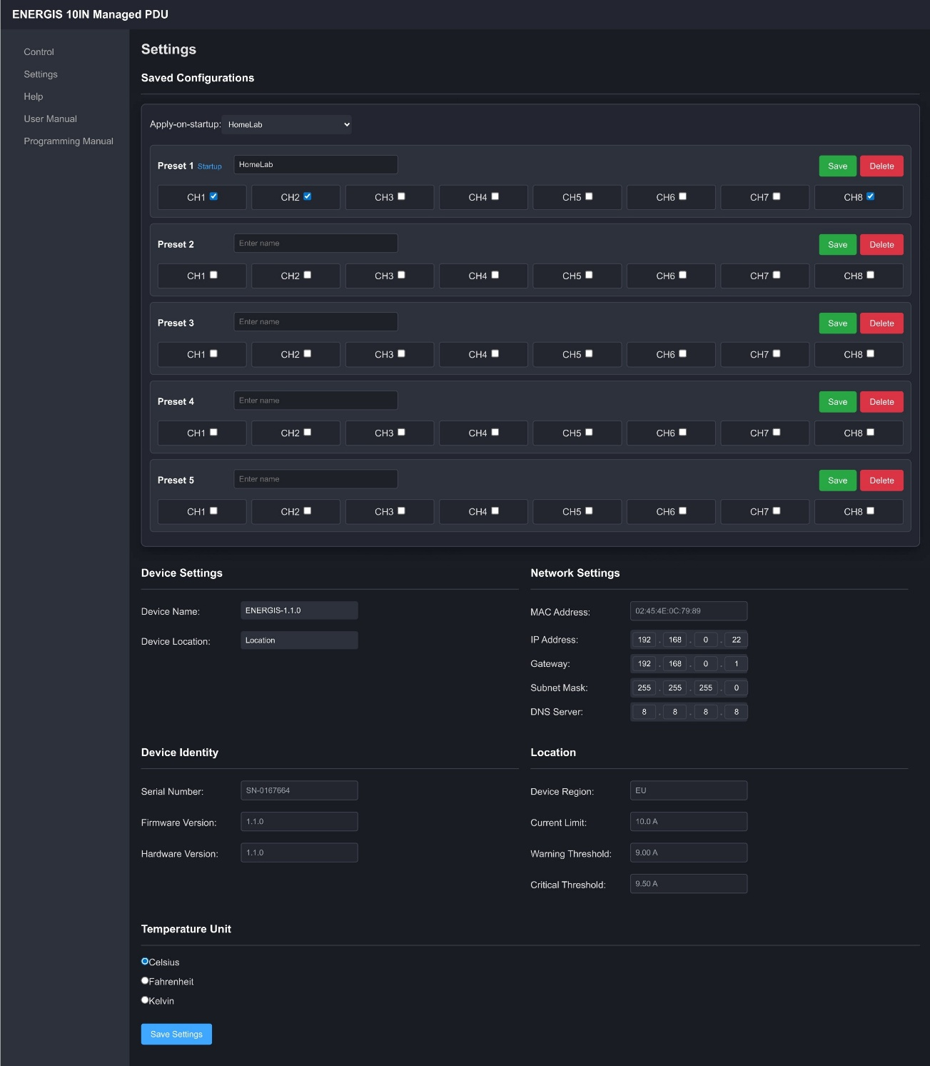
The settings page is used to change basic device properties and network configuration. It is intended for initial setup and occasional adjustments rather than frequent use.

On this page you can typically adjust:
- Presets and apply-on-startup
  - Apply-on-Startup allows you to select one preset to auto-apply during system start.
  - 5 user-configurable presets, with individual names let you save often used configurations. These presets can be applied on the control screen or can be set to be auto applied during startup.
- Device information
  - Device name: label used in the web interface and, depending on configuration, in monitoring systems.
  - Location: free-text field to identify where the unit is installed (rack, room or site).
  - Temperature unit: selection between Celsius, Kelvin and Fahrenheit.
- Network settings
  - IP address
  - Subnet mask
  - Default gateway
  - DNS server

These values define how ENERGIS appears on the network and how it communicates with other systems.
After making changes:
- Submit the form using the button provided on the page.
- The device stores the new settings and, if network parameters were changed, performs a reboot for them to take effect.

CAUTION - Changing the IP address, subnet mask or gateway can make the device temporarily unreachable if the new settings are incorrect or outside the current subnet. Always record the new values before applying them and plan access to the new address after the reboot.

6.4 Help and documentation pages
In addition to the control and settings views, the web interface provides simple documentation entry points.

- Quick help (/help.html)
  - A small page served directly from the device.
  - Summarizes front panel behavior, basic network checks, and common issues.
  - Does not require internet access and is intended for on-site troubleshooting.
- Manual links (/user_manual.html, /programming_manual.html)
  - Small pages that link to the User Manual and Automation Manual PDFs hosted online.
  - When the device has access to the internet and the browser can reach the hosting site, selecting these links opens the full documentation.

The help page provides a minimal reference when the network is local-only or offline, while the manual links offer direct access to the complete documentation set when external connectivity is available.

6.5 Advanced monitoring and integration
The web interface intentionally presents a simplified view of the device: it focuses on per-channel switching, basic measurements and essential settings. Internal telemetry and configuration are richer than what is shown on these pages.
For environments that require detailed monitoring, trending and integration with existing management systems, ENERGIS also provides:
- An SNMPv1 interface for polling outlet states, power and energy telemetry and selected system parameters.
- An OpenMetrics-compatible /metrics endpoint suitable for scraping by Prometheus and similar monitoring tools.
Both interfaces expose more metrics and control points than the basic web pages and are intended for use by automation and monitoring software rather than by end users. Their structure, available fields and configuration examples are described in detail in the ENERGIS Automation Manual.

7. Basic Troubleshooting
This section covers common issues that can be diagnosed and resolved on site without specialized tools. It focuses on visible indicators and simple checks. No protocol knowledge is required.

7.1 Cannot reach the web interface

Symptoms: entering http://<device-ip>/ in the browser does not load the control page.

- Check device status
  - Verify that the PWR LED on the front panel is lit.
  - Verify that the LAN LED is lit or blinking, indicating that an Ethernet link is present.
- Check cabling and network
  - Confirm that the Ethernet cable is firmly plugged into both the ENERGIS front-panel RJ-45 port and the switch or router.
  - Check that the switch port is enabled and not administratively shut down.
  - Ensure that the PC and ENERGIS are connected to the same IP subnet or that routing is configured appropriately.
- Verify basic connectivity
  - From a PC in the same network segment, open a command prompt and send a ping to the device IP address.
  - If ping fails, re-check IP configuration and cable connections.
- Clear error and restart if necessary
  - If the ERR LED is lit, press and hold the Set button on the front panel for about one second to clear the error.
  - If communication is still not possible, disconnect the mains supply, wait a few seconds, and reconnect it to perform a clean restart.

If the problem persists after these checks, refer to the Automation Manual or contact support with details of the LED states and network configuration.

7.2 Outlets do not switch
Symptoms: pressing Set on the front panel or toggling an outlet in the web interface does not change the outlet state; the green channel LED does not update as expected.

- Check error status
  - Look at the ERR LED. If it is lit, clear the error with a long press of the Set button on the front panel.
  - After clearing, try switching the outlet again.
- Check total load and supply
  - Confirm that the total load connected to the unit does not exceed the 10A EU, 15A US/CA inlet rating.
  - Verify that the upstream circuit breaker or fuse has not tripped and that the mains supply is present.
- Check outlet assignment
  - Confirm that you are operating the correct channel (front-panel channel number and wiring on the rear panel match your documentation).
If the outlets still do not respond, disconnect the mains supply and connected loads and have the installation inspected by qualified personnel.

7.3 Measurements show zero
Symptoms: the web interface or other monitoring shows voltage, current or power as zero for a channel that is expected to be active.

- Check outlet state and load
  - Verify that the green LED for the channel is on, indicating that the outlet is switched on.
  - Confirm that a load is actually connected to the corresponding rear-panel C13 outlet.
- Allow time for measurement update
  - After switching a channel on, allow a few seconds for the internal power meter to update. Measurements are not instantaneous.
- Check for very light loads
  - Very small loads may be below the minimum current threshold and can appear close to zero in the measurements.

If a channel continues to report zero values while driving a known load, note the channel number and conditions and refer to the Automation Manual or support for further diagnosis.

7.4 Forgotten or unknown IP address

Symptoms: the device is powered, the LAN LED is on, but the current IP address is not known.

- Check the product label
  - The factory-default IP address and network settings are printed on the label on the underside of the unit.
  - If your installation uses the defaults, or has been reset to defaults, the device should respond on this address.
- Check installation documentation
  - The installer or system administrator may have recorded the configured IP address and name in project documentation or in the network inventory.
- Restore network settings (if permitted)
  - If the device has been configured with unknown settings and cannot be reached, network parameters can be restored to their factory defaults via the service console using the factory reset procedure.
  - This operation resets network configuration and user preferences to their original values but does not change the firmware.
  - For the exact reset sequence and precautions, refer to the Automation Manual or contact support.

CAUTION - A factory reset clears custom network settings. After the reset, the device will use the default IP configuration printed on the label, and any integrations that rely on the previous address must be updated.

8. Overcurrent Protection

The ENERGIS PDU is protected against overload by an automatic overcurrent protection system. This system continuously monitors the total current drawn by all connected outputs together and prevents unsafe operation:
- Prevents the PDU from operating above its rated current
- Automatically turns off loads if a dangerous overload occurs
- Blocks turning channels ON until the overload is resolved
- Allows channels to be turned OFF at all times for safety

This protection works automatically and does not require user interaction under normal operation.

8.1 Maximum Current Limits

The maximum allowed current depends on the product version:

- EU version: 10 A maximum total current
- US version: 15 A maximum total current

All protection actions are based on this total current limit.

8.2 The protection workflow

As the total current increases, the system reacts in stages:

- Approaching the limit: When the total current gets close to the maximum, the device records a warning. Operation continues normally.
- Overcurrent detected: If the total current becomes dangerously high, the device:
  - Automatically turns OFF the most recently switched-on channel
  - Blocks turning ON any channels
  - Records the event for diagnostics
- Recovery: When the total current drops to a clearly safe level, normal operation is restored automatically.

8.3 Channel Behavior During Overload

The last channel that was turned ON is switched OFF first. This helps disconnect the load that most likely caused the overload.

If the device cannot determine which channel caused the overload, all channels are turned OFF as a safety measure.

Turning channels **OFF is always allowed, even during an overload condition.

8.4 Manual Reset

If required, the overcurrent lockout can be cleared manually using the control interface or console. This should only be done after reducing the connected load, otherwise the protection may trigger again.

Important Notes

- The protection monitors total current, not individual channels.
- Short, harmless current spikes are ignored.
- The system uses automatic recovery to avoid repeated on/off cycling.
- Overcurrent events are logged and can be reviewed for troubleshooting.

This protection system ensures safe and reliable operation of the ENERGIS PDU, even in the event of accidental overload.

9. Firmware Updates
Firmware updates may introduce new features, performance improvements or fixes. This section outlines the standard update method for ENERGIS using the RP2040 USB mass-storage bootloader. If your installation is managed by an integrator or IT department, follow their procedures. If in doubt, do not perform updates yourself.

9.1 General notes
- Only install firmware images obtained from the official project repository or your system supplier.
- Do not interrupt power or disconnect the USB cable during the update process.
- An incorrect or interrupted update may render the device temporarily unusable until it is recovered.

9.2 Update procedure (UF2 via USB)
- Obtain the firmware file
  - Download the appropriate .uf2 firmware file for your hardware revision from the official source specified by the maintainer.

- Prepare the connection
  - Connect the ENERGIS USB-C port to a computer using a suitable USB cable.
  - If the device is already powered from the mains, you may leave the AC connection in place during the update.

- Enter bootloader mode
  - Put the device into USB mass-storage boot by sending the command “BOOTSEL” via serial terminal
  - When successful, the computer will detect a new removable drive representing the device bootloader.

- Copy the firmware
  - Drag and drop the .uf2 file onto the newly appeared drive.
  - Wait until the file copy has completed. The drive will disconnect automatically when the update is finished.
  - After the update, ENERGIS restarts into the new firmware.

- Verification
  - Verify that the PWR LED is on and that the device responds as expected (front panel and web interface).
  - Sending the command “SYSINFO” via Serial terminal will display general system information. Look for the section:
=== Device Firmware Info ===
[ECHO] Device Serial: SN-xxxxxxx
[ECHO] Firmware Ver: x.x.x

  - The firmware version shall match with the displayed version

CAUTION - Do not remove power or the USB cable while the .uf2 file is being copied. Interrupting the update process may corrupt the firmware image and require a recovery procedure.

CAUTION - If an update fails or the device does not restart correctly, disconnect power, wait a few seconds and reconnect it. If the issue persists, repeat the update procedure or contact support with the firmware version and a description of the behavior.

10. Technical Data (Summary)

This section summarizes the main electrical, environmental and mechanical characteristics of ENERGIS, together with its external interfaces. For definitive values and tolerances, refer to the product label and mechanical drawing for the specific hardware revision.

10.1 Electrical characteristics
Parameter | Value / Range | Note
Input voltage | 85-305 VAC | See rating label for permissible tolerance
Input frequency | 50 / 60 Hz | Mains supply
Maximum input current | - 10A EU  - 15A US/CA | Do not exceed 10A EU, 15A US/CA at the inlet!
Number of outlets | 8 × IEC C13 | Rear panel, channels CH1–CH8
Maximum outlet current | - 10A EU per outlet  - 15A US/CA per outlet | Do not exceed 10A EU, 15A US/CA total (all outlets combined) at the outlet
Internal overcurrent limit | Fuse:  - T10A 250VAC (EU)  - T15A 250VAC (US/CA) | Upstream protection must be sized appropriately
Internal power consumption | 3.6W  (230V 16mA) | PDU electronics only, no load
Protective earth | Mandatory | Via AC inlet; must be connected

The values above define the permissible operating envelope for the unit when used as specified in this manual.

10.2 Environmental conditions
Parameter | Value / Range | Note
Operating temperature | 0 °C to 50 °C | Derate load at higher ambient temperatures
Storage temperature | –20 °C to 60 °C | Device not energized
Relative humidity | 20 % to 80 % RH | Non-condensing
Installation location | Indoor, dry | No direct exposure to moisture or dust

Operation outside these ranges may affect accuracy, lifetime or safety and is not recommended.

10.3 Mechanical data

Parameter | Value / Description | Note
Form factor | 10-inch rack unit | Front mounting ears integrated
Height | 1U, 44.4mm | See mechanical drawing
Width | 10-inch standard  - Bracket-bracket:  - 246mm  - Enclosure body:  - 215mm | See mechanical drawing
Depth | 175.6mm | Measured from front panel to rear. See mechanical drawing
Approximate weight | [to be specified] | Without packaging
Enclosure material | Aluminum 5052

For exact dimensions and mounting hole positions, refer to the mechanical drawing provided with the hardware files.

10.4 Interfaces

Interface | Type / Standard | Description
Mains inlet | IEC appliance inlet | AC input, 85-305 VAC, up to 10A EU, 15A US/CA
Load outlets | 8 × IEC C13 | Switched outlets, channels CH1–CH8
Ethernet | RJ-45, 10/100 Mbit/s | Network access for web UI and automation services
USB | USB-C, USB device (CDC) | Serial console for configuration and diagnostics
Internal power meter | HLW8032 (per channel) | Internal metering only, not directly accessible

The internal metering interface is used exclusively by the firmware and has no user-accessible connector.

10.5 Regional Variants and Ratings

ENERGIS is supplied in two regional variants. The ratings printed on the ENERGIS rating label are authoritative. Electrical limits are also stated throughout this manual for clarity.

- EU variant: IEC (International Electrotechnical Commission)
ENEC (European Norms Electrical Certification)
  - Maximum input current: 10 A
  - Maximum outlet current (per outlet): 10 A
  - Maximum total load (all outlets combined): 10 A
  - Internal overcurrent protection: T10A 250 VAC time-delay fuse
- US/Canada variant: UL (Underwriters Laboratories)
CSA (Canadian Standards Association)
  - Maximum input current: 15 A
  - Maximum outlet current (per outlet): 15 A
  - Maximum total load (all outlets combined): 15 A
  - Internal overcurrent protection: T15A 250 VAC time-delay fuse

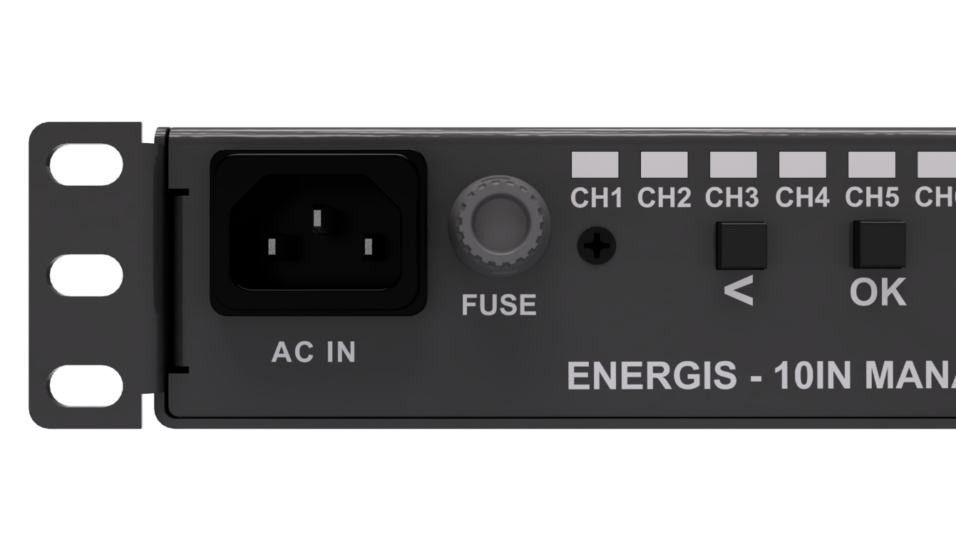
Fuse location:

11. Support and Warranty

11.1 Firmware, documentation and issue tracking
Firmware, schematics, mechanical files and the latest versions of the manuals are maintained in the project’s public repository. Users are encouraged to consult the repository for release notes, known issues and updates.
- Project repository: https://github.com/DvidMakesThings/HW_10-In-Rack_PDU
- Online manuals and additional documentation:
  - User manual (this document): https://dvidmakesthings.github.io/HW_10-In-Rack_PDU/Manuals/User_Manual.pdf
  - Automation manual:
https://dvidmakesthings.github.io/HW_10-In-Rack_PDU/Manuals/AUTOMATION_MANUAL.pdf

Bug reports and feature requests can be submitted via the issue tracker in the repository. When reporting a problem, include the firmware version, a description of the setup and any relevant log or console output.

11.2 Warranty and limitations

The ENERGIS hardware and firmware are provided as part of an open design. Warranty terms, if any, depend on how the unit was obtained (self-built from sources, supplied as a kit, or delivered as an assembled device by a third party). Refer to the terms supplied by your vendor or integrator.

When ENERGIS is supplied as a fully assembled device by the designer, each unit is functionally tested before shipment to verify that it operates correctly at the time of delivery. This ensures that the device leaves production in a working state, but it does not replace any incoming inspection, burn-in or acceptance tests required by the end user.

In general:

- The manufacturer or designer cannot be held liable for damage resulting from incorrect installation, operation outside the specified ratings, unauthorized modifications, or use in applications for which the device was not intended (including but not limited to safety critical, medical or life support systems).
- It is the responsibility of the installer and operator to ensure that the device is used in accordance with local regulations and the guidance given in this manual.

- Any opening of the enclosure, bypassing of safety features or modification of the internal wiring is strictly at the user’s own risk and falls outside any warranty or support obligation.
For assembled devices, a tamper evident security seal is applied to the enclosure. This seal is intended to show whether the device has been opened or mechanically altered after shipment. If the seal is broken, removed or damaged, it is taken as evidence that the unit has been opened or modified and any warranty or goodwill support related to manufacturing defects may be refused.

If the device is part of a larger system, any additional warranties, certifications or compliance requirements are the responsibility of the system integrator.

