**PEC4: Razonamiento aproximado**

## DAVID VIEJO POMATA

**Preguntas**

Consideramos un sistema Mamdani con t-norma min y t-conorma max.

1. Calcular las funciones de pertenencia para cada uno de los términos lingüísticos de las variables del sistema.

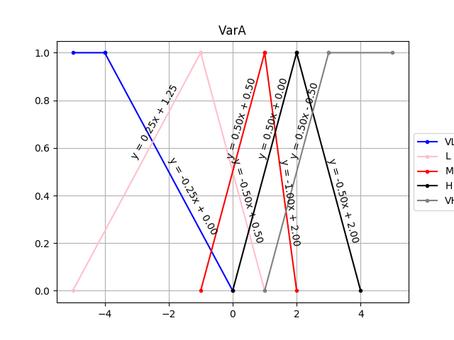

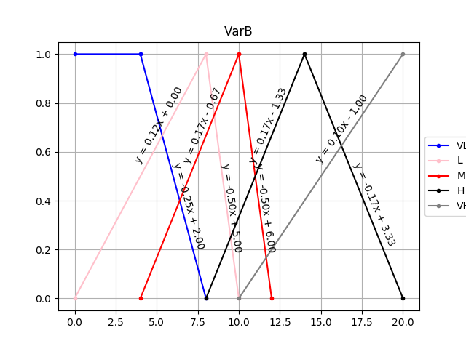

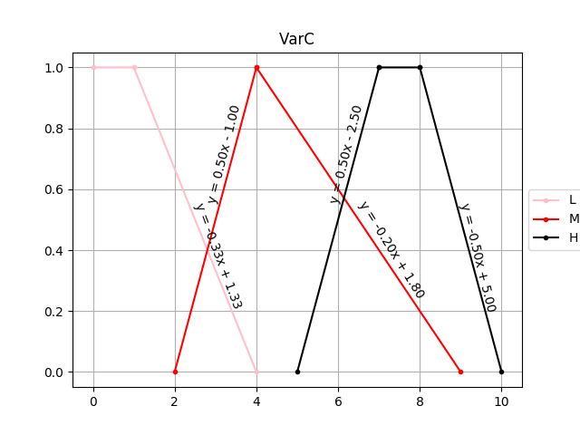

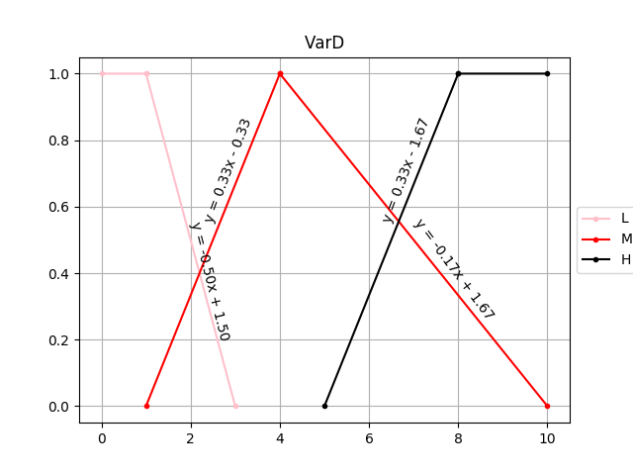

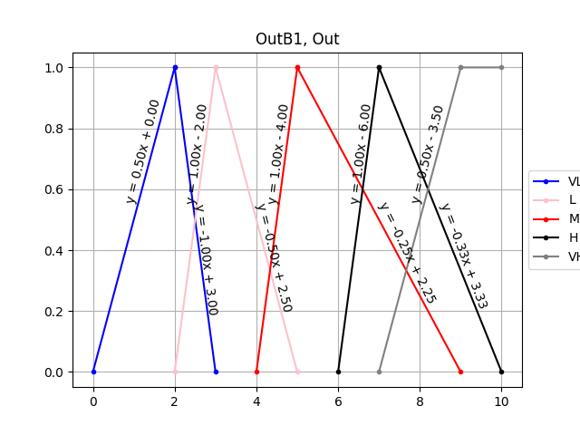

1. Calcular la salida nítida y describir el proceso seguido para los valores de entrada siguientes:

## (VarA, VarB, VarC, VarD) = (0.5, 11, 6, 6)

Bloque1

|  |  |  |  |  |
| --- | --- | --- | --- | --- |
| Regla | VarA |  | VarB | OutB1 |
| 00 | VL | AND | VL | VL |
| 01 | VL | AND | L | VL |
| 02 | VL | AND | M (0.50) | VL |
| 03 | VL | AND | H (0.50) | L |
| 04 | VL | AND | VH (0.10) | M |
| 05 | L (0.25) | AND | VL | L |
| 06 | L (0.25) | AND | L | L |
| 07 * | L (0.25) | AND | M (0.50) | M (0.25) |
| 08 * | L (0.25) | AND | H (0.50) | M (0.25) |
| 09 * | L (0.25) | AND | VH (0.10) | H (0.10) |
| 10 | M (0.75) | AND | VL | M |
| 11 | M (0.75) | AND | L | M |
| 12 * | M (0.75) | AND | M (0.50) | M (0.50) |
| 13 * | M (0.75) | AND | H (0.50) | M (0.50) |
| 14 * | M (0.75) | AND | VH (0.10) | H (0.10) |
| 15 | H (0.25) | AND | VL | H |
| 16 | H (0.25) | AND | L | H |
| 17 * | H (0.25) | AND | M (0.50) | H (0.25) |
| 18 * | H (0.25) | AND | H (0.50) | H (0.25) |
| 19 * | H (0.25) | AND | VH (0.10) | VH (0.10) |
| 20 | VH | AND | VL | H |
| 21 | VH | AND | L | H |
| 22 | VH | AND | M (0.50) | H |
| 23 | VH | AND | H (0.50) | VH |
| 24 | VH | AND | VH (0.10) | VH |

Bloque 2

|  |  |  |  |  |  |  |
| --- | --- | --- | --- | --- | --- | --- |
| Regla | OutB1 |  | VarC |  | VarD | Out |
| 00 | VL | AND | L | AND | L | VL |
| 01 | VL | AND | L | AND | M (0.67) | VL |
| 02 | VL | AND | L | AND | H (0.33) | M |
| 03 | VL | AND | M (0.60) | AND | L | VL |
| 04 | VL | AND | M (0.60) | AND | M (0.67) | VL |
| 05 | VL | AND | M (0.60) | AND | H (0.33) | M |
| 06 | VL | AND | H (0.50) | AND | L | VL |
| 07 | VL | AND | H (0.50) | AND | M (0.67) | M |
| 08 | VL | AND | H (0.50) | AND | H (0.33) | H |
| 09 | L | AND | L | AND | L | L |
| 10 | L | AND | L | AND | M (0.67) | L |
| 11 | L | AND | L | AND | H (0.33) | M |
| 12 | L | AND | M (0.60) | AND | L | L |
| 13 | L | AND | M (0.60) | AND | M (0.67) | L |
| 14 | L | AND | M (0.60) | AND | H (0.33) | M |
| 15 | L | AND | H (0.50) | AND | L | L |
| 16 | L | AND | H (0.50) | AND | M (0.67) | L |
| 17 | L | AND | H (0.50) | AND | H (0.33) | H |
| 18 | M (0.50) | AND | L | AND | L | M |
| 19 | M (0.50) | AND | L | AND | M (0.67) | M |
| 20 | M (0.50) | AND | L | AND | H (0.33) | M |
| 21 | M (0.50) | AND | M (0.60) | AND | L | M |
| 22 * | M (0.50) | AND | M (0.60) | AND | M (0.67) | M (0.50) |
| 23 * | M (0.50) | AND | M (0.60) | AND | H (0.33) | M (0.33) |
| 24 | M (0.50) | AND | H (0.50) | AND | L | M |
| 25 * | M (0.50) | AND | H (0.50) | AND | M (0.67) | M (0.50) |
| 26 * | M (0.50) | AND | H (0.50) | AND | H (0.33) | M (0.33) |
| 27 | H (0.25) | AND | L | AND | L | M |
| 28 | H (0.25) | AND | L | AND | M (0.67) | M |
| 29 | H (0.25) | AND | L | AND | H (0.33) | H |
| 30 | H (0.25) | AND | M (0.60) | AND | L | M |
| 31 * | H (0.25) | AND | M (0.60) | AND | M (0.67) | M (0.25) |
| 32 * | H (0.25) | AND | M (0.60) | AND | H (0.33) | H (0.25) |
| 33 | H (0.25) | AND | H (0.50) | AND | L | M |
| 34 * | H (0.25) | AND | H (0.50) | AND | M (0.67) | M (0.25) |
| 35 * | H (0.25) | AND | H (0.50) | AND | H (0.33) | H (0.25) |
| 36 | VH (0.10) | AND | L | AND | L | M |
| 37 | VH (0.10) | AND | L | AND | M (0.67) | M |
| 38 | VH (0.10) | AND | L | AND | H (0.33) | H |
| 39 | VH (0.10) | AND | M (0.60) | AND | L | H |
| 40 * | VH (0.10) | AND | M (0.60) | AND | M (0.67) | H (0.10) |
| 41 * | VH (0.10) | AND | M (0.60) | AND | H (0.33) | H (0.10) |
| 42 | VH (0.10) | AND | H (0.50) | AND | L | VH |
| 43 * | VH (0.10) | AND | H (0.50) | AND | M (0.67) | VH (0.10) |
| 44 * | VH (0.10) | AND | H (0.50) | AND | H (0.33) | VH (0.10) |

**3)** Volver a calcular la salida nítida y describir el proceso seguido para los valores de entrada:

## (VarA, VarB, VarC, VarD) = (2, 2, 4, 4)

Bloque1

|  |  |  |  |  |
| --- | --- | --- | --- | --- |
| Regla | VarA |  | VarB | OutB1 |
| 00 | VL | AND | VL | VL |
| 01 | VL | AND | L (0.25) | VL |
| 02 | VL | AND | M | VL |
| 03 | VL | AND | H | L |
| 04 | VL | AND | VH | M |
| 05 | L | AND | VL | L |
| 06 | L | AND | L (0.25) | L |
| 07 | L | AND | M | M |
| 08 | L | AND | H | M |
| 09 | L | AND | VH | H |
| 10 | M | AND | VL | M |
| 11 | M | AND | L (0.25) | M |
| 12 | M | AND | M | M |
| 13 | M | AND | H | M |
| 14 | M | AND | VH | H |
| 15 | H (1.00) | AND | VL | H |
| 16 * | H (1.00) | AND | L (0.25) | H (0.25) |
| 17 | H (1.00) | AND | M | H |
| 18 | H (1.00) | AND | H | H |
| 19 | H (1.00) | AND | VH | VH |
| 20 | VH (0.50) | AND | VL | H |
| 21 * | VH (0.50) | AND | L (0.25) | H (0.25) |
| 22 | VH (0.50) | AND | M | H |
| 23 | VH (0.50) | AND | H | VH |
| 24 | VH (0.50) | AND | VH | VH |

Bloque 2

|  |  |  |  |  |  |  |
| --- | --- | --- | --- | --- | --- | --- |
| Regla | OutB1 |  | VarC |  | VarD | Out |
| 00 | VL | AND | L | AND | L | VL |
| 01 | VL | AND | L | AND | M (1.00) | VL |
| 02 | VL | AND | L | AND | H | M |
| 03 | VL | AND | M (1.00) | AND | L | VL |
| 04 | VL | AND | M (1.00) | AND | M (1.00) | VL |
| 05 | VL | AND | M (1.00) | AND | H | M |
| 06 | VL | AND | H | AND | L | VL |
| 07 | VL | AND | H | AND | M (1.00) | M |
| 08 | VL | AND | H | AND | H | H |
| 09 | L | AND | L | AND | L | L |
| 10 | L | AND | L | AND | M (1.00) | L |
| 11 | L | AND | L | AND | H | M |
| 12 | L | AND | M (1.00) | AND | L | L |
| 13 | L | AND | M (1.00) | AND | M (1.00) | L |
| 14 | L | AND | M (1.00) | AND | H | M |
| 15 | L | AND | H | AND | L | L |
| 16 | L | AND | H | AND | M (1.00) | L |
| 17 | L | AND | H | AND | H | H |
| 18 | M | AND | L | AND | L | M |
| 19 | M | AND | L | AND | M (1.00) | M |
| 20 | M | AND | L | AND | H | M |
| 21 | M | AND | M (1.00) | AND | L | M |
| 22 | M | AND | M (1.00) | AND | M (1.00) | M |
| 23 | M | AND | M (1.00) | AND | H | M |
| 24 | M | AND | H | AND | L | M |
| 25 | M | AND | H | AND | M (1.00) | M |
| 26 | M | AND | H | AND | H | M |
| 27 | H (0.25) | AND | L | AND | L | M |
| 28 | H (0.25) | AND | L | AND | M (1.00) | M |
| 29 | H (0.25) | AND | L | AND | H | H |
| 30 | H (0.25) | AND | M (1.00) | AND | L | M |
| 31 * | H (0.25) | AND | M (1.00) | AND | M (1.00) | M (0.25) |
| 32 | H (0.25) | AND | M (1.00) | AND | H | H |
| 33 | H (0.25) | AND | H | AND | L | M |
| 34 | H (0.25) | AND | H | AND | M (1.00) | M |
| 35 | H (0.25) | AND | H | AND | H | H |
| 36 | VH | AND | L | AND | L | M |
| 37 | VH | AND | L | AND | M (1.00) | M |
| 38 | VH | AND | L | AND | H | H |
| 39 | VH | AND | M (1.00) | AND | L | H |
| 40 | VH | AND | M (1.00) | AND | M (1.00) | H |
| 41 | VH | AND | M (1.00) | AND | H | H |
| 42 | VH | AND | H | AND | L | VH |
| 43 | VH | AND | H | AND | M (1.00) | VH |
| 44 | VH | AND | H | AND | H | VH |

Notas para las preguntas 2) y 3)

Per calcular el valor nítido, usar el método del centro de masas. Si se hace siguiendo el método discreto, considerar una resolución de 3 decimales.

En todos los casos, describid las reglas que se activan, representar gráficamente la salida obtenida y el proceso seguido para obtener el resultado.

# Recursos

Para hacer esta PEC el material imprescindible es el Tema 2 -

Sistemas difusos, del módulo 4.

También dentro del paquete de PECs resueltas de semestres anteriores, hay numerosos ejemplos de sistemas difusos.

# Criterios de valoración

La pregunta 1 vale **2 puntos**.

La pregunta 2 vale **4 puntos**.

La pregunta 3 vale **4 puntos.**

# Formato y fecha de entrega

Para dudas y aclaraciones sobre el enunciado, dirigiros al consultor responsable del aula.

Hay que entregar la solución en un archivo PDF usando una de las plantillas entregadas conjuntamente con este enunciado. Adjuntar el fichero a un mensaje en el apartado Entrega y Registro de EC (REC).

El nombre del archivo debe ser *Apellidos_Nombre*_IA_PEC4 con la extensión .pdf (PDF).

La fecha límite de entrega es el: **21 de diciembre de 2018** (a las 24 horas).

Razonad la respuesta en todos los ejercicios. Las respuestas sin justificación no recibirán puntuación.

Nota: **Propiedad intelectual**

A menudo es inevitable, al producir una obra multimedia, hacer uso de recursos creados por terceras personas. Es por tanto comprensible hacerlo en el marco de una práctica de los estudios de Informática, siempre que se documente claramente y no suponga plagio en la práctica.

Por lo tanto, al presentar una práctica que haga uso de recursos ajenos, se presentará junto con ella un documento en el que se detallen todos ellos, especificando el nombre de cada recurso, su autor, el lugar donde se obtuvo y el su estatus legal: si la obra está protegida por copyright o se acoge a alguna otra licencia de uso (Creative Commons, licencia GNU, GPL ...).

El estudiante deberá asegurarse de que la licencia que sea no impide específicamente su uso en el marco de la práctica. En caso de no encontrar la información correspondiente deberá asumir que la obra está protegida por copyright.

Deberán, además, adjuntar los archivos originales cuando las obras utilizadas sean digitales, y su código fuente esté corresponde.