Online Private Tutor System

________________

A Capstone Project Presented to

The Faculty of the College of Computer Studies

Tarlac State University

Tarlac City

________________

In Partial Fulfillment

of the Requirements for the Degree

Bachelor in Science of Information and Technology

________________

by:

Ronalie T. Caguiat

Roel G. Guzman   
Ryan Christian G. Cajucom

Rustom D. Pioquinto

November 2021

APPROVAL SHEET

This Capstone project of **Ronalie T. Caguiat, Roel G. Guzman, Ryan Christian G. Cajucom,** and **Rustom D. Pioquinto** titled **"** **Online Private Tutor System,"** is prepared and submitted in partial fulfillment of the requirements for the degree **Bachelor in Science of Information and Technology** has been examined and hereby recommended for approval and acceptance.

|  |  |
| --- | --- |
| **GLORIA L. PRELLEIA** | |
| *Technical Adviser*  **PANEL COMMITTEE** | |
| **THEDA FLAIR G. QUILALA** | |
| *Chairman* | |
| **REGINA P. ARCEO** | **CARLOS P. FLORES** |
| *Member* | *Member* |

Approved and Accepted in partial fulfillment of the requirements for the degree **Bachelor in Science of Information and Technology**

**Alvincent E. Danganan**

*Dean, College of Computer Studies*

# Abstract

**Title of research:** Online Private Tutor System

**Researchers:** Ronalie T. Caguiat

Roel G. Guzman

Ryan Christian G. Cajucom

Rustom D. Pioquinto

**Degree:** Bachelor of Science in Information Technology

**Date of Completion:** November 2021

**Key words:** Tutoring, Student, Tutor

The challenges of a large-scale higher education system and an increasingly diverse student body with a wider range of requirements have prompted significant interest in the function of the Tutor in higher education. Teaching personnel is urged to help students become more integrated into student life and build active independent research approaches, based on the concept that integration and academic support will affect student retention.

The system's goal is to provide quick access and communication between a tutor and a student. We all know that private tutoring has been around for a long time in the Philippines. Nonetheless, its popularity has exploded in recent years, undermining the educational system's core. This private tutoring system can assist you in locating tutors who are experts in your subject. Tutors can sign up for a student by going into the website and creating a profile.

ACKNOWLEDGMENT

The completion of this project required a lot of guidance, assistance, and help from many people, and the developers are highly fortunate to have this all along with the completion of this project. We are very thankful for those people that helped us in any way.

The developers would like to thank their thesis coordinator, Rogel L. Quilala, for his guidance and assistance during the project's development. Without him, the developers will not be able to finish the task correctly.

The developers are also thankful for the guidance and assistance given by their adviser, Gloria L. Prelleia, during the project's development stage, for the comments and suggestions. They are accommodating in completing the project.

The developers would also like to express their gratitude to Regina P. Arceo, Carlos P. Flores, and the lead panelist, Theda Flair G. Quilala, for the comments and suggestions regarding improving the developed system. Also, for giving the developers a chance to enhance and complete the design.

The developers are sincerely thankful to their parents and guardians for understanding and supporting them throughout the whole semester, especially financially. The developers thank them for the encouragement that undoubtedly helped them remember that all of the hard work will be paid when you have perseverance.

Lastly, the developers are also very thankful for having supportive and helpful friends and classmates. When the developers are in need, their classmates are there to help and give the developers ideas in developing the project.

# TABLE OF CONTENTS

APPROVAL SHEET ii

ABSTRACT iii

DEDICATION iv

ACKNOWLEDGMENT v

TABLE OF CONTENTS vi

LIST OF TABLES ix

LIST OF FIGURES x

1 INTRODUCTION 1

1.1 Project Context 1

1.2 Purpose And Descriptions 1

1.3 Objectives 1

1.4 Scope and Delimitations 2

2 RELATED LITERATURE 3

2.1 Discussion of Models 3

2.2 Conceptual Framework 3

3 TECHNICAL BACKGROUND 4

3.1 Software Development Requirements 4

3.2 Hardware Development 4

3.3 Sources of Data 4

4 METHODOLOGY 5

4.1 Methods in Data Gathering 5

4.1.1 Interview Method 5

4.1.2 Internet Method 5

4.1.3 Observation 5

4.2 Design and Development of <Title> This is objective number 1 6

4.2.1 Requirement Analysis and Documentation 6

4.2.2 Design of Software and/or System and/or Product and/or Processes 8

4.2.3 System Development Methodology 10

4.3 To evaluate the performance of <system> by means of <type of tests e.g. functional, repeated trial, accuracy, others> tests. This is objective number 2 11

4.3.1 Functional Test <Replace this with whatever test you will use> 11

5 RESULTS AND DISCUSSION 12

5.1 Design and Development of <Title> This is objective number 1 12

5.2 To evaluate the performance of <system> by means of <type of tests e.g. functional, repeated trial, accuracy, others> tests. This is objective number 2 13

6 CONCLUSIONS AND RECOMMENDATIONS 14

6.1 Conclusions 14

Write the general statement that says you achieved the objective here. Then specifically, itemize the conclusion based on the stated objective in Chapter 1 as follows. There is one is to one correspondence with respect to the objectives and conclusion. 14

6.2 Recommendations 14

REFERENCES 15

APPENDICES 16

<Appendix A:> <Title> 16

<Appendix B:> <Relevant Source Code> 16

CURRICULUM VITAE 17

LIST OF TABLES

Table 1. Functional Requirement for Login Module 18

Table 2. Non-Functional Requirement for Safety and Security of <title> 19

Table 3. <Title of your table> 21

Table 4. <Title of your table> 21

LIST OF FIGURES

Figure 1. Use Case Diagram of <title> 17

Figure 2. Database Schema of <title> 19

Figure 3. Functional Decomposition Diagram of <Title> 20

Figure 4. Burn Down Chart Sample Only 22

Figure 5. Log-in Page of Admin 24

Figure 6. Dashboard 25

# INTRODUCTION

## Project Context

The challenges of a mass higher education system and an increasingly diverse student body with a broader spectrum of needs have sparked widespread interest in the Tutor's role in higher education. In the premise that integration and academic assistance will impact student retention, teaching personnel is encouraged to help students become more integrated into student life and create active independent research techniques to some degree. [1] In online learning, the tasks of the teacher and the students are divided in time and space. While they can be synchronous, most teaching practices are asynchronous, allowing for greater personalization of the needs of the students. Compared to conventional face-to-face classroom instruction, it is challenging for teachers to understand the complete picture of learners' progress in an online course. Teachers will, however, learn more about the instructional process by reviewing the learning process records on an online learning website. It is essential to draw on these records to improve online teaching.

By developing an Online Private Tutor System, the problem of finding and having face-to-face tutoring will be covered by the system by using the system's features, which is using the system to find a tutor and conducting a class using the system. Tutoring programs can assist your child in developing study and learning skills that will prepare them for success throughout their lives. [2] Tutoring systems have many benefits. Individualized and distinct educational experience Your child will benefit from an individualized learning environment that they will not obtain in a traditional classroom setting. Tutors can tailor lessons and activities to your child's specific needs. Individualized attention Tutors become familiar with your child's unique learning style and adjust their teaching methods accordingly. They serve as your child's Tutor. Enhances academic achievement. Tutoring will help your child prepare for tests and exams while also focusing on specific problem areas. When your child works with a tutor, their grades and understanding of the subject will significantly improve. Improves students' attitudes toward school and learning. For your child, education will become enjoyable. Your child will no longer feel overwhelmed or frustrated at school if you provide constant encouragement and praise. Assists your child in preparing for college students going to college will learn how to make study plans, improve their study skills, and manage their time better. Tutoring in college has numerous advantages, including reinforcing existing knowledge and a better understanding of a field of study.

The cost of private tutoring is one of the most significant disadvantages. Hiring a qualified tutor with prior experience can be expensive, and many families may not afford it. That is why the proponents want to develop a system that has a low cost of tutor reservation. The personality of the Tutor and the child's ability to get along with them can help improve the results of private tutoring [3]. Children perform better when they can relate to their Tutor, according to studies. The inverse, on the other hand, can be harmful. It may cause the child to dislike or even rebel against the subject. If you notice that your child dislikes or resents the Tutor, you must address the situation. Unfortunately, many people believe that hiring someone with a specific subject degree will guarantee good tutoring results. It isn't, however, a guarantee. Teaching is a skill that everyone does not possess. Hiring a tutor who lacks teaching skills can result in boring lessons, lowering your child's motivation to study even more. Many parents are hesitant to entrust their children to an adult they do not know well. Students work in a secure environment when they use a laptop or desktop provided by the school on campus. A comprehensive firewall protects the schools' network. An advanced endpoint protection suite also protects the endpoints. Educational institutions devote a significant amount of time and money to ensuring that sensitive student and organizational data is protected from advanced threats.

Due to the advantages and disadvantages of tutoring, the proponents want to create an "Online Private Tutor System" system. This system will be used by a tutor approved by the admin and a student from one place to another. This system covers all the disadvantages of the system, especially the high cost of tutoring and having no safety from the students and Tutors.

## Purpose And Descriptions

The purpose of the system is to have easy access and connection to a tutor and a student. We all know private tutoring has been around in the Philippines for a long time. Still, it has exploded in popularity in recent years, affecting the educational system's core. This private tutoring system will help you find tutors who specialize in your field. By logging into the website and creating a profile, tutors can also sign up for a student.

The Private Tutoring System is a web-based system where multiple users can access it. Those various users can log in and register to the system anytime, and this system was specialized for Tutor and student interaction. The students can view the available tutors and book their tutoring dates. The Tutor can see their booked dates and schedules so they can be ready for their students.

## Objectives

To design and develop an Online Tutoring System that can help the student and teacher to communicate efficiently. The applications aim to create and design an online tutoring system where users can easily access the online tutoring system. Also, it will help the teacher and students in using the system.

Specifically, the study aims to achieve the following:

1. To develop a Web Page or a system with comprehensive features such as;

* 1. Login/Registration Module
     1. Tutor and Student Registration
  2. Dashboard User/Tutor
  3. Record Management
     1. Payment Transactions
     2. Reservation Transactions

1.4 Reservation Module

* 1. Library Management
     1. Activity List
     2. Lesson List
  2. Billing Management
     1. Paypal
  3. Classroom module
     1. Video Conference

2. To evaluate and improve the proposed system using the characteristics of ISO/IEC 25010:2011.

## Scope and Delimitations

There are three people in the personal tutor finder system: Admin, Students, and Tutor. Admins can access the framework and handle tutors by adding new tutors and upgrading their profiles. The Tutor may also take e-books by adding new books to the library. The administrator may also look up the names of the student who have enrolled. Admin will register tutors, and credentials will be sent to tutors via registration by uploading a CV. Students should build an account and password, and they can view tutors. The system will only upload files with a file type of .asc .doc .docx .rtf .msg, .pdf .txt .wpd .wps .xls .xld .xlk.

Students can filter and choose a tutor, and after they have done so, they can have a sample lecture. They can book the Tutor online and view the E-Books after attending the class. They should look for a proposal for a presentation lecture and accept it. They can also check the status of the reservation. They must build a profile. This private tutor system will assist tutors in attracting students and parents to find the best tutors for their children. The student's transaction will start when the webRTC link is generated automatically when the student conducts the reservation. The lessons will be inserted in the students' library, where all the lectures, assignments, and projects will be placed. The payment transaction will be conducted when the reservation is undertaken, and the proponents think that PayPal was an excellent choice for completing the payment. The Tutor will follow the subject that the students choose, the Tutor will ready a lesson for the student wherein it is appropriate in their age and issues.

The online private tutor system will be limited to web-based only because most online classes or tutoring are conducted on a desktop or laptop, especially to the tutors. Also, the system will be using webRTC when a video conference is needed, or an online class has started. The system will not cover any session that the student misses, and the reservation cannot be revoked by the student so the system does not offer refunding, and cancellation of any transactions that had been processed.

The study aims to develop an Online Tutoring System to help students in struggling schools. It will also help the parents to find the best Tutor suitable for their child. Since we are amid the pandemic, a lot of students are falling behind the review level. Students are still adjusting to the new normal process of studying. The system will consist of significant features like registration, reservation, viewing the Tutor's profile, and scheduling module in tutoring online.

Online tutoring system is a web-based system with many advantages, especially now that we are fighting and protecting our lives from coronavirus. Most online modules allow students to work at their own pace, which is a fantastic benefit for anyone with a busy schedule. And, depending on the subject, web-based learning refines computing, word processing, and web-based competencies, all of which will be sought after by future employers.

# RELATED LITERATURE

The chapters include the ideas, finished thesis, discussion of models, conceptual framework, and definitions of terms. Those included in this chapter helps in familiarizing information that is relevant and similar to the present study.

## Discussion of Models

According to Brett Montrose study, The Biggest Problems with Online Tutoring, According to Tutors,Peer learning is a broad term for a variety of learning strategies. It encompasses a wide range of activities in which people learn through various methods. These activities included everything from traditional proctoring in schools to more innovative learning groups in colleges and universities. Senior students serve as tutors, while junior students serve as tutees in the proctor model. On the other hand, in innovative learning groups, students of the same age group or level assist one another by forming partnerships. To respond to the challenge of innovating educational delivery mechanisms in higher education, colleges and universities across the globe ventured into different practices such as distance education, online teaching, remote learning, blended learning, and mobile learning. These practices can be collectively called emergency remote education (ERE). It is the temporary change in the delivery of instruction caused by the sudden occurrence of a crisis [5]

The effect of an online tutoring program on the math achievement of struggling middle school students, tutor descriptions of their online tutoring practices, and student perceptions of tutoring experiences as they happened in real-time. [6]According to OnlineSchool.org, Learners' expectations, readiness, identity, and participation in online courses were all discussed. The role of instructors in content development, multimedia integration in content, instructional strategies in content development, and content development considerations were all discussed. The four specific categories of changing faculty roles, transitioning from face-to-face to online, time management, and teaching styles were all addressed about instructors According to Chiasson, Terras, and Smart. Thus, universities across the country are forced to close indefinitely. Classes in various universities already opened just these past few months and remote learning are faced with multiple challenges which later became difficult to handle by Filipino university students. Complicating this picture even is the fact that, not every student can provide and adapt to the rapid advances of technology in today’s digital age especially for developing countries like the Philippines in which education is plagued by problems even before the pandemic [7]

Many colleges have begun to investigate the possibility of providing tutoring through distance education formats as higher education institutions seek to support students through innovative learning and teaching methods According to Aldredge et. Al. [8] Because the educational platform appears to be the preferred method of delivering e-tutoring programs, more emphasis should be placed on developing such platforms that are accessible, user-friendly, and user-centered, with multiple options for data access and analysis, and thus suitable for the digital-native student According to Bakia, Shear, Toyama and Lasseter. In this Philippine context, remote learning reveals a digital divide among Filipino students. This current situation in remote learning may most possibly exacerbate existing inequalities and may translate to barriers in online learning. For example, a cross-sectional study conducted nationwide reported that thirty-two percent (32 %) and twenty-two percent (22%) out of 3, 670 Filipino medical students surveyed have difficulties adjusting to new learning styles and do not have reliable internet access, respectively [9]

Regardless of the challenges and demands, online teaching provides a teaching medium that can address society's and students' needs to raise educational standards. Educators and students can be pushed out of their comfort zones by online teaching and learning. It can, however, be used to encourage active participation and facilitate growth through peer interaction According to Elsi Janse van Rensburg [10] Service learning is a well-known method of enhancing students' educational opportunities. Learning experiences gained through community engagement help university students deepen the relevance of their knowledge and contribute to a better understanding of social responsibility, advancing the applicability and societal benefits of higher education According to J. Bandy. For some, it may present difficulty to purchase a facilitative learning device to easily tune in to online classes and immediately turn in assignments in the online. Despite the efforts to make education accessible for all, many difficulties are still confronting Filipino university students in the practice of distance education. [11]

Researchers and educators must consider the effectiveness of online learning compared to traditional face-to-face learning and the factors that influence online course effectiveness. The findings and challenges of online learning are organized and summarized into positive, unfavorable, mixed, and null results in this study, examining their effectiveness According to Nguyen. It is also emphasized that, in this case, online learning is the best term to describe education during this interruption and is not the same as those distance education practices long before Considering current COVID-19 crisis, World Bank emphasized that education systems must make use of ERE and prepare if needed, different learning delivery modalities to ensure that students are engaged and can continue their learning. [12]

The researchers will use the following studies to improve the development and the proposed system by using the past studies from the related literature.

Table 1. Functionality and Feature Matrix

|  |  |  |  |  |
| --- | --- | --- | --- | --- |
| Screen / Role | **Online Private Tutor System** | Electronic Pupil Interactive Learning System | ClassNet | ATutor Learning Management System |
| Sign in | x | x | x | x |
| Registration | x | x | x | x |
| Complete Profile | x |  |  | x |
| Home Page | x | x | x | x |
| Dashboard | x | x | x | x |
| Record Section | x | x | x | x |
| Booking Section | x | x |  |  |

## Conceptual Framework

**Knowledge Requirements**

* Web Development/Design
* Technology
* Database Design

**Software Requirements**

* PHP
* MySQL
* Internet Browser

**Hardware Requirements**

* Laptop
* Desktop

**REQUIREMENTS**

Identification of Problems and Its best solutions

**DESIGN**

Physical and Logical Design of the Application/System

**IMPLEMENTATION**

Coding/Programming

**VERIFICATION**

Testing of Online Private Tutor System

**MAINTENANCE**

Implementation of the Project

**Online Private Tutor System**

**Evaluation**

**INPUT**

**PROCESS**

**OUTPUT**

Figure 1. Conceptual Framework of the Online Private Tutor System

The inputs necessary for developing the Development of An Online Private Tutor System are divided into three categories: Knowledge requirements, Software requirements, and Hardware requirements. To complete the proposed project, knowledge of the three conditions is needed in the study.

The process for the project to be developed consists of procedures such as Requirements, Design, Implementation, Verification, and Maintenance.

The output referred to in this research is the proposed Online Private Tutor System.

The evaluation will be conducted using ISO/IEC 25010:2011 to achieve the system effectiveness, efficiency, satisfaction, freedom from risk, and context coverage.

# TECHNICAL BACKGROUND

The technical background contains a discussion on the current trends and technologies to develop and implement the proposed system. This chapter includes Software Development Requirements, Hardware Development Requirements, Network Architecture, and data sources for Development and Testing.

## Software Development Requirements

Table 2. Software Requirements

|  |  |
| --- | --- |
| **SOFTWARE** | **DESCRIPTION** |
| Operating System | -The proponents allow to development and run of the system using sublime. |
| Microsoft Word 2013 | - The proponents used Microsoft Word 2013 for the documentation. |
| Microsoft PowerPoint 2013 | - The proponents used Microsoft PowerPoint 2013 for the presentation. |
| Sublime | - The proponents used the Sublime because it has more advanced features than notepad and notepad++. |
| Xampp | - The proponents used the Xampp because it was easier to use and primarily used by other programmers. |

Table 2 contains all the software that you will be using, including their names and description. The laptop's Operating System should be Windows 10 for an updated feature, and it will also help the sublime and xampp run faster. Microsoft Word and PowerPoint will be used for documentation and presentation. Sublime and Xampp will be the Medium to use in the development of the system.

## Hardware Development

Table 3. Hardware Requirements

|  |  |
| --- | --- |
| **HARDWARE** | **SPECIFICATION** |
| Keyboard | - Length: 456 mm (17.95 in)  - Height: 34.68 mm (1.37 in)  - Weight: 1035 g (36.5 oz)  - Color: Black |
| Mouse | - Length: 127.65 mm (5.03 in)  - Height: 42.05 mm (1.66 in)  - Weight: 119 g (4.20 oz)  - Color: Black |
| Laptop | - RAM: 8GB (1 x 819mb)  - DDR4, 3200MHz  - CPU: AMD Ryzen 5 3600H.  - Display: 15.6” Full HD (1920x1080), IPS  - Storage: 1TB, 500 SSD  - Color: Black |

Table 3 contains all the hardware that you will be using, including their names and specifications. We will generally use a set of desktops or laptops to perform the development phase of the thesis.

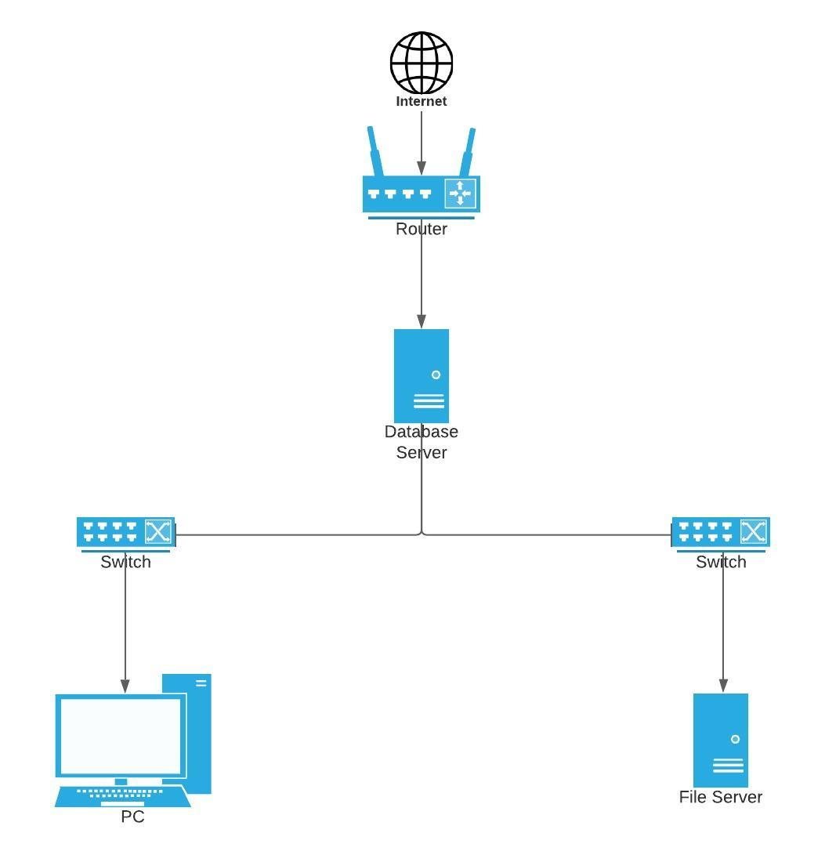

Figure 2. Network Architecture

Figure 2 shows the proposed network architecture. The proposed network architecture will go first in the router then check the database server before switching for the user and admin.

## Sources of Data

The proponents adopted some features that the review-related system has, such as elements, functions, conditions, security, and the simple user interface. Through these features, the proponents came up with a new system composed of the components inspired by the proponent's chosen related method. The data used came from a related study that says online tutors play an important role in e-learning delivery and may help reduce the alarming dropout rates that e-learning courses have shown in recent years. Online tutors assist students in meeting their expectations, which can lead to dropping out if they are not met. This is especially important for part-time students who do not appear to receive adequate support from traditional education. Because the role of online tutors is so essential, it's critical to hire people who already have a set of skills that can be honed through carefully designed training programs.

# METHODOLOGY

The methodology contains a discussion on the diagrams that will be used in the development. This chapter includes Requirements Analysis and Design Software.

## Methods in Data Gathering

For data gathering procedures, The total sampling participants will be given by the parts of questionnaires: for demographic profile and evaluation questioner of the system. If possible, all online survey questionnaires will be administered daily to reduce the potential effects of external factors not included in the study. And an informal discussion will also be conducted online using google forms to seek more participants affected by the research study.

### Interview Method

The interview method will be a survey questionnaire that will be conducted online using google forms. It will be applicable because of the pandemic and lockdown, so a face-to-face interview will not be sufficient.

### Internet Method

The internet method, the proponents, used it to search for related studies that will help the researchers know what to insert on the system and what is not.

## Design and development of Online Tutoring System

### Requirement Analysis and Documentation

#### User Requirements

Figure 3. Use Case Diagram of Online Private Tutor System

Figure 3 shows the Use Case Diagram of User Requirements. This figure shows all the possible access that the system users can access. The student can register, view a profile and also check the records. The teacher can register, view profiles, review the records and reservations. And there will be some admins that will have access to viewing profiles and maintenance of the system.

#### User Characteristics

The primary user of the system is the teacher and students. The administrator is the proprietor. Both are not expected to be computer experts, so user-friendly software shall be considered in the design.

The teacher will be able to:

1. View the profile of the students
2. Check the records
3. Check the reservations that the students made

The students will be able to:

1. Register
2. Check the records
3. View the profile of the teachers

The administrator will be able to:

1. Add Teachers
2. Edit Users Profile
3. Can do what the users can do
4. Have an overall access

#### Functional Requirements

Table 3. Functional Requirement for Login of the Student and Tutor

| Req.ID | Requirement Description | Priority | Complexity |
| --- | --- | --- | --- |
|  | Before the login module, a home page will show a little advertisement for the system. On the home page, there will be two user choices: the student and Tutor. | High | Medium |
|  | Once the user chooses the student, the page will be changed into the system's login and registration module. To log in, you will need a registered account that consists of Full name, Email, and Password. | High | Low |
|  | Once the user chooses the Tutor, the page will be changed into the system's login and registration module. To log in, you will need a registered account that consists of Full name, Email, Password, and the Uploaded Curriculum Vitae of the Tutor. | High | Low |
|  | Create a database that will consist of two tables for the student and Tutor. | High | Low |

Table 4. Functional Requirement for Dashboard of the Student

| Req.ID | Requirement Description | Priority | Complexity |
| --- | --- | --- | --- |
|  | Log in as a student, and the student will be directed to a student dashboard. You will see your upcoming appointment to a tutor, what specialization you choose, and the Tutor's information in the dashboard. Also, the student will have some graphs that have a report of the competition of appointments with the student tutor. | High | Medium |
|  | For the student, their dashboard will record the transactions made, a list of a given activity, and lessons from the Tutor. | High | Low |
|  | There will be a reservation module of a tutor wherein it will show a list of tutors with their specialization and availability. Also, there will be a billing module used once the student sets a reservation for the Tutor. | High | Low |
|  | Lastly, once the student has a reservation, the classroom will be open when the student makes a reservation. And also, there will be buttons with links generated to redirect the student to a particular tutor appointment. | High | Low |

Table 5. Functional Requirement for the Admin

| Req.ID | Requirement Description | Priority | Complexity |
| --- | --- | --- | --- |
|  | Admin can login in neither of the chosen login modules. | High | Medium |
|  | Admin dashboard will consist of the data that shows the number of tutors, students, and tutors that have an appointment. | High | Low |
|  | Admin will be the one that approves the tutor application or registration. | High | Low |

Table 6. Functional Requirement for Dashboard of the Tutor

| Req.ID | Requirement Description | Priority | Complexity |
| --- | --- | --- | --- |
|  | Log in as a tutor, and the Tutor will be directed to a tutor dashboard. In the dashboard, you will see your upcoming appointment with a student and the student's information. | High | Medium |
|  | The Tutor has a record of transactions that has been made, the past activity of the user, and a record of the appointments of the Tutor. | High | Low |
|  | The Tutor has a library module wherein the Tutor will upload lessons and activities for the students. | High | Low |
|  | Classroom, the classroom will open 15 minutes before the appointed time. | High | Low |

#### Non-Functional Requirements

Table 7. Non-Functional Requirement for Safety and Security of Online Private Tutor System

|  |  |
| --- | --- |
| Code | Dependencies Description |
| SS1 | Accessing the software will require a username and password |
| SS2 | The database where the password should be saved shall have encryption |
| SS3 | All transactions, including adding, editing, and deleting of records, are recorded in audit logs |
| SS4 | Backup and restore function |

### Design of Software and System and Product and Processes

#### ER Diagram

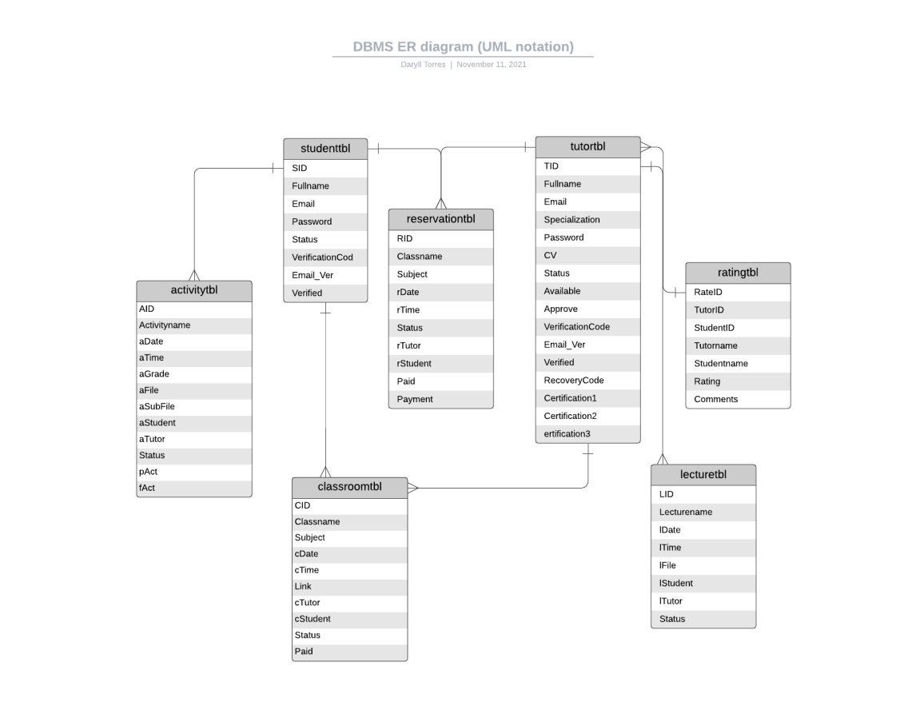

Figure 4 shows the Entity Relationship Diagram of the software. This diagram will show the contents of the two users and show that all of the transactions made by the users will be recorded in a transaction table.

Figure 4. Database Schema of Online Private Tutor System

#### Functional Decomposition Diagram

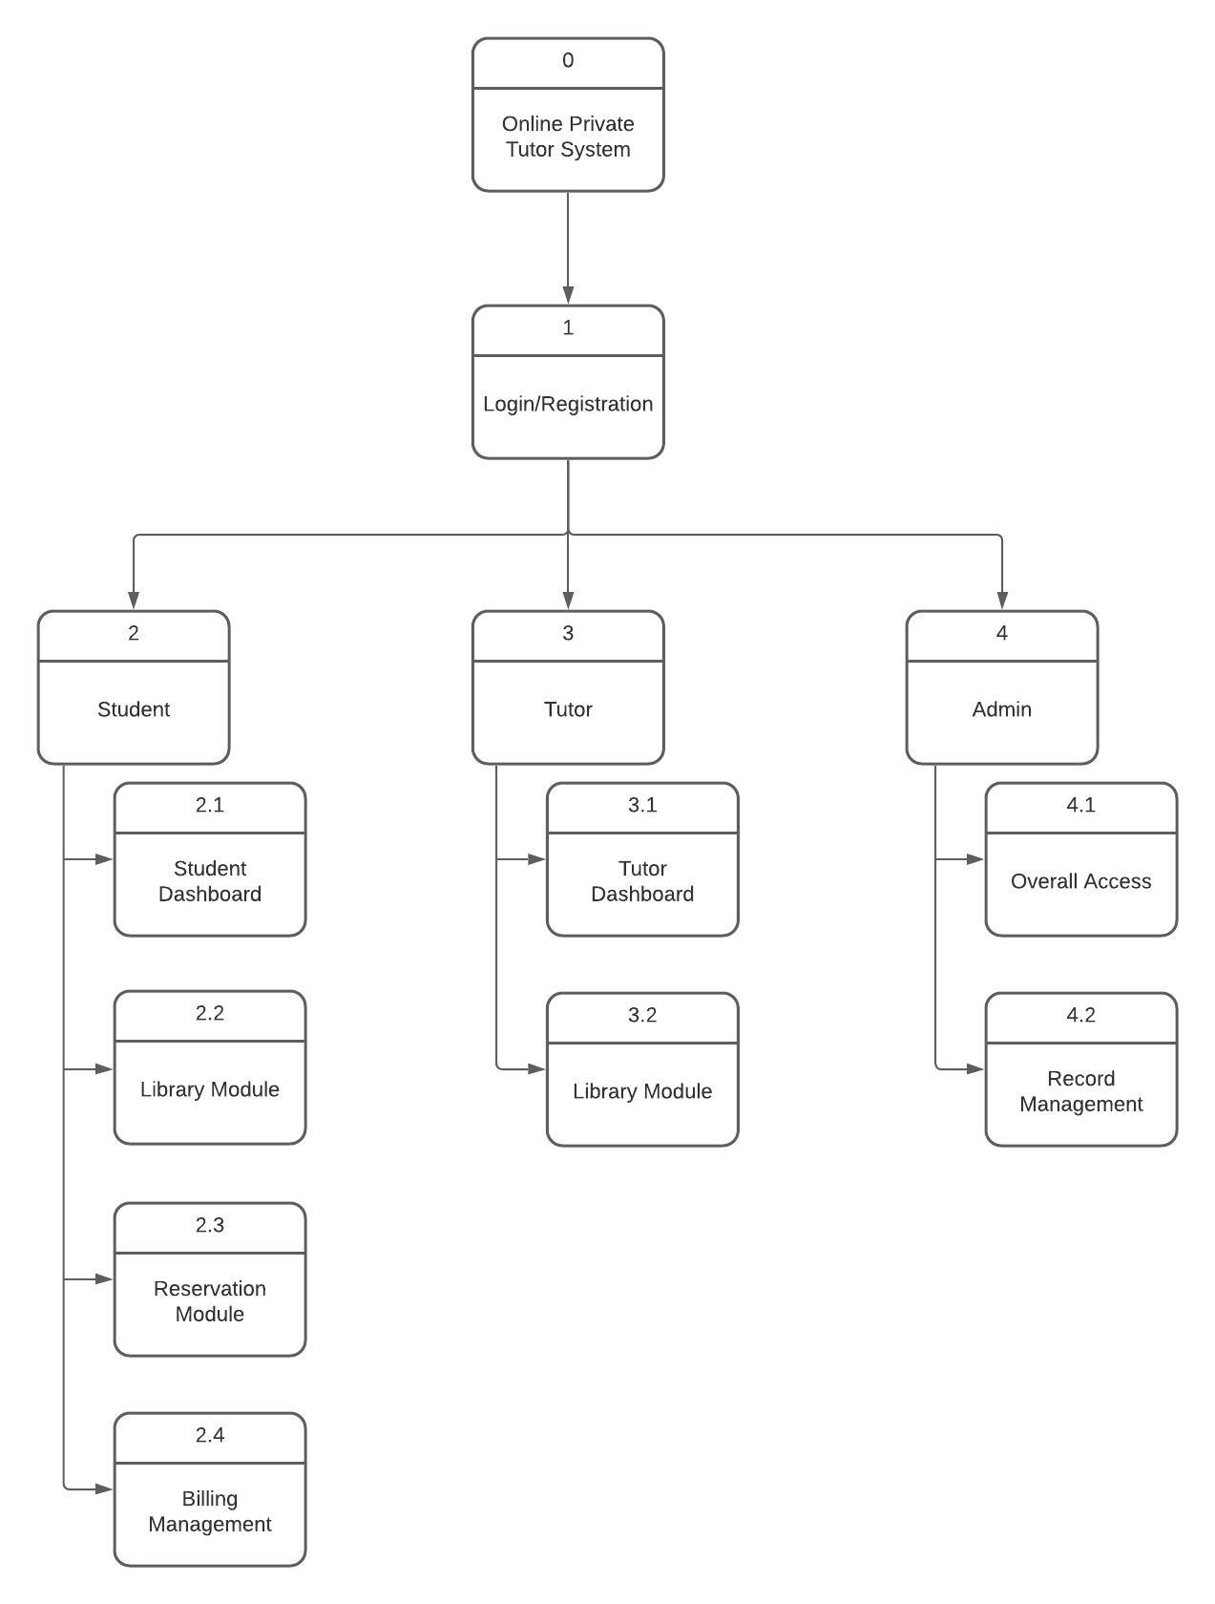

Figure 5. Functional Decomposition Diagram of Online Private Tutor System

Figure 5 shows the Functional Decomposition Diagram of the Online Private Tutor System. In this figure, you will see the registration part of the system wherein each user has different access in the system.

#### Operating Environment.

Table 8. Operational Environment Table

| Code | Environment Description |
| --- | --- |
| OE1 | Windows 7 or higher operating system |
| OE2 | Xampp shall be installed on the computer for the database |

#### Design and Implementation Constraints

Table 9. Design and Implementation Constraints Table

|  |  |
| --- | --- |
| Code | Design Constraints and Implementation Constraints Description |
| DC1 | The software shall be programmed in Php, where the database will be used in xampp |
| IC1 | The system shall have a user's manual |
| IC2 | The system shall have no network security in place |

### 

#### List of Software Development Tools

* **Notepad++** - is a free source code editor and Notepad replacement that support several languages. Notepad++ is a high-end programming language editor that helps users to write and edit any language including HTML, PHP, JavaScript, CSS, ASP, JSP and more. If you are trying write some codes, there is no other better and free programming language editor than Notepad++. o
* **CSS** - Short term for Cascading Style Sheet, is a stylesheet language used to describe the presentation of a document written in HTML or XML (including XML dialects such as SVG or XHTML). CSS describes how elements should be rendered on screen, on paper, in speech, or in other media. CSS also defines the animation present in a webpage. o
* **HTML5** - is a mark-up language used for structuring and presenting content in the World Wide Web. It is the fifth and current major version of the HTML standard and subsumes XHTML. o PHP - stand for “Hypertext Pre-processor”.
* **PHP** is an HTML-embedded Web scripting language. This means PHP code can be inserted into the HTML of a web page. When a PHP page is accessed, the PHP code is read or “parsed” by the server the page resides on. The output from the PHP function on the page is typically returned as HTML code which can be read by the browser
* **XAMPP** - is the most popular PHP development environment. XAMPP is completely free, easily to install Apache distribution containing MariaDB, PHP and Perl. The XAMPP open-source package has been set up to be incredibly easy to install and to use.

### System Development Methodology

The spiral model is a methodology that extends the waterfall model by introducing prototyping. The spiral model guides the team to adopt elements of one or more processes. This model has four phases Planning, Risk-Analysis, Engineering, and Evaluation. Every step can contain different sub-phases that the developers can follow. The developers chose the Iterative Spiral Model because of the high amount of risk analysis; hence avoidance of risks is enhanced. These phases are Planning: This phase starts with the gathering of business requirements. In the subsequent spirals as the product matures, identification of system requirements and unit requirements are done in this phase. This also includes understanding of system requirements by continual communication between the customer and the analyst. At the end of the spiral the product is deployed. Design: Design phase starts with the design in the baseline spiral and involves architectural, logical design of modules, physical product design and final design in the successive spirals. Construct: Construct phase refers to development of the final software product at every spiral. In the spiral when the product is just thought and the design is being developed, a Proof of Concept (POC) is developed in this phase to get the users’ feedback.

Then in the successive spirals with higher clarity on requirements and design a working model of the software called build is developed with a version number. These versions are sent to the users for feedback. Evaluation and Risk Analysis: Risk analysis includes identifying, estimating, and observing technical feasibility such as schedule slippage and cost overrun. After testing the build, at the end of first iteration, user evaluates the software and provides the feedback. Based on the customer assessment, development process enters into the next iteration and afterwards follows the linear approach to implement the feedback provided by the user. The process of iterations along the spiral carries on with throughout the life of the software.

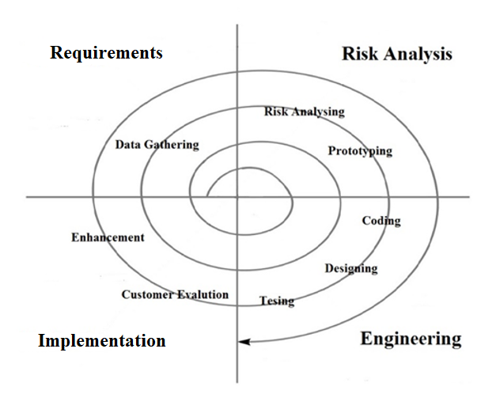

**Figure 6.** Spiral Model

#### Requirement Phase

In which the requirements for the software are gathered and analyzed. Iteration should eventually result in the requirements phase that produces a complete and final specification of requirements. In this phase, the developers analyzed the advantages and disadvantages of online tutoring and face-to-face tutoring. The developers did the initial planning for the system and conceptualized the final output.

#### Analysis Phase

In this phase, risk analysis needs to estimate and monitor possible technical feasibility and management risks. In our case, the developers are ensuring the security of our system. In creating design specifications, we also have several questions that serve to analyze the security of our system.

#### Engineering Phase

This software solution is developed to meet the requirements? This could be a brand-new structure or an expansion of an older one. In our case, the developers designed a one-of-a-kind design that is both simple and effective for users to run the system. The developers' purpose during this phase is to learn more about the target audience, collect feedback on a recent event, product, or service, and build favorable relationships.

#### Implementation Phase

When the software has been developed, tested, and integrated. During this phase, the developers used sublime and XAMPP to build the system. The developer checked whether the automated system created or acquired the subscriber's needs and was ready for implementation in the final phase of shifting the solution from development to production state.

#### Testing Procedure

Since the proponents were able to discover the system's errors, they discussed the system's testing. The proponents came to the conclusion that the system needed to be modified further in order to meet the needs of the target audience. The supporters were able to determine which modules needed to be enhanced or redesigned in order to improve the system. It is critical to conduct continuous testing of the system in order to identify problems that users will face and to enhance the system based on user comments and ideas gathered during testing, as well as to meet the requirements to suit the demands of users and target audiences..

## Evaluation

The proponents developed the proposed system by conducting research and doing some testing. Researching on how to create a design for sending answers for surveys. A system that will provide security for the records of users. The proponents analyzed the problems that the system is facing, and together they reviewed how to eliminate those problems with the help of every proponent.

**4.3.1 Functional Test**

The proponents conducts the functional test on the target participant for the Online Private Tutor. We provide a survey questionnaire in order to acquire all the information regarding on the development of the system by different categories for the system to evaluate. This will help the proponents to identify if the system is fully satisfied all the needs of the target participants which is the student and the tutor .

# RESULTS AND DISCUSSION

The concept of strategy implementation can seem simple at first glance: the strategy is formulated and then implemented. However, putting tactics into effect is a much more complicated and challenging process, as shown by a literature study on strategy execution. This is backed up by the findings of this survey, which revealed that respondents were much less pleased with the behavior associated with policy execution than they were with strategic planning. Conclusions about the target participant data and information will be discussed in the remaining chapters in the documentation.

The study's proponents employ an online survey questionnaire to aid them in the system's development phase. The Tutor of the given subject will be the respondent in this study. This will demonstrate how the suggested project system can assist target participants in teaching students. In addition, the proponents will keep the respondent's information for their personal use.

## Design and Development of Online Private Tutor System

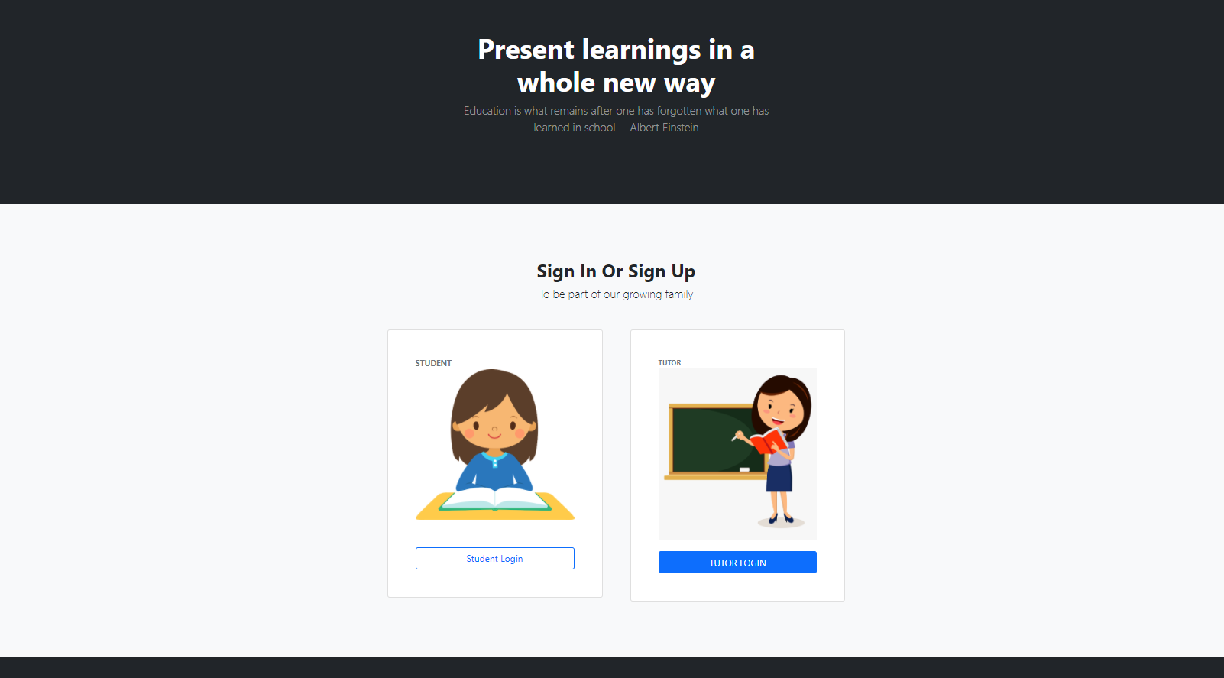

*Figure 5.1 Home Page of the System*

Figure 5.1 shows the home page of the system. This will indicate where the user is a student or a tutor in order to access the right log in page. 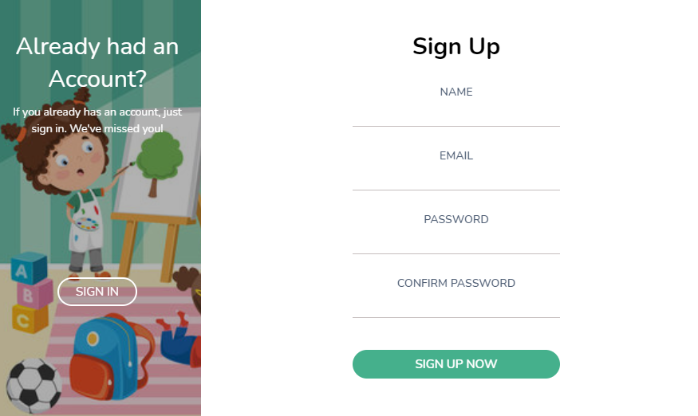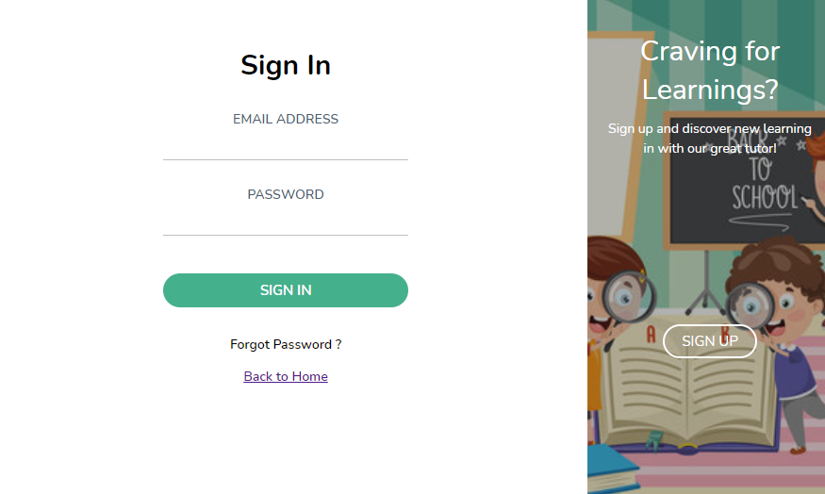

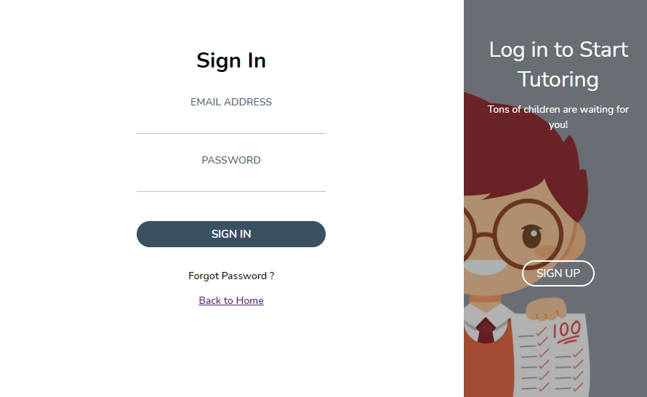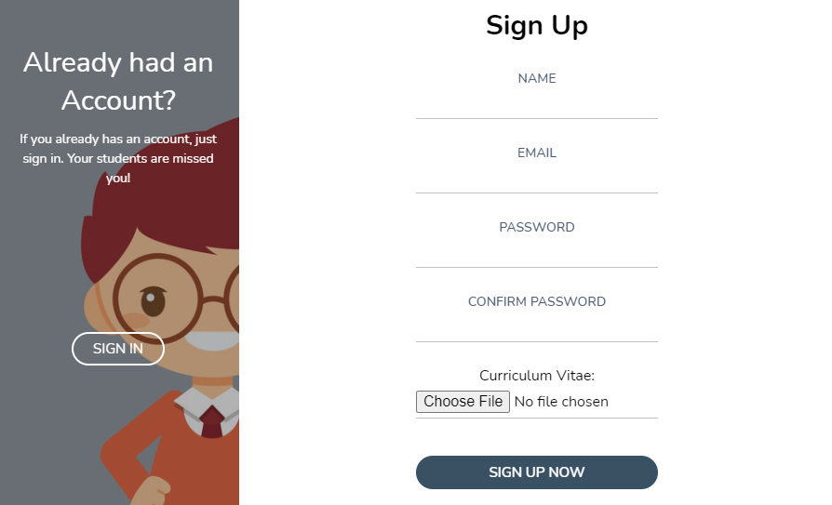

*Figure 5.2Tutor/ Student Login and Registration Page*

Figure 5.2 show the login page for the student/tutor user. Using this page, the user can access the student dashboard of the system and create a new account for new user.

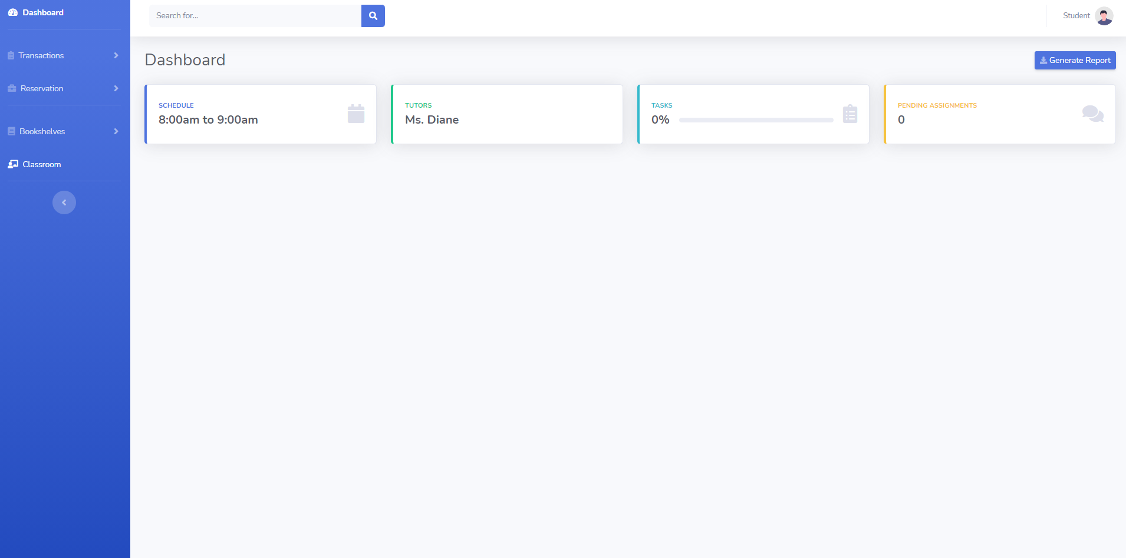

Student

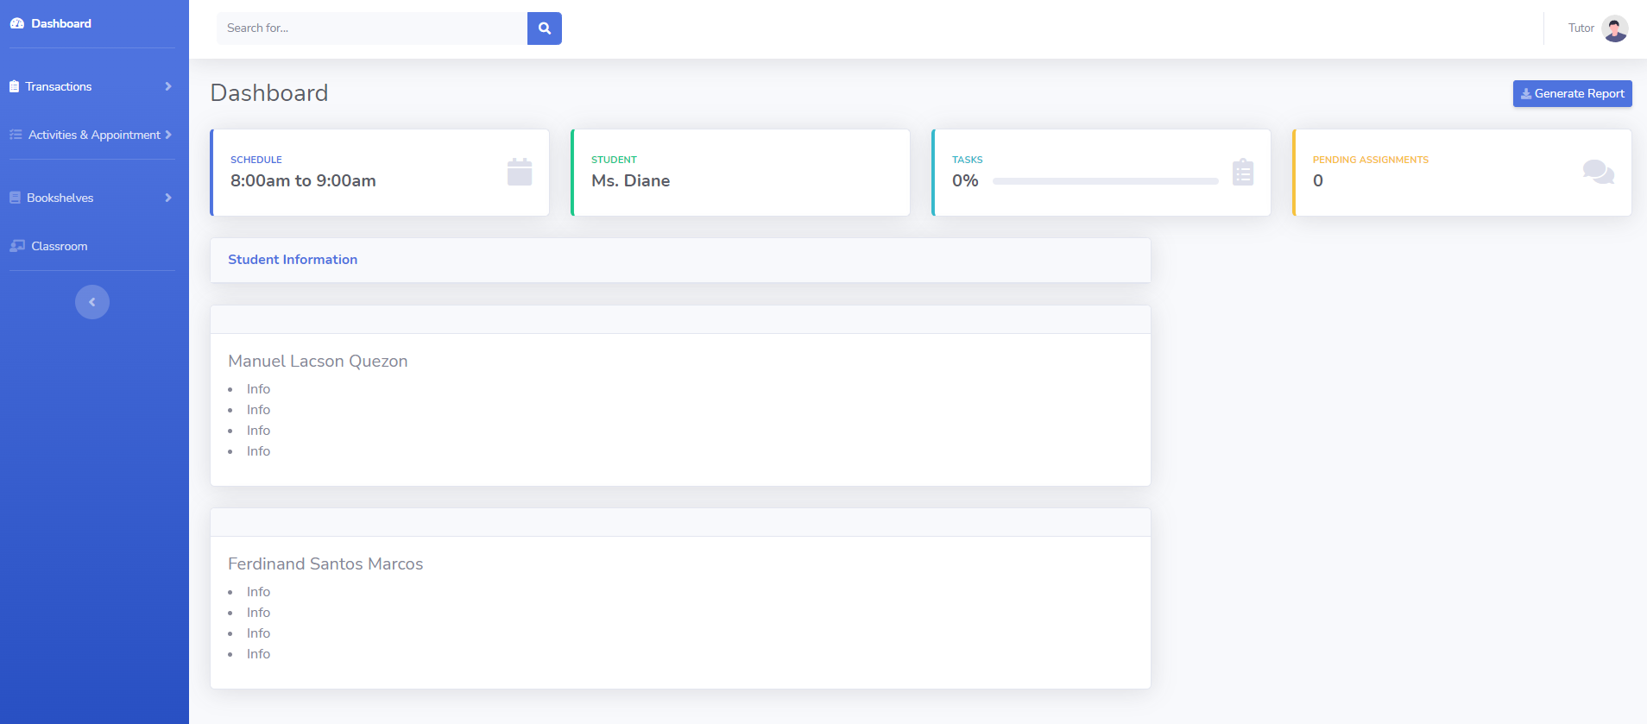

Tutor

*Figure 5.3 Student/Tutor Dashboards*

Figure 5.3 show the main dashboard of the student/tutor account dashboard. The dashboard is consists of schedule of the student, name of the tutor, task and pending assignments. The user can access all the modules inside the dashboard. There are modules that dedicated on specific task specially on tutoring task. The dashboard is consists of schedule of the tutor, name of the student, task and pending assignments. The user can access all the modules inside the dashboard. There are modules that dedicated on specific task specially on tutoring task.

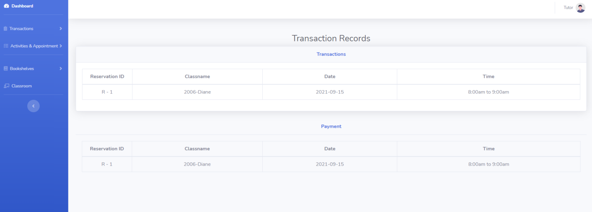

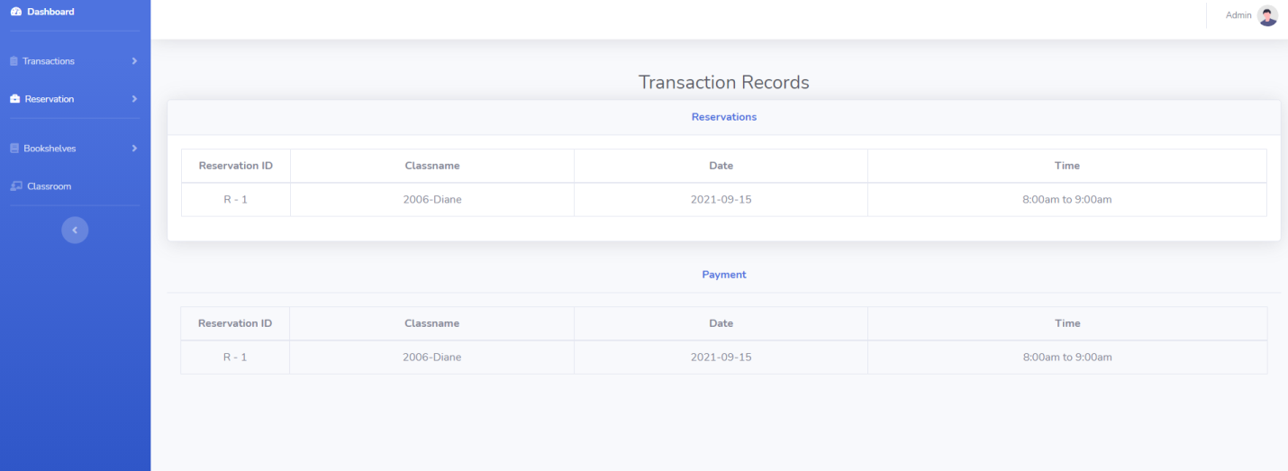

*Figure 5.4 Transaction module of Student/Tutor Dashboard*

Figure 5.4 shows the transactions module of the student/tutor account dashboard. This will show all the transactions and reservations information of the student/tutor in order to have a track of their records. This will shows all the transactions and reservations information made of the student/tutor to a particular subject in order to have a track of their records.

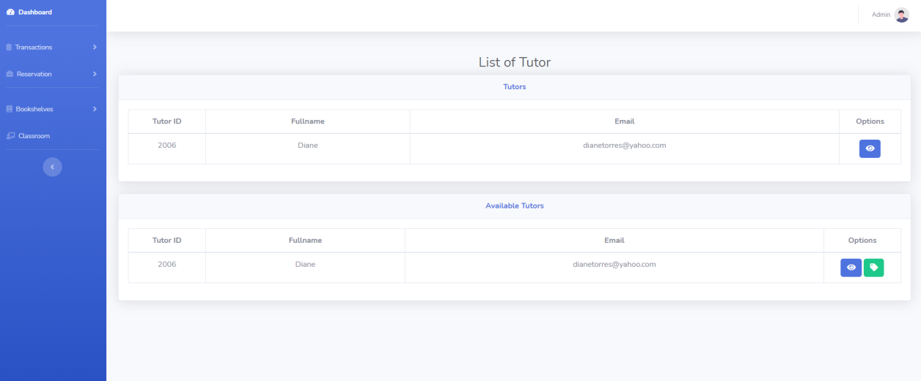

*Figure 5.5 Reservation Module of Student Dashboard*

Figure 5.5 shows the reservation module of the student account dashboard. This will show all the available and unavailable tutors inside the system and you can set a reservation on a particular subject and tutor for a limited time.

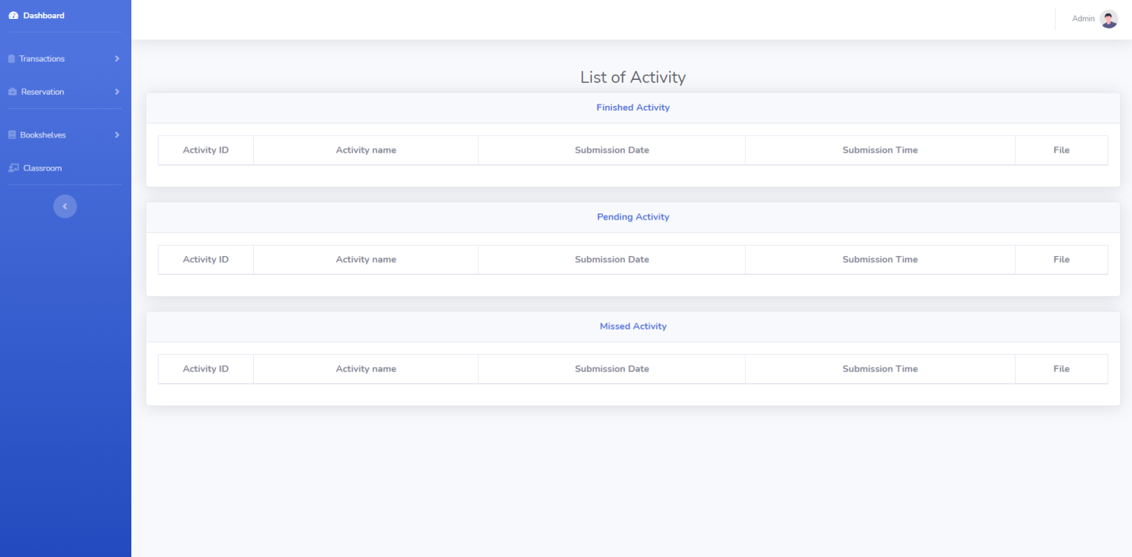

*Figure 5.6 Bookshelves – Activity Module of Student Dashboard*

Figure 5.6 shows the bookshelves – activity module for the student account dashboard. This will show all the list of activity that the student have from missed, pending, and finished activities of a specific subject.

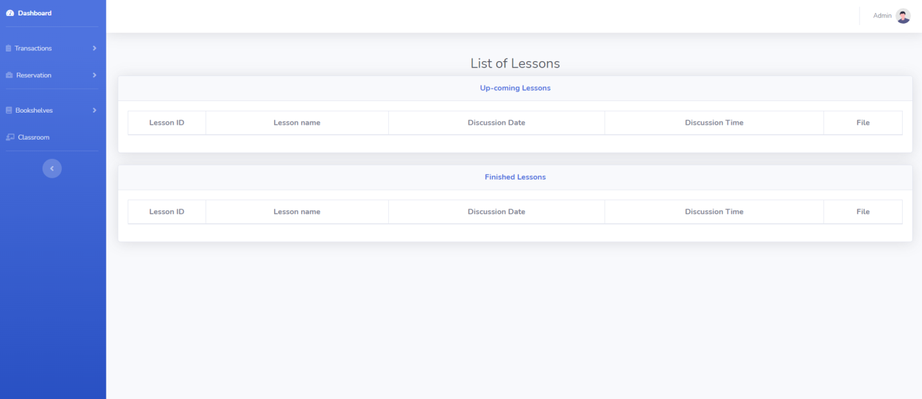

*Figure 5.7 Bookshelves – Lesson Module of Student Dashboard*

Figure 5.8 shows the bookshelves –lesson module for the student account dashboard. This will show all the list of lessons of the student from up-coming to finished lessons of a particular subject.

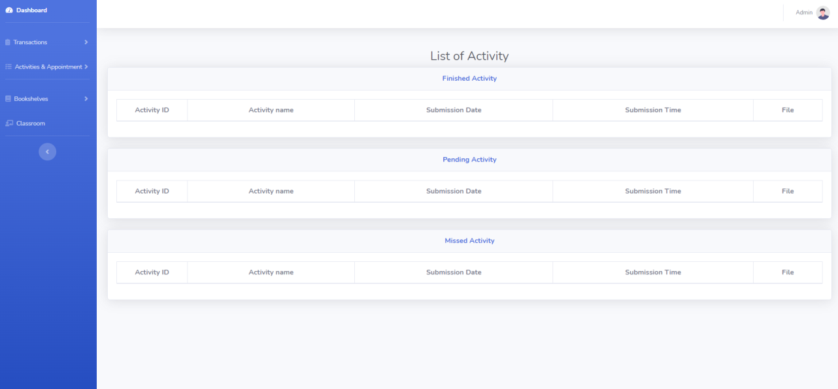

*Figure 5.11 Activity Module of Tutor Dashboard*

Figure 5.11 shows the activity module for the tutor account dashboard. This will show all the list of activity that the student have from missed, pending, and finished activities of a specific subject.

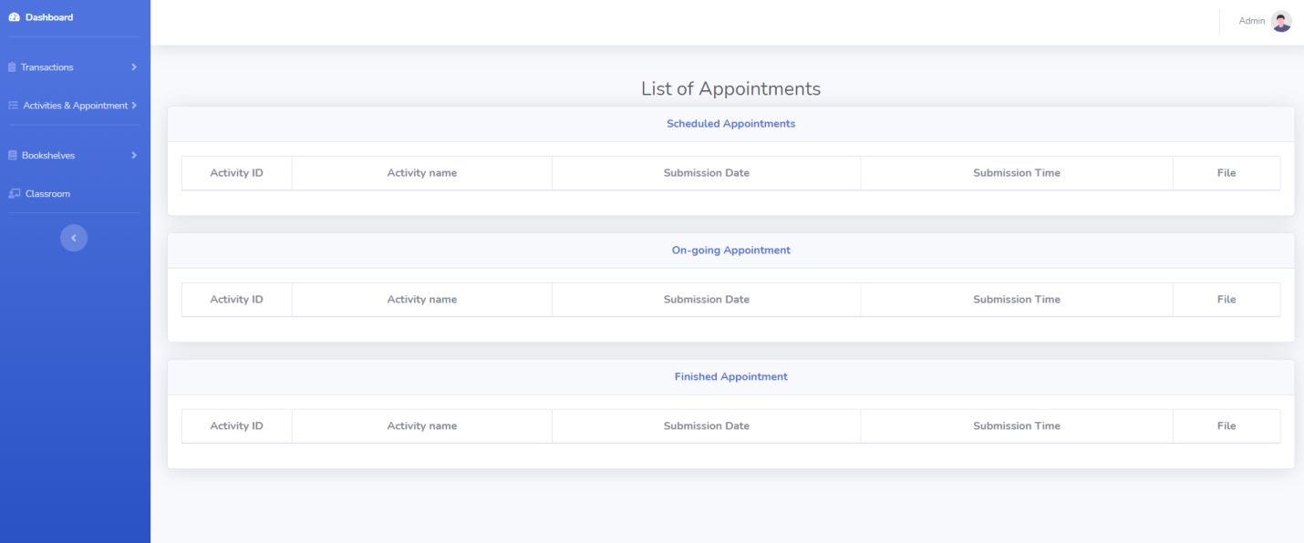

*Figure 5.12 Appointment Module of Tutor Dashboard*

Figure 5.12 shows the appointment module for the tutor account dashboard. This will show all the list of appointment of the tutor from scheduled, on-going, and finished appointment of a particular lesson.

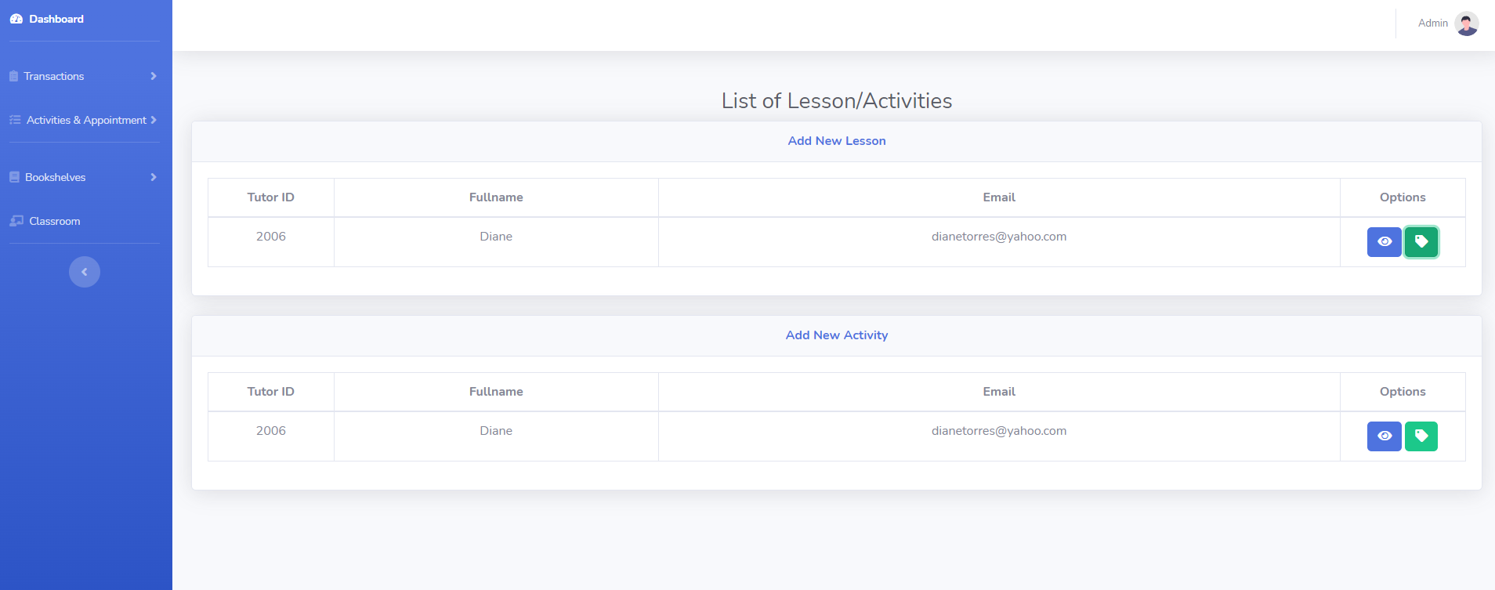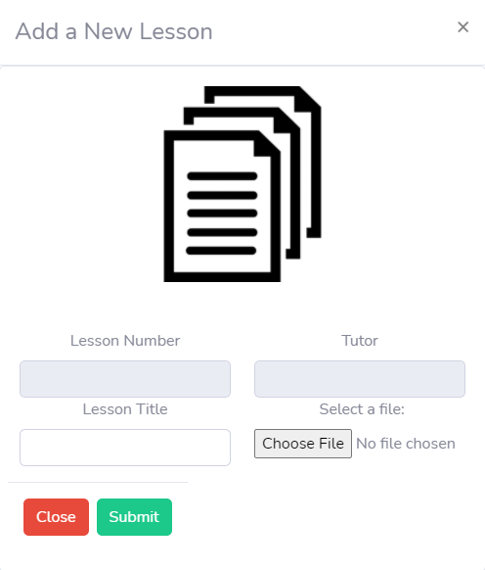

*Figure 5.13 Bookshelves – Lesson Module of Tutor Dashboard*

Figure 5.13 shows the bookshelves – lesson module for the tutor account dashboard. This will shows all the list of lesson of the tutor and adding of new lessons for the students.

**5.2 To evaluate the performance of Online Private Tutor System by means of survey questionnaire. This will shows all the information to the user regarding on the performance of the system.**

The process of defining the structural design modules, components, interface, and data for the system are known as the project structure. Proposed system should be reliable, accurate and preform its function and usage in order to give accurate result, solve the problem and a good feedback.

5.2.1 Presentation of Data

**Table 1**

**Frequency and Percent Distribution of the Demographic Profile**

**According to Respondents Age**

|  |  |  |
| --- | --- | --- |
| **Age** | **Frequency (f)** | **Percentage (%)** |
| **15-30** | 21 | 70% |
| **31-40** | 9 | 30% |
| **Total** | **30** | **100%** |

The table above shows the distribution of the respondents by age. The majority of the respondents are from the ages of 15 - 30 with a percentage of 70%. While the minority of the respondents are at the ages of 31 - 40 with a percentage of 30%.

**Table 2**

Frequency and Percent Distribution of the Demographic Profile

According to Respondents Gender

|  |  |  |
| --- | --- | --- |
| Gender | Frequency (f) | Percentage (%) |
| Male | 17 | 56.67% |
| Female | 13 | 43.33% |
| Total | 30 | 100% |

The table shows the distribution of the respondents by gender. It shows that most of the respondents are male with a frequency value of 17 or 56.67%.

Table 3

Frequency and Percent Distribution of the Evaluation form

According to “Functionality and Suitability – Easy to Use”

|  |  |  |
| --- | --- | --- |
| Answers | Frequency (f) | Percentage (%) |
| Agree | 24 | 80% |
| Maybe | 6 | 20% |
| Disagree | 0 | 0 |
| Total | 30 | 100% |

The table shows the distribution of the respondents by the evaluation form “Easy to Use” It shows that most of the respondents answered agree with a frequency value of 24 or 80%.

Table 4

Frequency and Percent Distribution of the Evaluation form

According to “Functionality and Suitability – Very convenient”

|  |  |  |
| --- | --- | --- |
| Answers | Frequency (f) | Percentage (%) |
| Agree | 26 | 86.67% |
| Maybe | 4 | 13.33% |
| Disagree | 0 | 0 |
| Total | 30 | 100% |

The table shows the distribution of the respondents by the evaluation form “Very convenient” It shows that most of the respondents answered agree with a frequency value of 26 or 86.67%.

Table 5

Frequency and Percent Distribution of the Evaluation form

According to “Functionality and Suitability – User-friendliness”

|  |  |  |
| --- | --- | --- |
| Answers | Frequency (f) | Percentage (%) |
| Agree | 28 | 93.33% |
| Maybe | 2 | 6.67% |
| Disagree | 0 | 0 |
| Total | 30 | 100% |

The table shows the distribution of the respondents by the evaluation form “User-friendliness” It shows that most of the respondents answered agree with a frequency value of 28 or 93.33%.

Table 6

Frequency and Percent Distribution of the Evaluation form

According to “Content – Accuracy of Content”

|  |  |  |
| --- | --- | --- |
| Answers | Frequency (f) | Percentage (%) |
| Agree | 28 | 93.33% |
| Maybe | 2 | 6.67% |
| Disagree | 0 | 0 |
| Total | 30 | 100% |

The table shows the distribution of the respondents by the evaluation form “User-friendliness” It shows that most of the respondents answered agree with a frequency value of 28 or 93.33%.

Table 7

Frequency and Percent Distribution of the Evaluation form

According to “Content – Update of content”

|  |  |  |
| --- | --- | --- |
| Answers | Frequency (f) | Percentage (%) |
| Agree | 27 | 90% |
| Maybe | 3 | 10% |
| Disagree | 0 | 0 |
| Total | 30 | 100% |

The table shows the distribution of the respondents by the evaluation form “Update of Content” It shows that most of the respondents answered agree with a frequency value of 27 or 90%.

Table 8

Frequency and Percent Distribution of the Evaluation form

According to “Content – Presentation of Content”

|  |  |  |
| --- | --- | --- |
| Answers | Frequency (f) | Percentage (%) |
| Agree | 28 | 93.33% |
| Maybe | 2 | 6.67% |
| Disagree | 0 | 0 |
| Total | 30 | 100% |

The table shows the distribution of the respondents by the evaluation form “Presentation of Content” It shows that most of the respondents answered agree with a frequency value of 28 or 93.33%.

Table 9

Frequency and Percent Distribution of the Evaluation form

According to “Reliability – Conformance to Desired Result ”

|  |  |  |
| --- | --- | --- |
| Answers | Frequency (f) | Percentage (%) |
| Agree | 28 | 93.33% |
| Maybe | 2 | 6.67% |
| Disagree | 0 | 0 |
| Total | 30 | 100% |

The table shows the distribution of the respondents by the evaluation form “Presentation of Content” It shows that most of the respondents answered agree with a frequency value of 28 or 93.33%.

Table 10

Frequency and Percent Distribution of the Evaluation form

According to “Reliability – Absence of Failures”

|  |  |  |
| --- | --- | --- |
| Answers | Frequency (f) | Percentage (%) |
| Agree | 29 | 96.67% |
| Maybe | 1 | 3.33% |
| Disagree | 0 | 0 |
| Total | 30 | 100% |

The table shows the distribution of the respondents by the evaluation form “Absence of Failures” It shows that most of the respondents answered agree with a frequency value of 29 or 96.67%.

Table 11

Frequency and Percent Distribution of the Evaluation form

According to “Reliability – Accuracy in Performance”

|  |  |  |
| --- | --- | --- |
| Answers | Frequency (f) | Percentage (%) |
| Agree | 30 | 100% |
| Maybe | 0 | 0 |
| Disagree | 0 | 0 |
| Total | 30 | 100% |

The table shows the distribution of the respondents by the evaluation form “Absence of Failures” It shows that most of the respondents answered agree with a frequency value of 30 or 100%.

Table 12

Frequency and Percent Distribution of the Evaluation form

According to “Availability – Performs according to specification”

|  |  |  |
| --- | --- | --- |
| Answers | Frequency (f) | Percentage (%) |
| Agree | 28 | 93.33% |
| Maybe | 2 | 6.67% |
| Disagree | 0 | 0 |
| Total | 30 | 100% |

The table shows the distribution of the respondents by the evaluation form “Performs according to specification” It shows that most of the respondents answered agree with a frequency value of 28 or 93.33%.

Table 13

Frequency and Percent Distribution of the Evaluation form

According to “Availability – Provision for security requirements”

|  |  |  |
| --- | --- | --- |
| Answers | Frequency (f) | Percentage (%) |
| Agree | 29 | 96.67% |
| Maybe | 1 | 3.33% |
| Disagree | 0 | 0 |
| Total | 30 | 100% |

The table shows the distribution of the respondents by the evaluation form “Provision for security requirements” It shows that most of the respondents answered agree with a frequency value of 28 or 96.67%.

Table 14

Frequency and Percent Distribution of the Evaluation form

According to “Availability – Completeness of the system”

|  |  |  |
| --- | --- | --- |
| Answers | Frequency (f) | Percentage (%) |
| Agree | 30 | 100% |
| Maybe | 0 | 0 |
| Disagree | 0 | 0 |
| Total | 30 | 100% |

The table shows the distribution of the respondents by the evaluation form “Completeness of the system” It shows that most of the respondents answered agree with a frequency value of 30 or 100%.

# CONCLUSIONS AND RECOMMENDATIONS

## Conclusions

In this study, the proponents try to find a solution to how a system helps a particular user with an online private tutor. That is why the study proponents use an online survey questionnaire to aid them in the system's development phase. The majority of the respondents are males between the ages of 15 and 30, and the proponents demonstrated that the majority of the users are young and eager to acquire more knowledge when it comes to studying.

Based on the results and discussions presented, this claimed the following:

1. The proposed is valuable and easy to use, especially for the target participant, to ensure all the features will be used daily.
2. There are problems in conducting data and information from the target participant due to the pandemic lockdown and social distancing in many establishments.
3. The proposed system for the Online Private Tutor System provides an easy and accessible way of assisting students in specific subjects. This will help both Tutor and students interact consistently using this system and have quality time discussing a particular topic.

To fully develop a system, researchers must seek more information regarding this project. This will improve the system shortly, wherein many convenient features may acquire in the system's development phase. One of the future features that the system may receive is not only applicable for web-based only because of the situation due to the Covid-19 pandemic. It can also help the researcher develop a system that uses only its party rather than acquiring a third-party application. This will allow the researchers to adapt to much software and become the sole provider of video conferences.

## Recommendations

Based on the conclusion of the study, the proponents recommend the following to the:

1. The administration may endorse the utilization of the system for high school and college students.
2. Working students and people who have back subjects may use the system for a more systematic and time-efficient daily use. And for more reliable and efficient processes of scheduling their session.
3. As end-users, the target participant may use it for fast checking of activities and lessons.
4. Future researchers may improve the system as they provide innovations for its features in the future.

# REFERENCES

[1] "Analysis of Online Learning Behaviour from a Tutor ..." [Online]. Available: https://www.emerald.com/insight/content/doi/10.1108/AAOUJ-10-02-2015-B004/full/pdf?title=analysis-of-online-learning-behaviour-from-a-tutor-perspective-reflections-on-interactive-teaching-and-learning-in-the-big-data-erasup1sup. [Accessed: 14-Mar-2021].

[2] "Benefits of Tutoring - How Does Tutoring Help Students?," *Oxford Learning*, 14-Feb-2017. [Online]. Available: https://www.oxfordlearning.com/benefits-of-tutoring/. [Accessed: 14-Mar-2021].

[3] S. Pal, "What are the disadvantages of tutoring? " *Quora*. [Online]. Available: https://www.quora.com/What-are-the-disadvantages-of-tutoring. [Accessed: 14-Mar-2021].

[4] "Challenges teachers face when teaching online," *CoderZ*, 27-May-2020. [Online]. Available: https://gocoderz.com/blog/challenges-teachers-face-when-teaching-online/. [Accessed: 14-Mar-2021].

[5] According to Tutors, B. Montrose, "The Biggest Problems with Online Tutoring," *Medium*, 11-Jan-2017. [Online]. Available: https://medium.com/accelerated/the-biggest-problems-with-online-tutoring-according-to-tutors-2eaccf8d19e1. [Accessed: 14-Mar-2021].

[6] S. Writers, "Benefits of Online Tutoring," *OnlineSchools.org*, 17-Feb-2021. [Online]. Available: https://www.onlineschools.org/online-tutoring/. [Accessed: 14-Mar-2021].

[7] "(PDF) Impact of Peer Tutoring on Learning of Students." [Online]. Available: https://www.researchgate.net/publication/319292234_Impact_of_Peer_Tutoring_on_Learning_of_Students. [Accessed: 14-Mar-2021].

[8] "An Examination of an Online Tutoring Program's Impact on ..." [Online]. Available: https://files.eric.ed.gov/fulltext/EJ1085790.pdf. [Accessed: 14-Mar-2021].

[9] I. A. Copaci and A. S. Rusu, "A Profile Outline of Higher Education E-Tutoring Programs for the Digital-Native Student – Literature Review," *Procedia - Social and Behavioral Sciences*, 11-Dec-2015. [Online]. Available: https://www.sciencedirect.com/science/article/pii/S1877042815056177. [Accessed: 14-Mar-2021].

[10] E. S. J. van Rensburg, "Effective online teaching and learning practices for undergraduate health sciences students: An integrative review," *International Journal of Africa Nursing Sciences*, 24-Aug-2018. [Online]. Available: https://www.sciencedirect.com/science/article/pii/S2214139118300398. [Accessed: 14-Mar-2021].

[11] “Online Tutoring Service for Enriching College Students ...” [Online]. Available: https://core.ac.uk/download/pdf/82562733.pdf. [Accessed: 14-Mar-2021].

[12] "The Effectiveness of Online Learning: Beyond No ..." [Online]. Available: https://jolt.merlot.org/Vol11no2/Nguyen_0615.pdf. [Accessed: 14-Mar-2021].

# APPENDICES

Appendix A Source Code

<!DOCTYPE html>

<html>

<head>

<title>Tutor Login</title>

<meta charset="UTF-8">

<meta name="viewport" content="width=device-width, initial-scale=1">

<link rel="stylesheet" type="text/css" href="styles.css">

<link href="https://fonts.googleapis.com/css?family=Nunito:400,600,700,800&display=swap" rel="stylesheet">

</head>

<body>

<div class="cont">

<form method="POST" action="logSuccessTutor.php">

<div class="form sign-in">

<h2>Sign In</h2>

<label>

<span>Email Address</span>

<input type="email" name="email" required>

</label>

<label>

<span>Password</span>

<input type="password" name="pword" required>

</label>

<button class="submit" type="submit">Sign In</button>

<p class="forgot-pass">Forgot Password ?</p>

<p class="forgot-pass"><a href="index.php">Back to Home</p></a>

</div>

</form>

<div class="sub-cont">

<div class="img">

<div class="img-text m-up">

<h2>Log in to Start Tutoring</h2>

<p>Tons of children are waiting for you!</p>

</div>

<div class="img-text m-in">

<h2>Already had an Account?</h2>

<p>If you already has an account, just sign in. Your students are missed you!</p>

</div>

<div class="img-btn">

<span class="m-up">Sign Up</span>

<span class="m-in">Sign In</span>

</div>

</div>

<form method="POST" action="conTutorRegister.php" enctype="multipart/form-data">

<div class="form sign-up">

<h2>Sign Up</h2>

<label>

<span>Name</span>

<input type="text" name="fname" required>

</label>

<label>

<span>Email</span>

<input type="email" name="email" required>

</label>

<label>

<span>Password</span>

<input type="password" name="pword" required>

</label>

<label>

<span>Confirm Password</span>

<input type="password" name="cnpword" required>

<label for="myfile">Curriculum Vitae:</label>

<input type="file" id="myfile" name="myfile" required>

</label>

<button type="submit" class="submit">Sign Up Now</button>

</div>

</form>

</div>

</div>

<script type="text/javascript" src="script.js"></script>

</body>

</html>

<?php

include("condb.php");

$fname = $_POST['fname'];

$email = $_POST['email'];

$pword = $_POST['pword'];

$cnpword = $_POST['cnpword'];

$pname = rand(1000,10000)."-".$_FILES["myfile"]["name"];

$tname = $_FILES["myfile"]["tmp_name"];

$uploads_dir = 'files';

move_uploaded_file($tname, $uploads_dir.'/'.$pname);

$sql = "SELECT * FROM tutortbl where Email = '$email'";

$res = mysqli_query($cn, $sql);

if($res && mysqli_num_rows($res)>0)

{

function myAlert($msg, $url)

{

echo '<script language="javascript">alert("'.$msg.'");</script>';

echo "<script>document.location = '$url'</script>";

}

myAlert("Email already taken!", "SignTutor.php");

}

else

{

if ($_POST['pword'] === $_POST['cnpword']){

$sql2 = "INSERT INTO tutortbl(Fullname,Email,Password,CV,Status,Available) VALUE ('$fname','$email','$pword','$pname','1','0')";

$result = mysqli_query($cn, $sql2);

function myAlert1($msg, $url){

echo '<script language="javascript">alert("'.$msg.'");</script>';

echo "<script>document.location = '$url'</script>";

}

myAlert1("Registration Success!", "SignTutor.php");

}

else {

function myAlert1($msg, $url){

echo '<script language="javascript">alert("'.$msg.'");</script>';

echo "<script>document.location = '$url'</script>";

}

myAlert1("Password Did Not Match!", "SignTutor.php");

}

}

?>

<!DOCTYPE html>

<?php

session_start();

?>

<html lang="en">

<head>

<meta charset="utf-8">

<meta http-equiv="X-UA-Compatible" content="IE=edge">

<meta name="viewport" content="width=device-width, initial-scale=1, shrink-to-fit=no">

<meta name="description" content="">

<meta name="author" content="">

<title>Student - Dashboard</title>

<!-- Custom fonts for this template-->

<link href="vendor/fontawesome-free/css/all.min.css" rel="stylesheet" type="text/css">

<link

href="https://fonts.googleapis.com/css?family=Nunito:200,200i,300,300i,400,400i,600,600i,700,700i,800,800i,900,900i"

rel="stylesheet">

<!-- Custom styles for this template-->

<link href="css/sb-admin-2.min.css" rel="stylesheet">

</head>

<body id="page-top">

<!-- Page Wrapper -->

<div id="wrapper">

<!-- Sidebar -->

<ul class="navbar-nav bg-gradient-primary sidebar sidebar-dark accordion" id="accordionSidebar">

<!-- Sidebar - Brand -->

<!-- Divider -->

<hr class="sidebar-divider my-0">

<!-- Nav Item - Dashboard -->

<li class="nav-item active">

<a class="nav-link" href="sDashboard.php">

<i class="fas fa-fw fa-tachometer-alt"></i>

<span>Dashboard</span></a>

</li>

<!-- Divider -->

<hr class="sidebar-divider">

<!-- Heading -->

<!-- Nav Item - Pages Collapse Menu -->

<li class="nav-item">

<a class="nav-link collapsed" href="#" data-toggle="collapse" data-target="#collapseTwo"

aria-expanded="true" aria-controls="collapseTwo">

<i class=" fas fa-clipboard-list"></i>

<span>Transactions</span>

</a>

<div id="collapseTwo" class="collapse" aria-labelledby="headingTwo" data-parent="#accordionSidebar">

<div class="bg-white py-2 collapse-inner rounded">

<h6 class="collapse-header">View:</h6>

<a class="collapse-item" href="sRecord.php">Record Transactions</a>

</div>

</div>

</li>

<!-- Nav Item - Utilities Collapse Menu -->

<li class="nav-item">

<a class="nav-link collapsed" href="#" data-toggle="collapse" data-target="#collapseUtilities"

aria-expanded="true" aria-controls="collapseUtilities">

<i class="fas fa-briefcase"></i>

<span>Reservation</span>

</a>

<div id="collapseUtilities" class="collapse" aria-labelledby="headingUtilities"

data-parent="#accordionSidebar">

<div class="bg-white py-2 collapse-inner rounded">

<h6 class="collapse-header">View:</h6>

<a class="collapse-item" href="sReservation.php">Set a Reservation</a>

</div>

</li>

<!-- Divider -->

<hr class="sidebar-divider">

<!-- Nav Item - Pages Collapse Menu -->

<li class="nav-item">

<a class="nav-link collapsed" href="#" data-toggle="collapse" data-target="#collapsePages"

aria-expanded="true" aria-controls="collapsePages">

<i class="fa fa-book"></i>

<span>Bookshelves</span>

</a>

<div id="collapsePages" class="collapse" aria-labelledby="headingPages" data-parent="#accordionSidebar">

<div class="bg-white py-2 collapse-inner rounded">

<a class="collapse-item" href="sActivity.php">Activity</a>

<a class="collapse-item" href="sLesson.php">Lessons</a>

</div>

</div>

</li>

<!-- Nav Item - Charts -->

<li class="nav-item">

<a class="nav-link" href="sClassroom.php">

<i class="fas fa-chalkboard-teacher"></i>

<span>Classroom</span></a>

</li>

<!-- Divider -->

<hr class="sidebar-divider d-none d-md-block">

<!-- Sidebar Toggler (Sidebar) -->

<div class="text-center d-none d-md-inline">

<button class="rounded-circle border-0" id="sidebarToggle"></button>

</div>

<!-- Sidebar Message -->

</ul>

<!-- End of Sidebar -->

<!-- Content Wrapper -->

<div id="content-wrapper" class="d-flex flex-column">

<!-- Main Content -->

<div id="content">

<!-- Topbar -->

<nav class="navbar navbar-expand navbar-light bg-white topbar mb-4 static-top shadow">

<!-- Sidebar Toggle (Topbar) -->

<button id="sidebarToggleTop" class="btn btn-link d-md-none rounded-circle mr-3">

<i class="fa fa-bars"></i>

</button>

<!-- Topbar Search -->

<!-- Topbar Navbar -->

<ul class="navbar-nav ml-auto">

<!-- Nav Item - Search Dropdown (Visible Only XS) -->

<li class="nav-item dropdown no-arrow d-sm-none">

<a class="nav-link dropdown-toggle" href="#" id="searchDropdown" role="button"

data-toggle="dropdown" aria-haspopup="true" aria-expanded="false">

<i class="fas fa-search fa-fw"></i>

</a>

<!-- Dropdown - Messages -->

<div class="dropdown-menu dropdown-menu-right p-3 shadow animated--grow-in"

aria-labelledby="searchDropdown">

<form class="form-inline mr-auto w-100 navbar-search">

<div class="input-group">

<input type="text" class="form-control bg-light border-0 small"

placeholder="Search for..." aria-label="Search"

aria-describedby="basic-addon2">

<div class="input-group-append">

<button class="btn btn-primary" type="button">

<i class="fas fa-search fa-sm"></i>

</button>

</div>

</div>

</form>

</div>

</li>

<div class="topbar-divider d-none d-sm-block"></div>

<!-- Nav Item - User Information -->

<li class="nav-item dropdown no-arrow">

<a class="nav-link dropdown-toggle" href="#" id="userDropdown" role="button"

data-toggle="dropdown" aria-haspopup="true" aria-expanded="false">

<span class="mr-2 d-none d-lg-inline text-gray-600 small"><?php echo $_SESSION["Fullname"]; ?></span>

<img class="img-profile rounded-circle"

src="img/undraw_profile.svg">

</a>

<!-- Dropdown - User Information -->

<div class="dropdown-menu dropdown-menu-right shadow animated--grow-in"

aria-labelledby="userDropdown">

<a class="dropdown-item" href="#">

<i class="fas fa-user fa-sm fa-fw mr-2 text-gray-400"></i>

Profile

</a>

<div class="dropdown-divider"></div>

<a class="dropdown-item" href="" data-toggle="modal" data-target="#logoutModal">

<i class="fas fa-sign-out-alt fa-sm fa-fw mr-2 text-gray-400"></i>

Logout

</a>

</div>

</li>

</ul>

</nav>

<!-- End of Topbar -->

<!-- Begin Page Content -->

<div class="container-fluid" style = "text-align:center">

<!-- Page Heading -->

<h1 class="h1 mb-0 text-gray-800" >Dashboard</h1>

<br>

<!-- Content Row -->

<div div class="row d-flex justify-content-center" style = "text-align:center">

<!-- Earnings (Monthly) Card Example -->

<div class="col-xl-3 col-md-6 mb-4">

<div class="card border-left-primary shadow h-100 py-2">

<div class="card-body">

<div class="row no-gutters align-items-center">

<div class="col mr-2">

<?php

include ("condb.php");

$sname = $_SESSION["Fullname"];

$sql = "SELECT * FROM classroomtbl WHERE Status = '1' AND cStudent='$sname' ORDER BY cTime";

$result2 = mysqli_query($cn, $sql);

$row2 = mysqli_fetch_assoc($result2);

echo '<div class="text-xs font-weight-bold text-primary text-uppercase mb-1">

Schedule</div>';

if ($row2 === null) {

echo '<div class="h5 mb-0 font-weight-bold text-gray-800">No Schedule Available</div>';

}else{

echo '<div class="h5 mb-0 font-weight-bold text-gray-800">'.$row2['cTime'].'</div>';

}

?>

</div>

<div class="col-auto">

<i class="fas fa-calendar fa-2x text-gray-300"></i>

</div>

</div>

</div>

</div>

</div>

<!-- Earnings (Monthly) Card Example -->

<div class="col-xl-3 col-md-6 mb-4">

<div class="card border-left-success shadow h-100 py-2">

<div class="card-body">

<div class="row no-gutters align-items-center">

<div class="col mr-2">

<?php

include ("condb.php");

$sname = $_SESSION["Fullname"];

$sql = "SELECT * FROM classroomtbl WHERE Status = '1' AND cStudent='$sname' ORDER BY cTime";

$result2 = mysqli_query($cn, $sql);

$row2 = mysqli_fetch_assoc($result2);

echo '<div class="text-xs font-weight-bold text-success text-uppercase mb-1">

Tutors</div>';

if ($row2 === null) {

echo '<div class="h5 mb-0 font-weight-bold text-gray-800">No Tutor Available</div>';

}else{

echo '<div class="h5 mb-0 font-weight-bold text-gray-800">'.$row2['cTutor'].'</div>';

}

?>

</div>

<div class="col-auto">

</div>

</div>

</div>

</div>

</div>

<!-- End of Content Wrapper -->

</div>

<!-- End of Page Wrapper -->

<!-- Scroll to Top Button-->

<a class="scroll-to-top rounded" href="#page-top">

<i class="fas fa-angle-up"></i>

</a>

<!-- Logout Modal-->

<div class="modal fade" id="logoutModal" tabindex="-1" role="dialog" aria-labelledby="exampleModalLabel"

aria-hidden="true">

<div class="modal-dialog" role="document">

<div class="modal-content">

<div class="modal-header">

<h5 class="modal-title" id="exampleModalLabel">Ready to Leave?</h5>

<button class="close" type="button" data-dismiss="modal" aria-label="Close">

<span aria-hidden="true">×</span>

</button>

</div>

<div class="modal-footer">

<button class="btn btn-secondary" type="button" data-dismiss="modal">Cancel</button>

<a class="btn btn-primary" href="outSuccess.php">Logout</a>

</div>

</div>

</div>

</div>

<!-- Bootstrap core JavaScript-->

<script src="vendor/jquery/jquery.min.js"></script>

<script src="vendor/bootstrap/js/bootstrap.bundle.min.js"></script>

<!-- Core plugin JavaScript-->

<script src="vendor/jquery-easing/jquery.easing.min.js"></script>

<!-- Custom scripts for all pages-->

<script src="js/sb-admin-2.min.js"></script>

<!-- Page level plugins -->

<script src="vendor/chart.js/Chart.min.js"></script>

<!-- Page level custom scripts -->

<script src="js/demo/chart-area-demo.js"></script>

<script src="js/demo/chart-pie-demo.js"></script>

</body>

</html>

<!DOCTYPE html>

<?php

session_start();

?>

<html lang="en">

<head>

<meta charset="utf-8">

<meta http-equiv="X-UA-Compatible" content="IE=edge">

<meta name="viewport" content="width=device-width, initial-scale=1, shrink-to-fit=no">

<meta name="description" content="">

<meta name="author" content="">

<title>Student - Dashboard</title>

<!-- Custom fonts for this template-->

<link href="vendor/fontawesome-free/css/all.min.css" rel="stylesheet" type="text/css">

<link

href="https://fonts.googleapis.com/css?family=Nunito:200,200i,300,300i,400,400i,600,600i,700,700i,800,800i,900,900i"

rel="stylesheet">

<!-- Custom styles for this template-->

<link href="css/sb-admin-2.min.css" rel="stylesheet">

</head>

<body id="page-top">

<!-- Page Wrapper -->

<div id="wrapper">

<!-- Sidebar -->

<ul class="navbar-nav bg-gradient-primary sidebar sidebar-dark accordion" id="accordionSidebar">

<!-- Sidebar - Brand -->

<!-- Divider -->

<hr class="sidebar-divider my-0">

<!-- Nav Item - Dashboard -->

<li class="nav-item active">

<a class="nav-link" href="sDashboard.php">

<i class="fas fa-fw fa-tachometer-alt"></i>

<span>Dashboard</span></a>

</li>

<!-- Divider -->

<hr class="sidebar-divider">

<!-- Heading -->

<!-- Nav Item - Pages Collapse Menu -->

<li class="nav-item">

<a class="nav-link collapsed" href="#" data-toggle="collapse" data-target="#collapseTwo"

aria-expanded="true" aria-controls="collapseTwo">

<i class=" fas fa-clipboard-list"></i>

<span>Transactions</span>

</a>

<div id="collapseTwo" class="collapse" aria-labelledby="headingTwo" data-parent="#accordionSidebar">

<div class="bg-white py-2 collapse-inner rounded">

<h6 class="collapse-header">View:</h6>

<a class="collapse-item" href="sRecord.php">Record Transactions</a>

</div>

</div>

</li>

<!-- Nav Item - Utilities Collapse Menu -->

<li class="nav-item">

<a class="nav-link collapsed" href="#" data-toggle="collapse" data-target="#collapseUtilities"

aria-expanded="true" aria-controls="collapseUtilities">

<i class="fas fa-briefcase"></i>

<span>Reservation</span>

</a>

<div id="collapseUtilities" class="collapse" aria-labelledby="headingUtilities"

data-parent="#accordionSidebar">

<div class="bg-white py-2 collapse-inner rounded">

<h6 class="collapse-header">View:</h6>

<a class="collapse-item" href="sReservation.php">Set a Reservation</a>

</div>

</li>

<!-- Divider -->

<hr class="sidebar-divider">

<!-- Nav Item - Pages Collapse Menu -->

<li class="nav-item">

<a class="nav-link collapsed" href="#" data-toggle="collapse" data-target="#collapsePages"

aria-expanded="true" aria-controls="collapsePages">

<i class="fa fa-book"></i>

<span>Bookshelves</span>

</a>

<div id="collapsePages" class="collapse" aria-labelledby="headingPages" data-parent="#accordionSidebar">

<div class="bg-white py-2 collapse-inner rounded">

<a class="collapse-item" href="sActivity.php">Activity</a>

<a class="collapse-item" href="sLesson.php">Lessons</a>

</div>

</div>

</li>

<!-- Nav Item - Charts -->

<li class="nav-item">

<a class="nav-link" href="sClassroom.php">

<i class="fas fa-chalkboard-teacher"></i>

<span>Classroom</span></a>

</li>

<!-- Divider -->

<hr class="sidebar-divider d-none d-md-block">

<!-- Sidebar Toggler (Sidebar) -->

<div class="text-center d-none d-md-inline">

<button class="rounded-circle border-0" id="sidebarToggle"></button>

</div>

<!-- Sidebar Message -->

</ul>

<!-- End of Sidebar -->

<!-- Content Wrapper -->

<div id="content-wrapper" class="d-flex flex-column">

<!-- Main Content -->

<div id="content">

<!-- Topbar -->

<nav class="navbar navbar-expand navbar-light bg-white topbar mb-4 static-top shadow">

<!-- Sidebar Toggle (Topbar) -->

<button id="sidebarToggleTop" class="btn btn-link d-md-none rounded-circle mr-3">

<i class="fa fa-bars"></i>

</button>

<!-- Topbar Search -->

<!-- Topbar Navbar -->

<ul class="navbar-nav ml-auto">

<!-- Nav Item - Search Dropdown (Visible Only XS) -->

<li class="nav-item dropdown no-arrow d-sm-none">

<a class="nav-link dropdown-toggle" href="#" id="searchDropdown" role="button"

data-toggle="dropdown" aria-haspopup="true" aria-expanded="false">

<i class="fas fa-search fa-fw"></i>

</a>

<!-- Dropdown - Messages -->

<div class="dropdown-menu dropdown-menu-right p-3 shadow animated--grow-in"

aria-labelledby="searchDropdown">

<form class="form-inline mr-auto w-100 navbar-search">

<div class="input-group">

<input type="text" class="form-control bg-light border-0 small"

placeholder="Search for..." aria-label="Search"

aria-describedby="basic-addon2">

<div class="input-group-append">

<button class="btn btn-primary" type="button">

<i class="fas fa-search fa-sm"></i>

</button>

</div>

</div>

</form>

</div>

</li>

<div class="topbar-divider d-none d-sm-block"></div>

<!-- Nav Item - User Information -->

<li class="nav-item dropdown no-arrow">

<a class="nav-link dropdown-toggle" href="#" id="userDropdown" role="button"

data-toggle="dropdown" aria-haspopup="true" aria-expanded="false">

<span class="mr-2 d-none d-lg-inline text-gray-600 small"><?php echo $_SESSION["Fullname"]; ?></span>

<img class="img-profile rounded-circle"

src="img/undraw_profile.svg">

</a>

<!-- Dropdown - User Information -->

<div class="dropdown-menu dropdown-menu-right shadow animated--grow-in"

aria-labelledby="userDropdown">

<a class="dropdown-item" href="#">

<i class="fas fa-user fa-sm fa-fw mr-2 text-gray-400"></i>

Profile

</a>

<div class="dropdown-divider"></div>

<a class="dropdown-item" href="" data-toggle="modal" data-target="#logoutModal">

<i class="fas fa-sign-out-alt fa-sm fa-fw mr-2 text-gray-400"></i>

Logout

</a>

</div>

</li>

</ul>

</nav>

<!-- End of Topbar -->

<!-- Begin Page Content -->

<<div class="container-fluid" style = "text-align:center">

<!-- Page Heading -->

<h1 class="h3 mb-2 text-gray-800">Transaction Records</h1>

<!-- DataTales Example -->

<div class="card shadow mb-4">

<div class="card-header py-3">

<h6 class="m-0 font-weight-bold text-primary">Reservations</h6>

</div>

<div class="card-body">

<div class="table-responsive">

<table class="table table-bordered" id="dataTable" width="100%" cellspacing="0">

<?php

include ("condb.php");

echo"<thead>

<tr>

<th width='10%'>Reservation ID</th>

<th>Classname</th>

<th>Date</th>

<th>Time</th>

</tr>";

$sname = $_SESSION["Fullname"];

$sql = "SELECT * FROM reservationtbl WHERE Status = '1' AND rStudent ='$sname' ORDER BY RID";

$result = mysqli_query($cn, $sql);

while($row = mysqli_fetch_assoc($result))

{

echo"<tbody>";

echo "<tr>";

echo "<form method='POST' action='Remove.php?id=" . $row['RID'] . "'>";

echo "<input type='hidden' id='ID' name='ID' value='" . $row['RID'] . "'>";

echo "<td>R - " . $row['RID'] . " </td> ";

echo "<td>" . $row['Classname'] . " </td> ";

echo "<td>" . $row['rDate'] . " </td> ";

echo "<td>" . $row['rTime'] . " </td> ";

echo "</form>";

echo "</tr>";

}

?>

</table>

</div>

</div>

</div>

</div>

<!-- End of Content Wrapper -->

</div>

<!-- End of Page Wrapper -->

<!-- Scroll to Top Button-->

<a class="scroll-to-top rounded" href="#page-top">

<i class="fas fa-angle-up"></i>

</a>

<!-- Logout Modal-->

<div class="modal fade" id="logoutModal" tabindex="-1" role="dialog" aria-labelledby="exampleModalLabel"

aria-hidden="true">

<div class="modal-dialog" role="document">

<div class="modal-content">

<div class="modal-header">

<h5 class="modal-title" id="exampleModalLabel">Ready to Leave?</h5>

<button class="close" type="button" data-dismiss="modal" aria-label="Close">

<span aria-hidden="true">×</span>

</button>

</div>

<div class="modal-footer">

<button class="btn btn-secondary" type="button" data-dismiss="modal">Cancel</button>

<a class="btn btn-primary" href="outSuccess.php">Logout</a>

</div>

</div>

</div>

</div>

<!-- Bootstrap core JavaScript-->

<script src="vendor/jquery/jquery.min.js"></script>

<script src="vendor/bootstrap/js/bootstrap.bundle.min.js"></script>

<!-- Core plugin JavaScript-->

<script src="vendor/jquery-easing/jquery.easing.min.js"></script>

<!-- Custom scripts for all pages-->

<script src="js/sb-admin-2.min.js"></script>

<!-- Page level plugins -->

<script src="vendor/chart.js/Chart.min.js"></script>

<!-- Page level custom scripts -->

<script src="js/demo/chart-area-demo.js"></script>

<script src="js/demo/chart-pie-demo.js"></script>

</body>

</html>

<!doctype html>

<html>

<head>

<meta charset='utf-8'>

<meta name='viewport' content='width=device-width, initial-scale=1'>

<title>Payment</title>

<link href='https://maxcdn.bootstrapcdn.com/bootstrap/4.0.0/css/bootstrap.min.css' rel='stylesheet'>

<link href='https://use.fontawesome.com/releases/v5.8.1/css/all.css' rel='stylesheet'>

<script type='text/javascript' src='https://cdnjs.cloudflare.com/ajax/libs/jquery/3.2.1/jquery.min.js'></script>

<style>body {

background: #f5f5f5

}

.rounded {

border-radius: 1rem

}

.nav-pills .nav-link {

color: #555

}

.nav-pills .nav-link.active {

color: white

}

input[type="radio"] {

margin-right: 5px

}

.bold {

font-weight: bold

}</style>

</head>

<body oncontextmenu='return false' class='snippet-body'>

<div class="container py-5">

<!-- For demo purpose -->

<div class="row mb-4">

<div class="col-lg-8 mx-auto text-center">

<h1 class="display-6">Payment Forms</h1>

</div>

</div> <!-- End -->

<div class="row">

<div class="col-lg-6 mx-auto">

<div class="card ">

<div class="card-header">

<div class="bg-white shadow-sm pt-4 pl-2 pr-2 pb-2">

<!-- Credit card form tabs -->

<ul role="tablist" class="nav bg-light nav-pills rounded nav-fill mb-3">

<li class="nav-item"> <a data-toggle="pill" href="#credit-card" class="nav-link active "> <i class="fas fa-credit-card mr-2"></i> Credit Card </a> </li>

<li class="nav-item"> <a data-toggle="pill" href="#paypal" class="nav-link "> <i class="fab fa-paypal mr-2"></i> Paypal </a> </li>

<li class="nav-item"> <a data-toggle="pill" href="#net-banking" class="nav-link "> <i class="fas fa-mobile-alt mr-2"></i> Net Banking </a> </li>

</ul>

</div> <!-- End -->

<!-- Credit card form content -->

<div class="tab-content">

<!-- credit card info-->

<div id="credit-card" class="tab-pane fade show active pt-3">

<form role="form" onsubmit="event.preventDefault()">

<div class="form-group"> <label for="username">

<h6>Card Owner</h6>

</label> <input type="text" name="username" placeholder="Card Owner Name" required class="form-control "> </div>

<div class="form-group"> <label for="cardNumber">

<h6>Card number</h6>

</label>

<div class="input-group"> <input type="text" name="cardNumber" placeholder="Valid card number" class="form-control " required>

<div class="input-group-append"> <span class="input-group-text text-muted"> <i class="fab fa-cc-visa mx-1"></i> <i class="fab fa-cc-mastercard mx-1"></i> <i class="fab fa-cc-amex mx-1"></i> </span> </div>

</div>

</div>

<div class="row">

<div class="col-sm-8">

<div class="form-group"> <label><span class="hidden-xs">

<h6>Expiration Date</h6>

</span></label>

<div class="input-group"> <input type="number" placeholder="MM" name="" class="form-control" required> <input type="number" placeholder="YY" name="" class="form-control" required> </div>

</div>

</div>

<div class="col-sm-4">

<div class="form-group mb-4"> <label data-toggle="tooltip" title="Three digit CV code on the back of your card">

<h6>CVV <i class="fa fa-question-circle d-inline"></i></h6>

</label> <input type="text" required class="form-control"> </div>

</div>

</div>

<div class="card-footer"> <button type="button" class="subscribe btn btn-primary btn-block shadow-sm" href = "sReservation.php"> Confirm Payment </button>

</form>

</div>

</div> <!-- End -->

<!-- Paypal info -->

<div id="paypal" class="tab-pane fade pt-3">

<h6 class="pb-2">Select your paypal account type</h6>

<div class="form-group "> <label class="radio-inline"> <input type="radio" name="optradio" checked> Domestic </label> <label class="radio-inline"> <input type="radio" name="optradio" class="ml-5">International </label></div>

<p> <button type="button" class="btn btn-primary" onclick="document.location='https://www.paypal.com/ph/signin'"><i class="fab fa-paypal mr-2"></i> Log into my Paypal</button> </p>

<p class="text-muted"> Note: After clicking on the button, you will be directed to a secure gateway for payment. After completing the payment process, you will be redirected back to the website to view details of your order. </p>

</div> <!-- End -->

<!-- bank transfer info -->

<div id="net-banking" class="tab-pane fade pt-3">

<div class="form-group "> <label for="Select Your Bank">

<h6>Select your Bank</h6>

</label> <select class="form-control" id="ccmonth">

<option value="" selected disabled>--Please select your Bank--</option>

<option>Bank 1</option>

<option>Bank 2</option>

<option>Bank 3</option>

<option>Bank 4</option>

<option>Bank 5</option>

<option>Bank 6</option>

<option>Bank 7</option>

<option>Bank 8</option>

<option>Bank 9</option>

<option>Bank 10</option>

</select> </div>

<div class="form-group">

<p> <button type="button" class="btn btn-primary "><i class="fas fa-mobile-alt mr-2"></i> Proceed Payment</button> </p>

</div>

<p class="text-muted">Note: After clicking on the button, you will be directed to a secure gateway for payment. After completing the payment process, you will be redirected back to the website to view details of your order. </p>

</div> <!-- End -->

<!-- End -->

</div>

</div>

</div>

</div>

<script type='text/javascript' src='https://stackpath.bootstrapcdn.com/bootstrap/4.0.0/js/bootstrap.bundle.min.js'></script>

<script type='text/javascript'>$(function() {

$('[data-toggle="tooltip"]').tooltip()

})</script>

</body>

</html>

<html>

<head>

<meta content="width=device-width, initial-scale=1" name="viewport" />

<link rel="stylesheet" href="https://stackpath.bootstrapcdn.com/bootstrap/4.4.1/css/bootstrap.min.css" integrity="sha384-Vkoo8x4CGsO3+Hhxv8T/Q5PaXtkKtu6ug5TOeNV6gBiFeWPGFN9MuhOf23Q9Ifjh" crossorigin="anonymous">

<link rel="stylesheet" href="https://use.fontawesome.com/releases/v5.7.2/css/all.css" integrity="sha384-fnmOCqbTlWIlj8LyTjo7mOUStjsKC4pOpQbqyi7RrhN7udi9RwhKkMHpvLbHG9Sr" crossorigin="anonymous">

<script src='/socket.io/socket.io.js'></script>

<script type="module" src='assets/js/rtc.js'></script>

<script type="module" src='assets/js/events.js'></script>

<script src="https://cdnjs.cloudflare.com/ajax/libs/webrtc-adapter/7.3.0/adapter.min.js" integrity="sha256-2qQheewaqnZlXJ3RJRghVUwD/3fD9HNqxh4C+zvgmF4=" crossorigin="anonymous"></script>

<script src="https://cdnjs.cloudflare.com/ajax/libs/moment.js/2.24.0/moment.min.js"></script>

<script src='https://cdn.scaledrone.com/scaledrone.min.js'></script>

<meta charset="utf-8">

<meta name="viewport" content="width=device-width">

<style>

#video-call-div {

position: absolute;

top: 0;

left: 0;

width: 100%;

height: 100%;

display: none;

}

#localVideo {

position: absolute;

top: 0;

left: 0;

margin: 16px;

border-radius: 16px;

max-width: 20%;

max-height: 20%;

background: #ffffff;

}

#remoteVideo {

background: #000000;

width: 100%;

height: 100%;

}

.call-action-div {

position: absolute;

left: 45%;

bottom: 32px;

}

button {

cursor: pointer;

}

</style>

</head>

<body>

<video class="local-video" id='localVideo' autoplay muted></video>

<video class="local-video" id='remoteVideo' autoplay></video>

<div class="call-action-div">

<button onclick="muteVideo()"><i class="fa fa-camera" style="font-size:36px" aria-hidden="true"></i>

</button>

<button onclick="muteAudio()"><i class="fa fa-microphone" aria-hidden="true" style="font-size:36px"></i></button>

<button><i class="fa fa-desktop" aria-hidden="true" style="font-size:36px"></i></button>

</div>

</body>

<script>

// Generate random room name if needed

if (!location.hash) {

location.hash = "#231ewqdddd"//Math.floor(Math.random() * 0xFFFFFF).toString(16);

}

const roomHash = location.hash.substring(1);

// TODO: Replace with your own channel ID

const drone = new ScaleDrone('y0N6q0oVsjY9fEiu');

// Room name needs to be prefixed with 'observable-'

const roomName = 'observable-' + roomHash;

const configuration = {

iceServers: [{

urls: 'stun:stun.l.google.com:19302'

}]

};

let room;

let pc;

function onSuccess() {};

function onError(error) {

console.error(error);

};

drone.on('open', error => {

if (error) {

return console.error(error);

}

room = drone.subscribe(roomName);

room.on('open', error => {

if (error) {

onError(error);

}

});

// We're connected to the room and received an array of 'members'

// connected to the room (including us). Signaling server is ready.

room.on('members', members => {

console.log('MEMBERS', members);

// If we are the second user to connect to the room we will be creating the offer

const isOfferer = members.length === 2;

startWebRTC(isOfferer);

});

});

// Send signaling data via Scaledrone

function sendMessage(message) {

drone.publish({

room: roomName,

message

});

}

function startWebRTC(isOfferer) {

pc = new RTCPeerConnection(configuration);

// 'onicecandidate' notifies us whenever an ICE agent needs to deliver a

// message to the other peer through the signaling server

pc.onicecandidate = event => {

if (event.candidate) {

sendMessage({'candidate': event.candidate});

}

};

// If user is offerer let the 'negotiationneeded' event create the offer

if (isOfferer) {

pc.onnegotiationneeded = () => {

pc.createOffer().then(localDescCreated).catch(onError);

}

}

// When a remote stream arrives display it in the #remoteVideo element

pc.onaddstream = event => {

remoteVideo.srcObject = event.stream;

};

navigator.mediaDevices.getUserMedia({

audio: true,

video: true,

}).then(stream => {

// Display your local video in #localVideo element

localVideo.srcObject = stream;

// Add your stream to be sent to the conneting peer

pc.addStream(stream);

}, onError);

// Listen to signaling data from Scaledrone

room.on('data', (message, client) => {

// Message was sent by us

if (client.id === drone.clientId) {

return;

}

if (message.sdp) {

// This is called after receiving an offer or answer from another peer

pc.setRemoteDescription(new RTCSessionDescription(message.sdp), () => {

// When receiving an offer lets answer it

if (pc.remoteDescription.type === 'offer') {

pc.createAnswer().then(localDescCreated).catch(onError);

}

}, onError);

} else if (message.candidate) {

// Add the new ICE candidate to our connections remote description

pc.addIceCandidate(

new RTCIceCandidate(message.candidate), onSuccess, onError

);

}

});

}

function localDescCreated(desc) {

pc.setLocalDescription(

desc,

() => sendMessage({'sdp': pc.localDescription}),

onError

);

}

let isAudio = true

function muteAudio() {

isAudio = !isAudio

localStream.getAudioTracks()[0].enabled = isAudio

}

let isVideo = true

function muteVideo() {

isVideo = !isVideo

localStream.getVideoTracks()[0].enabled = isVideo

}

</script>

</html>

## Appendix B Source Code

# CURRICULUM VITAE

Write your CV here.