e-Lista: A WEB-BASED RESIDENT PROFILING SYSTEM

A **Thesis**

Presented to the Faculty of the

College of Communication and Information Technology University of Northern Philippines

Vigan City

In Partial Fulfillment

of the Requirements for the Degree

# Bachelor of Science in Information Technology

**Kristine Mae Caguntas Daphne Lou Agcalis Joshua Cyr Allen Ligon**

**August 2021**

**Table of Contents**

**Chapter**

1. **THE PROBLEM**

Introduction… 1

History 3

Vision & Mission… 4

Research Locale 5

Organizational Chart 6

Statement of Objectives 7

Significance of the Study 9

Scope and Delimitation… 10

1. REVIEW OF RELATED LITERATURE AND METHODOLOGY

Related Literature 11

Operational Definition of Terms 14

Methodology 16

1. RESULT AND DISCUSSION

Problems met in the Current Situation… 19

Use Case Diagram 22

Data Flow Diagram 28

Data Dictionary 29

Data Structure 30

Input-Process-Output (IPO)… 31

Hierarchical Input-Process-Output (HIPO) 32

**CHAPTER 1**

# INTRODUCTION

Regular days on barangays or different government sectors that are not modernized with technology suffer this issue. Usually, clients have a hard copy of their files or records. This routine seems not to be convenient for the clients and workers. Sorting of files over again and again is being done. Mostly it's time-consuming for both parties. Waiting for their records and finding the records eats the time. In the end, limited clients are being entertained, and many are unaccomplished because of their limited time. The barangay personnel usually experience this inconvenience. Most of the records are located on physical cabinets and other places for hard copies. With this problem, usually, 4ps are the ones who experienced it a lot.

The Pantawid Pamilyang Pilipino Program (4Ps) is a national government-sponsored human development initiative that gives conditional cash payments to the poor to enhance their health, nutrition, and education. The 4Ps also assist the Philippine government in meeting its Millennium Development Goals. The Millennium Development Goals (MDGs) focus on alleviating extreme poverty and hunger, establishing universal primary education, promoting gender equality, lowering child mortality, and enhancing maternal health care. From the two forms of financial awards granted to them, a household with three children might receive P1,400 per month or a total of P15,000 per year for five years.

These cash grants are distributed to the household beneficiaries through the Land Bank of the Philippines or, if not feasible, through alternate payment schemes such as

Globe G-Cash remittance and rural bank transactions. For the first through third quarters of 2015, which covered January to August payments, a total of P27.15 billion in cash awards were granted to eligible and complying beneficiaries. P13.23 billion was allocated to education, and the rest of P13.92 billion was given to health.

The current trend calls for a high level of automation in web-based profiling systems. As the organizations grow exponentially, keeping students and staff in a uniform structure is becoming increasingly challenging. The manual dependency is significantly reduced by the comprehensive automation of web-based profiling solutions. It inherits all of the characteristics of a computerized system, such as quick response, reduced processing time, non-discrimination, quick recovery, resilience, flexibility, reliability, and scalability.

e-Lista: A Web-Based Resident Profiling System is a system for a specific barangay that helps the user or officials who will use the system to sort out residents' files in a particular barangay. The system also has a feature that will sort the 4p's candidate for that barangay. This system was made by sublime, which helps the proponents achieve their objectives in the study.

# HISTORY

HOW DUYAY-YAT GOT ITS NAME

In the olden days, Duyay-yat is a very small village or community. They were in group with a few inhabitants. The older as the leader in that time. They called the place Bariquir (BARIKIR) because it is located at the foot of the mountains that composed the southern positions of the place. In this part, most of the houses were erected.

For more years, it happened a stranger came to the place. They were husband and wife. Their names were Puyo for the man and Capi for the woman. When they call and respect each other, they used the word "CA" as Ca-Capi. Also to her husband Ca-Puyo. They were childless. Their leisure time before was to swing themselves upon holding a large vines.

When the stranger ended, the inhabitants inherited the word "CA" to call and respect other especially when ones is talking to the elders. Also swinging upon the vines until they used object straight or curve by hanging the opposite edges by a strong vines as ropes today. For the sake of the strangers, they called BARIKIR by combining their names Ca-Capi and Ca-Puyo as CAPCAPUYO by removing some unnecessary letters.

For more pears again, the peoples became more educated. They used the hanging objects for their leisure time. They used to include their loving babies to swing. For the purpose of making their sleep fast. Accompanied by sweet song pleasant sounds. They call this "DUAYYA" in Ilocano terms. Because what they often include in swing are the fruits of their love, they annexed LOVE or AYAT in Ilocano language forming the word DUYAN NI AYAT. Again a problem comes. It's too long and hard them to pronounce and

also for more reasons they remove some letters until they formed the official name of the barangay, DUYAY-YAT that exist up to this time and days

# VISION

Ipakat ti napudno ken umiso nga serbisyo dagiti mangidaulo para ti idudue-as iti barangay Duyay-yat.

# MISSION

Napintas, natalna, nadur-as ken nadalus nga barangay Duyay-yat.

# Figure 1

Research Locale

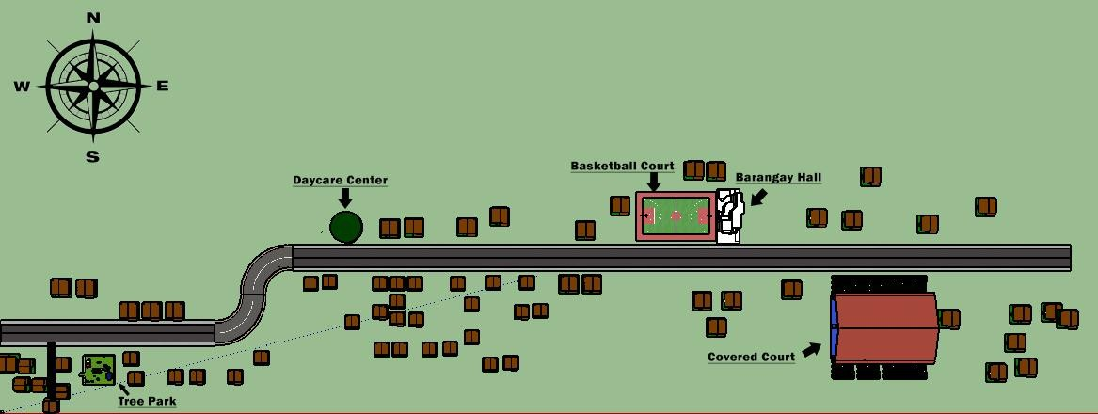

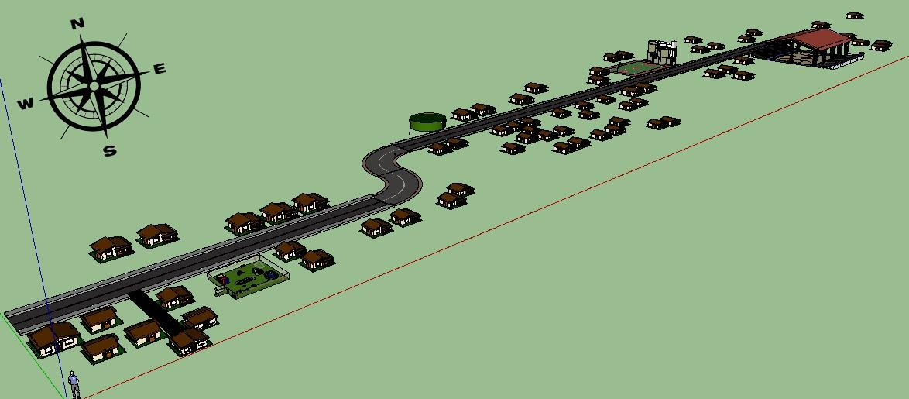

**Figure 2 Organizational Chart** Barangay Duyay-yat

SK Chairmain

Baragay Captain

BARANGAY LUPON

BARANGAY WORKERS

BARANGAY TANOD

#7 Councilor

#6 Councilor

#5 Councilor

#4 Councilor

Treasurer

Secretary

#3 Councilor

#2 Councilor

#1 Councilor

# STATEMENT OF OBJECTIVES

The project aims to design and develop a Web-Based Profiling System for Barangay Duyay-yat, Sinait, Ilocos Sur.

Specifically, it aimed to meet the following objectives:

1. Determine the process in the current system.
2. Identify the software requirements of the e-Lista: A Web-Based Resident Profiling System.
3. Develop the e-Lista: A Web-Based Resident Profiling System using the spiral model.
4. Determine the level of acceptability of e-Lista: A Web-Based Resident Profiling System using the ISO 25010 along:
   1. User Friendly,
   2. Security,
   3. Usability,
   4. Completeness and
   5. Reliability

# General Statement of the Objectives

To feed the interest and specialization, the researcher would like to provide a Barangay Profiling System of Barangay Duyay-yat to lessen the workload, reduce human errors and processing times.

# Specific Statement of the Objectives

* 1. To design, develop, and implement a profiling-based system wherein all the records of a certain resident are encoded on one system, which helped them have more time for the other waiting clients that need to be entertained upon their request.
  2. To design, develop and implement a user-friendly interface where the user won't have a problem using the system.
  3. To design, develop, and implement a 4p's sorting module, the system will choose the 4p's candidate without a problem.
  4. To design, develop and implement an admin module where it can edit out the details of a resident or a specific official.

# SIGNIFICANCE OF THE STUDY

This study will contribute a big help not just to the barangays or people residing. Society will gain from having a systematized system. A web-based system can be accessed from any location as long as they have access to the internet, a web browser, and the necessary login credentials. This means that consumers can get the info they need even when they're not at work.

It also opens the door to employees working from home. Web-based tools make it much easier to share data and collaborate on projects. Users can share data and collaborate on projects because data is stored in one central area. Web-based systems are also easier to incorporate than a standalone desktop applications. Web-based systems make providing real-time information more convenient. Online reports and digital dashboards can replace paper reports, which might take days to create and disseminate. Across a company, this can increase the quality and speed of decision-making. Computerization's evolutionary trends have achieved their pinnacles, reaching worldwide goals in all fields and industries. Web-based profiling systems are becoming more automated, leading to a fresh and novel approach to those above.

# SCOPE AND DELIMITATION

This study will limit only to the personnel who work on the barangays. And, of course, with the data privacy applied on the said system. This will only be used for the said business or filing or gathering data of every individual residing on each barangay.

This study requires a dependable web-based provider where data privacy will be applied for personal purposes. Approval for the officers elected on barangay and with the higher positions also needs the project's support. The potential weakness of this study is that many individuals do not know when it comes to systematized systems. Many will mislead or misunderstood the project due to a lack of knowledge.

# Chapter II

**REVIEW OF RELATED LITERATURE AND METHODOLOGY**

# Related Literature

Barangays, according to Nestor (2016), are the government's face on the ground. They are the pinnacle of government service and the people's first port of call.

Furthermore, according to Medel (2015), a manual information system does not rely on any computerized systems, whereas a computer-based information system does. In a manual-based system, data is recorded and stored in various formats, such as paper files. On the other hand, a computer-based information system will have data stored in multiple computer programs such as databases, Word documents, Excel, etc. This study backs up the proponents' proposed plan by utilizing database technology for Barangay Unang Sigaw's Computerized Barangay Resident Information Management with Issuance System; this will allow them to have accurate information about their residents to use in their reports for upcoming LGU meetings.

Martinez's research (2018) The Computerized Barangay Information System is designed for use by barangay employees who need access to barangay residents' profile information for direct reports. Furthermore, departmental organizational staff with a business need for this information for their business unit can also benefit. This is in charge of ensuring that barangay employees and residents have an effective and efficient approach. It will allow them to complete tasks more quickly and eliminate the need for a large staff. It will provide residents with information based on their profiles.

According to a Barangay Resident Record Management System study, the study focuses on the said Barangay's records management system. The Barangay Secretary is responsible for keeping track of records, capturing and maintaining up-to-date records of all issuance transactions daily, particularly getting cedulas, certifications, and permits. The constituents who make the request must go through a lengthy process before the task can be completed. They used folders and papers to store files, update, access data, and record expenses. In retrieving and recording files, the staff encountered difficulties and a lengthy procedure. (2015, Algara)

SMS (Short Message Services) support for the Barangay Management Information System. This allows users to search and view records while also keeping track of and updating information. It is for a Barangay's benefit, but this time the proposed system includes SMS support. To send messages to constituents, SMS Support requires a broadband connection. The SMS service is unable to ship to all of the Barangay's residents. The use of software that can provide information services for an institution is how computer-based information retrieval works. (2015, Kazuya)

This system makes barangay management more accessible by allowing the client barangay to keep their resident records as up-to-date and easily accessible as possible for verification, monitoring, and reference. It consists of an Automatic Business Process that facilitates Barangay Clearances and other sources of Barangay revenue, such as charges. Other Barangay-related functions, such as blotter reports and other services, are also available. Barangay Permits and Certifications are prepared and printed using forms and reports. Standard-based complies with Section 394 of the Local Government Code, which mandates that each barangay keep an up-to-date record of residents for easy identification and reference on the Local Barangay Statistics. (Mirasol, 2015)

This research aims to keep a complete and up-to-date database that is easily accessible for verification, monitoring, and reference. They can also automate the record-keeping process to produce efficient and accurate reports and proper automated file management. The system ensures that the file is secure and protected, and it also requires authorization before anyone can use it. This ensures that the file is securely stored in the system and that the file's data is backed up in the event of a technical failure. It can also generate a report for the municipality on the Barangay's status. Residents of the Barangay and Barangay employees who manage the system and the Barangay itself will be impacted significantly by the proposal. The goal of their implementation is to change the way the Barangay keeps its files. This will also ensure that all records are complete and up to date. (Lado, Maloloy-on, Perez, Rizaldo, Tacocong, 2017)

According to TalentMagnifier (2017), management information systems are critical for making decisions in both professional and personal life. Organizational decision-making is essential to its success. There is fierce competition today, so making effective decisions is critical. To beat the competition, managers need accurate information. Information flows more freely with the help of MIS. At all levels of the organization, MIS is used. Data is collected, information is processed, and MIS applications control information. MIS is required for the functioning, performance, and support roles.

According to Bert Markgraf (2019), you must use all of your company's information system's capabilities to get the most out of it. Information systems are essential because they process data from company inputs to produce information that can be used to manage your operations. You can either add more data to make the information more accurate or use the information in new ways to improve the effectiveness of the information system.

This is referred to as an information audit by Henczel (n.d.). It focuses on the information sources, resources, display, and how the information contributes to the objectives of an organization such as a barangay. This study is a solution to the problems mentioned and an attempt to improve the quality of service provided by a barangay office to its clients. Furthermore, this serves as a wake-up call for all government offices, from the highest to the lowest levels, to align their views on globalization and competitiveness in today's information age with the government's.

# Operational Definition of Terms

To better understand the terms used in the study, the following terms result from this definition.

**Automation is the process or technique of a system wherein everything will be automatically** uploaded to a plan. This automation will help the study to be more automated with all the files needed for uploading on the said system

**Data Privacy** - concerned with the proper handling of data consent, notice, and regulatory obligations. Data privacy is what the study needs for the system to be more trustworthy of a system.

**Dependable Web-Based Provider –** a web-based reliable provider is one of the critical tools for this study to apply.

**Modernization –** it is the process of making everything into a well modern high tech reliable one. This will help the barangay offices to have the modernization they need when it comes to profiling.

**New Innovative Way– a** new way of idea or method. This will also help the modernization of the study in an innovative way.

**Systematized System -** to arrange by a definite plan or schema. This will help all the files be arranged systematically for a Better Way of finding one's information.

# Methodology

In software development, the methodology is critical. It contains project guidelines and suggestions. Thinking and deciding what goes for a specific problem is tedious for the programmer and system analyst. In terms of methodology, the proponent will be able to identify and make explicit the procedures. (TUTO2020)

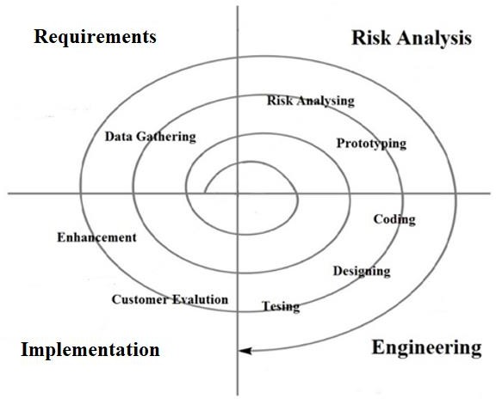

**Figure 3** Spiral Model

The spiral model is a methodology that incorporates prototyping into the waterfall model. The spiral model leads the team through the adoption of one or more processes. Planning, Risk-Analysis, Engineering, and Evaluation are the four phases of this model. Each step can have multiple sub-phases that the developers can work through. The creators

I chose the Iterative Spiral Model because of the high amount of risk analysis; hence avoidance of risks is enhanced.

**Requirements Phase**

This is where the software's requirements are gathered and analyzed. Iteration should eventually lead to the requirements phase, which produces a complete and final requirement specification. In this phase, the developers compared the benefits and drawbacks of a web-based barangay system to a manual one. The developers were in charge of the system's initial planning and conceptualization.

**Analysis Phase**

During this phase, risk analysis must identify, estimate, and monitor the potential technical feasibility and management risks. In our case, the developers are responsible for the system's security. During the process of developing design specifications, we asked a series of questions to assess the safety of our system.

**Engineering Phase**

In our case, the developers created a new design that is simple yet effective for users, allowing them to operate the system efficiently. The developers' goal in this phase is to understand the target audience better, receive feedback on a recent event, product, or service, and build positive relationships.

**Implementation**

When the software has been developed, tested, and integrated. During this phase, the developers used sublime and XAMPP to build the system. To move the solution from development to production, the developer ran a test to see if the automated system had developed or acquired the subscriber's needs and was ready for implementation.

**Testing Procedure**

Because the proponents were able to identify the system's errors, they discussed the testing that the system undergoes. The supporters concluded that the system needed to be improved even more to meet the needs of the target audience. The proponents understood which modules need to be enhanced or remodeled and how they will improve the system. It is critical to conduct continuous testing of the system to identify problems that users will face and enhance the system based on the comments and suggestions of users during the testing process, as well as to meet the requirements to satisfy the users' needs and target audiences.

**Evaluation**

The proponents created the proposed system after extensive research and testing. I'm looking into how to set up a plan for sending survey responses. A system that will ensure the security of user records. The proponents analyzed the system's problems and brainstormed ways to solve them with the help of each other.

# Chapter III RESULT AND DISCUSSION

**Problems Met in the Current System**

The proponents gathered some data regarding the existing system or any related system that the proponents wish to develop. Many researchers and programmers already developed many barangay systems. That is why the proponents want to improve those systems by implementing a 4p monitoring wherein it will allow the barangay officials and residents easy access to 4p's candidates. The proponents gathered some data to have more knowledge about the 4p's candidates. The proponents want to develop and implement this feature because it could help the barangay because some barangay and residents are having difficulty knowing if they are 4p's candidates. Also, this system will help them in the filings about the information about the 4p's candidates and information about the residents of the barangay.

# Functional and Non-functional Requirements of the Developed System

Based on the analysis of the problems encountered in the developed system, the following system requirements, broken down into functional and non-functional requirements, were formulated.

The functional and non-functional requirements of the proposed system are presented in the tables below.

# Table 1

**Functional Requirements of the Developed System for the Barangay Officials**

|  |  |  |
| --- | --- | --- |
| **Barangay Official** | | |
| **Functional Requirement** | **Description** | **Scenario** |
| Register Account or Login | The barangay official can only be registered by the  admin of the system. | The form cannot be accepted if the condition is  incomplete. |
| Manage Account | The admin is the only one who can access the information and manage the accounts of the  barangay official | The system will allow the admin to edit and view the profile of the registered users |
| Manage Residents | The admin can register the residents and create  account for them | The system will allow the admin to add and edit a  a resident of the barangay |
| Manage 4ps | The admin can manage the 4ps candidate's application  forms | The system will allow the admin if the application  forms are approved or not |

**Table 2**

**Functional Requirements of the Developed System for the Residents**

|  |  |  |
| --- | --- | --- |
| **Residents** | | |
| **Functional Requirement** | **Description** | **Scenario** |
| Register Account or Login | The residents need to contact an admin to have themselves register an account. | The form cannot be accepted if the condition is incomplete and not authorized by the admin. |
| Manage Account | The user can check and update the account. | The system will allow the user to view the profile. |
| 4ps Application | The user can fill up the  application form intended for the user | The state cannot be  accepted if the condition is incomplete. |

**Table 3**

**Non - Functional Requirements of the Developed System**

|  |  |
| --- | --- |
| **Non – Functional Requirement** | **Description** |
| Account Security | Accounts are secured from unauthorized  used and exploitation. |
| Reliability | The system is reliable as long as there is  an internet connection. |
| Functional Suitability | The system should provide functions that  meet stated and implied needs when used. |
| Usability | The user interface is well organized,  presentable and easy to use. |
| Compatibility | The system can exchange information and  perform its required functions. |
| Internet Connection | The system requires a stable internet  connection |
| PHP and MySQL support | The server should have supports to PHP  and MySQL |

**The Developed e-Lista: A Web-Based Resident Profiling System**

The developed web-based resident profiling system was modeled using different software modeling tools. The researchers used the Use Case Diagram, illustrated in Figure 4, to model the designed applications.

# Figure 4

# Use Case Diagram

Registration

Login

**Brgy. Officer**

View Profile

Update's

**Client**

Maintainance

# Figure 5

**Use Case Activity Diagram for Login**

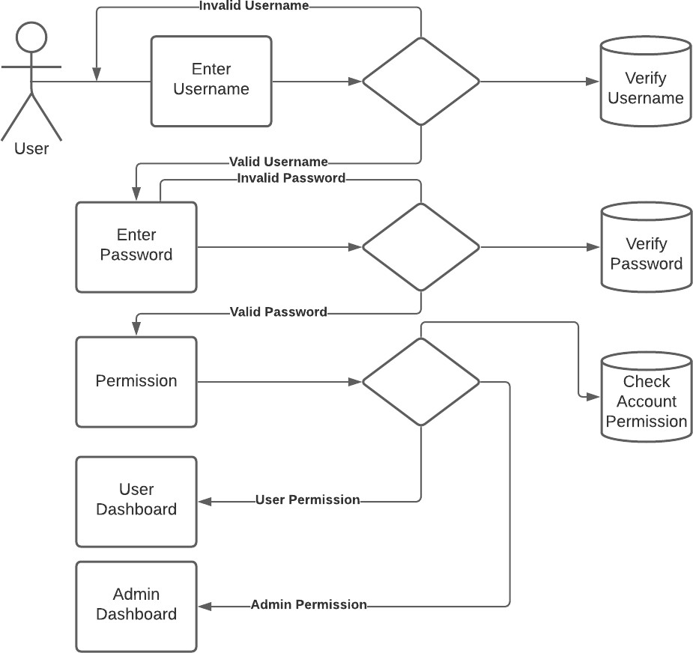

**Figure 6**

**Use Case Activity Diagram for User Registration**

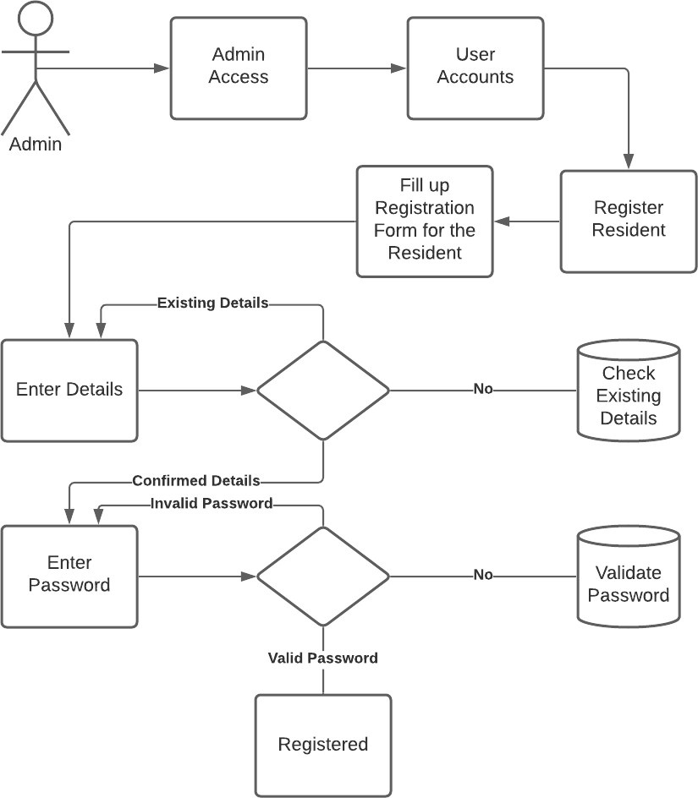

**Figure 7**

**Use Case Activity Diagram for Admin Registration**

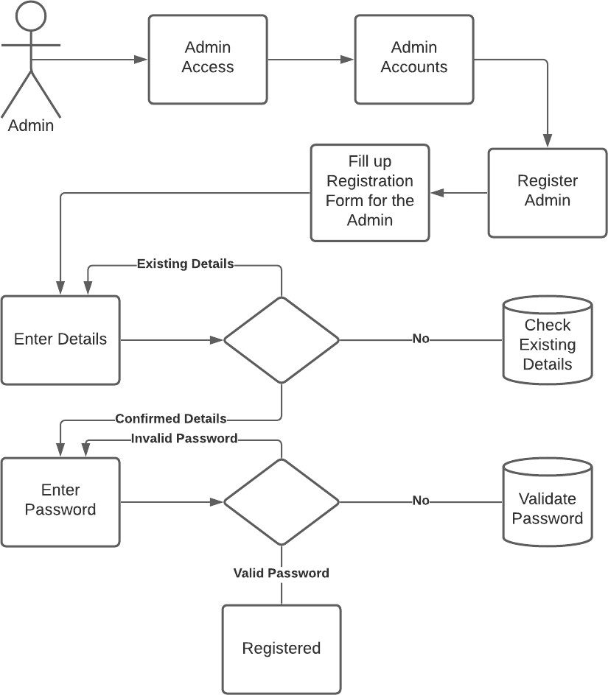

**Figure 8**

**Use Case Activity Diagram for Updating Profile**

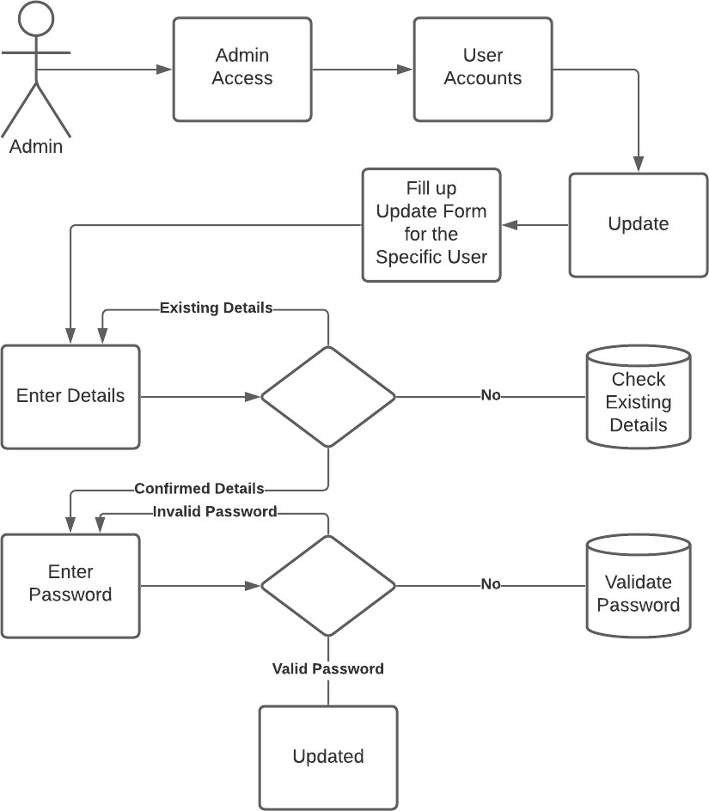

**Figure 9**

**Use Case Activity Diagram for Viewing**

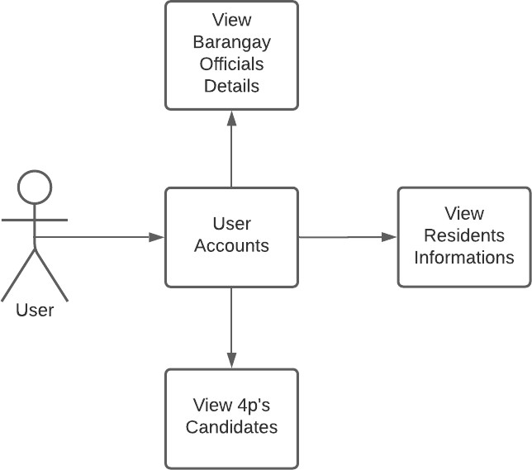

User's ID password

User’s ID password

Change Password

Logout

Profile Account

User Access

Registration’s Office

Admin, Barangay Official, Residents

|  |
| --- |
| 1.1 |
| Login |

# Figure 10 Data Flow Diagram

Users

# Data Dictionary

|  |  |
| --- | --- |
| **A** |  |
| Address | {legal characters} + {legal numbers} |
| Age | {2} |
| **C** |  |
| Contact | {0900 -000-0000} |
| **E** |  |
| Email | {valid email} |
| **F** |  |
| First name | {legal characters} |
| **G** |  |
| Gender | {Male/Female} |
| **L** |  |
| Last name | {legal characters} |
| Log type | {Barangay Officials/Residents} |
| **M** |  |
| Middle name | {legal characters} |
| **P** |  |
| Password | {legal characters} + {legal numbers} |
| Position | {Resident/Barangay Captain/Secretary/Treasurer/Kagawad-1/ Kagawad-2/ Kagawad-3/ Kagawad-4/ Kagawad-5/ Kagawad-6/ Kagawad-7} |
| **S** |  |
| Status | {Active/Inactive} |
| **U** |  |
| UID | {legal numbers} |
| **#** |  |
| 4ps | {Candidate/Not Candidate} |
| **Legend:** |  |
| {} – repetition of characters or numbers | |
| [] – choice inclusive in the data range | |

+ - serves as a separator

# Data Structure with Sample Records

**Table 4**

**Data Structure of usertbl**

|  |  |  |
| --- | --- | --- |
| **Field Name** | **Data Type** | **Field Size** |
| UID | int | 11 |
| Fname | varchar | 255 |
| Mname | varchar | 255 |
| Lname | varchar | 255 |
| Address | varchar | 255 |
| Contact | varchar | 255 |
| Age | varchar | 255 |
| Gender | varchar | 255 |
| Position | varchar | 255 |
| Email | varchar | 255 |
| Password | varchar | 255 |
| Logtype | tinyint | 4 |
| Status | tinyint | 4 |
| 4ps | tinyint | 4 |
| application | varbinary | 1024 |

**Table 6**

**Sample Records of usertbl**

|  |  |  |  |
| --- | --- | --- | --- |
| **UID** | 1004 | 1007 | 1006 |
| **Fname** | Km | Daphne | Joshua |
| **Mname** | Impelido | Lou | Allen |
| **Lname** | Caguntas | Agcalis | Ligon |
| **Address** | Ilocos Sur | New York City | New York City |
| **Contact** | 0900-000-000 | 0900-000-000 | 0900-000-000 |
| **Age** | 22 | 21 | 21 |
| **Gender** | Female | Female | Male |
| **Position** | Secretary | Resident | Kagawad-4 |
| **Email** | [Km@gmail.com](mailto:Km@gmail.com) | [Daph@gmail.com](mailto:Daph@gmail.com) | [Joshua@gmail.com](mailto:Joshua@gmail.com) |
| **Password** | Caguntas123456789 | Daph123456789 | Joshua123456789 |
| **Logtype** | 0 | 1 | 1 |
| **Status** | 1 | 1 | 1 |
| **4ps** | 1 | 0 | 0 |
| **application** | e-Lista.pdf | null | null |

**Figure 12**

# Input Process Output (IPO)

**INPUT PROCESS OUTPUT**

1. **RESIDENT INFORMATION**
   1. **Add Supplier Information**

Resident Information

Add Resident Information

New Resident Information

* 1. **Edit Supplier Information**

Id Lastname Firstname

Update Resident Information

Updated Resident Information

* 1. **Archive Supplier Information**

Id Lastname Firstname

Archive Resident Information

Archived Resident Information

# INPUT PROCESS OUTPUT

1. **BARANGAY OFFICIAL INFORMATION**
   1. **Add Farmer Information**

**2**B**.** arangay Official Information

Add Barangay Official Information

New Barangay Official

Information

* 1. **Edit Farmer Information**

Id Lastname Firstname

Update Barangay Official Information

Updated Barangay Official Information

* 1. **Archive Farmer Information**

Id Lastname Firstname

Archive Barangay Official Information

Archived Barangay Official Information

# Figure 13 Hierarchical Input-Process-Output

**(Barangay Official)**

Files/ Records

User Account

Profile

Update Profile

Update Records

Updates

Inquire

e-Lista

Web-based Resident Profiling System

4p’s data

The administrator needs to log in first to access the system. The administrator is only allowed to approve or decline the 4p's application form. And also, the admin can register residents accounts and additional admin accounts or barangay officials.

# Figure 14 Hierarchical Input-Process-Output

**(Residents)**

Inquire

Profile

e-Lista

Web-based Resident Profiling System

User Account

4p’s Applicatio n

The Residents will log in first to access the system. The Residents are only allowed to view the barangay official and residents in the system. And also, the residents can answer the application form intended.