FINAL PROJECT DOCUMENTATION
CASA VISTA
Resort Management System

Group Number  SWU-007 | Group Members  Abarquez, Divinangelo C.  Astrologo, Russell John M.  Cabilao, John Michael L. | Date  October 2026

Table of Contents
Project Summary 2
System Use Cases 4
CVRMS-01 Book Room or Exclusive Resort Reservation 4
CVRMS-02 Reserve Sports Court & Gear Rental 6
CVRMS-03 Process Cashless Payment via Maya API 8
Entity-Relationship Diagram 11
Relational Schema 13
Normalization Proof 17
Unnormalized Form (UNF) 17
First Normal Form (1NF) 19
Second Normal Form (2NF) 23
Third Normal Form (3NF) 27
System Architecture and Technology Stack 32
GitHub Repository 34
Deployed API 35

SECTION 01

Project Summary
What the system is, the problem it solves, and who it is for.

Overview
Casa Vista Resort Management System (CVRMS) is an integrated mobile and cloud reservation platform built for Casa Vista Resort in Bay-ang, Babag, Cebu City. It centralizes room reservations, sports court rentals, on-site cashier sales, and customer payment records into one shared system. Guests use the system to check availability and book stays or court time, while resort staff and management use it to run front-desk check-ins, record sales, and track property revenue.

Problem Statement
Casa Vista Resort is a brand-new business preparing to open its doors with zero digital infrastructure in place. Currently, the management has to handle all early inquiries, availability questions, and reservations manually through direct phone calls, personal chat messages, and paper notebooks. Opening the property under manual workflow creates serious operational risks including booking collisions, payment vulnerabilities, missed on-site charges, and manual tracking of sales.

Purpose and Objectives
The primary purpose of CVRMS is to provide Casa Vista Resort with an automated reservation, court scheduling, and cashier platform before launch, ensuring organized operations, zero double-bookings and accurate financial tracking from day one.
1. To hold a selected room or sports court slot for 15 minutes while the customer completes payment, preventing anyone else from taking the same slot.
2. To calculate court rental fees automatically, switching between daytime and nighttime rates and adding gear rental charges.
3. To check customer GCash and Maya transaction reference numbers against database records so that duplicate payment records are rejected.
4. To let staff update room availability flags (Available, Cleaning, Maintenance) so the booking schedule stays accurate during daily turnovers.
5. To generate automated daily, weekly, and monthly revenue summaries for owner auditing without manual paperwork.

Target Users
User | Description | What They Do in the System
Guest / Customer | Prospective travelers, local pickleball players, and event organizers planning visits to the resort. | Checks real-time room and court availability, books lodging or court hours, selects paddle rentals, enters e-wallet payment reference numbers, and tracks their booking history.
Resort Staff | On-site resort employees assigned to handle reception, guest check-ins, and counter sales. | Welcomes arriving guests, confirms check-ins and check-outs, flags room being cleaned or repaired, rings up walk-in court sessions and issues final bills.
Super Admin / Owner (Dr. Lemyel Yap) | The resort owner who oversees operations, staff tasks, and business revenue. | Sets base room and court rental rates, manages staff accounts, tracks property occupancy, and reviews revenue and profit-and-loss reports.

Scope and Limitations
Scope | - Advance booking for 3 guest rooms (Standard Rooms at ₱ 2,500/day; Deluxe Family Suite at ₱ 3,500/day) and exclusive full-resort buyouts (₱ 12,000/day).  - Hourly reservation for 3 pickleball courts (₱ 400/hr daytime, ₱ 600/hr nighttime) and 1 basketball court (₱ 500/hr daytime, ₱ 750/hr nighttime) with an automatic 6:00 PM rate switch.  - Paddle rental tracking (₱ 100/paddle)  - Automated 15-minute reservation hold window and enforcement of the 24-hour cancellation cutoff.  - E-wallet transaction reference logging (GCash/Maya) with duplicate-entry prevention.  - Automated online cashless processing via Maya Checkout API (Sandbox Environment), featuring instant automated reservation confirmation upon successful authorization. Manual cashier auditing is reserved strictly for on-site cash and walk-in counter.  - Room status management (Available, Cleaning, Maintenance) and administrative revenue report generation.
Limitations | - No direct automated bank integration.  - No physical hardware automation (the system does not control resort amenities, smart door locks or electrical light switches).  - No native iOS application; the guest mobile app runs natively on Android, while non-Android guests book through a web browser.  - Requires an active internet connection; it does not support offline multi-device database syncing.
SECTION 02

System Use Cases
What the system does, described from the user’s point of view.

CVRMS-01 Book Room or Exclusive Resort Reservation

Use Case Description
Use Case ID | CVRMS-01
Use Case Name | Book Room or Exclusive Resort Reservation
Primary Actor | Customer
Secondary Actor(s) | Maya Payment Gateway
Description | Allows a customer to reserve 1 to 2 standard rooms, a deluxe room, or the entire resort (Exclusive Whole-Resort buyout) for specified dates, calculates total charges, creates a temporary 15-minute inventory hold, and initiates payment settlement.
Trigger | Customer selects accommodation dates on the resort booking page.
Preconditions | - The accommodation units exist in the system and are physically operational (Status != ‘Maintenance’ / ‘Cleaning’).  - The customer is authenticated and logged into an active account.
Postconditions | - A new Booking record is created with Status = ‘Pending’, staff_id = NULL, and the calculated total stored in total_amount.  - Selected rooms (or all rooms if Exclusive) are locked under a 15-minute temporary hold (Hold_expires_at).
Basic Flow | - The customer selects the check-in date, check-out date, and total number of guests.  - The customer chooses the booking category; Standard Room(s), Deluxe Room, or Exclusive Whole-Resort Buyout.  - The system checks booking date ranges to confirm that the selected units are not reserved or held by another guest (includes Validate Schedule Availability).  - For Standard rooms, the customer selects between 1 or 2 available rooms (up to 4 guests per room at ₱2,500/day); for Deluxe, 1 room (up to 6 guests at ₱3,500/day); for Exclusive, the entire property is selected (₱12,000/day).  - The system automatically retrieves the authenticated customer’s profile (customer_id, first_name, last_name, phone, email) to bind the reservation.  - The system calculates the reservation total, creates a pending booking record with staff_id = NULL, freezes the computed cost into Booking.total_amount, and sets a 15-minute hold timestamp (Hold_expires_at).  - The system redirects the customer to complete payment (includes Process Cashless Payment via Maya API).  - The system updates Booking.Status to ‘Confirmed’ and displays the booking summary with a confirmation reference.
Alternative Flow | 4a. If the customer chooses an Exclusive Whole-Resort reservation, the system sets Booking.Exclusive = TRUE, validates that no rooms are booked for those dates, and places an inventory block on all resort rooms for the selected date range.
Exception Flow | 3a. If Conflicting Booking or Active Hold:  - If any selected room is already booked or currently locked under an active 15-minute hold, the system notifies the customer, displays blocked dates on the calendar, and prompts them to pick alternate dates.  8a. Hold Expiration (Payment Timeout):  - If payment is not completed within 15 minutes, the system automatically sets Booking.status = ‘Cancelled’ and releases the room inventory back to the public pool.
Include / Extend | «include» Validate Schedule Availability  «include» Process Cashless Payment via Maya API

Use Case Diagram
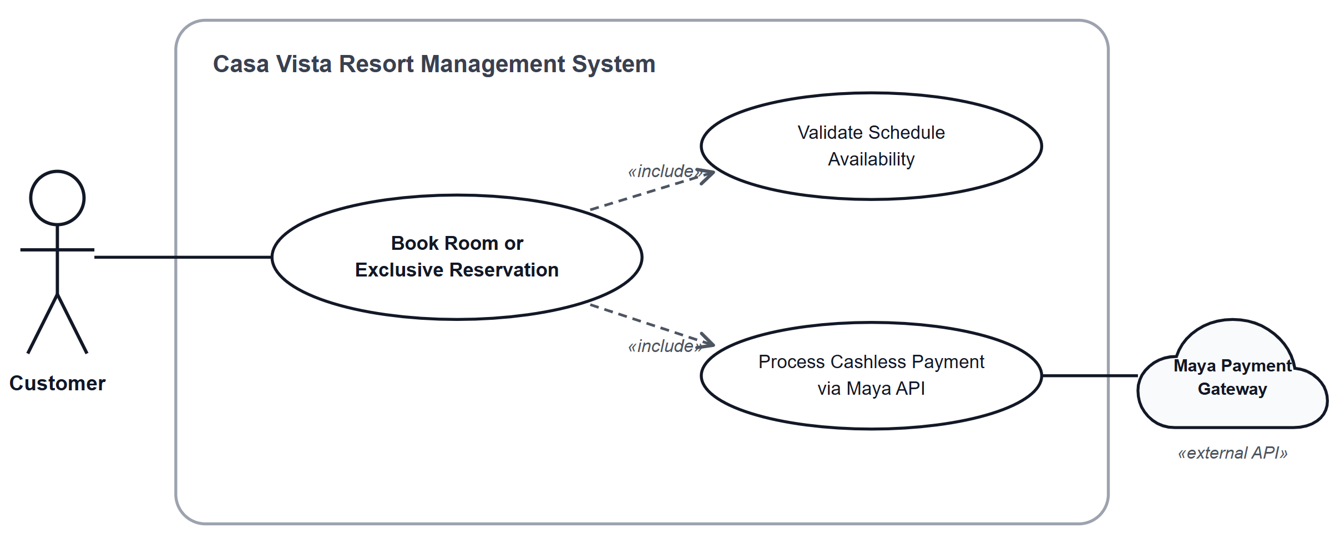
Figure 1. Book Room or Exclusive Reservation use case diagram

CVRMS-02 Reserve Sports Court & Gear Rental

Use Case Description
Use Case ID | CVRMS-02
Use Case Name | Reserve Sports Court & Gear Rental
Primary Actor | Customer
Secondary Actor(s) | Maya Payment Gateway
Description | Allows a customer to reserve an hourly time slot for a Pickleball court or the Basketball Court, request optional pickleball paddle rentals, compute charges across daytime and nighttime rate brackets, place a 15-minute hold, and settle payment.
Trigger | Customer clicks “Reserve Court” on the app.
Preconditions | 1. Sports courts exist with configured daytime and nighttime rates.  2. The customer is authenticated and logged into an active account.
Postconditions | 1. A new Booking record is created with court_id populated, staff_id = NULL, and total_amount calculated and stored.  2. The chosen court slot is locked under a 15-minute hold (Hold_expires_at).
Basic Flow | 1. The customer selects the court facility (Pickleball Court 1, 2, 3 or Basketball Court), reservation date, and time slot (Start Time to End Time).  2. The system queries confirmed and pending court reservations to verify that the time window is open (includes Validate Schedule Availability).  3. If Pickleball is selected, the customer specifies the quantity of paddle rentals; if Basketball is selected, paddle rental is locked to 0.  4. The system calculates the total cost using the 18:00 (6:00 PM) day/night cutoff: Pickleball at ₱400 daytime / ₱600 nighttime; Basketball at ₱500 daytime / ₱750 nighttime; plus paddle rentals at ₱100 per paddle.  5. The system retrieves the authenticated customer’s profile details (customer_id, first_name, last_name, phone, email) to associate with the court booking.  6. The system creates a booking record with court_id, staff_id = NULL, freezes the calculated fee in Booking.total_amount, and sets a 15-minute hold window (Hold_expires_at).  7. The system redirects the customer to complete payment (includes Process Cashless Payment via Maya API).  8. The system updates Booking.status to ‘Confirmed’ and displays the reservation confirmation.
Alternative Flow | 3a. Customer Brings Own Equipment:  If the customer selects 0 paddles for a Pickleball reservation, the system bypasses paddle charges and bills only the court rental fee.
Exception Flow | 2a. Time Slot Unavailable:  If the selected court time slot overlaps an existing booking or active hold, the system notifies the customer and highlights open hours or other pickleball courts.  7a. Hold Window Expires:  If payment is not completed before Hold_expires_at is reached, the system cancels the booking and opens the time slot to other users.
Include / Extend | «include» Validate Schedule Availability  «include» Process Cashless Payment via Maya API

Use Case Diagram
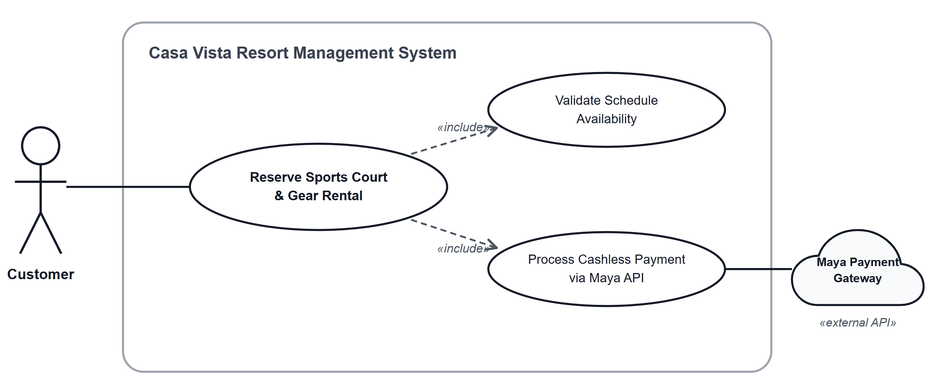
Figure 2. Reserve Sports Court & Gear Rental use case diagram

CVRMS-03 Process Cashless Payment via Maya API

Use Case Description
Use Case ID | CVRMS-03
Use Case Name | Process Cashless Payment via Maya API
Primary Actor | Customer
Secondary Actor(s) | Maya Payment Gateway
Description | Processes online payments for pending reservations using Maya API sandbox simulation, writes audit logs to the payment ledger, confirms the booking, and handles cancellation refunds according to the 24-hour policy.
Trigger | The system initiates checkout from an active booking hold, OR a customer submits a reservation cancellation request.
Preconditions | 1. A booking record exists with Status = ‘Pending’ and an active hold window (Hold_expires_at > current time).  2. Maya Payment Gateway API sandbox service is reachable.
Postconditions | 1. A new record is inserted into Payment with positive Amount, Method = ‘Maya’, and payment_type set to ‘Payment’ (or ‘Refund’).  2. Booking.status transitions to ‘Confirmed’ upon successful payment, or to ‘Cancelled’ upon approved refund.
Basic Flow | 1. The system retrieves the pending booking_id and the stored Booking.total_amount.  2. The customer selects Maya as the payment channel and submits payment credentials through the Maya checkout interface.  3. Maya API processes the transaction and returns a success response with a transaction reference ID.  4. The system inserts a new Payment record with positive Amount, Method = ‘Maya’, payment_type = ‘Payment’, and Paid_at timestamp.  5. The system updates Booking.status from ‘Pending’ to ‘Confirmed’.  6. The system displays a payment confirmation receipt with the transaction ID.
Alternative Flow | 1a. Cancellation Outside 24-Hour Window (Refund Approved):  If a customer cancels more than 24 hours prior to check-in/start time, the system invokes the refund process (extends Process Cancellation Refund).  1b. Processing Refund via Maya:  The system initiates a refund via Maya API, records a new entry in Payment with a positive Amount matching the refund, sets payment_type = ‘Refund’, and updates Booking.status to ‘Cancelled’.
Exception Flow | 3a. Maya Transaction Declined or Timed Out:  If Maya returns an authorization error or the payment times out, the system alerts the customer and allows them to reattempt payment as long as the 15-minute hold has not expired.  1c. Cancellation Within 24-Hour Window (Non-Refundable):  If a customer cancels less than 24 hours before check-in/start time, the system sets Booking.status = ‘Cancelled’ without issuing a refund, strictly enforcing resort policy.
Include / Extend | «extend» Process Cancellation Refund

Use Case Diagram
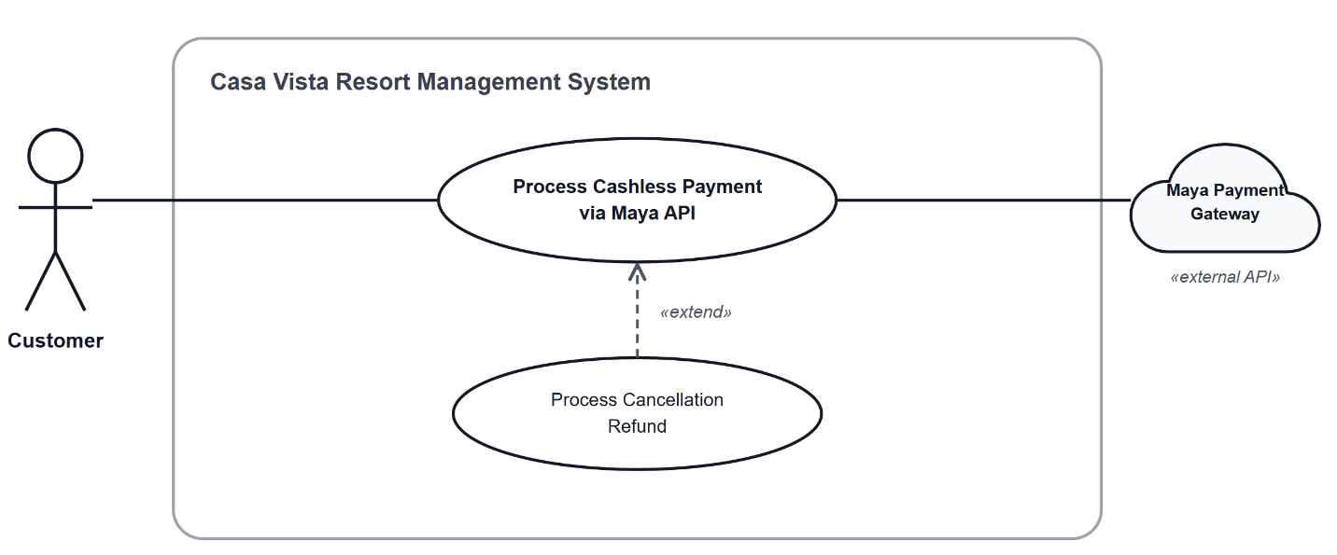
Figure 3. Process Cashless Payment via Maya API use case diagram
SECTION 03

Entity-Relationship Diagram
The entities, their attributes, and how they relate.
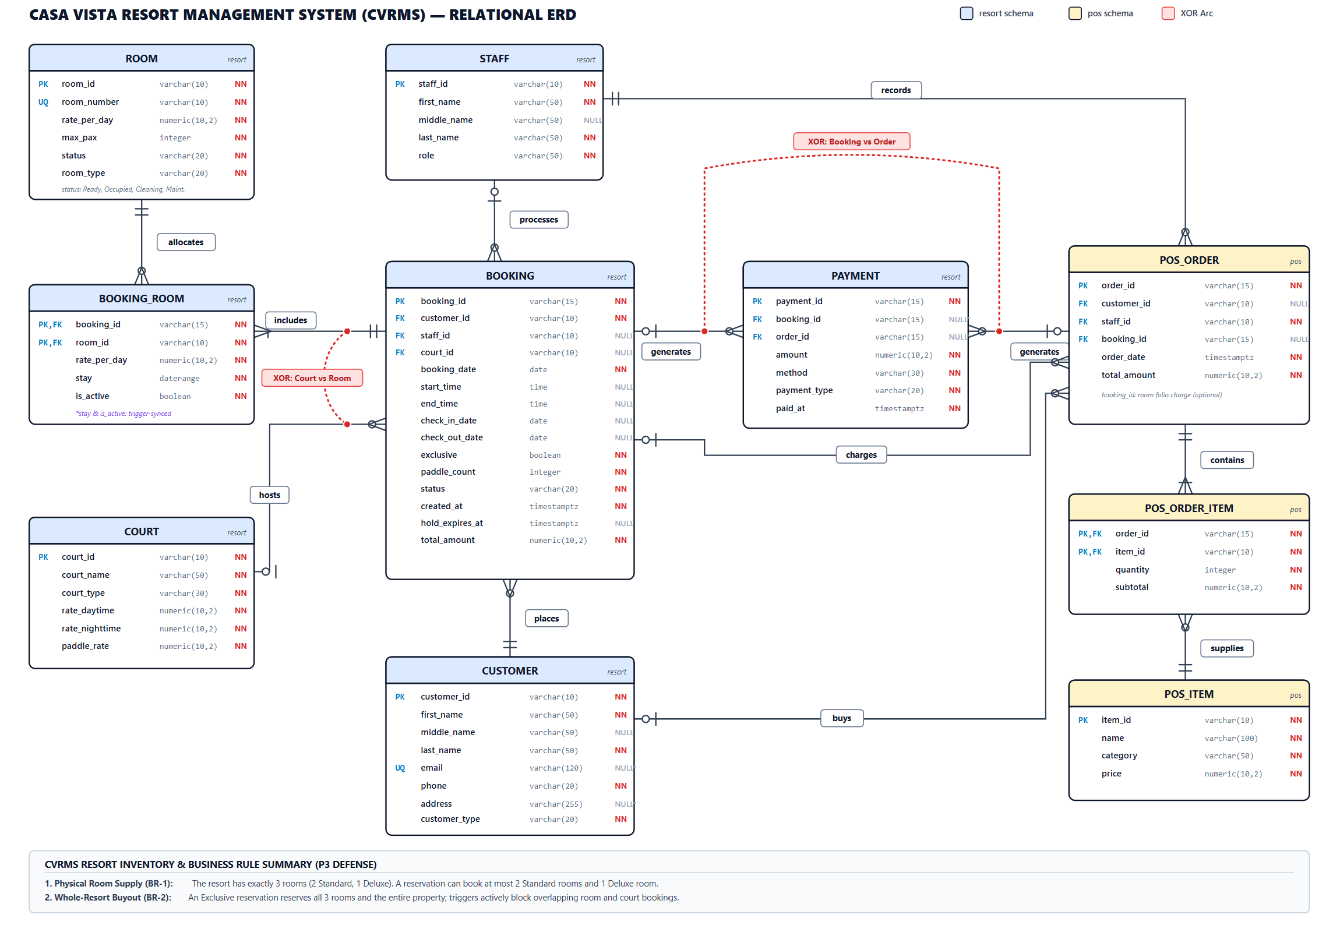
Figure 4. Entity-Relationship Diagram of Casa Vista Resort Management System

Relationship Summary
Entity | Relationship | Related Entity | Cardinality | Business Rule
CUSTOMER | places | BOOKING | 1 : N | A customer places zero or more bookings; each booking belongs to exactly one customer.
STAFF | processes | BOOKING | 1 : N | A staff member processes zero or more bookings; each booking is processed by zero or one staff member.
BOOKING | includes | BOOKING_ROOM | 1 : N | A booking includes one or more booking rooms; each booking room belongs to exactly one booking.
ROOM | allocates | BOOKING_ROOM | 1 : N | A room allocates zero or more booking rooms; each booking room refers to exactly one room.
COURT | hosts | BOOKING | 1 : N | A court hosts zero or more bookings; each court booking refers to zero or one court.
BOOKING | generates | PAYMENT | 1 : N | A booking generates zero or more payments; each booking payment settles exactly one booking.
STAFF | records | POS_ORDER | 1 : N | A staff member records zero or more POS orders; each POS order is recorded by exactly one staff member.
POS_ORDER | generates | PAYMENT | 1 : N | A POS order generates zero or more payments; each order payment settles exactly one POS order.
BOOKING | charges | POS_ORDER | 1 : N | A booking charges zero or more POS orders via folio billing; each POS order links to zero or one booking.
CUSTOMER | buys | POS_ORDER | 1 : N | A customer buys zero or more POS orders; each POS order links to zero or one customer.
POS_ORDER | contains | POS_ORDER_ITEM | 1 : N | A POS order contains one or more order items; each order item belongs to exactly one POS order.
POS_ITEM | supplies | POS_ORDER_ITEM | 1 : N | A POS item supplies zero or more order items; each order item refers to exactly one POS item.
SECTION 04

Relational Schema
The tables, keys, and data types of the database.

Schema Notation
Legend primary_key = Primary Key foreign_key* = Foreign Key

CUSTOMER (customer_id, first_name, middle_name, last_name, email, phone, address, customer_type)

STAFF (staff_id, first_name, middle_name, last_name, role)

ROOM (room_id, room_number, rate_per_day, max_pax, status, room_type)

COURT (court_id, court_name, court_type, rate_daytime, rate_nighttime, paddle_rate)

BOOKING (booking_id, customer_id*, staff_id*, court_id*, booking_date, start_time, end_time, check_in_date, check_out_date, exclusive, paddle_count, status, created_at, hold_expires_at, total_amount)

BOOKING_ROOM (booking_id*, room_id*, rate_per_day, stay, is_active)

PAYMENT (payment_id, booking_id*, order_id*, amount, method, payment_type, paid_at)

POS_ITEM (item_id, name, category, price)

POS_ORDER (order_id, customer_id*, staff_id*, booking_id*, order_date, total_amount)

POS_ORDER_ITEM (order_id*, item_id*, quantity, subtotal)

Data Dictionary
CUSTOMER
Attribute | Data Type | Key | Constraints
customer_id | VARCHAR(10) | PK | DEFAULT 'CUST-' || seq
first_name | VARCHAR(50) |  | NOT NULL
middle_name | VARCHAR(50) |  | NULL
last_name | VARCHAR(50) |  | NOT NULL
email | VARCHAR(120) |  | NULL, UNIQUE (NOT NULL if Registered)
phone | VARCHAR(20) |  | NOT NULL
address | VARCHAR(255) |  | NULL (NOT NULL if Registered)
customer_type | VARCHAR(20) |  | NOT NULL, DEFAULT 'Registered', CHECK ('Registered', 'Walk-In')
STAFF
Attribute | Data Type | Key | Constraints
staff_id | VARCHAR(10) | PK | NOT NULL
first_name | VARCHAR(50) |  | NOT NULL
middle_name | VARCHAR(50) |  | NULL
last_name | VARCHAR(50) |  | NOT NULL
role | VARCHAR(50) |  | NOT NULL, CHECK ('Front Desk', 'Cashier', 'Manager', 'Admin')
ROOM
Attribute | Data Type | Key | Constraints
room_id | VARCHAR(10) | PK | NOT NULL
room_number | VARCHAR(10) |  | NOT NULL, UNIQUE
rate_per_day | NUMERIC(10,2) |  | NOT NULL, CHECK (rate_per_day >= 0)
max_pax | INTEGER |  | NOT NULL, CHECK (max_pax > 0)
status | VARCHAR(20) |  | NOT NULL, CHECK ('Ready', 'Occupied', 'Cleaning', 'Maintenance')
room_type | VARCHAR(20) |  | NOT NULL, DEFAULT 'Standard', CHECK ('Standard', 'Deluxe')
COURT
Attribute | Data Type | Key | Constraints
court_id | VARCHAR(10) | PK | NOT NULL
court_name | VARCHAR(50) |  | NOT NULL
court_type | VARCHAR(30) |  | NOT NULL, CHECK ('Pickleball', 'Basketball')
rate_daytime | NUMERIC(10,2) |  | NOT NULL, CHECK (rate_daytime >= 0)
rate_nighttime | NUMERIC(10,2) |  | NOT NULL, CHECK (rate_nighttime >= 0)
paddle_rate | NUMERIC(10,2) |  | NOT NULL, CHECK (paddle_rate >= 0)
BOOKING
Attribute | Data Type | Key | Constraints
booking_id | VARCHAR(15) | PK | NOT NULL
customer_id | VARCHAR(10) | FK | NOT NULL
staff_id | VARCHAR(10) | FK | NULL
court_id | VARCHAR(10) | FK | NULL
booking_date | DATE |  | NOT NULL, DEFAULT CURRENT_DATE
start_time | TIME |  | NULL
end_time | TIME |  | NULL, CHECK (end_time > start_time)
check_in_date | DATE |  | NULL
check_out_date | DATE |  | NULL, CHECK (check_out_date > check_in_date)
exclusive | BOOLEAN |  | NOT NULL, DEFAULT FALSE
paddle_count | INTEGER |  | NOT NULL, DEFAULT 0, CHECK (paddle_count >= 0)
status | VARCHAR(20) |  | NOT NULL, DEFAULT 'Pending', CHECK ('Pending', 'Confirmed', 'Checked-In', 'Completed', 'Cancelled')
created_at | TIMESTAMPTZ |  | NOT NULL, DEFAULT CURRENT_TIMESTAMP
hold_expires_at | TIMESTAMPTZ |  | NULL
total_amount | NUMERIC(10,2) |  | NOT NULL, DEFAULT 0.00, CHECK (total_amount >= 0)
BOOKING_ROOM
Attribute | Data Type | Key | Constraints
booking_id | VARCHAR(15) | PK, FK | NOT NULL
room_id | VARCHAR(10) | PK, FK | NOT NULL
rate_per_day | NUMERIC(10,2) |  | NOT NULL, CHECK (rate_per_day >= 0)
stay | DATERANGE |  | NOT NULL (Trigger-Maintained)
is_active | BOOLEAN |  | NOT NULL, DEFAULT TRUE (Trigger-Maintained)
PAYMENT
Attribute | Data Type | Key | Constraints
payment_id | VARCHAR(15) | PK | NOT NULL
booking_id | VARCHAR(15) | FK | NULL (XOR with order_id)
order_id | VARCHAR(15) | FK | NULL (XOR with booking_id)
amount | NUMERIC(10,2) |  | NOT NULL, CHECK (amount > 0)
method | VARCHAR(30) |  | NOT NULL, CHECK ('Cash', 'Card', 'GCash', 'Maya', 'Online Gateway')
payment_type | VARCHAR(20) |  | NOT NULL, CHECK ('Payment', 'Refund')
paid_at | TIMESTAMPTZ |  | NOT NULL, DEFAULT CURRENT_TIMESTAMP
POS_ITEM
Attribute | Data Type | Key | Constraints
item_id | VARCHAR(10) | PK | NOT NULL
name | VARCHAR(100) |  | NOT NULL
category | VARCHAR(50) |  | NOT NULL
price | NUMERIC(10,2) |  | NOT NULL, CHECK (price >= 0)
POS_ORDER
Attribute | Data Type | Key | Constraints
order_id | VARCHAR(15) | PK | NOT NULL
customer_id | VARCHAR(10) | FK | NULL
staff_id | VARCHAR(10) | FK | NOT NULL
booking_id | VARCHAR(15) | FK | NULL
order_date | TIMESTAMPTZ |  | NOT NULL, DEFAULT CURRENT_TIMESTAMP
total_amount | NUMERIC(10,2) |  | NOT NULL, DEFAULT 0.00, CHECK (total_amount >= 0)
POS_ORDER_ITEM
Attribute | Data Type | Key | Constraints
order_id | VARCHAR(15) | PK, FK | NOT NULL
item_id | VARCHAR(10) | PK, FK | NOT NULL
quantity | INTEGER |  | NOT NULL, CHECK (quantity > 0)
subtotal | NUMERIC(10,2) |  | NOT NULL, CHECK (subtotal >= 0)

SECTION 05

Normalization Proof
From Unnormalized Form to Third Normal Form, with justification.

Unnormalized Form (UNF)
Rule
A relation is unnormalized when it contains repeating groups or attributes that hold more than one value.
Source Documents
- Guest Registration Form (Customer personal details and account classification)
- Resort Reservation Voucher / Billing Folio (Accommodation stay, room assignments, court rentals, and payment records)
- Sports Court Rental Slip (Court bookings, daytime/nighttime schedules, paddle rentals)
- POS Sales Receipt (Snack bar/restaurant orders, itemized line items, and folio charge slips)
- Official Payment Receipt (Settlement transactions and refund vouchers)
Relation
- RESORT_BOOKING_UNF
RESORT_BOOKING_UNF ( booking_id, booking_date, check_in_date, check_out_date, start_time, end_time, exclusive, paddle_count, booking_status, created_at, hold_expires_at, booking_total, customer_id, customer_name, customer_email, customer_phone, customer_address, customer_type, staff_id, staff_name, staff_role, court_id, court_name, court_type, rate_daytime, rate_nighttime, paddle_rate, {room_id, room_number, rate_per_day, max_pax, room_status, room_type}, {payment_id, payment_amount, payment_method, payment_type, paid_at} )
Braces { } enclose the repeating group.
- POS_ORDER_UNF
POS_ORDER_UNF (order_id, order_date, order_total, booking_id, customer_id, customer_name, staff_id, staff_name, staff_role, {item_id, item_name, category, price, quantity, subtotal}, {payment_id, payment_amount, payment_method, payment_type, paid_at)
Braces { } enclose the repeating group.

Sample Data
booking_id | booking_date | customer_name | staff_name | court_id | room_id | room_number | rate_per_day | room_type | payment_id | payment_amount
BK-001 | 2026-11-10 | Astrologo, Russell John M. | Aldave, Resty S. | NULL | RM-101, RM-102 | 101, 102 | 2500.00, 2500.00 | Standard, Standard | Pay-001 | 5000.00
BK-002 | 2026-11-15 | Cabilao, John Michael L. | Aldave, Resty S. | CRT-01 | NULL | NULL | NULL | NULL | Pay-002 | 700.00
BK-003 | 2026-11-20 | Abarquez, Divinangelo C. | NULL | NULL | RM-201 | 201 | 3500.00 | Deluxe | Null | Null

Justification
- Repeating Groups: A single reservation record (BK-001) contains multiple rooms (RM-101, RM-102) stored within a single row. Similarly, multiple payment receipts can settle in a single booking.
- Non-Atomic Attributes: Fields such as customer_name and staff_name combine multiple discrete data items (last name, first name, and middle initial) into a single composite attribute.

First Normal Form (1NF)
Rule
A relation is in 1NF when it has no repeating groups, every attribute holds a single atomic value, and a primary key is identified.

TRANSFORMATION STEPS
- Eliminate Repeating Groups: Extract repeating sets into their own relations linked back via the parent’s primary key:
  - Repeating rooms {room_id, room_number, …} become BOOKING_ROOM_1NF.
  - Repeating order items {item_id, item_name, …} become POS_ORDER_ITEM_1NF.
  - Repeating payments {payment_id, …} become PAYMENT_1NF.
- Atomize Composite Attributes: Split customer_name and staff_name into atomic columns: first_name, middle_name, and last_name.
Relation
- BOOKING_1nF
BOOKING_1NF ( booking_id, customer_id, first_name, middle_name, last_name, email, phone, address, customer_type, staff_id, staff_first_name, staff_middle_name, staff_last_name, staff_role, court_id, court_name, court_type, rate_daytime, rate_nighttime, paddle_rate, booking_date, start_time, end_time, check_in_date, check_out_date, exclusive, paddle_count, status, created_at, hold_expires_at, total_amount ) Primary Key: (booking_id)
- BOOKING_ROOM_1nF
BOOKING_ROOM_1NF (booking_id, room_id, room_number, rate_per_day, max_pax, status, room_type) Primary Key: (booking_id, room_id)
- POS_ORDER_1nF
POS_ORDER_1NF ( order_id, customer_id, staff_id, staff_first_name, staff_middle_name, staff_last_name, staff_role, order_date, total_amount, booking_id ) Primary Key: (order_id)
- POS_ORDER_ITEM_1nF
POS_ORDER_ITEM_1NF ( order_id, item_id, name, category, price, quantity, subtotal ) Primary Key: (order_id, item_id)
- PAYMENT_1nF
PAYMENT_1NF ( payment_id, booking_id, order_id, amount, method, payment_type, paid_at ) Primary Key: (payment_id)
Sample Data

BOOKING_1nF
booking_id | customer_id | first_name | middle_name | last_name | staff_id | staff_first_name | staff_middle_name | staff_last_name | court_id | check_in_date
BK-001 | CUST-001 | Russell John | M. | Astrologo | STF-001 | Resty | S. | Aldave | NULL | 2026-11-15
BK-002 | CUST-002 | John Michael | L. | Cabilao | STF-001 | Resty | S. | Aldave | CRT-01 | NULL
BK-003 | CUST-003 | Divinangelo | C. | Abarquez | NULL | NULL | NULL | NULL | NULL | 2026-11-22
BOOKING_ROOM_1nF
booking_id | room_id | room_number | rate_per_day | max_pax | status | room_type
BK-001 | RM-101 | 101 | 2500.00 | 2 | Ready | Standard
BK-001 | RM-102 | 102 | 2500.00 | 2 | Ready | Standard
BK-003 | RM-201 | 201 | 3500.00 | 4 | Ready | Deluxe
PAYMENT_1NF
payment_id | booking_id | order_id | amount | method | payment_type | paid_at
PAY-001 | BK-001 | NULL | 5000.00 | Maya | Payment | 2026-11-10 10:15:00
PAY-002 | BK-002 | NULL | 700.00 | Cash | Payment | 2026-11-15 14:05:00

Functional Dependencies
FD1 booking_id, room_id → rate_per_day
FD2 room_id → room_number, rate_per_day, max_pax, status, room_type
FD3 order_id, item_id → quantity, subtotal
FD4 item_id → name, category, price
FD5 booking_id → customer_id, staff_id, court_id, booking_date, start_time, end_time, check_in_date, check_out_date, exclusive, paddle_count, status, created_at, hold_expires_at, total_amount
FD6 customer_id → first_name, middle_name, last_name, email, phone, address, customer_type
FD7 staff_id → first_name, middle_name, last_name, role
FD8 court_id → court_name, court_type, rate_daytime, rate_nighttime, paddle_rate
FD9 order_id → customer_id, staff_id, booking_id, order_date, total_amount
FD10 payment_id → booking_id, order_id, amount, method, payment_type, paid_at
Analysis:
- Full Dependencies: FD1, FD3, FD5, FD9, FD10.
- Partial Dependencies (2NF Violations): FD2 depends on room_id (only part of composite key {booking_id, room_id}). FD4 depends on item_id (only part of composite key {order_id, item_id}).
- Action: Decompose FD2 into ROOM and FD4 into POS_ITEM to achieve 2NF.

Justification
Repeating groups were extracted into BOOKING_ROOM_1NF, POS_ORDER_ITEM_1NF, and PAYMENT_1NF, while names were split into atomic columns (first_name, middle_name, last_name). However, 1NF introduces partial dependencies: in BOOKING_ROOM_1NF, room attributes depend only on room_id (FD2) and not the whole key {booking_id, room_id}. In POS_ORDER_ITEM_1NF, item attributes depend only on item_id (FD4). These partial dependencies violate 2NF.

Second Normal Form (2NF)
Rule
A relation is in 2NF when it is in 1NF and every non-key attribute depends on the whole primary key, with no partial dependencies.
Partial Dependencies Found
FD2 and FD4. Room details depend on room_id alone, which is only part of the composite key (booking_id, room_id). Similarly, item details depend on item_id alone, which is only part of the composite key (order_id, item_id).
Resulting Relations
ROOM_2NF (room_id, room_number, rate_per_day, max_pax, status, room_type) Primary Key: (room_id)
BOOKING_ROOM_2NF (booking_id, room_id, rate_per_day, stay, is_active) Primary Key: (booking_id, room_id)
POS_ITEM_2NF (item_id, name, category, price) Primary Key: (item_id)
POS_ORDER_ITEM_2NF (order_id, item_id, quantity, subtotal) Primary Key: (order_id, item_id)
BOOKING_2NF (booking_id, customer_id, first_name, middle_name, last_name, email, phone, address, customer_type, staff_id, staff_first_name, staff_middle_name, staff_last_name, staff_role, court_id, court_name, court_type, rate_daytime, rate_nighttime, paddle_rate, booking_date, start_time, end_time, check_in_date, check_out_date, exclusive, paddle_count, status, created_at, hold_expires_at, total_amount) Primary Key: (booking_id)
POS_ORDER_2NF (order_id, customer_id, staff_id, order_date, total_amount, booking_id) Primary Key: (order_id)
PAYMENT_2NF (payment_id, booking_id, order_id, amount, method, payment_type, paid_at) Primary Key: (payment_id)
SAMPLE DATA
ROOM_2nF
room_id | room_number | rate_per_day | max_pax | status | room_type
RM-101 | 101 | 2500.00 | 2 | Ready | Standard
RM-102 | 102 | 2500.00 | 2 | Ready | Standard
RM-201 | 201 | 3500.00 | 4 | Ready | Deluxe
BOOKING_ROOM_2NF
booking_id | room_id | rate_per_day | stay | is_active
BK-001 | RM-101 | 2500.00 | [2026-11-15, 2026-11-17) | TRUE
BK-001 | RM-102 | 2500.00 | [2026-11-15, 2026-11-17) | TRUE
BK-003 | RM-201 | 3500.00 | [2026-11-22, 2026-11-24) | TRUE
POS_ITEM_2NF
item_id | name | category | price
ITM-001 | Club Sandwich | Food | 180.00
ITM-002 | Iced Latte | Beverage | 140.00
POS_ORDER_ITEM_2NF
order_id | item_id | quantity | subtotal
ORD-001 | ITM-001 | 2 | 360.00
ORD-001 | ITM-002 | 1 | 140.00
BOOKING_2NF
booking_id | customer_id | first_name | last_name | staff_id | staff_first_name | court_id | court_name | total_amount
BK-001 | CUST-001 | Russell John | Astrologo | STF-001 | Resty | NULL | NULL | 10000.00
BK-002 | CUST-002 | John Michael | Cabilao | STF-001 | Resty | CRT-01 | Pickleball 1 | 700.00
BK-003 | CUST-003 | Divinangelo | Abarquez | NULL | NULL | NULL | NULL | 7000.00
POS_ORDER_2NF
order_id | customer_id | staff_id | order_date | total_amount | booking_id
ORD-001 | CUST-001 | STF-002 | 2026-11-15 12:30:00 | 500.00 | BK-001
PAYMENT_2NF
payment_id | booking_id | order_id | amount | method | payment_type | paid_at
PAY-001 | BK-001 | NULL | 5000.00 | Maya | Payment | 2026-11-10 10:15:00
PAY-002 | BK-002 | NULL | 700.00 | Cash | Payment | 2026-11-15 14:05:00
FUNCTIONAL DEPENDENCIES (2NF)
FD1 booking_id → customer_id, staff_id, court_id, booking_date, start_time, end_time, check_in_date, check_out_date, exclusive, paddle_count, status, created_at, hold_expires_at, total_amount
FD2 customer_id → first_name, middle_name, last_name, email, phone, address, customer_type
FD3 staff_id → first_name, middle_name, last_name, role
FD4 court_id → court_name, court_type, rate_daytime, rate_nighttime, paddle_rate
FD5 booking_id, room_id → rate_per_day, stay, is_active
FD6 room_id → room_number, rate_per_day, max_pax, status, room_type
FD7 order_id → customer_id, staff_id, booking_id, order_date, total_amount
FD8 order_id, item_id → quantity, subtotal
FD9 item_id → name, category, price
FD10 payment_id → booking_id, order_id, amount, method, payment_type, paid_at
Justification
Partial dependencies were removed by separating ROOM_2NF and POS_ITEM_2NF. However, BOOKING_2NF still contains transitive dependencies: non-key attributes determine other non-key attributes (booking_id → customer_id → customer details, booking_id → staff_id → staff details, and booking_id → court_id → court details). These transitive chains violate 3NF.

Third Normal Form (3NF)
Rule
A relation is in 3NF when it is in 2NF and no non-key attribute depends on another non-key attribute, with no transitive dependencies.
Transitive Dependencies Found
booking_id → customer_id → first_name, middle_name, last_name, email, phone, address, customer_type
booking_id → staff_id → first_name, middle_name, last_name, role
booking_id → court_id → court_name, court_type, rate_daytime, rate_nighttime, paddle_rate

Final Relations
CUSTOMER (customer_id, first_name, middle_name, last_name, email, phone, address, customer_type) Primary Key: (customer_id)
STAFF (staff_id, first_name, middle_name, last_name, role) Primary Key: (staff_id)
ROOM (room_id, room_number, rate_per_day, max_pax, status, room_type) Primary Key: (room_id)
COURT (court_id, court_name, court_type, rate_daytime, rate_nighttime, paddle_rate) Primary Key: (court_id)
BOOKING (booking_id, customer_id*, staff_id*, court_id*, booking_date, start_time, end_time, check_in_date, check_out_date, exclusive, paddle_count, status, created_at, hold_expires_at, total_amount) Primary Key: (booking_id)
BOOKING_ROOM (booking_id*, room_id*, rate_per_day, stay, is_active) Primary Key: (booking_id, room_id)
PAYMENT (payment_id, booking_id*, order_id*, amount, method, payment_type, paid_at) Primary Key: (payment_id)
POS_ITEM (item_id, name, category, price) Primary Key: (item_id)
POS_ORDER (order_id, customer_id*, staff_id*, booking_id*, order_date, total_amount) Primary Key: (order_id)
POS_ORDER_ITEM (order_id*, item_id*, quantity, subtotal) Primary Key: (order_id, item_id)
SAMPLE DATA
CUSTOMER
customer_id | first_name | middle_name | last_name | email | phone | address | customer_type
CUST-001 | Russell John | M. | Astrologo | russell.astrologo@example.com | 09171112222 | Cebu City | Registered
CUST-002 | John Michael | L. | Cabilao | NULL | 09183334444 | NULL | Walk-In
CUST-003 | Divinangelo | C. | Abarquez | dvn.abarquez@example.com | 09195556666 | Pardo, Cebu City | Registered
STAFF
staff_id | first_name | middle_name | last_name | role
STF-001 | Resty | S. | Aldave | Front Desk
STF-002 | Ana | L. | Reyes | Cashier
STF-003 | Roberto | G. | Gomez | Manager
ROOM
room_id | room_number | rate_per_day | max_pax | status | room_type
RM-101 | 101 | 2500.00 | 2 | Ready | Standard
RM-102 | 102 | 2500.00 | 2 | Ready | Standard
RM-201 | 201 | 3500.00 | 4 | Ready | Deluxe
COURT
court_id | court_name | court_type | rate_daytime | rate_nighttime | paddle_rate
CRT-01 | Pickleball Court 1 | Pickleball | 400.00 | 600.00 | 100.00
CRT-02 | Basketball Half-Court | Basketball | 500.00 | 750.00 | 0.00
BOOKING
booking_id | customer_id | staff_id | court_id | booking_date | check_in_date | check_out_date | exclusive | status | total_amount
BK-001 | CUST-001 | STF-001 | NULL | 2026-11-10 | 2026-11-15 | 2026-11-17 | FALSE | Confirmed | 10000.00
BK-002 | CUST-002 | STF-001 | CRT-01 | 2026-11-15 | NULL | NULL | FALSE | Completed | 700.00
BK-003 | CUST-003 | NULL | NULL | 2026-11-20 | 2026-11-22 | 2026-11-24 | FALSE | Pending | 7000.00
BOOKING_ROOM
booking_id | room_id | rate_per_day | stay | is_active
BK-001 | RM-101 | 2500.00 | [2026-11-15, 2026-11-17) | TRUE
BK-001 | RM-102 | 2500.00 | [2026-11-15, 2026-11-17) | TRUE
BK-003 | RM-201 | 3500.00 | [2026-11-22, 2026-11-24) | TRUE
PAYMENT
payment_id | booking_id | order_id | amount | method | payment_type | paid_at
PAY-001 | BK-001 | NULL | 5000.00 | Maya | Payment | 2026-11-10 10:15:00
PAY-002 | BK-002 | NULL | 700.00 | Cash | Payment | 2026-11-15 14:05:00
POS_ITEM
item_id | name | category | price
ITM-001 | Club Sandwich | Food | 180.00
ITM-002 | Iced Latte | Beverage | 140.00
POS_ORDER
order_id | customer_id | staff_id | order_date | total_amount | booking_id
ORD-001 | CUST-001 | STF-002 | 2026-11-15 12:30:00 | 500.00 | BK-001
POS_ORDER_ITEM
order_id | item_id | quantity | subtotal
ORD-001 | ITM-001 | 2 | 360.00
ORD-001 | ITM-002 | 1 | 140.00

FUNCTIONAL DEPENDENCIES (3NF)
FD1 customer_id → first_name, middle_name, last_name, email, phone, address, customer_type
FD2 staff_id → first_name, middle_name, last_name, role
FD3 room_id → room_number, rate_per_day, max_pax, status, room_type
FD4 court_id → court_name, court_type, rate_daytime, rate_nighttime, paddle_rate
FD5 booking_id → customer_id, staff_id, court_id, booking_date, start_time, end_time, check_in_date, check_out_date, exclusive, paddle_count, status, created_at, hold_expires_at, total_amount
FD6 booking_id, room_id → rate_per_day, stay, is_active
FD7 payment_id → booking_id, order_id, amount, method, payment_type, paid_at
FD8 item_id → name, category, price
FD9 order_id → customer_id, staff_id, booking_id, order_date, total_amount FD10 order_id, item_id → quantity, subtotal
Justification
Transitive dependencies were removed by isolating CUSTOMER, STAFF, and COURT into their own tables and referencing them as foreign keys (customer_id, staff_id, court_id) inside BOOKING. Every non-key attribute now depends solely on the candidate key of its respective table, satisfying 3NF and matching the 10 physical tables in the database catalog.
SECTION 06

System Architecture and Technology Stack
How the parts of the system connect, and the tools used to build it.

Architecture Diagram
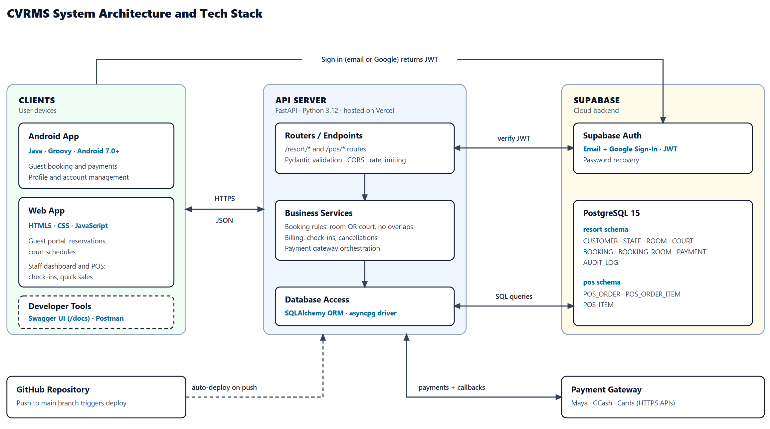
Figure 5. System architecture of Casa Vista Resort Management System

Architecture Description
CVRMS follows a three-tier client-server architecture. A client, such as the Android app, the web app, or Postman, sends an HTTPS request to the REST API. Users sign in through Supabase Auth, which gives them a token that the client sends with each request, and the API checks that token before doing anything. The routers receive the request and pass it to the services layer, which applies the business rules, such as no overlapping room stays, one-hour court slots, and the 15-minute payment hold. The database access layer reads and writes data in the PostgreSQL database on Supabase, which is split into the resort and pos schemas, and the API sends the result back to the client as JSON. Payments go through an outside gateway (Maya, GCash, or card), which sends a callback to the API once a payment is confirmed. Every push to the main branch on GitHub redeploys the API on Vercel automatically.
Note: Debit/Credit card payments will be implemented soon as the developers are still figuring out how to integrate those.

Technology Stack
Layer | Technology | Role in the System
Client | Android app (Java Groovy) (Android version 7.0+), web app (HTML5, CSS, JS), Swagger UI, Postman | Sends requests to the API and displays the responses
Authentication | Supabase Auth | Handles email and Google sign-in, password recovery, and issues the login token
Backend | Python 3.12, FastAPI | Defines the endpoints and applies the business rules
Data access | SQLAlchemy (asyncpg), Pydantic | Maps tables to Python models and validates request data
Database | PostgreSQL 15 (Supabase) | Stores customers, staff, rooms, courts, bookings, payments, POS orders, and audit logs
Payments | Maya, GCash, cards | Process cashless payments and confirms them to the API
Hosting | Vercel (API), Supabase (database) | Keeps the API and database online and reachable
Version control | Git, GitHub | Tracks changes and triggers automatic deployment
Tools | VS Code, Android Studio + Android Emulator, Figma, Supabase SQL Editor, Google Cloud Console, Maya sandbox, draw.io, Gemini, Claude | Used for coding, database design, interface design, diagrams, and AI-assisted development
SECTION 07

GitHub Repository
Where the source code and database scripts live.
Repository URL | https://github.com/Dvn-Code/cvrms_android
Visibility | Public
Default Branch | main

Repository Contents
Item | Location | Description
README | /README.md | Main documentation detailing system overview, group members, tech stack, database instructions, and step-by-step setup guide.
Proprietary License | /LICENSE | Proprietary and Confidential license restricting usage strictly to academic coursework evaluation and reserving all legal rights.
Source code | /app | Core Android application module containing Java/Kotlin source code for User/Guest, Admin, and Super Admin dashboards, XML layouts, vector drawables, and adapters.
Android Manifest | /app/src/main/AndroidManifest.xml | Declares app activities (Splash, Login, Signup, Main, Admin, Super Admin), permissions, themes, and entry points.
Official Database script | /database/casavista.sql | Official Supabase PostgreSQL database dump containing resort and pos schemas, tables, PL/pgSQL collision/cap triggers, RLS policies, and test seed records.
Schema SQL Script | /database/schema.sql | Mirror copy of the database structure and seed data for flexible database initialization across local PostgreSQL / Supabase instances.
Environment sample | /.env.example | Template file containing placeholder environment variables (BASE_URL, SUPABASE_URL, GOOGLE_WEB_CLIENT_ID).
Dependencies | /requirements.txt | Lists Python/FastAPI backend packages (fastapi, supabase, uvicorn) and required Android Studio/JDK 17 specifications. (https://github.com/Dvn-Code/cvrms_api)
Root Build Script | /build.gradle | Top-level Gradle configuration specifying Android Application and plugins.
SECTION 08

Deployed API
The live API and the endpoints it exposes.
Framework | FastAPI (Python)
Base URL | https://cvrms-api.vercel.app/
API Documentation | https://cvrms-api.vercel.app/docs
Hosting Platform | Vercel
Database | PostgreSQL 15 (cloud-hosted)
Test Credentials | Username: cvrms_prd_service_account  Password: @Guest12345

Endpoints
Method | Endpoint | Description | Use Case
GET | /rooms | List rooms and their status (filter ? status=Ready for available ones) | CVRMS-01
GET | /bookings/active | List confirmed and held bookings, used to check schedule conflicts | CVRMS-01
GET | /customers/{customer_id} | Retrieve the customer profile to attach to the booking | CVRMS-01
GET | /courts | List courts with day and night rates | CVRMS-02
GET | /courts/{court_id}/availability | Show reserved and held slots for a date | CVRMS-02
GET | /courts/calculate-price | Compute the court fee (6 PM day/night switch) plus paddle rental | CVRMS-02
POST | /bookings | Create a pending room or court booking with a 15-minute hold | CVRMS-01, CVRMS-02
POST | /payments | Record a payment (confirms the booking) or a refund | CVRMS-03
GET | /bookings/{booking_id} | Get the booking and its status for the receipt | CVRMS-03
PUT | /bookings/{booking_id}/status | Update booking status, e.g. Cancelled | CVRMS-03

