Module-7 Route 53
1.Establishing a Hosted Zone, which acts as a container for your domain's DNS records. This step defines whether the domain will be accessible over the public internet or restricted to an internal VPC.
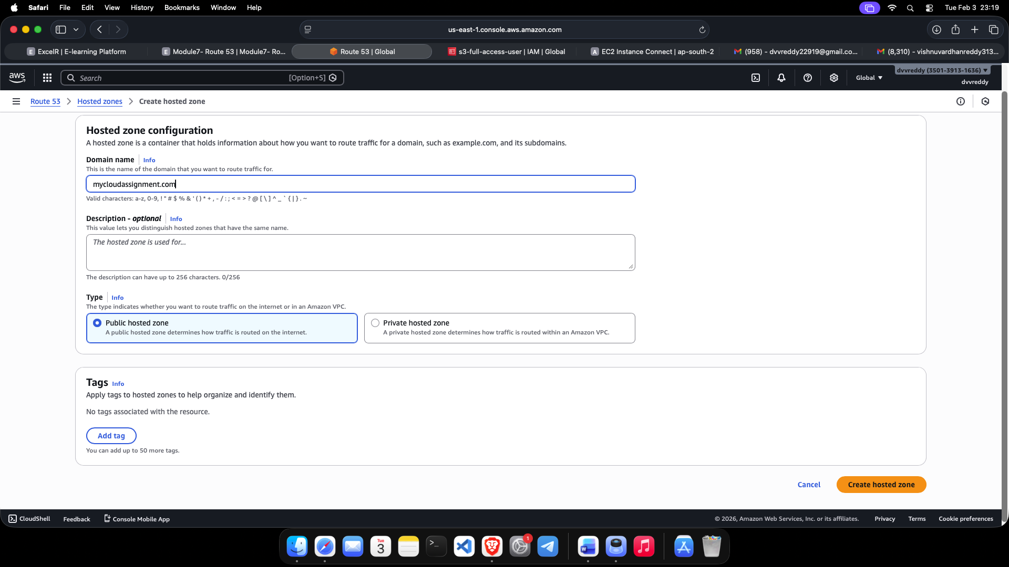

2.Reviewing the default Name Server (NS) and Start of Authority (SOA) records. AWS automatically generates these to identify the authoritative servers for your domain and provide essential propagation and management information.
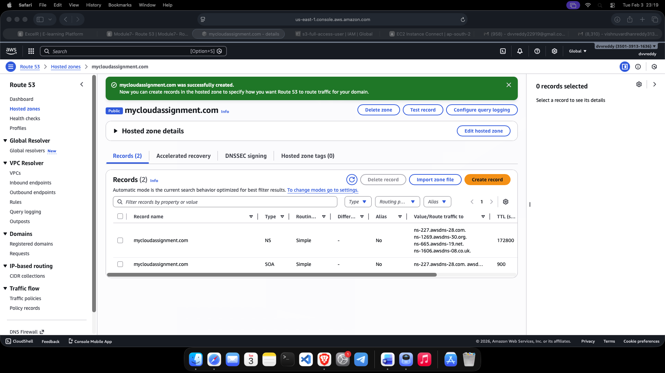

3.Creating a specific DNS record (such as an A record) within the hosted zone. This record maps your domain name to a specific resource, such as the IP address of an EC2 instance or an ELB endpoint.