Module 5: IAM
1.Created a new IAM User with AWS Management Console access. This establishes a unique identity for an individual.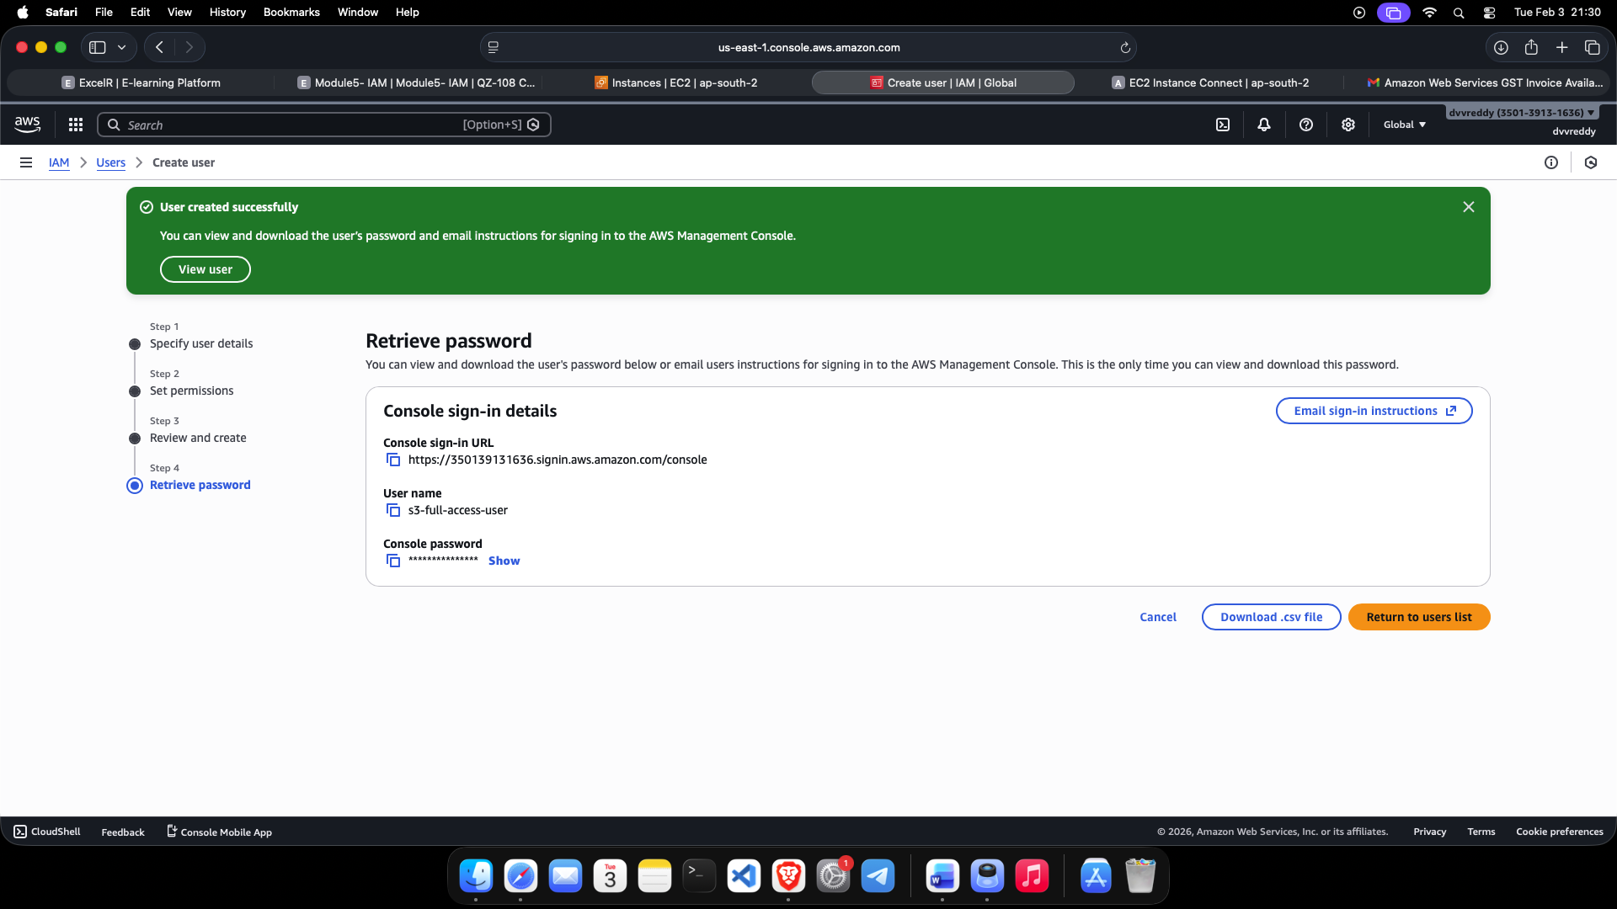

2.Configuring a Virtual MFA device. This adds a secondary layer of security by requiring a unique code from an authenticator app during the sign-in process.
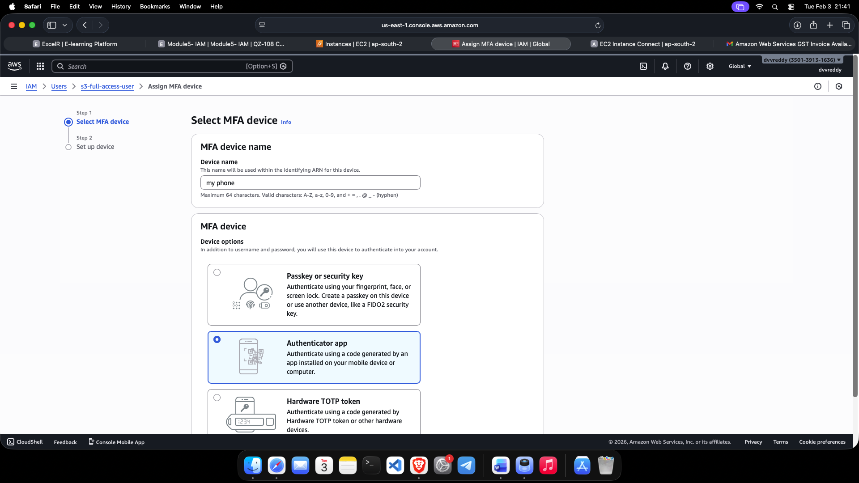

3.Verification that the MFA device is active. The IAM user is now protected by two-factor authentication, fulfilling a core AWS security best practice.
