Module-6 MONITORING

1.Configuring a CloudWatch Alarm for a specific EC2 instance. This setup monitors a metric (typically CPU Utilization) and defines a threshold that, when crossed, triggers an automated action or notification.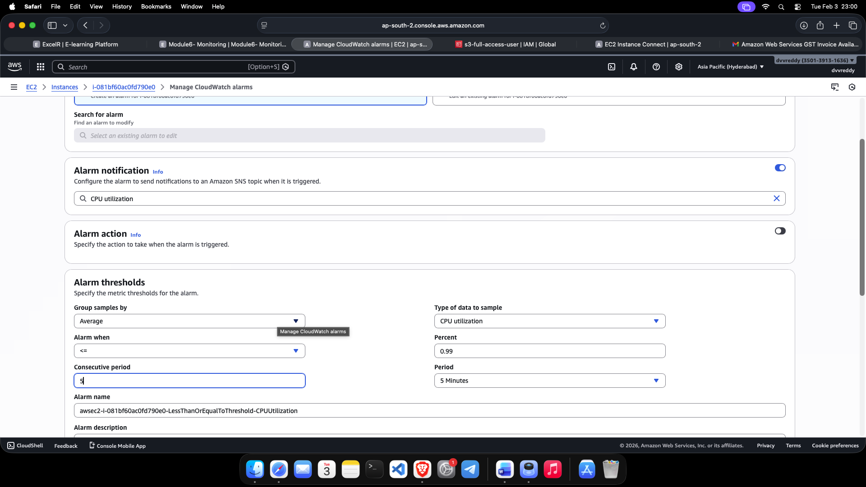

2.Manually testing the alarm's state. This step ensures the alarm is correctly integrated with the instance and can transition between states like OK and ALARM based on the resource's performance.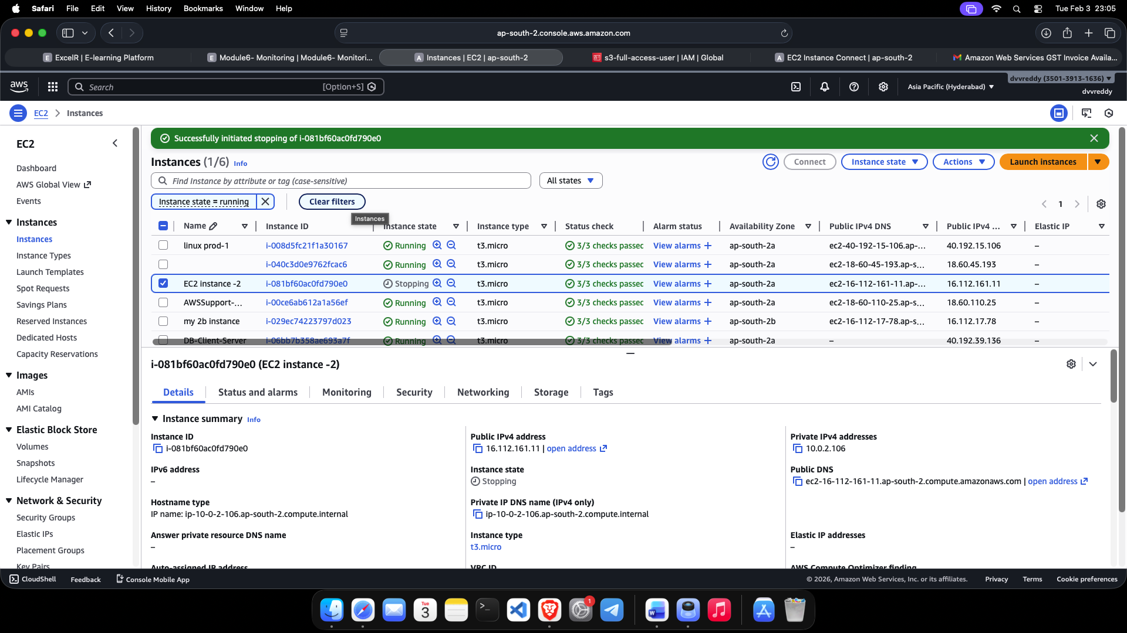

3.The CloudWatch Alarm Dashboard showing a triggered state. This confirms the metric has breached the defined threshold, successfully moving the alarm into the ALARM status and validating that the monitoring system is working as intended.