ASSIGNMENT-1.
Backup and Instance Management
Objective: Demonstrate how to take a backup of an instance and launch a new instance from that backup with the same configuration, specifically moving data across different Availability Zones (AZs)

1.created and Running the EC2.Verified that the source EC2 instance "linux prod-1" is in a running state before beginning the backup process
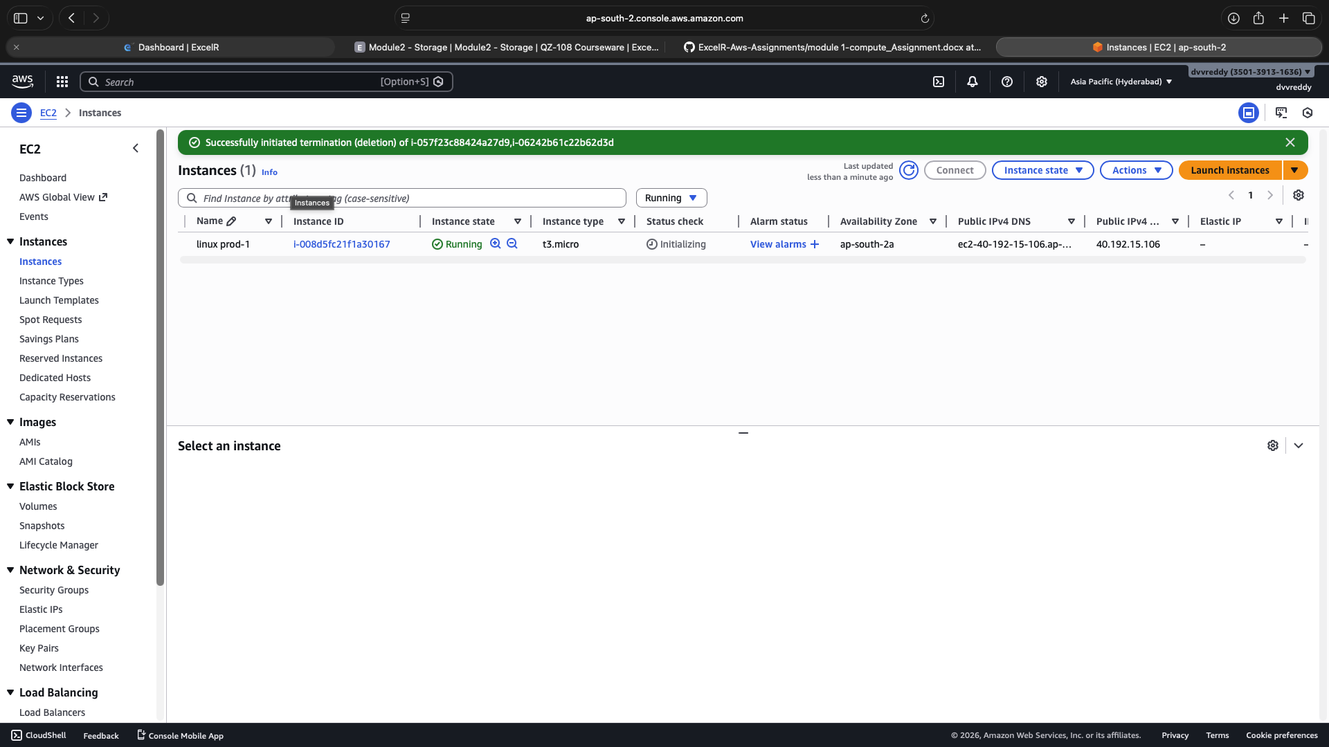

2.creating the Amazon machine image.Successfully created a private Amazon Machine Image (AMI) named "linux prod-1 backup" to serve as a system backup.
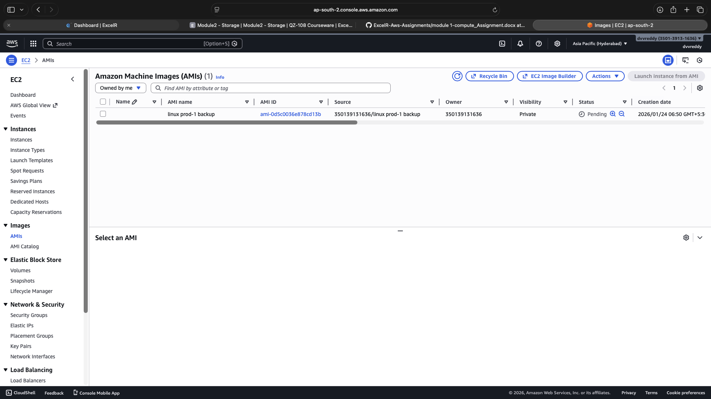

3.creating the instance with amazon machine image.Launched a brand new EC2 instance using the previously created backup AMI to ensure configuration consistency.

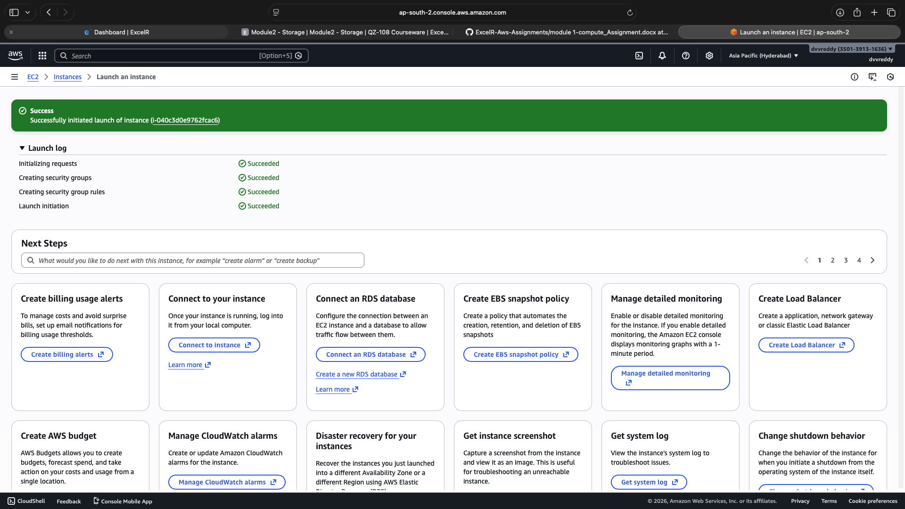

4.Created a new 5 GiB gp3 EBS volume in the ap-south-2a availability zone to be used as additional storage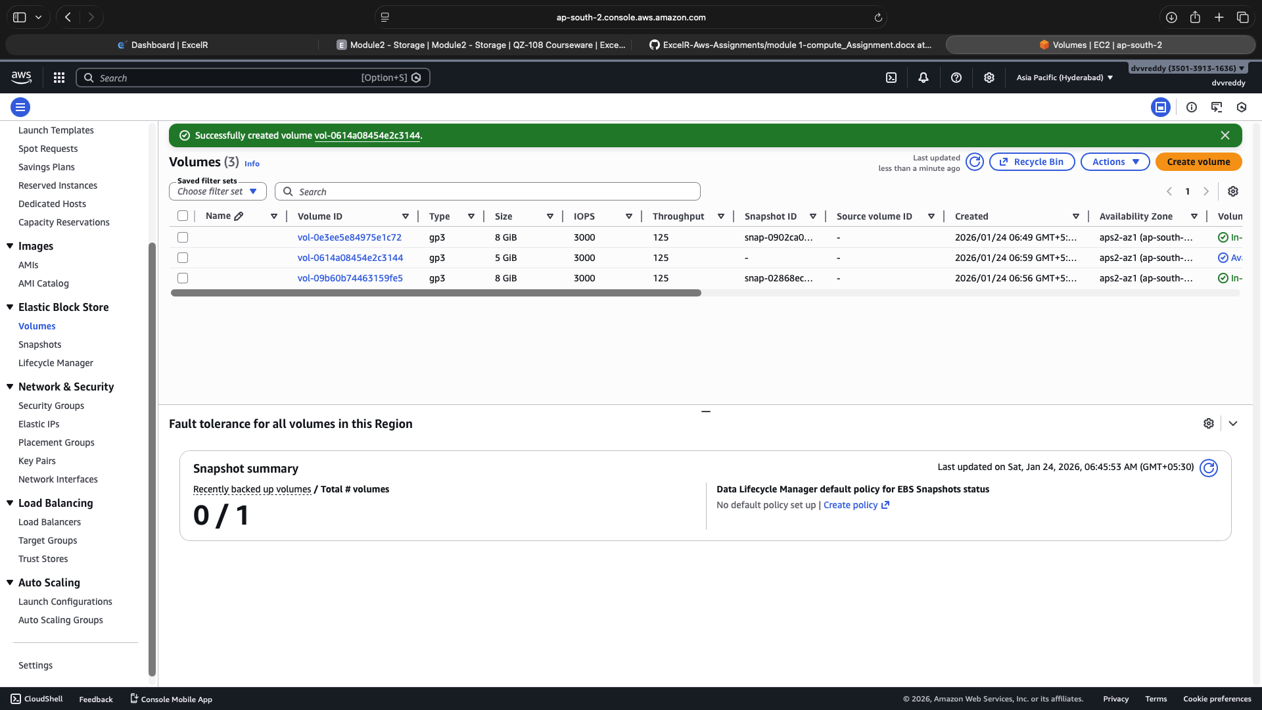
5.Attached the newly created EBS volume to the running "linux prod-1" instance as device /dev/sdf.
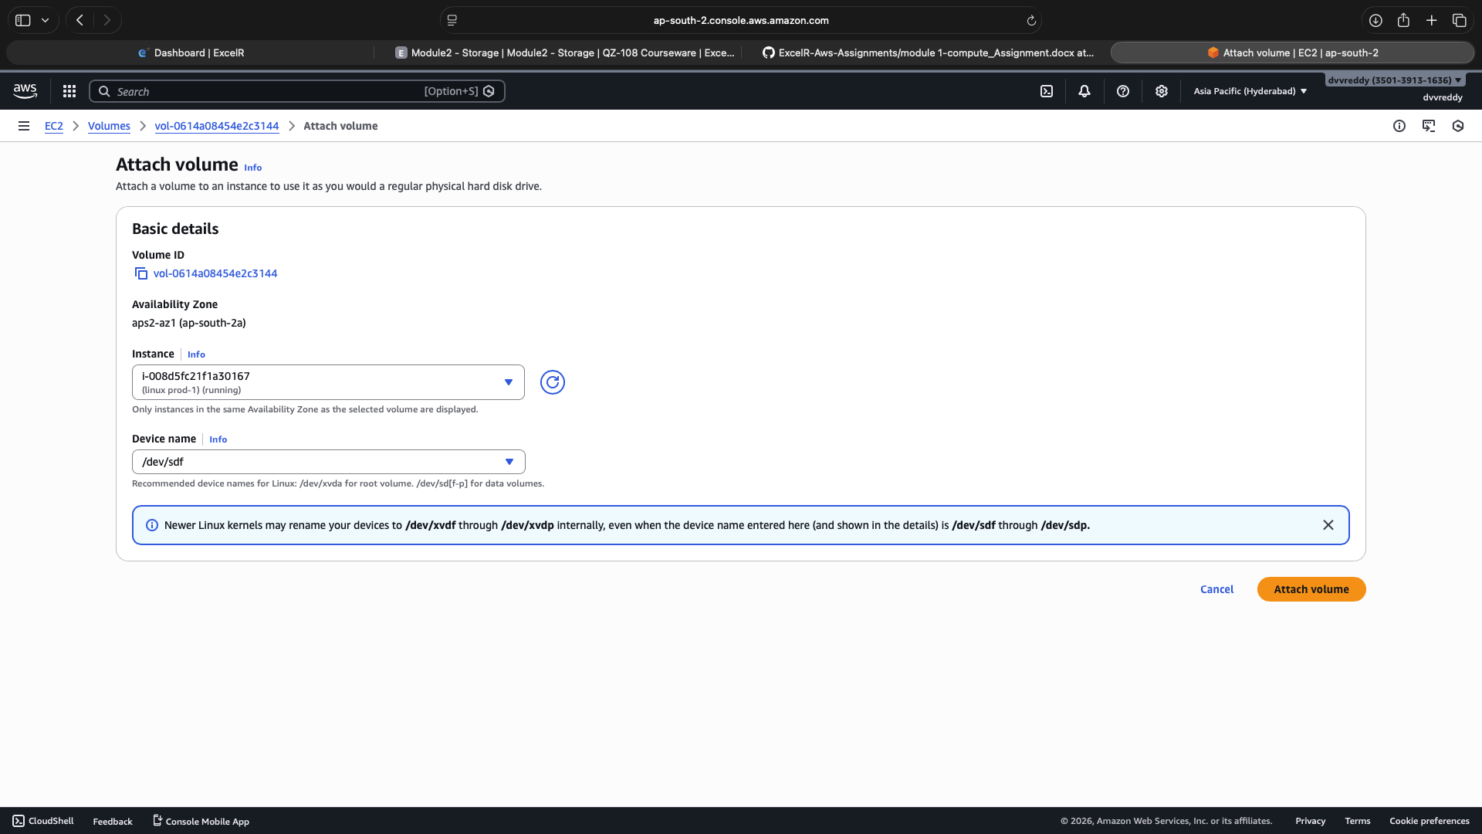

6.Demonstrated the safe detachment of the EBS volume from the first instance to prepare it for migration or reattachment.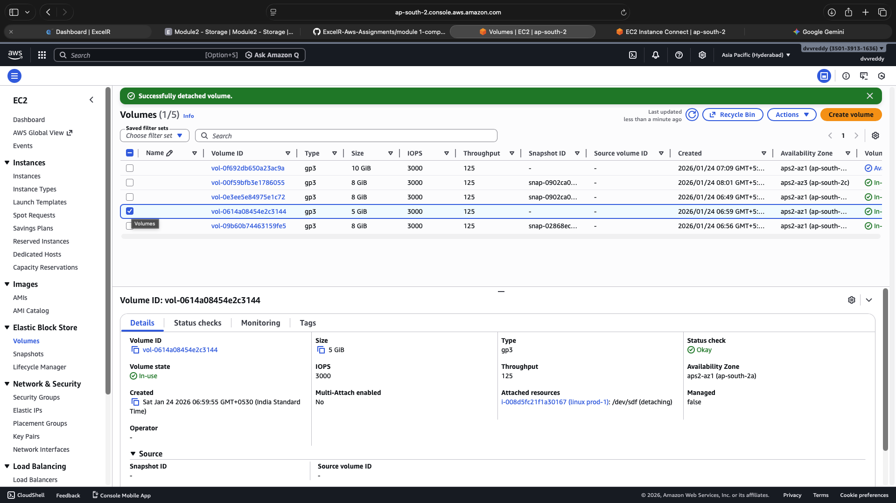

Instance Migration & Multi-AZ Deployment
1.Created a new VPC subnet to provide the necessary network environment for migrating or launching instances in a different zone.

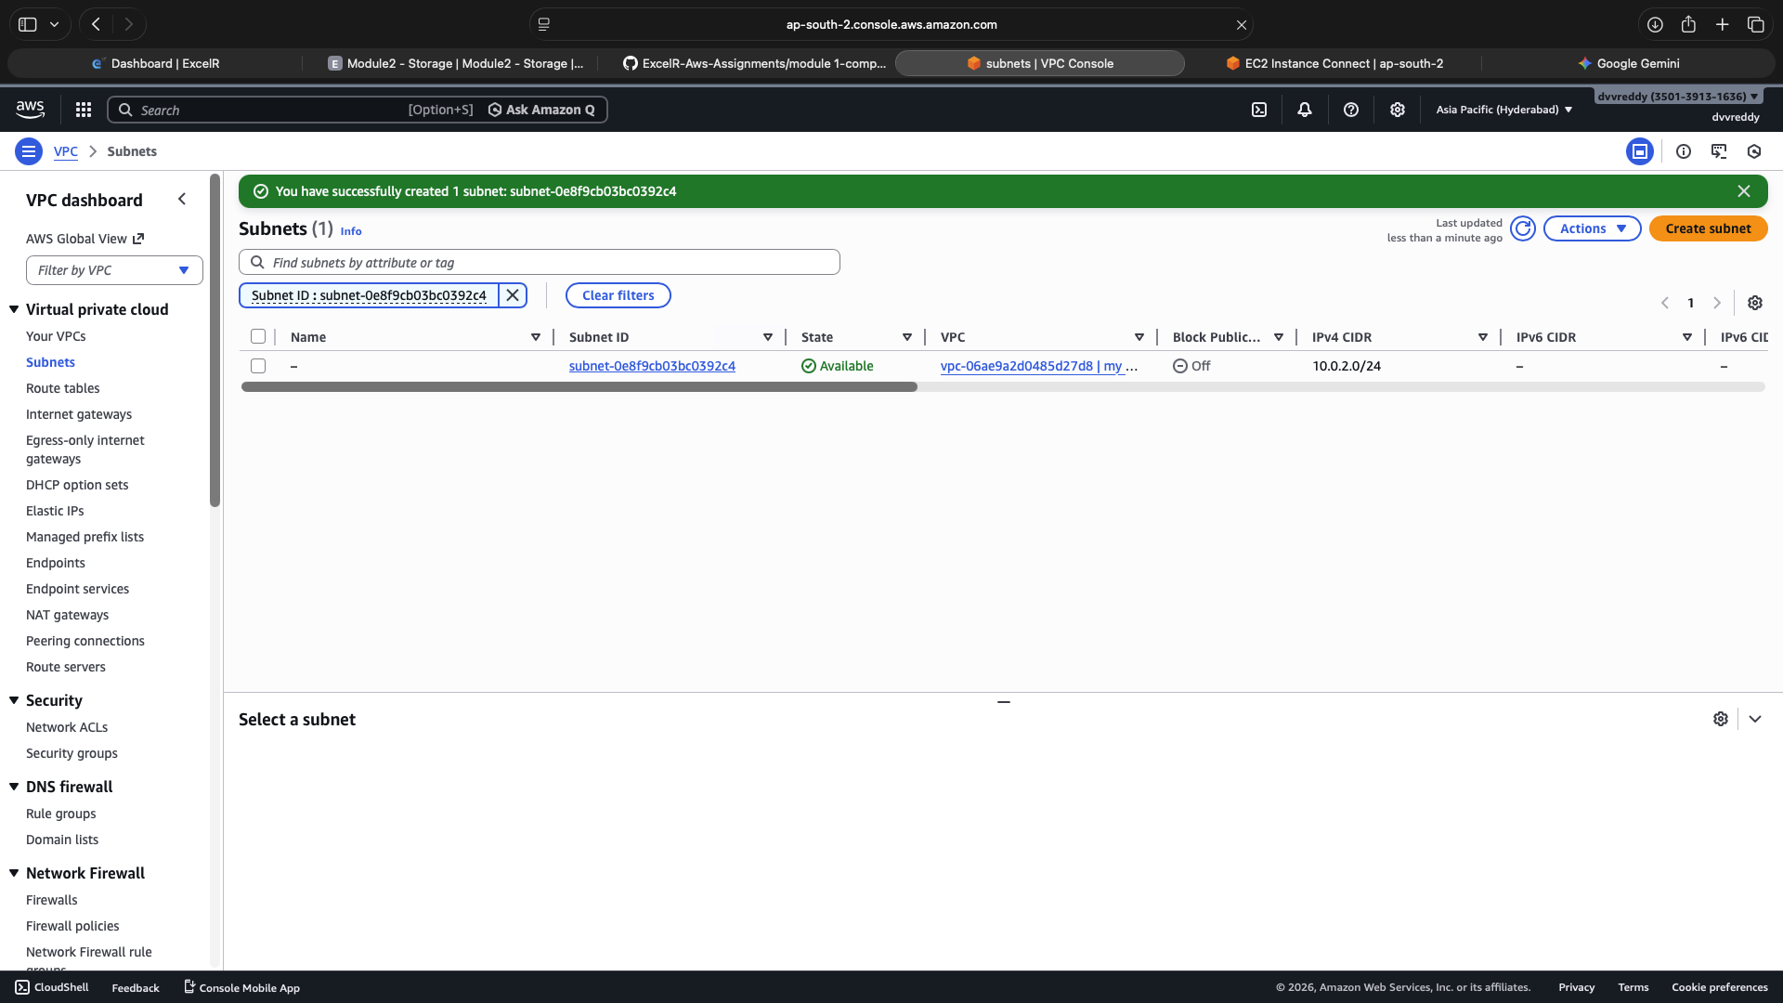

2.Successfully attached the existing data volume to a new instance located within the newly created VPC subnet.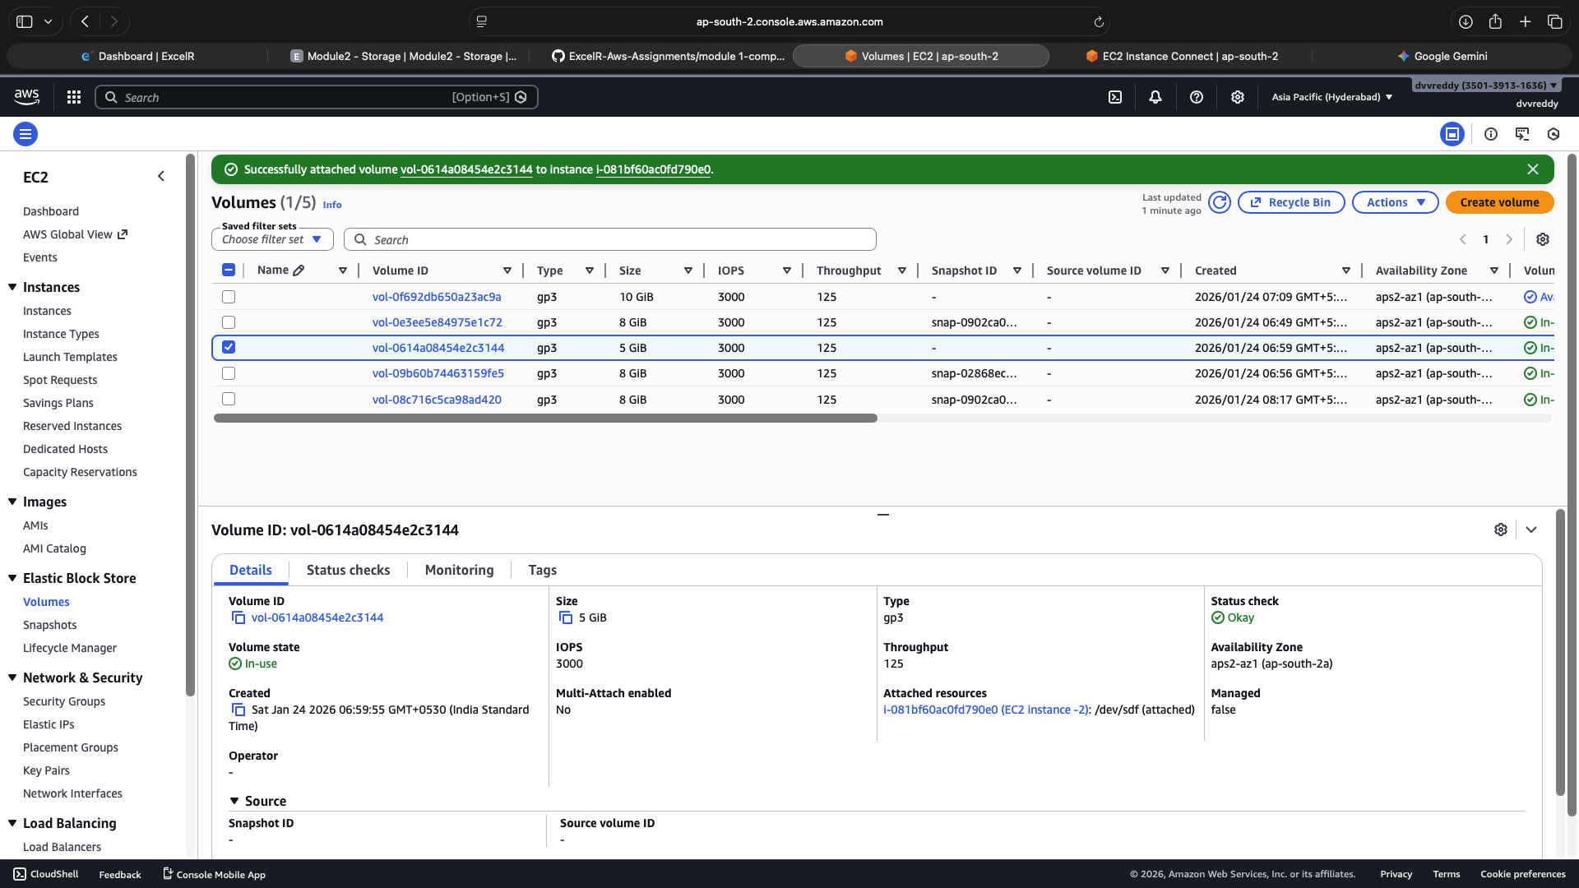
3.Accessed the instance via CLI and used lsblk and df -h to verify that the 5GB volume is mounted and accessible at /data. 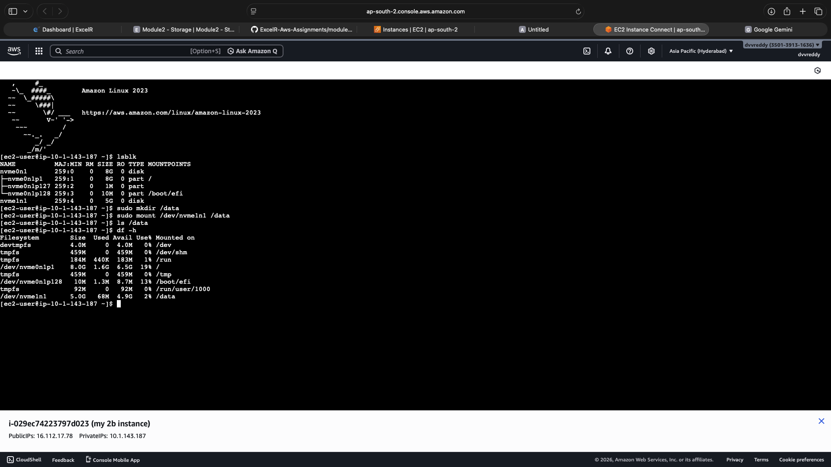
4.Configuring the AWSSupport-CopyEC2Instance runbook within AWS Systems Manager to automate the migration of an EC2 instance across subnets or regions.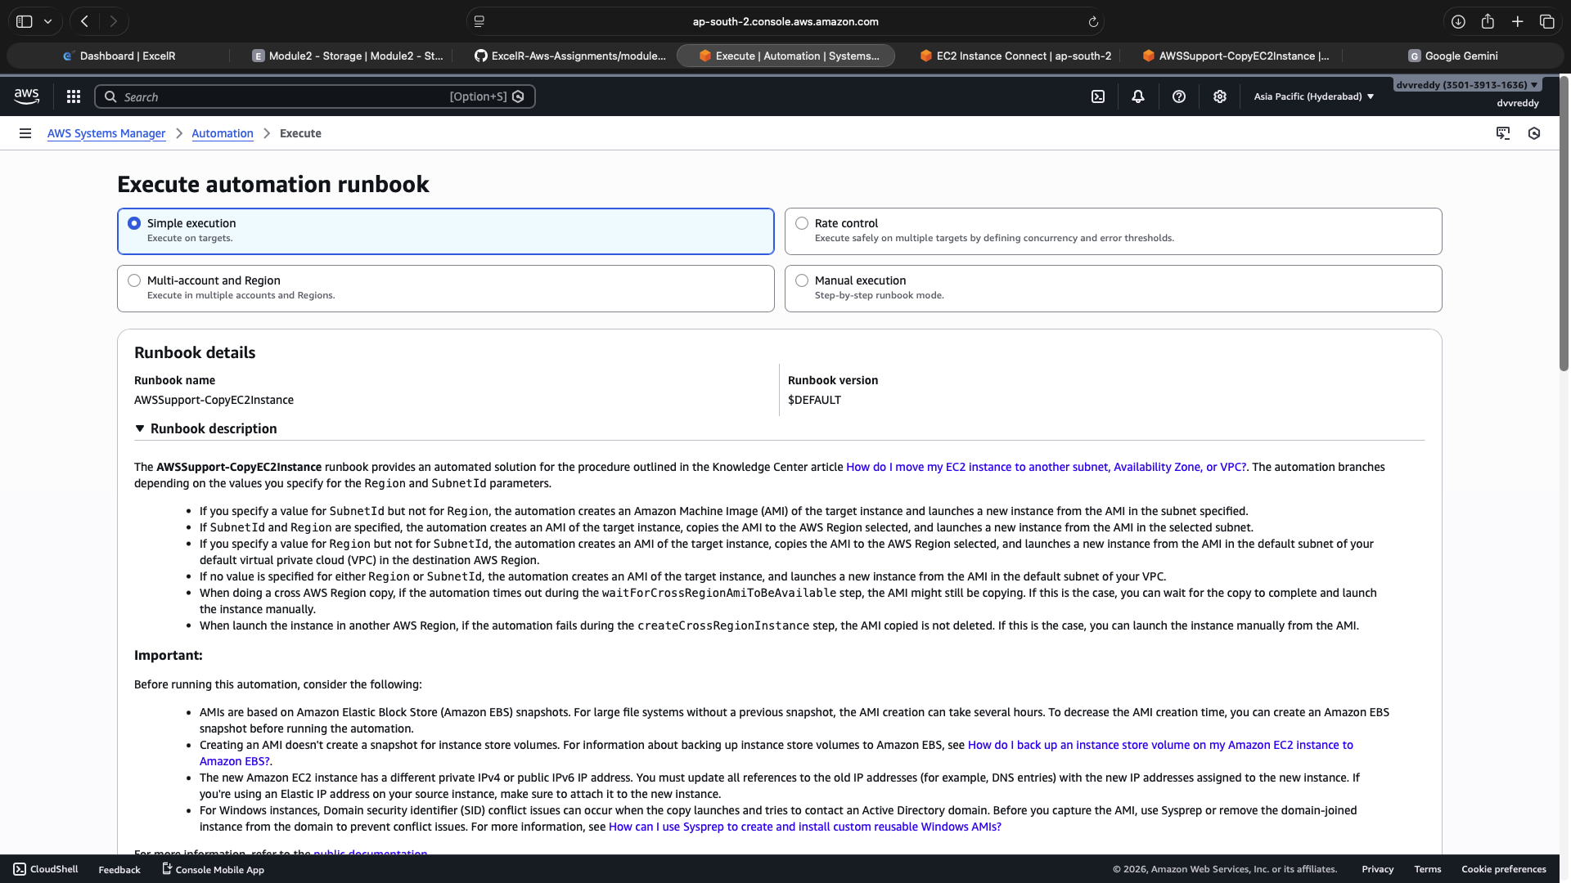
5.Reviewing the execution details which confirm that the automation runbook successfully completed all 10 workflow steps, including image creation and instance tagging.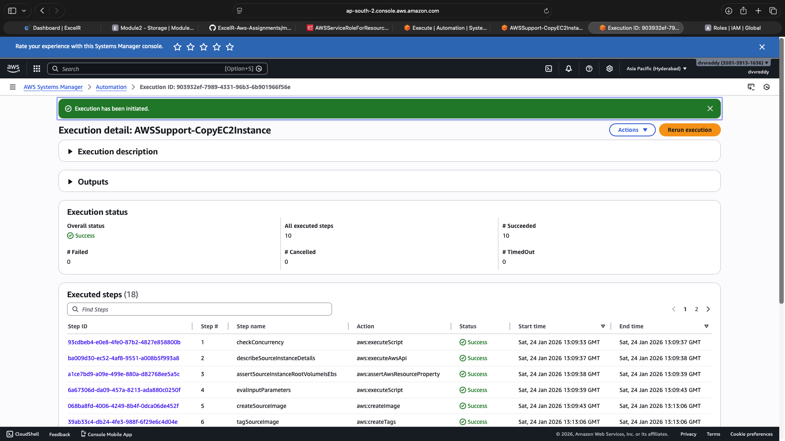
6.Demonstrating the manual migration workflow by creating a custom Amazon Machine Image (AMI) titled manual-migration-ami from the source production instance.
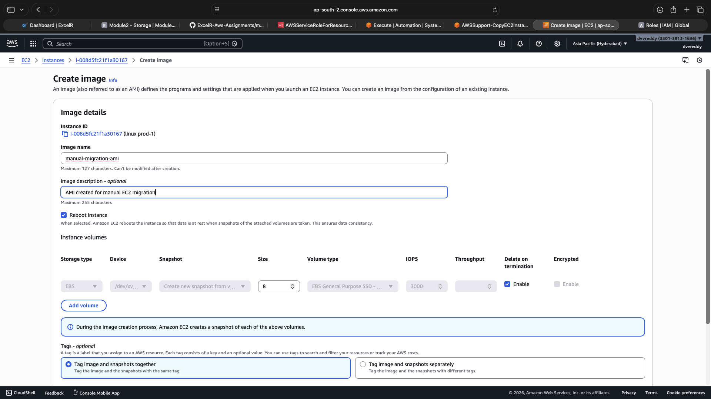
7.Final verification showing the successful initialization of the new EC2 instance, completing the migration process from the previously created image.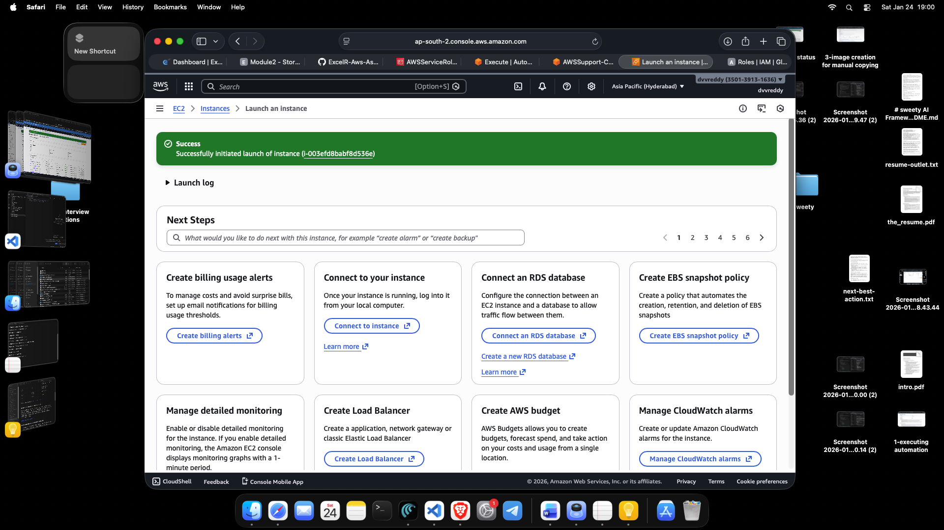

Deploying a Web Application with AWS Elastic Beanstalk
1.Initializing the creation of a "Web server environment" for the application named myweb-using-beanstalk, defining the environment name and domain settings.

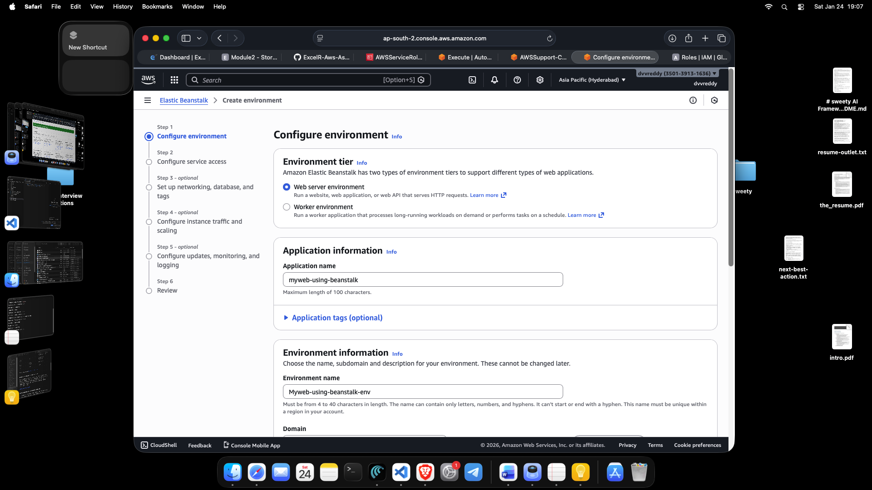

2.Setting up security and permissions by assigning the aws-elasticbeanstalk-service-role and an EC2 instance profile (aws-elasticbeanstalk-ec2-role) to allow Beanstalk to manage resources on the user's behalf.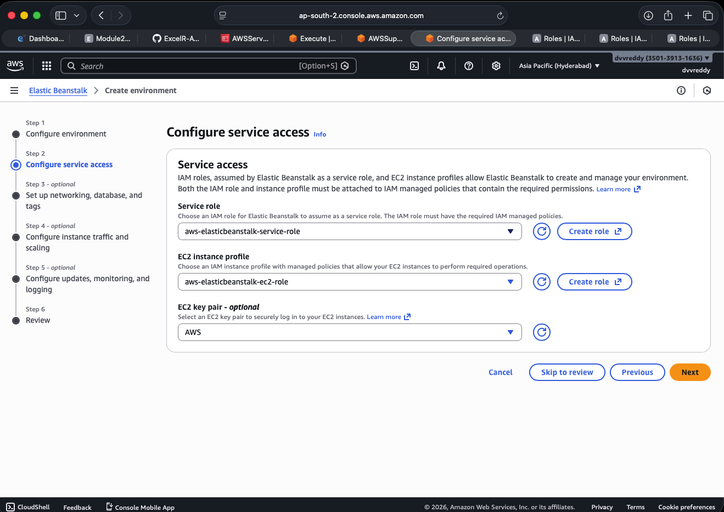
3.Final confirmation of the environment Myweb-using-beanstalk-env being successfully launched with an "Ok" health status, running on the Python 3.14 platform.
