Module 4: Database
1.Successfully provisioned an Amazon RDS MySQL instance using the Free Tier template, ensuring the database is hosted in the default VPC for secure internal access.
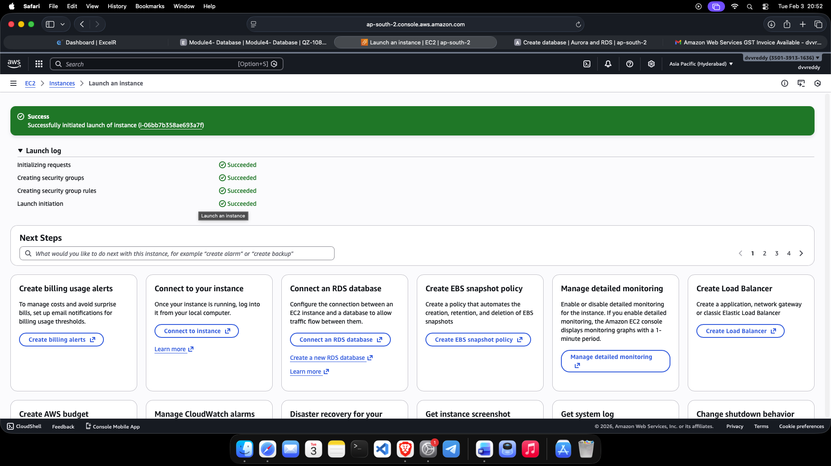

2.Launching an EC2 Linux instance (Amazon Linux 2023) to act as the database client, configured with SSH access for remote administration.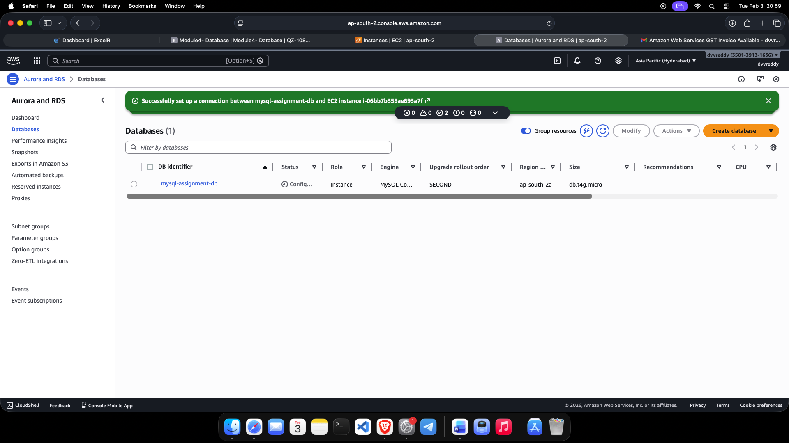

3.Verified the connection between the EC2 instance and the RDS MySQL database using the mysql-client CLI and the unique RDS Endpoint.
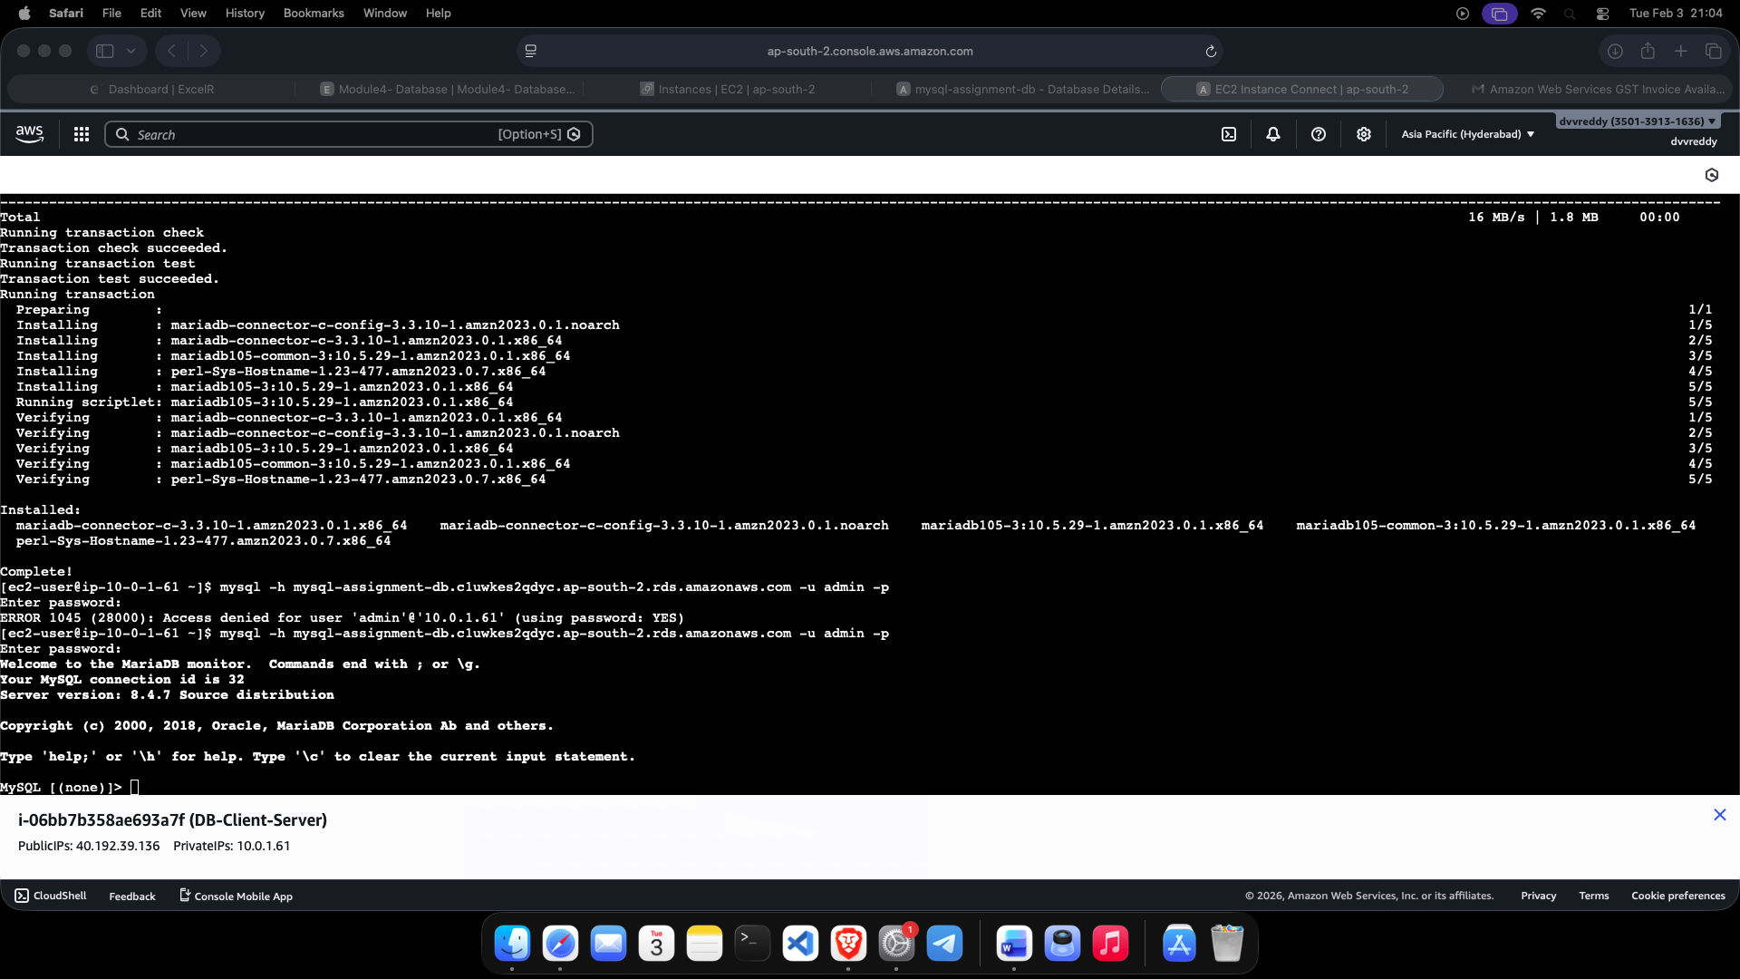
4.Executed SQL queries to create a database schema and a "Persons" table, followed by the insertion of test records to verify successful read/write operations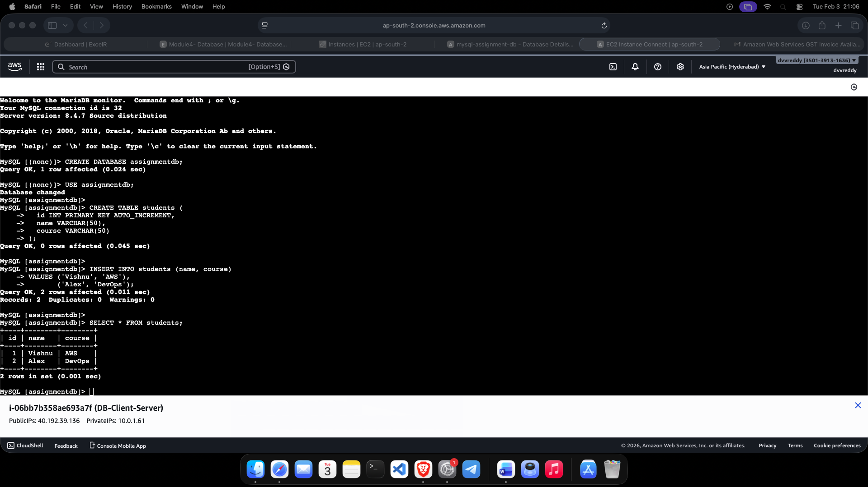
5.Creation of a serverless DynamoDB table named Population (or AssignmentTable) with a defined Partition Key to demonstrate NoSQL database management.
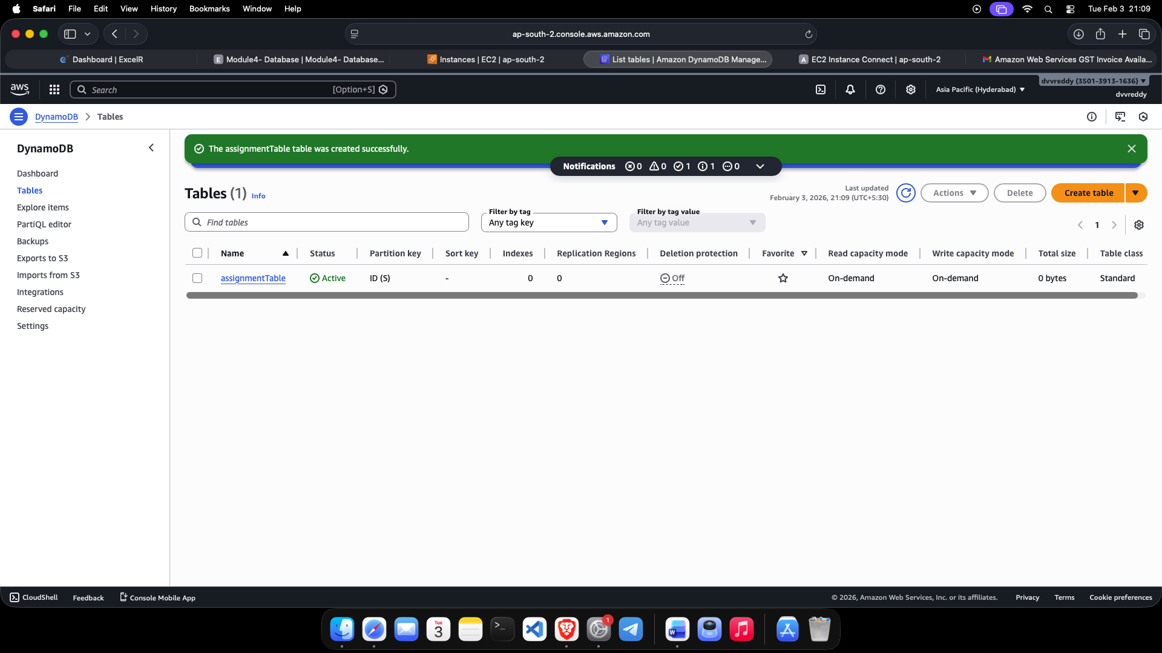
6.Manually adding attributes and items into the DynamoDB table via the AWS Console, confirming the flexible, schema-less nature of the NoSQL service.
