Module-2 STORAGE

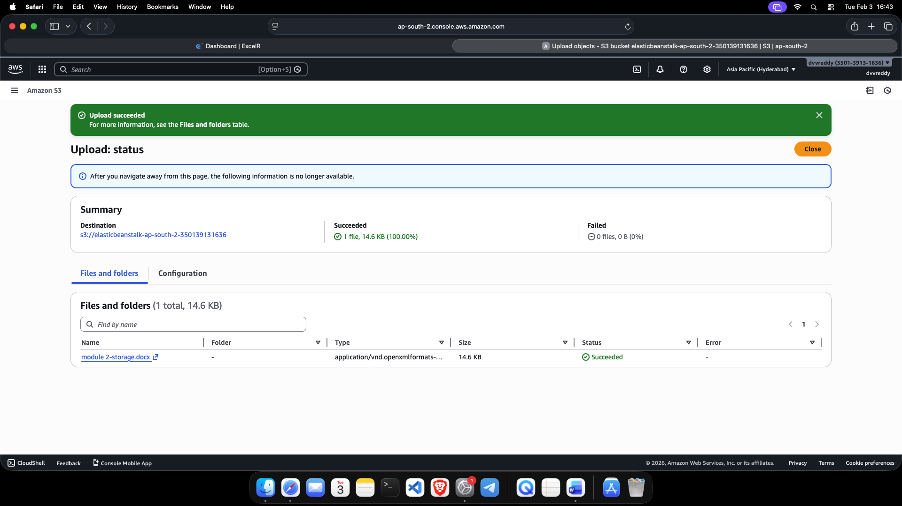
1. an object was successfully uploaded to the Amazon S3 bucket, confirming bucket access and storage functionality.

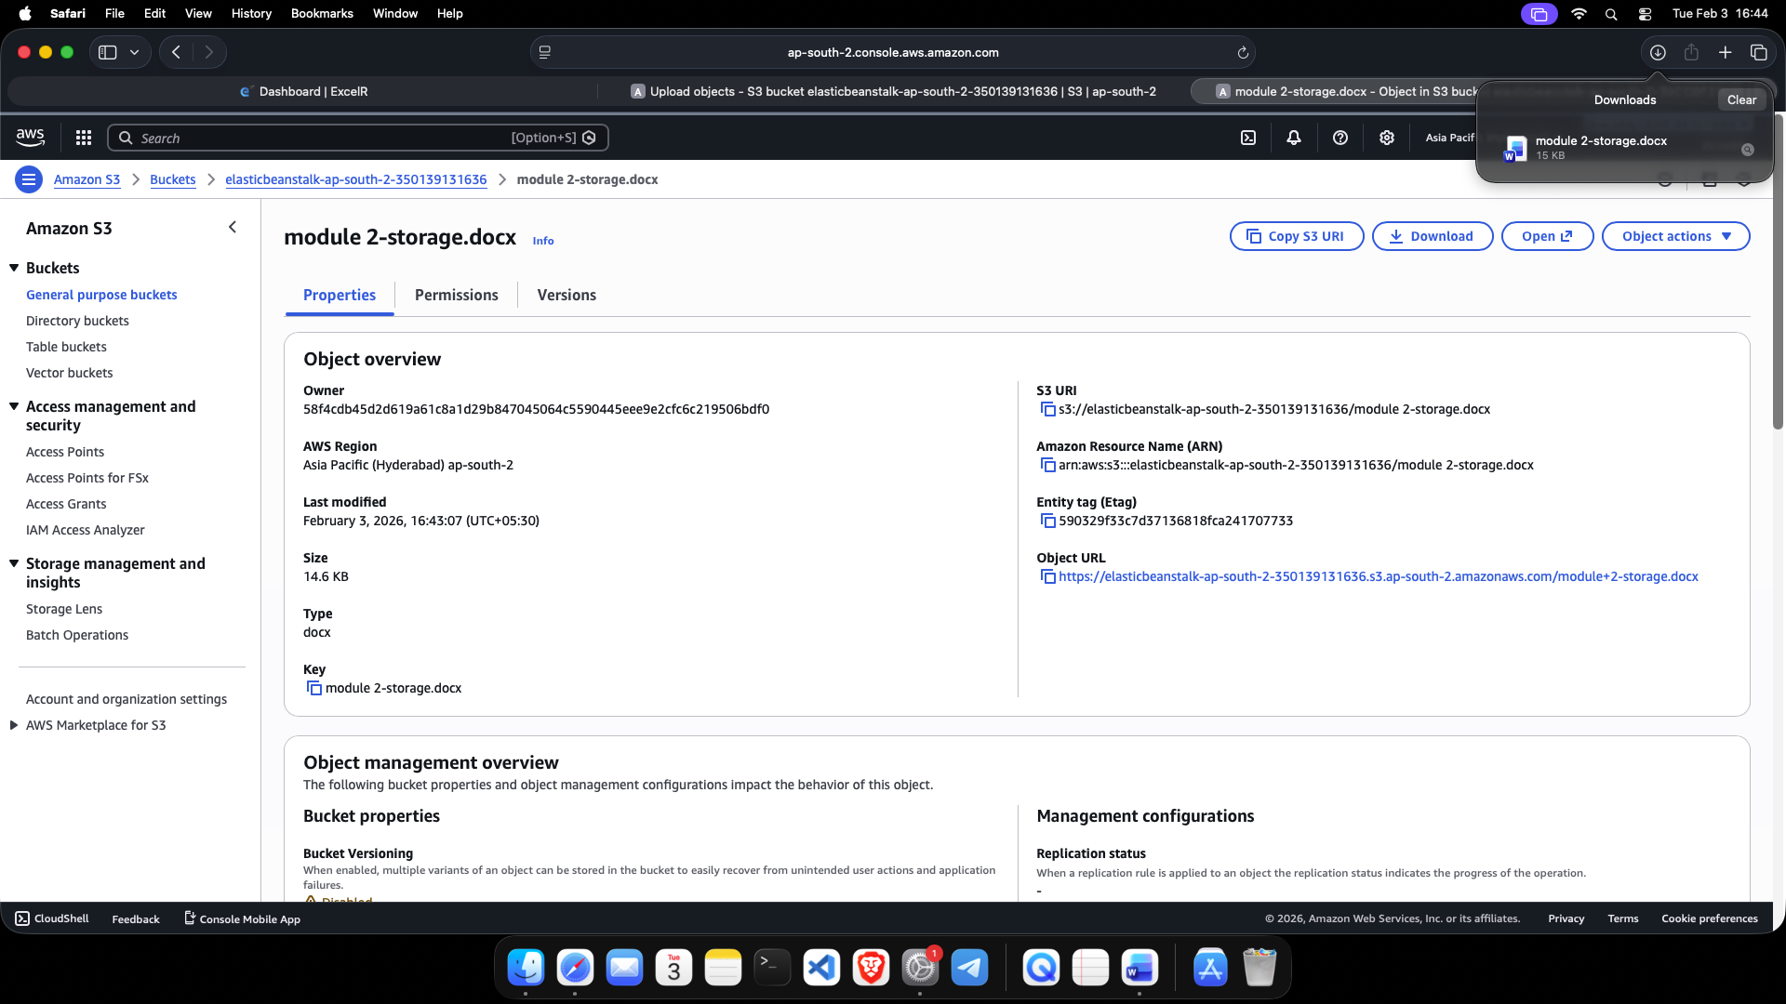
2.The uploaded object was downloaded from the S3 bucket, verifying successful data retrieval.

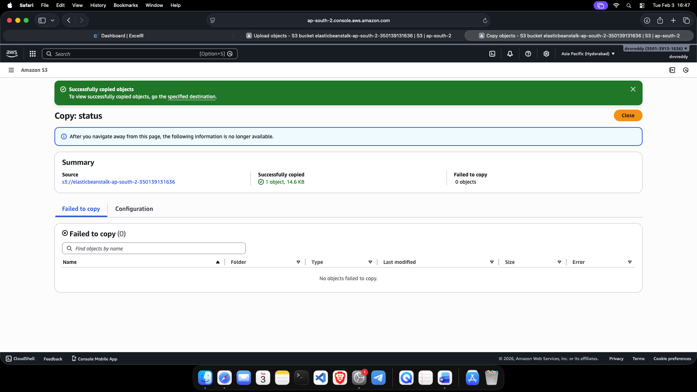
3.The object was copied into a folder within the same S3 bucket, demonstrating object management.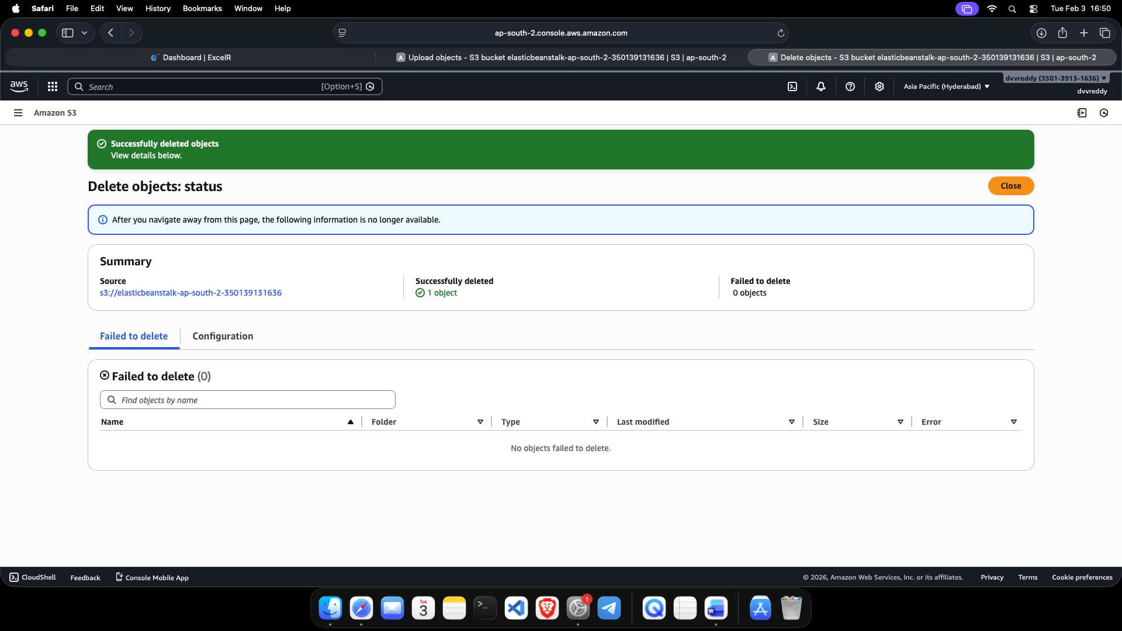
4.The object was deleted from the S3 bucket to manage and clean up stored data.
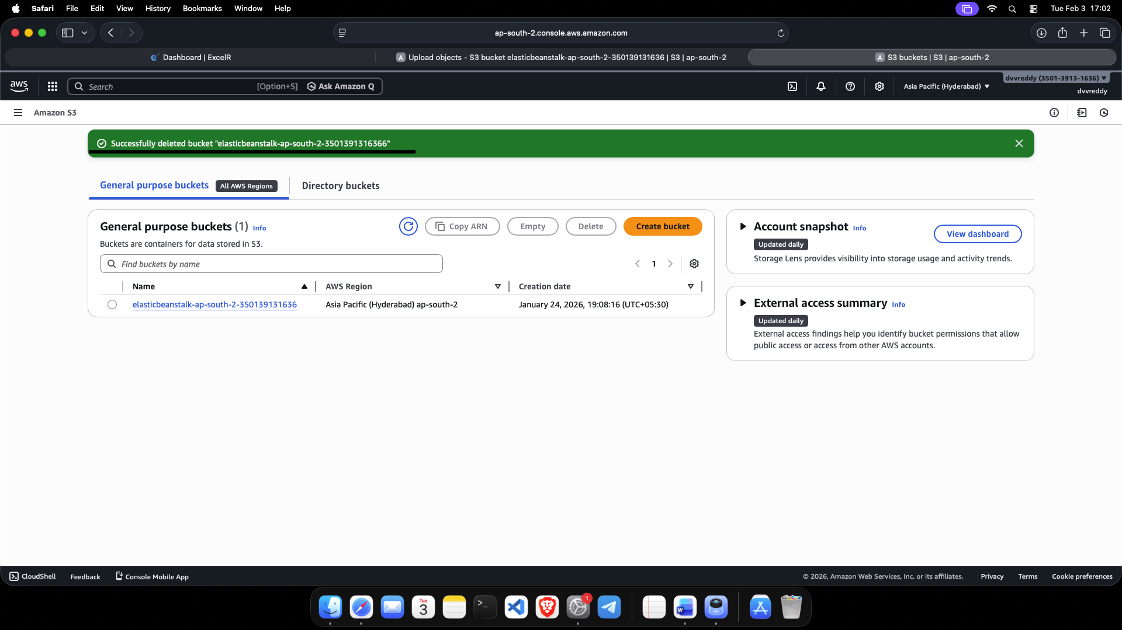
5.After removing all objects, the S3 bucket was successfully deleted.

