**Data**

To find the best location for a Japanese restaurant, we will use the following sources of information:

1. From Foursquare Venues: Category 4bf58dd8d48988d111941735 (Japanese restaurant) available at  <https://developer.foursquare.com/docs/resources/categories>

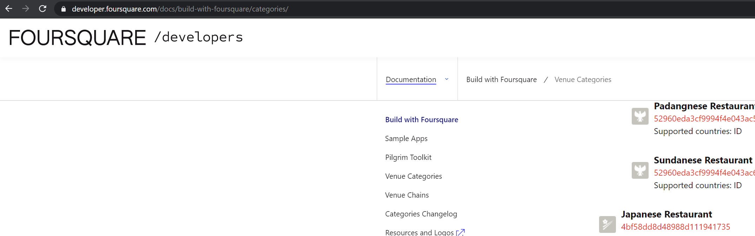

1. Newyork has a total of 5 boroughs and 306 neighborhoods (with latitude and longitude coordinates) available at <https://geo.nyu.edu/catalog/nyu_2451_34572>

