# The Battle of the Neighborhoods

## Introduction and Business Problem :

In 2017, the city had an estimated population density of 28,491 inhabitants per square mile (11,000/km2), rendering it the nation's most densely populated of all municipalities (of more than 100,000), with several small cities (of fewer than 100,000) in adjacent Hudson County, New Jersey having greater density, as per the 2010 census. Geographically co-extensive with New York County, the borough of Manhattan's 2017 population density of 72,918 inhabitants per square mile (28,154/km2) makes it the highest of any county in the United States and higher than the density of any individual American city.

**Business Problem**

New York City's food culture includes an array of international cuisines influenced by the city's immigrant history. Central and Eastern European immigrants, especially Jewish immigrants from those regions, brought bagels, cheesecake, hot dogs, knishes, and delicatessens (or delis) to the city. Italian immigrants brought New York-style pizza and Italian cuisine into the city, while Jewish immigrants and Irish immigrants brought pastrami and corned beef, respectively. Chinese and other Asian restaurants, sandwich joints, trattorias, diners, and coffeehouses are ubiquitous throughout the city.

In this context, we would like to find the best location for a Japanese restaurant.

**Goal: Find the best location in New York Manhattan**

The location of the restaurant is critical and has to factor various parameter (of which location against the competition)

**Target Audience**

I would like to open a restaurant in Manhattan. The target audience is any entrepreneur that would like to open such a business

## Data

To find the best location for a Japanese restaurant, we will use the following sources of information:

1. From Foursquare Venues: Category 4bf58dd8d48988d111941735 (Japanese restaurant) available at  <https://developer.foursquare.com/docs/resources/categories>

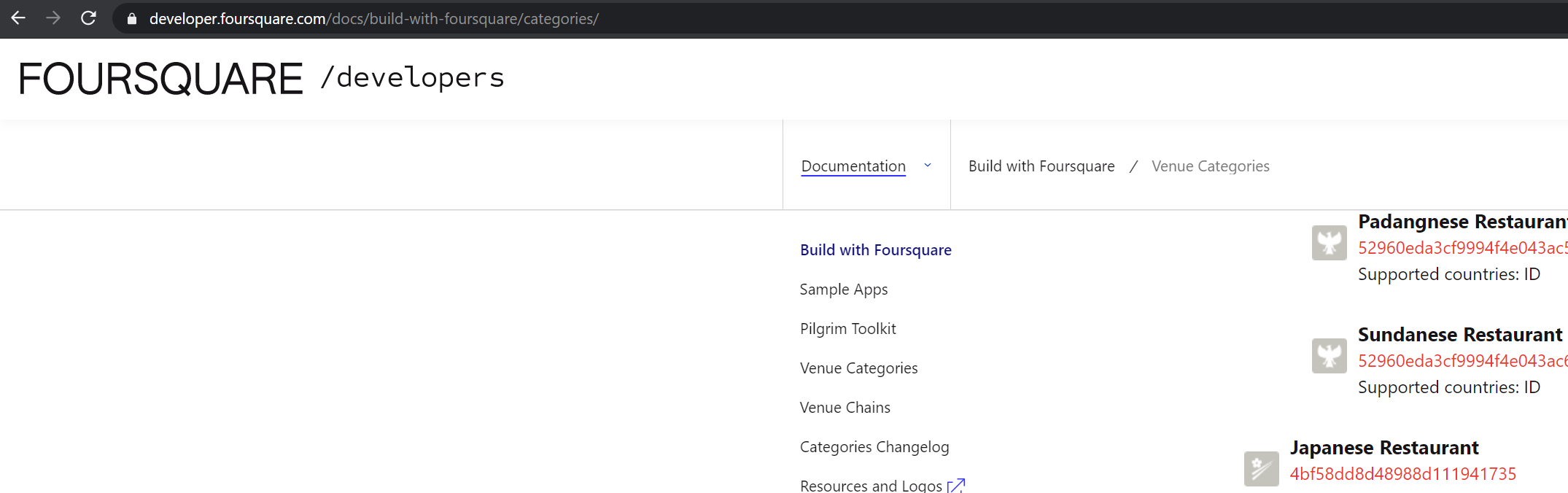

1. Newyork has a total of 5 boroughs and 306 neighborhoods (with latitude and longitude coordinates) available at <https://geo.nyu.edu/catalog/nyu_2451_34572>

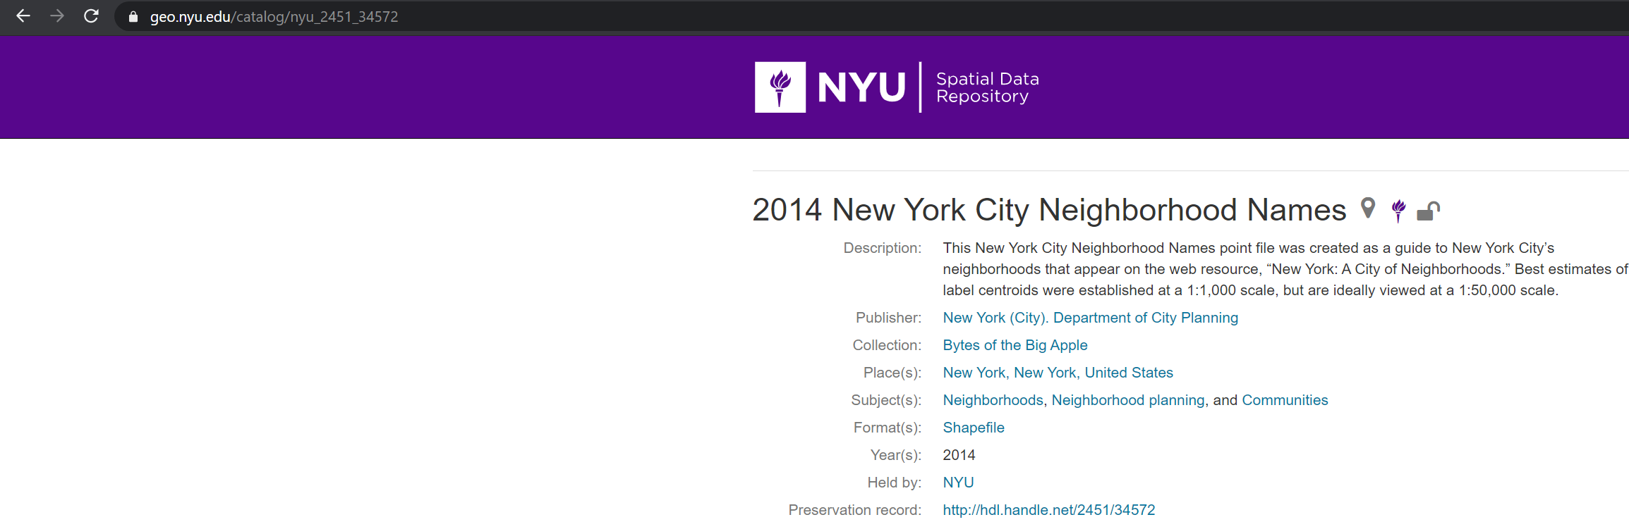

## Methodology

The Week 3 methodology will be used.

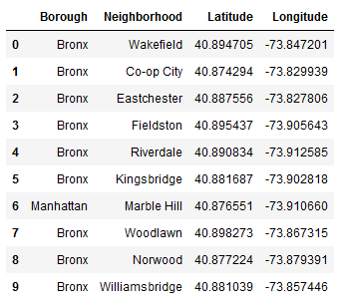

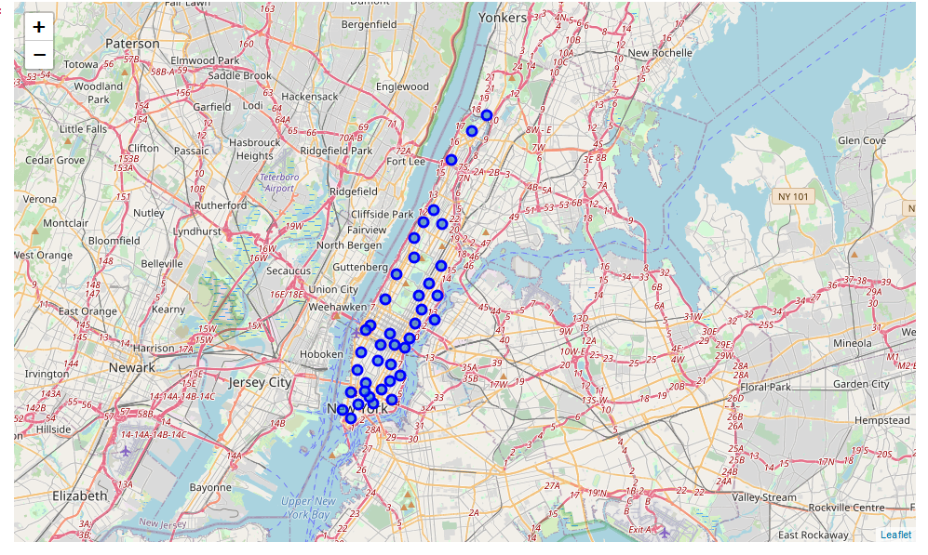

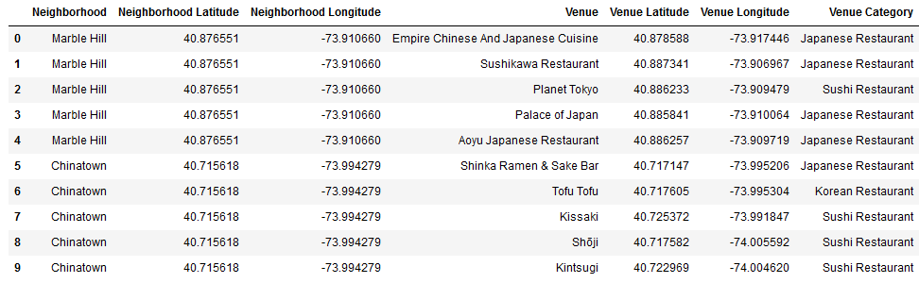

The neighborhoods are grouped into clusters (K-means clustering algorithm is used).

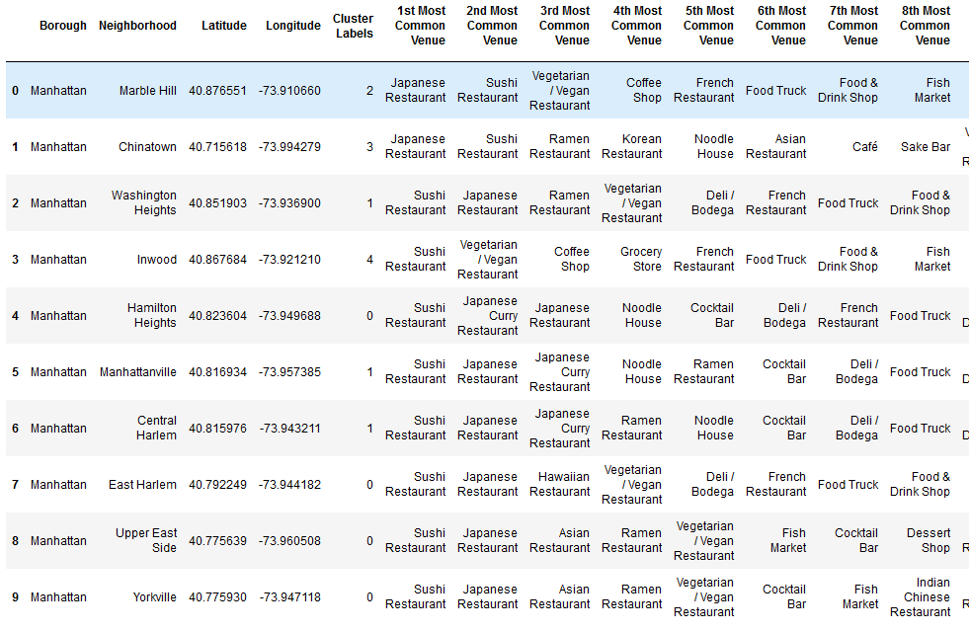

Visualization using folium:

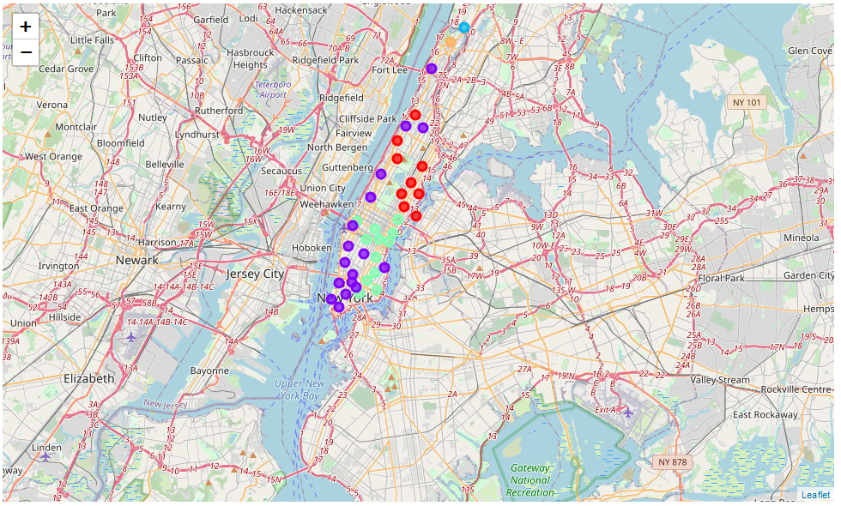

## Results

Clusters with the less number of japanese restaurant:

**Cluster 0**

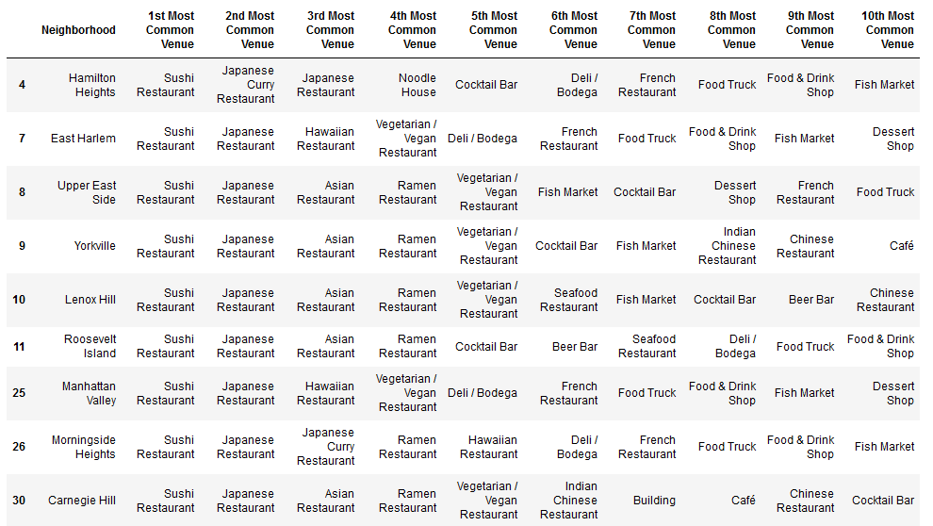

**Cluster 1**

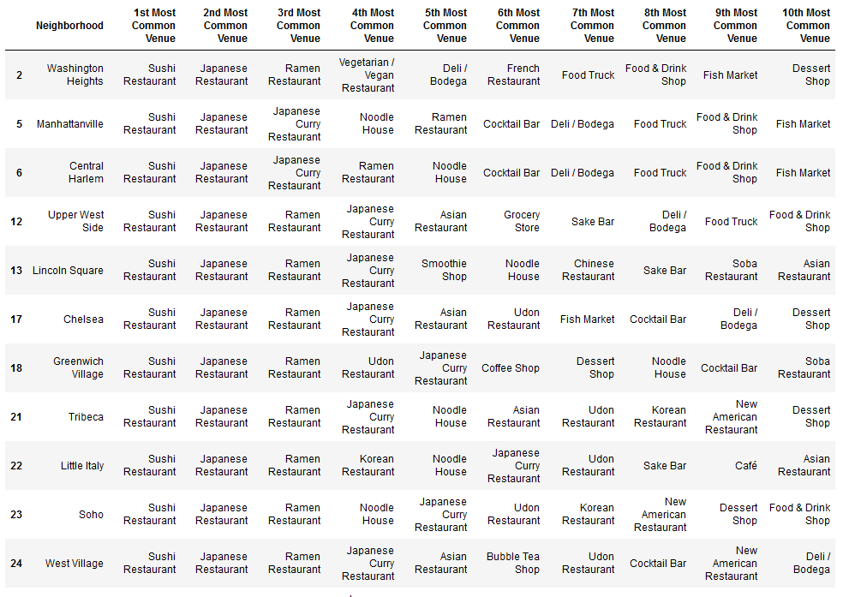

**Cluster 2**

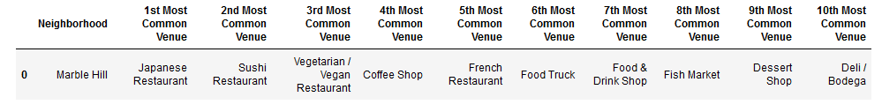

**Cluster 3**

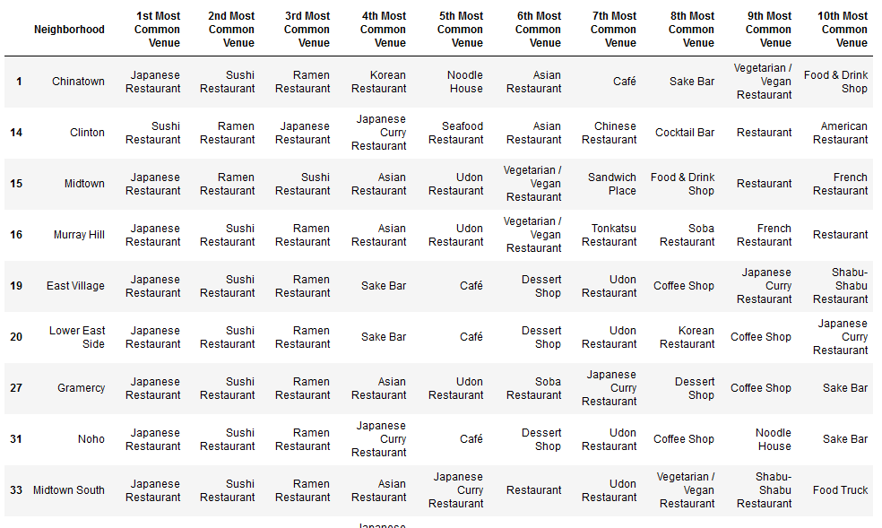

**Cluster 4**

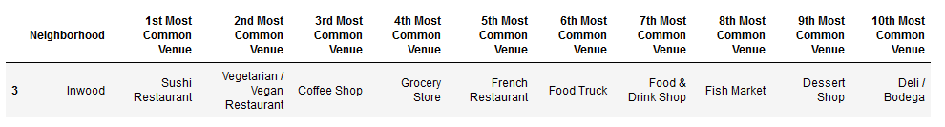

The best locations are cluster 2 and 4 for the Japanese restaurant

## Discussion

The result is based on extracted Foursquare data only. A lot more factors are to be taken into account when choosing a location (traffic, rent prices,…)

## Conclusion

The best locations were found (cluster 2 and 4) based on the available data and the methodology described above but they are not the only factors to be taken into account when opening a Japanese restaurant